- Supplementary Material

Appendix I – Screening of emulsifier and solvent for microemulsions

Table S1. List of available solvents for dissolving ibuprofen. Solvents were evaluated based on key characteristics such as miscibility, water solubility, boiling point, ibuprofen solubility, and vapor pressure. Additionally, each solvent’s classification type within the pharmaceutical industry was considered, leading to the elimination of certain options.
Solvent | Included | Class Type  Solvent | Solubility in  Water [g/100 mL] | Boiling Point  [°C] | Ibuprofen  Solubility | Vapor Pressure  @ 20°C [mm Hg]
acetic acid | ✗
acetone | ✗
acetonitrile | ✗
benzene | ✓ | Class 1 | 0.184 | 80.1
n-butanol | ✓ | Class 3 | 6.800 | 117.7
butyl acetate | ✓ | Class 3 | 0.840 | 126.0 | 30.4 | 10.0
carbon tetrachloride | ✓ | Class 1 | 0.100 | 170.1
chloroform | ✓ | Class 2 | 0.800 | 61.2 | 55.0 | 160.0
cyclohexane | ✓ | Class 2 | 0.005 | 80.7 | 15.8 | 78.0
1,2-dichloroetahne | ✓ | Class 1 | 0.870 | 83.5
dichloromethane | ✓ | Class 2 | 1.300 | 39.6 | 47.93 | 350.0
dimethyl formamide | ✗
dimethyl sulfoxide | ✗
dioxane | ✗
ethanol | ✗
ethyl acetate | ✓ | Class 3 | 8.000 | 77.1
diethyl ether | ✓ | Class 3 | 6.900 | 35.0
heptane | ✓ | Class 3 | 0.000 | 98.4 | 4.07 | 40.0
hexane | ✓ | Class 2 | 0.001 | 69.0 | 5.38 | 124.0
methanol | ✗
methyl-t-butyl ether | ✓ | Class 3 | 4.200 | 55.0
2-butanone | ✓ | Class 3 | 22.000 | 79.6
pentane | ✓ | Class 3 | 0.004 | 36.0 |  | 533.0
n-propanol | ✗
isopropanol | ✗
diisopropyl ether | ✓ | N/A | 0.200 | 69.0
tetrahydrofuran | ✗
toluene | ✓ | Class 2 | 0.005 | 111.0
trichloroethylene | ✓ | Class 2 | 0.128 | 87.2 |  | 58.0
anisole | ✓ | Class 3 | 0.104 | 155.0 | 28.0 | 3.5
xylene | ✓ | Class 2 | 0.017 | 140.0

Table S2. Selection of solvents and emulsifiers for emulsion stability testing. Four solvents were tested with three emulsifiers to determine the most stable combination. Sodium dodecyl sulfate (SDS) was excluded due to its toxicity to human cells, and Kolliphor® P188 was discarded due to its inability to form stable emulsions at a concentration of 2.00 w/v%.
Emulsifier  Solvent | Sodium dodecyl sulfate (SDS) | Kolliphor® P188 | Polyvinyl Alcohol (PVA)
Chloroform | 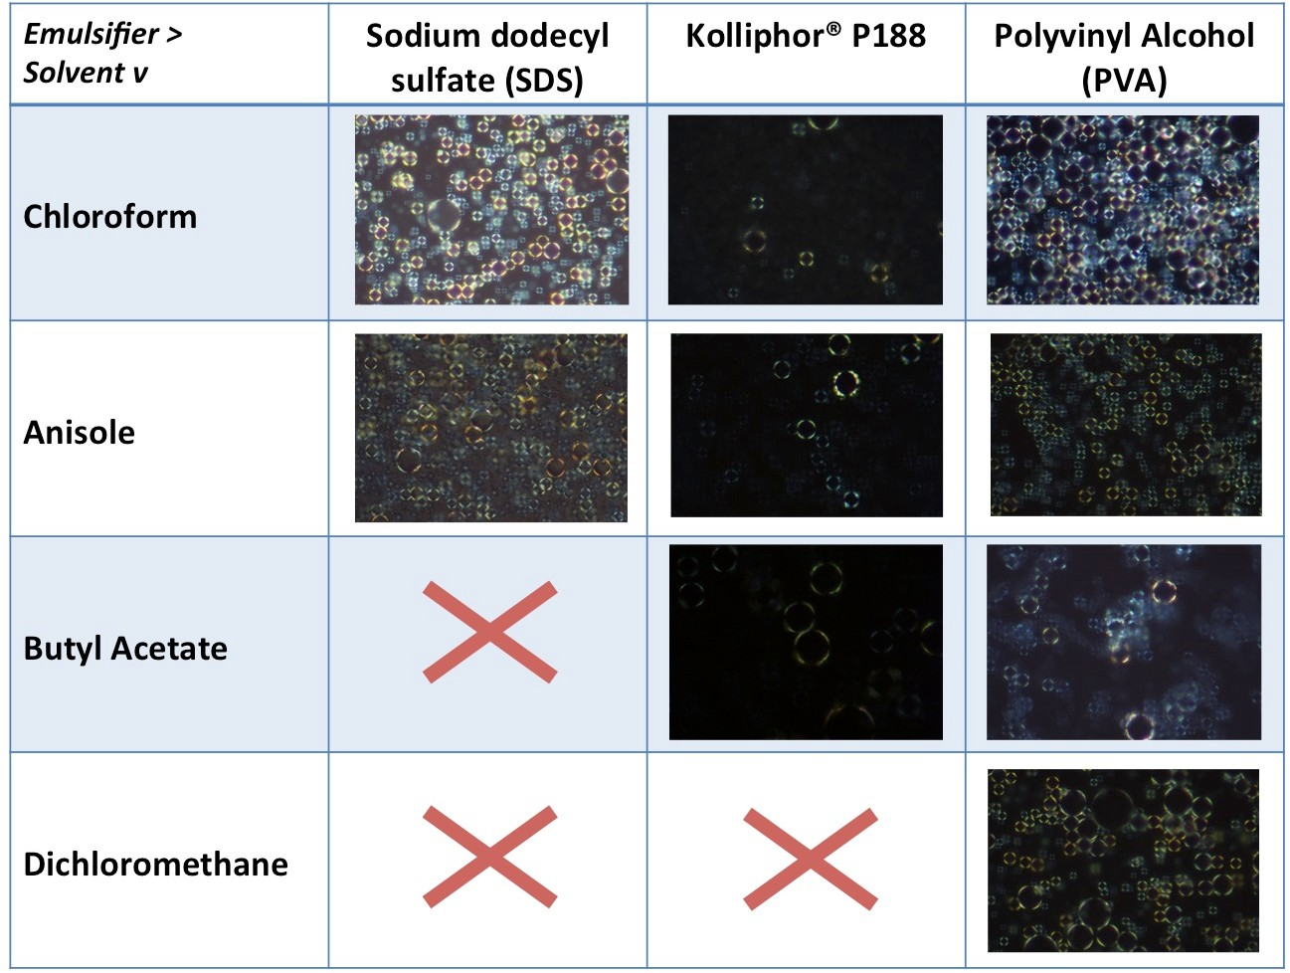
Anisole | 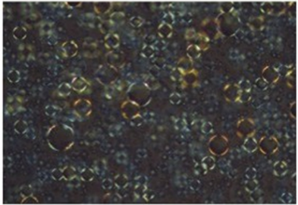 | 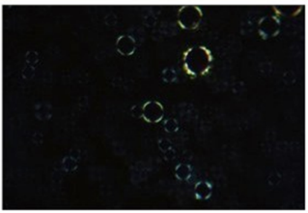 | 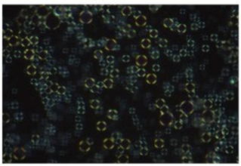
Butyl Acetate | ✗ |  | 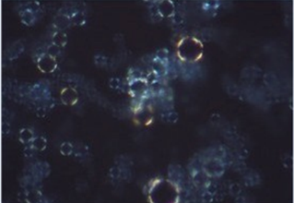
Dichloromethane | ✗ | ✗

Appendix II – Viscoelasticity vs. emulsion volume factor
Study of the viscoelastic behavior of different pre-gel solutions with varying emulsion volume factors. This study was conducted independently in the Myerson Lab at MIT to assess how different emulsion contents influence rheological properties. The graphs presented below demonstrate that, even with a 20% emulsion volume factor, there was no observable effect on the viscosity or other viscoelastic parameters, implying that the material properties remain stable despite changes in emulsion content.
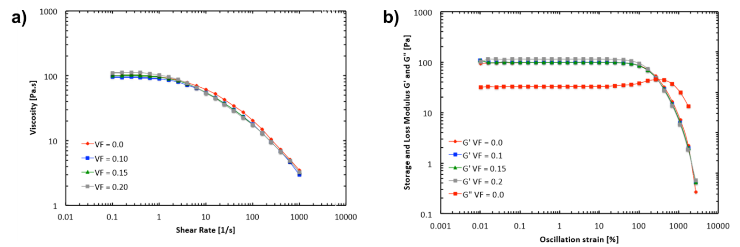
Figure S1. Study of the viscoelastic behavior of pre-gel solutions with different emulsion volume factors: a) viscosity ($η$) as a function of shear rate ($\dot{γ​}$) for pre-gel solutions HG-A and HG-B, with and without a 20% emulsion volume factor. All samples exhibit shear-thinning behavior, with no significant difference observed between emulsified and non-emulsified samples, indicating that the added emulsion does not alter viscosity; b) storage modulus (G′) and loss modulus (G′′) as functions of shear stress for the same samples. Both moduli demonstrate solid-like viscoelastic behavior (G′>G′′), with a yielding point at higher shear stresses. These results confirm that the viscoelastic properties remain unaffected by the emulsion within the tested volume factor.

Appendix III – FT-IR measurements of materials used to synthesize the composite hydrogel

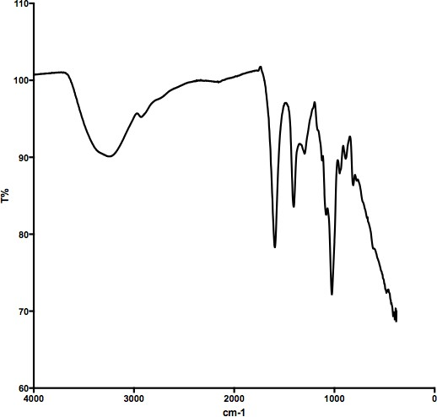
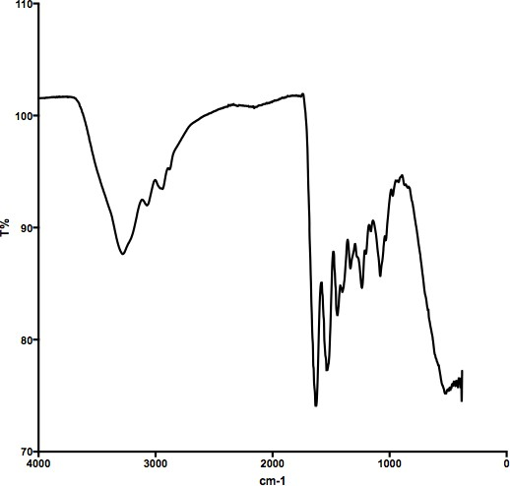
Alginate
Gelatin

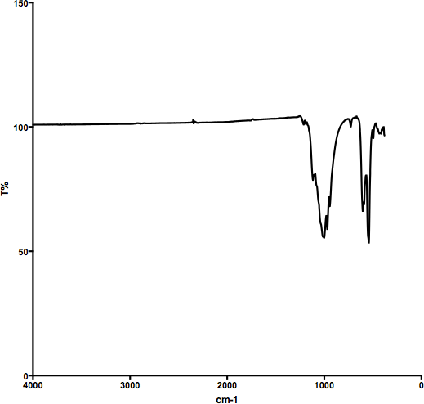
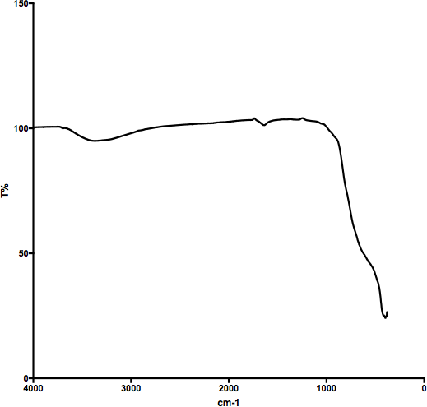
β-TCP
Titanium dioxide
Figure S2. FT-IR Spectra of Alginate, Gelatin, Titanium Dioxide, and β-TCP: Characteristic absorption peaks are marked for each material, illustrating specific functional groups that contribute to the composite hydrogel synthesis.

Appendix IV – EDX reports of elemental analysis of HG-A and HG-B systems
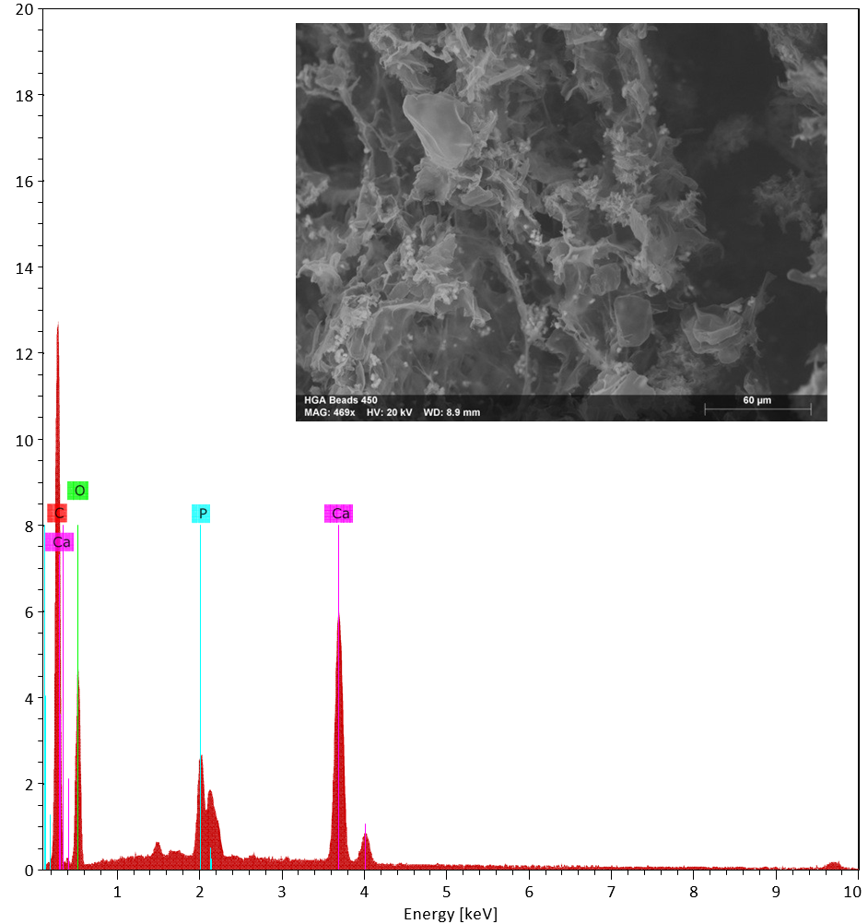
Figure S3. EDX spectrum of the HG-A hydrogel system, specifically for sample "HGA Beads 246," showing the intensity of each identified element. The SEM image displays the morphology of the analyzed sample.

Table S3. Elemental composition of the HG-A hydrogel system obtained through EDX, with normalized mass and atomic percentages and associated errors.
Element | Atomic No. | Line Series | Net Intensity | Mass [%] | Normalized Mass [%] | Atomic  [%] | Abs. Error [%]  (1 σ) | Abs. Error [%]  (2 σ) | Abs. Error [%]  (3 σ)
Carbon | 6 | K- Serie | 83297 | 40.10 | 50.3 | 61.70 | 4.59 | 9.18 | 11.45
Oxygen | 8 | K-Serie | 32902 | 28.10 | 35.06 | 32.46 | 3.45 | 6.91 | 12.29
Calcium | 20 | K-Serie | 95440 | 9.51 | 11.87 | 4.39 | 0.30 | 0.61 | 3.20
Phosphorus | 15 | K-Serie | 31022 | 2.43 | 3.04 | 1.45 | 0.12 | 0.24 | 4.97
Sum |  |  |  | 80.15 | 100.00 | 100.00

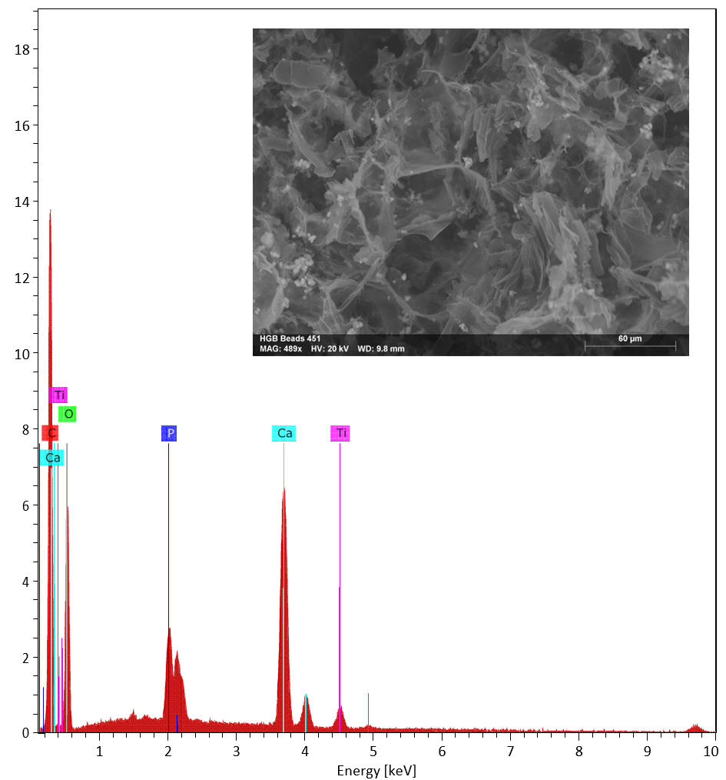
Figure S4. EDX spectrum of the HG-B hydrogel system, specifically for sample "HGA Beads 248," showing the intensity of each identified element. The SEM image displays the morphology of the analyzed sample.

Table S4. Elemental composition of the HG-B hydrogel system obtained through EDX, with normalized mass and atomic percentages and associated errors.
Element | Atomic No. | Line Series | Net Intensity | Mass [%] | Normalized Mass [%] | Atomic  [%] | Abs. Error [%]  (1 σ) | Abs. Error [%]  (2 σ) | Abs. Error [%]  (3 σ)
Carbon | 6 | K- Serie | 80153 | 39.73 | 46.48 | 58.00 | 4.56 | 9.12 | 11.48
Oxygen | 8 | K-Serie | 39532 | 33.08 | 38.70 | 36.25 | 4.00 | 8.00 | 12.09
Calcium | 20 | K-Serie | 90820 | 9.19 | 10.75 | 4.02 | 0.29 | 0.59 | 3.21
Phosphorus | 15 | K-Serie | 28595 | 2.27 | 2.66 | 1.29 | 0.11 | 0.23 | 5.05
Titanium | 22 | K-Serie | 8364 | 1.21 | 1.42 | 0.44 | 0.06 | 0.12 | 5.10
Sum |  |  |  | 85.48 | 100.00 | 100.00
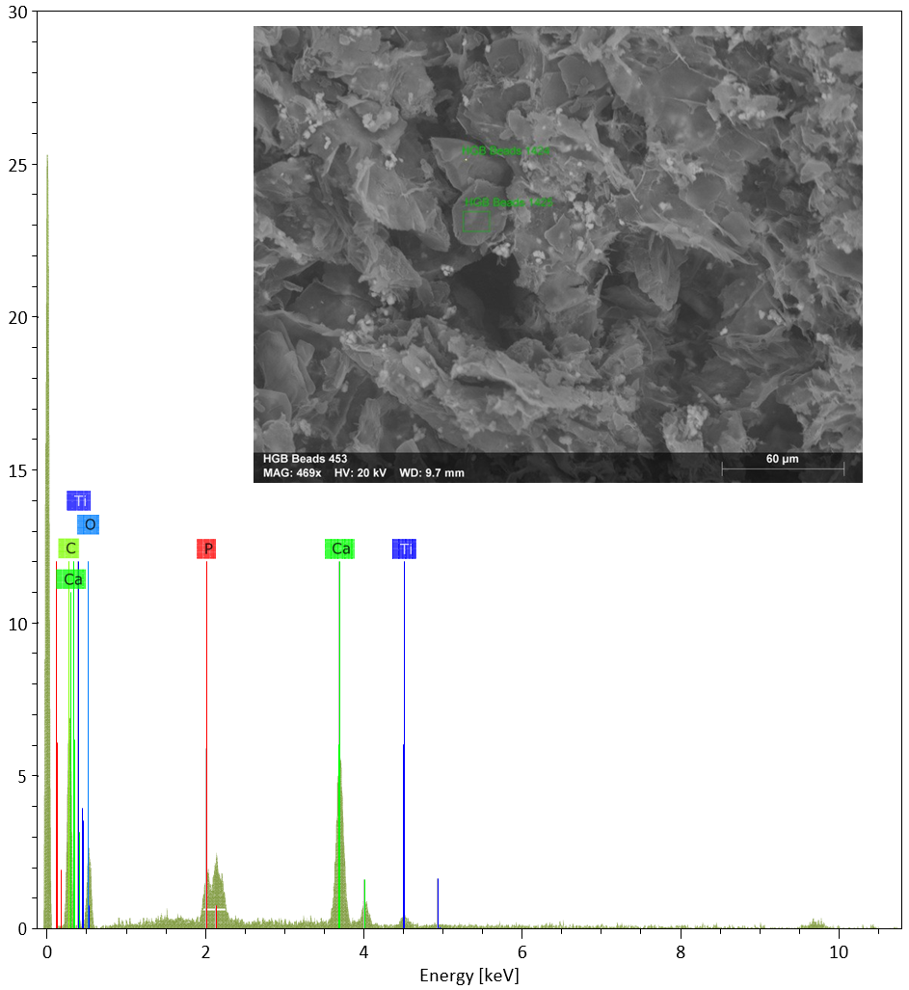
Figure S5. EDX spectrum of a selected crystal of ibuprofen for point-specific elemental analysis. This crystal was selected from the HG-B system; one reason for the small percentage of titanium on the crystal surface is identified. The spectrum shows the intensity of each detected element, while the SEM image displays the morphology of the analyzed sample.

Table S5. Elemental composition of the selected crystal obtained through EDX, showing normalized mass and atomic percentages with associated errors.
Element | Atomic No. | Line Series | Net Intensity | Mass [%] | Normalized Mass [%] | Atomic  [%] | Abs. Error [%]  (1 σ) | Abs. Error [%]  (2 σ) | Abs. Error [%]  (3 σ)
Carbon | 6 | K- Serie | 5382 | 23.37 | 43.94 | 57.25 | 3.64 | 7.27 | 15.56
Oxygen | 8 | K-Serie | 2026 | 18.91 | 35.56 | 34.78 | 3.60 | 7.19 | 19.02
Calcium | 20 | K-Serie | 9627 | 9.69 | 18.22 | 7.12 | 0.33 | 0.66 | 3.41
Titanium | 22 | K-Serie | 622 | 0.89 | 1.67 | 0.55 | 0.07 | 0.14 | 8.05
Phosphorus | 15 | K-Serie | 408 | 0.32 | 0.61 | 0.31 | 0.05 | 0.10 | 14.91
Sum |  |  |  | 53.18 | 100.00 | 100.00
Appendix V – Morphology of Single particles of β-TCP.

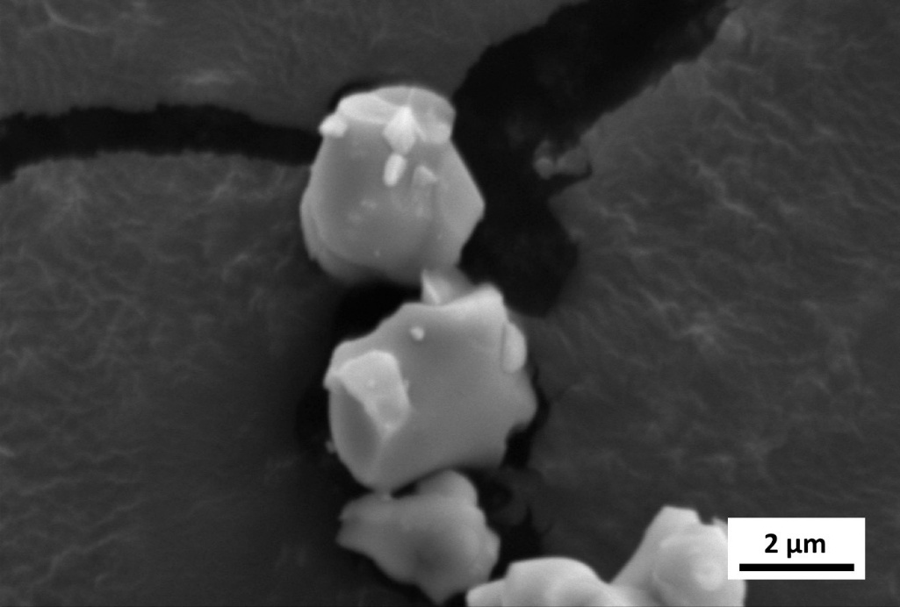
Figure S6. Single particles of β-TCP.

Appendix VI – EDX report of point elemental analysis of bioactivity test
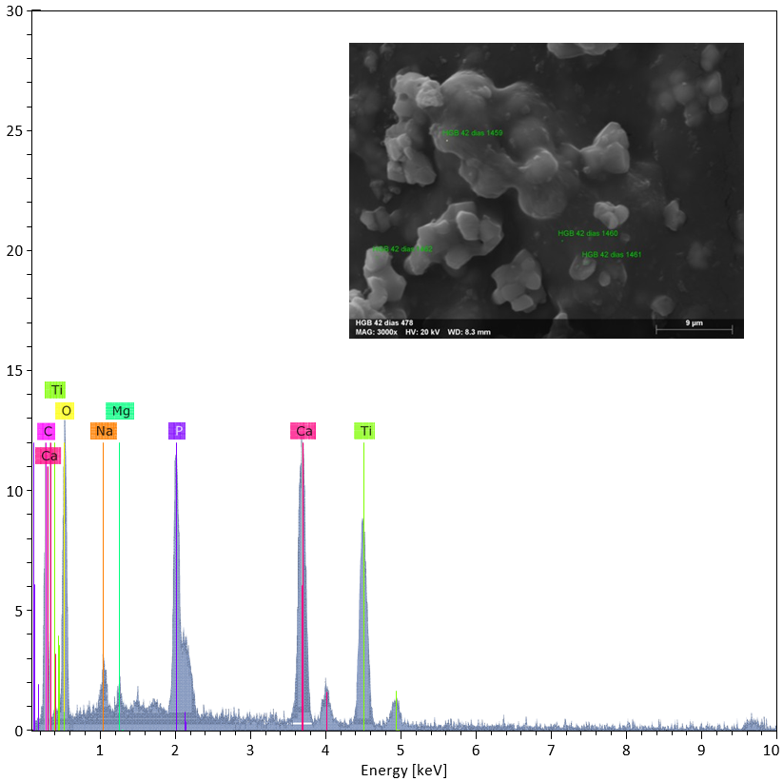
Figure S7. EDX spectrum of the bioactivity sample analyzed, showing the elemental peaks corresponding to the identified elements. The SEM image highlights the morphology of the agglomerate where the elemental analysis was conducted.

Table S6. Elemental composition of the bioactivity sample obtained through EDX analysis, listing normalized mass and atomic percentages along with absolute and relative error values.
Element | Atomic No. | Line Series | Net Intensity | Mass [%] | Normalized Mass [%] | Atomic  [%] | Abs. Error [%]  (1 σ) | Abs. Error [%]  (2 σ) | Abs. Error [%]  (3 σ)
Oxygen | 8 | K-Series | 3697 | 45.59 | 44.46 | 49.12 | 7.58 | 15.16 | 16.63
Carbon | 6 | K-Series | 2495 | 25.84 | 25.21 | 37.09 | 4.68 | 9.36 | 18.10
Titanium | 22 | K-Series | 5727 | 12.64 | 12.33 | 4.55 | 0.42 | 0.85 | 3.36
Calcium | 20 | K-Series | 7546 | 11.55 | 11.26 | 4.97 | 0.40 | 0.79 | 3.43
Phosphorus | 15 | K-Series | 4270 | 4.62 | 4.51 | 2.57 | 0.23 | 0.46 | 4.92
Sodium | 11 | K-Series | 654 | 1.73 | 1.68 | 1.29 | 0.18 | 0.35 | 10.27
Magnesium | 12 | K-Series | 326 | 0.56 | 0.55 | 0.40 | 0.08 | 0.16 | 13.79
Sum |  |  |  | 102.53 | 100.00 | 100.00

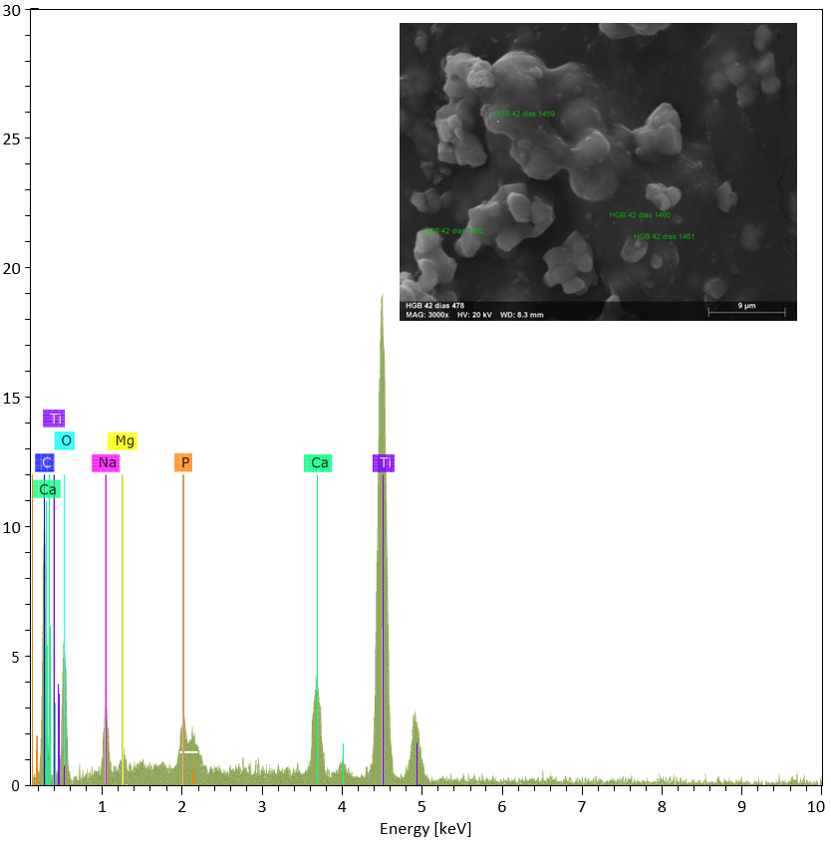
Figure S8. EDX spectrum of the bioactivity sample analyzed, with the point of elemental analysis positioned on the surface of the material, deliberately avoiding any agglomerates observed in the SEM image. The spectrum indicates a significant decrease in the mass percentage of calcium and phosphate, with increases in other elements, supporting the presence of calcium phosphate within the agglomerates.

Table S7. Elemental composition of the bioactivity sample surface obtained via EDX analysis, listing normalized mass and atomic percentages alongside absolute and relative error values.
Element | Atomic No. | Line Series | Net Intensity | Mass [%] | Normalized Mass [%] | Atomic [%] | Abs. Error [%]  (1 σ) | Abs. Error [%]  (2 σ) | Abs. Error [%] (3 σ)
Titanium | 22 | K-Series | 15945 | 28.96 | 33.74 | 13.64 | 0.87 | 1.74 | 3.00
Oxygen | 8 | K-Series | 1911 | 27.32 | 31.83 | 38.50 | 5.26 | 10.51 | 19.24
Carbon | 6 | K-Series | 2993 | 22.82 | 26.58 | 42.83 | 3.98 | 7.95 | 17.42
Calcium | 20 | K-Series | 2862 | 3.40 | 3.96 | 1.91 | 0.15 | 0.30 | 4.38
Sodium | 11 | K-Series | 1108 | 2.41 | 2.81 | 2.36 | 0.22 | 0.44 | 9.07
Phosphorus | 15 | K-Series | 655 | 0.55 | 0.64 | 0.40 | 0.06 | 0.12 | 10.84
Magnesium | 12 | K-Series | 248 | 0.39 | 0.45 | 0.36 | 0.06 | 0.13 | 16.56
Sum |  |  |  | 85.84 | 100.00 | 100.00
Appendix VII – 3D printing set-up

Table S7. Screening of 3D microextrusion process parameters for alginate composite hydrogel in modified 3D printer.
# | Crosslinking Method | Print Speed [mm/s] | Extruder Diameter [mm] | Screening [✓/✗] | Observations
1 | Crosslinking after printing design | - | - | ✓ | Viscosity must be optimized for designs with good resolution
2 | Crosslinking layer by layer during print | - | - | ✗ | Independent layers without achieving final design
3 | Bioplotting (print alginate in crosslinking solution) | - | - | ✗ | Printed line crosslinked immediately, hindering correct design build
4 | Inverse bioplotting (print crosslinking agent in alginate) | - | - | ✗ | Not recommended for intended application
5 | Crosslinking after printing design | 15.0 | 0.50 | ✗ | Fast printing; line not printed, forming dots instead
6 | Crosslinking after printing design | 10.0 | 0.50 | ✗ | Fast printing; line not consistently printed
7 | Crosslinking after printing design | 5.0 | 0.50 | ✓ | Line is printed on the platform. Resolution can be improved
8 | Crosslinking after printing design | 2.0 | 0.50 | ✗ | Design takes too long to print (>4 hours)
9 | Crosslinking after printing design | 5.0 | 0.10 | ✗ | Insufficient material extrusion. Needle partially blocked
10 | Crosslinking after printing design | 5.0 | 0.25 | ✓ | Increased resolution of printed line
11 | Crosslinking after printing design | 5.0 | 0.75 | ✗ | Line printed with poor resolution

Table S8. Complete list of parameters of the software Cura
Parameter | Value | Parameter | Value
Basic Settings |  | Expert Config
Layer height (mm) | 0.15 | Minimum travel (mm) | 1.5
Shell thickness (mm) | 0.25 | Enable combing | All
Enable retraction | Yes | Minimal extrusion before retracting (mm) | 0.02
Bottom/Top thickness (mm) | 0.6 | Z hop when retracting (mm) | 0.0
Fill Density (%) | 100 | Skirt
Print speed (mm/s) | 4.5 | Line count | 0
Printing temperature (°C) | - | Start distance (mm) | 3.0
Support type | None | Minimal length (mm) | 150.0
Platform adhesion type | None | Cool
Filament Diameter (mm) | 14 | Fan full on at height (mm) | 0.5
Flow (%) | 100 | Fan speed min (%) | 100
Nozzle size (mm) | 0.25 | Fan speed max (%) | 100
Advanced Settings |  | Minimal speed (mm/s) | 10
Retraction Speed (mm/s) | 40 | Cool head lift | No
Retraction Distance (mm) | 0 | Support
Initial layer thickness (mm) | 0 | Structure type | Lines
Initial layer line width (%) | 100 | Overhang angle for support (deg) | 60
Cut off object bottom (mm) | 0 | Fill amount (%) | 15
Dual extrusion overlap (mm) | 0.15 | Distance X/Y (mm) | 0.7
Travel speed (mm/s) | 5 | Distance Z (mm) | 0.15
Bottom layer speed (mm/s) | 4 | Black Magic
Infill speed (mm/s) | 0 | Spiralize the outer contour | No
Top/bottom speed (mm/s) | 0 | Only follow mesh surface | No
Outer shell speed (mm/s) | 0 | Brim
Inner shell speed (mm/s) | 0 | Brim line amount | 20
Minimal layer time (sec) | 5 | Raft
Enable cooling fan | Yes | Extra margin (mm) | 5.0
 |  | Line spacing (mm) | 3.0
 |  | Base thickness (mm) | 0.3

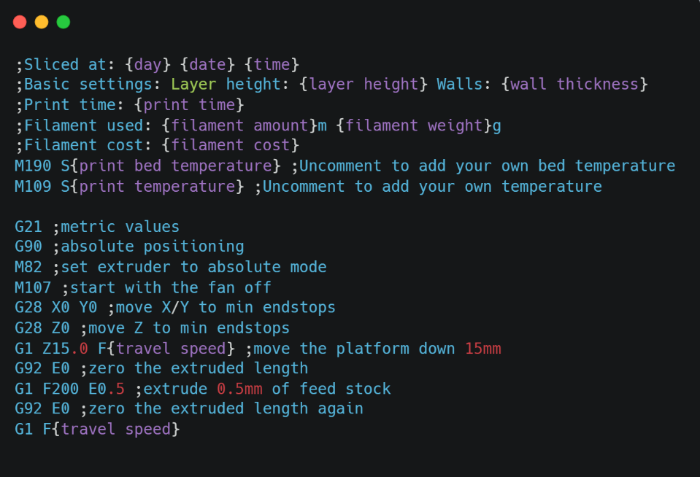
Figure S9. Modified start route for G-code generation to optimize extrusion of precrosslinked hydrogel.

Appendix VIII – Resolution of the crosslinked grid design as the viscosity of the pre-crosslinked hydrogel increases

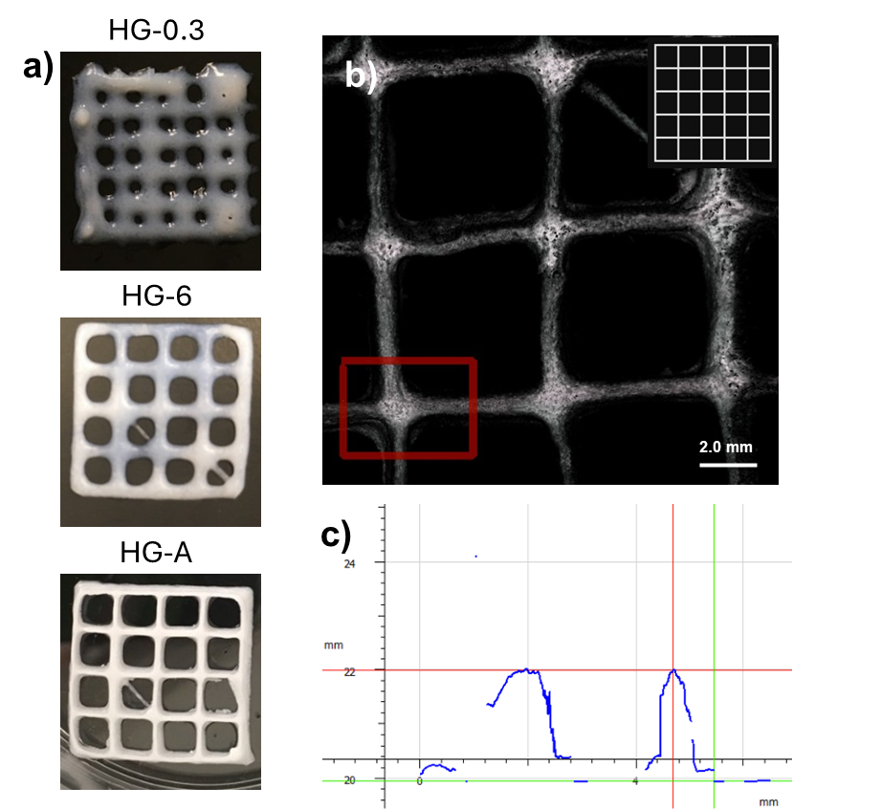

Figure S10. a) Resolution of the crosslinked grid design as the viscosity of the pre-crosslinked hydrogel increases; b) 3D scan of the grid design of HG-A using the Alicona microscope; c) Graph of the 3D mapping of the image.

