Supporting Information

Polymer Connectivity Governs Electrophotocatalytic Activity in the Solid State

Jianheng Ling,^{a,‡} Amy L. Vonder Haar,^{a,‡} Kiser Z. Colley,ª Juno Kim,ª Andrew J. Musser,^{a,}* Phillip J. Milner ^{a,}*

ªDepartment of Chemistry and Chemical Biology, Cornell University, Ithaca, NY 14853, United States
‡Contributed equally; *Correspondence to: ajm557@cornell.edu, pjm347@cornell.edu

Table of Contents
1. General procedures. 3
2. Synthesis and characterization of monomers. 5
a. Tetrakis(4-aminophenyl)methane (TPAPM). 5
3. Synthesis and characterization of molecular catalysts. 11
a. N-(2,6-diisopropylphenyl)-1,8-naphthalimide (NDCMA-di^{i}PrAn). 11
b. N,N'-bis(2,6-diisopropylphenyl)-1,4,5,8-naphthalenetetracarboxylic diimide (NTCDA-di^{i}PrAn). 14
c. N,N'-bis(2,6-diisopropylphenyl)-3,4,9,10-perylenetetracarboxylic diimide (PTCDA-di^{i}PrAn). 17
4. Synthesis and characterization of polymer catalysts. 23
a. NTCDA-en from 1,4,5,8-naphthalene tetracarboxylic dianhydride (NTCDA) and ethylenediamine (en). 24
b. PMDA-en from pyromellitic dianhydride (PMDA) and ethylenediamine (en). 29
c. PTCDA-en from 3,4,9,10-perylene tetracarboxylic dianhydride (PTCDA) and ethylenediamine (en). 34
d. PTCDA-pn from 3,4,9,10-perylene tetracarboxylic dianhydride (PTCDA) and 1,3-diaminopropane (pn). 43
e. PTCDA-nBut from 3,4,9,10-perylene tetracarboxylic dianhydride (PTCDA) and 1,4-diaminobutane (nBut). 48
f. PTCDA-nHex from 3,4,9,10-perylene tetracarboxylic dianhydride (PTCDA) and 1,6-diaminohexane (nHex). 53
g. PTCDA-men from 3,4,9,10-perylene tetracarboxylic dianhydride (PTCDA) and 1,2-diaminopropane (men). 58
h. PTCDA-dmpn from 3,4,9,10-perylene tetracarboxylic dianhydride (PTCDA) and 2,2-dimethyl-1,3-diaminopropane (dmpn). 62
i. PTCDA-TPAPA from 3,4,9,10-perylene tetracarboxylic dianhydride (PTCDA) and tris(4-aminophenyl)amine (TPAPA). 67
j. PTCDA-TPAPM from 3,4,9,10-perylene tetracarboxylic dianhydride (PTCDA) and tetrakis(4-aminophenyl)methane (TPAPM). 72
k. PTCDA-TPAPT from 3,4,9,10-perylene tetracarboxylic dianhydride (PTCDA) and 2,4,6-tris(4-aminophenyl)-1,3,5-triazine (TPAPT). 77
5. Synthesis and characterization of substrates. 83
a. 4-(ethoxycarbonyl)-N,N,N-trimethylbenzeneammonium iodide. 83
b. 4-(ethoxycarbonyl)benzenediazonium tetrafluoroborate. 85
6. Fabrication of polymer-functionalized electrodes. 88
a. Small-scale production. 88
b. Estimation of polymer loading on electrodes. 89
c. Bulk production of PTCDA-en-functionalized electrodes. 90
d. Electrochemical setup. 92
7. General electrolysis procedures. 93
a. Initial optimizations using PTCDA-di^{i}PrAn. 93
b. Molecular catalysts (MCs) screen. 95
c. Polymer catalysts (PCs) screen. 96
d. Further optimizations using PTCDA-en. 97
e. Reductive borylation using PTCDA-en. 100
f. Hydrodehalogenation using PTCDA-en. 101
g. Characterization of purified products. 102
h. Background yields. 109
8. Mechanistic investigations. 110
a. Cathode potential measurement. 110
b. Additional CV characterizations of PTCDA-en. 112
c. UV-Vis studies of PTCDA-di^{i}PrAn. 114
d. UV-Vis studies of PTCDA-en. 134
e. Solubility studies of PTCDA-en. 139
f. UV-Vis studies of PTCDA-TPAPA. 140
9. Photophysical measurements. 145
a. Transient absorption (TA) measurements of PTCDA-di^{i}PrAn. 146
b. Transient absorption (TA) measurements of PTCDA-en. 148
c. Transient absorption (TA) measurements of PTCDA-TPAPA. 151
10. NMR spectra of products. 152
11. References. 172

General procedures.
All reagents and materials, including imidazole (99%, Fluka), pyromellitic dianhydride (PMDA, 98%, TCI), 1,8-naphthalic anhydride (NDCMA, Acros, 97%), 1,4,5,8-naphthalene tetracarboxylic dianhydride (NTCDA, 97%, Alfa Aesar), 3,4,9,10-perylene tetracarboxylic acid dianhydride (PTCDA, 98%, Oakwood), 2,6-diisopropylaniline (di^{i}PrAn, 90%, Fisher Scientific), 1,2-ethylenediamine (en, 99%, Acros), 1,3-diaminopropane (pn, 99%, Aldrich), 1,4-diaminobutane (nBut, 99%, Oakwood), 1,6-diaminohexane (nHex, 99%, Chem-Impex), 1,2-diaminopropane (men, 98.5%, Santa Cruz), 2,2-dimethyl-1,3-diaminopropane (dmpn, 98%, Oakwood), tris(4-aminophenyl)amine (TPAPA, 97%, AstaTech), 2,4,6-tris(4-aminophenyl)-1,3,5-triazine (TPAPT, 95%, AstaTech), 1-methyl-2-pyrrolidinone (NMP, anhydrous 99.5%, Sigma Aldrich), N,N-diisopropylethylamine (DIPEA, 99%, Aldrich), lithium perchlorate (LiClO₄, anhydrous 95%, Alfa Aesar), sodium perchlorate (NaClO₄, anhydrous 98.0–102.0%, Beantown Chemical), potassium perchlorate (KClO₄, anhydrous 99%, Alfa Aesar), tetrabutylammonium perchlorate (TBAClO₄, anhydrous 98%, TCI), Super P carbon (Imerys Graphite & Carbon) and polyvinylidene fluoride (PVDF, Kynar Flex), were purchased from commercial vendors and used without further purification, unless otherwise specified. Anhydrous, degassed solvents, including acetonitrile (MeCN, 99.9%, Fisher Scientific) and N,N-dimethylformamide (DMF, 99.8%, Fisher Scientific), were obtained by vigorously sparging with Ar for 30 min and then passing the solvent through two columns of activated alumina using a Phoenix SDS J. C. Meyer solvent system. All electrolytes (LiClO₄, NaClO₄, KClO₄, and TBAClO₄) and solvents were stored in a N₂-filled glovebox when not in use.
Electrolysis experiments were performed using a Gamry Interface 1010E potentiostat or a Tacklife DC power supply with a carbon felt cathode (Fuel Cell Store) and a sacrificial Zn anode (Strem Chemicals, 99.98%). Cyclic voltammetry (CV) measurements were conducted at 22 °C on a Gamry Interface 1010E potentiostat using a glassy carbon working electrode, a platinum wire counter electrode, and an Ag/AgNO₃ reference electrode in a N₂-filled glovebox. In general, three scans were collected: one with ferrocene (Fc) as an internal reference, and two without Fc. The potential values were then converted to potentials vs. standard hydrogen electrode (SHE) (Fc/Fc⁺ = +0.400 V vs. SHE). All potentials are reported against SHE. The Ag/AgNO₃ reference electrode (CH Instruments) was stored in a 0.01 M solution of silver(I) nitrate (AgNO₃, 100%, Aldon Corporation) and 0.1 M tetrabutylammonium hexafluorophosphate (TBAPF₆, 98%, Oakwood) in MeCN in a N₂-filled glovebox when not in use.
Infrared (IR) spectra were collected on a Bruker Tensor II IR spectrometer with a diamond Attenuated Total Reflectance (ATR) attachment. Powder X-ray diffraction (PXRD) patterns were collected on a Rigaku Ultima IV diffractometer equipped with a Cu Kα source (λ = 1.5406 Å) and were baseline-corrected using OriginPro. Solution-state NMR data were collected on a Bruker INOVA 400 MHz or a Bruker INOVA 500 MHz spectrometer and are referenced to residual solvent. Solution-state UV-Vis spectra were collected in 10 mm air-tight quartz cuvettes using a Shimadzu UV-2600i Spectrophotometer and were normalized using OriginPro. Solid-state UV-Vis spectra were collected on samples dispersed in spectroscopic grade BaSO₄ using a Shimadzu UV-2600i Spectrophotometer equipped with an ISR-2660 Plus Integration Sphere and were normalized and smoothed using OriginPro. Surface area data were collected on a Micromeritics ASAP 2020 or a Micromeritics ASAP 2460 gas sorption analyzer using ultrapure N₂ (99.999%) and a liquid N₂ bath. Brunauer-Emmett-Teller (BET) and Langmuir surface areas were determined by linear least squares regression analysis using the linearized forms of the BET and Langmuir equations, respectively. Combustion elemental analysis was performed by Atlantic Microlab, Inc. Thermogravimetric decomposition profiles were collected on a TA Instruments 550 thermogravimetric analyzer using a temperature ramp of 5.00 °C/min from 40.00 °C to 600.00 °C under an atmosphere of ultrapure N₂ (99.999%).
Incandescent heat lamps (125 W) used for drying polymer-functionalized electrodes (Section 6) were purchased from Feit Electric Company, Inc. Compact fluorescent lamps (CFLs, 15 W, Figure S1) were purchased from Westinghouse Electric Corporation.
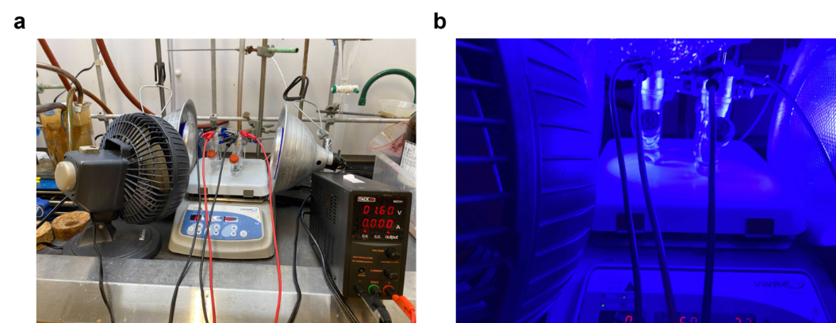
Figure S1. (a) Reaction setup with (b) blue CFLs used in this work.
Kessil PR160L LEDs (max. 40 W, Figure S2) were purchased from Kessil LED PhotoReaction Lighting.
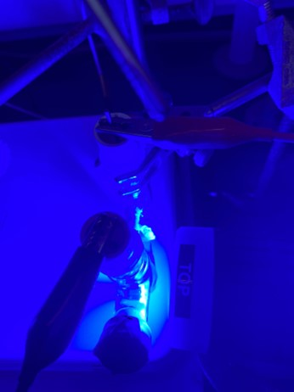
Figure S2. Reaction setup with Kessil PR160L-456 nm LED (max. 40 W).

Synthesis and characterization of monomers.

Tetrakis(4-aminophenyl)methane (TPAPM).

Figure S3. Synthesis of tetraphenylmethane from chlorotriphenylmethane and aniline.
Synthesis of tetraphenylmethane. This procedure was adapted from the literature.¹ To a 250 mL round-bottom flask equipped with a stir bar, chlorotriphenylmethane (12.50 g, 44.84 mmol, 1.00 equiv.) and aniline (11 mL, 116.58 mmol, 2.60 equiv.) were added. The reaction mixture was heated to 190 °C in a silicone oil bath and allowed to stir at 190 °C for 15 min. At this time, it was allowed to cool to room temperature. After addition of 2 M aq. HCl (60 mL) and MeOH (90 mL), the reaction mixture was sonicated for 1 h, and the chunky solids were broken up into smaller pieces using a spatula. The mixture was then heated at 80 °C for 30 min, before cooling to room temperature. The resulting solid was filtered and washed with DI water (200 mL) and acetone (50 mL). The solid was suspended in DMF (125 mL). The mixture was cooled to −20 °C using an ice water bath containing NaCl. Concentrated H₂SO₄ (14 mL) and isoamyl nitrite (10 mL) were added dropwise into the mixture. The resulting mixture was allowed to stir at −20 °C for 1 h, before H₃PO₂ (30% in water, 37.5 mL) was added dropwise. The resulting mixture was heated at 50 °C for 1 h, by which time gas evolution ceased. The resulting solid was allowed to cool to room temperature, filtered, washed with DI water (250 mL), EtOH (250 mL) and acetone (250 mL). The solid was suspended in acetone (250 mL) and allowed to stand for 16 h, before being filtered again to yield tetraphenylmethane as an off-white solid (10.70 g, 74% yield). ¹H NMR (400 MHz, CDCl₃): δ 7.36–7.15 (m, 20H) ppm; ¹³C NMR (101 MHz, CDCl₃): δ 146.94, 131.33, 127.60, 126.04, 65.14 ppm. These spectra are consistent with those reported in the literature.¹
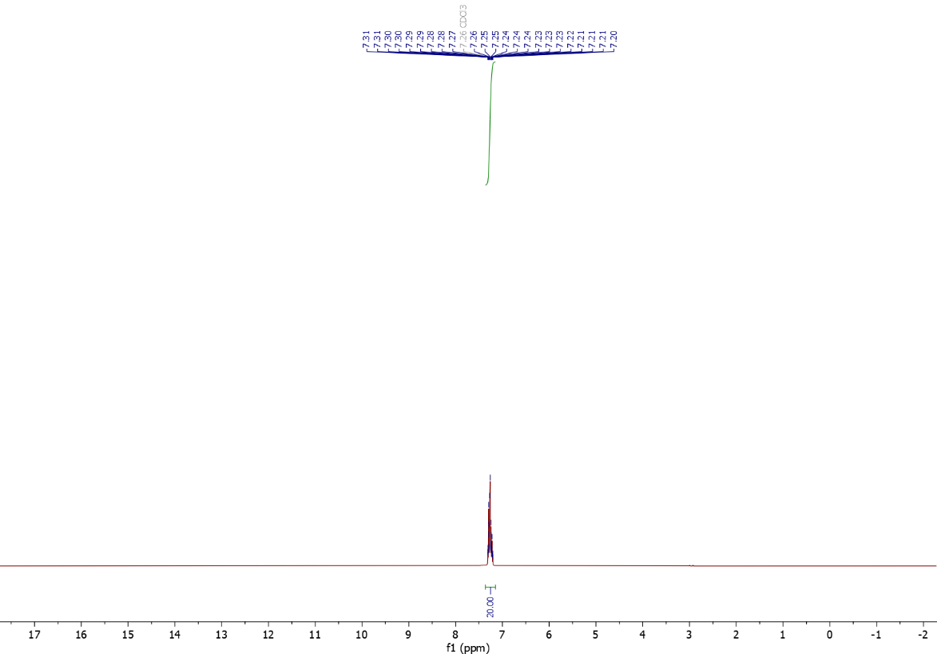
Figure S4. ¹H NMR (400 MHz, CDCl₃) spectrum of tetraphenylmethane.
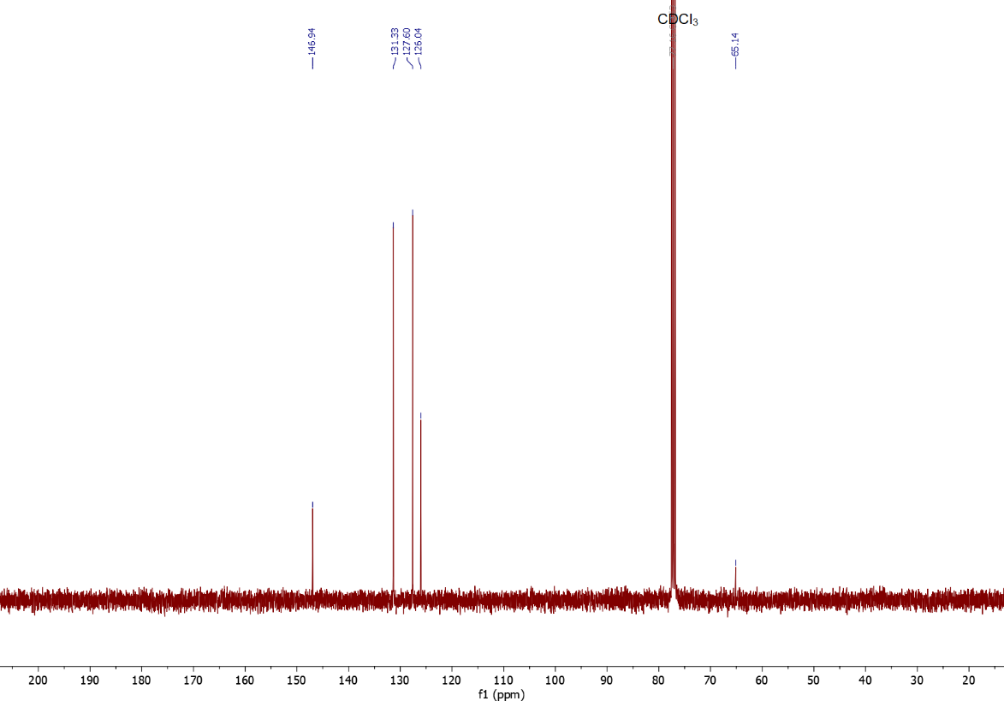
Figure S5. ¹³C NMR (101 MHz, CDCl₃) spectrum of tetraphenylmethane.

Figure S6. Synthesis of tetrakis(4-nitrophenyl)methane from tetraphenylmethane.
Synthesis of tetrakis(4-nitrophenyl)methane. This procedure was adapted from the literature.^{2,3} To a 250 mL round-bottom flask equipped with a stir bar, tetraphenylmethane (7.37 g, 23 mmol, 1.00 equiv.) was added. After cooling down to −40 °C using an acetonitrile bath containing dry ice, fuming HNO₃ (40 mL), Ac₂O (12.5 mL) and AcOH (25 mL) were sequentially added to the flask. The reaction mixture was allowed to gradually warm to room temperature and stir for 16 h. The reaction mixture was diluted with DI water (100 mL) and filtered. The resulting solid was rinsed with DI water (50 mL), followed by EtOH (50 mL) and acetone (100 mL). The solid was then suspended in acetone (250 mL) and allowed to stand for 16 h, before being filtered to yield tetrakis(4-nitrophenyl)methane as a light yellow solid (2.47 g, 21% yield). ¹H NMR (400 MHz, DMSO-d₆): δ 8.23 (d, J = 9.0 Hz, 8H), 7.60 (d, J = 9.0 Hz, 8H) ppm; ¹³C NMR (101 MHz, DMSO-d₆): δ 151.04, 146.11, 131.50, 123.82, 65.29 ppm. These spectra are consistent with those reported in the literature.⁴
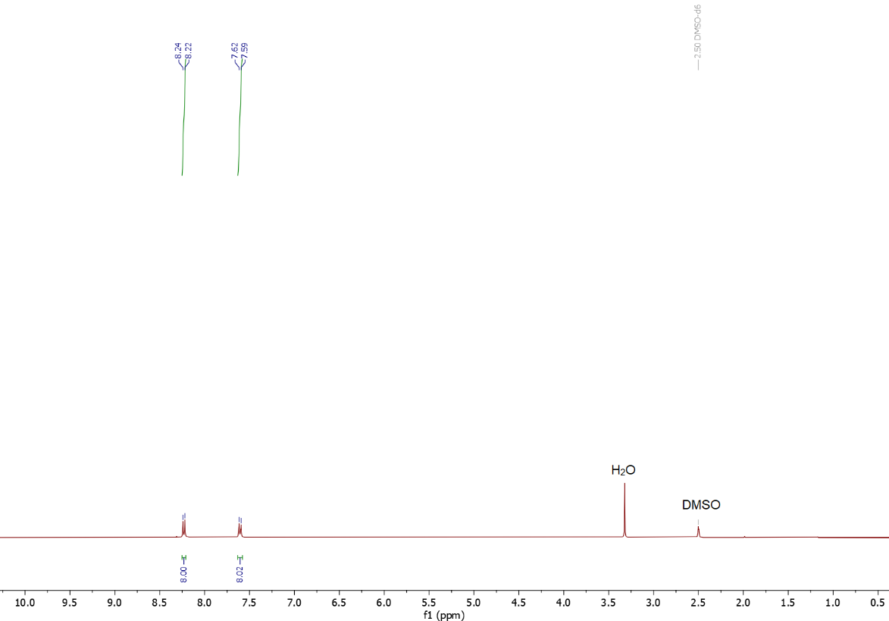
Figure S7. ¹H NMR (400 MHz, DMSO-d₆) spectrum of tetrakis(4-nitrophenyl)methane.
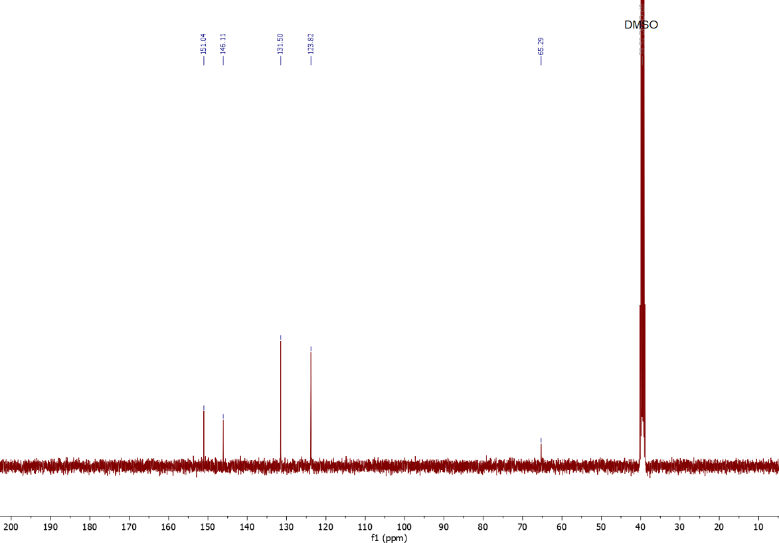
Figure S8. ¹³C NMR (101 MHz, DMSO-d₆) spectrum of tetrakis(4-nitrophenyl)methane.

Figure S9. Synthesis of TPAPM from tetrakis(4-nitrophenyl)methane.
Synthesis of TPAPM. This procedure was adapted from the literature.⁴ To a 10 mL screw-cap reaction tube equipped with a stir bar, tetrakis(4-nitrophenyl)methane (150 mg, 0.30 mmol, 1.00 equiv.), palladium on activated carbon (10 wt% Pd, 30 mg), THF (3 mL), and hydrazine hydrate (1.50 mL, 30.87 mmol, 102.90 equiv.) were added. The reaction mixture was heated to 80 °C and allowed to stir at 80 °C for 16 h. At this time, the reaction mixture was allowed to cool to room temperature. The reaction mixture was diluted with THF (20 mL) and filtered. The resulting filtrate was concentrated under reduced pressure to yield tetrakis(4-aminophenyl)methane (TPAPM) as an off-white solid (34.10 mg, 30% yield). ¹H NMR (400 MHz, DMSO-d₆): δ 6.68 (d, J = 8.6 Hz, 8H), 6.39 (d, J = 8.6 Hz, 8H), 4.86 (s, 8H) ppm; ¹³C NMR (101 MHz, DMSO-d₆): δ 145.61, 135.87, 131.04, 112.61, 61.12 ppm. These spectra are consistent with those reported in the literature.⁴
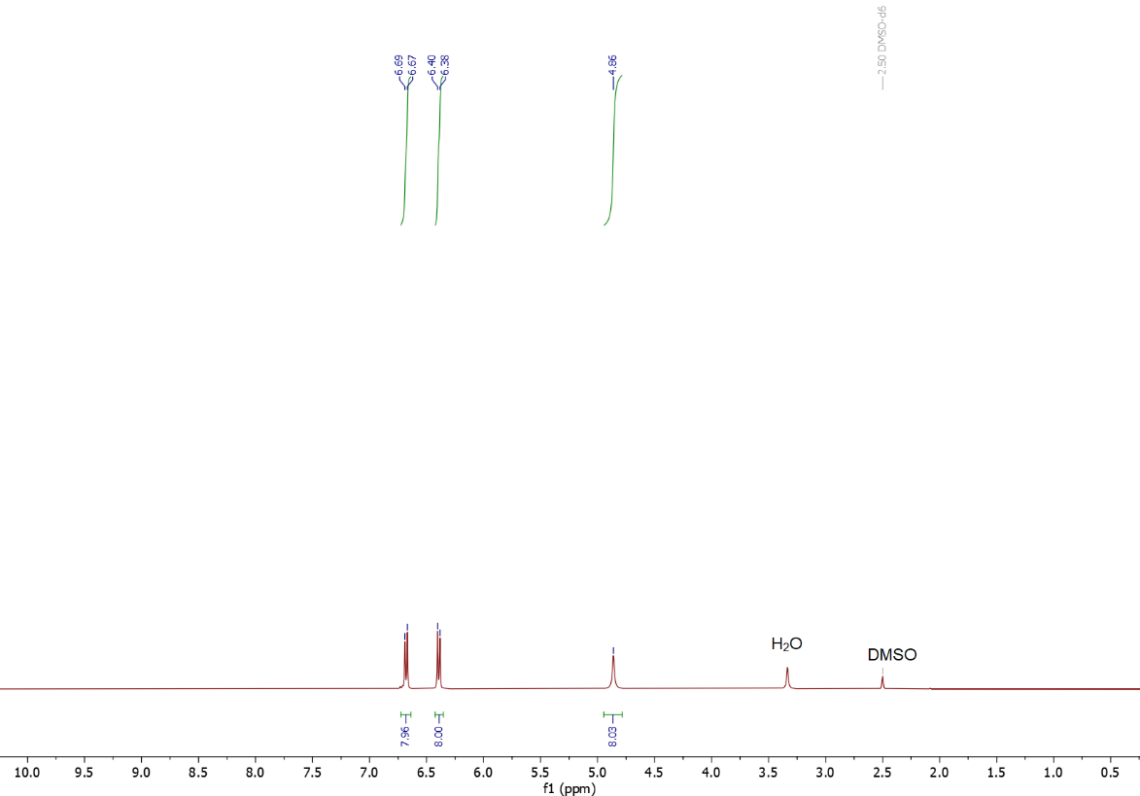
Figure S10. ¹H NMR (400 MHz, DMSO-d₆) spectrum of TPAPM.
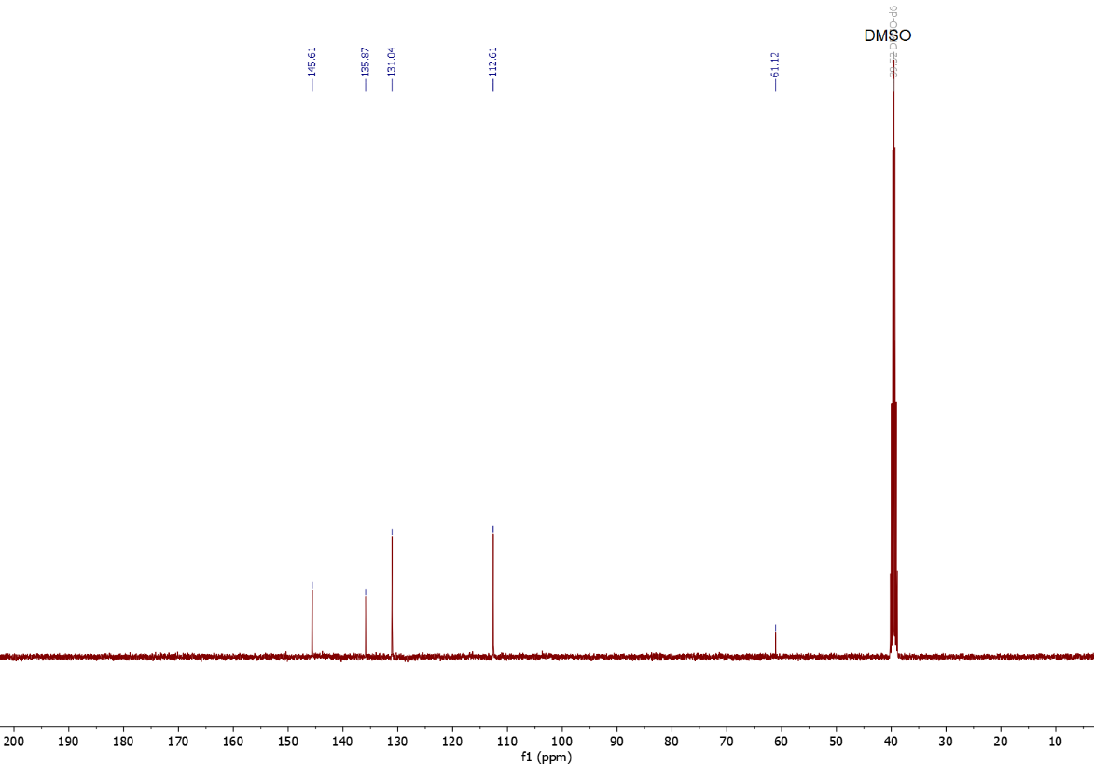
Figure S11. ¹³C NMR (101 MHz, DMSO-d₆) spectrum of TPAPM.

Synthesis and characterization of molecular catalysts.

N-(2,6-diisopropylphenyl)-1,8-naphthalimide (NDCMA-di^{i}PrAn).

Figure S12. Synthesis of NDCMA-di^{i}PrAn from NDCMA and di^{i}PrAn.
Synthesis of NDCMA-di^{i}PrAn. This procedure was adapted from the literature.⁵ To a 250 mL round-bottom flask equipped with a stir bar, NDCMA (1.00 g, 5.05 mmol, 1.00 equiv.), AcOH (20 mL), and di^{i}PrAn (5.71 mL, 30.30 mmol, 6.00 equiv.) were added. The reaction mixture was heated to 110 °C and allowed to stir at 110 °C for 16 h. At this time, the reaction mixture was allowed to cool to room temperature. The reaction mixture was diluted with DI water (100 mL) and filtered. The resulting solid was rinsed with DI water (50 mL) and EtOH (50 mL) to yield N-(2,6-diisopropylphenyl)-1,8-naphthalimide (NDCMA-di^{i}PrAn) as a white solid (1.47 g, 82% yield). ¹H NMR (400 MHz, CDCl₃): δ 8.68 (dd, J = 7.3, 1.1 Hz, 2H), 8.30 (dd, J = 8.3, 1.1 Hz, 2H), 7.82 (dd, J = 8.2, 7.3 Hz, 2H), 7.48 (t, J = 7.8 Hz, 1H), 7.34 (d, J = 7.7 Hz, 2H), 2.76 (sept, J = 6.8 Hz, 2H), 1.16 (d, J = 6.8 Hz, 12H) ppm; ¹³C NMR (101 MHz, CDCl₃): δ 164.35, 145.81, 134.33, 131.98, 131.88, 131.00, 129.63, 128.96, 127.18, 124.16, 122.91, 29.26, 24.12 ppm. These spectra are consistent with those reported in the literature.⁶
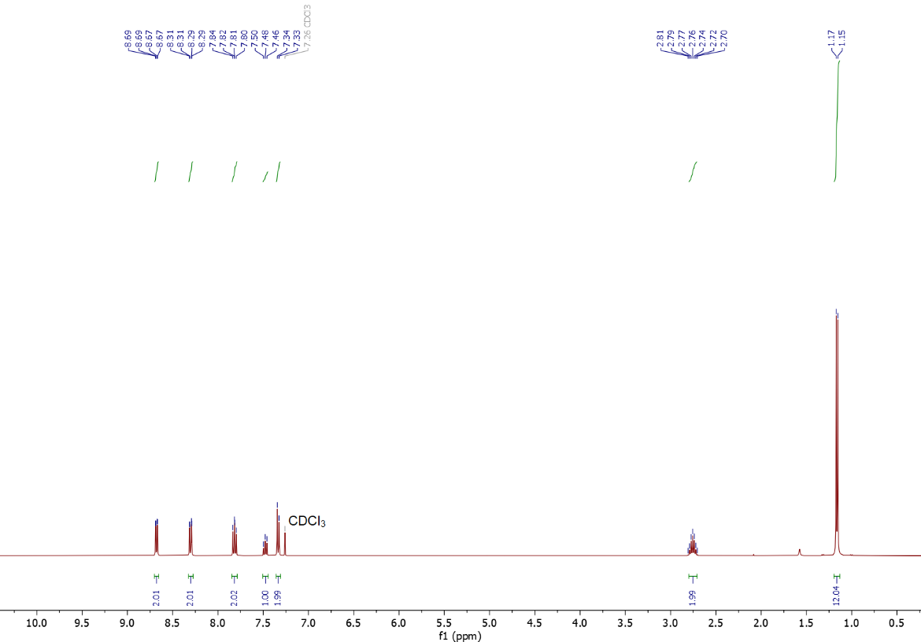
Figure S13. ¹H NMR (400 MHz, CDCl₃) spectrum of NDCMA-di^{i}PrAn used in this work.
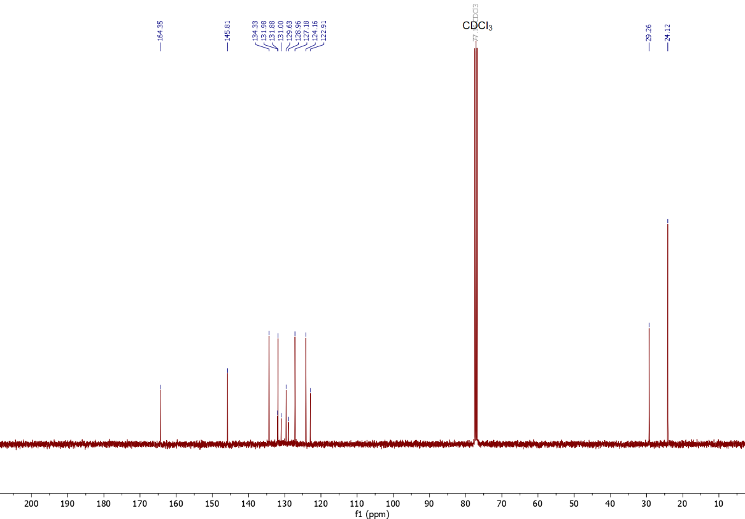
Figure S14. ¹³C NMR (101 MHz, CDCl₃) spectrum of NDCMA-di^{i}PrAn used in this work.

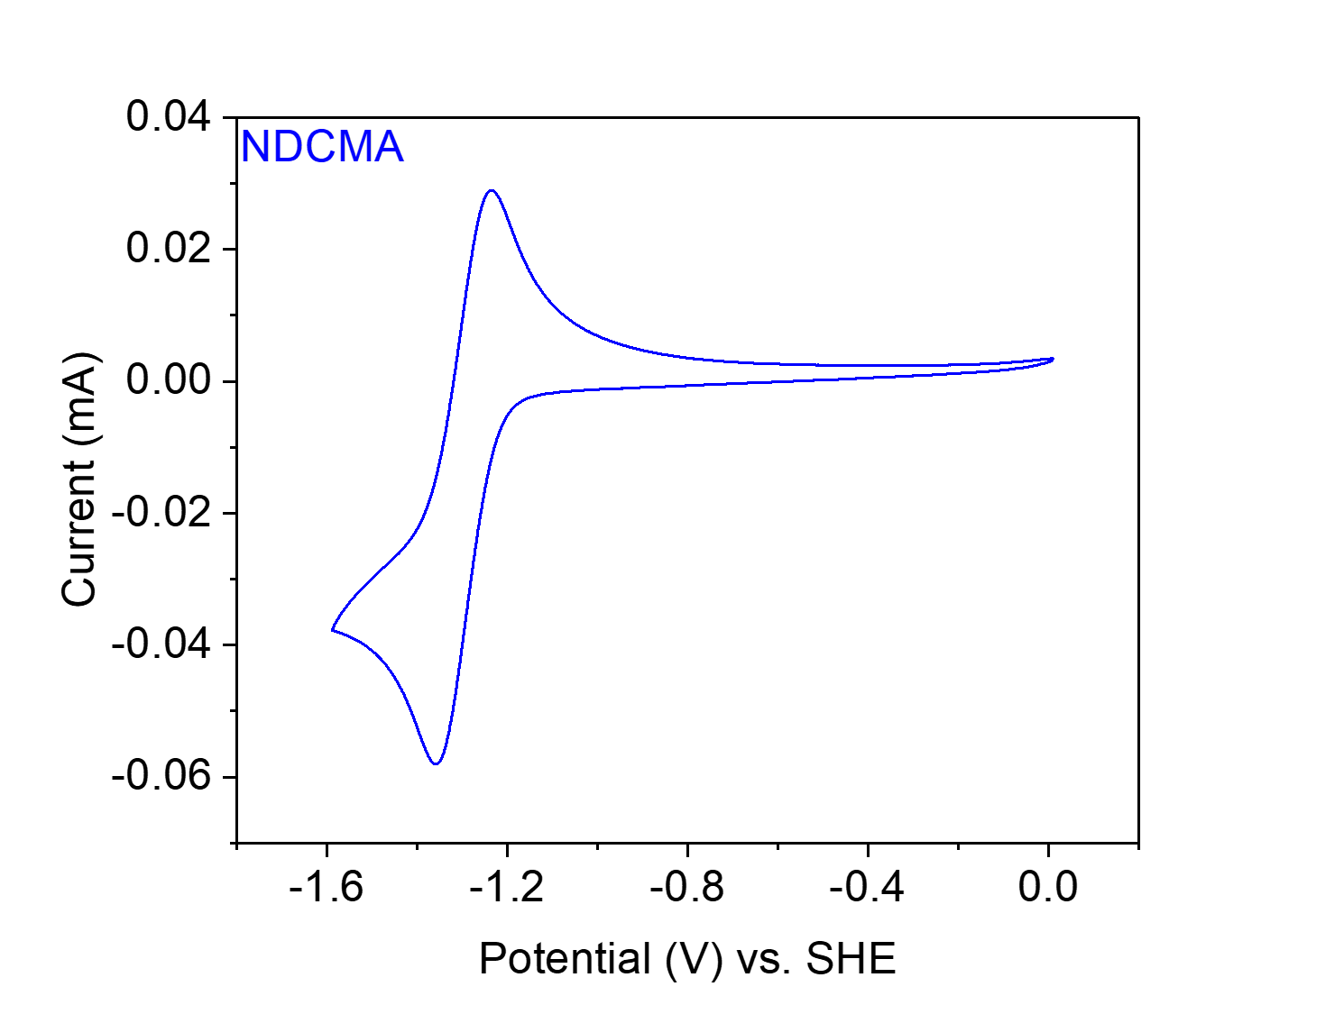
Figure S15. CV at 20 mV s⁻¹ of NDCMA-di^{i}PrAn in 0.1 M NaClO₄ in MeCN.

N,N'-bis(2,6-diisopropylphenyl)-1,4,5,8-naphthalenetetracarboxylic diimide (NTCDA-di^{i}PrAn).
Figure S16. Synthesis of NTCDA-di^{i}PrAn from NTCDA and di^{i}PrAn.
Synthesis of NTCDA-di^{i}PrAn. This procedure was adapted from the literature.⁷ To a 250 mL round-bottom flask equipped with a stir bar, NTCDA (1.34 g, 5.00 mmol, 1.00 equiv.), CH₃COOH (70 mL), and di^{i}PrAn (11.32 mL, 60.00 mmol, 12.00 equiv.) were added. The reaction mixture was heated to 130 °C and allowed to stir at 130 °C for 16 h. At this time, the reaction mixture was allowed to cool to room temperature. The reaction mixture was diluted with DI water (100 mL) and filtered. The resulting solid was rinsed with DI water (50 mL), followed by EtOH (50 mL) to yield N,N’-bis(2,6-diisopropylphenyl)-1,4,5,8-naphthalenetetracarboxylic diimide (NTCDA-di^{i}PrAn) as an off-white solid (2.22 g, 76% yield). ¹H NMR (400 MHz, CDCl₃): δ 8.89 (s, 4H), 7.53 (t, J = 7.8 Hz, 2H), 7.37 (d, J = 7.8 Hz, 4H), 2.71 (sept, J = 6.9 Hz, 4H), 1.17 (d, J = 6.9 Hz, 24H) ppm; ¹³C NMR (101 MHz, CDCl₃): δ 163.08, 145.67, 131.74, 130.15, 127.82, 127.06, 124.39, 29.46, 24.11 ppm. These spectra are consistent with those reported in the literature.⁷
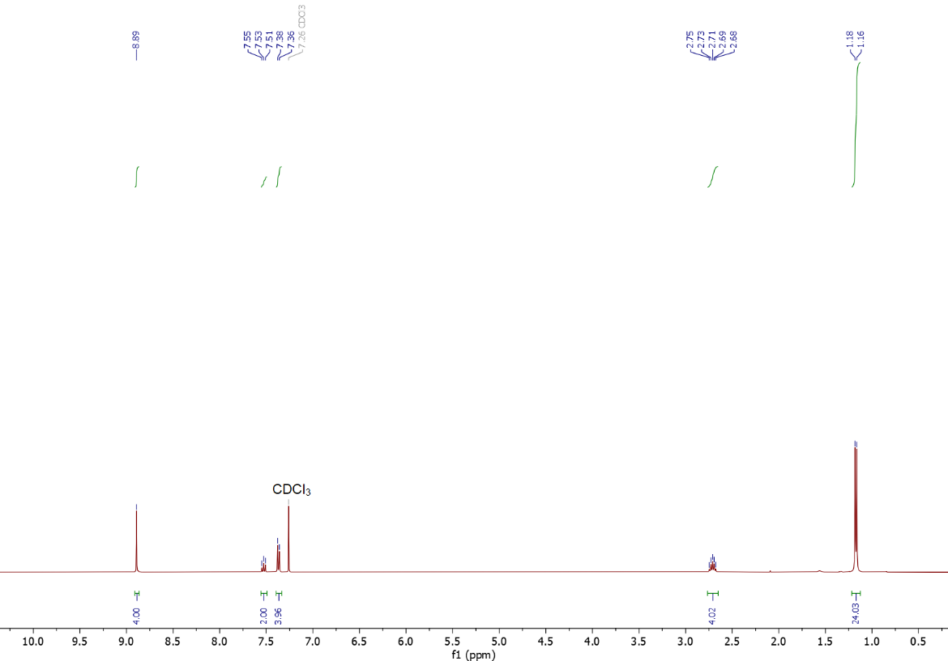
Figure S17. ¹H NMR (400 MHz, CDCl₃) spectrum of NTCDA-di^{i}PrAn used in this work.
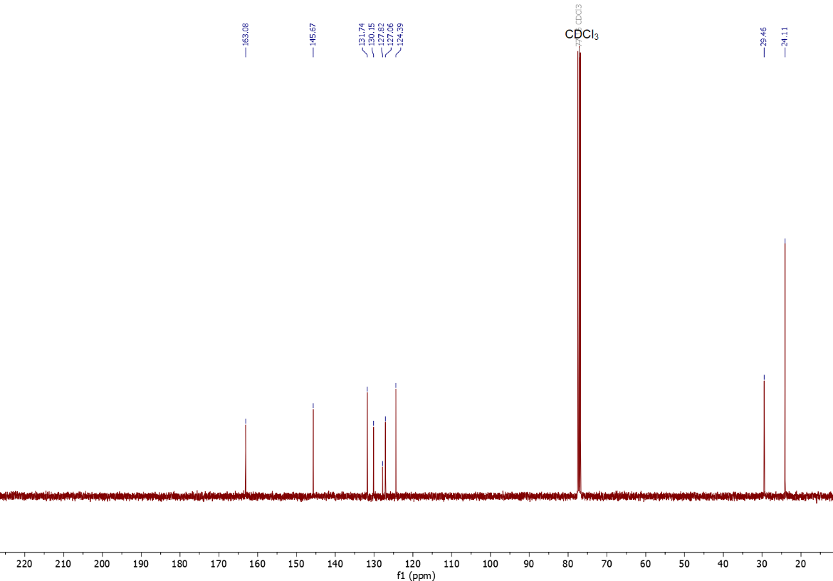
Figure S18. ¹³C NMR (101 MHz, CDCl₃) spectrum of NTCDA-di^{i}PrAn used in this work.

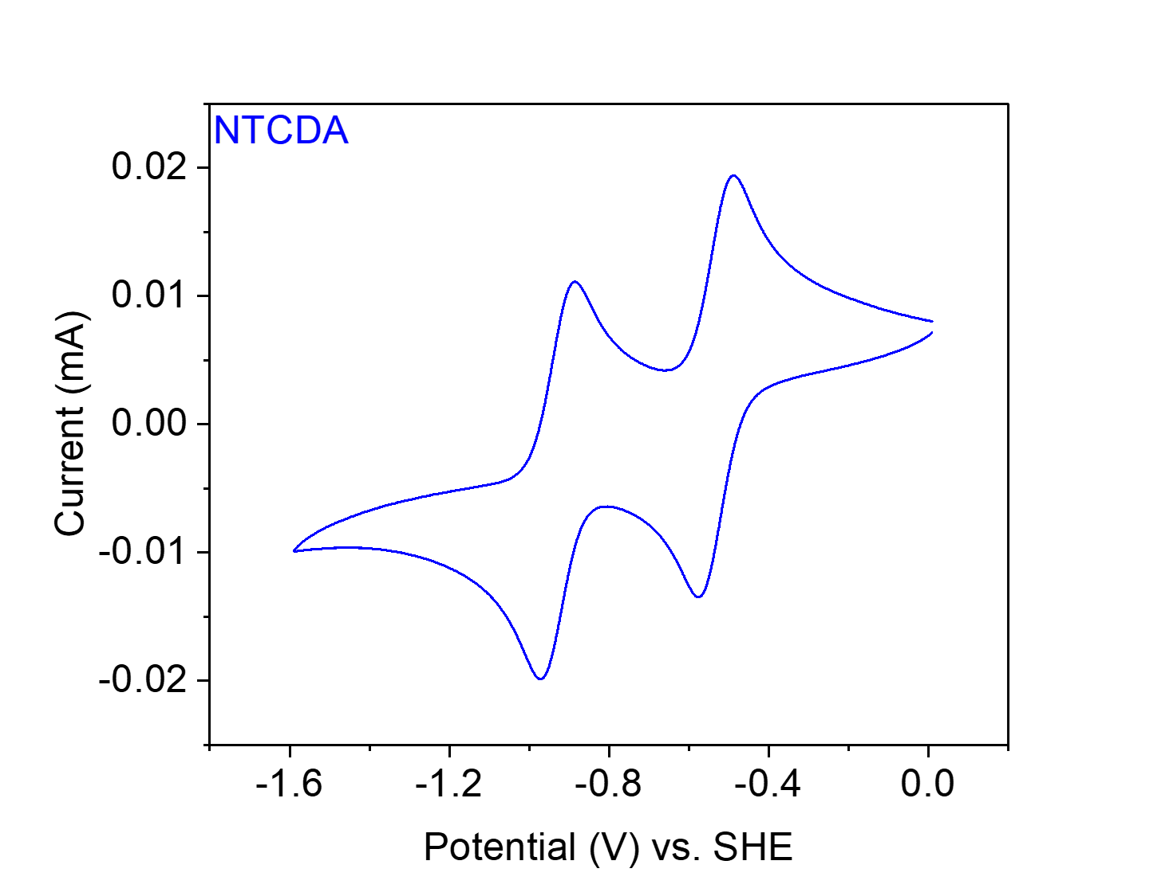
Figure S19. CV at 20 mV s⁻¹ of NTCDA-di^{i}PrAn in 0.1 M NaClO₄ in MeCN.

N,N'-bis(2,6-diisopropylphenyl)-3,4,9,10-perylenetetracarboxylic diimide (PTCDA-di^{i}PrAn).
Figure S20. Synthesis of PTCDA-di^{i}PrAn from PTCDA and di^{i}PrAn.
Synthesis of PTCDA-di^{i}PrAn. This procedure was adapted from the literature.^{7,8} To a 12 mL Teflon autoclave, PTCDA (1.00 g, 2.55 mmol, 1.00 equiv.), imidazole (7.5 g), and di^{i}PrAn (5.77 mL, 30.60 mmol, 12.00 equiv.) were added. The autoclave was sealed and placed in a pre-heated oven. The reaction mixture was heated for 16 h at 190 °C. At this time, the reaction mixture was allowed to cool to room temperature. The resulting solid was then washed with 3 M HCl (aq.) (500 mL), DI water (500 mL), and EtOH (50 mL). The solid was then recrystallized with acetone to yield N,N’-bis(2,6-diisopropylphenyl)-3,4,9,10-perylenetetracarboxylic diimide (PTCDA-di^{i}PrAn) as a red solid (0.49 g, 27% yield). ¹H NMR (400 MHz, CDCl₃): δ 8.80 (d, J = 8.0 Hz, 4H), 8.75 (d, J = 8.1 Hz, 4H), 7.51 (t, J = 7.8 Hz, 2H), 7.36 (d, J = 7.8 Hz, 4H), 2.76 (sept, J = 6.8 Hz, 4H), 1.19 (d, J = 6.8 Hz, 24H) ppm; ¹³C NMR (126 MHz, CDCl₃): δ 163.62, 145.78, 135.22, 132.25, 130.65, 130.34, 129.86, 127.01, 124.28, 123.57, 123.49, 29.37, 24.16 ppm. These spectra are consistent with those reported in the literature.⁷
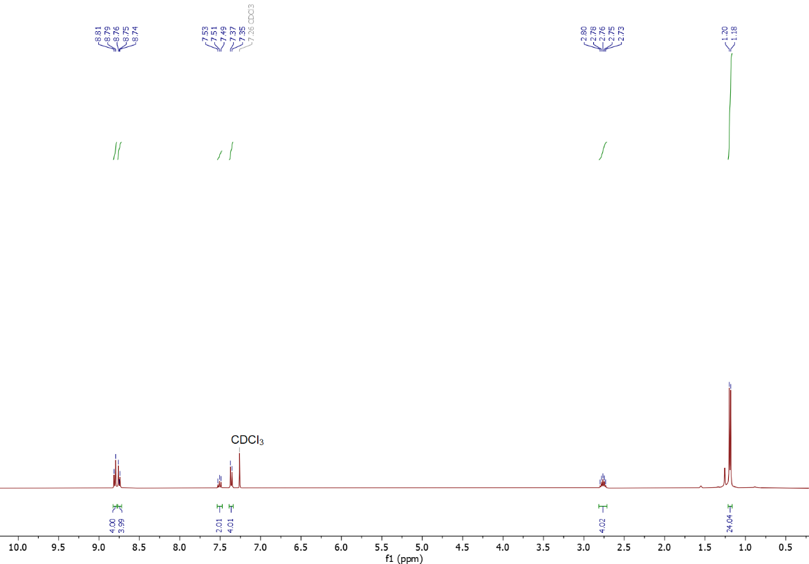
Figure S21. ¹H NMR (400 MHz, CDCl₃) spectrum of PTCDA-di^{i}PrAn used in this work.
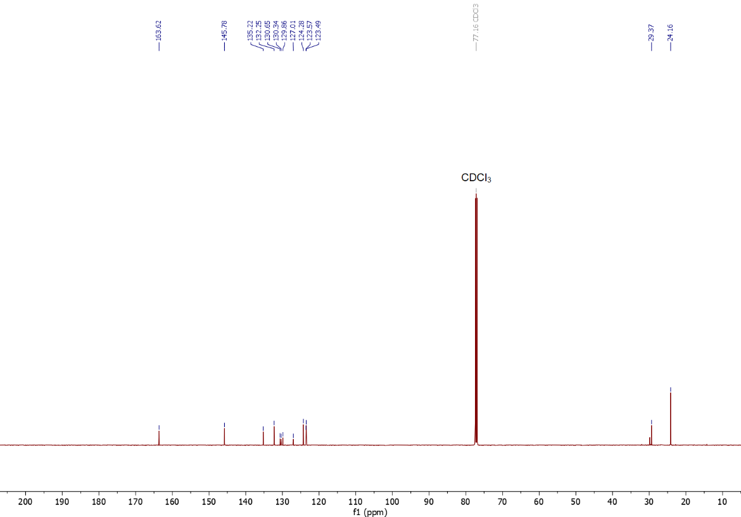
Figure S22. ¹³C NMR (125 MHz, CDCl₃) spectrum of PTCDA-di^{i}PrAn used in this work.

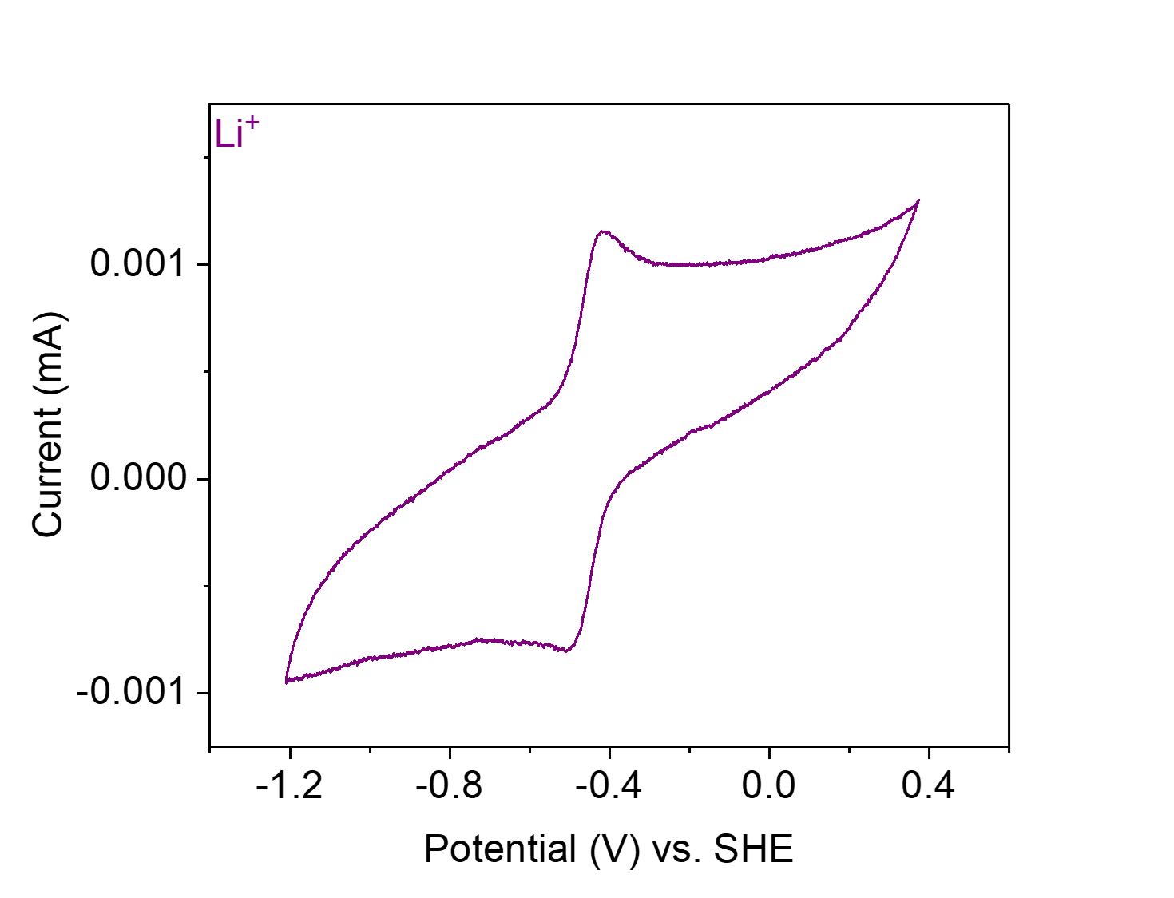
Figure S23. CV at 20 mV s⁻¹ of PTCDA-di^{i}PrAn in 0.1 M LiClO₄ in MeCN.
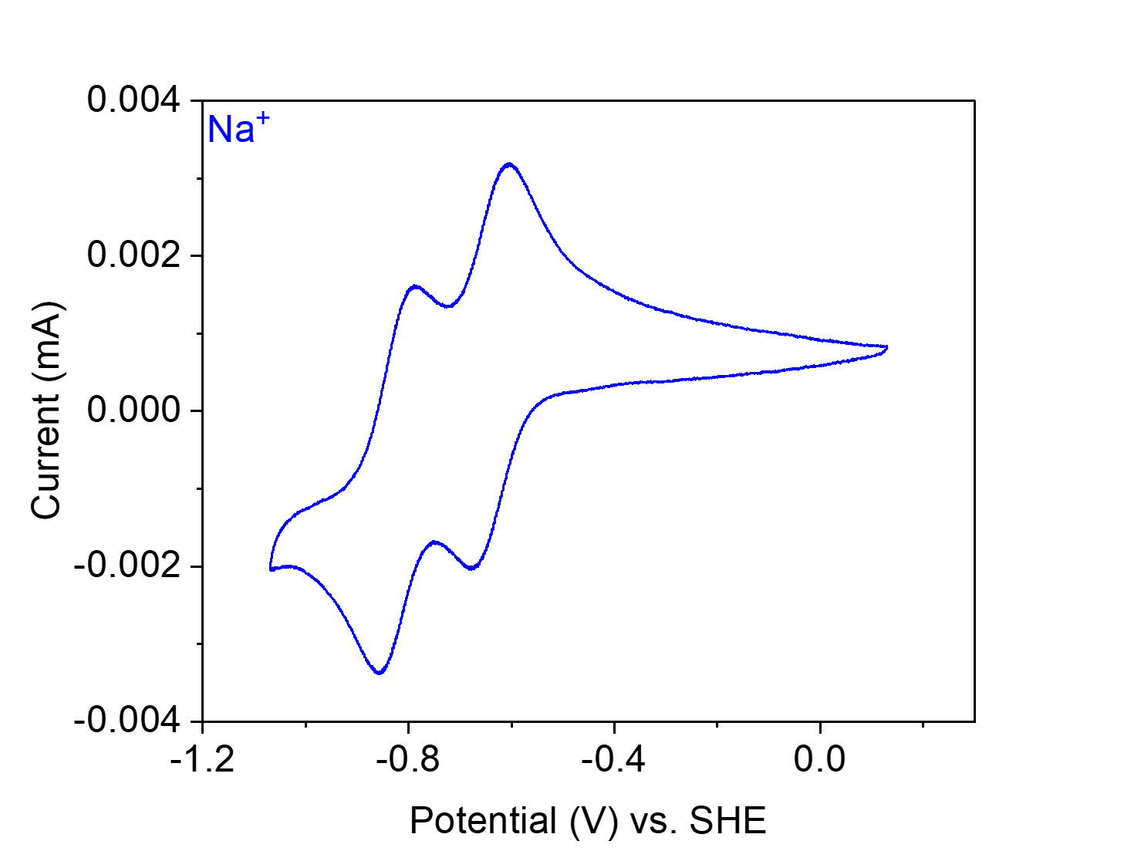
Figure S24. CV at 20 mV s⁻¹ of PTCDA-di^{i}PrAn in 0.1 M NaClO₄ in MeCN.
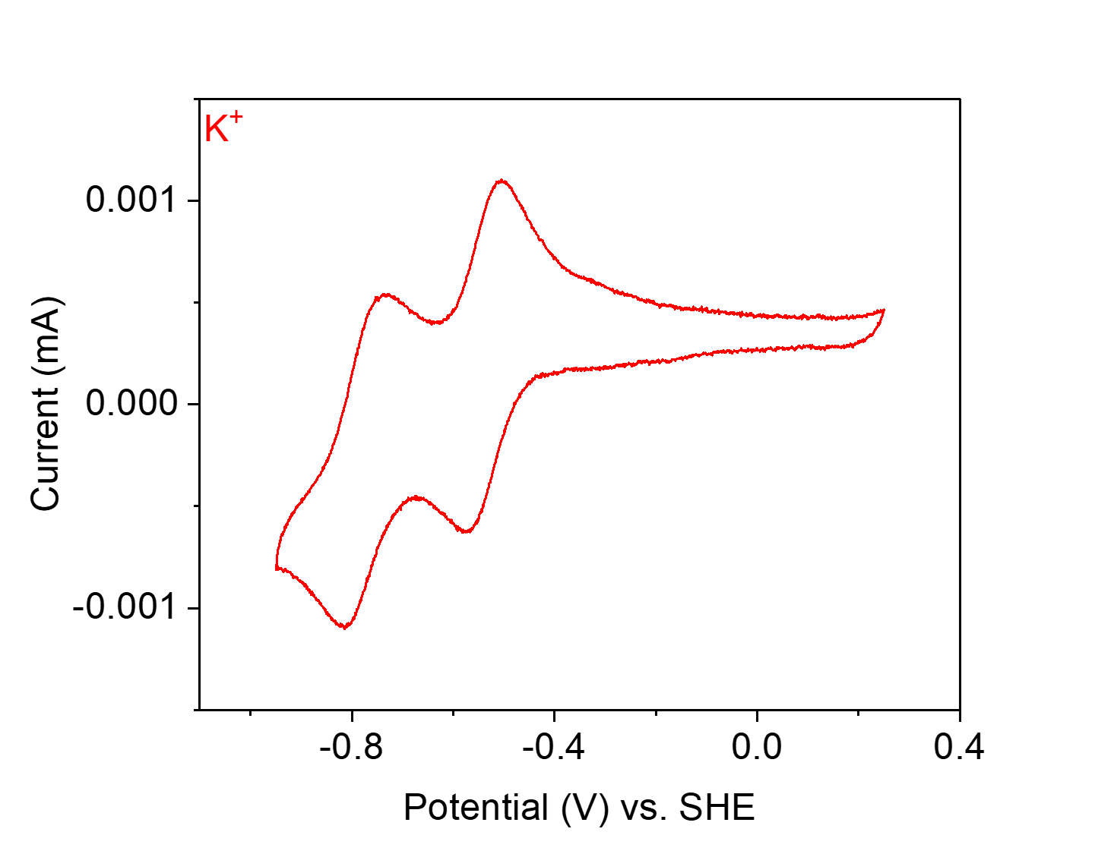
Figure S25. CV at 20 mV s⁻¹ of PTCDA-di^{i}PrAn in 0.1 M KClO₄ in MeCN.
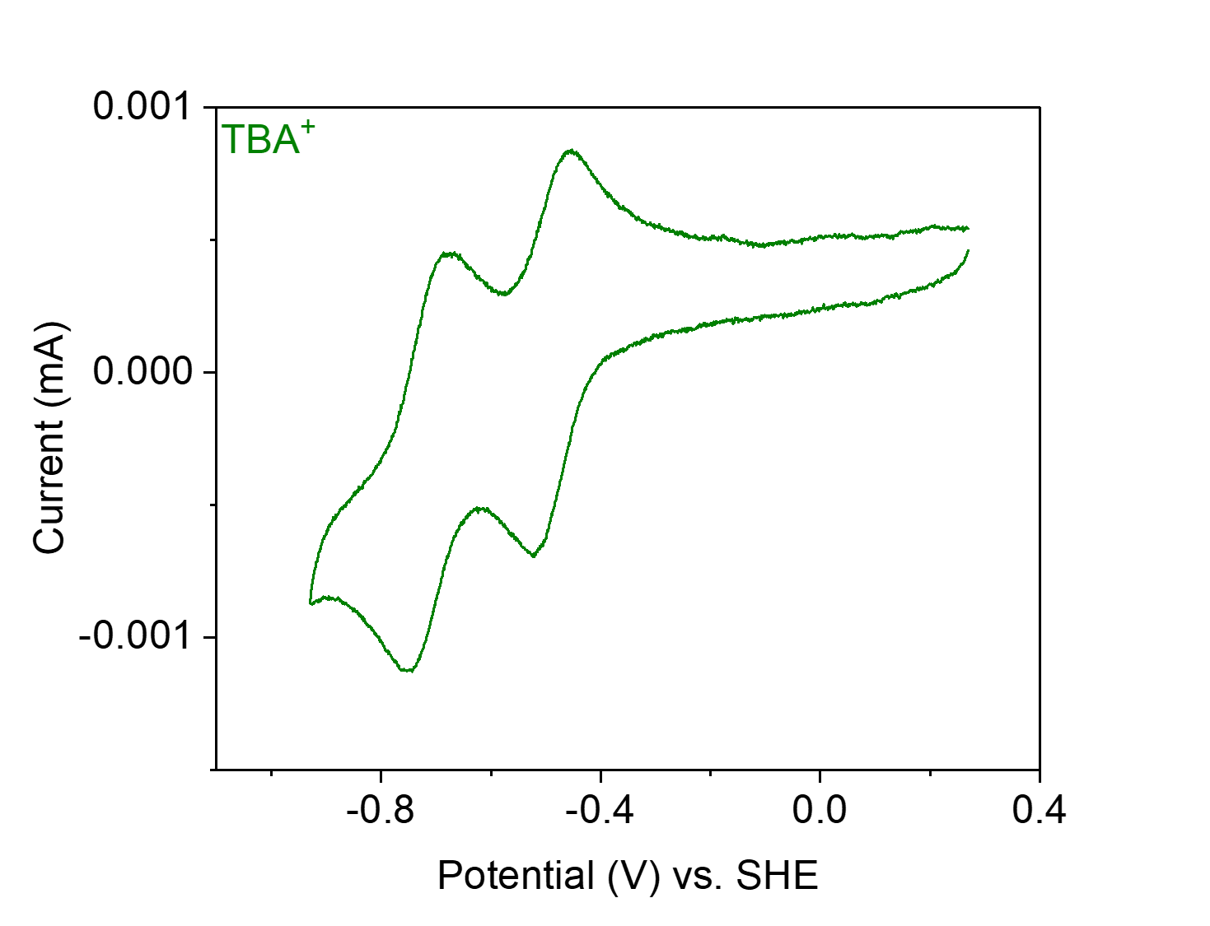
Figure S26. CV at 20 mV s⁻¹ of PTCDA-di^{i}PrAn in 0.1 M TBAClO₄ in MeCN.

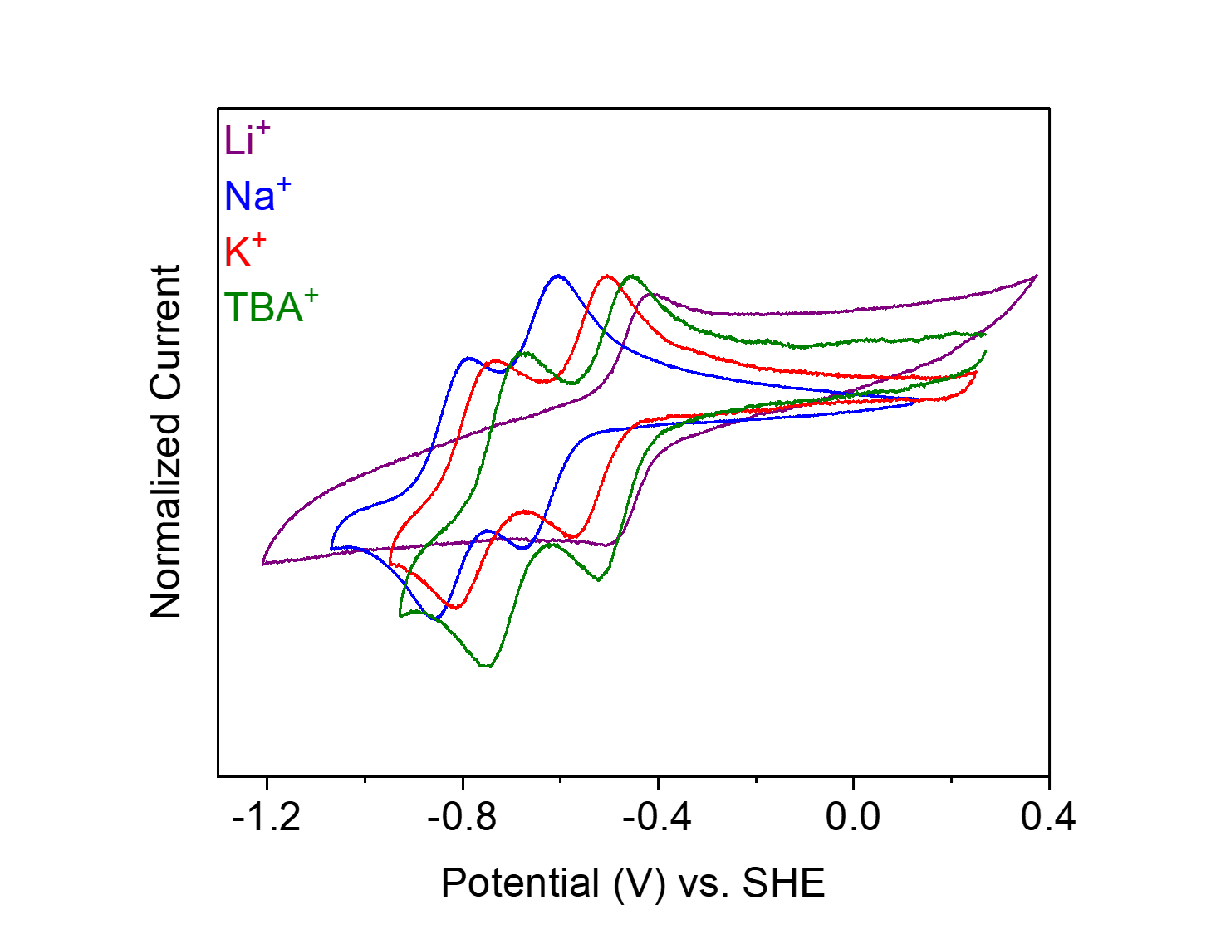
Figure S27. CVs at 20 mV s⁻¹ of PTCDA-di^{i}PrAn in 0.1 M LiClO₄ (purple), NaClO₄ (blue), KClO₄ (red), and TBAClO₄ (olive) in MeCN.

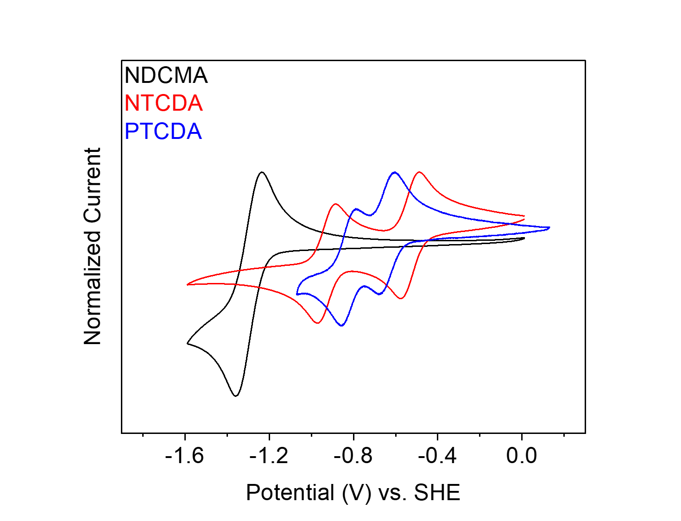
Figure S28. CVs at 20 mV s⁻¹ of NDCMA-di^{i}PrAn (black), NTCDA-di^{i}PrAn (red), and PTCDA-di^{i}PrAn (blue) in 0.1 M NaClO₄ in MeCN.

Catalyst¹ | E_{1/2} (V vs. SHE)
NDCMA-di^{i}PrAn (NaClO₄) | −1.30
NTCDA-di^{i}PrAn (NaClO₄) | −0.53, −0.93
PTCDA-di^{i}PrAn (LiClO₄) | −0.46
PTCDA-di^{i}PrAn (NaClO₄) | −0.64, −0.82
PTCDA-di^{i}PrAn (KClO₄) | −0.54, −0.78
PTCDA-di^{i}PrAn (TBAClO₄) | −0.49, −0.72
Table S1. Tabulated summary of the redox potentials (E_{1/2}) of the molecular catalysts.
¹Electrolyte (0.1 M in MeCN) in parentheses.

Synthesis and characterization of polymer catalysts.
General Procedure A. Following a modified literature procedure.⁹ To a 75 mL screw-cap high-pressure reaction vessel, the dianhydride (1.00 equiv.), the amine (1.00 equiv.), and imidazole (17.70 g per mmol dianhydride) were added. The reaction vessel was sealed and placed in a silicone oil bath that had been pre-heated to 130 °C. The reaction mixture was allowed to stir for 24 h at 130 °C. At this time, the reaction mixture was allowed to cool to room temperature. The resulting solid was then washed with DI water (100 mL) and acetone (100 mL) and filtered. The resulting solid residue was rinsed with additional acetone (200 mL) and filtered, before washing via Soxhlet extraction with chloroform for 48 h to remove soluble impurities. The solid was then dried under vacuum at 120 °C for 16 h prior to characterization.

General Procedure B. Following a modified literature procedure.⁹ To a 75 mL screw-cap high-pressure reaction vessel, PTCDA (1.00 equiv.), the amine (0.67 equiv. for PTCDA-TPAPA & PTCDA-TPAPT or 0.50 equiv. for PTCDA-TPAPM), and imidazole (10.00 g per mmol dianhydride) were added. The reaction vessel was sealed and placed in a silicone oil bath that had been pre-heated to 130 °C. The reaction mixture was allowed to stir for 24 h at 130 °C. At this time, the reaction mixture was allowed to cool to room temperature. The resulting solid was then washed with DI water (100 mL) and acetone (300 mL), before further washing via Soxhlet extraction with chloroform for 48 h to remove soluble impurities. The solid was then dried under vacuum at 120 °C for 16 h prior to characterization.

NTCDA-en from 1,4,5,8-naphthalene tetracarboxylic dianhydride (NTCDA) and ethylenediamine (en).
Figure S29. Scheme for the synthesis of NTCDA-en from NTCDA and en.
Synthesis of NTCDA-en. Following General Procedure A, NTCDA (268 mg, 1.00 mmol, 1.00 equiv.), en (66.8 μL, 1.00 mmol, 1.00 equiv.) and imidazole (17.70 g) were added to a 75 mL screw-cap high-pressure reaction vessel and heated at 130 °C for 24 h. The resulting solid was washed and dried to yield NTCDA-en (69.1 mg, 24% yield) as a brown solid.

Element | Average Wt %¹ | Theoretical Wt %
C | 59.96 | 65.76
O | 23.42² | 21.89
H | 2.73 | 2.76
N | 13.89 | 9.59
Total: | 100.00 | 100.00
Table S2. Tabulated combustion analysis data for NTCDA-en.
¹Average of two trials.
²The remaining mass not attributed to C, H, and N was assumed to come from O, as O was not directly analyzed during combustion analysis.

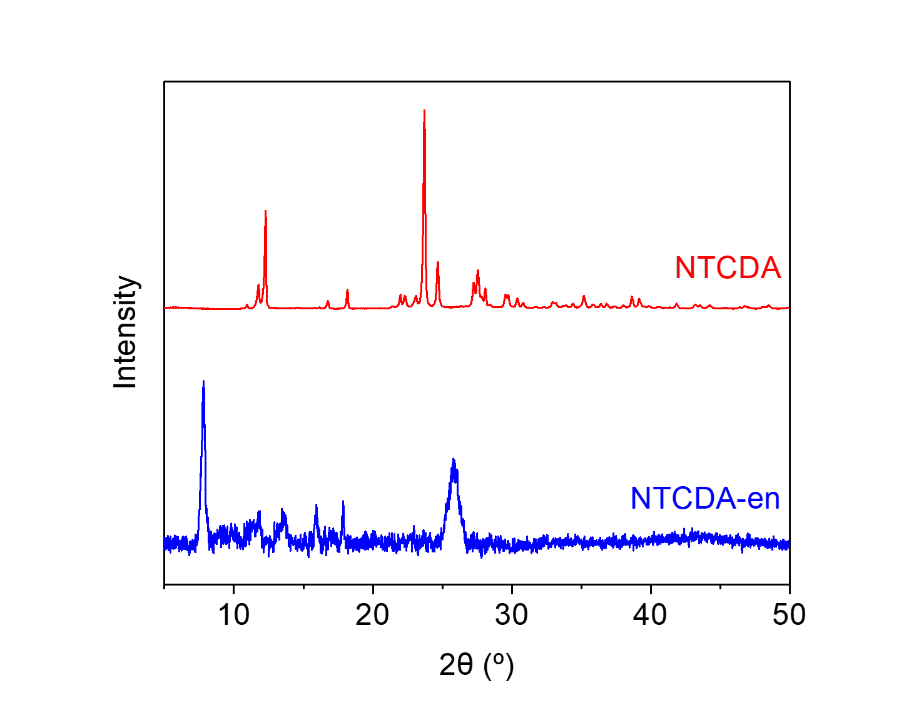
Figure S30. PXRD patterns (λ = 1.54 Å) of NTCDA and NTCDA-en. These patterns indicate that NTCDA-en is a microcrystalline polymer and is likely not contaminated with NTCDA.
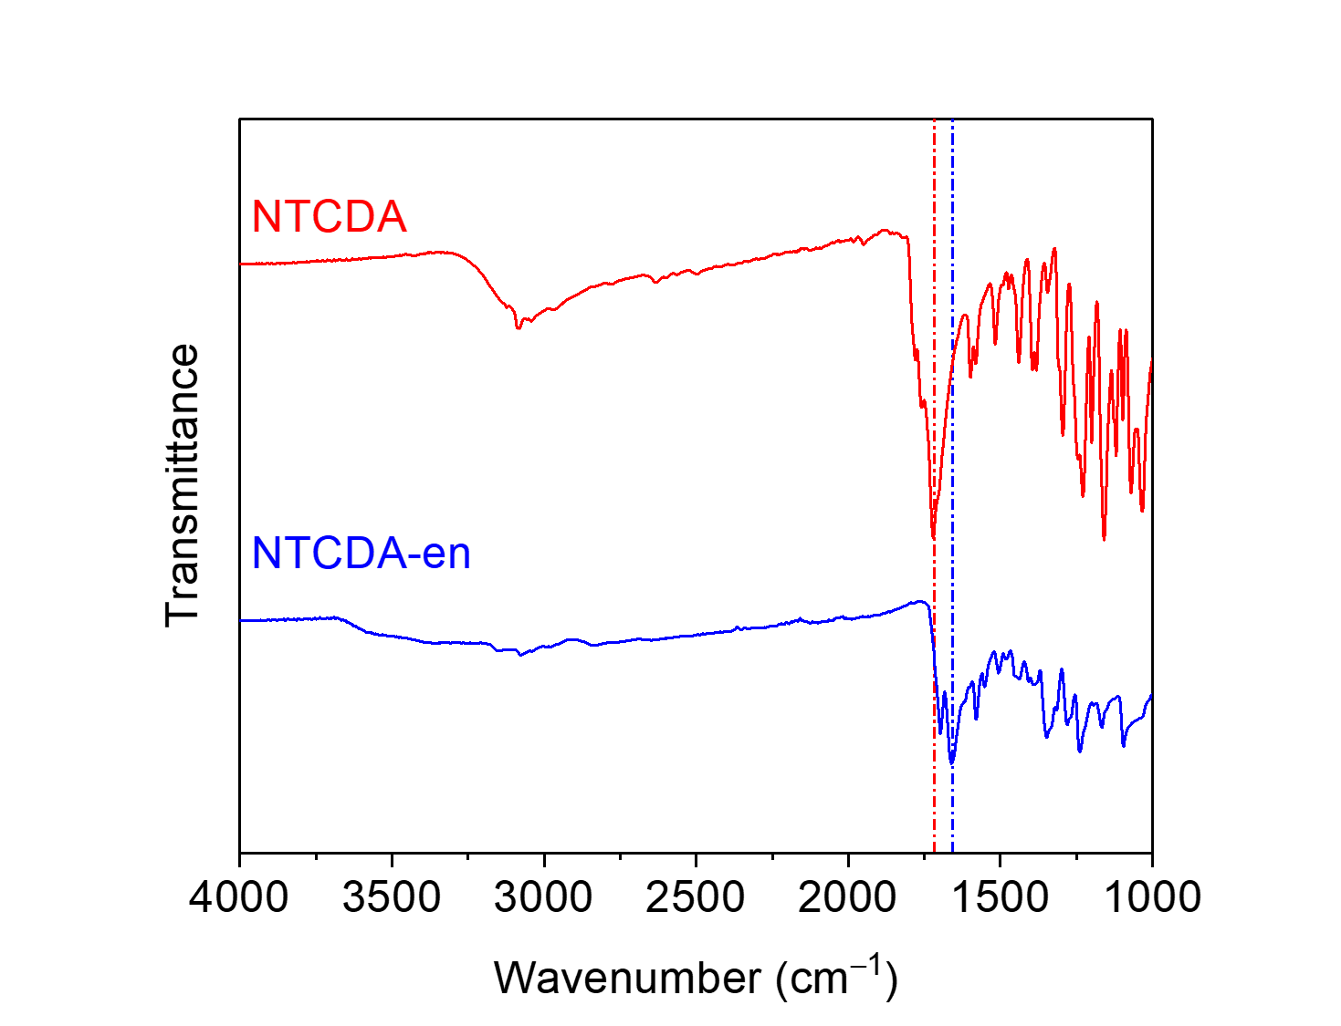
Figure S31. ATR-IR spectra for NTCDA and NTCDA-en. The shift in the carbonyl stretching frequency between the dianhydride (1721 cm⁻¹) and the diimide (1659 cm⁻¹) is indicated.
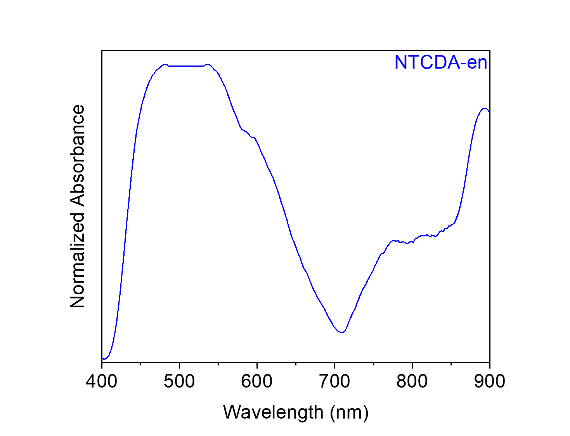
Figure S32. Solid-state UV-Vis absorption spectrum of NTCDA-en dispersed in BaSO₄.
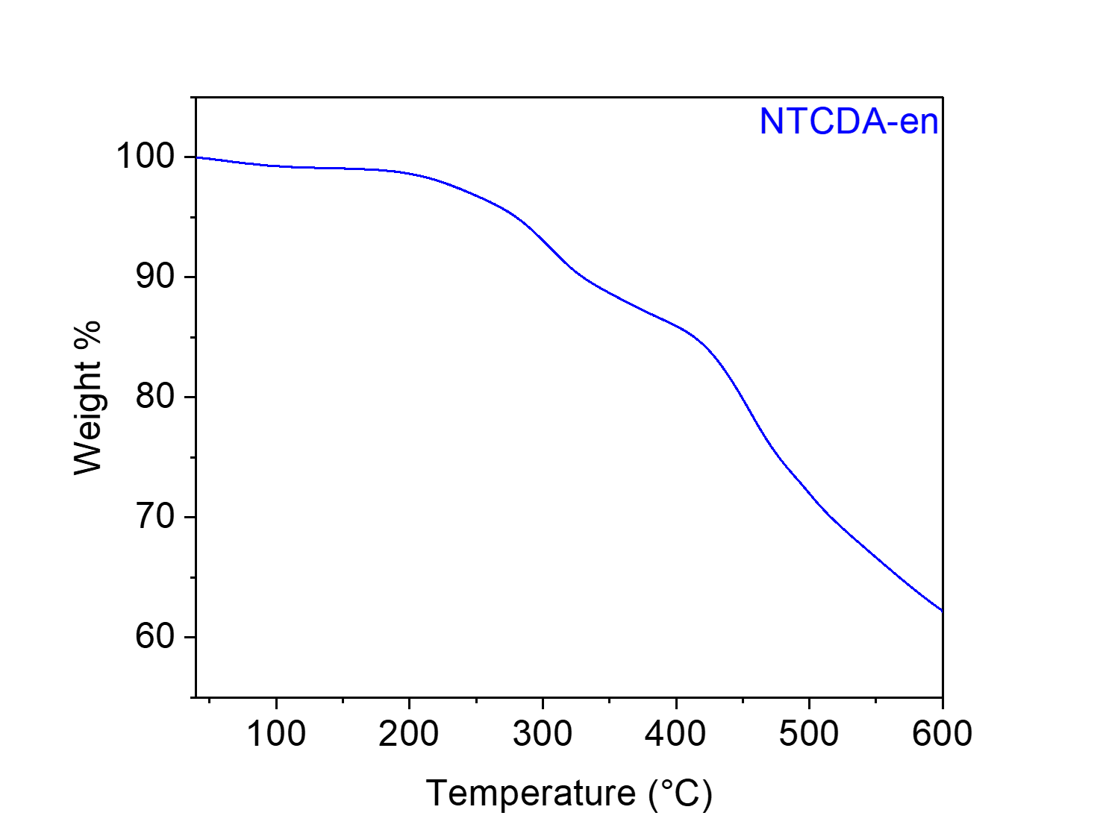
Figure S33. Thermogravimetric decomposition profile of NTCDA-en, indicating that it is stable below 250 °C. The gradual weight loss from this material upon heating is likely due to the loss of solvent/water.
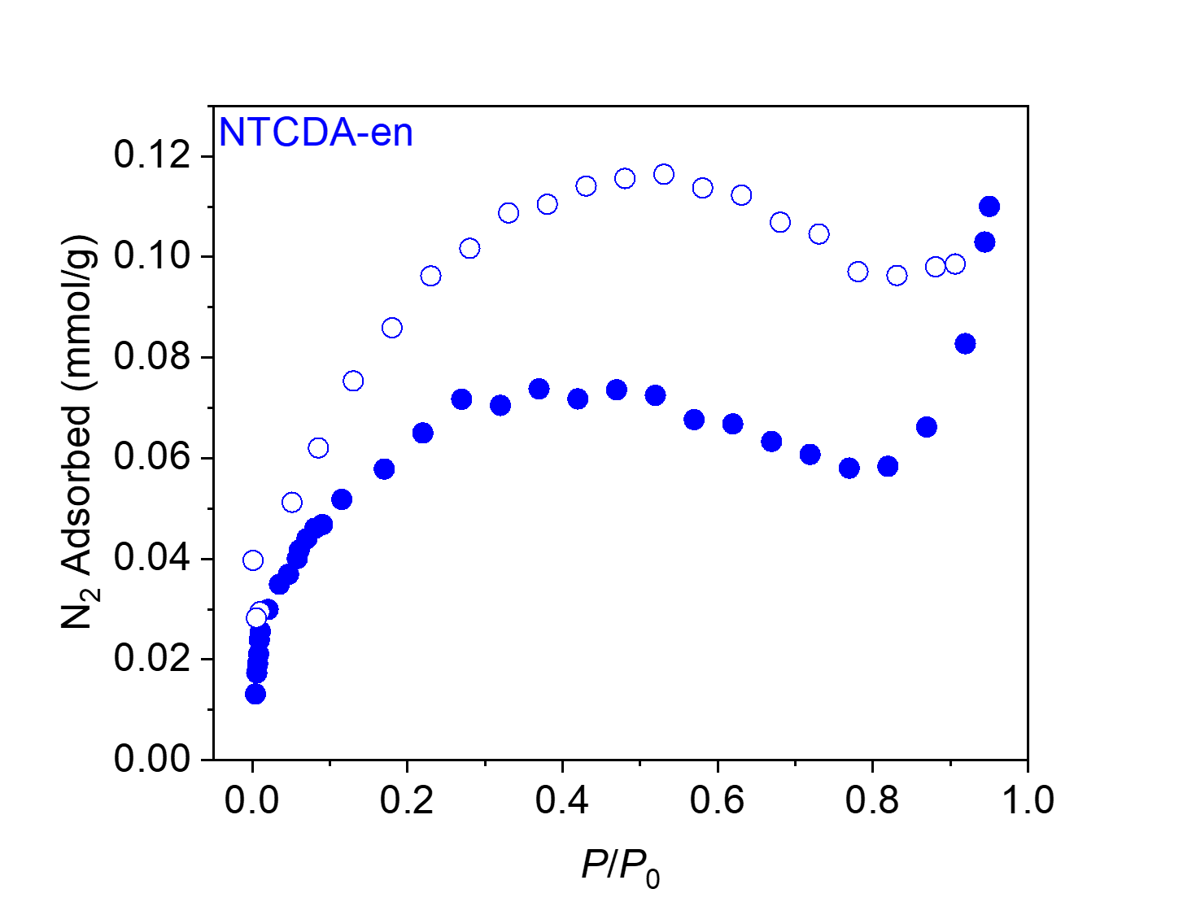
Figure S34. 77 K N₂ adsorption (filled circles) and desorption (open circles) isotherms for NTCDA-en. The BET and Langmuir surface areas were determined to be 5 m²/g and 8 m²/g, respectively.
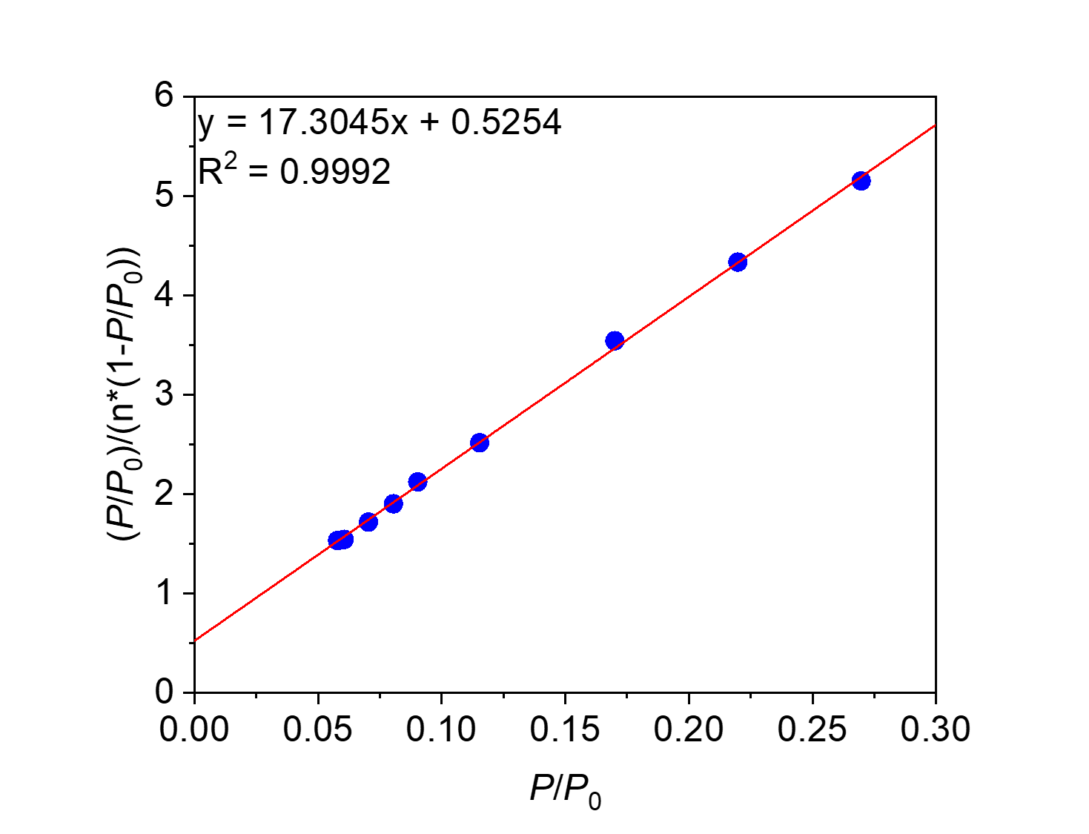
Figure S35. Linearized BET plot of NTCDA-en.

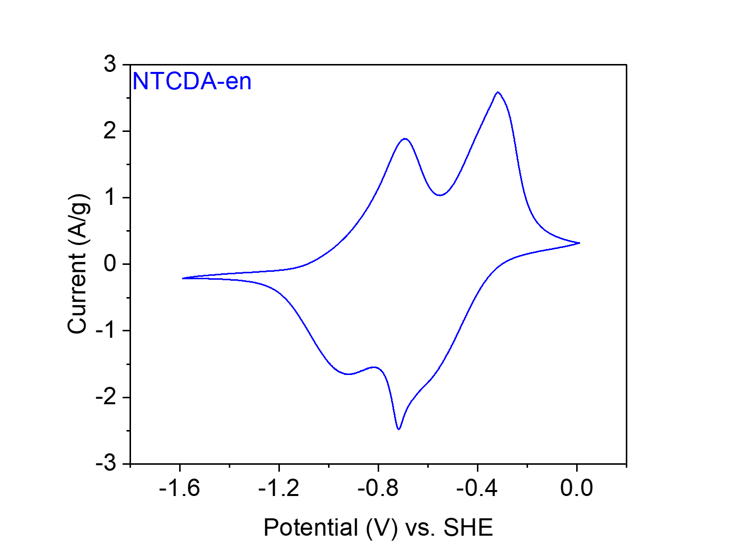
Figure S36. CV at 20 mV s⁻¹ of NTCDA-en in 0.1 M NaClO₄ in MeCN.

PMDA-en from pyromellitic dianhydride (PMDA) and ethylenediamine (en).
Figure S37. Scheme for the synthesis of PMDA-en from PMDA and en.
Synthesis of PMDA-en. Following General Procedure A, PMDA (218 mg, 1.00 mmol, 1.00 equiv.), en (66.8 μL, 1.00 mmol, 1.00 equiv.) and imidazole (17.70 g) were added to a 75 mL screw-cap high-pressure reaction vessel and heated at 130 °C for 24 h. The resulting solid was washed and dried to yield PMDA-en (82 mg, 34% yield) as a light-yellow solid.

Element | Average Wt %¹ | Theoretical Wt %
C | 56.43 | 59.51
O | 27.75² | 26.42
H | 3.05 | 2.50
N | 12.77 | 11.57
Total: | 100.00 | 100.00
Table S3. Tabulated combustion analysis data for PMDA-en.
¹Average of two trials.
²The remaining mass not attributed to C, H, and N was assumed to come from O, as O was not directly analyzed during combustion analysis.

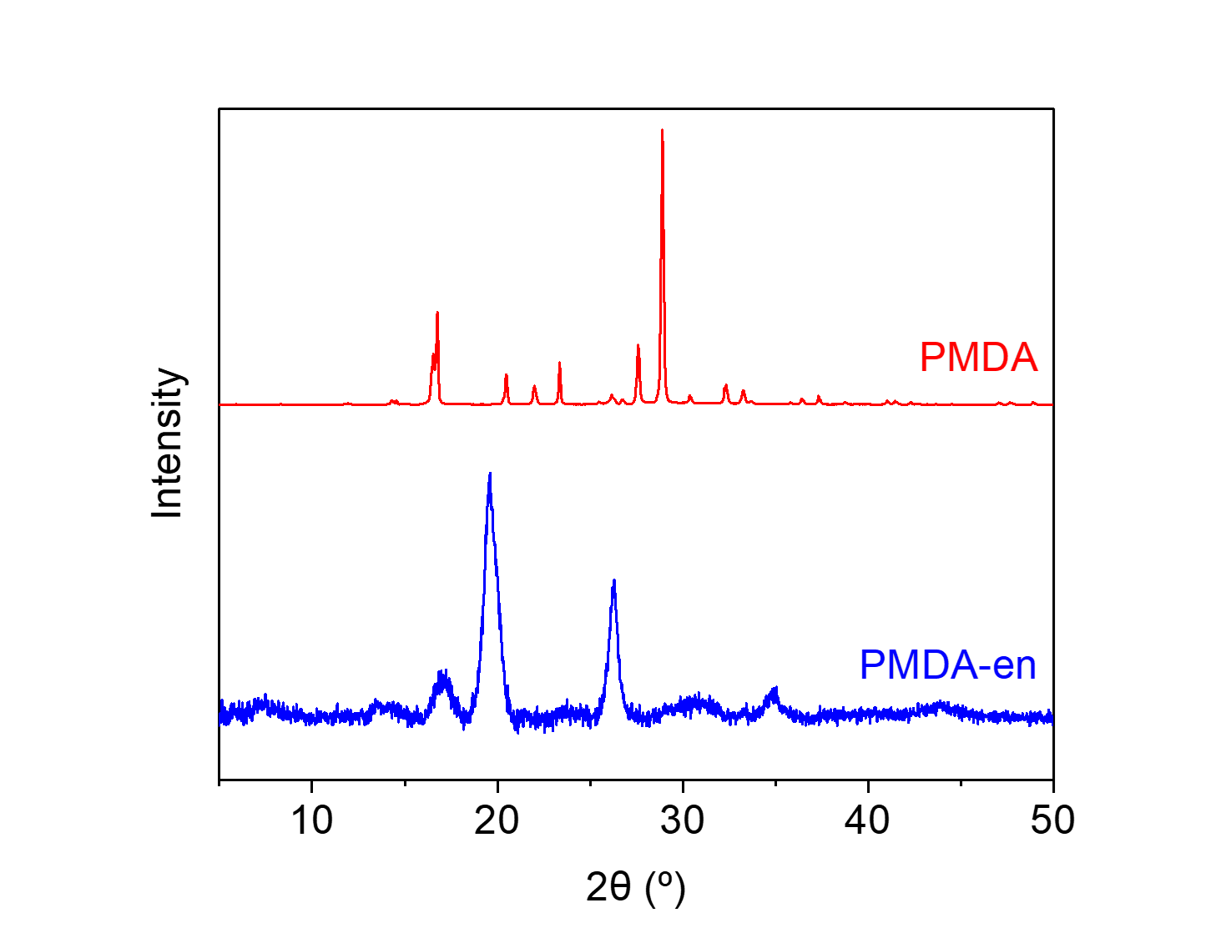
Figure S38. PXRD patterns (λ = 1.54 Å) of PMDA and PMDA-en. These patterns indicate that PMDA-en is a microcrystalline polymer and is likely not contaminated with PMDA.
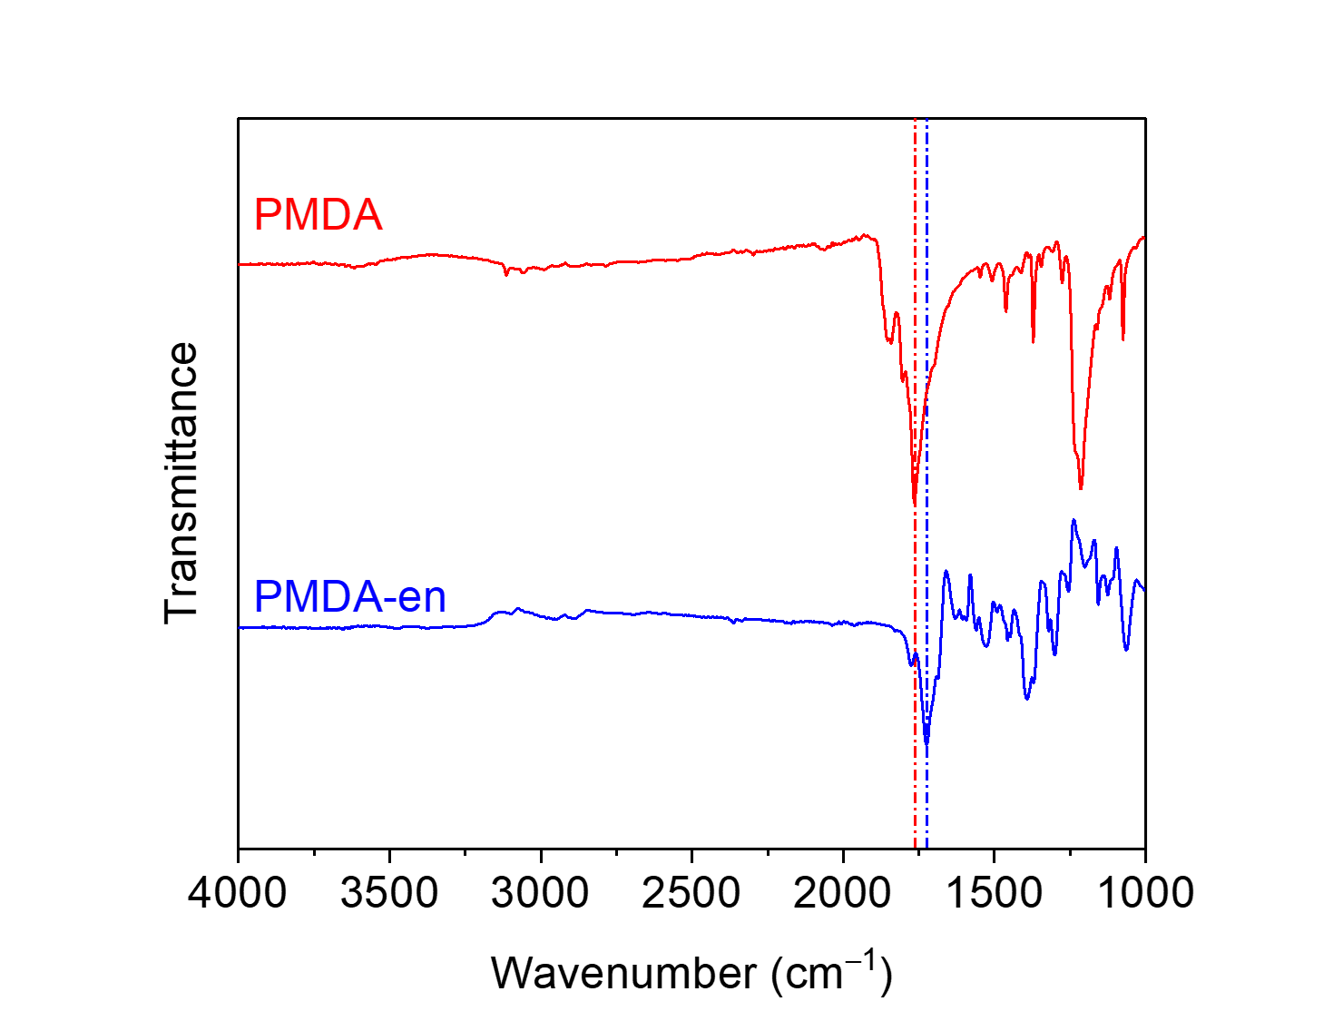
Figure S39. ATR-IR spectra for PMDA and PMDA-en. The shift in the carbonyl stretching frequency between the dianhydride (1765 cm⁻¹) and the diimide (1725 cm⁻¹) is indicated.
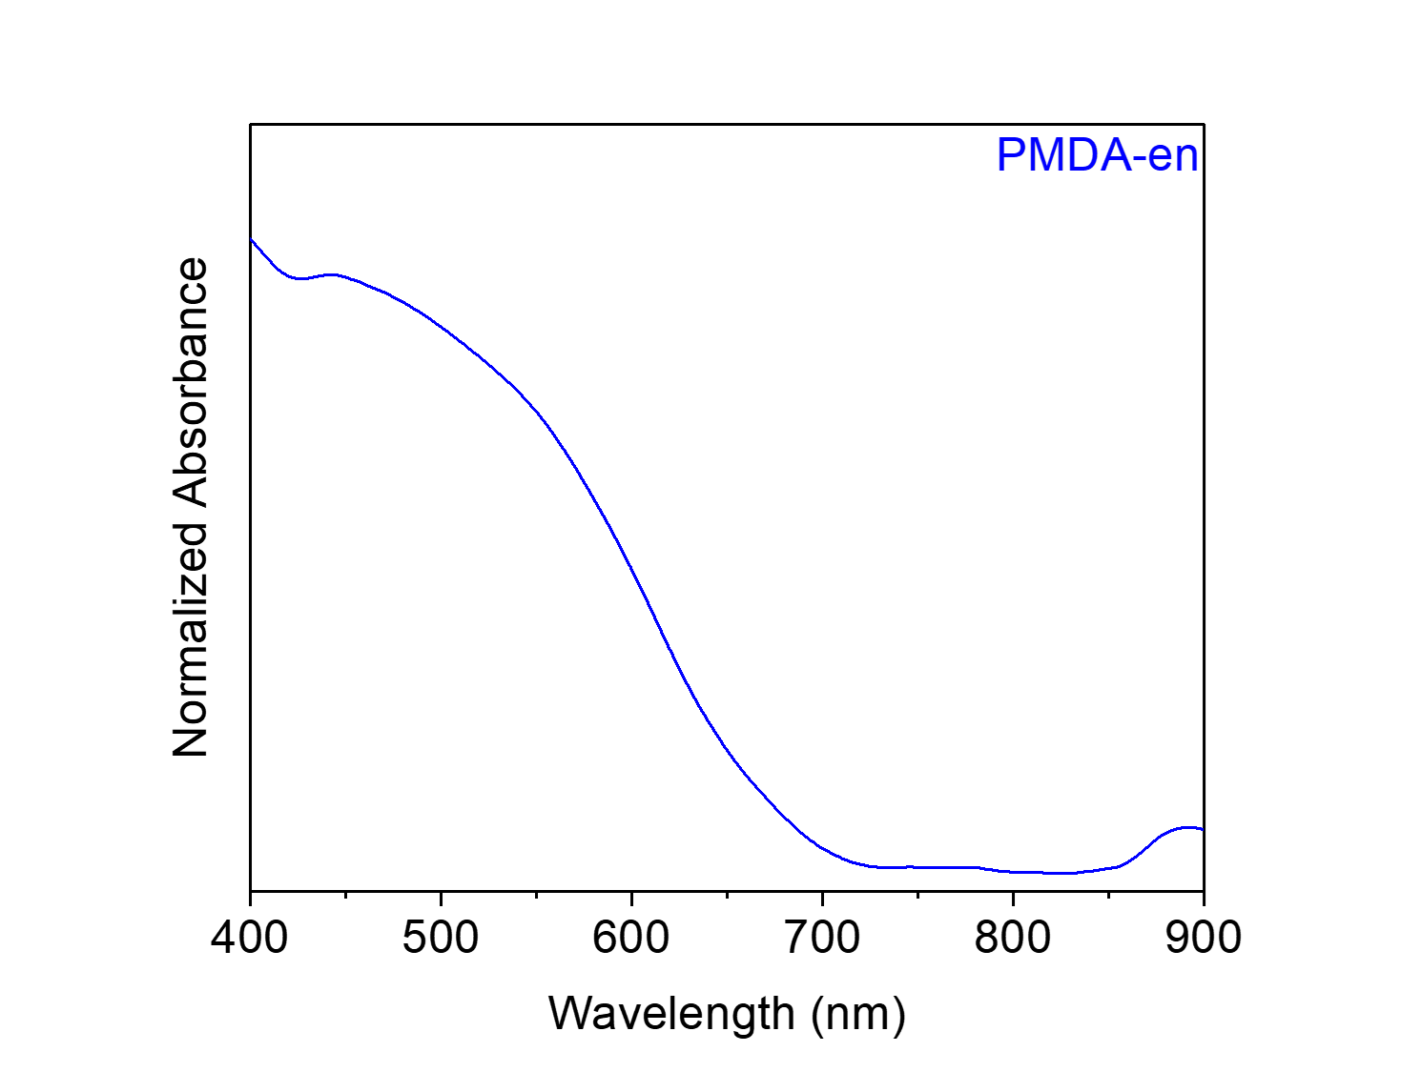
Figure S40. Solid-state UV-Vis absorption spectrum of PMDA-en dispersed in BaSO₄.
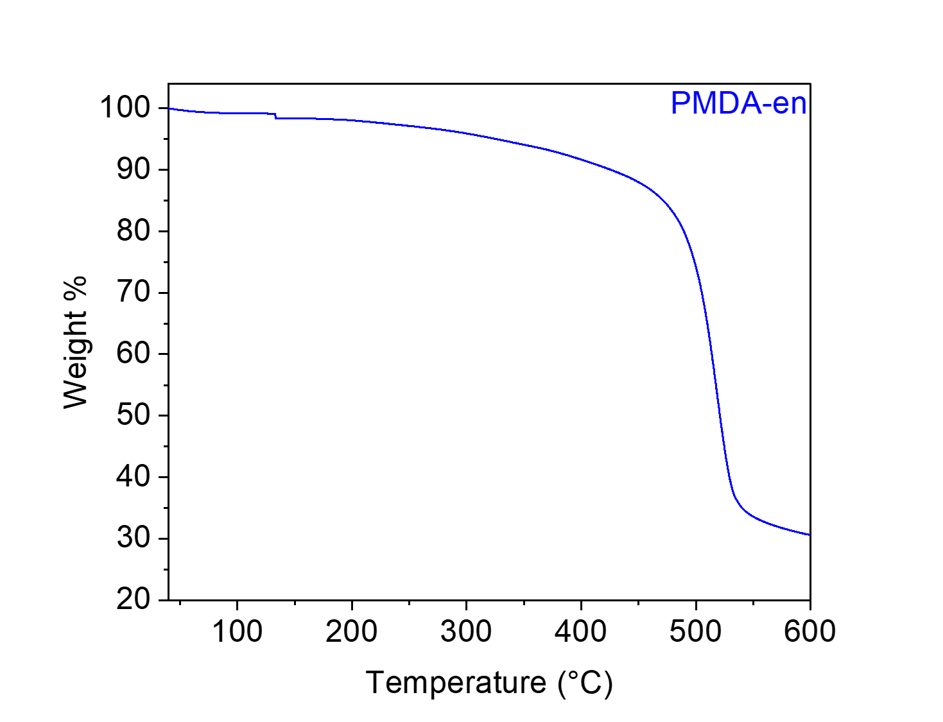
Figure S41. Thermogravimetric decomposition profile of PMDA-en, indicating that it is stable below 400 °C. The gradual weight loss from this material upon heating is likely due to the loss of solvent/water.
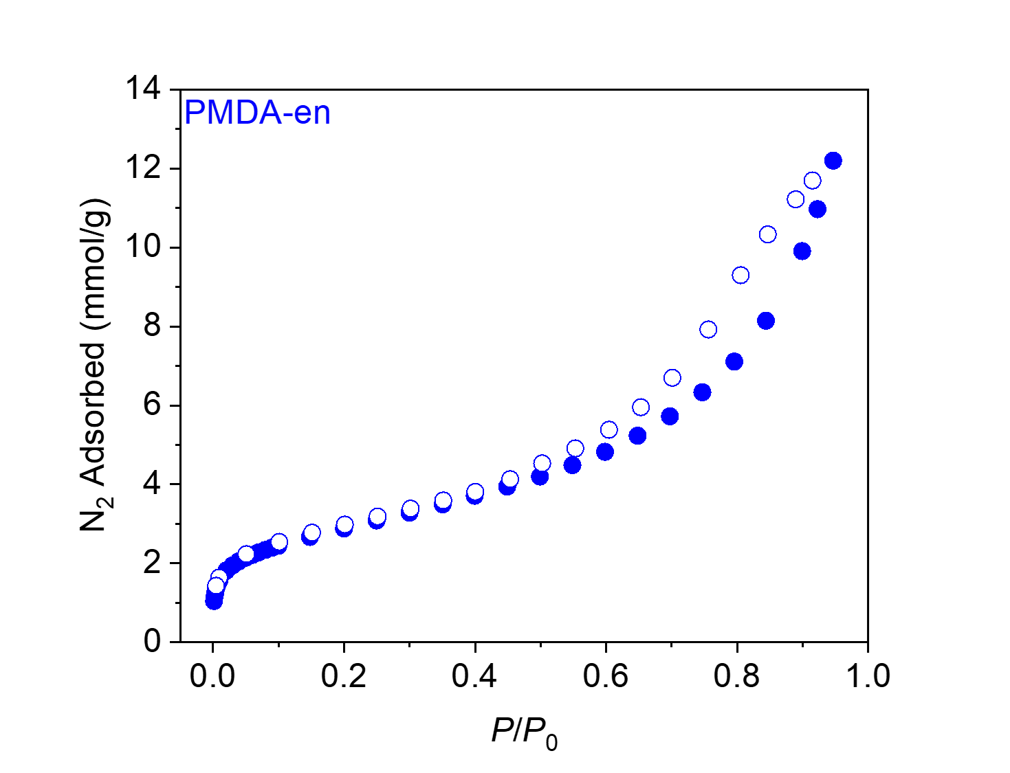
Figure S42. 77 K N₂ adsorption (filled circles) and desorption (open circles) isotherms for PMDA-en. The BET and Langmuir surface areas were determined to be 227 ± 1 m²/g and 804 ± 87 m²/g, respectively.
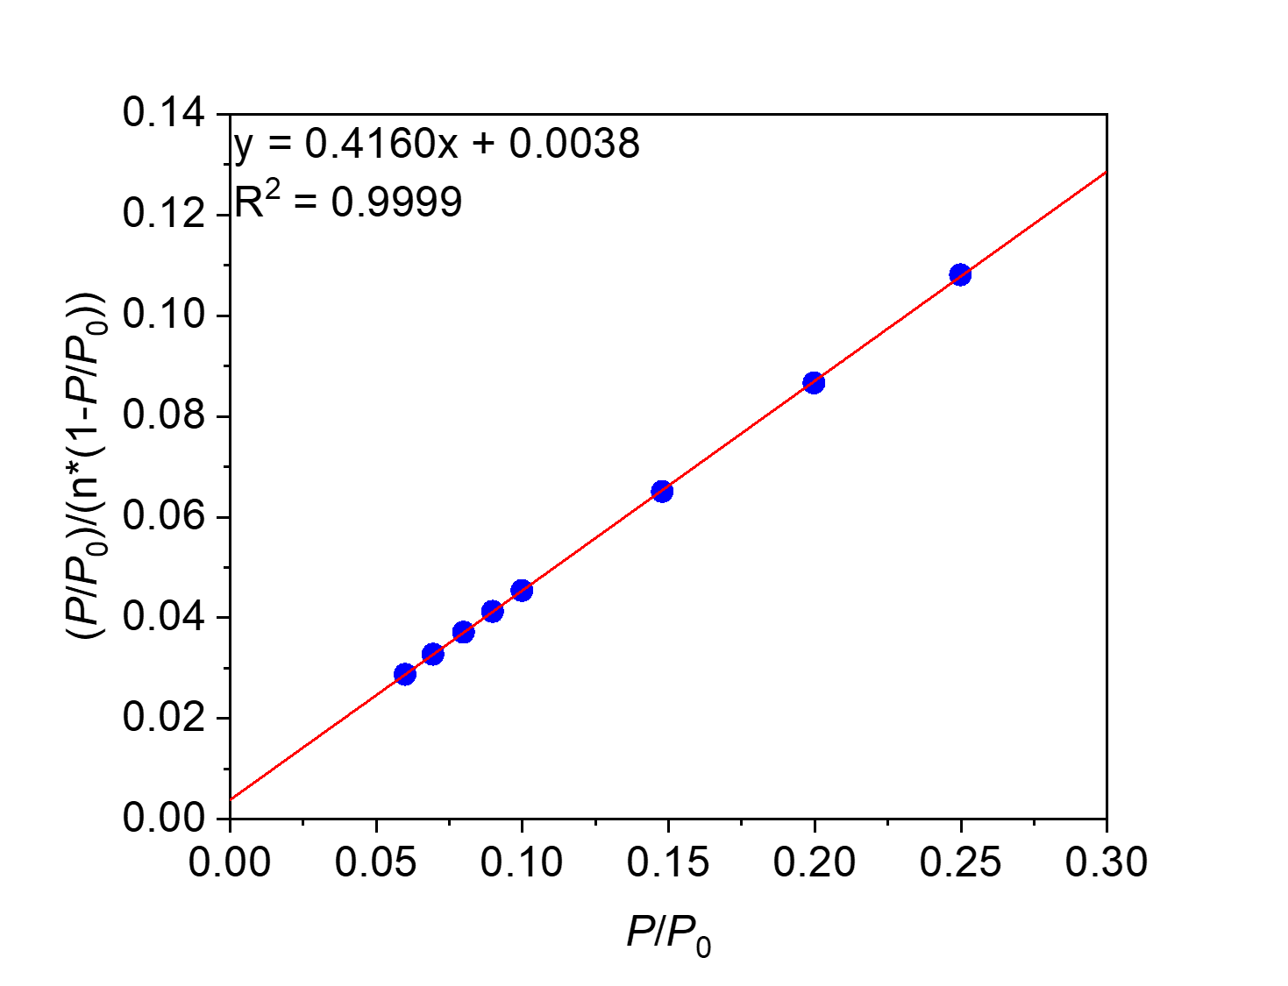
Figure S43. Linearized BET plot of PMDA-en.

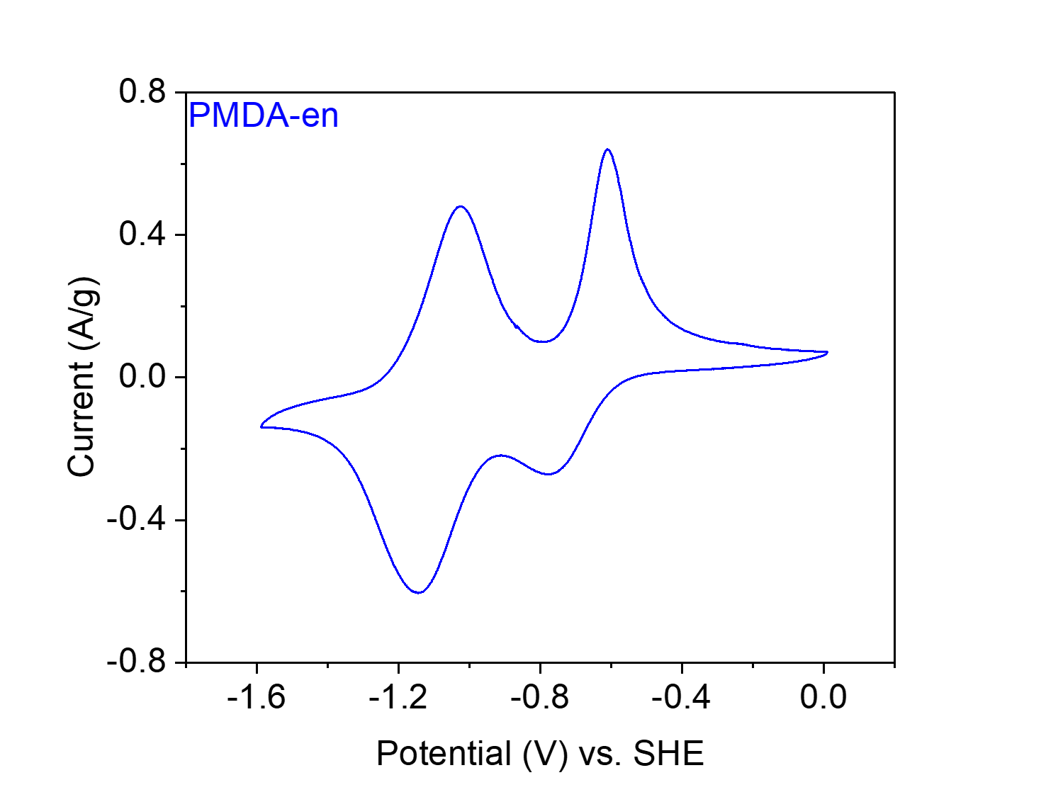
Figure S44. CV at 20 mV s⁻¹ of PMDA-en in 0.1 M NaClO₄ in MeCN.

PTCDA-en from 3,4,9,10-perylene tetracarboxylic dianhydride (PTCDA) and ethylenediamine (en).
Figure S45. Scheme for the synthesis of PTCDA-en from PTCDA and en.
Small-scale synthesis of PTCDA-en. Following General Procedure A, PTCDA (1.96 g, 5.00 mmol, 1.00 equiv.), en (334 μL, 5.00 mmol, 1.00 equiv.) and imidazole (88.50 g) were added to a 75 mL screw-cap high-pressure reaction vessel and heated at 130 °C for 24 h. The resulting solid was washed and dried to yield PTCDA-en (1.45 g, 70% yield) as a dark purple-black solid.

Large-scale synthesis of PTCDA-en. Following General Procedure A with slight modification, PTCDA (11.80 g, 30.00 mmol, 1.00 equiv.), en (2.00 mL, 30.00 mmol, 1.00 equiv.) and imidazole (88.50 g) were added to a 350 mL screw-cap high-pressure reaction vessel and heated at 130 °C for 24 h. The resulting solid was washed with DI water (1 L) and acetone (500 mL), soaked in acetone (1 L) for 24 h, further washed via Soxhlet extraction with chloroform for 96 h, and finally dried at 120 °C under vacuum to yield PTCDA-en (12.1 g, 97% yield) as a dark purple-black solid.

Element | Average Wt %¹ | Theoretical Wt %
C | 73.50 | 75.00
O | 14.01² | 15.37
H | 3.28 | 2.90
N | 9.21 | 6.73
Total: | 100.00 | 100.00
Table S4. Tabulated combustion analysis data for PTCDA-en.
¹Average of two trials.
²The remaining mass not attributed to C, H, and N was assumed to come from O, as O was not directly analyzed during combustion analysis.
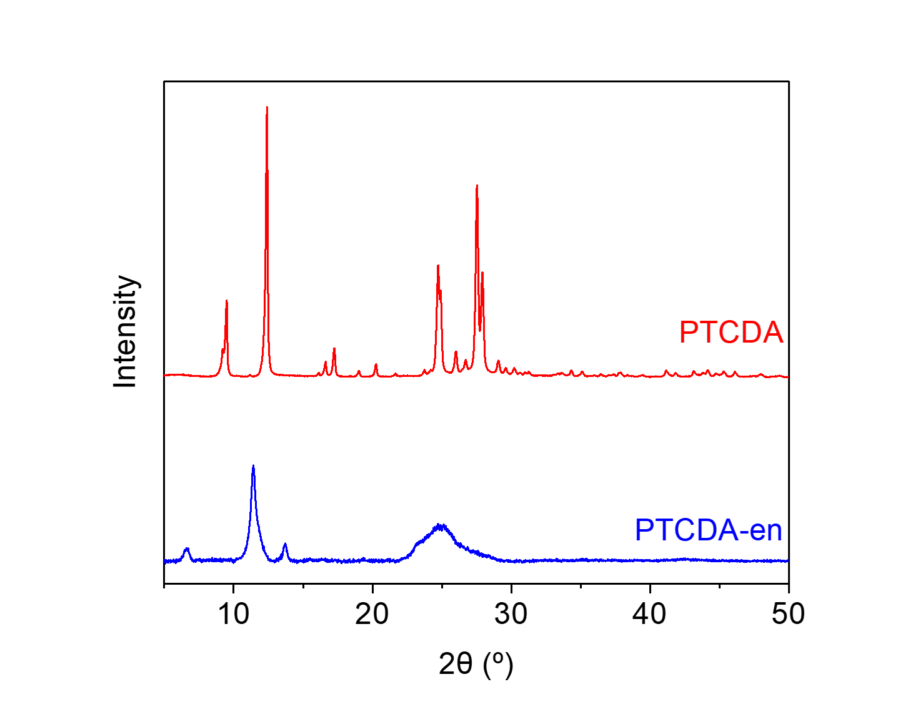
Figure S46. PXRD patterns (λ = 1.54 Å) of PTCDA and PTCDA-en. These patterns indicate that PTCDA-en is a microcrystalline polymer and is likely not contaminated with PTCDA.
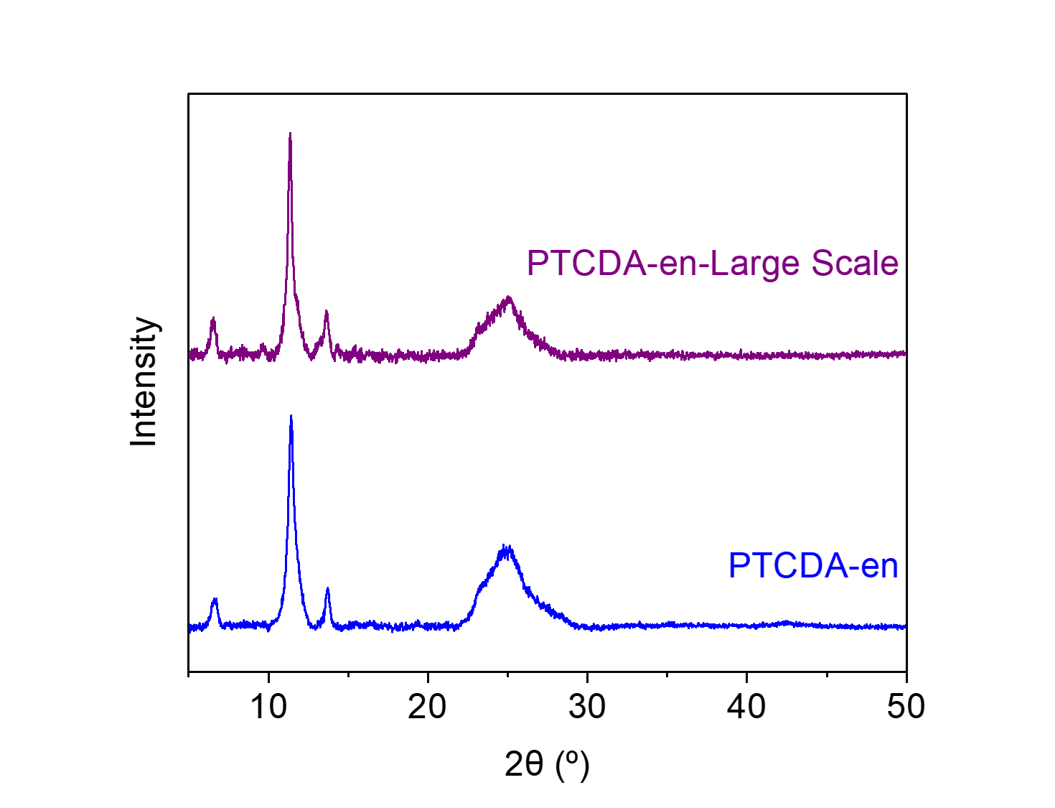
Figure S47. PXRD patterns (λ = 1.54 Å) of PTCDA-en and PTCDA-en-Large Scale.
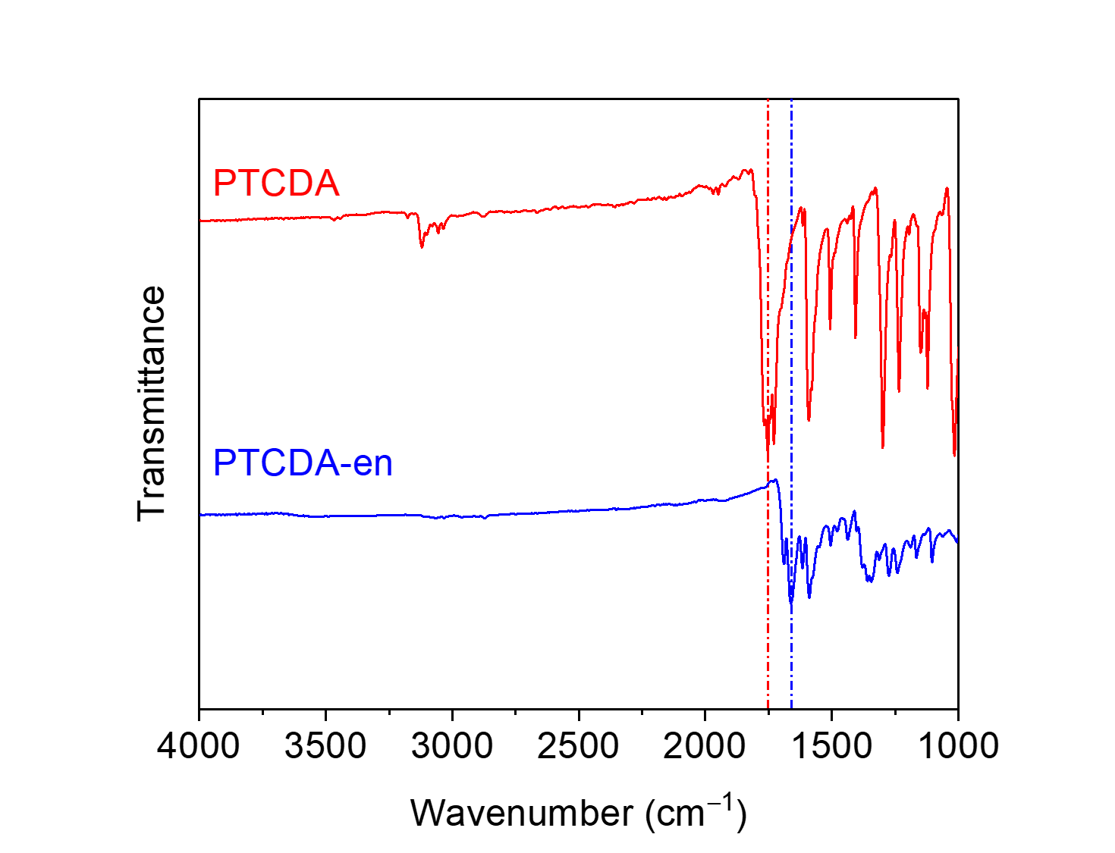
Figure S48. ATR-IR spectra for PTCDA and PTCDA-en. The shift in the carbonyl stretching frequency between the dianhydride (1753 cm⁻¹) and the diimide (1659 cm⁻¹) is indicated.
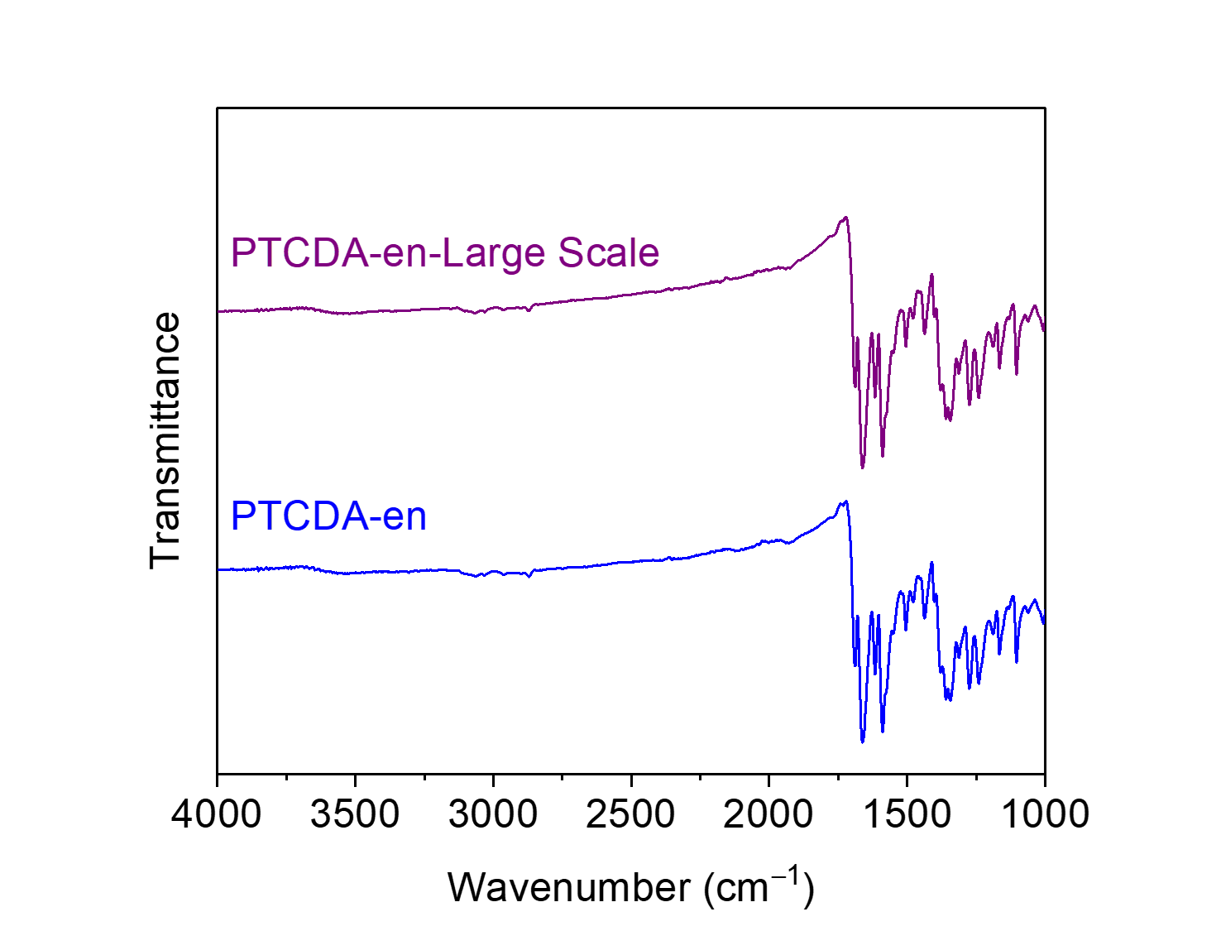
Figure S49. ATR-IR spectra for PTCDA-en and PTCDA-en-Large Scale.
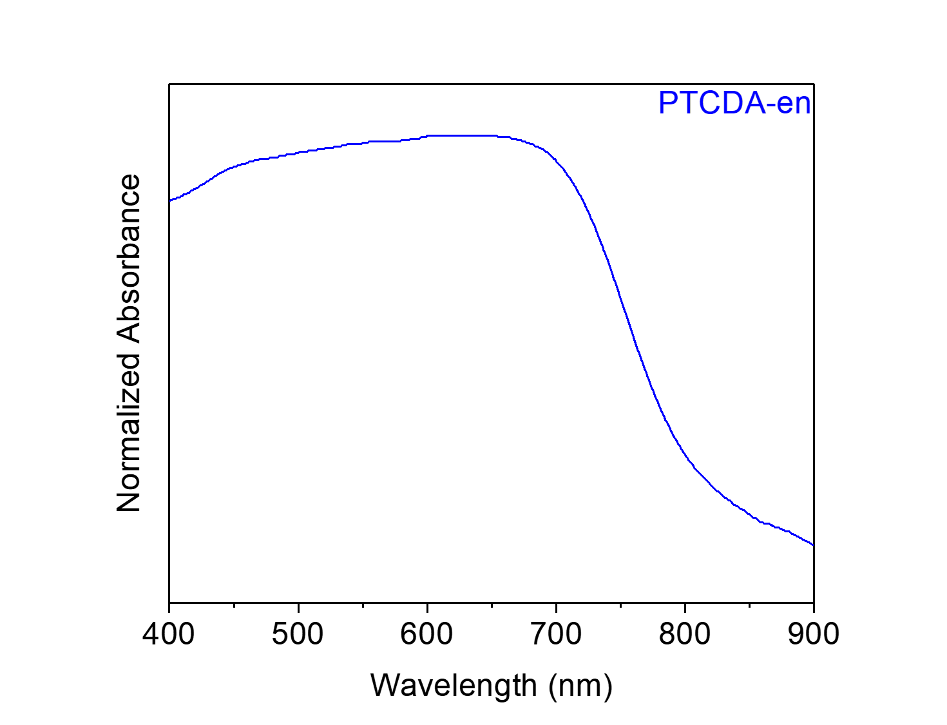
Figure S50. Solid-state UV-Vis absorption spectrum of PTCDA-en dispersed in BaSO₄.
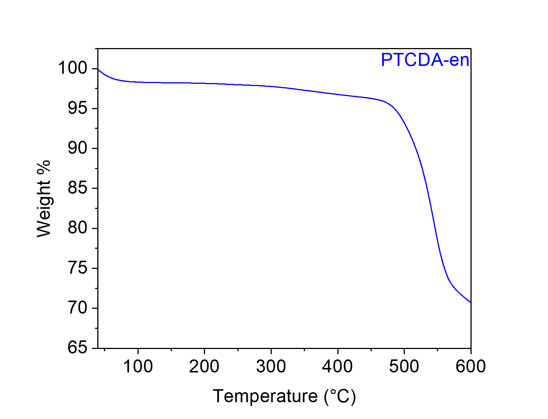
Figure S51. Thermogravimetric decomposition profile of PTCDA-en, indicating that it is stable below 500 °C. The gradual weight loss from this material upon heating is likely due to the loss of solvent/water.
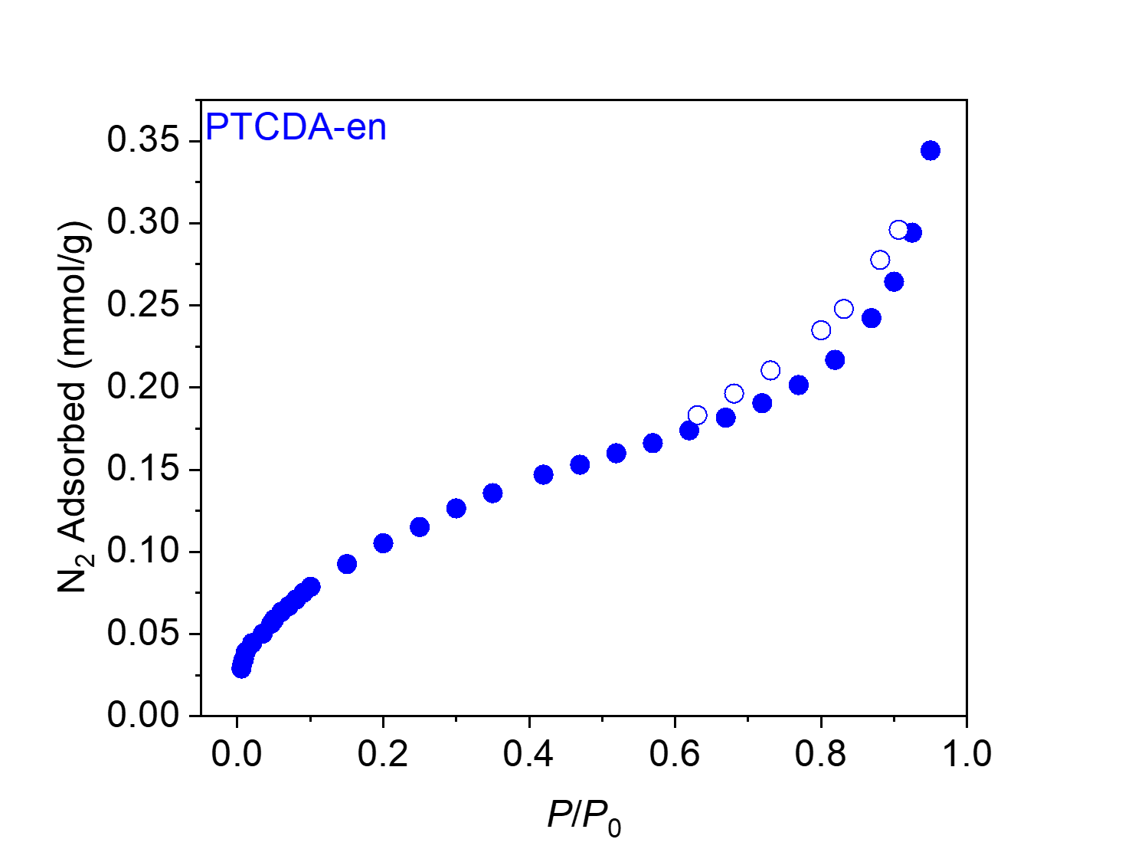
Figure S52. 77 K N₂ adsorption (filled circles) and desorption (open circles) isotherms for PTCDA-en. The BET and Langmuir surface areas were determined to be 9 m²/g and 27 ± 2 m²/g, respectively.
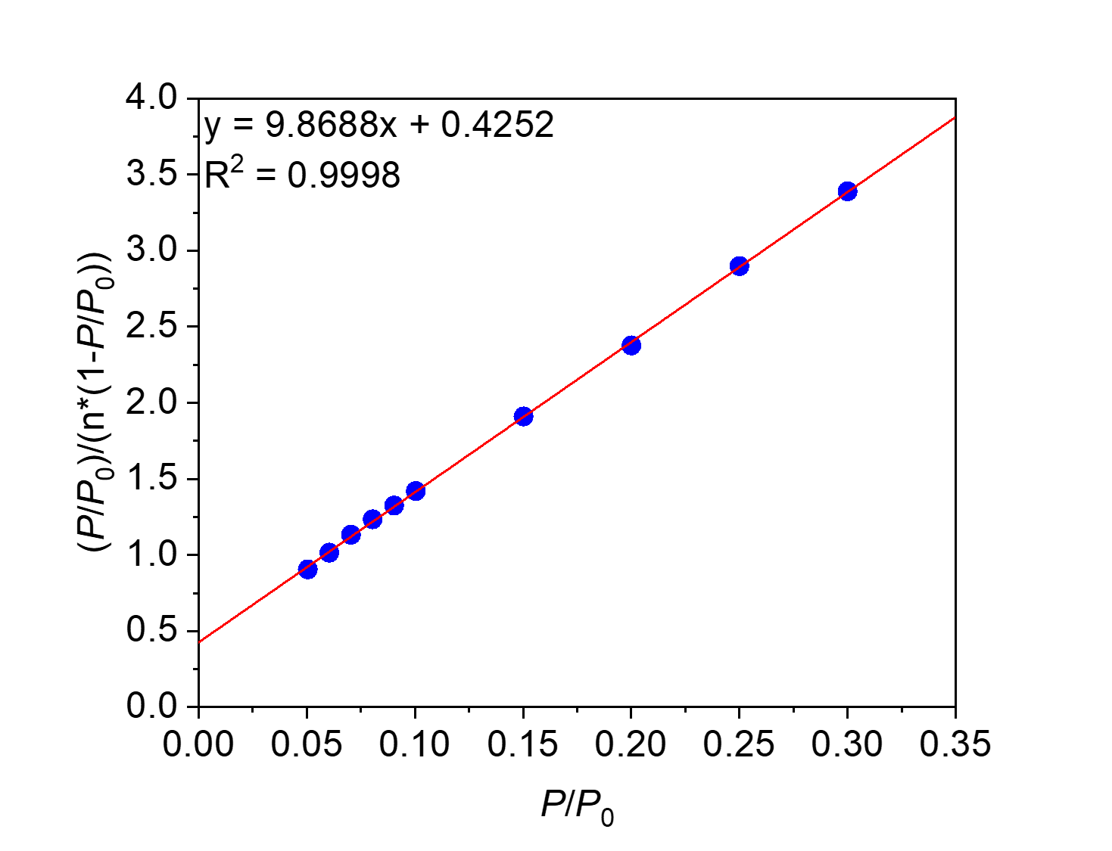
Figure S53. Linearized BET plot of PTCDA-en.
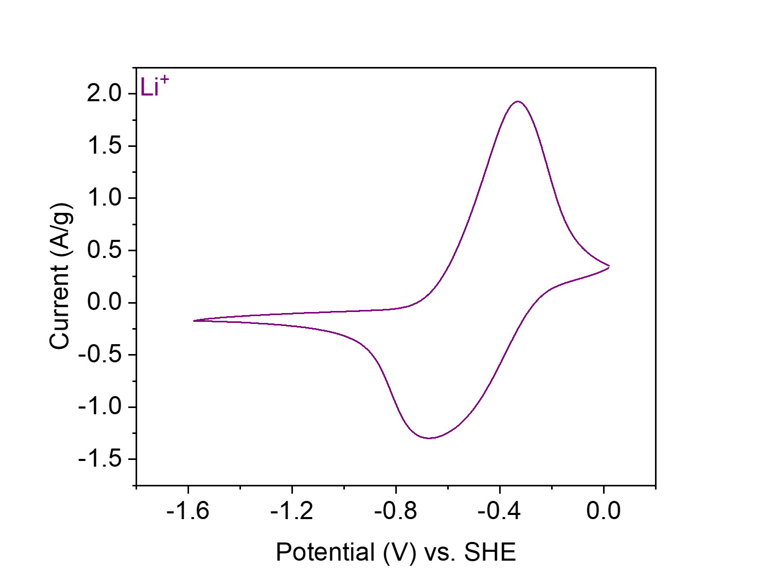
Figure S54. CV at 20 mV s⁻¹ of PTCDA-en in 0.1 M LiClO₄ in MeCN.
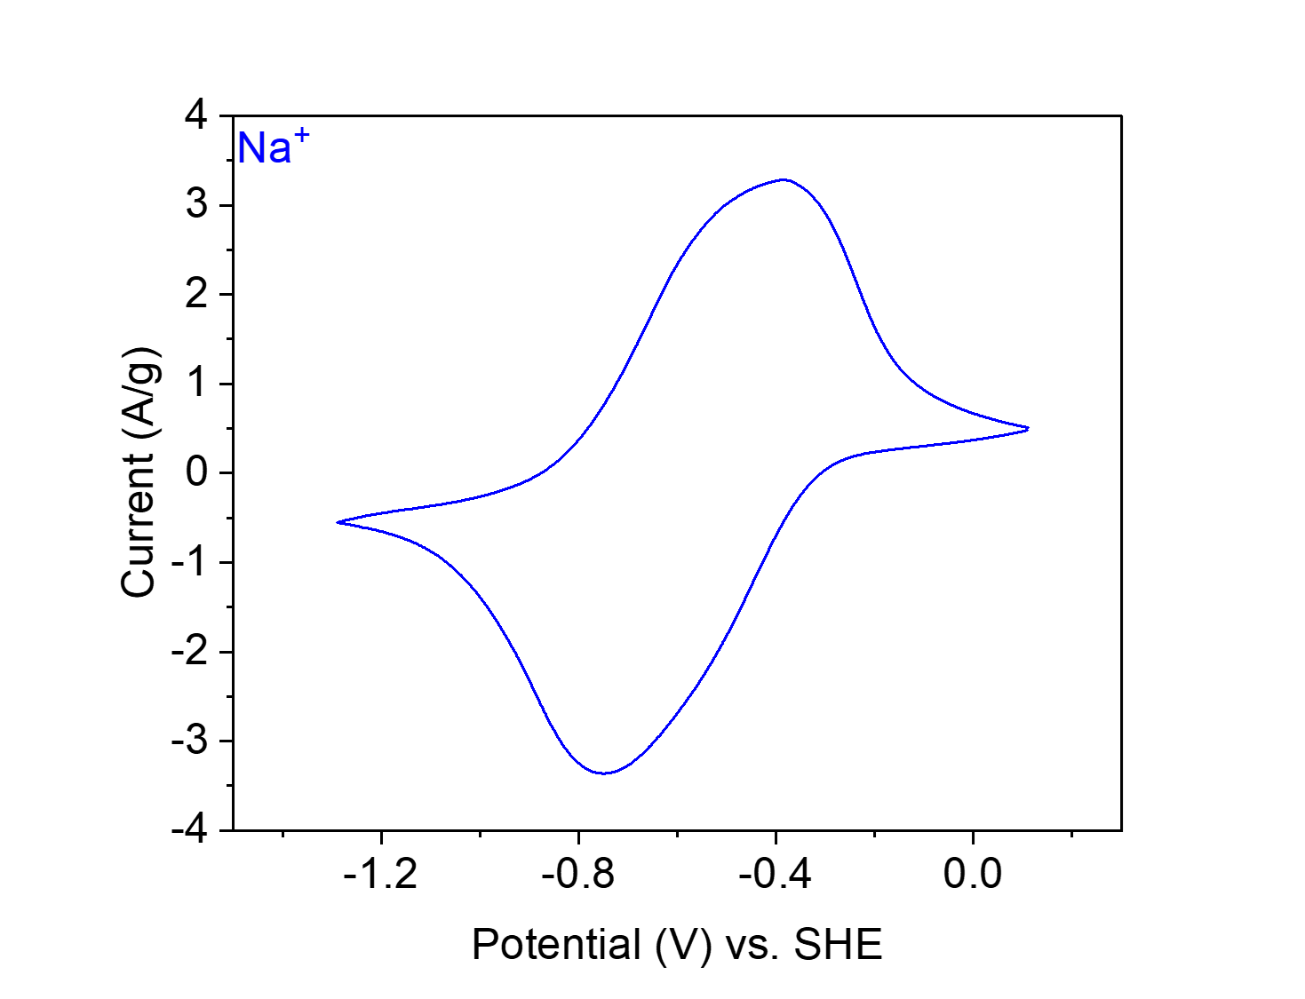
Figure S55. CV at 20 mV s⁻¹ of PTCDA-en in 0.1 M NaClO₄ in MeCN.
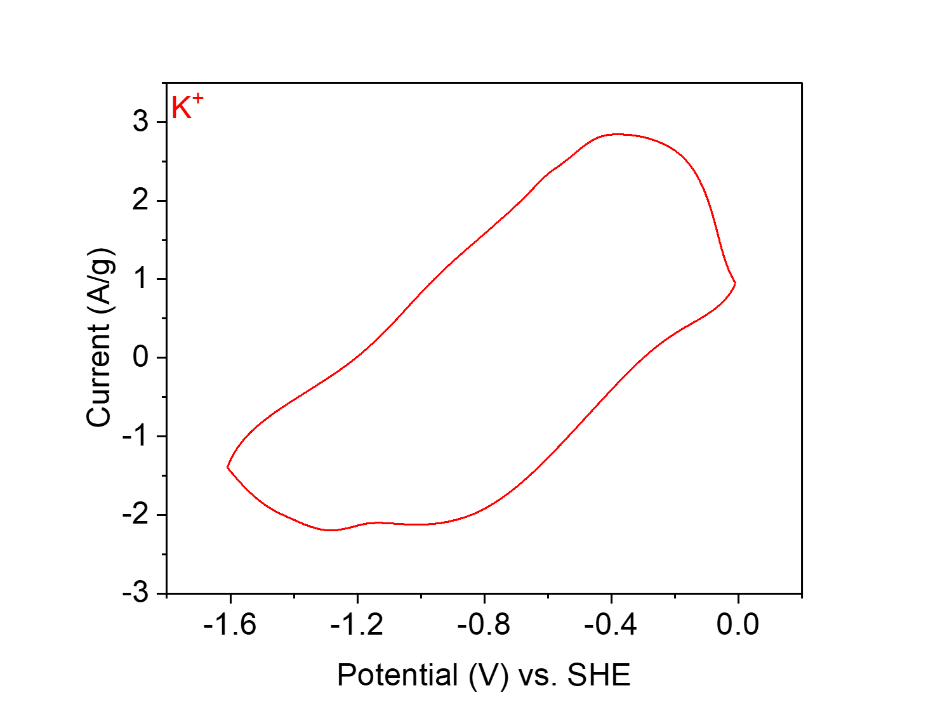
Figure S56. CV at 20 mV s⁻¹ of PTCDA-en in 0.1 M KClO₄ in MeCN.
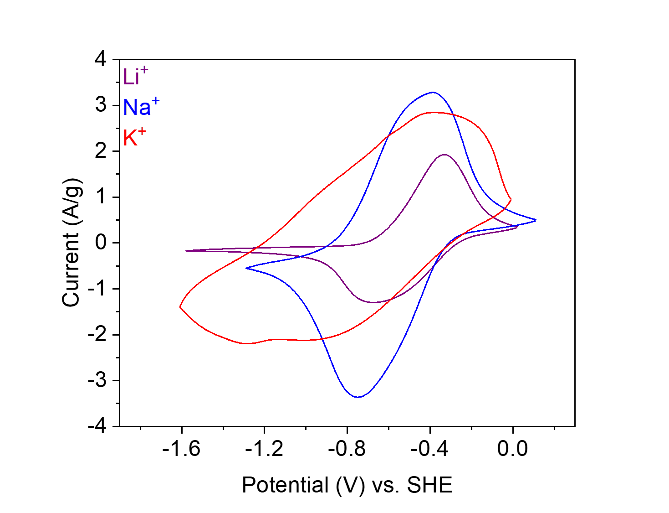
Figure S57. CVs at 20 mV s⁻¹ of PTCDA-en in 0.1 M LiClO₄ (purple), NaClO₄ (blue), and KClO₄ (red) in MeCN.

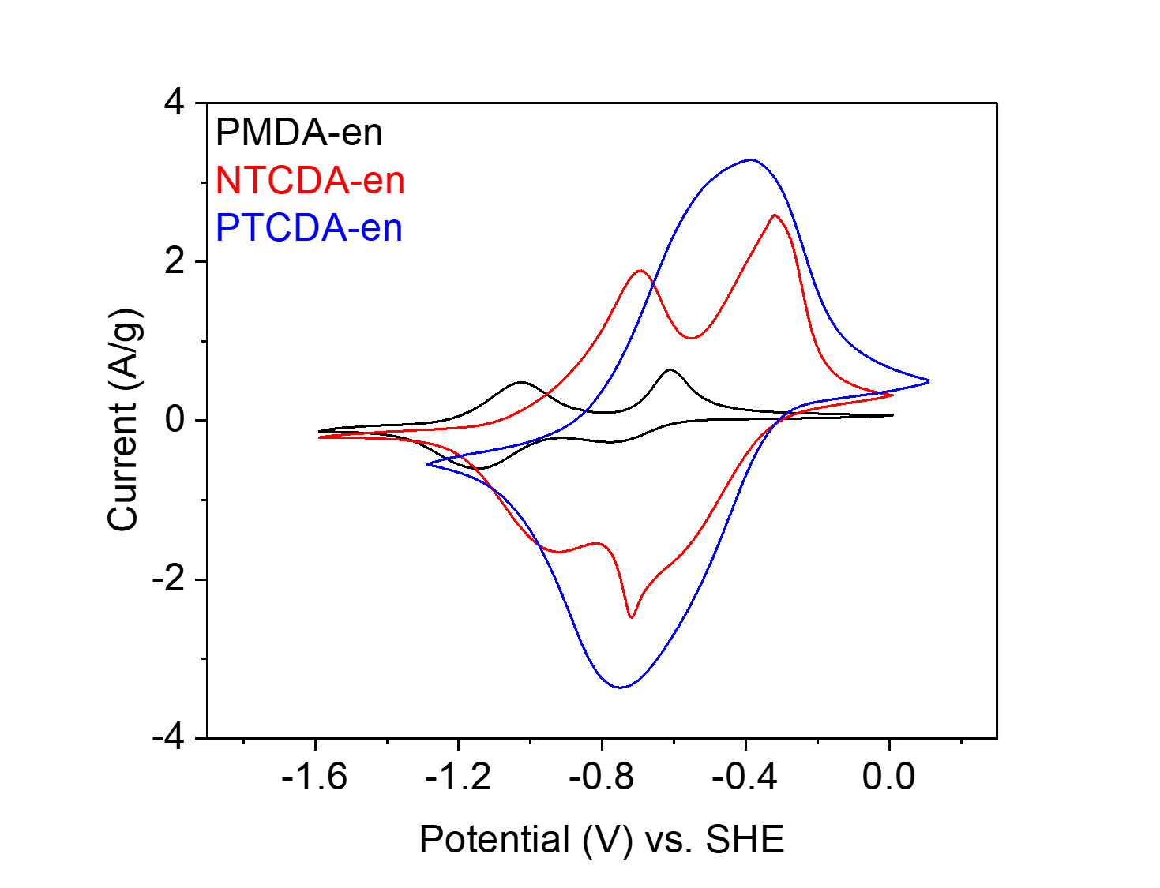
Figure S58. CVs at 20 mV s⁻¹ of PMDA-en (black), NTCDA-en (red), and PTCDA-en (blue) in 0.1 M NaClO₄ in MeCN.

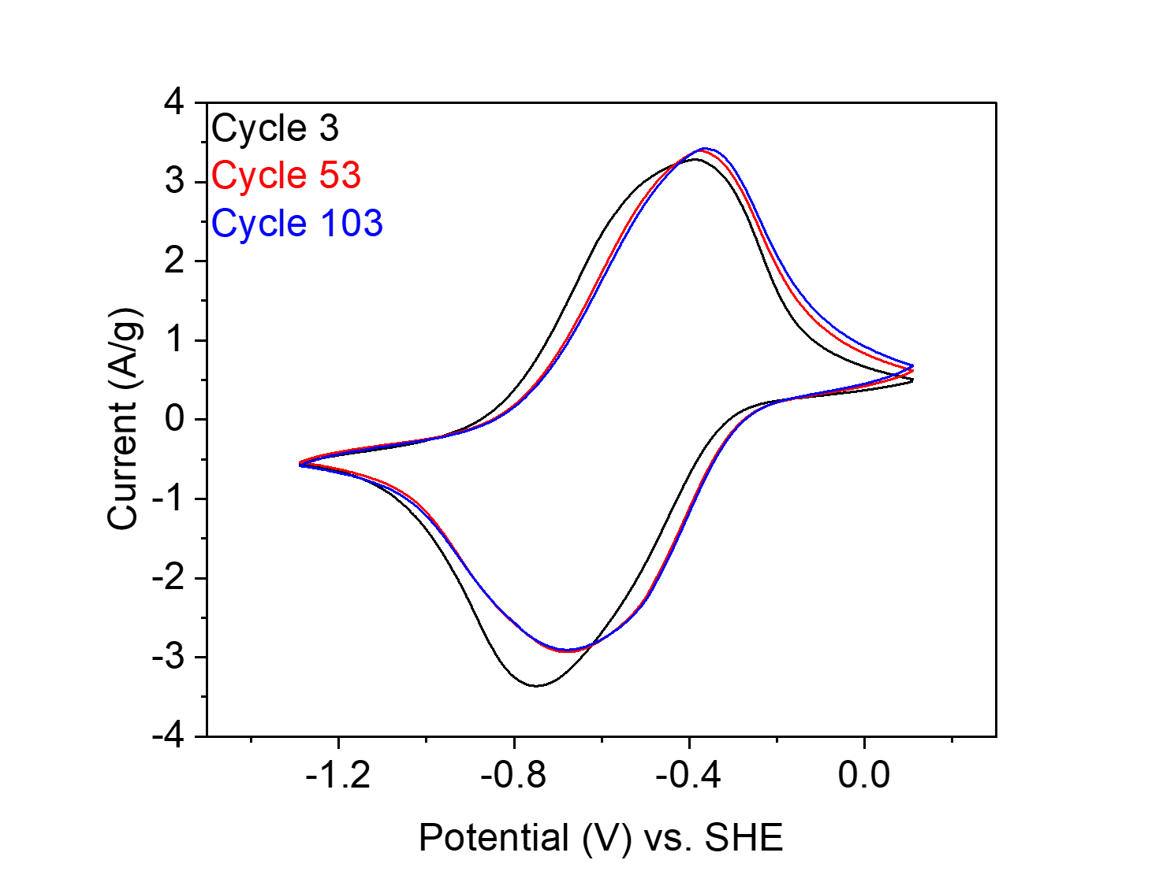
Figure S59. Cycling test at 20 mV s⁻¹ of PTCDA-en in 0.1 M NaClO₄ in MeCN for 103 cycles. These CVs indicate that PTCDA-en is electrochemically stable for at least 103 cycles.
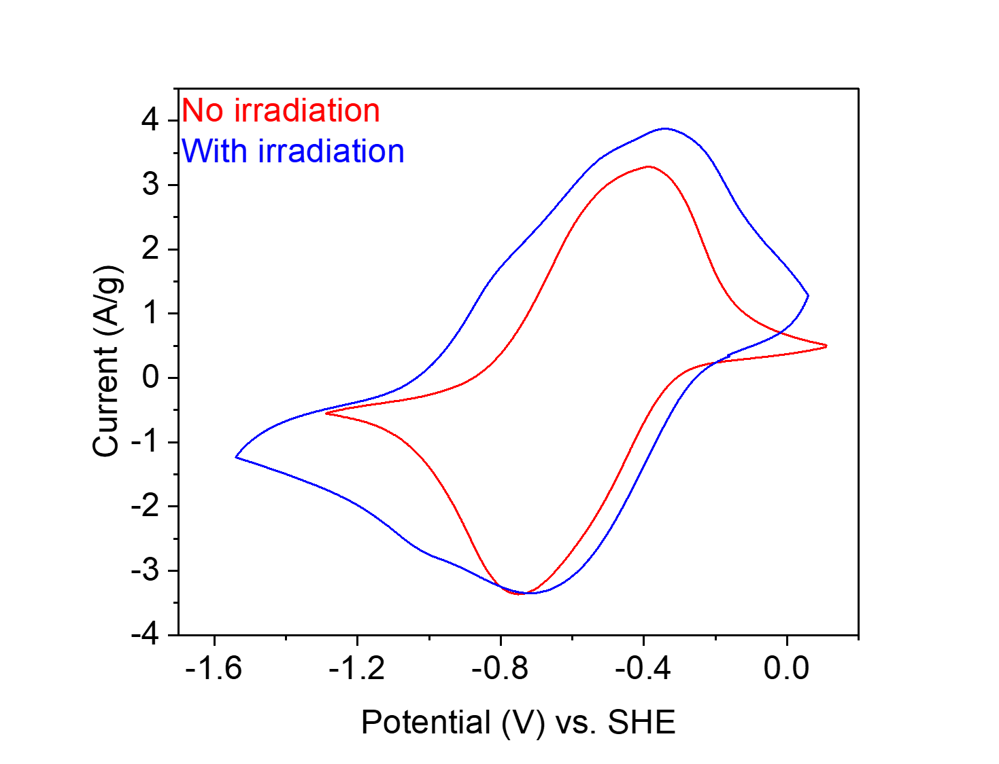
Figure S60. CVs at 20 mV s⁻¹ of PTCDA-en with (blue) and without (red) blue Kessil LED (456 nm, 40 W) irradiation in 0.1 M NaClO₄ in MeCN.

PTCDA-pn from 3,4,9,10-perylene tetracarboxylic dianhydride (PTCDA) and 1,3-diaminopropane (pn).
Figure S61. Scheme for the synthesis of PTCDA-pn from PTCDA and pn.
Synthesis of PTCDA-pn. Following General Procedure A with slight modifications, PTCDA (196 mg, 0.50 mmol, 1.00 equiv.), pn (45.8 μL, 0.55 mmol, 1.10 equiv.) and imidazole (8.85 g) were added to a 75 mL screw-cap high-pressure reaction vessel and heated at 130 °C for 24 h. The resulting solid was washed and dried to yield PTCDA-pn (117 mg, 55% yield) as a dark red solid.

Element | Average Wt %¹ | Theoretical Wt %
C | 71.66 | 75.34
O | 17.99² | 14.87
H | 3.63 | 3.28
N | 6.72 | 6.51
Total: | 100.00 | 100.00
Table S5. Tabulated combustion analysis data for PTCDA-pn.
¹Average of two trials.
²The remaining mass not attributed to C, H, and N was assumed to come from O, as O was not directly analyzed during combustion analysis.

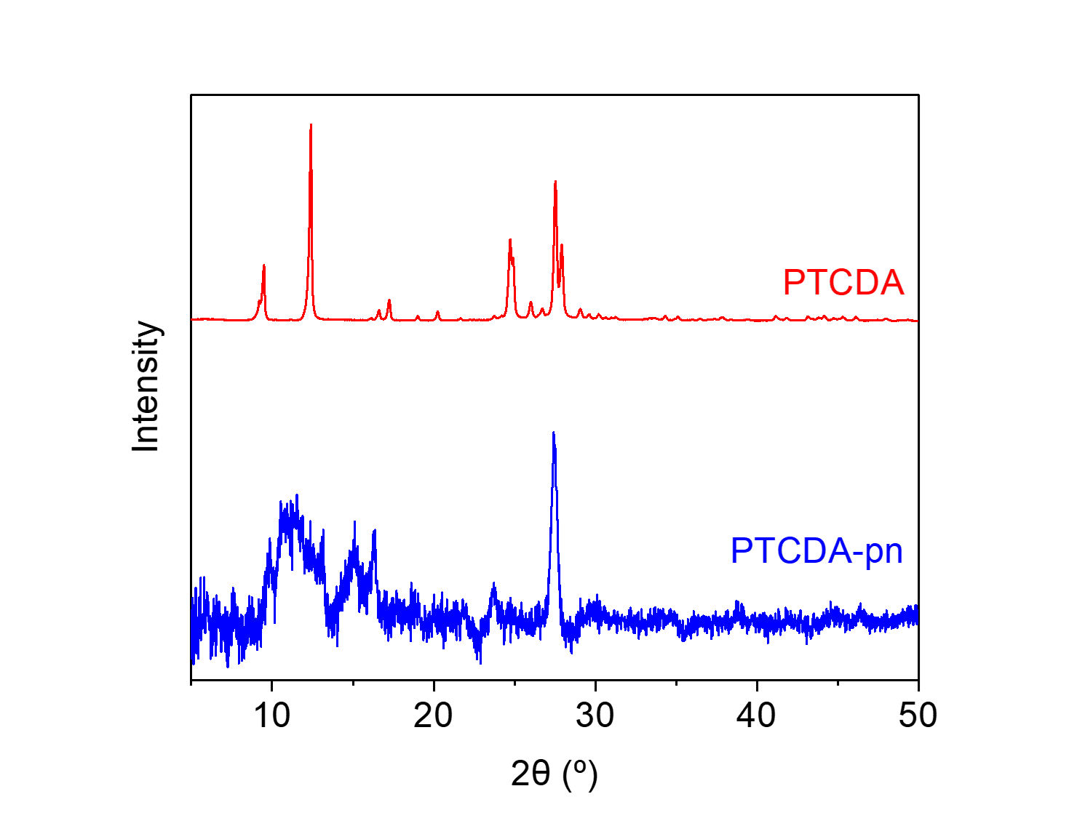
Figure S62. PXRD patterns (λ = 1.54 Å) of PTCDA and PTCDA-pn. These patterns indicate that PTCDA-pn is a microcrystalline polymer and is likely not contaminated with PTCDA.
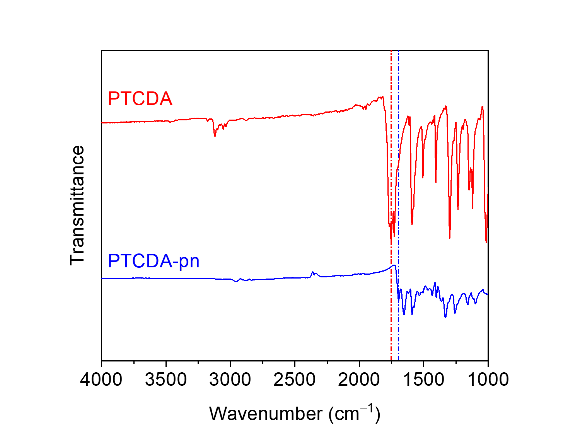
Figure S63. ATR-IR spectra for PTCDA and PTCDA-pn. The shift in the carbonyl stretching frequency between the dianhydride (1753 cm⁻¹) and the diimide (1696 cm⁻¹) is indicated.
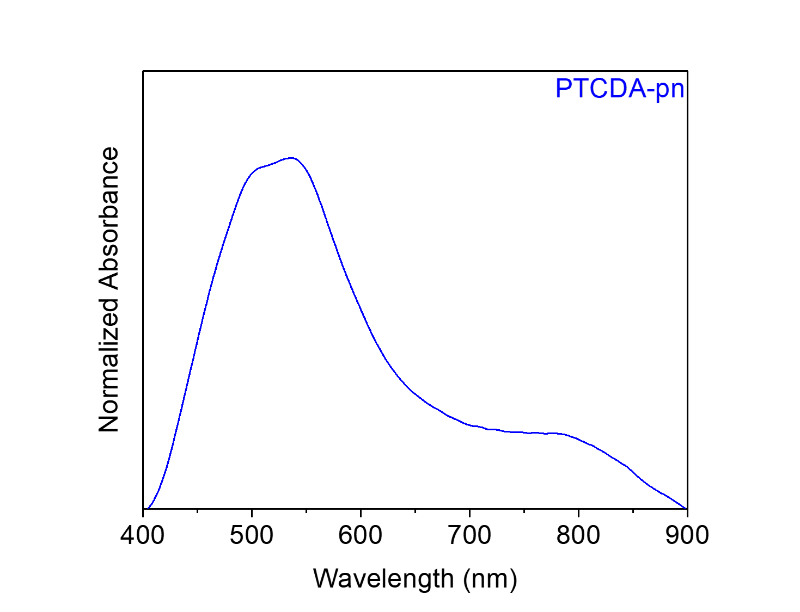
Figure S64. Solid-state UV-Vis absorption spectrum of PTCDA-pn dispersed in BaSO₄.
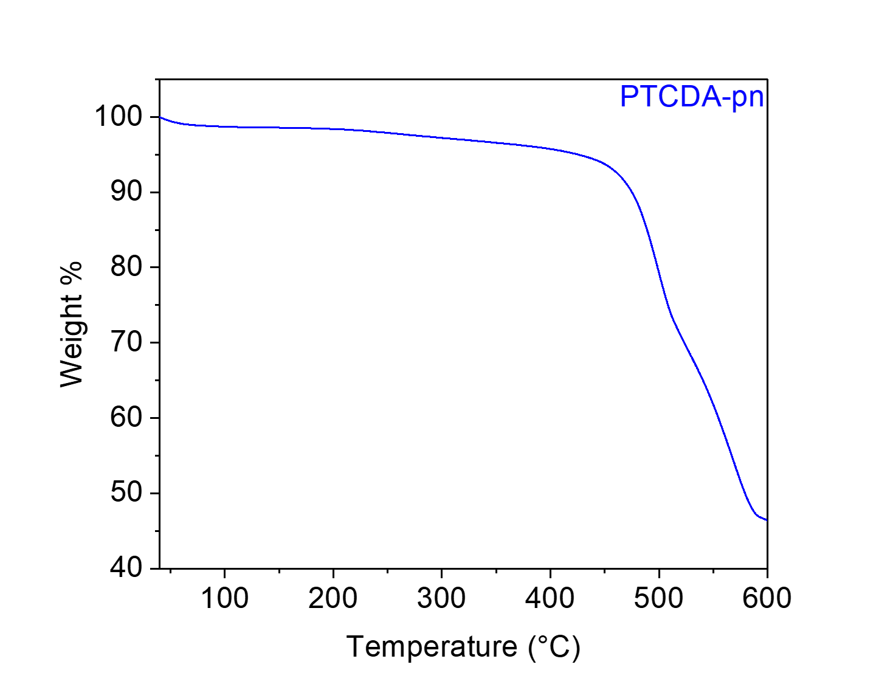
Figure S65. Thermogravimetric decomposition profile of PTCDA-pn, indicating that it is stable below 450 °C. The gradual weight loss from this material upon heating is likely due to the loss of solvent/water.

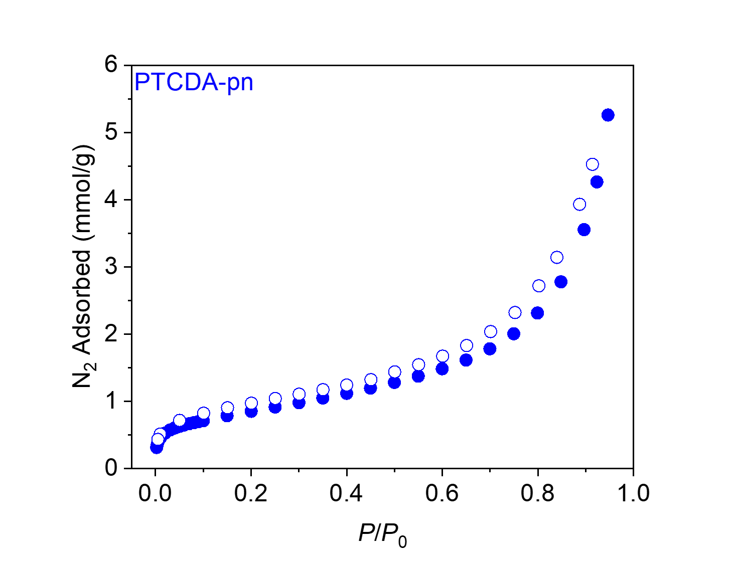
Figure S66. 77 K N₂ adsorption (filled circles) and desorption (open circles) isotherms for PTCDA-pn. The BET and Langmuir surface areas were determined to be 67 m²/g and 280 ± 40 m²/g, respectively. This is consistent with the literature.⁹
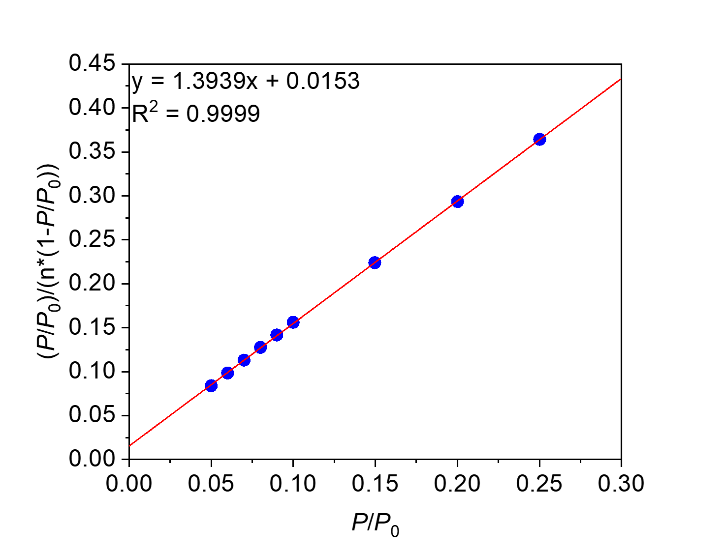
Figure S67. Linearized BET plot of PTCDA-pn.

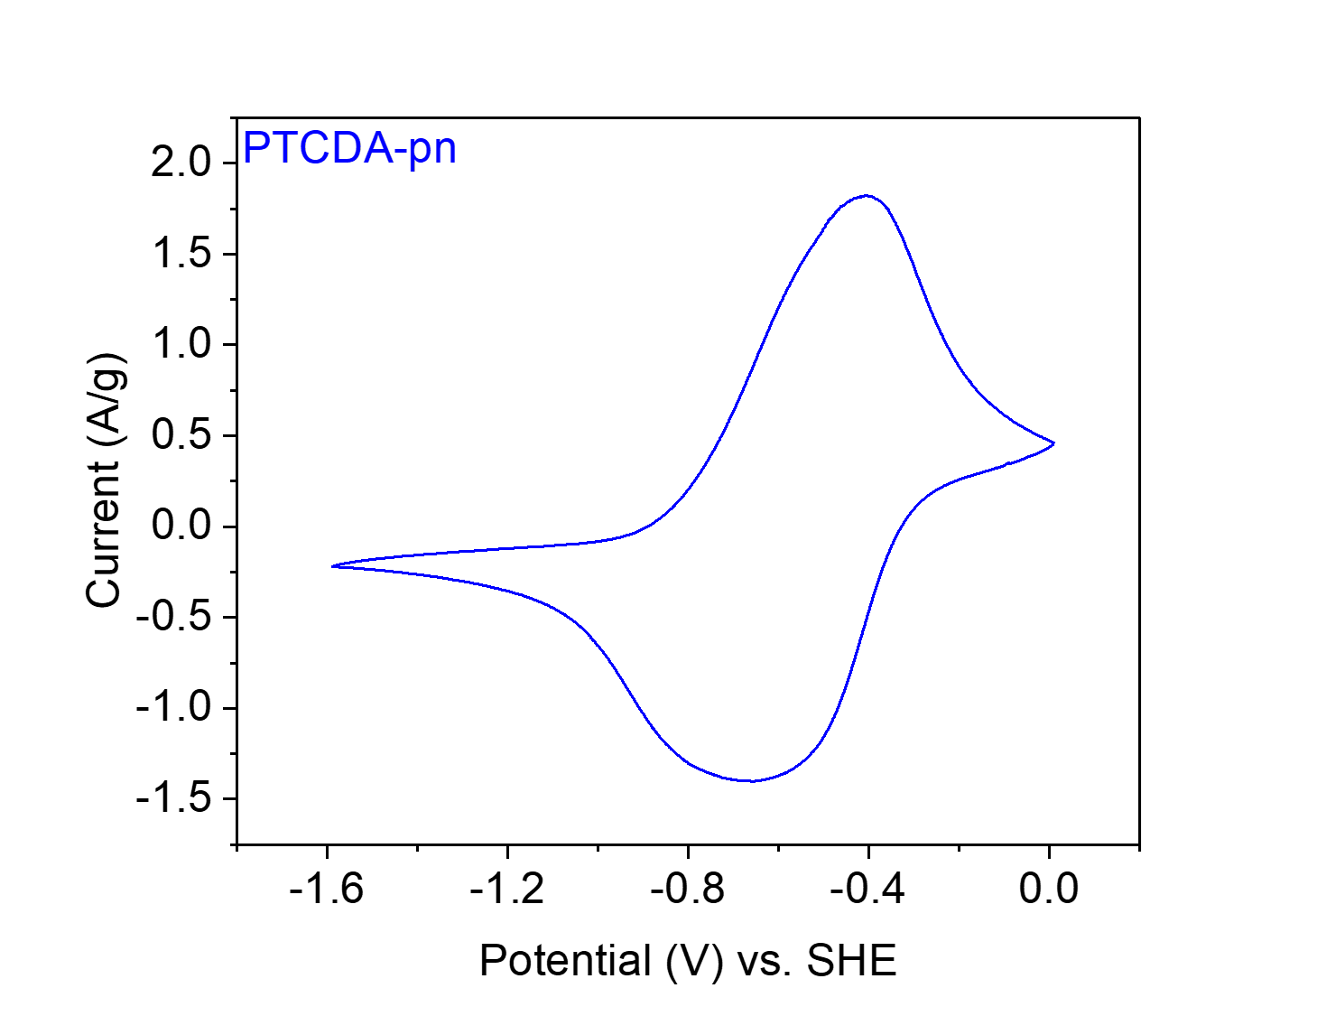
Figure S68. CV at 20 mV s⁻¹ of PTCDA-pn in 0.1 M NaClO₄ in MeCN.

PTCDA-nBut from 3,4,9,10-perylene tetracarboxylic dianhydride (PTCDA) and 1,4-diaminobutane (nBut).
Figure S69. Scheme for the synthesis of PTCDA-nBut from PTCDA and nBut.
Synthesis of PTCDA-nBut. Following General Procedure A with slight modifications, PTCDA (196 mg, 0.50 mmol, 1.00 equiv.), nBut (55.3 μL, 0.55 mmol, 1.10 equiv.) and imidazole (8.85 g) were added to a 75 mL screw-cap high-pressure reaction vessel and heated at 130 °C for 24 h. The resulting solid was washed and dried to yield PTCDA-nBut (137 mg, 61% yield) as a dark purple-black solid.

Element | Average Wt %¹ | Theoretical Wt %
C | 71.64 | 75.67
O | 16.70² | 14.41
H | 3.94 | 3.62
N | 7.72 | 6.30
Total: | 100.00 | 100.00
Table S6. Tabulated combustion analysis data for PTCDA-nBut.
¹Average of two trials.
²The remaining mass not attributed to C, H, and N was assumed to come from O, as O was not directly analyzed during combustion analysis.

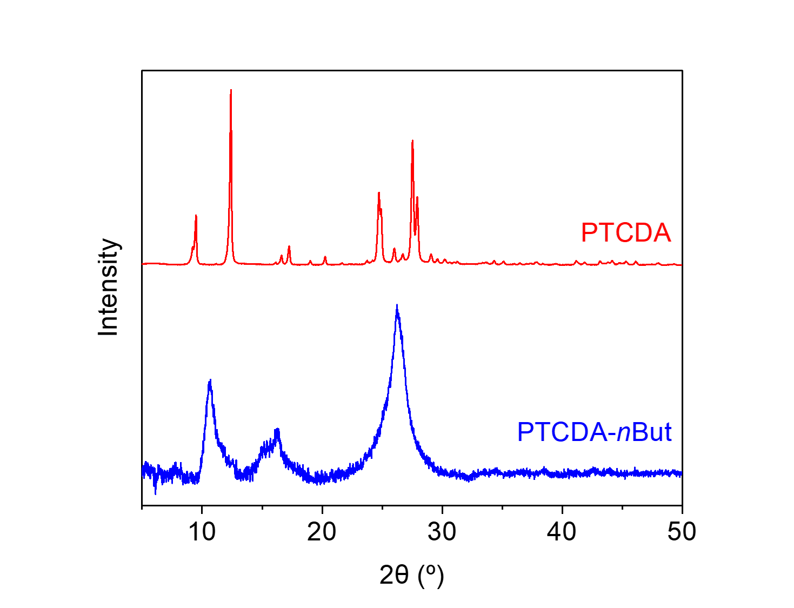
Figure S70. PXRD patterns (λ = 1.54 Å) of PTCDA and PTCDA-nBut. These patterns indicate that PTCDA-nBut is a microcrystalline polymer and is likely not contaminated with PTCDA.
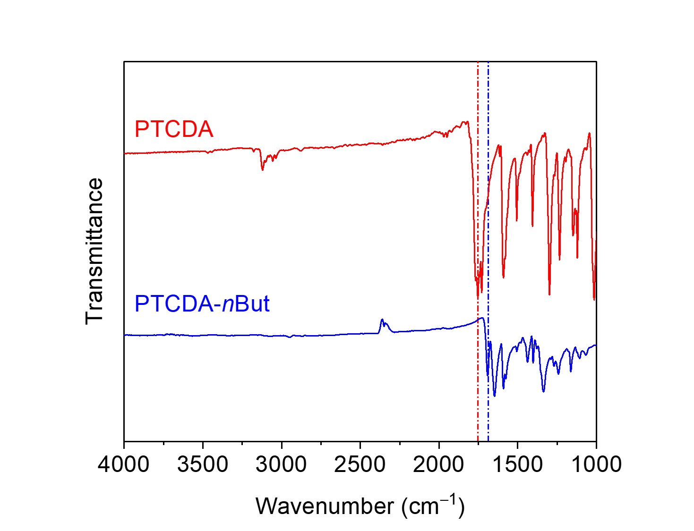
Figure S71. ATR-IR spectra for PTCDA and PTCDA-nBut. The shift in the carbonyl stretching frequency between the dianhydride (1753 cm⁻¹) and the diimide (1691 cm⁻¹) is indicated.
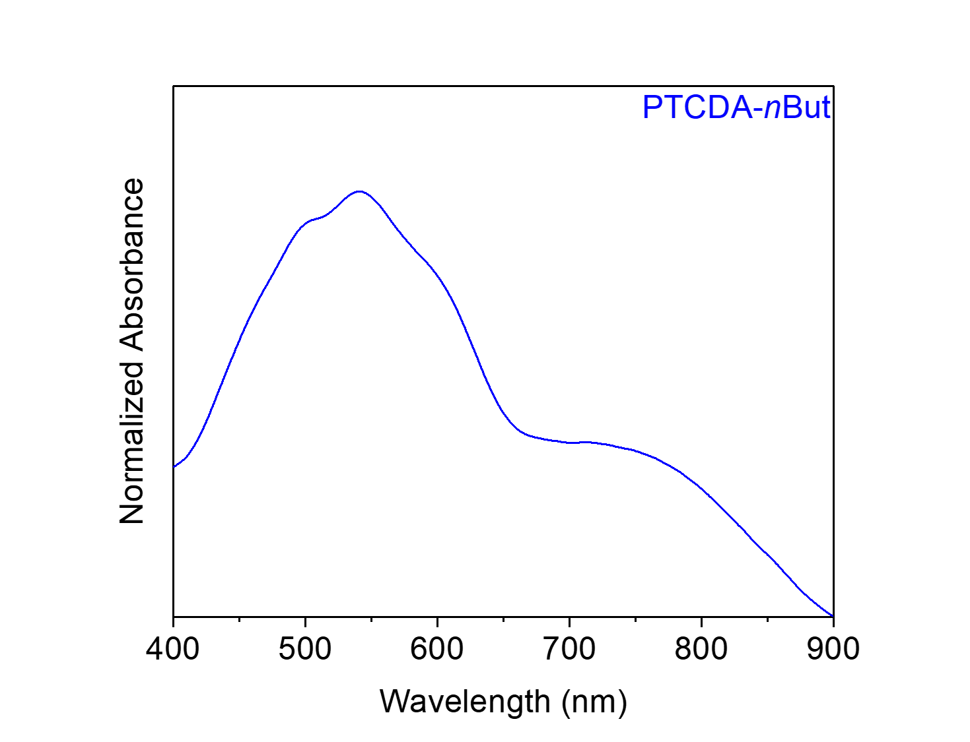
Figure S72. Solid-state UV-Vis absorption spectrum of PTCDA-nBut dispersed in BaSO₄.

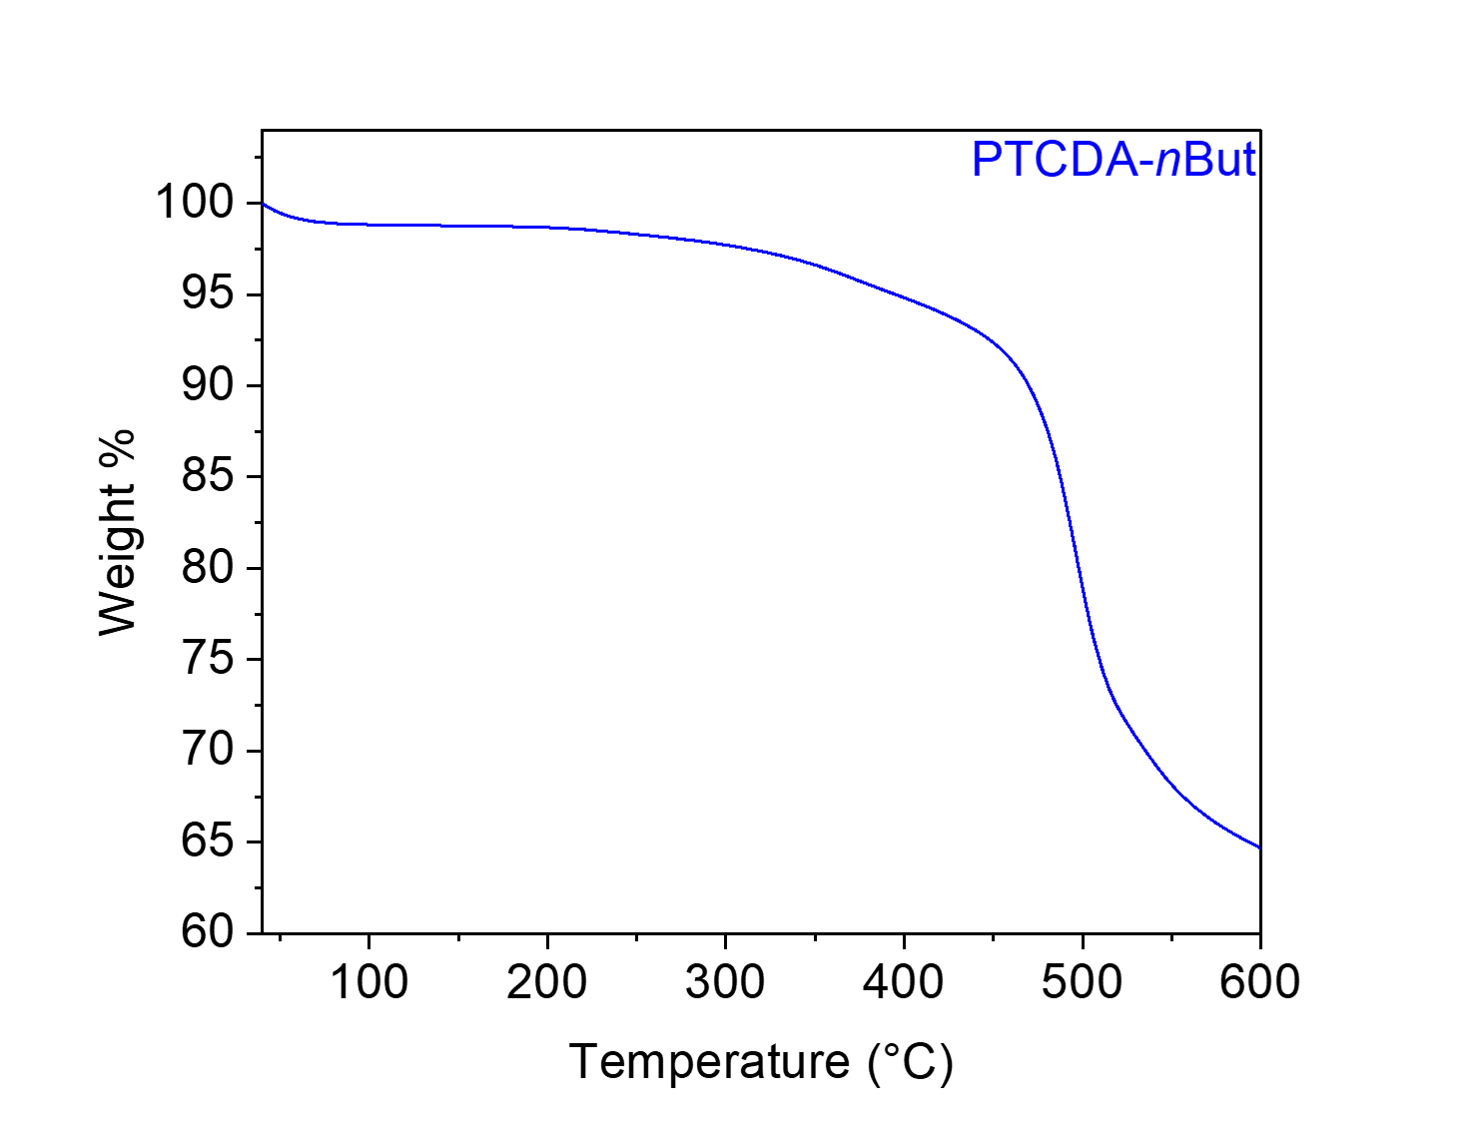
Figure S73. Thermogravimetric decomposition profile of PTCDA-nBut, indicating that it is stable below 400 °C. The gradual weight loss from this material upon heating is likely due to the loss of solvent/water.

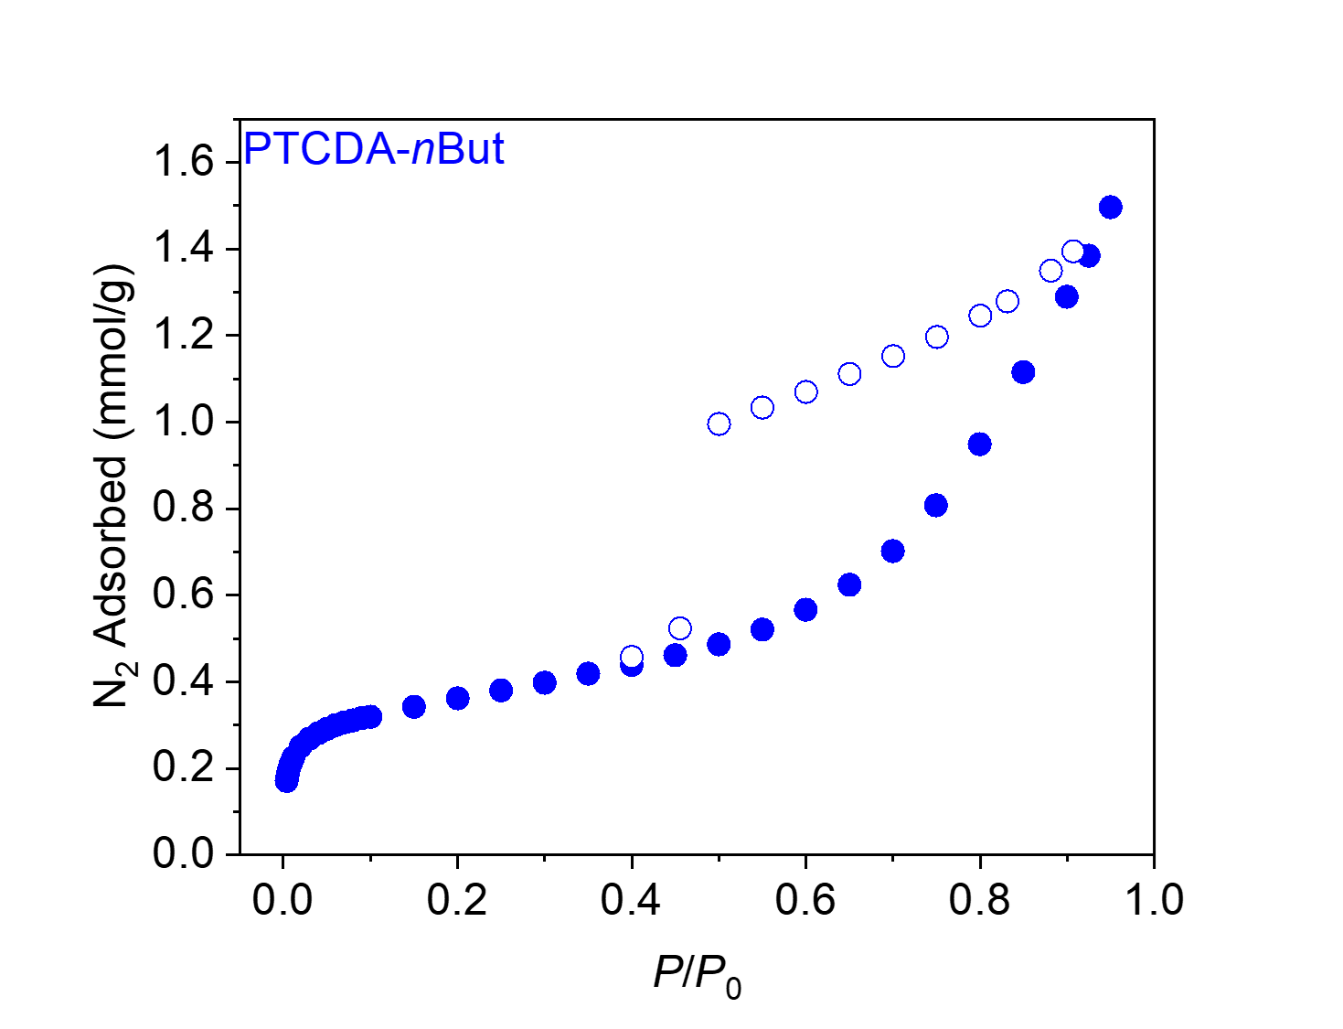
Figure S74. 77 K N₂ adsorption (filled circles) and desorption (open circles) isotherms for PTCDA-nBut. The BET and Langmuir surface areas were determined to be 29 m²/g and 102 ± 13 m²/g, respectively. This is consistent with the literature.⁹
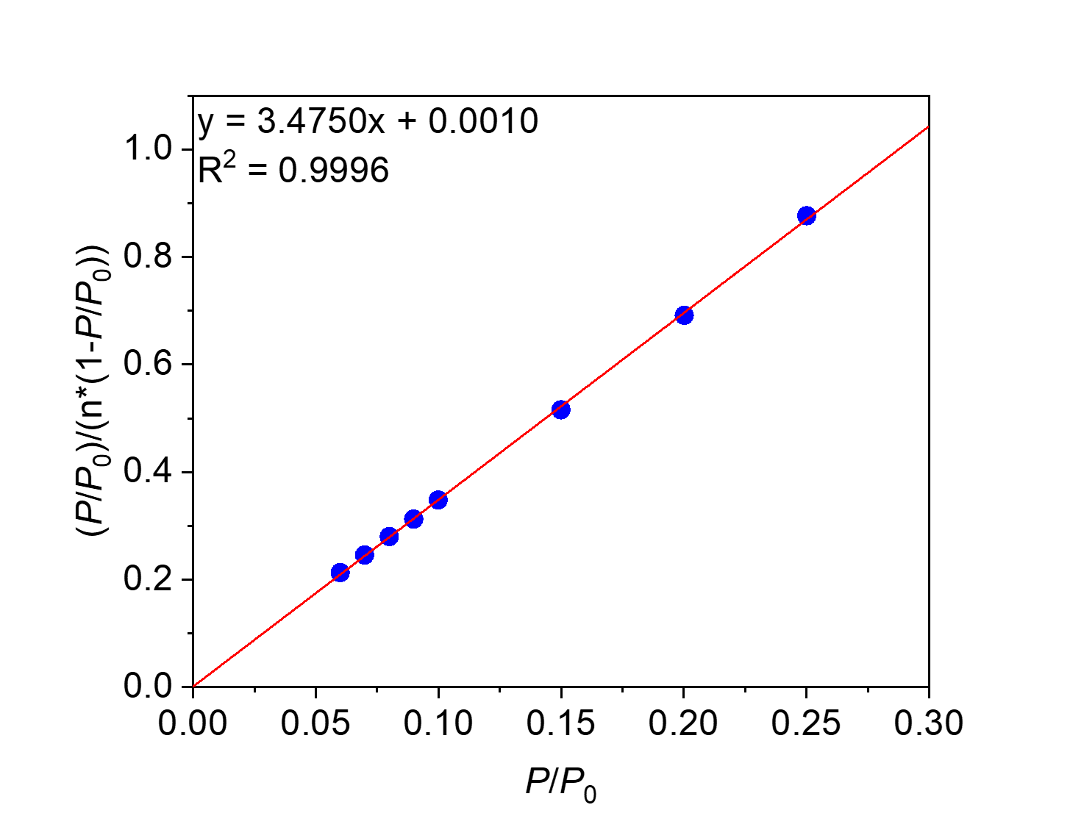
Figure S75. Linearized BET plot of PTCDA-nBut.

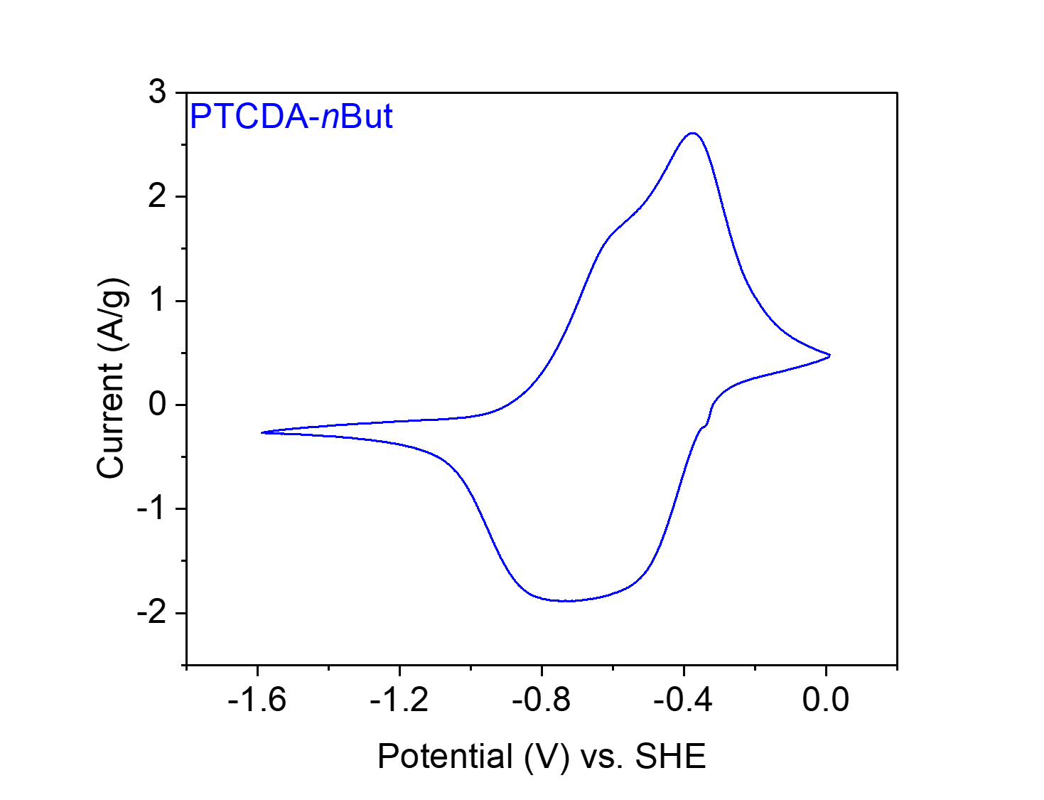
Figure S76. CV at 20 mV s⁻¹ of PTCDA-nBut in 0.1 M NaClO₄ in MeCN.

PTCDA-nHex from 3,4,9,10-perylene tetracarboxylic dianhydride (PTCDA) and 1,6-diaminohexane (nHex).
Figure S77. Scheme for the synthesis of PTCDA-nHex from PTCDA and nHex.
Synthesis of PTCDA-nHex. Following General Procedure A with slight modifications, PTCDA (196 mg, 0.50 mmol, 1.00 equiv.), nHex (71.8 μL, 0.55 mmol, 1.10 equiv.) and imidazole (8.85 g) were added to a 75 mL screw-cap high-pressure reaction vessel and heated at 130 °C for 24 h. The resulting solid was washed and dried to yield PTCDA-nHex (238 mg, ~100% yield) as a dark purple-black solid.

Element | Average Wt %¹ | Theoretical Wt %
C | 71.64 | 76.26
O | 15.67² | 13.54
H | 4.70 | 4.27
N | 7.99 | 5.93
Total: | 100.00 | 100.00
Table S7. Tabulated combustion analysis data for PTCDA-nHex.
¹Average of two trials.
²The remaining mass not attributed to C, H, and N was assumed to come from O, as O was not directly analyzed during combustion analysis.

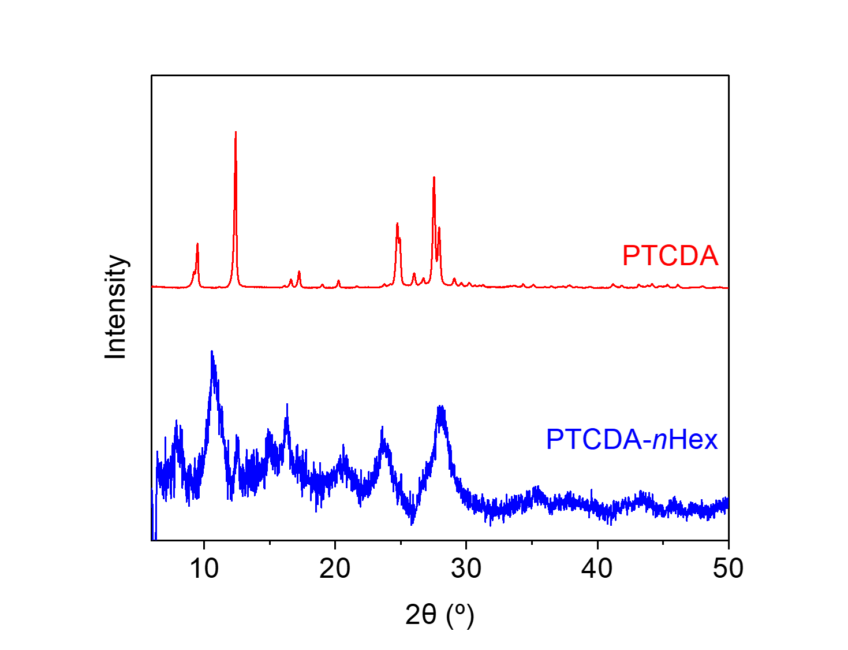
Figure S78. PXRD patterns (λ = 1.54 Å) of PTCDA and PTCDA-nHex. These patterns indicate that PTCDA-nHex is a microcrystalline polymer and is likely not contaminated with PTCDA.

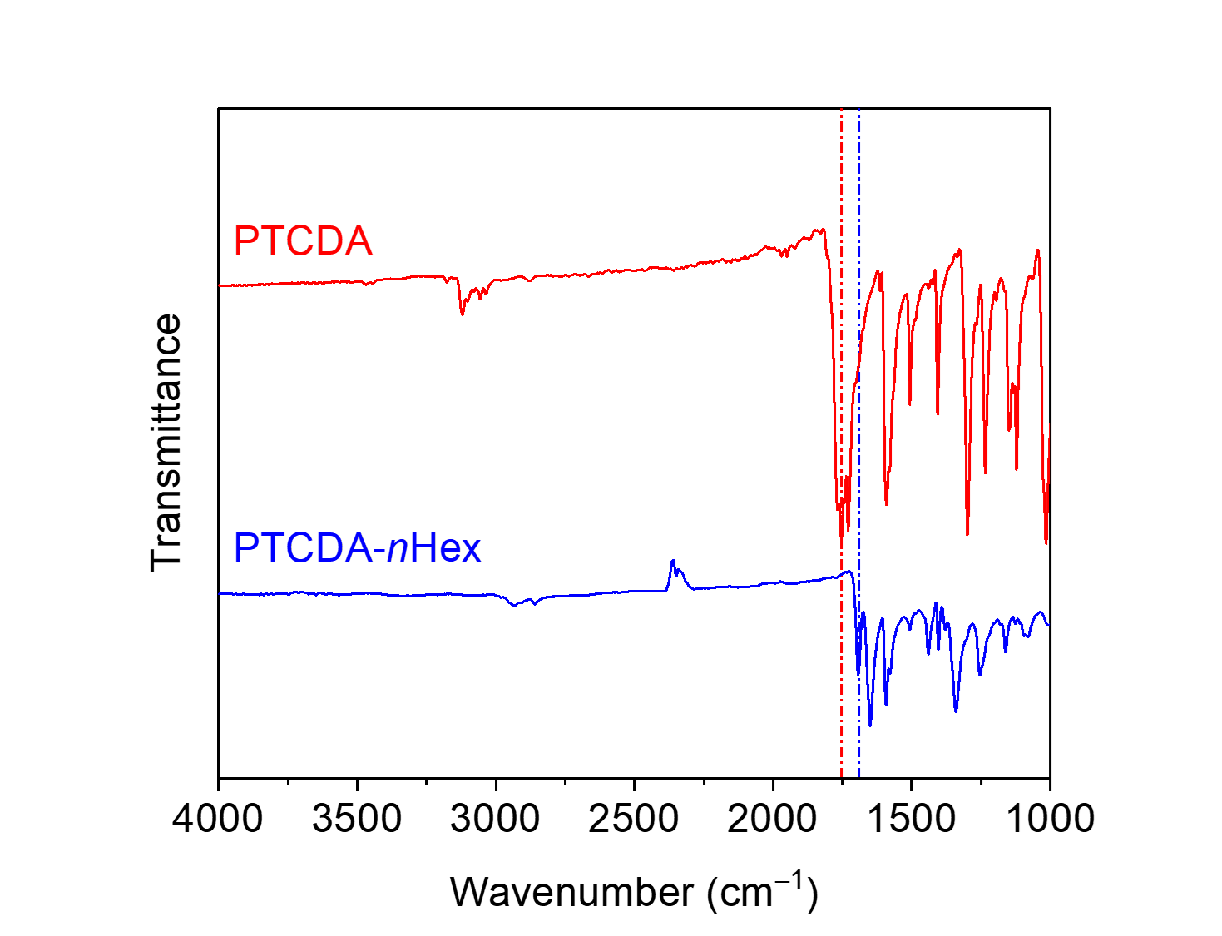
Figure S79. ATR-IR spectra for PTCDA and PTCDA-nHex. The shift in the carbonyl stretching frequency between the dianhydride (1753 cm⁻¹) and the diimide (1693 cm⁻¹) is indicated.
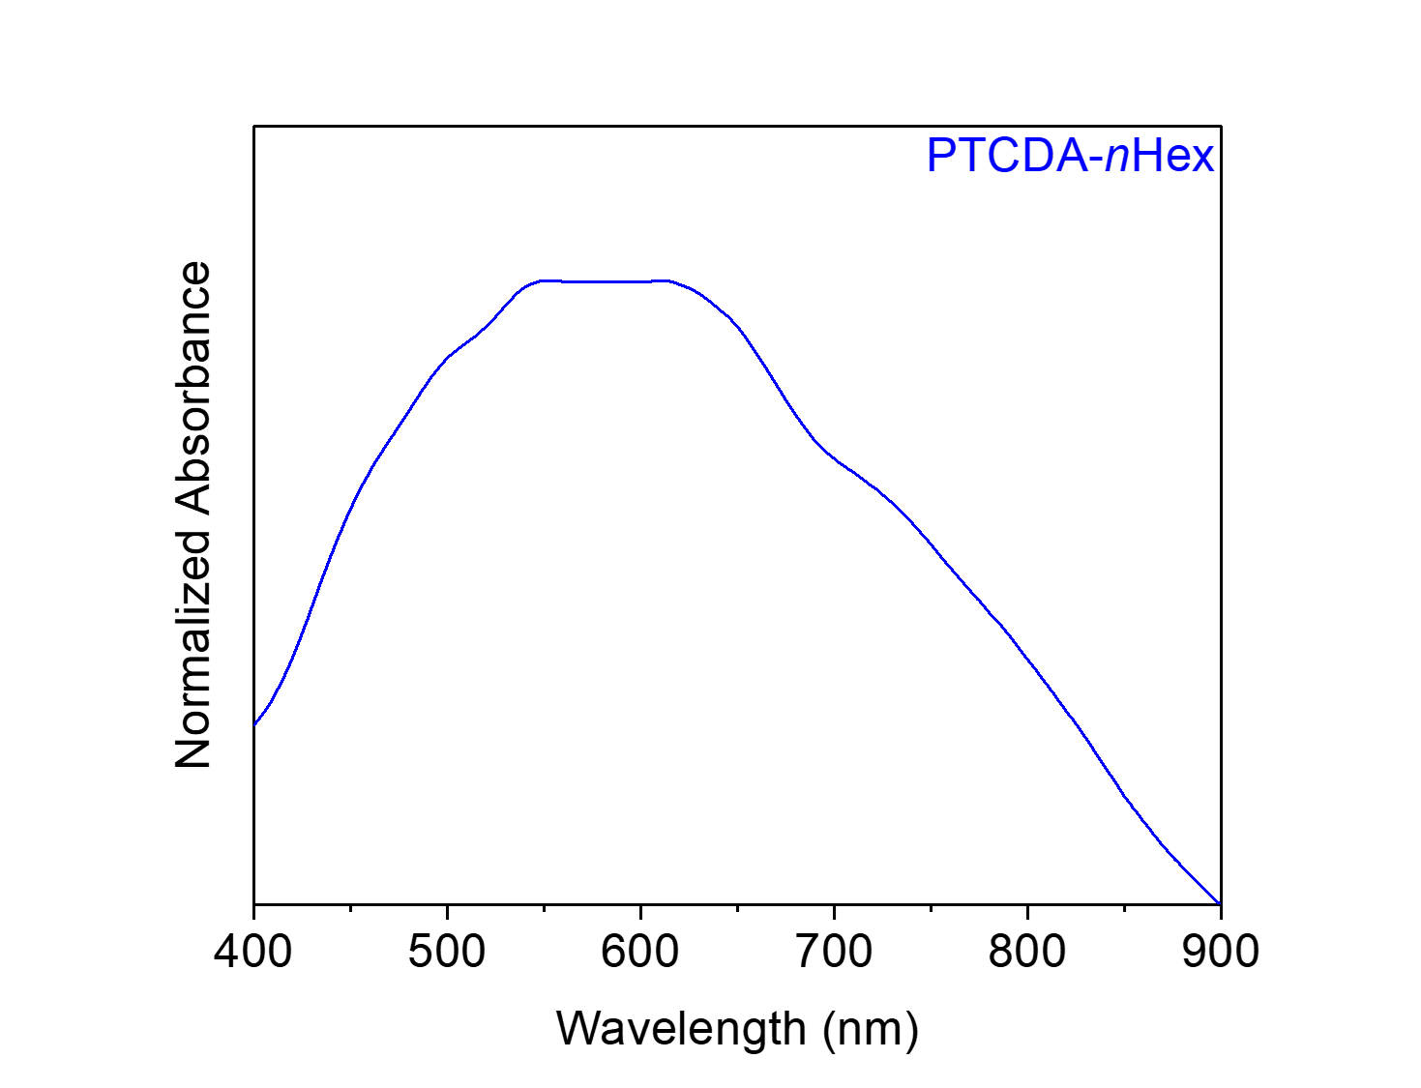
Figure S80. Solid-state UV-Vis absorption spectrum of PTCDA-nHex dispersed in BaSO₄.

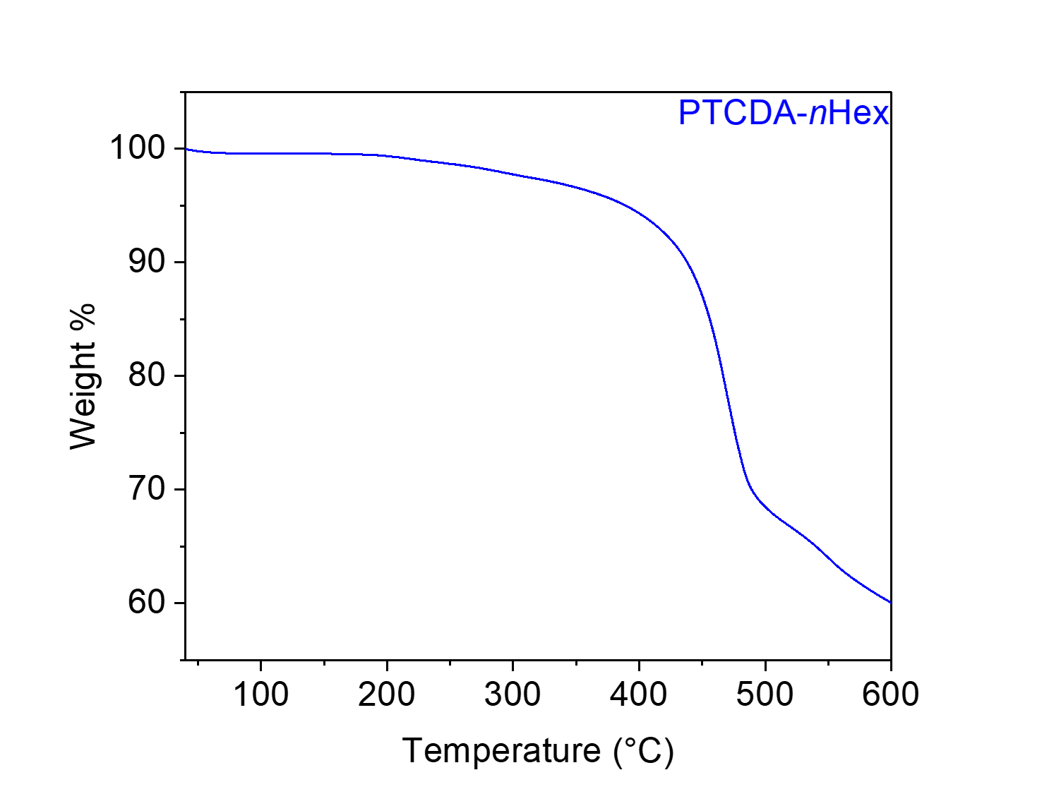
Figure S81. Thermogravimetric decomposition profile for PTCDA-nHex, indicating that it is stable below 400 °C. The gradual weight loss from this material upon heating is likely due to the loss of solvent/water.

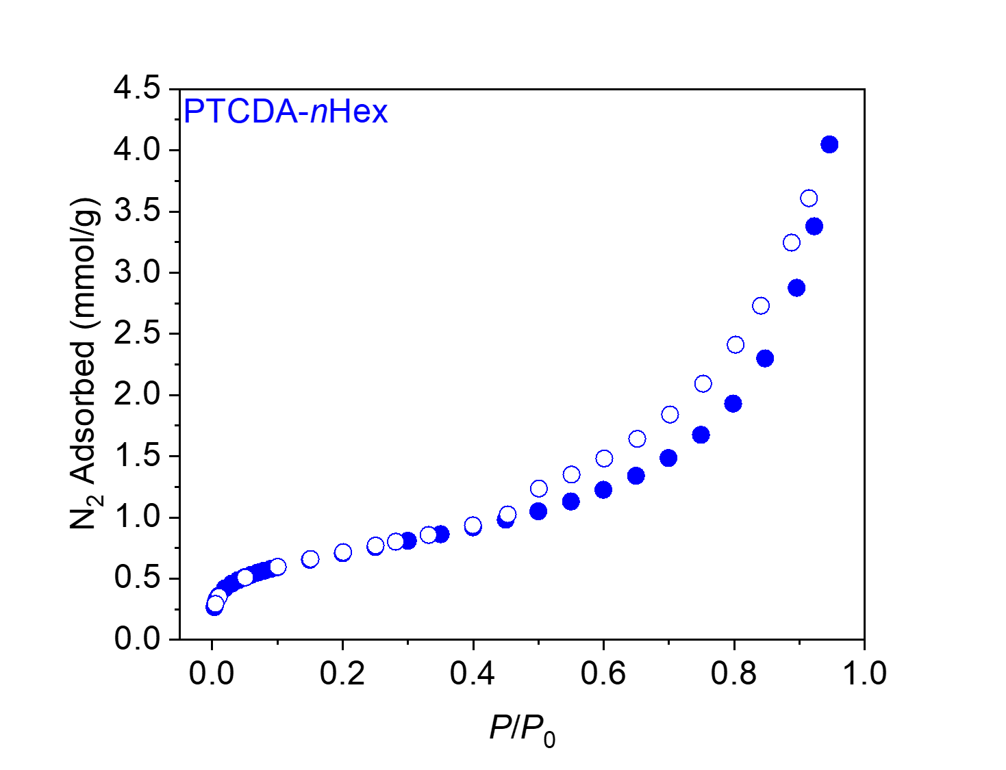
Figure S82. 77 K N₂ adsorption (filled circles) and desorption (open circles) isotherms for PTCDA-nHex. The BET and Langmuir surface areas were determined to be 56 m²/g and 233 ± 34 m²/g, respectively. This is consistent with the literature.⁹
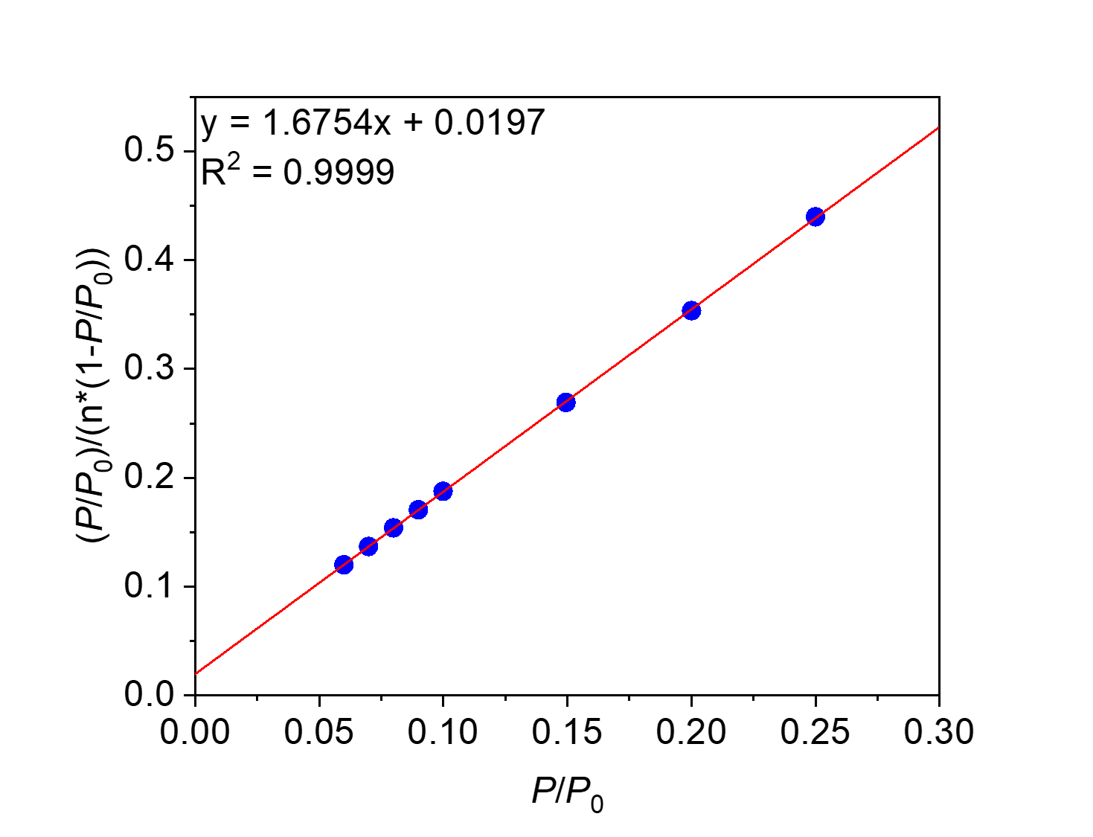
Figure S83. Linearized BET plot of PTCDA-nHex.

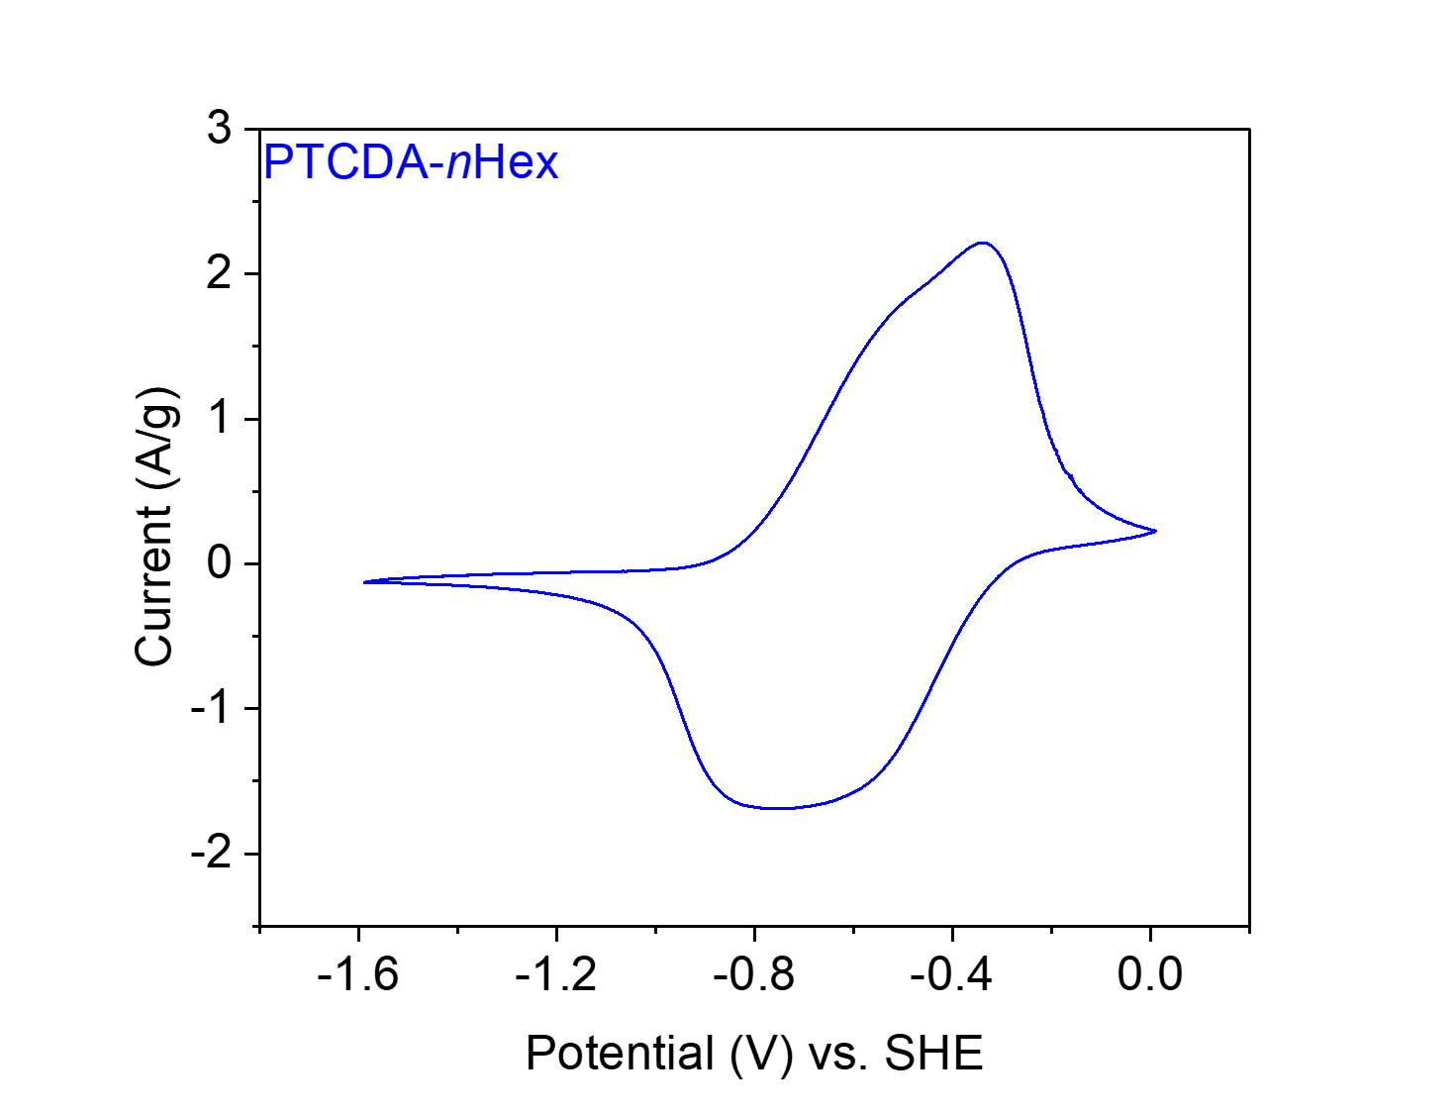
Figure S84. CV at 20 mV s⁻¹ of PTCDA-nHex in 0.1 M NaClO₄ in MeCN.

PTCDA-men from 3,4,9,10-perylene tetracarboxylic dianhydride (PTCDA) and 1,2-diaminopropane (men).
Figure S85. Scheme for the synthesis of PTCDA-men from PTCDA and men.
Synthesis of PTCDA-men. Following General Procedure A with slight modifications, PTCDA (196 mg, 0.50 mmol, 1.00 equiv.), men (46.9 μL, 0.55 mmol, 1.10 equiv.) and imidazole (8.85 g) were added to a 75 mL screw-cap high-pressure reaction vessel and heated at 130 °C for 24 h. The resulting solid was washed and dried to yield PTCDA-men (155 mg, 72% yield) as a dark purple-black solid.

Element | Average Wt %¹ | Theoretical Wt %
C | 72.63 | 75.34
O | 16.87² | 14.87
H | 3.42 | 3.28
N | 7.08 | 6.51
Total: | 100.00 | 100.00
Table S8. Tabulated combustion analysis data for PTCDA-men.
¹Average of two trials.
²The remaining mass not attributed to C, H, and N was assumed to come from O, as O was not directly analyzed during combustion analysis.

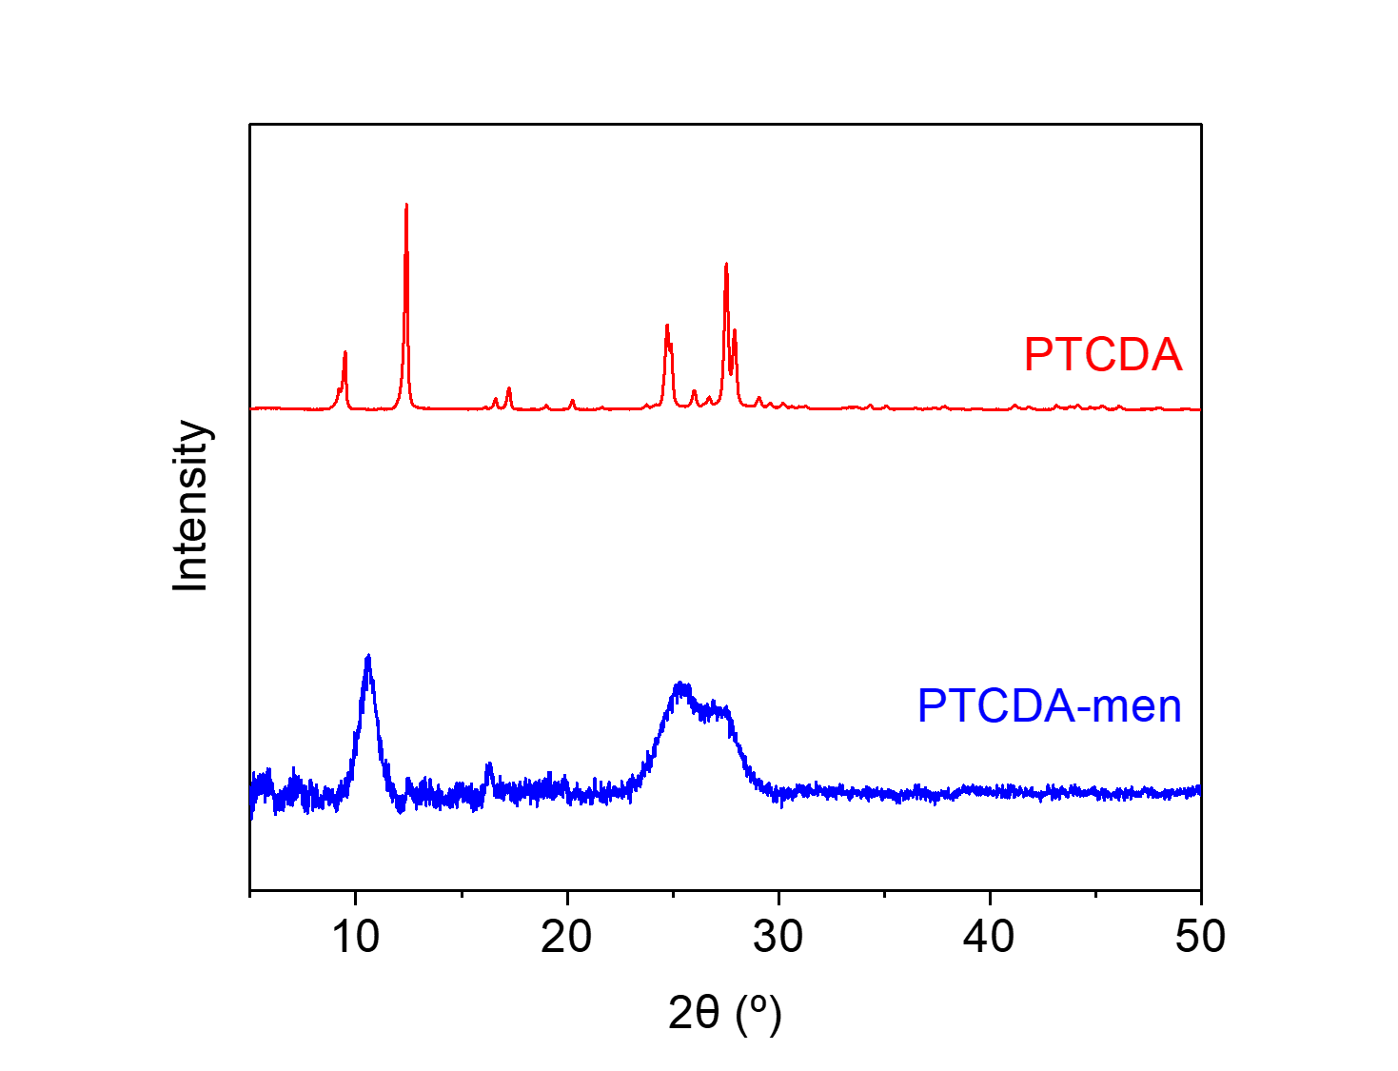
Figure S86. PXRD patterns (λ = 1.54 Å) of PTCDA and PTCDA-men. These patterns indicate that PTCDA-men is a microcrystalline polymer and is likely not contaminated with PTCDA.
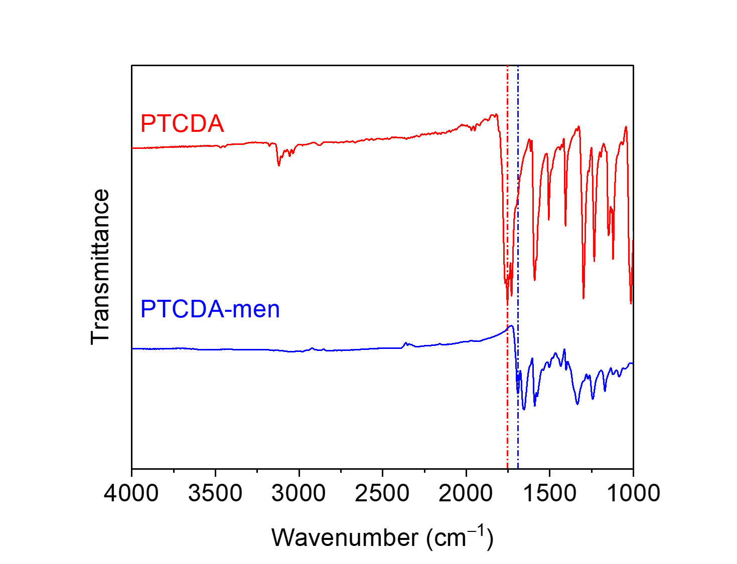
Figure S87. ATR-IR spectra for PTCDA and PTCDA-men. The shift in the carbonyl stretching frequency between the dianhydride (1753 cm⁻¹) and the diimide (1690 cm⁻¹) is indicated.
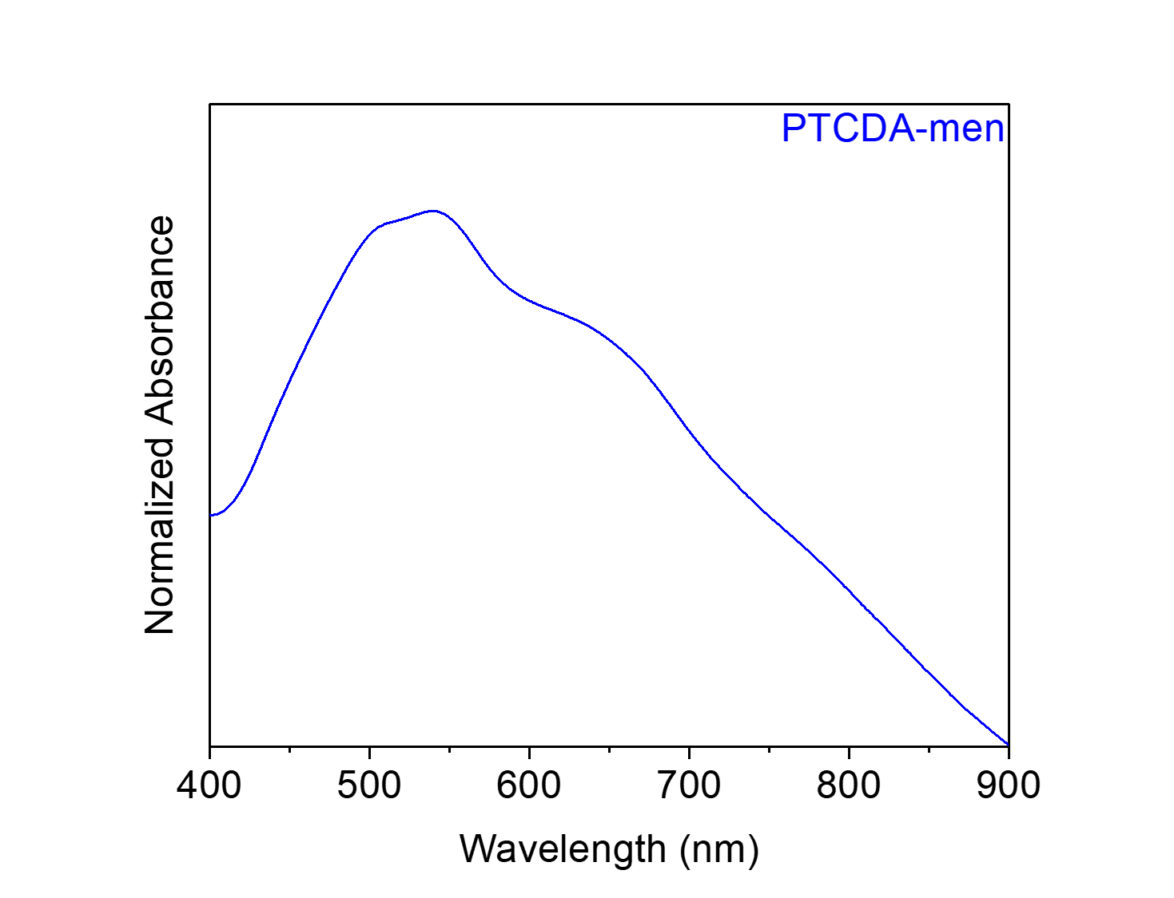
Figure S88. Solid-state UV-Vis absorption spectrum of PTCDA-men dispersed in BaSO₄.
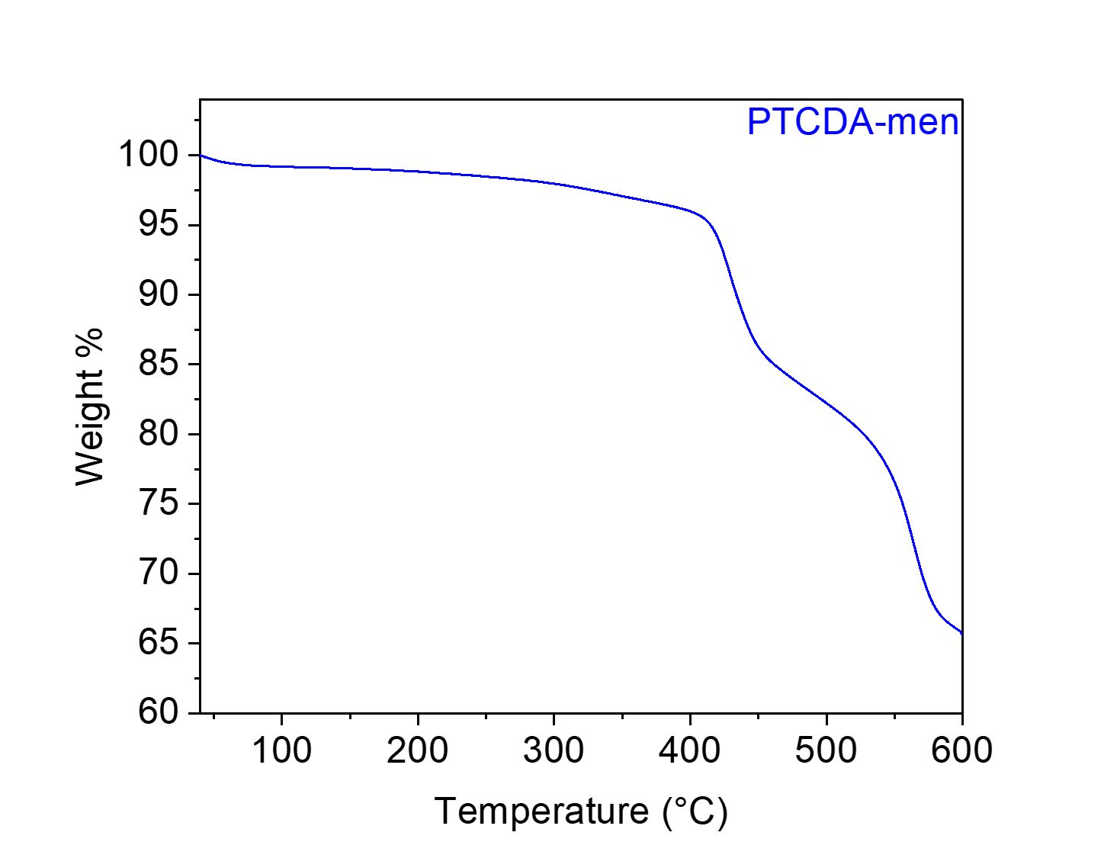
Figure S89. Thermogravimetric decomposition profile of PTCDA-men, indicating that it is stable below 400 °C. The gradual weight loss from this material upon heating is likely due to the loss of solvent/water.
Surface area measurement. Consistent with the literature,⁹ PTCDA-men was found to be non-porous.
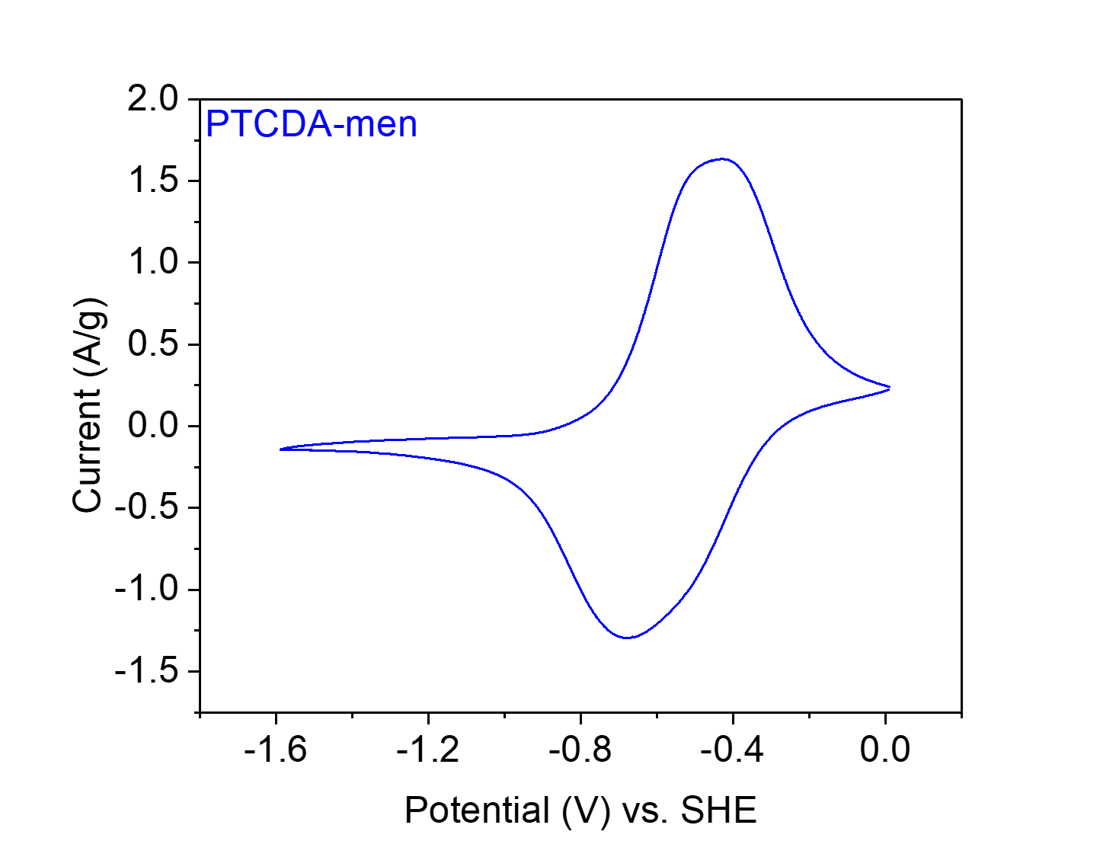
Figure S90. CV at 20 mV s⁻¹ of PTCDA-men in 0.1 M NaClO₄ in MeCN.

PTCDA-dmpn from 3,4,9,10-perylene tetracarboxylic dianhydride (PTCDA) and 2,2-dimethyl-1,3-diaminopropane (dmpn).
Figure S91. Scheme for the synthesis of PTCDA-dmpn from PTCDA and dmpn.
Synthesis of PTCDA-dmpn. Following General Procedure A with slight modifications, PTCDA (196 mg, 0.50 mmol, 1.00 equiv.), dmpn (66.0 μL, 0.55 mmol, 1.10 equiv.) and imidazole (8.85 g) were added to a 75 mL screw-cap high-pressure reaction vessel and heated at 130 °C for 24 h. The resulting solid was washed and dried to yield PTCDA-dmpn (116 mg, 51% yield) as a dark red solid.

Element | Average Wt %¹ | Theoretical Wt %
C | 66.46 | 75.97
O | 21.42² | 13.96
H | 3.46 | 3.96
N | 8.66 | 6.11
Total: | 100.00 | 100.00
Table S9. Tabulated combustion analysis data for PTCDA-dmpn.
¹Average of two trials.
²The remaining mass not attributed to C, H, and N was assumed to come from O, as O was not directly analyzed during combustion analysis.
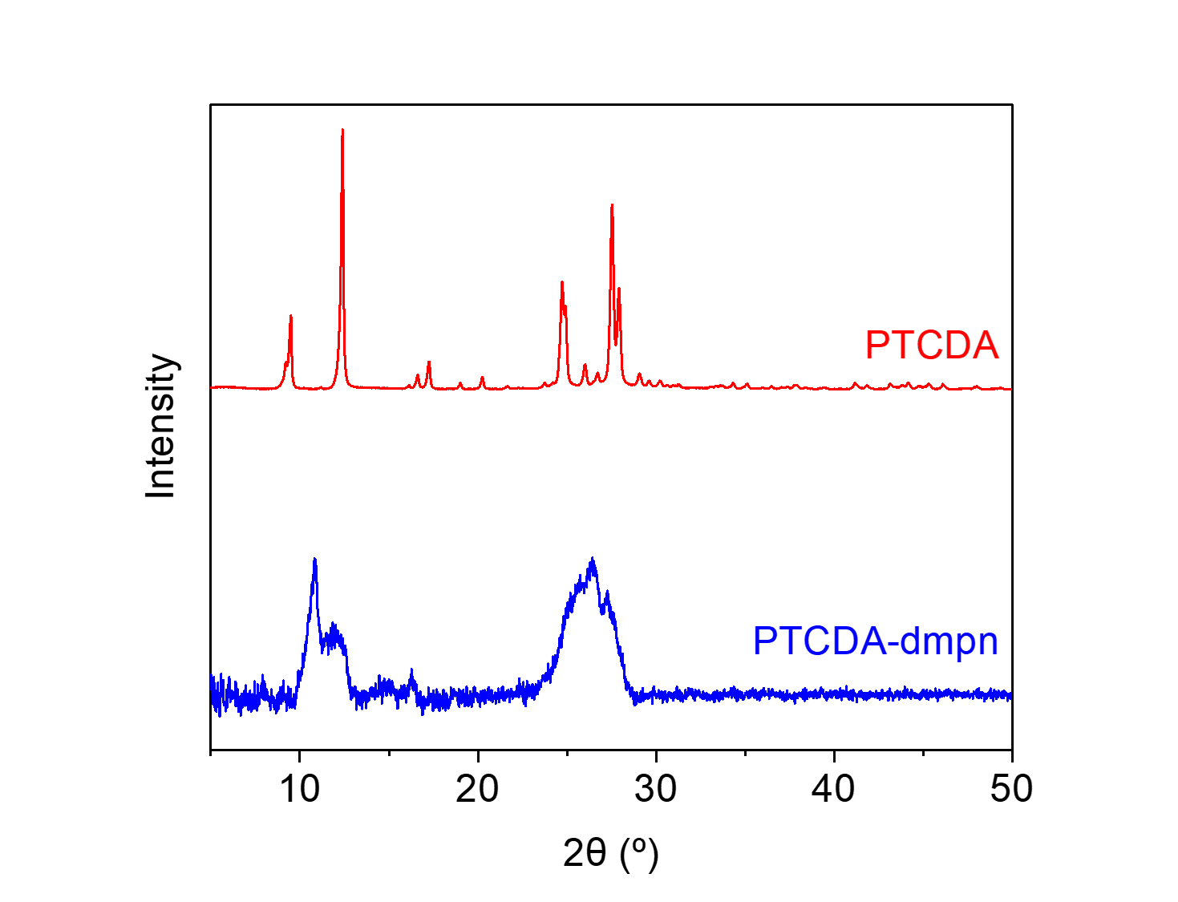
Figure S92. PXRD patterns (λ = 1.54 Å) of PTCDA and PTCDA-dmpn. These patterns indicate that PTCDA-dmpn is a microcrystalline polymer and is likely not contaminated with PTCDA.

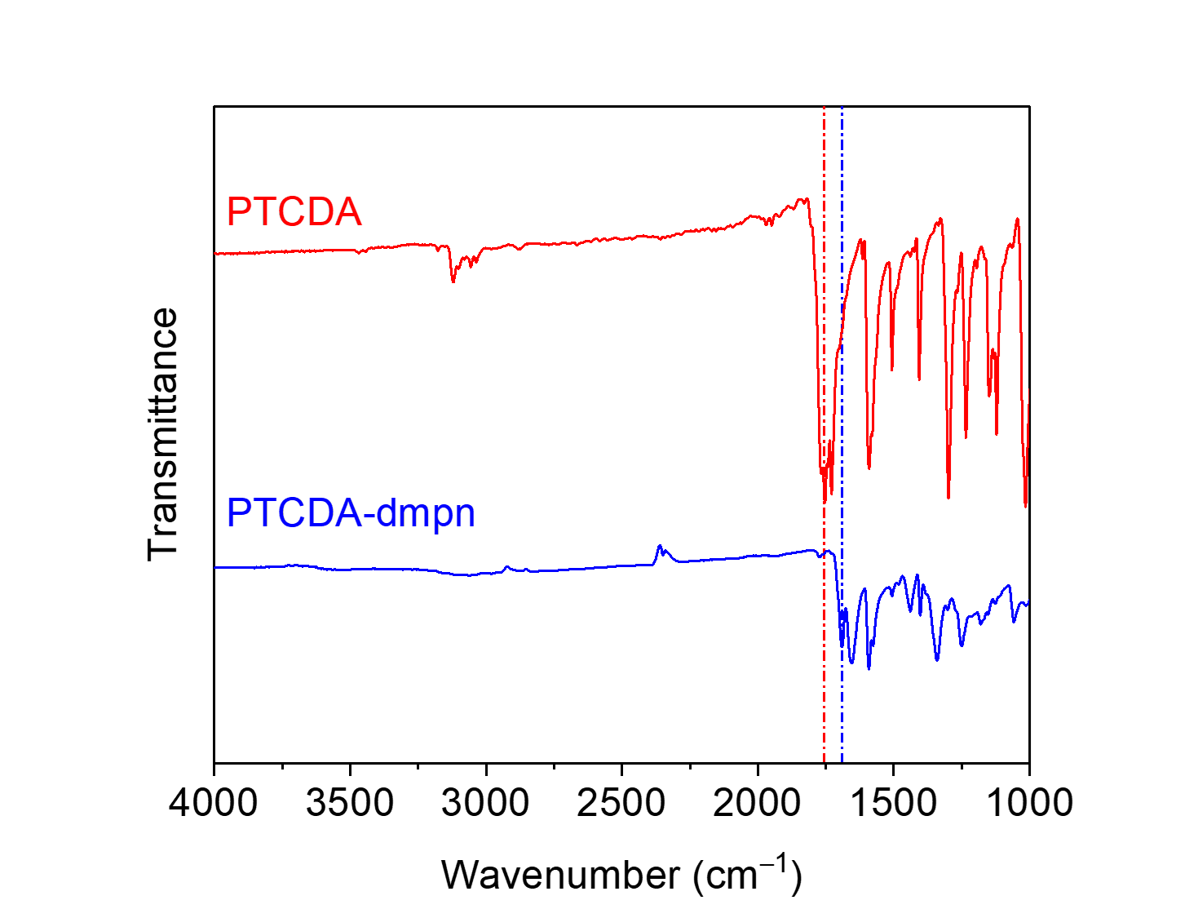
Figure S93. ATR-IR spectra for PTCDA and PTCDA-dmpn. The shift in the carbonyl stretching frequency between the dianhydride (1753 cm⁻¹) and the diimide (1691 cm⁻¹) is indicated.
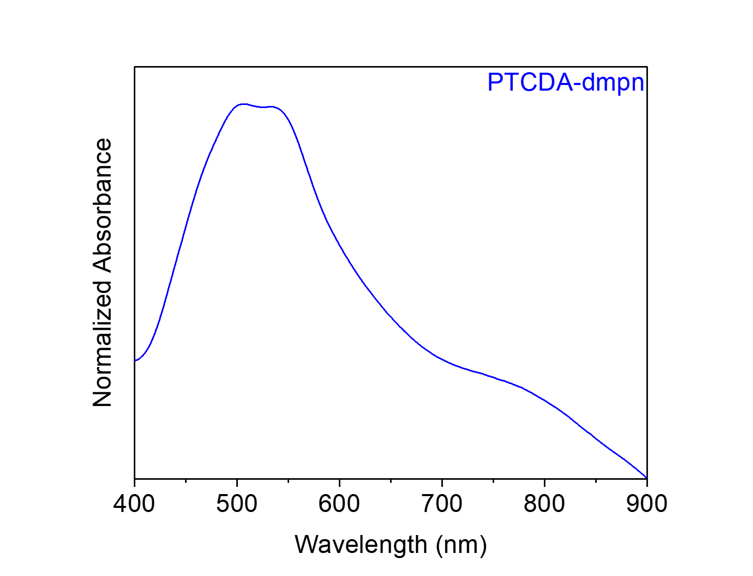
Figure S94. Solid-state UV-Vis absorption spectrum of PTCDA-dmpn dispersed in BaSO₄.

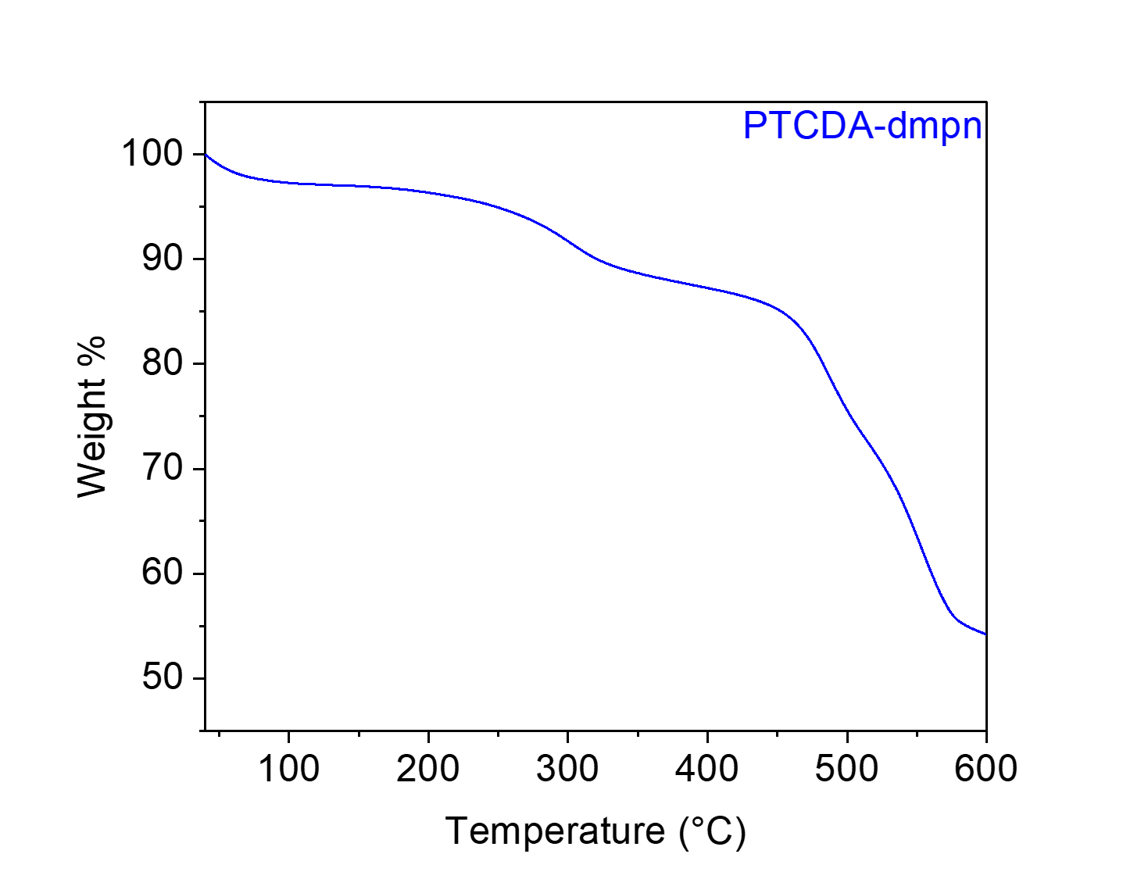
Figure S95. Thermogravimetric decomposition profile of PTCDA-dmpn, indicating that it is stable below 250 °C. The gradual weight loss from this material upon heating is likely due to the loss of solvent/water.

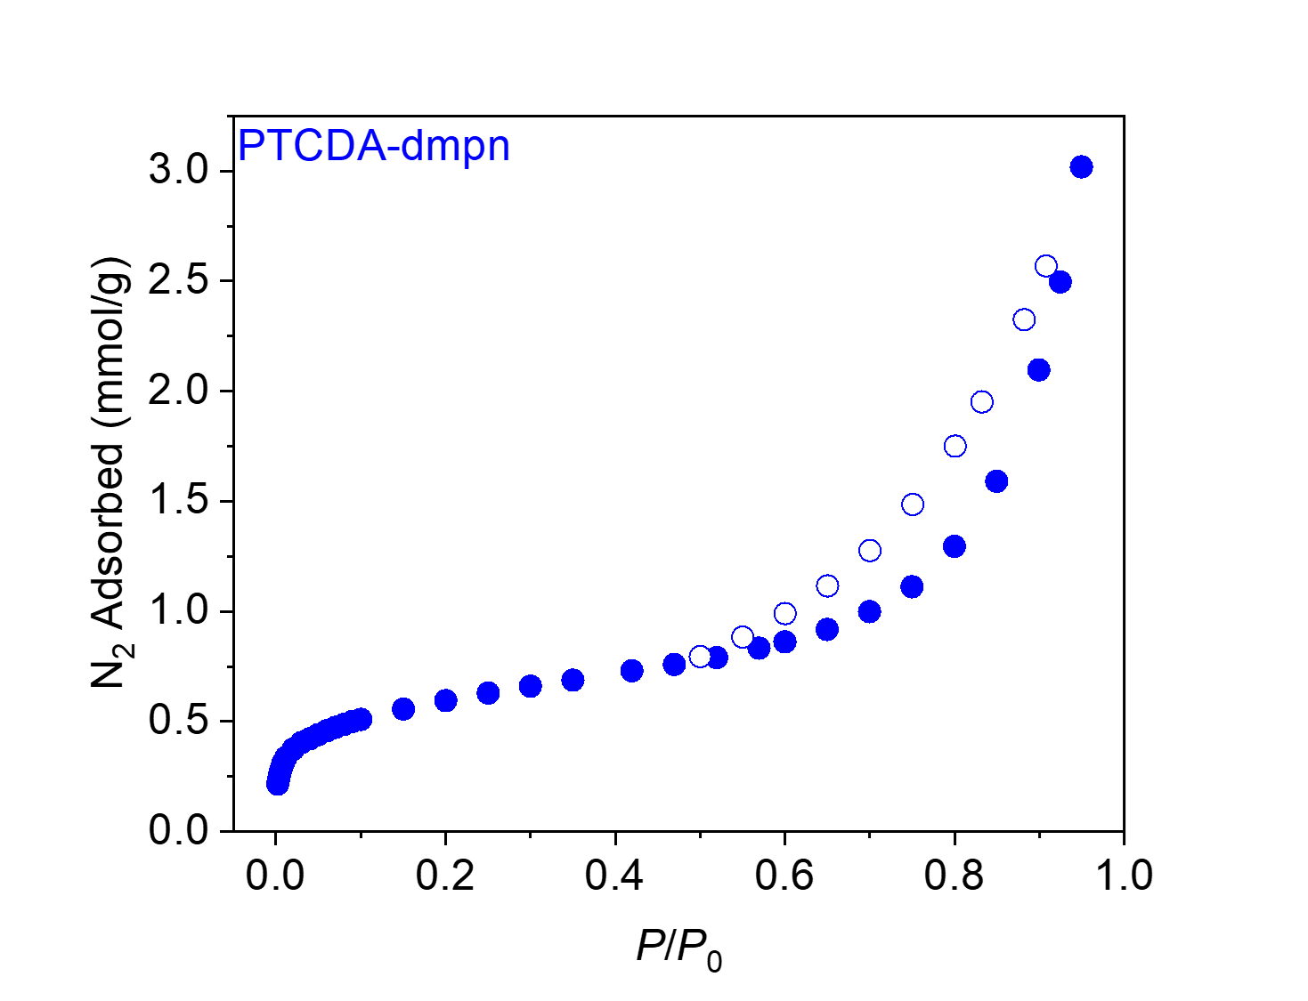
Figure S96. 77 K N₂ adsorption (filled circles) and desorption (open circles) isotherms for PTCDA-dmpn. The BET and Langmuir surface areas were determined to be 47 m²/g and 156 ± 20 m²/g, respectively. This is consistent with the literature.⁹
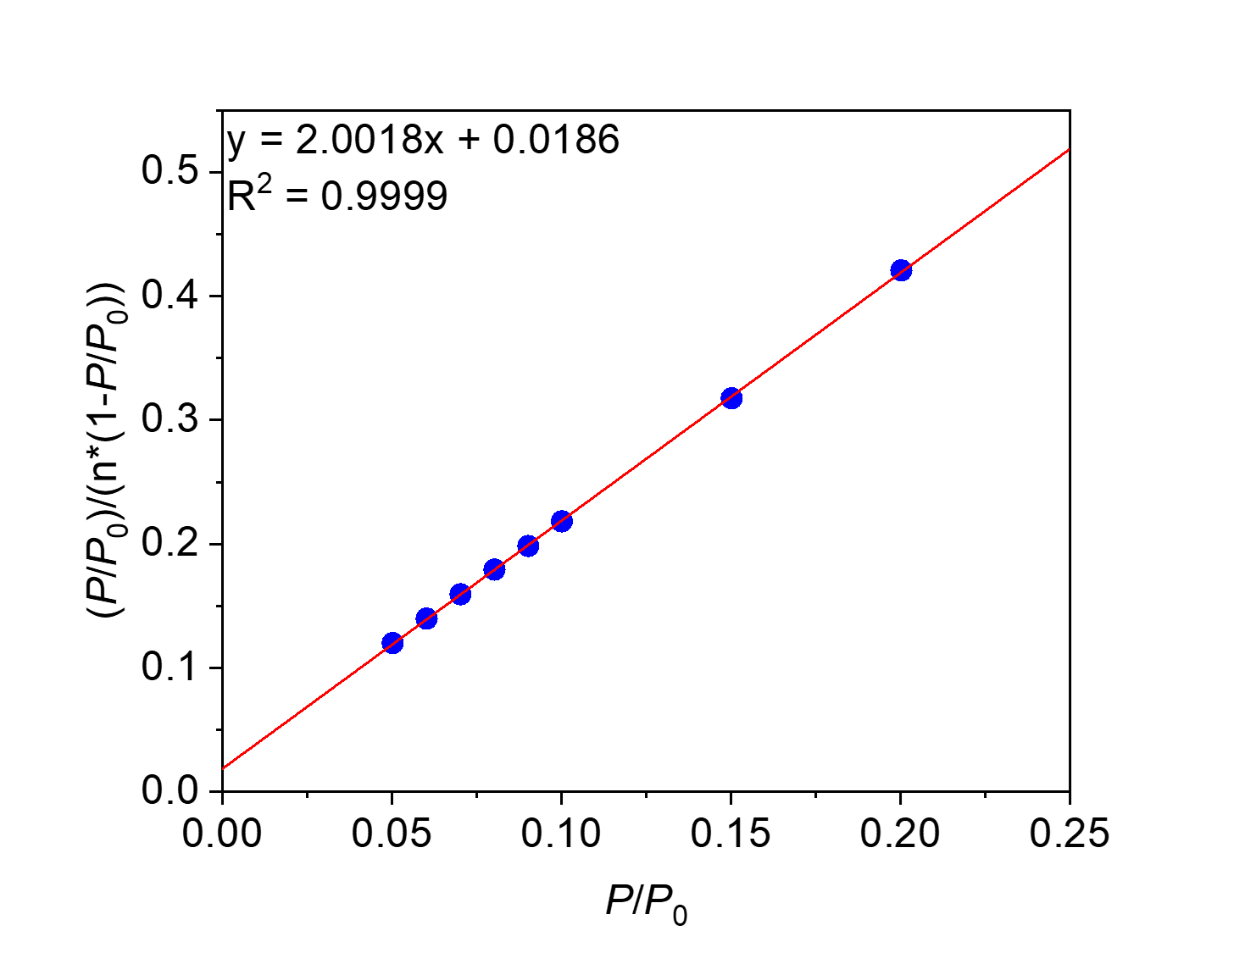
Figure S97. Linearized BET plot of PTCDA-dmpn.

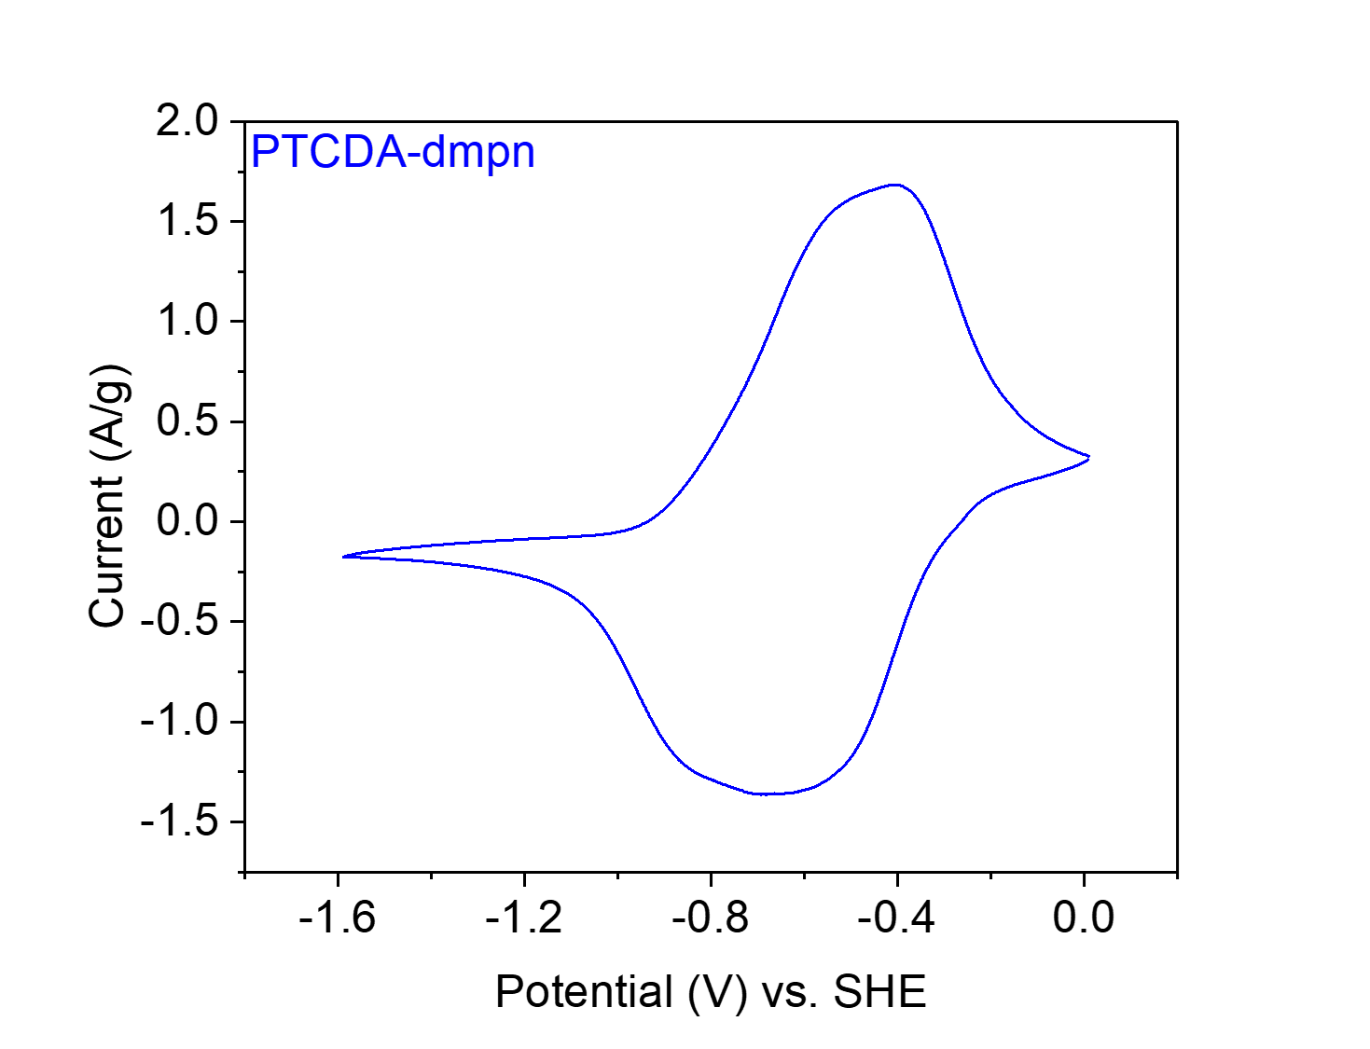
Figure S98. CV at 20 mV s⁻¹ of PTCDA-dmpn in 0.1 M NaClO₄ in MeCN.

PTCDA-TPAPA from 3,4,9,10-perylene tetracarboxylic dianhydride (PTCDA) and tris(4-aminophenyl)amine (TPAPA).

Figure S99. Scheme for the synthesis of PTCDA-TPAPA from PTCDA and TPAPA.
Synthesis of PTCDA-TPAPA. Following General Procedure B, PTCDA (235.4 mg, 0.60 mmol, 1.00 equiv.), TPAPA (116.1 mg, 0.40 mmol, 0.67 equiv.) and imidazole (6.00 g) were added to a 75 mL screw-cap high-pressure reaction vessel and heated at 130 °C for 24 h. The resulting solid was washed and dried to yield PTCDA-TPAPA (292.7 mg, 89% yield) as a red solid.

Element | Average Wt %¹ | Theoretical Wt %
C | 69.51 | 78.64
O | 19.92² | 11.64
H | 3.06 | 2.93
N | 7.51 | 6.79
Total: | 100.00 | 100.00
Table S10. Tabulated combustion analysis data for PTCDA-TPAPA.
¹Average of two trials.
²The remaining mass not attributed to C, H, and N was assumed to come from O, as O was not directly analyzed during combustion analysis.
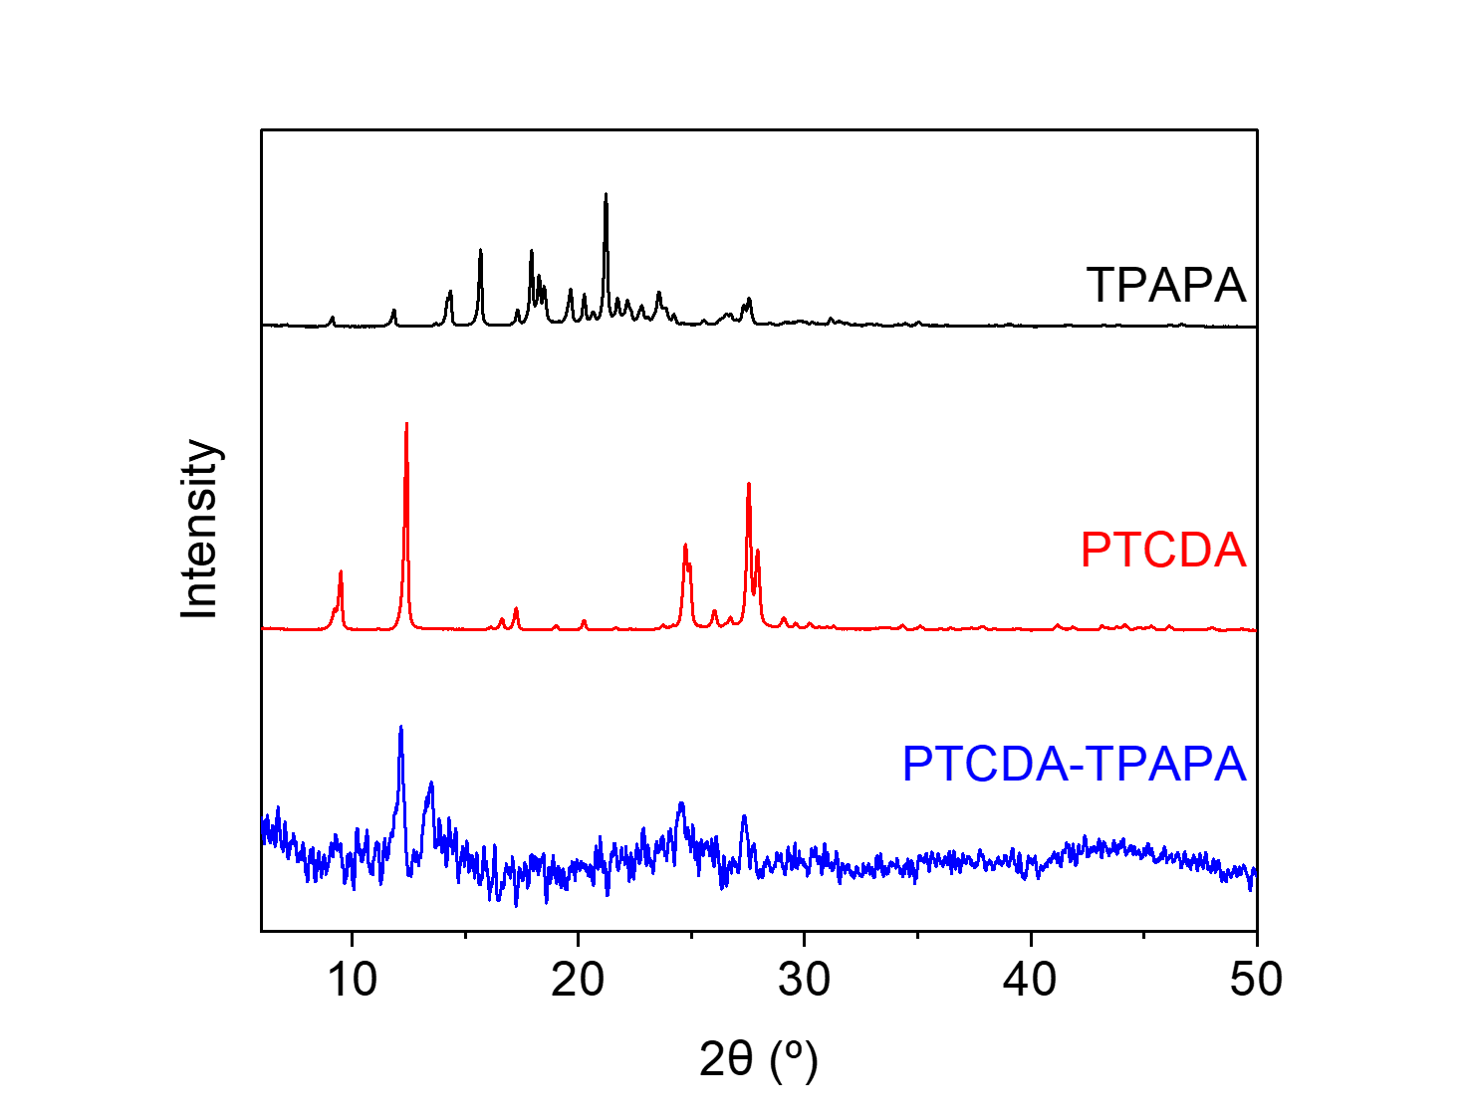
Figure S100. PXRD patterns (λ = 1.54 Å) of PTCDA, TPAPA, and PTCDA-TPAPA. These patterns indicate that PTCDA-TPAPA is a largely amorphous polymer and is likely not contaminated with PTCDA and TPAPA.

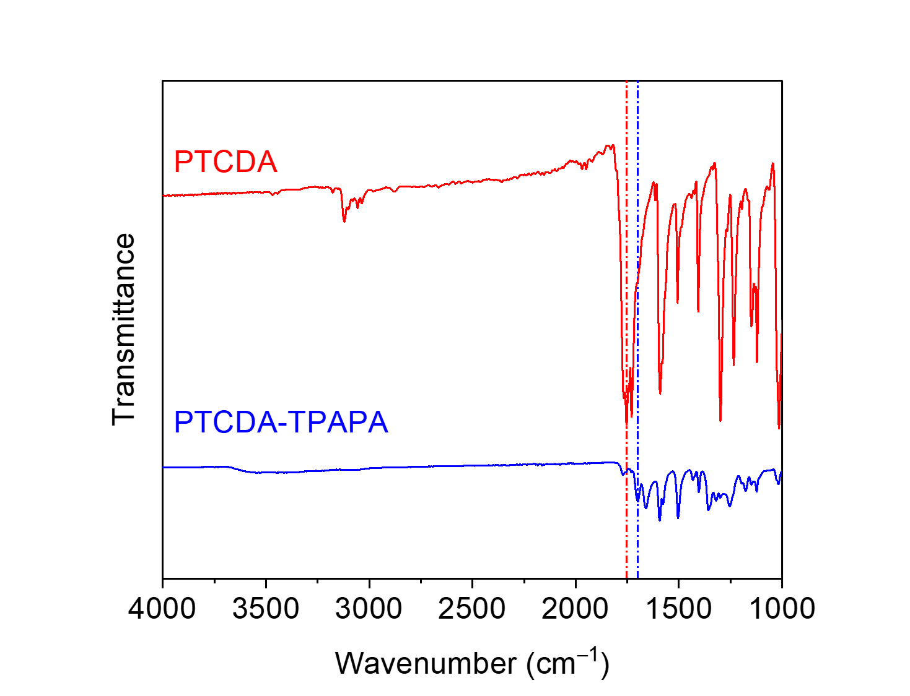
Figure S101. ATR-IR spectra for PTCDA and PTCDA-TPAPA. The shift in the carbonyl stretching frequency between the dianhydride (1753 cm⁻¹) and the diimide (1699 cm⁻¹) is indicated.
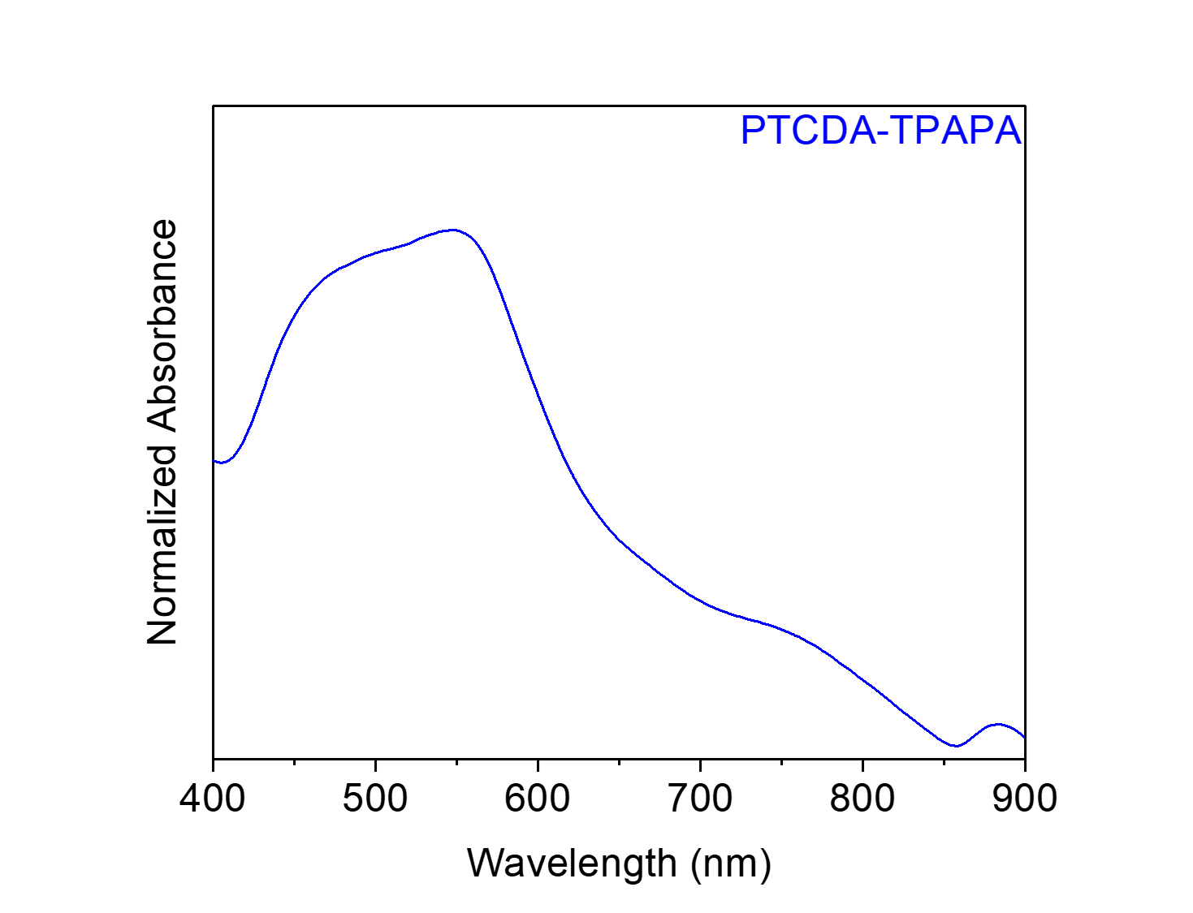
Figure S102. Solid-state UV-Vis absorption spectrum of PTCDA-TPAPA dispersed in BaSO₄.

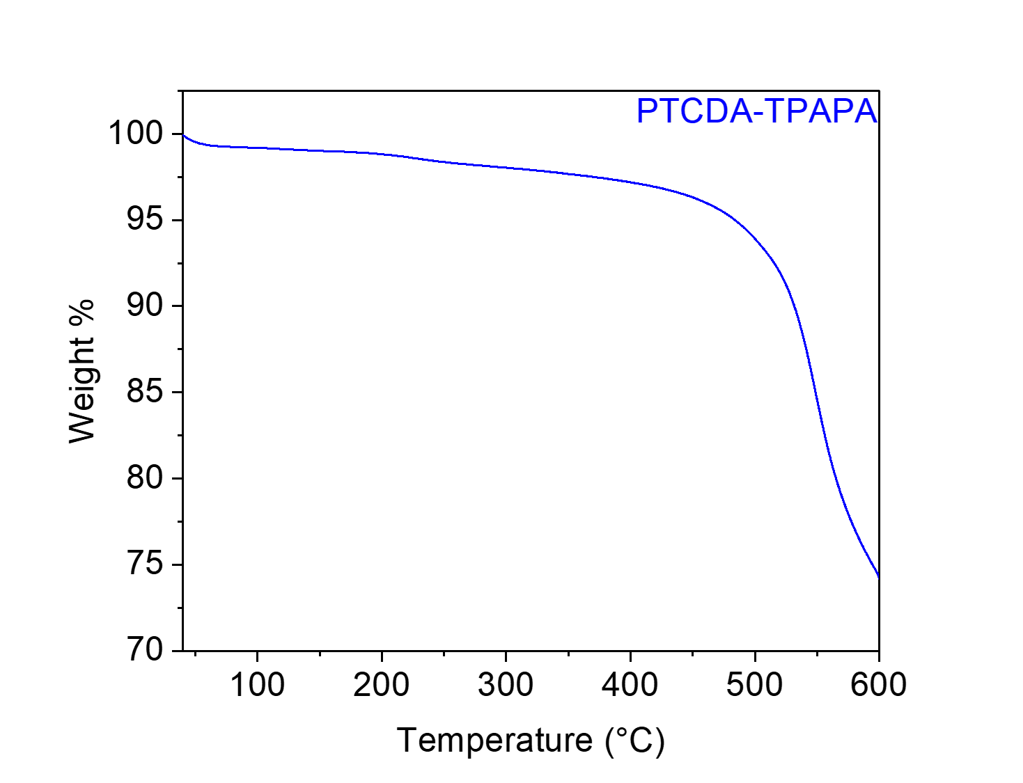
Figure S103. Thermogravimetric decomposition profile of PTCDA-TPAPA, indicating that it is stable below 500 °C. The gradual weight loss from this material upon heating is likely due to the loss of solvent/water.
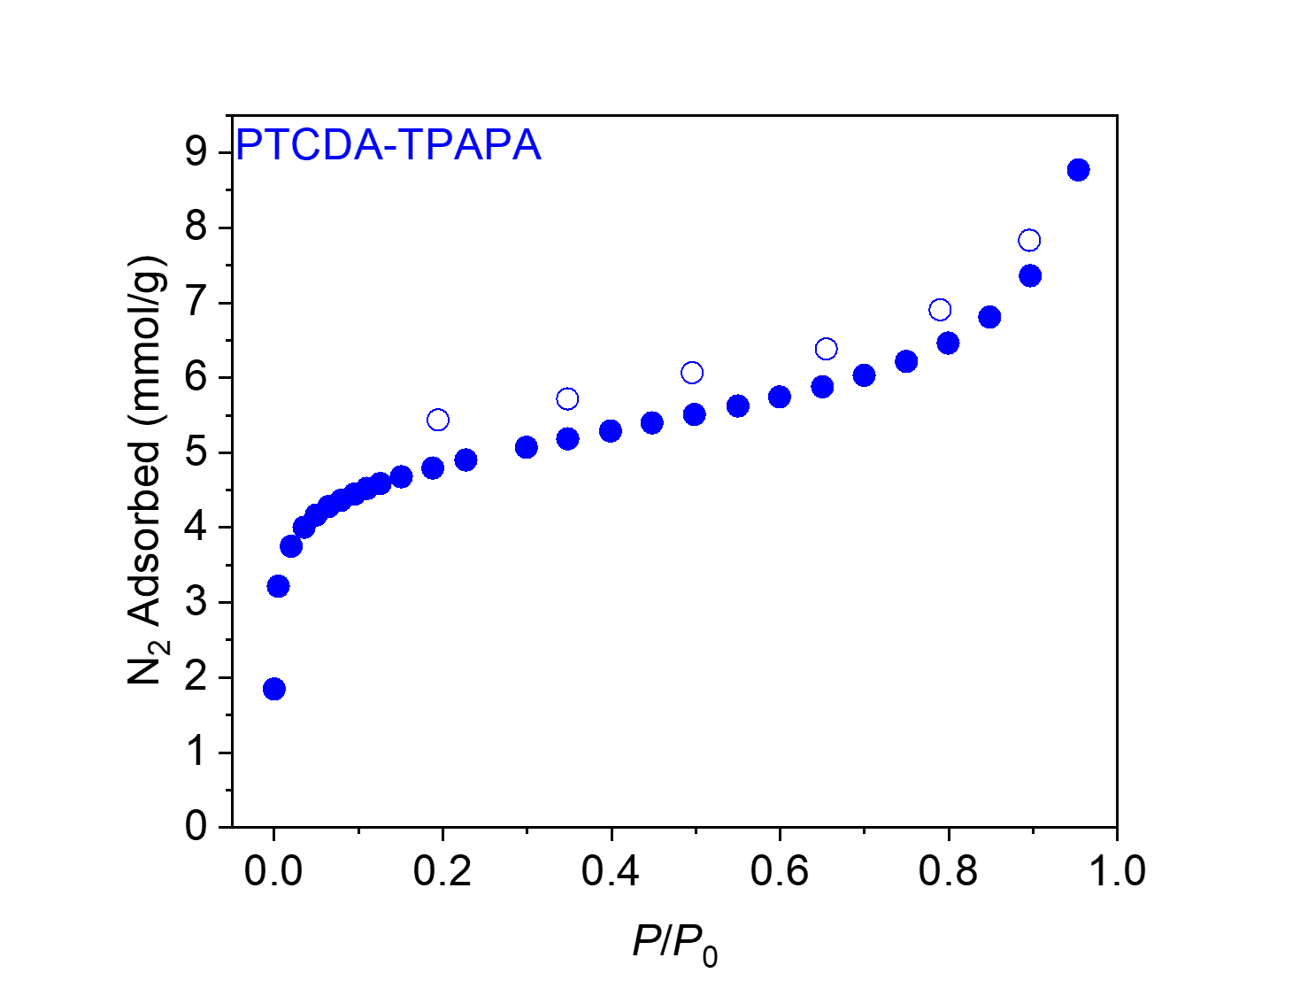
Figure S104. 77 K N₂ adsorption (filled circles) and desorption (open circles) isotherms for PTCDA-TPAPA. The BET and Langmuir surface areas were determined to be 396 ± 2 m²/g and 698 ± 32 m²/g, respectively.
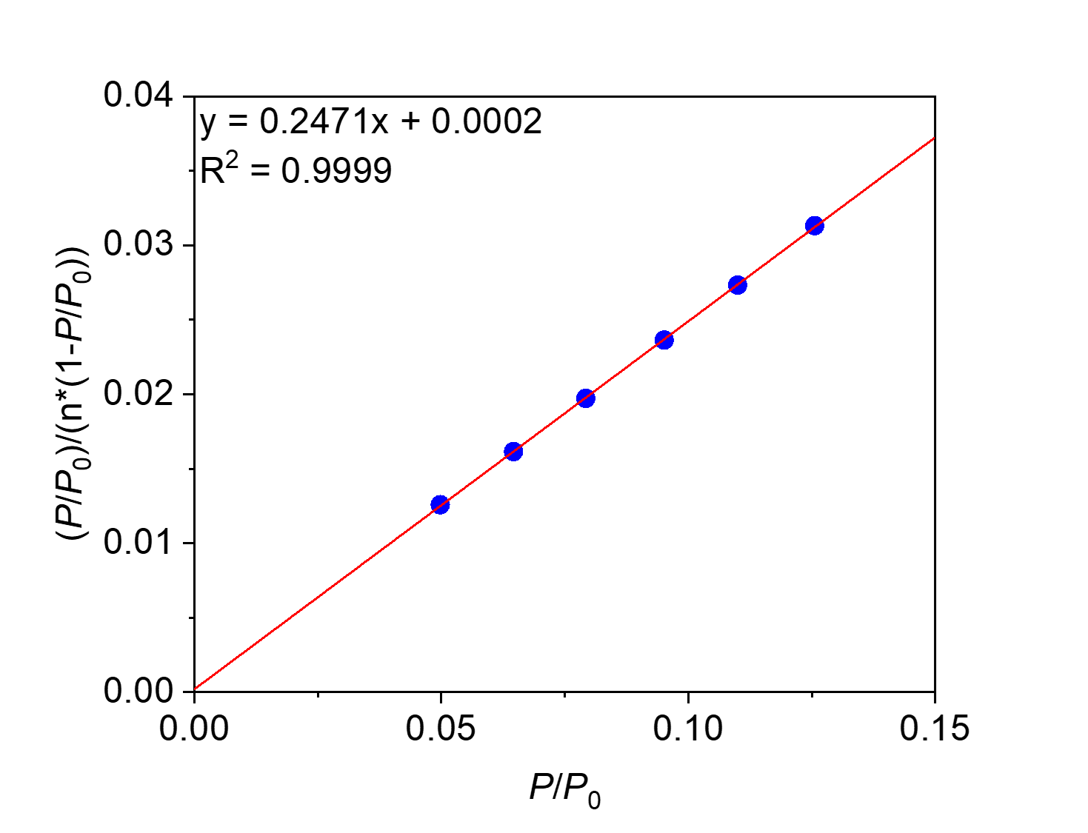
Figure S105. Linearized BET plot of PTCDA-TPAPA.
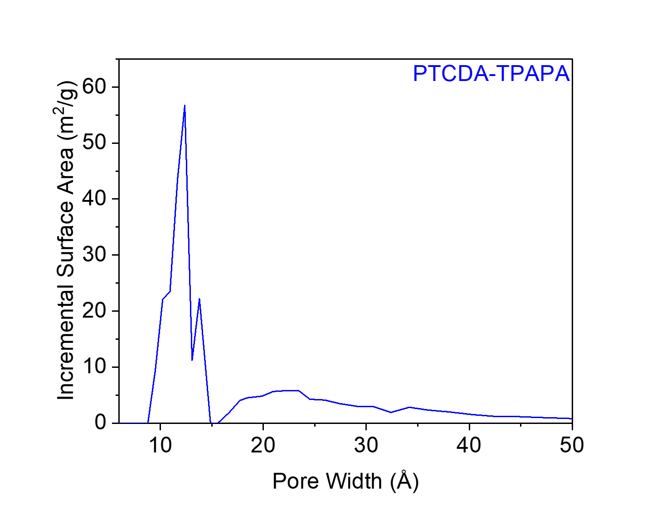
Figure S106. The N₂-Tarazona NLDFT-calculated pore size distribution of PTCDA-TPAPA, assuming a cylindrical pore geometry.
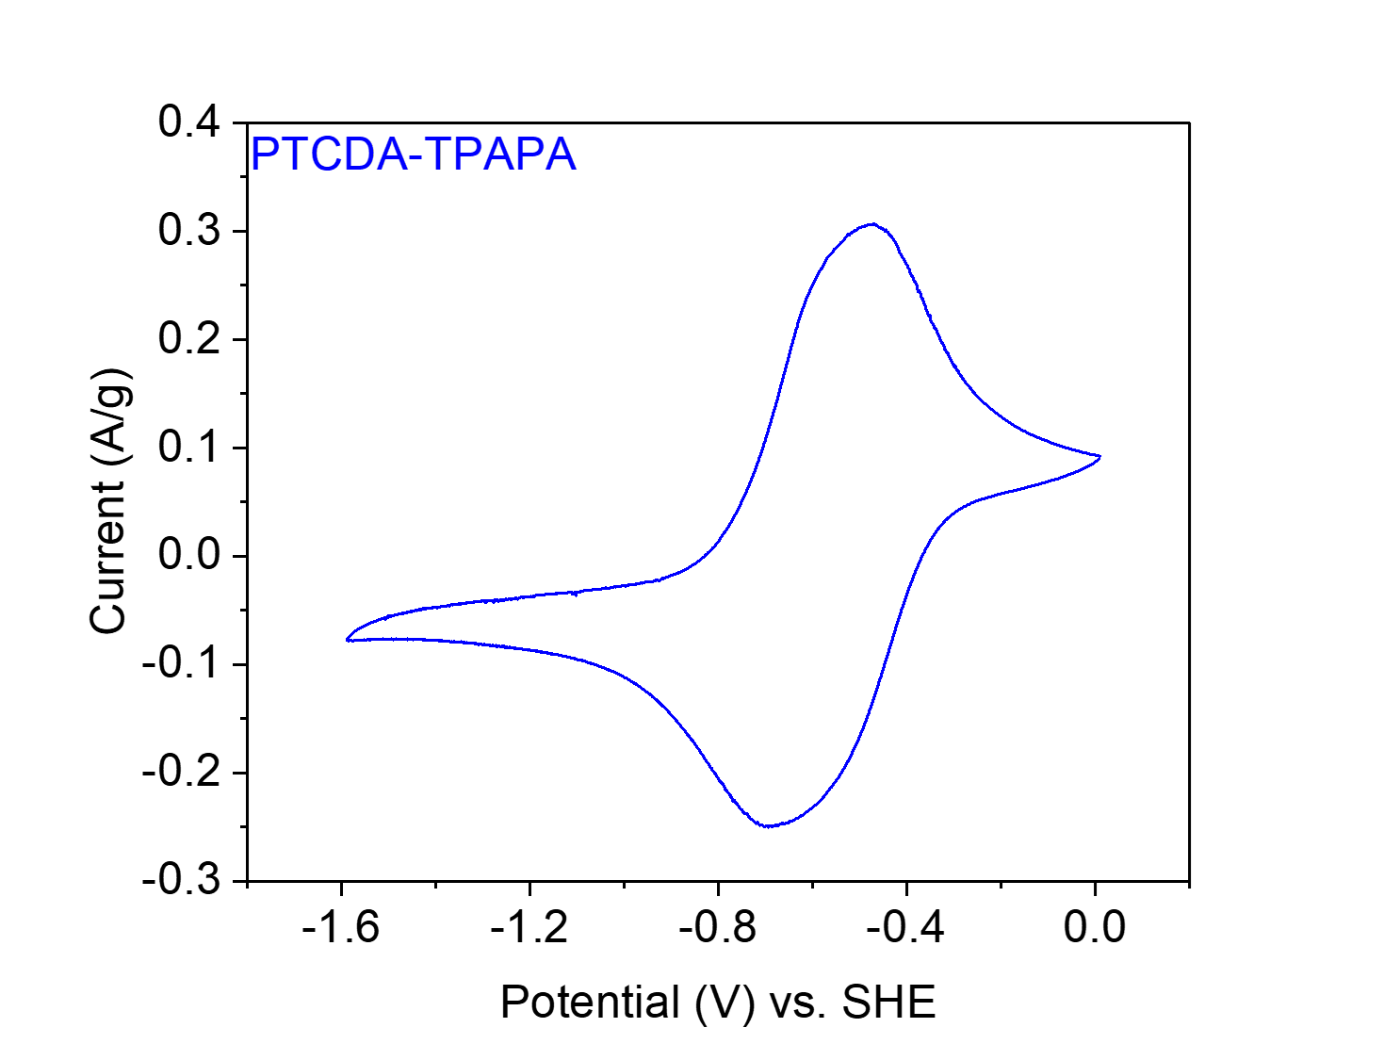
Figure S107. CV at 20 mV s⁻¹ of PTCDA-TPAPA in 0.1 M NaClO₄ in MeCN.

PTCDA-TPAPM from 3,4,9,10-perylene tetracarboxylic dianhydride (PTCDA) and tetrakis(4-aminophenyl)methane (TPAPM).

Figure S108. Scheme for the synthesis of PTCDA-TPAPM from PTCDA and TPAPM.
Synthesis of PTCDA-TPAPM. Following General Procedure B, PTCDA (235.4 mg, 0.60 mmol, 1.00 equiv.), TPAPM (114.1 mg, 0.30 mmol, 0.50 equiv.) and imidazole (6.00 g) were added to a 75 mL screw-cap high-pressure reaction vessel and heated at 130 °C for 24 h. The resulting solid was washed and dried to yield PTCDA-TPAPM (185.4 mg, 57% yield) as a purple-red solid.

Element | Average Wt %¹ | Theoretical Wt %
C | 74.65 | 80.21
O | 15.29² | 11.71
H | 3.38 | 2.95
N | 6.68 | 5.13
Total: | 100.00 | 100.00
Table S11. Tabulated combustion analysis data for PTCDA-TPAPM.
¹Average of two trials.
²The remaining mass not attributed to C, H, and N was assumed to come from O, as O was not directly analyzed during combustion analysis.
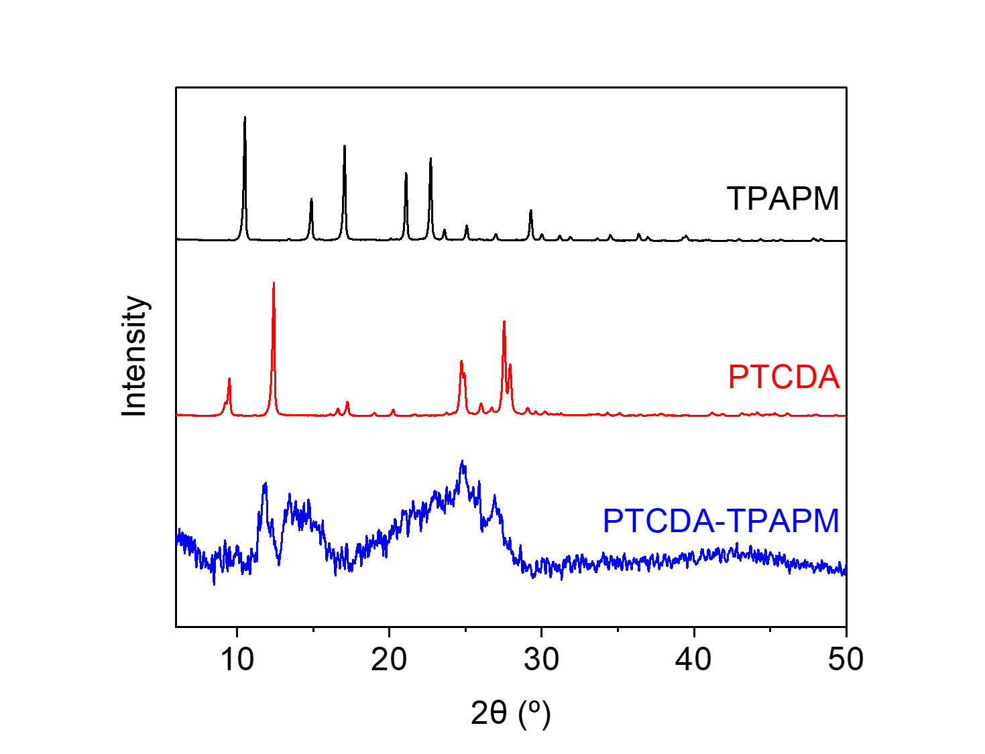
Figure S109. PXRD patterns (λ = 1.54 Å) of PTCDA, TPAPM, and PTCDA-TPAPM. These patterns indicate that PTCDA-TPAPM is a largely amorphous polymer and is likely not contaminated with PTCDA and TPAPM.

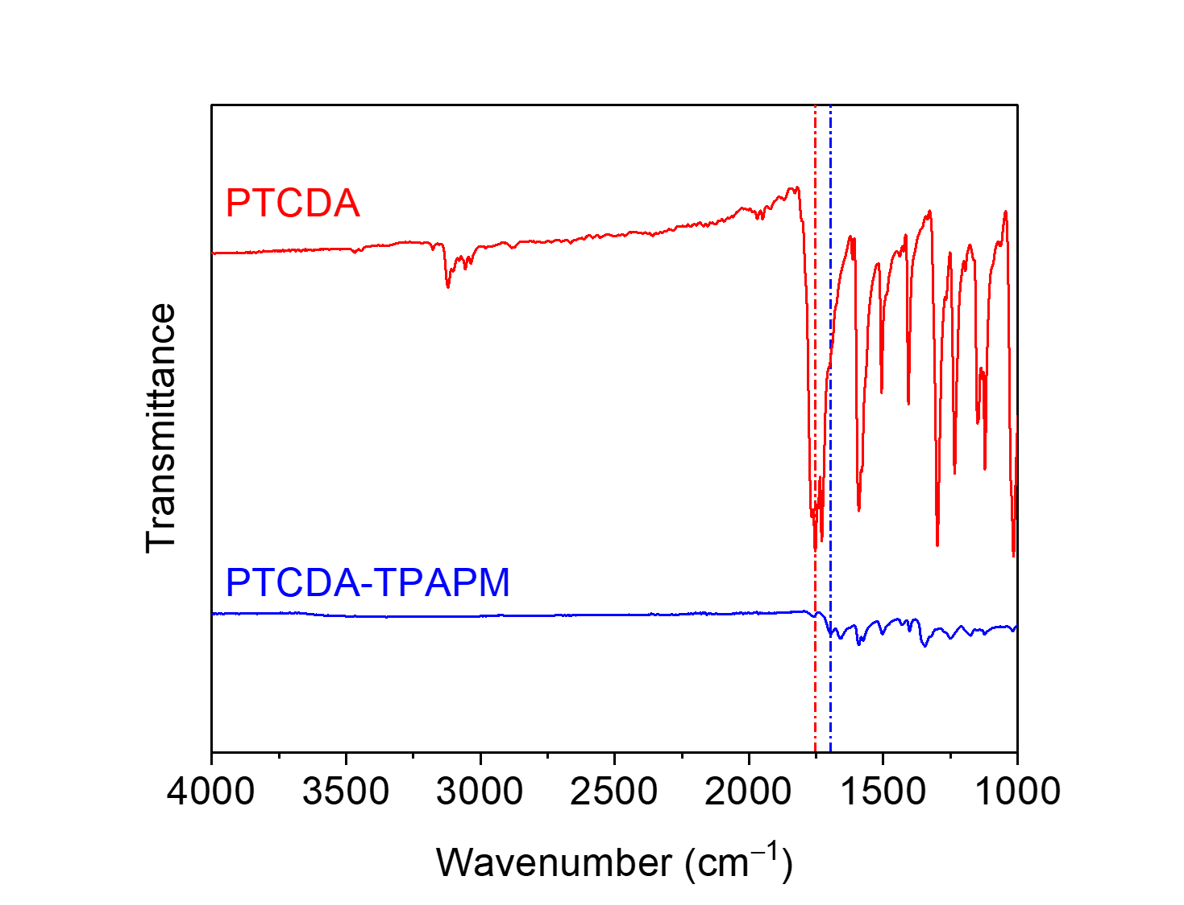
Figure S110. ATR-IR spectra for PTCDA and PTCDA-TPAPM. The shift in the carbonyl stretching frequency between the dianhydride (1753 cm⁻¹) and the diimide (1696 cm⁻¹) is indicated.
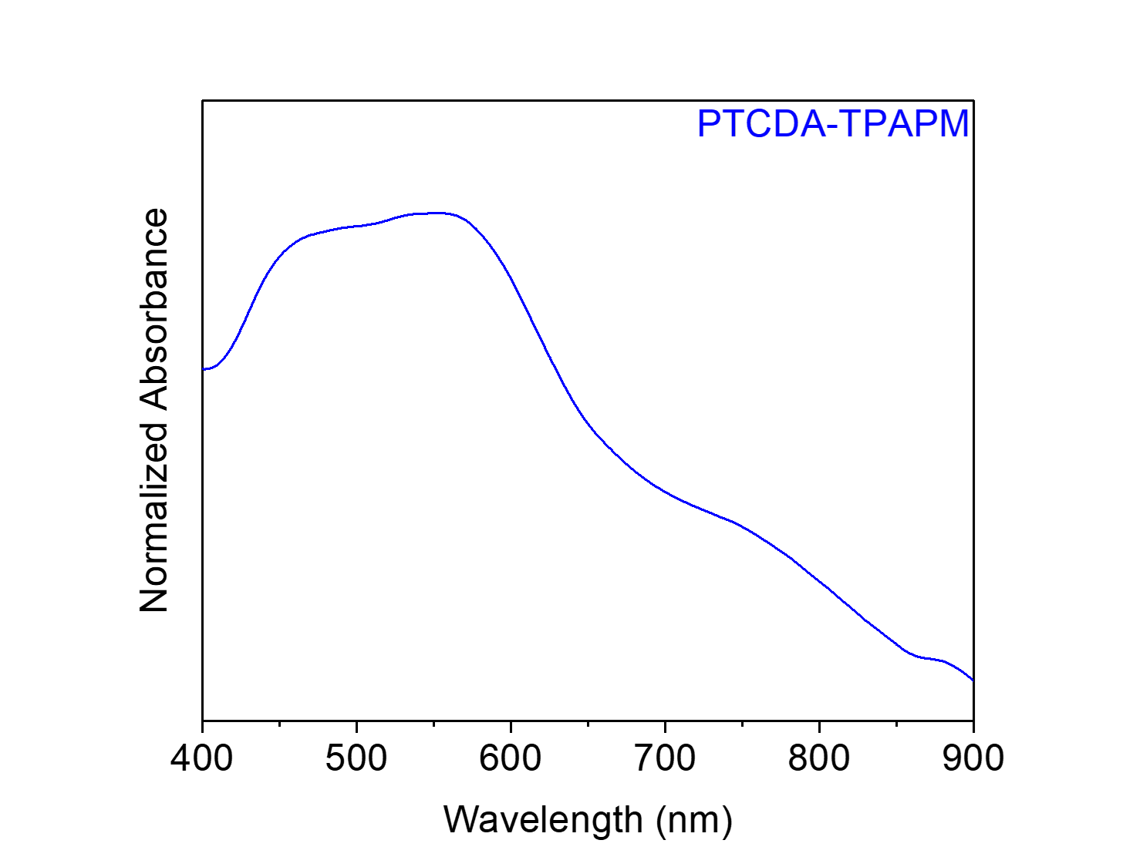
Figure S111. Solid-state UV-Vis absorption spectrum of PTCDA-TPAPM dispersed in BaSO₄.

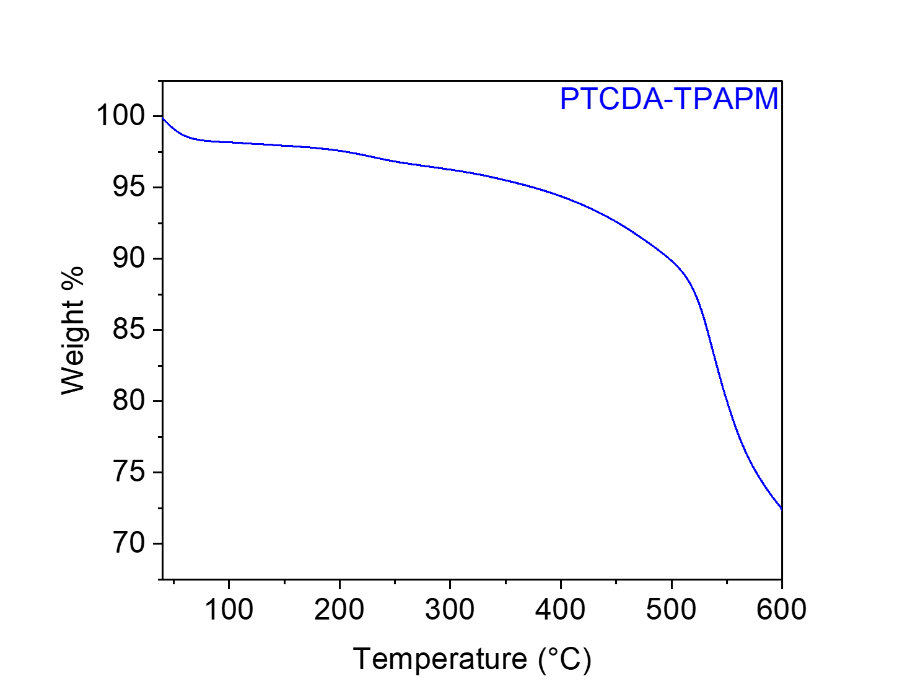
Figure S112. Thermogravimetric decomposition profile of PTCDA-TPAPM, indicating that it is stable below 400 °C. The gradual weight loss from this material upon heating is likely due to the loss of solvent/water.
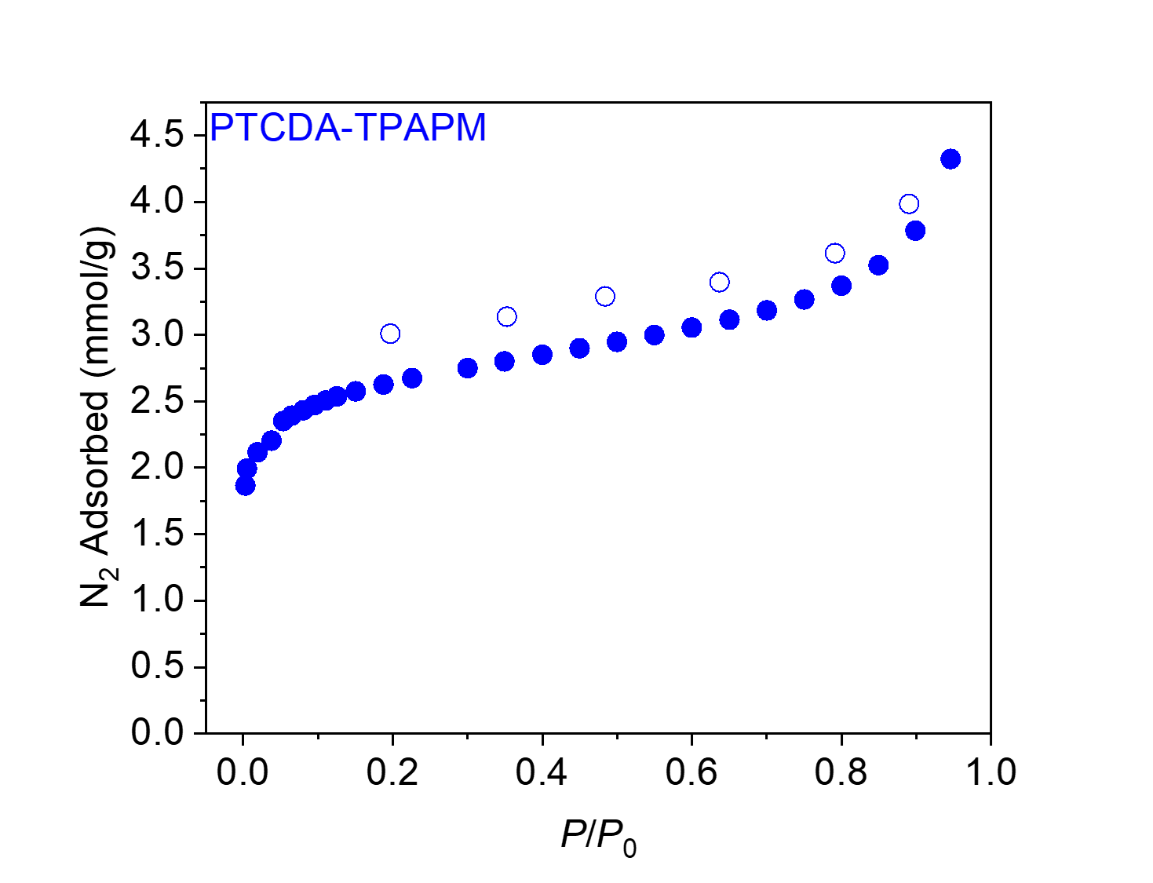
Figure S113. 77 K N₂ adsorption (filled circles) and desorption (open circles) isotherms for PTCDA-TPAPM. The BET and Langmuir surface areas were determined to be 220 ± 2 m²/g and 361 ± 14 m²/g, respectively.
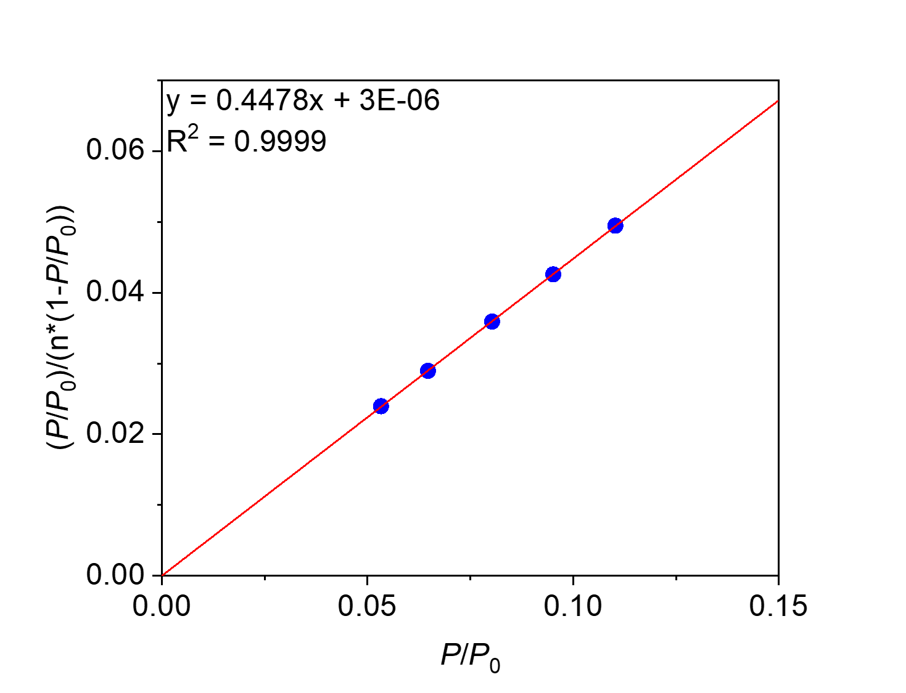
Figure S114. Linearized BET plot of PTCDA-TPAPM.
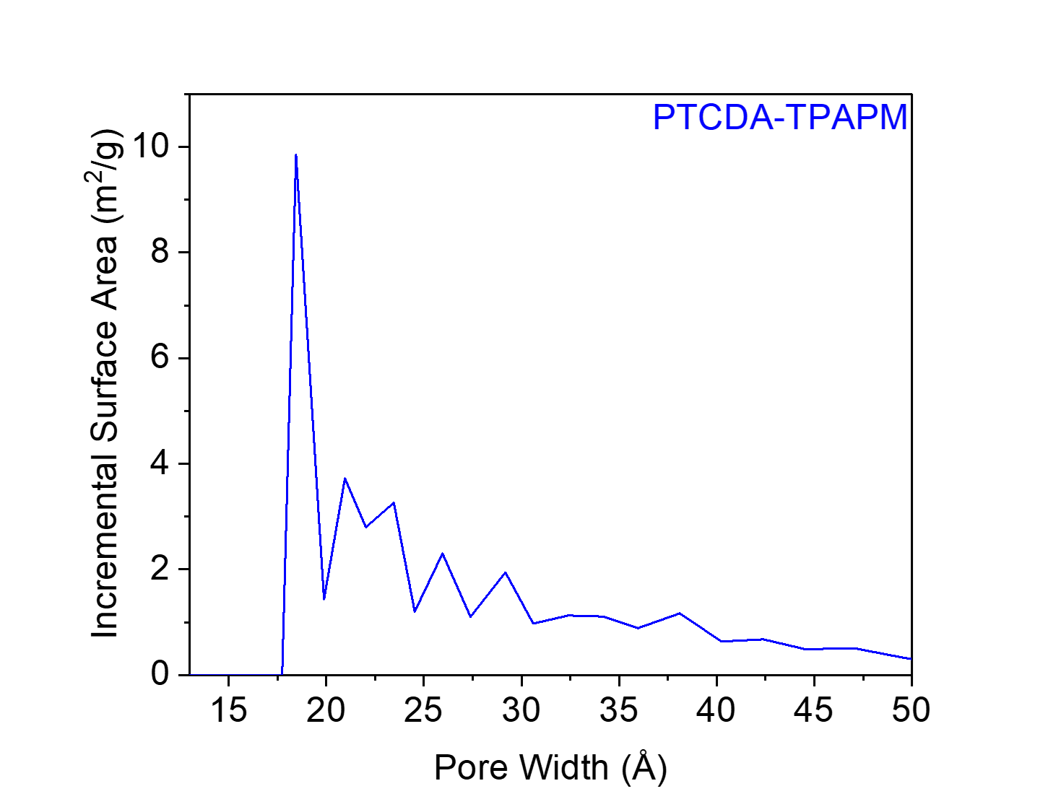
Figure S115. The N₂-Tarazona NLDFT-calculated pore size distribution of PTCDA-TPAPM, assuming a cylindrical pore geometry.
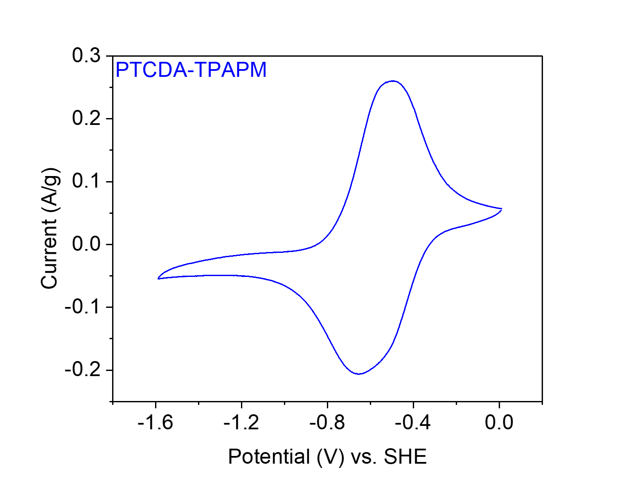
Figure S116. CV at 20 mV s⁻¹ of PTCDA-TPAPM in 0.1 M NaClO₄ in MeCN.

PTCDA-TPAPT from 3,4,9,10-perylene tetracarboxylic dianhydride (PTCDA) and 2,4,6-tris(4-aminophenyl)-1,3,5-triazine (TPAPT).

Figure S117. Scheme for the synthesis of PTCDA-TPAPT from PTCDA and TPAPT.
Synthesis of PTCDA-TPAPT. Following General Procedure B, PTCDA (235.4 mg, 0.60 mmol, 1.00 equiv.), TPAPT (141.8 mg, 0.40 mmol, 0.67 equiv.) and imidazole (6.00 g) were added to a 75 mL screw-cap high-pressure reaction vessel and heated at 130 °C for 24 h. The resulting solid was washed and dried to yield PTCDA-TPAPT (286.1 mg, 80% yield) as a red solid.

Element | Average Wt %¹ | Theoretical Wt %
C | 71.84 | 77.02
O | 14.50² | 10.80
H | 3.13 | 2.72
N | 10.53 | 9.46
Total: | 100.00 | 100.00
Table S12. Tabulated combustion analysis data for PTCDA-TPAPT.
¹Average of two trials.
²The remaining mass not attributed to C, H, and N was assumed to come from O, as O was not directly analyzed during combustion analysis.
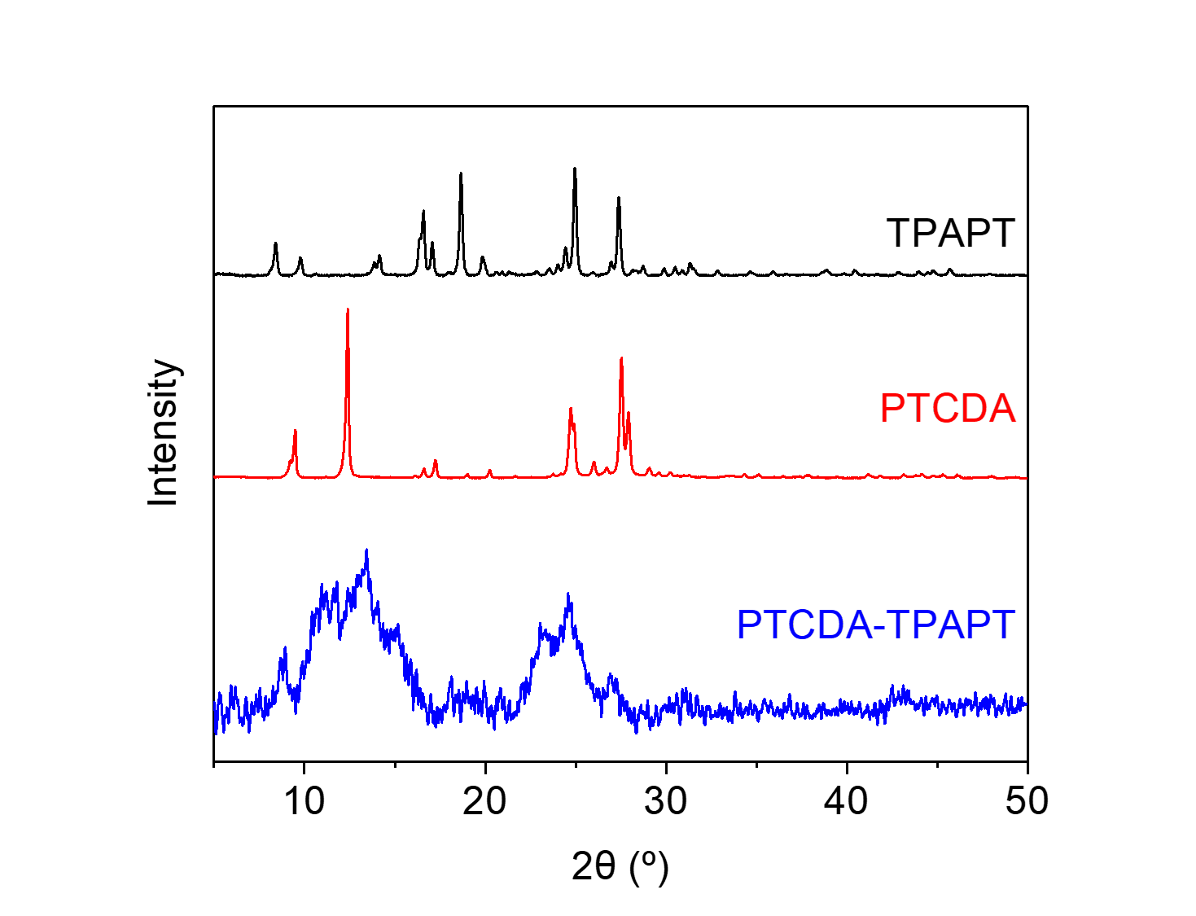
Figure S118. PXRD patterns (λ = 1.54 Å) of PTCDA, TPAPT, and PTCDA-TPAPT. These patterns indicate that PTCDA-TPAPT is a largely amorphous polymer and is likely not contaminated with PTCDA and TPAPT.

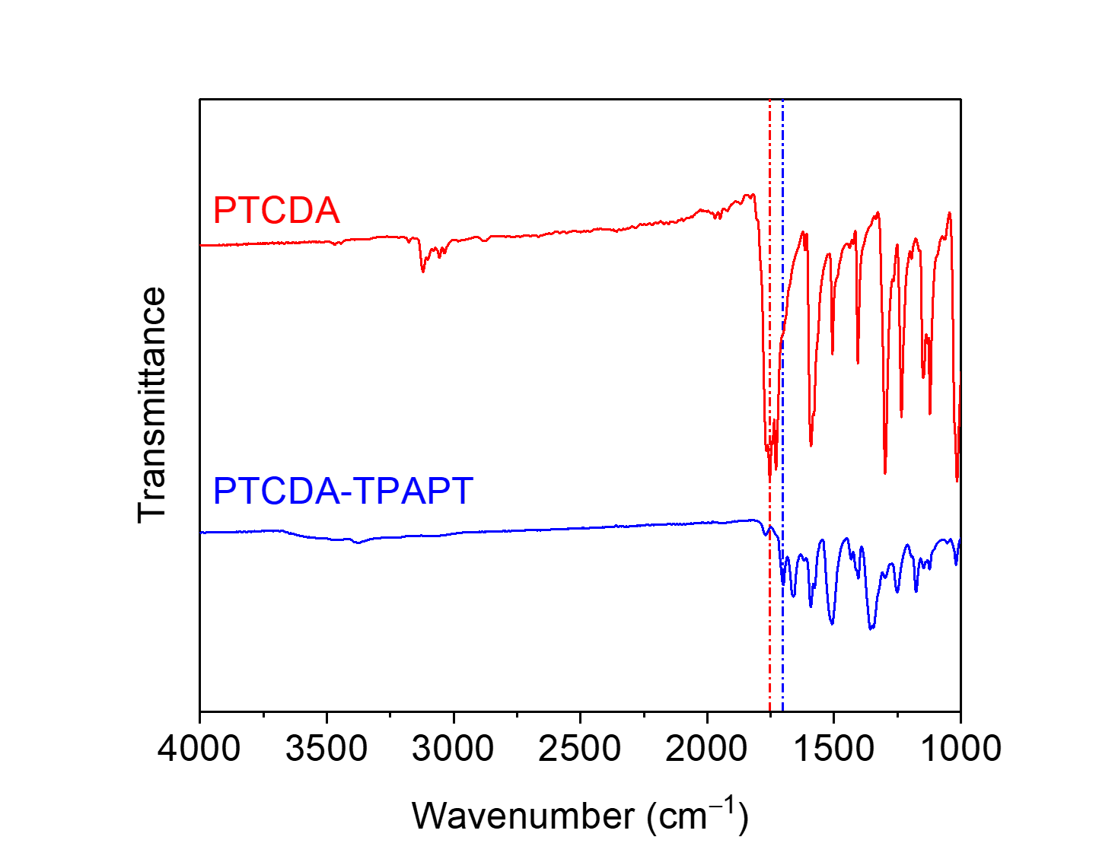
Figure S119. ATR-IR spectra for PTCDA and PTCDA-TPAPT. The shift in the carbonyl stretching frequency between the dianhydride (1753 cm⁻¹) and the diimide (1702 cm⁻¹) is indicated.
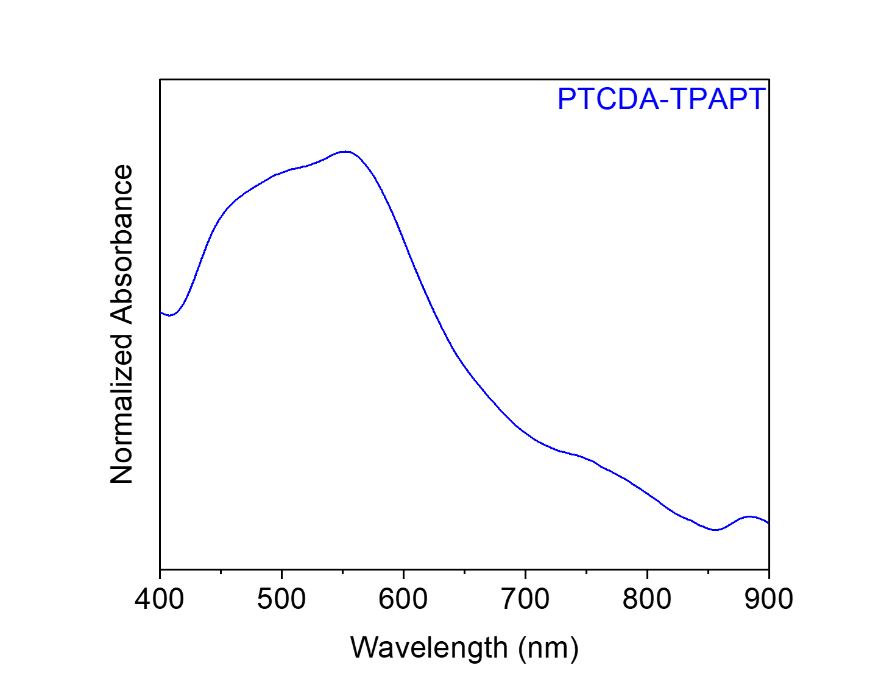
Figure S120. Solid-state UV-Vis absorption spectrum of PTCDA-TPAPT dispersed in BaSO₄.

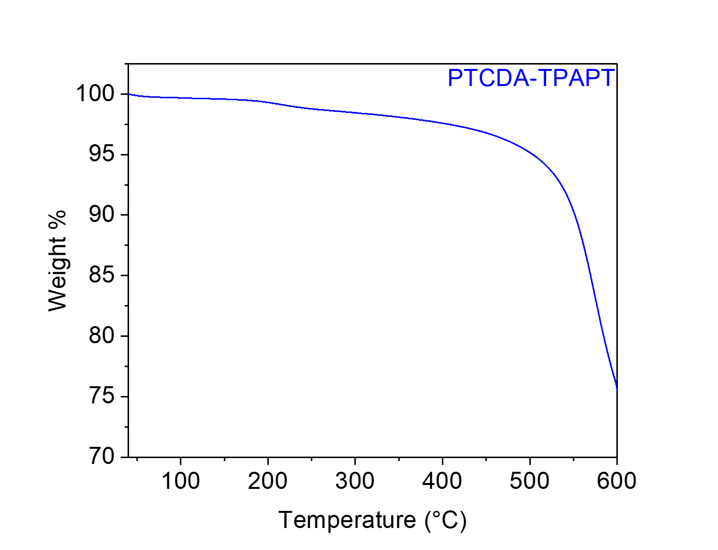
Figure S121. Thermogravimetric decomposition profile of PTCDA-TPAPT, indicating that it is stable below 500 °C. The gradual weight loss from this material upon heating is likely due to the loss of solvent/water.
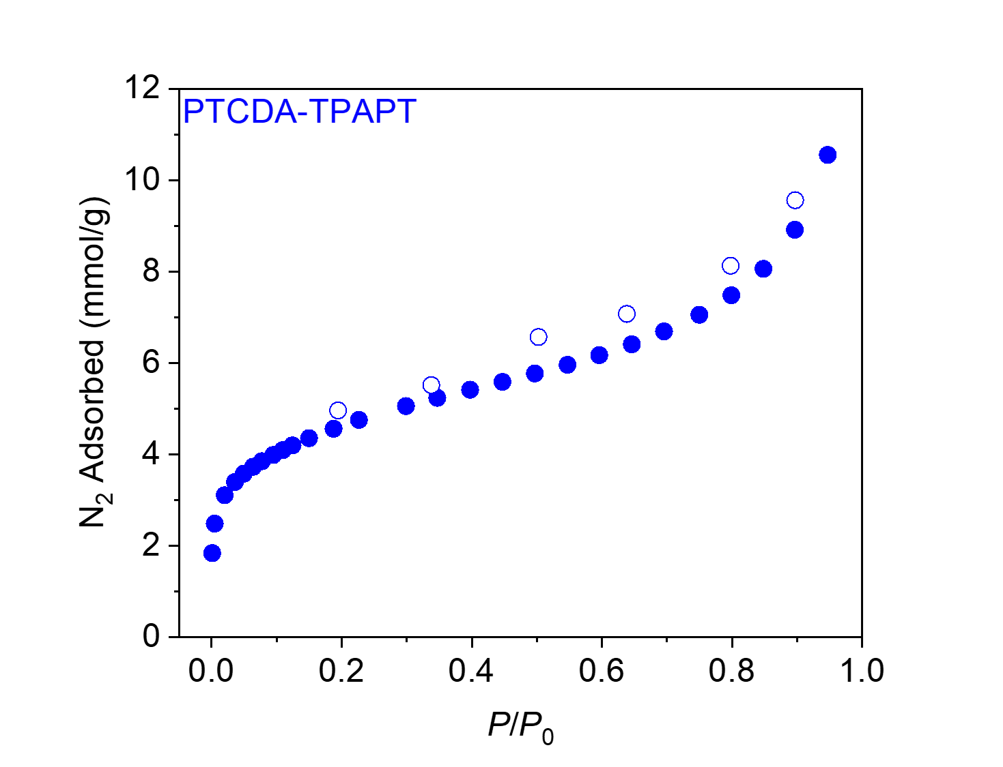
Figure S122. 77 K N₂ adsorption (filled circles) and desorption (open circles) isotherms for PTCDA-TPAPT. The BET and Langmuir surface areas were determined to be 367 ± 3 m²/g and 838 ± 54 m²/g, respectively.
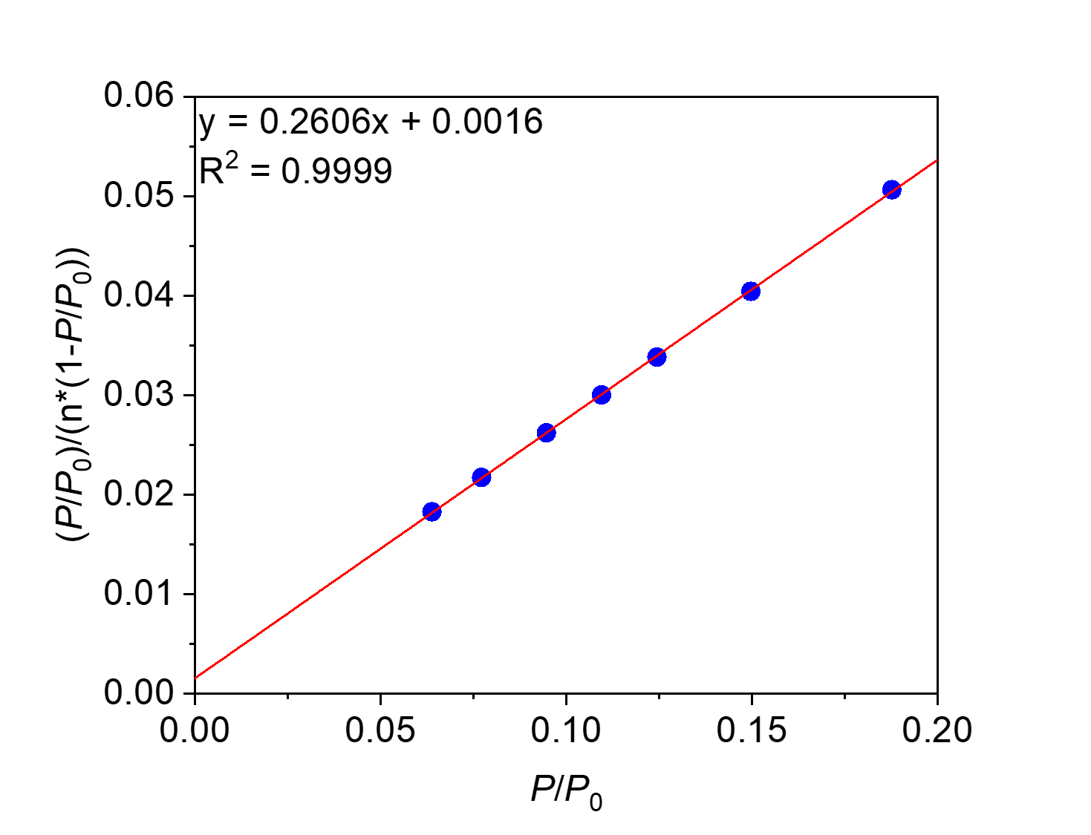
Figure S123. Linearized BET plot of PTCDA-TPAPT.
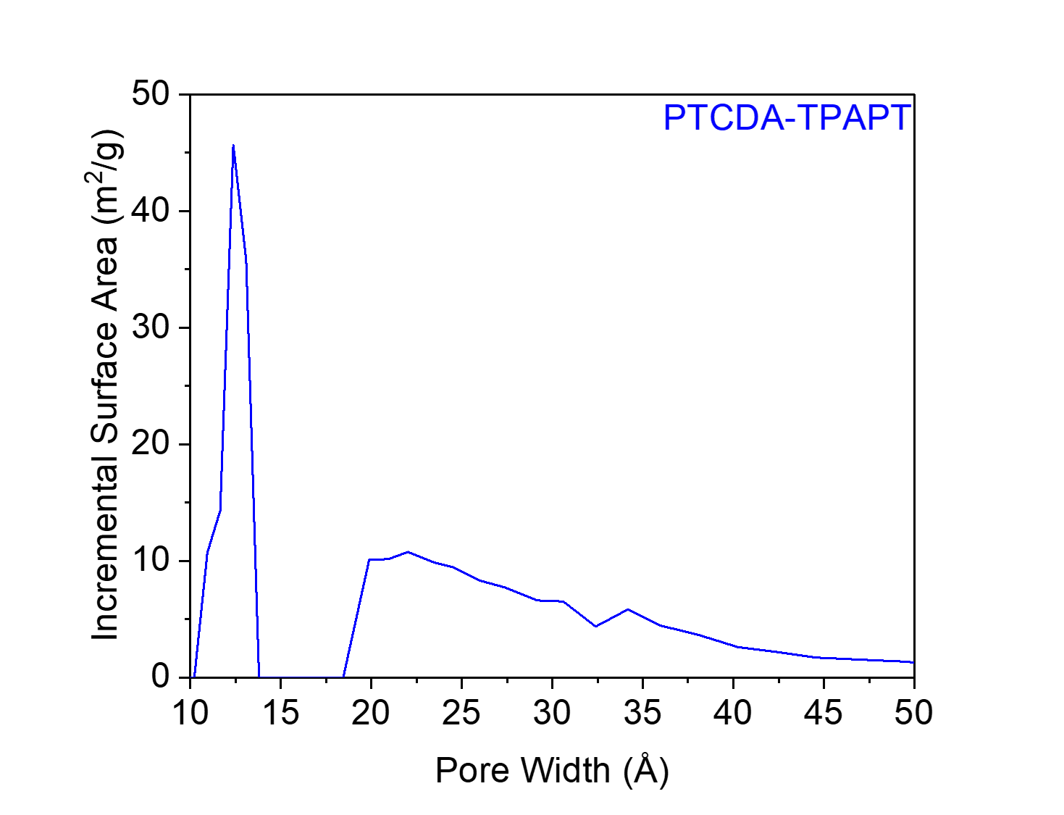
Figure S124. The N₂-Tarazona NLDFT-calculated pore size distribution of PTCDA-TPAPT, assuming a cylindrical pore geometry.
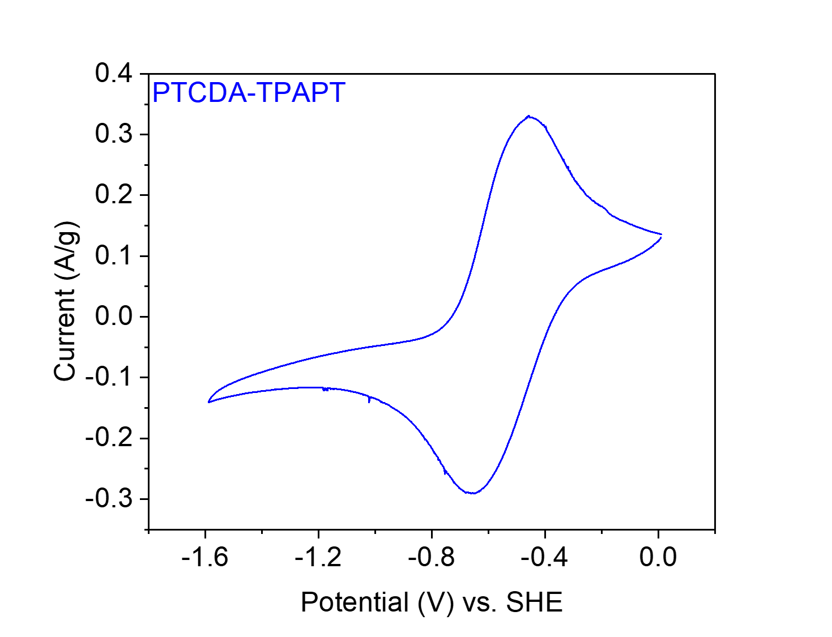
Figure S125. CV at 20 mV s⁻¹ of PTCDA-TPAPT in 0.1 M NaClO₄ in MeCN.

Catalyst | BET (m²/g) | Langmuir (m²/g)
PMDA-en | 227 ± 1 | 804 ± 87
NTCDA-en | 5 | 8
PTCDA-en | 9 | 27 ± 2
PTCDA-pn | 67 | 280 ± 40
PTCDA-nBut | 29 | 102 ± 13
PTCDA-nHex | 56 | 233 ± 34
PTCDA-men | Non-porous | Non-porous
PTCDA-dmpn | 47 | 156 ± 20
PTCDA-TPAPA | 396 ± 2 | 698 ± 32
PTCDA-TPAPM | 220 ± 2 | 361 ± 14
PTCDA-TPAPT | 367 ± 3 | 838 ± 54
Table S13. Tabulated summary of the surface areas of the polymer catalysts.

Catalyst¹ | E_{1/2} (V vs. SHE)
PMDA-en (NaClO₄) | −0.70, −1.09
NTCDA-en (NaClO₄) | −0.52, −0.81
PTCDA-en (LiClO₄) | −0.50
PTCDA-en (NaClO₄) | −0.57
PTCDA-en (KClO₄) | −0.62
PTCDA-pn (NaClO₄) | −0.54
PTCDA-nBut (NaClO₄) | −0.56
PTCDA-nHex (NaClO₄) | −0.56
PTCDA-men (NaClO₄) | −0.55
PTCDA-dmpn (NaClO₄) | −0.54
PTCDA-TPAPA (NaClO₄) | −0.58
PTCDA-TPAPM (NaClO₄) | −0.57
PTCDA-TPAPT (NaClO₄) | −0.56
Table S14. Tabulated summary of the redox potentials (E_{1/2}) of the polymer catalysts.
¹Electrolyte (0.1 M in MeCN) in parentheses.

Synthesis and characterization of substrates.

4-(ethoxycarbonyl)-N,N,N-trimethylbenzeneammonium iodide.

Figure S126. Synthesis of 4-(ethoxycarbonyl)-N,N,N-trimethylbenzeneammonium iodide.
Synthesis of 4-(ethoxycarbonyl)-N,N,N-trimethylbenzeneammonium iodide. This procedure was adapted from the literature.¹⁰ To a 10 mL screw-cap reaction tube equipped with a stir bar, ethyl 4-(dimethylamino)benzoate (193 mg, 1.00 mmol, 1.00 equiv.), DMF (0.50 mL), and MeI (93 μL, 1.50 mmol, 1.50 equiv.) were added. The reaction mixture was heated to 50 °C and allowed to stir at 50 °C for 24 h. At this time, the reaction mixture was allowed to cool to room temperature. The reaction mixture was diluted with Et₂O (5 mL) and filtered. The resulting solid was rinsed with additional Et₂O (10 mL) to yield 4-(ethoxycarbonyl)-N,N,N-trimethylbenzeneammonium iodide as a white solid (267.5 mg, 80% yield). ¹H NMR (400 MHz, DMSO-d₆): δ 8.15 (s, 4H), 4.36 (q, J = 7.1 Hz, 2H), 3.66 (s, 9H), 1.34 (t, J = 7.1 Hz, 3H) ppm; ¹³C NMR (101 MHz, DMSO-d₆): δ 164.36, 150.43, 131.30, 130.67, 121.34, 61.40, 56.39, 14.08 ppm. These spectra are consistent with those reported in the literature.¹⁰
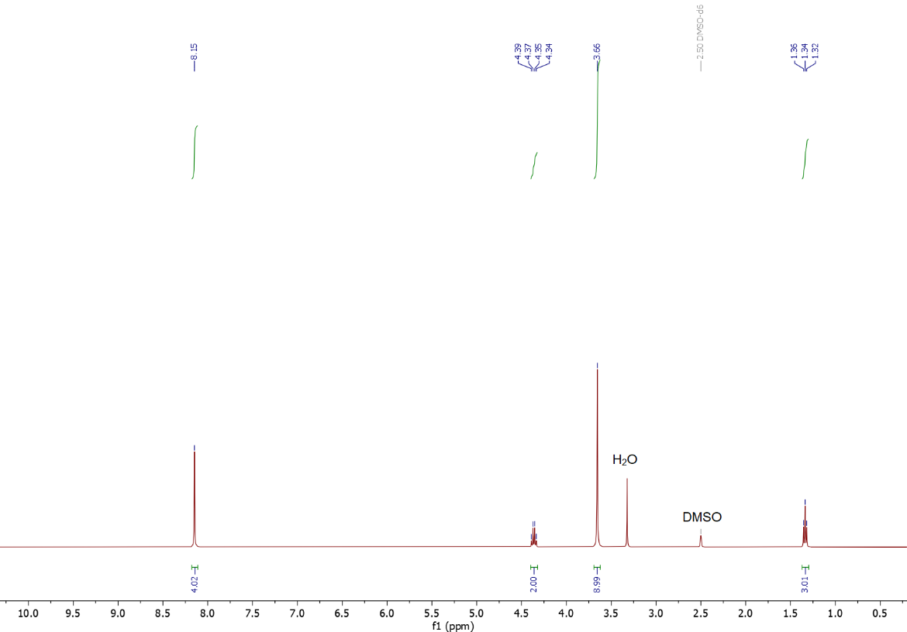
Figure S127. ¹H NMR (400 MHz, DMSO-d₆) spectrum of 4-(ethoxycarbonyl)-N,N,N-trimethylbenzeneammonium iodide used in this work.
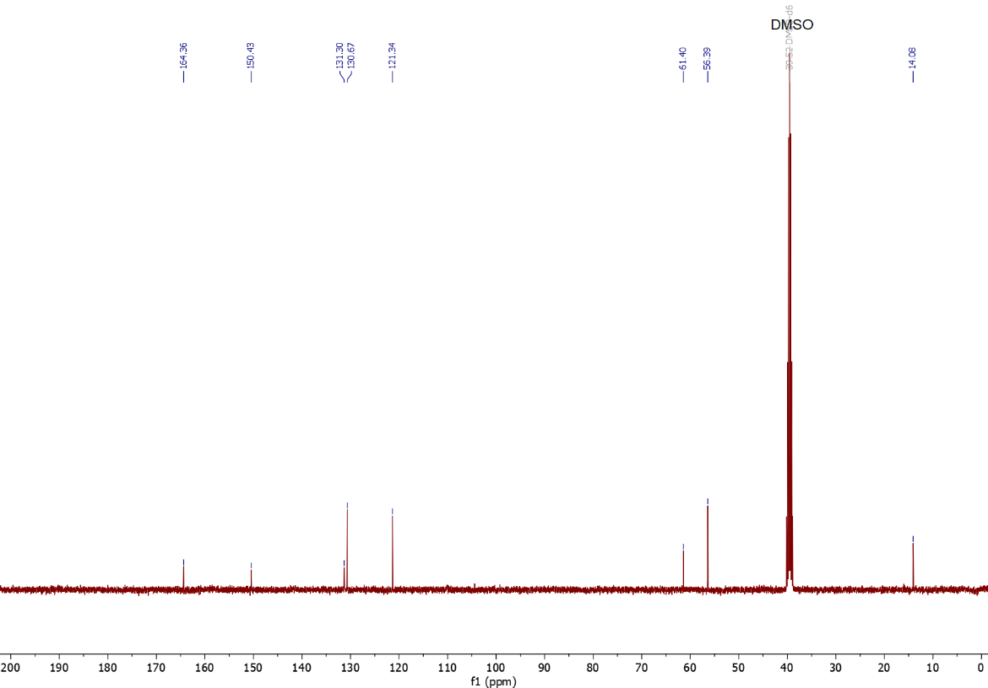
Figure S128. ¹³C NMR (101 MHz, DMSO-d₆) spectrum of 4-(ethoxycarbonyl)-N,N,N-trimethylbenzeneammonium iodide used in this work.

4-(ethoxycarbonyl)benzenediazonium tetrafluoroborate.

Figure S129. Synthesis of 4-(ethoxycarbonyl)benzenediazonium tetrafluoroborate.
Synthesis of 4-(ethoxycarbonyl)benzenediazonium tetrafluoroborate. This procedure was adapted from the literature.¹¹ To a 10 mL screw-cap reaction tube equipped with a stir bar, ethyl 4-aminobenzoate (166 mg, 1.00 mmol, 1.00 equiv.), DI water (0.30 mL), and HBF₄ (48% aq., 0.34 mL) were added. The reaction mixture was cooled to 0 °C in an ice bath, before NaNO₂ (69.3 mg, 1.00 mmol, 1.00 equiv.) in DI water (0.20 mL) was added. The reaction mixture was allowed to gradually warm to room temperature and stir for 3 h. The reaction mixture was diluted with Et₂O (50 mL) and filtered. The resulting solid was dissolved in acetone (5 mL), before additional Et₂O (200 mL) was added, resulting in precipitation of a solid from solution. The resulting solid was filtered and rinsed with cold Et₂O (10 mL) to yield 4-(ethoxycarbonyl)benzenediazonium tetrafluoroborate as a white solid (109.5 mg, 41% yield). ¹H NMR (400 MHz, DMSO-d₆): δ 8.79 (d, J = 8.9 Hz, 2H), 8.44 (d, J = 8.9 Hz, 2H), 4.41 (q, J = 7.1 Hz, 2H), 1.36 (t, J = 7.1 Hz, 3H) ppm; ¹³C NMR (101 MHz, DMSO-d₆): δ 163.32, 139.43, 133.17, 131.21, 120.19, 62.42, 13.95 ppm; ¹⁹F NMR (376 MHz, DMSO-d₆): δ −148.24, −148.29 ppm. These spectra are consistent with those reported in the literature.¹²
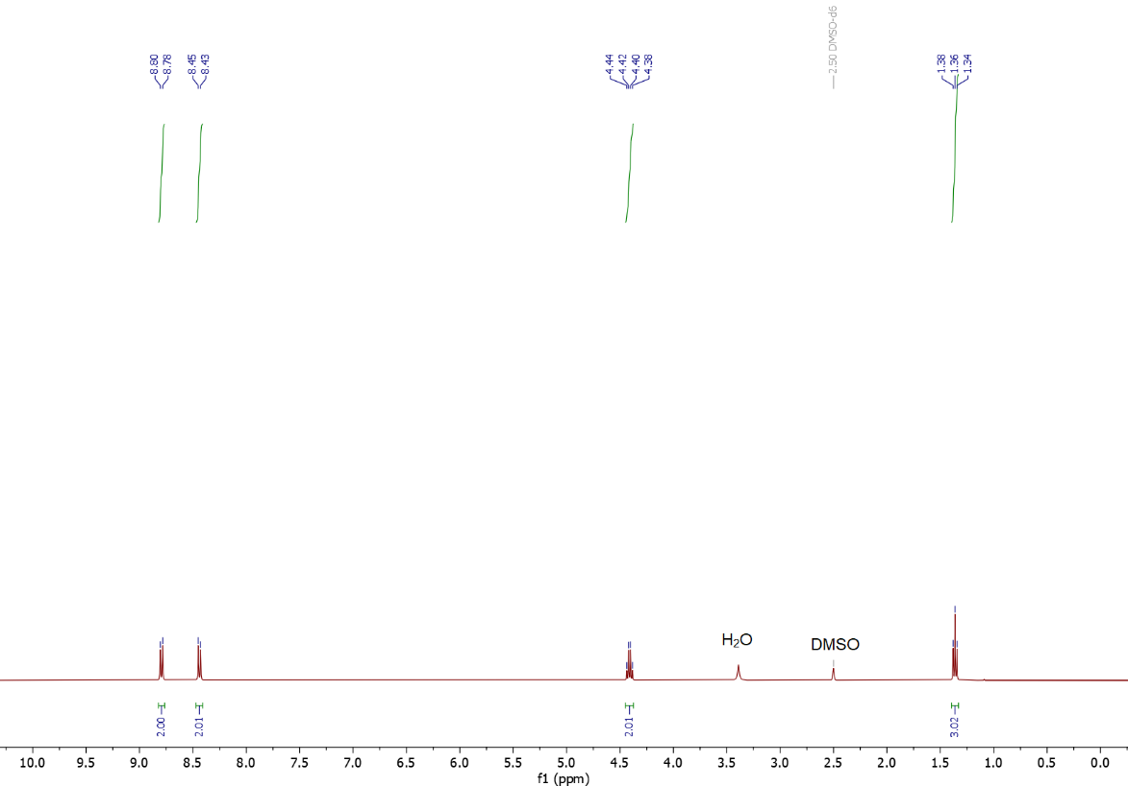
Figure S130. ¹H NMR (400 MHz, DMSO-d₆) spectrum of 4-(ethoxycarbonyl)benzenediazonium tetrafluoroborate used in this work.
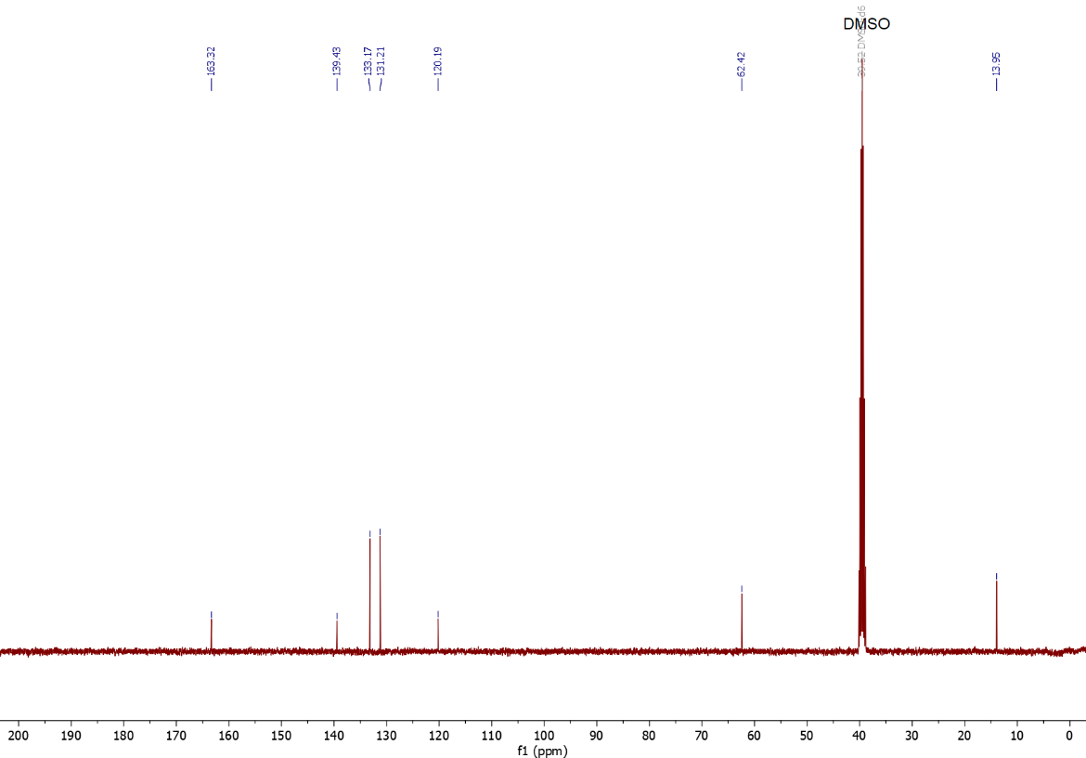
Figure S131. ¹³C NMR (101 MHz, DMSO-d₆) spectrum of 4-(ethoxycarbonyl)benzenediazonium tetrafluoroborate used in this work.

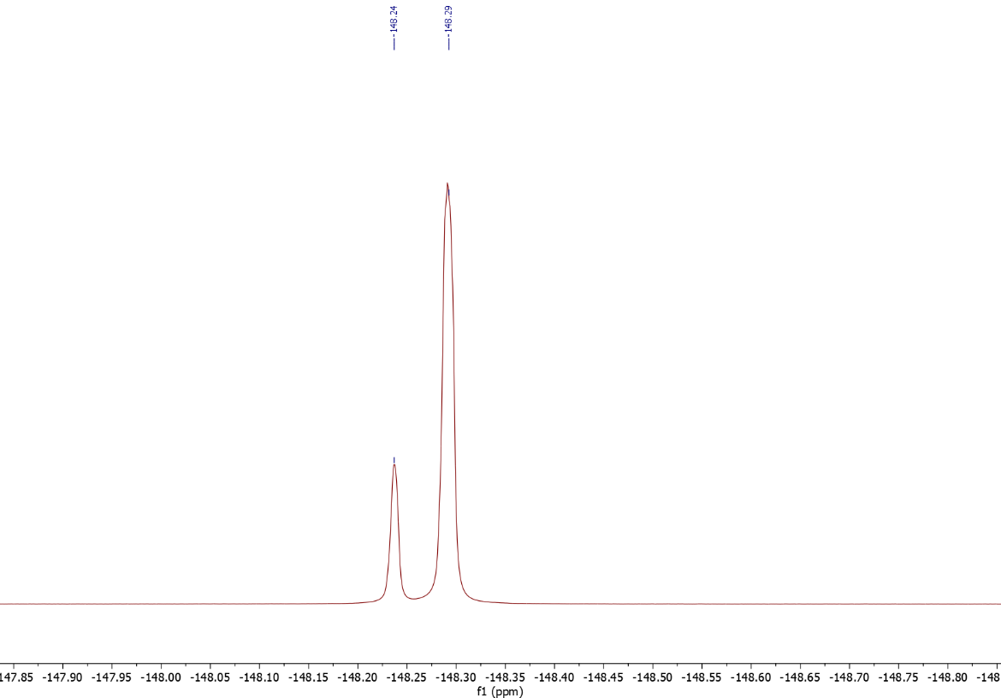
Figure S132. ¹⁹F NMR (376 MHz, DMSO-d₆) spectrum of 4-(ethoxycarbonyl)benzenediazonium tetrafluoroborate used in this work.

Fabrication of polymer-functionalized electrodes.

Small-scale production.
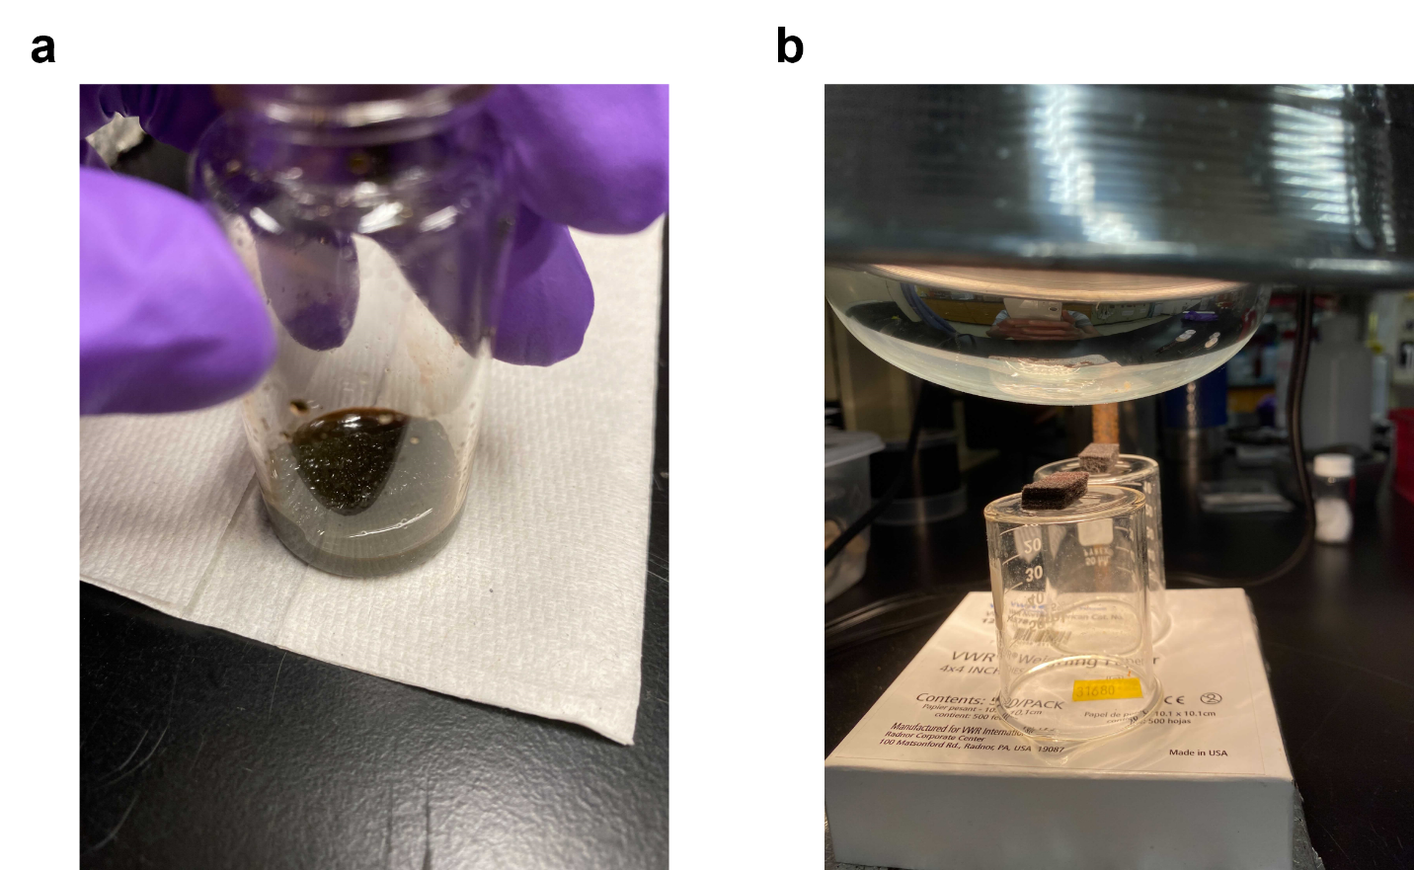
Figure S133. Preparation of polymer-functionalized electrodes on small scale. (a) Soaking of the carbon felt cathode inside the vial containing the polymer slurry prior to sonication, and (b) heat lamp-assisted drying of the polymer-functionalized carbon felt cathodes after sonication in polymer slurry.
Polymer slurry preparation for CV measurements. To a 20 mL scintillation vial, the active material (polymer, 0.02 mmol, 4 mM in NMP) and PVDF were mixed at a ratio of 4:1 (by wt) in NMP (5 mL). The resulting slurry was sonicated for 1 h to ensure homogeneous dispersion, before being drop-casted (30 μL) onto a glassy carbon working electrode. Then, the electrode was placed under a heat lamp until the NMP completely evaporated.

Preparation of the polymer-functionalized cathodes. The carbon felt was cut into a square (35 mm × 24 mm × 6.5 mm) and put into the vial containing the polymer slurry (Figure S133a). The vial was sonicated for 30 min before the carbon felt was removed from the vial using a tweezer. The wet carbon felt was then placed on top of an upside down 50 mL beaker and dried under a heat lamp for 5 h (at which point the NMP should have completely evaporated off and the carbon felt should be dry and stiff) prior to use (Figure S133b).

Estimation of polymer loading on electrodes.

n(polymer in slurry) | 0.02 mmol
V (total volume of slurry) | 5.00 mL
V (volume absorbed by carbon felt) | 1.50 mL*
n(polymer absorbed by carbon felt) | 0.006 mmol
Table S15. Estimation of polymer loading on carbon felt cathodes.
*Average of three trials.

We can estimate how much polymer is absorbed by a piece of carbon felt (35 mm × 24 mm × 6.5 mm), given that the total amount of polymer in the slurry mixture is 0.02 mmol and the total volume of the slurry is 5 mL. We have observed that a piece of carbon felt typically absorbs 1.50 mL slurry, which is 30% of the total volume of the slurry mixture. Hence, the amount of polymer absorbed by the carbon felt is estimated to be 0.02 mmol * 30% = 0.006 mmol. Therefore, for a 0.2 mmol scale reaction, the approximate polymer loading is (0.006 mmol/0.2 mmol) * 100% = 3 mol% (Table S15).

Bulk production of PTCDA-en-functionalized electrodes.
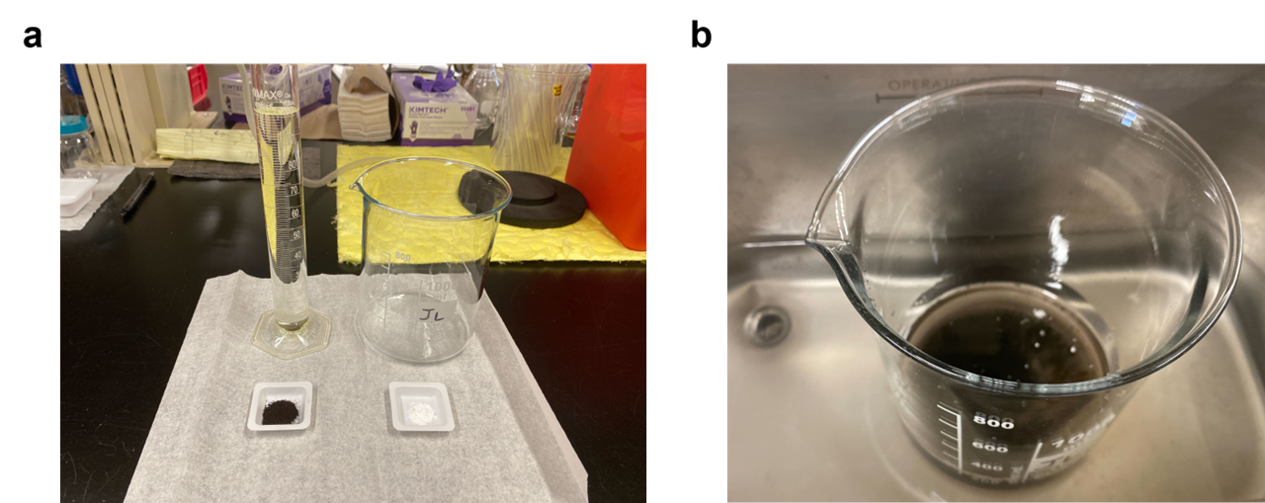
Figure S134. (a) Starting materials, and (b) the slurry-containing beaker being sonicated. It is important to place the beaker at the bottom of the sonicator (as shown) for effective sonication.
Large-scale PTCDA-en slurry preparation. PTCDA-en (336 mg, 0.80 mmol, 4 mM in NMP) and PVDF (84 mg) were mixed at a ratio of 4:1 (by wt) in NMP (200 mL) in a 1 L beaker (Figure S134a). The resulting slurry was sonicated for 3 h to ensure homogeneous dispersion (Figure S134b), before 50 pre-cut carbon felt cathodes (35 mm × 24 mm × 6.5 mm) were put into the beaker (Figure S135a). The beaker was further sonicated for 2 h, before all electrodes were removed from the beaker using a tweezer. The electrodes were then placed in a 500 mL beaker and dried under a heat lamp for 24 h prior to use (Figure S135b). This method allows for the bulk production of at least 50 electrodes in a single batch (Figure S136).
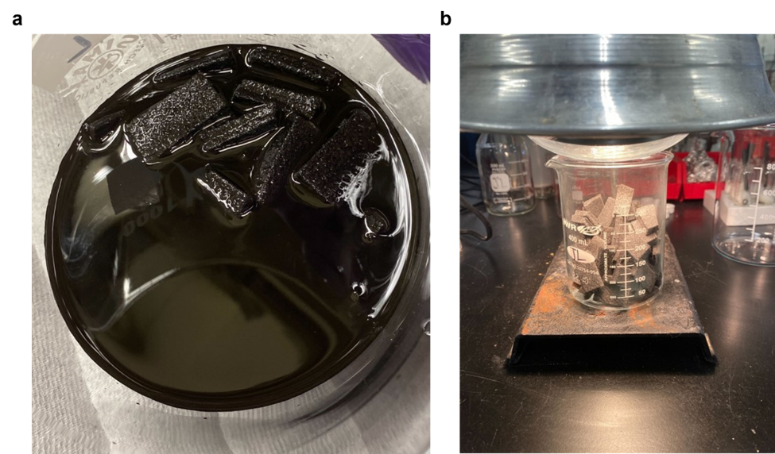
Figure S135. Production of PTCDA-en-functionalized carbon felt cathodes in bulk. (a) 50 pre-cut electrodes being soaked and sonicated in PTCDA-en slurry, and (b) the electrodes being dried under a heat lamp.
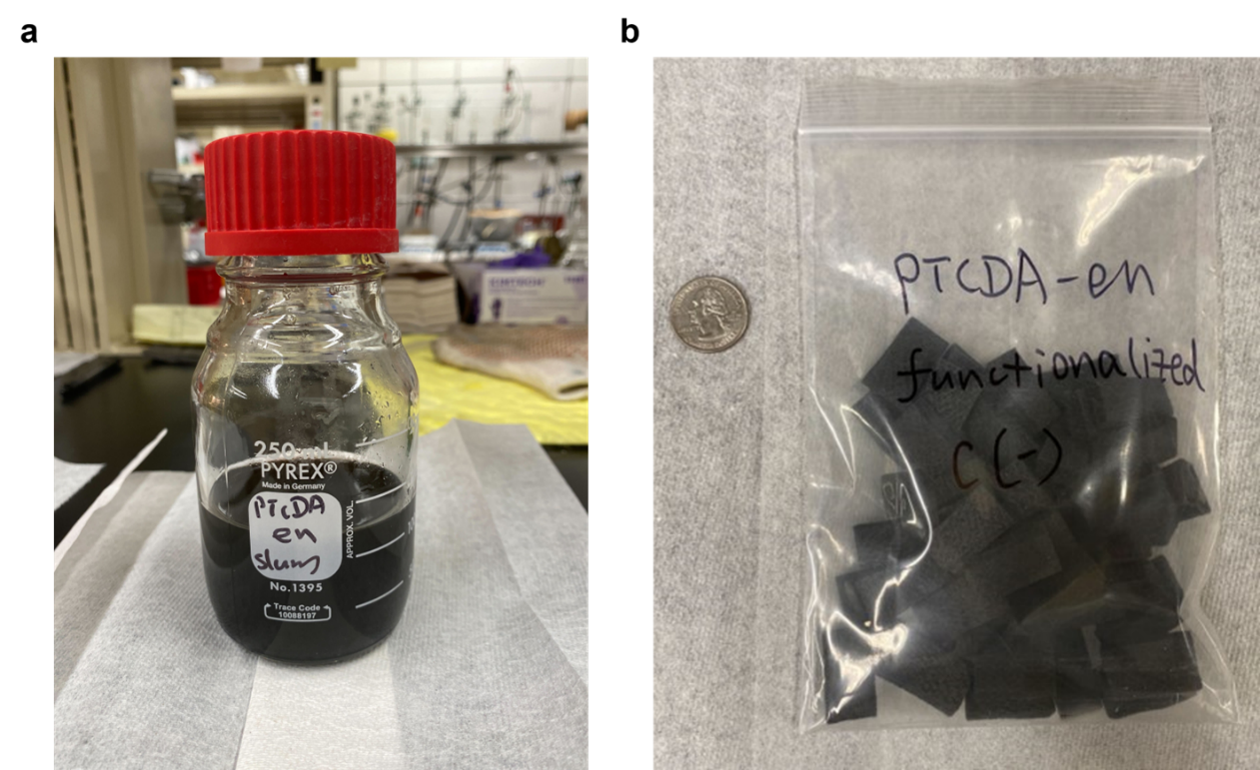
Figure S136. (a) PTCDA-en slurry, and (b) PTCDA-en-functionalized carbon felt cathodes produced in bulk.

Electrochemical setup.

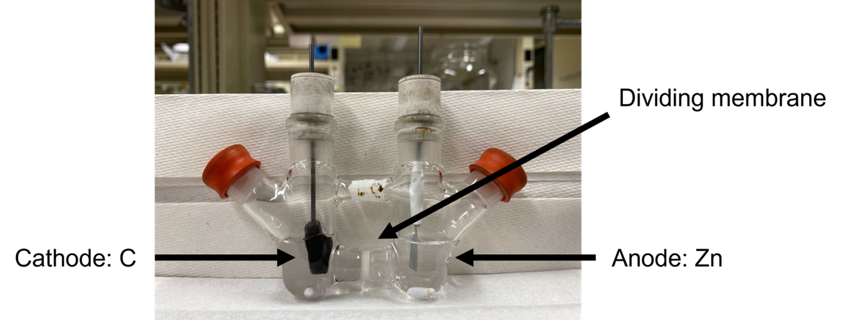
Figure S137. Custom-made H-type divided cell (H-cell) used in this work.
Preparation of cathode and anode. A white septum was pierced with a needle, and a 2B pencil lead (2 mm in diameter) was inserted through the hole. The polymer-functionalized carbon felt was impaled onto the pencil lead. The Zn plate (9 mm × 6 mm) was attached to the 2B pencil lead using parafilm (Figure S137).

General electrolysis procedures.

Initial optimizations using PTCDA-di^{i}PrAn.
Figure S138. Electrolyte evaluation.
Electrolyte | NMR Yield (%)*
LiClO₄ | 20
NaClO₄ | 63
KClO₄ | <5
TBAClO₄ | 61
Table S16. Tabulated yields for the model reaction using different electrolytes.
*Determined by ¹H NMR with CH₂Br₂ as the internal standard.

Figure S139. Cathode material evaluation.
Cathode Material | NMR Yield (%)*
Carbon paper | <5
Carbon felt | 63
Conductive carbon cloth | 43
Indium tin oxide (ITO)-coated glass | 0
Table S17. Tabulated yields for the model reaction using different cathode materials.
*Determined by ¹H NMR with CH₂Br₂ as the internal standard.

An initial screen of different cathode materials and electrolytes revealed that using carbon felt as the cathode and NaClO₄ as the electrolyte furnishes the desired borylated product, ethyl 4-(4,4,5,5-tetramethyl-1,3,2-dioxaborolan-2-yl)benzoate, in the highest yield (63% yield; Table S16 & Table S17). Following initial optimization, a series of control experiments revealed that electricity, PTCDA-di^{i}PrAn, and light irradiation are all necessary for high yields (Table S18; see Table S19 for tabulated yields for the model reaction using different molecular catalysts).

Figure S140. Model reaction using PTCDA-di^{i}PrAn.
Variation from above conditions | NMR Yield (%)*
None | 63
No applied voltage | 0
No PTCDA-di^{i}PrAn | 10
No light | 40
Table S18. Control experiments.
*Determined by ¹H NMR with CH₂Br₂ as the internal standard.

Molecular catalysts (MCs) screen.

Figure S141. Scheme for the reductive borylation of ethyl 4-chlorobenzoate using MCs.
Evaluation of MCs. In a N₂-filled glovebox, an oven-dried custom-made H-type divided cell was equipped with a stir bar on each side, a carbon felt cathode, and a Zn plate anode (Figure S137). The cathodic chamber was charged with MC (0.006 mmol, 0.03 equiv.), ethyl 4-chlorobenzoate (31.3 μL, 0.20 mmol, 1.0 equiv.), B₂Pin₂ (101.6 mg, 0.40 mmol, 2.0 equiv.) and NaClO₄ (49 mg, 0.40 mmol, 2.0 equiv., for a final concentration of 0.10 M in MeCN), while the anodic chamber was charged with NaClO₄ (49 mg, 0.40 mmol, 2.0 equiv., for a final concentration of 0.10 M in MeCN). Then, anhydrous degassed MeCN (4.0 mL) was added to each chamber. Subsequently, anhydrous degassed pyridine (3.3 μL, 0.04 mmol, 0.20 equiv.) was added to the cathodic chamber. The cell was sealed, transferred out of the glovebox, and stirred at a constant cell potential of 1.6 V at 22 ℃ for 16 h under blue CFL irradiation (2 × 15 W). When the reaction was finished, the reaction mixture of each chamber was collected, and the chambers were further rinsed with acetone (2 × 10 mL). After concentration under reduced pressure, the crude mixture was analyzed by ¹H NMR using CH₂Br₂ as the internal standard.

MC | NMR Yield (%)*
NDCMA-di^{i}PrAn | 41
NTCDA-di^{i}PrAn | 38
PTCDA-di^{i}PrAn | 63
Table S19. Tabulated yields for the model reaction using MCs.
*Determined by ¹H NMR with CH₂Br₂ as the internal standard.

The poor yield obtained with NDCMA-di^{i}PrAn compared to literature reports under similar conditions⁶ is because previous work employed constant current conditions, operating at a much more negative cathodic potential (~ −1.76 V vs. SHE) than in this work (~ −0.65 V vs. SHE), as determined using a three-electrode set-up (Figure S165). We note that previous work has shown that this catalyst is unstable under such harshly reductive conditions, decomposing to a molecular photoredox catalyst.¹³

Polymer catalysts (PCs) screen.

Figure S142. Scheme for the reductive borylation of ethyl 4-chlorobenzoate using PCs.
Evaluation of PCs. In a N₂-filled glovebox, an oven-dried custom-made H-type divided cell was equipped with a stir bar on each side, a PC-functionalized (0.006 mmol, 0.03 equiv.; see Section 6 for details on approximate determination of polymer loading) carbon felt cathode, and a Zn plate anode (Figure S137). The cathodic chamber was charged with ethyl 4-chlorobenzoate (31.3 μL, 0.20 mmol, 1.0 equiv.), B₂Pin₂ (101.6 mg, 0.40 mmol, 2.0 equiv.) and NaClO₄ (49 mg, 0.40 mmol, 2.0 equiv., for a final concentration of 0.10 M in MeCN), while the anodic chamber was charged with NaClO₄ (49 mg, 0.40 mmol, 2.0 equiv., for a final concentration of 0.10 M in MeCN). Then, anhydrous degassed MeCN (4.0 mL) was added to each chamber. Subsequently, anhydrous degassed pyridine (3.3 μL, 0.04 mmol, 0.20 equiv.) was added to the cathodic chamber. The cell was sealed, transferred out of the glovebox, and stirred at a constant cell potential of 1.6 V at 22 ℃ for 16 h under blue CFL irradiation (2 × 15 W). When the reaction was finished, the reaction mixture of each chamber was collected, and the chambers were further rinsed with acetone (2 × 10 mL). After concentration under reduced pressure, the crude mixture was analyzed by ¹H NMR using CH₂Br₂ as the internal standard.

PC | NMR Yield (%)*
NTCDA-en | 16
PMDA-en | 18
PTCDA-en | 55
PTCDA-pn | 22
PTCDA-nBut | 22
PTCDA-nHex | 14
PTCDA-men | 36
PTCDA-dmpn | 11
PTCDA-TPAPA | 26
PTCDA-TPAPM | 14
PTCDA-TPAPT | 12
Table S20. Tabulated yields for the model reaction using PCs.
*Determined by ¹H NMR with CH₂Br₂ as the internal standard.

Further optimizations using PTCDA-en.
Figure S143. Model reaction using PTCDA-en.
Variation from above conditions | NMR Yield (%)*
None | 55
LiClO₄ as electrolyte | 28
KClO₄ as electrolyte | 0
NaBF₄ as electrolyte | 31
2 mM slurry in NMP instead of 4 mM | 16
10 mM slurry in NMP instead of 4 mM | 42
90% polymer loading instead of 80%¹ | 43
DMSO as solvent | 17
Green Kessil LED (525 nm, 40 W) | 16
White LED (23 W) | 40
UV Kessil LED (390 nm, 40 W) | 45
Extra blue Kessil LED (456 nm, 40 W) | 43
1 equiv. pyridine | 48
2 equiv. pyridine | 38
B₂Pin₂ (4.0 equiv.), py (40 mol%) | 76
70 ℃ instead of 22 ℃ | 54
B₂Pin₂ (4.0 equiv.), py (40 mol%), heat at 70 ℃ | 61
B₂Pin₂ (4.0 equiv.), py (40 mol%), blue Kessil LED | 68
Table S21. Tabulated yields for further optimization using PTCDA-en.
*Determined by ¹H NMR with CH₂Br₂ as the internal standard.
¹During slurry preparation, the active material (polymer, 0.02 mmol, 4 mM in NMP) and PVDF were mixed at a ratio of 9:1 (by wt) in NMP (5 mL), instead of 4:1 (by wt).

Figure S144. Further optimization of the model reaction using PTCDA-en.
Variation from above conditions | NMR Yield (%)*
None | 68
40 h instead of 16 h | 72
U_{cell} = 1.8 V instead of 1.6 V | 82
No pyridine | 30
4-Hydroxypyridine instead of pyridine | 25
4-Dimethylaminopyridine instead of pyridine | 76
4-Iodopyridine instead of pyridine | <5
3,5-Dibromopyridine instead of pyridine | <5
Table S22. Tabulated yields for further optimization using PTCDA-en.
*Determined by ¹H NMR with CH₂Br₂ as the internal standard.

Figure S145. Cell potential evaluation.
U_{cell} | NMR Yield (%)*
1.2 V | 22
1.4 V | 18
1.5 V | 42
1.6 V | 68
1.8 V | 82
2.0 V | 73
Table S23. Tabulated yields for the yield of the model reaction at different cell potentials.
*Determined by ¹H NMR with CH₂Br₂ as the internal standard.

Figure S146. Optimized condition of the model reaction using PTCDA-en.
Variation from above conditions | NMR Yield (%)*
None | 82
PTCDA-en-functionalized cathode bulk-produced | 79
Set up on benchtop (Figure S147a) | 82
Set up in undivided cell (Figure S147b) | 15
Violet Kessil LED (390 nm, 40 W) | 77
Green Kessil LED (525 nm, 40 W) | 71
No light | 37
No PTCDA-en¹ | 17
No PTCDA-en² | 5
No PTCDA-en³ | <5
No applied voltage | 0
No applied voltage⁴ | 0
No applied voltage⁵ | 0
DMF as solvent | 18
X = Br instead of Cl | 44ª
X = I instead of Cl | 22
X = NMe₃I instead of Cl | 46
X = N₂BF₄ instead of Cl | 48
Table S24. Control experiments.
*Determined by ¹H NMR with CH₂Br₂ as the internal standard.
¹Carbon felt cathode unsoaked.
²Carbon felt cathode soaked in NMP.
³Carbon felt cathode soaked in a mixture of PVDF and NMP.
⁴0.75 equiv. tetrakis(dimethylamino)ethylene (TDAE, chemical reductant) added instead.
⁵240 equiv. TDAE added instead.
ª8 equiv. B₂Pin₂, 80 mol% py.
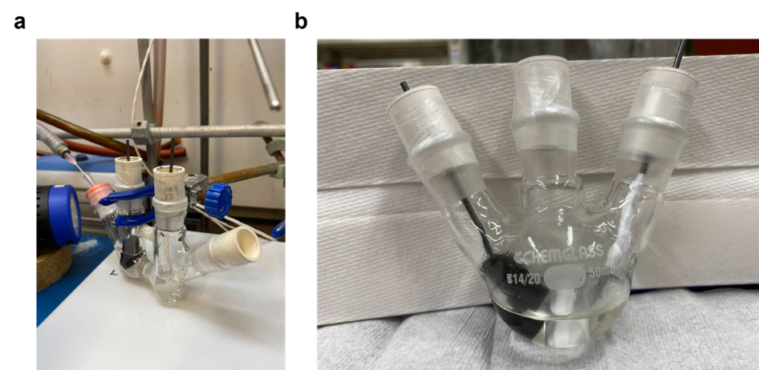
Figure S147. (a) Reaction setup on benchtop and (b) the undivided cell.

Reductive borylation using PTCDA-en.

Figure S148. Scheme for the PTCDA-en-mediated electrophotocatalytic reductive borylation.
General Procedure C. In a N₂-filled glovebox, an oven-dried custom-made H-type divided cell was equipped with a stir bar on each side, a PTCDA-en-functionalized (0.006 mmol, 0.03 equiv.; see Section 6 for details on approximate determination of polymer loading) carbon felt cathode, and a Zn plate anode (Figure S137). The cathodic chamber was charged with substrate (0.20 mmol, 1.0 equiv.), B₂Pin₂ (203.2 mg, 0.80 mmol, 4.0 equiv.) and NaClO₄ (49 mg, 0.40 mmol, 2.0 equiv., for a final concentration of 0.10 M in MeCN), while the anodic chamber was charged with NaClO₄ (49 mg, 0.40 mmol, 2.0 equiv., for a final concentration of 0.10 M in MeCN). Then, anhydrous degassed MeCN (4.0 mL) was added to each chamber. Subsequently, anhydrous degassed pyridine (6.6 μL, 0.08 mmol, 0.40 equiv.) was added to the cathodic chamber. The cell was sealed, transferred out of the glovebox, and stirred at a constant cell potential of 1.8 V at 22 ℃ for 16 h under blue Kessil LED irradiation (40 W). When the reaction was finished, the reaction mixture of each chamber was collected, and the chambers were further rinsed with acetone (2 × 10 mL). After concentration under reduced pressure, the product was purified by flash column chromatography on silica gel.

Hydrodehalogenation using PTCDA-en.

Figure S149. Scheme for the PTCDA-en-mediated electrophotocatalytic hydrodehalogenation using undivided cells.
General Procedure D. In a N₂-filled glovebox, an oven-dried, 25 mL 3-neck round-bottom flask was equipped with a PTCDA-en-functionalized (0.006 mmol, 0.03 equiv.; see Section 6 for details on approximate determination of polymer loading) carbon felt cathode, a carbon felt anode, and a stir bar. The flask was charged with substrate (0.20 mmol, 1.0 equiv.), DIPEA (0.28 mL, 1.60 mmol, 8.0 equiv.) and NaClO₄ (490 mg, 4.0 mmol, 20 equiv., for a final concentration of 1.0 M in MeCN). Then, anhydrous degassed MeCN (4.0 mL) was added to the flask. The flask was sealed, transferred out of the glovebox, and stirred at a constant cell potential of 1.8 V at 22 ℃ for 16 h under blue Kessil LED irradiation (40 W). When the reaction was finished, the reaction mixture was collected, and the flask was further rinsed with acetone (2 × 10 mL). After concentration under reduced pressure, the product was purified by flash column chromatography on silica gel.

Figure S150. Scheme for the PTCDA-en-mediated electrophotocatalytic hydrodehalogenation using H-cells.
General Procedure E. In a N₂-filled glovebox, an oven-dried custom-made H-type divided cell was equipped with a stir bar on each side, a PTCDA-en-functionalized (0.006 mmol, 0.03 equiv.; see Section 6 for details on approximate determination of polymer loading) carbon felt cathode, and a Zn plate anode (Figure S137). The cathodic chamber was charged with substrate (0.20 mmol, 1.0 equiv.), and NaClO₄ (490 mg, 4.0 mmol, 20 equiv., for a final concentration of 1.0 M in MeCN), while the anodic chamber was charged with NaClO₄ (490 mg, 4.0 mmol, 20 equiv., for a final concentration of 1.0 M in MeCN). Then, anhydrous degassed MeCN (4.0 mL) was added to each chamber. The cell was sealed, transferred out of the glovebox, and stirred at a constant cell potential of 1.8 V at 22 ℃ for 16 h under blue Kessil LED irradiation (40 W). When the reaction was finished, the reaction mixture of each chamber was collected, and the chambers were washed with acetone (2 × 10 mL). After concentration under reduced pressure, the product was purified by flash column chromatography on silica gel.

Characterization of purified products.

Figure S151. Ethyl 4-(4,4,5,5-tetramethyl-1,3,2-dioxaborolan-2-yl)benzoate (1).
Ethyl 4-(4,4,5,5-tetramethyl-1,3,2-dioxaborolan-2-yl)benzoate. Following General Procedure C, ethyl 4-chlorobenzoate (31.3 μL, 0.2 mmol, 1.0 equiv.), B₂Pin₂ (203.2 mg, 0.8 mmol, 4.0 equiv.), pyridine (6.6 μL, 0.08 mmol, 0.4 equiv.) and PTCDA-en-functionalized (0.006 mmol, 0.03 equiv.) carbon felt cathode were combined in the cathodic chamber of the H-cell. NaClO₄ (0.10 M in MeCN) and MeCN (4 mL) were added to both chambers. Then the reaction was stirred at a constant cell potential of 1.8 V at 22 ℃ for 16 h under blue Kessil LED irradiation (40 W). The crude product was purified by flash chromatography using a Biotage Isolera instrument (SiO₂, gradient of 0% → 5% EtOAc in hexanes) to afford 1 (34.8 mg, 63% yield) as a colorless oil. ¹H NMR (500 MHz, CDCl₃): δ 8.02 (d, J = 8.0 Hz, 2H), 7.86 (d, J = 8.2 Hz, 2H), 4.38 (q, J = 7.1 Hz, 2H), 1.39 (t, J = 7.1 Hz, 3H), 1.35 (s, 12H) ppm; ¹³C NMR (126 MHz, CDCl₃): δ 166.80, 134.75, 132.79, 128.68, 84.28, 61.16, 25.00, 14.44 ppm; ¹¹B NMR (160 MHz, CDCl₃): δ 31.04 ppm. These spectra are consistent with those reported in the literature.¹⁴

Figure S152. Ethyl 4-(4,4,6-trimethyl-1,3,2-dioxaborinan-2-yl)benzoate (1a).
Ethyl 4-(4,4,6-trimethyl-1,3,2-dioxaborinan-2-yl)benzoate. Following General Procedure C, ethyl 4-chlorobenzoate (31.3 μL, 0.2 mmol, 1.0 equiv.), 4,4,4',4',6,6'-hexamethyl-2,2'-bi(1,3,2-dioxaborinane) (203.2 mg, 0.8 mmol, 4.0 equiv.), pyridine (6.6 μL, 0.08 mmol, 0.4 equiv.) and PTCDA-en-functionalized (0.006 mmol, 0.03 equiv.) carbon felt cathode were combined in the cathodic chamber of the H-cell. NaClO₄ (0.10 M in MeCN) and MeCN (4 mL) were added to both chambers. Then the reaction was stirred at a constant cell potential of 1.8 V at 22 ℃ for 16 h under blue Kessil LED irradiation (40 W). The crude product was purified by flash chromatography using a Biotage Isolera instrument (SiO₂, gradient of 0% → 5% EtOAc in hexanes) to afford 1a (46.8 mg, 85% yield) as a white solid. ¹H NMR (500 MHz, CDCl₃): δ 7.99 (d, J = 8.0 Hz, 2H), 7.86 (d, J = 8.1 Hz, 2H), 4.41–4.31 (m, 3H), 1.88 (dd, J = 14.0, 3.0 Hz, 1H), 1.64–1.58 (m, 1H), 1.42–1.33 (m, 12H) ppm; ¹³C NMR (126 MHz, CDCl₃): δ 167.11, 133.78, 131.95, 128.47, 71.45, 65.33, 61.01, 46.11, 31.35, 28.31, 23.27, 14.47 ppm; ¹¹B NMR (160 MHz, CDCl₃): δ 27.06 ppm. These spectra are consistent with those reported in the literature.¹⁴

Figure S153. Ethyl 4-(5,5-dimethyl-1,3,2-dioxaborinan-2-yl)benzoate (1b).
Ethyl 4-(5,5-dimethyl-1,3,2-dioxaborinan-2-yl)benzoate. Following General Procedure C, ethyl 4-chlorobenzoate (31.3 μL, 0.2 mmol, 1.0 equiv.), 5,5,5',5'-tetramethyl-2,2'-bi(1,3,2-dioxaborinane) (180.8 mg, 0.8 mmol, 4.0 equiv.), pyridine (6.6 μL, 0.08 mmol, 0.4 equiv.) and PTCDA-en-functionalized (0.006 mmol, 0.03 equiv.) carbon felt cathode were combined in the cathodic chamber of the H-cell. NaClO₄ (0.10 M in MeCN) and MeCN (4 mL) were added to both chambers. Then the reaction was stirred at a constant cell potential of 1.8 V at 22 ℃ for 16 h under blue Kessil LED irradiation (40 W). The crude product was purified by flash chromatography using a Biotage Isolera instrument (SiO₂, gradient of 0% → 5% EtOAc in hexanes) to afford 1b (23.2 mg, 44% yield) as a white solid. ¹H NMR (500 MHz, CDCl₃): δ 8.01 (d, J = 7.9 Hz, 2H), 7.86 (d, J = 7.9 Hz, 2H), 4.38 (q, J = 7.1 Hz, 2H), 3.79 (s, 4H), 1.40 (t, J = 7.1 Hz, 3H), 1.03 (s, 6H) ppm; ¹³C NMR (126 MHz, CDCl₃): δ 167.00, 133.86, 132.31, 128.60, 72.51, 61.07, 32.03, 22.03, 14.47 ppm; ¹¹B NMR (160 MHz, CDCl₃): δ 27.09 ppm. These spectra are consistent with those reported in the literature.¹⁴
Figure S154. Ethyl 4-((3aS,4S,6S,7aR)-3a,5,5-trimethylhexahydro-4,6-methanobenzo[d][1,3,2]dioxaborol-2-yl)benzoate (1c).
Ethyl 4-((3aS,4S,6S,7aR)-3a,5,5-trimethylhexahydro-4,6-methanobenzo[d][1,3,2]dioxaborol-2-yl)benzoate. Following General Procedure C, ethyl 4-chlorobenzoate (31.3 μL, 0.2 mmol, 1.0 equiv.), bis[(+)-pinanediolato]diboron (286.4 mg, 0.8 mmol, 4.0 equiv.), pyridine (6.6 μL, 0.08 mmol, 0.4 equiv.) and PTCDA-en-functionalized (0.006 mmol, 0.03 equiv.) carbon felt cathode were combined in the cathodic chamber of the H-cell. NaClO₄ (0.10 M in MeCN) and MeCN (4 mL) were added to both chambers. Then the reaction was stirred at a constant cell potential of 1.8 V at 22 ℃ for 16 h under blue Kessil LED irradiation (40 W). The crude product was purified by flash chromatography using a Biotage Isolera instrument (SiO₂, gradient of 0% → 3% EtOAc in hexanes) to afford 1c (32.9 mg, 50% yield) as a white solid. ¹H NMR (500 MHz, CDCl₃): δ 8.03 (d, J = 7.8 Hz, 2H), 7.87 (d, J = 7.8 Hz, 2H), 4.47 (dd, J = 8.9, 1.9 Hz, 1H), 4.38 (q, J = 7.1 Hz, 2H), 2.42 (ddt, J = 14.1, 8.8, 2.4 Hz, 1H), 2.27–2.21 (m, 1H), 2.16 (t, J = 5.5 Hz, 1H), 2.01–1.92 (m, 2H), 1.49 (s, 3H), 1.40 (t, J = 7.1 Hz, 3H), 1.31 (s, 3H), 1.20 (d, J = 10.9 Hz, 1H), 0.89 (s, 3H) ppm; ¹³C NMR (126 MHz, CDCl₃): δ 166.79, 134.80, 132.76, 128.73, 86.76, 78.59, 61.17, 51.49, 39.63, 38.34, 35.59, 28.80, 27.21, 26.62, 24.17, 14.45 ppm; ¹¹B NMR (160 MHz, CDCl₃): δ 30.65 ppm. These spectra are consistent with those reported in the literature.¹⁴
Figure S155. Ethyl 4-(4,4,6,6-tetramethyl-1,3,2-dioxaborinan-2-yl)benzoate (1d).
Ethyl 4-(4,4,6,6-tetramethyl-1,3,2-dioxaborinan-2-yl)benzoate. Following General Procedure C, ethyl 4-chlorobenzoate (31.3 μL, 0.2 mmol, 1.0 equiv.), 4,4,4',4',6,6,6',6'-octamethyl-2,2'-bi(1,3,2-dioxaborinane) (225.6 mg, 0.8 mmol, 4.0 equiv.), pyridine (6.6 μL, 0.08 mmol, 0.4 equiv.) and PTCDA-en-functionalized (0.006 mmol, 0.03 equiv.) carbon felt cathode were combined in the cathodic chamber of the H-cell. NaClO₄ (0.10 M in MeCN) and MeCN (4 mL) were added to both chambers. Then the reaction was stirred at a constant cell potential of 1.8 V at 22 ℃ for 16 h under blue Kessil LED irradiation (40 W). The crude product was purified by flash chromatography using a Biotage Isolera instrument (SiO₂, gradient of 0% → 50% CH₂Cl₂ in hexanes) to afford 1d (30.0 mg, 52% yield) as a white solid. ¹H NMR (500 MHz, CDCl₃): δ 7.99 (d, J = 8.2 Hz, 2H), 7.88 (d, J = 8.1 Hz, 2H), 4.38 (q, J = 7.1 Hz, 2H), 1.93 (s, 2H), 1.43 (s, 12H), 1.40 (t, J = 7.1 Hz, 3H) ppm; ¹³C NMR (126 MHz, CDCl₃): δ 167.15, 133.84, 131.91, 128.46, 71.28, 61.01, 49.09, 31.93, 14.48 ppm; ¹¹B NMR (160 MHz, CDCl₃): δ 26.83 ppm. These spectra are consistent with those reported in the literature.¹⁴

Figure S156. Methyl 3-(4,4,5,5-tetramethyl-1,3,2-dioxaborolan-2-yl)benzoate (2).
Methyl 3-(4,4,5,5-tetramethyl-1,3,2-dioxaborolan-2-yl)benzoate. Following General Procedure C, methyl 3-chlorobenzoate (27.8 μL, 0.2 mmol, 1.0 equiv.), B₂Pin₂ (203.2 mg, 0.8 mmol, 4.0 equiv.), pyridine (6.6 μL, 0.08 mmol, 0.4 equiv.) and PTCDA-en-functionalized (0.006 mmol, 0.03 equiv.) carbon felt cathode were combined in the cathodic chamber of the H-cell. NaClO₄ (0.10 M in MeCN) and MeCN (4 mL) were added to both chambers. Then the reaction was stirred at a constant cell potential of 1.8 V at 22 ℃ for 16 h under blue Kessil LED irradiation (40 W). The crude product was purified by flash chromatography using a Biotage Isolera instrument (SiO₂, gradient of 0% → 5% EtOAc in hexanes) to afford 2 (26.7 mg, 51% yield) as a white solid. ¹H NMR (500 MHz, CDCl₃): δ 8.47 (s, 1H), 8.12 (d, J = 7.9 Hz, 1H), 7.98 (d, J = 7.3 Hz, 1H), 7.44 (t, J = 7.6 Hz, 1H), 3.91 (s, 3H), 1.35 (s, 12H) ppm; ¹³C NMR (126 MHz, CDCl₃): δ 167.30, 139.29, 135.96, 132.43, 129.69, 127.94, 84.23, 52.16, 25.00 ppm; ¹¹B NMR (160 MHz, CDCl₃): δ 30.94 ppm. These spectra are consistent with those reported in the literature.¹⁴

Figure S157. 4-(4,4,5,5-tetramethyl-1,3,2-dioxaborolan-2-yl)benzonitrile (3).
4-(4,4,5,5-tetramethyl-1,3,2-dioxaborolan-2-yl)benzonitrile. Following General Procedure C, 4-chlorobenzonitrile (27.5 mg, 0.2 mmol, 1.0 equiv.), B₂Pin₂ (203.2 mg, 0.8 mmol, 4.0 equiv.), pyridine (6.6 μL, 0.08 mmol, 0.4 equiv.) and PTCDA-en-functionalized (0.006 mmol, 0.03 equiv.) carbon felt cathode were combined in the cathodic chamber of the H-cell. NaClO₄ (0.10 M in MeCN) and MeCN (4 mL) were added to both chambers. Then the reaction was stirred at a constant cell potential of 1.8 V at 22 ℃ for 16 h under blue Kessil LED irradiation (40 W). The crude product was purified by flash chromatography using a Biotage Isolera instrument (SiO₂, gradient of 0% → 10% EtOAc in hexanes) to afford 3 (25.4 mg, 55% yield) as a white solid. ¹H NMR (500 MHz, CDCl₃): δ 7.88 (d, J = 8.2 Hz, 2H), 7.63 (d, J = 8.3 Hz, 2H), 1.34 (s, 12H) ppm; ¹³C NMR (126 MHz, CDCl₃): δ 135.22, 131.24, 118.98, 114.65, 84.61, 24.98 ppm; ¹¹B NMR (160 MHz, CDCl₃): δ 30.65 ppm. These spectra are consistent with those reported in the literature.¹⁴

Figure S158. 4,4,5,5-tetramethyl-2-(naphthalen-1-yl)-1,3,2-dioxaborolane (4).
4,4,5,5-tetramethyl-2-(naphthalen-1-yl)-1,3,2-dioxaborolane. Following General Procedure C with slight modifications, 1-chloronaphthalene (27.4 μL, 0.2 mmol, 1.0 equiv.), B₂Pin₂ (203.2 mg, 0.8 mmol, 4.0 equiv.), pyridine (32.3 μL, 0.4 mmol, 2.0 equiv.) and PTCDA-en-functionalized (0.006 mmol, 0.03 equiv.) carbon felt cathode were combined in the cathodic chamber of the H-cell. NaClO₄ (1.0 M in MeCN) and MeCN (4 mL) were added to both chambers. Then the reaction was stirred at a constant cell potential of 1.8 V at 22 ℃ for 16 h under blue Kessil LED irradiation (40 W). The crude product was purified by flash chromatography using a Biotage Isolera instrument (SiO₂, gradient of 0% → 10% EtOAc in hexanes) to afford 4 (22.3 mg, 44% yield) as a white solid. ¹H NMR (500 MHz, CDCl₃): δ 8.77 (d, J = 8.4 Hz, 1H), 8.09 (d, J = 8.2 Hz, 1H), 7.94 (d, J = 8.3 Hz, 1H), 7.84 (d, J = 8.8 Hz, 1H), 7.54 (ddd, J = 8.4, 6.8, 1.5 Hz, 1H), 7.48 (dd, J = 8.2, 6.8 Hz, 2H), 1.43 (s, 12H) ppm; ¹³C NMR (126 MHz, CDCl₃): δ 137.06, 135.78, 133.34, 131.75, 128.55, 128.48, 126.47, 125.62, 125.10, 83.87, 25.11 ppm; ¹¹B NMR (160 MHz, CDCl₃): δ 31.87 ppm. These spectra are consistent with those reported in the literature.¹⁴

Figure S159. 4,4,5,5-tetramethyl-2-(naphthalen-2-yl)-1,3,2-dioxaborolane (5).
4,4,5,5-tetramethyl-2-(naphthalen-2-yl)-1,3,2-dioxaborolane. Following General Procedure C, 2-chloronaphthalene (32.5 mg, 0.2 mmol, 1.0 equiv.), B₂Pin₂ (203.2 mg, 0.8 mmol, 4.0 equiv.), pyridine (6.6 μL, 0.08 mmol, 0.4 equiv.) and PTCDA-en-functionalized (0.006 mmol, 0.03 equiv.) carbon felt cathode were combined in the cathodic chamber of the H-cell. NaClO₄ (0.10 M in MeCN) and MeCN (4 mL) were added to both chambers. Then the reaction was stirred at a constant cell potential of 1.8 V at 22 ℃ for 16 h under blue Kessil LED irradiation (40 W). The crude product was purified by flash chromatography using a Biotage Isolera instrument (SiO₂, gradient of 0% → 10% EtOAc in hexanes) to afford 5 (24.9 mg, 49% yield) as a white solid. ¹H NMR (500 MHz, CDCl₃): δ 8.38 (s, 1H), 7.89 (d, J = 7.3 Hz, 1H), 7.86–7.81 (m, 3H), 7.53–7.45 (m, 2H), 1.40 (s, 12H) ppm; ¹³C NMR (126 MHz, CDCl₃): δ 136.39, 135.18, 132.96, 130.54, 128.81, 127.85, 127.12, 127.11, 125.93, 84.07, 25.07 ppm; ¹¹B NMR (160 MHz, CDCl₃): δ 31.62 ppm. These spectra are consistent with those reported in the literature.¹⁴

Figure S160. 2-([1,1'-biphenyl]-4-yl)-4,4,5,5-tetramethyl-1,3,2-dioxaborolane (6).
2-([1,1'-biphenyl]-4-yl)-4,4,5,5-tetramethyl-1,3,2-dioxaborolane. Following General Procedure C with slight modifications, 4-chloro-1,1'-biphenyl (37.7 mg, 0.2 mmol, 1.0 equiv.), B₂Pin₂ (203.2 mg, 0.8 mmol, 4.0 equiv.), pyridine (32.3 μL, 0.4 mmol, 2.0 equiv.) and PTCDA-en-functionalized (0.006 mmol, 0.03 equiv.) carbon felt cathode were combined in the cathodic chamber of the H-cell. NaClO₄ (1.0 M in MeCN) and MeCN (4 mL) were added to both chambers. Then the reaction was stirred at a constant cell potential of 1.8 V at 22 ℃ for 16 h under blue Kessil LED irradiation (40 W). The crude product was purified by flash chromatography using a Biotage Isolera instrument (SiO₂, gradient of 0% → 10% EtOAc in hexanes) to afford 6 (29.2 mg, 52% yield) as a white solid. ¹H NMR (500 MHz, CDCl₃): δ 7.89 (d, J = 8.2 Hz, 2H), 7.64–7.60 (m, 4H), 7.45 (t, J = 7.7 Hz, 2H), 7.38–7.34 (m, 1H), 1.37 (s, 12H) ppm; ¹³C NMR (126 MHz, CDCl₃): δ 144.03, 141.17, 135.40, 128.91, 127.70, 127.38, 126.61, 83.97, 25.03 ppm; ¹¹B NMR (160 MHz, CDCl₃): δ 31.48 ppm. These spectra are consistent with those reported in the literature.¹⁴

Figure S161. 2-(4-(4,4,5,5-tetramethyl-1,3,2-dioxaborolan-2-yl)phenyl)pyridine (7).
2-(4-(4,4,5,5-tetramethyl-1,3,2-dioxaborolan-2-yl)phenyl)pyridine. Following General Procedure C with slight modifications, 2-(4-bromophenyl)pyridine (46.8 mg, 0.2 mmol, 1.0 equiv.), B₂Pin₂ (203.2 mg, 0.8 mmol, 4.0 equiv.), pyridine (32.3 μL, 0.4 mmol, 2.0 equiv.) and PTCDA-en-functionalized (0.006 mmol, 0.03 equiv.) carbon felt cathode were combined in the cathodic chamber of the H-cell. NaClO₄ (1.0 M in MeCN) and MeCN (4 mL) were added to both chambers. Then the reaction was stirred at a constant cell potential of 1.8 V at 22 ℃ for 16 h under blue Kessil LED irradiation (40 W). The crude product was purified by flash chromatography using a Biotage Isolera instrument (SiO₂, gradient of 0% → 10% EtOAc in hexanes) to afford 7 (48.5 mg, 86% yield) as a white solid. ¹H NMR (500 MHz, CDCl₃): δ 8.71 (d, J = 4.6 Hz, 1H), 8.01 (d, J = 8.2 Hz, 2H), 7.92 (d, J = 8.2 Hz, 2H), 7.74 (dd, J = 6.8, 1.7 Hz, 2H), 7.23 (ddd, J = 6.7, 4.8, 1.9 Hz, 1H), 1.36 (s, 12H) ppm; ¹³C NMR (126 MHz, CDCl₃): δ 157.31, 149.82, 141.90, 136.88, 135.33, 126.20, 122.48, 120.94, 84.00, 25.02 ppm; ¹¹B NMR (160 MHz, CDCl₃): δ 31.38 ppm. These spectra are consistent with those reported in the literature.¹⁵

Figure S162. Phenanthrene (8).
Phenanthrene. Following General Procedure D, 9-bromophenanthrene (51.4 mg, 0.2 mmol, 1.0 equiv.), PTCDA-en-functionalized (0.006 mmol, 0.03 equiv.) carbon felt cathode, NaClO₄ (1.0 M in MeCN), MeCN (4 mL) and DIPEA (0.28 mL, 1.60 mmol, 8.0 equiv.) were added to the 25 mL 3-neck round-bottom flask. Then the reaction was stirred at a constant cell potential of 1.8 V at 22 ℃ for 16 h under blue Kessil LED irradiation (40 W). The crude product was purified by flash chromatography using a Biotage Isolera instrument (SiO₂, hexanes) to afford 8 (23.1 mg, 65% yield) as a white solid. ¹H NMR (400 MHz, CDCl₃): δ 8.70 (d, J = 8.2 Hz, 2H), 7.90 (dd, J = 7.8, 1.5 Hz, 2H), 7.75 (s, 2H), 7.67 (ddd, J = 8.3, 7.0, 1.5 Hz, 2H), 7.60 (ddd, J = 8.2, 7.1, 1.3 Hz, 2H) ppm; ¹³C NMR (101 MHz, CDCl₃): δ 132.19, 130.45, 128.71, 127.06, 126.70, 122.80 ppm. These spectra are consistent with those reported in the literature.¹⁶

Figure S163. Benzonitrile (9).
Benzonitrile. Following General Procedure D, 2-chlorobenzonitrile (27.5 mg, 0.2 mmol, 1.0 equiv.), PTCDA-en-functionalized (0.006 mmol, 0.03 equiv.) carbon felt cathode, NaClO₄ (1.0 M in MeCN), MeCN (4 mL) and DIPEA (0.28 mL, 1.60 mmol, 8.0 equiv.) were added to the 25 mL 3-neck round-bottom flask. Then the reaction was stirred at a constant cell potential of 1.8 V at 22 ℃ for 16 h under blue Kessil LED irradiation (40 W). The crude product was purified by flash chromatography using a Biotage Isolera instrument (SiO₂, gradient of 0% → 2% EtOAc in hexanes) to afford 9 (13.1 mg, 64% yield) as a colorless oil. ¹H NMR (400 MHz, CDCl₃): δ 7.70–7.58 (m, 3H), 7.48 (dd, J = 8.5, 7.1 Hz, 2H) ppm; ¹³C NMR (101 MHz, CDCl₃): δ 132.90, 132.31, 129.26, 118.99, 112.63 ppm. These spectra are consistent with those reported in the literature.¹⁷

Figure S164. Naphthalene (10).
Naphthalene. Following General Procedure E, 1-chloronaphthalene (27.4 μL, 0.2 mmol, 1.0 equiv.), PTCDA-en-functionalized (0.006 mmol, 0.03 equiv.) carbon felt cathode, NaClO₄ (1.0 M in MeCN), MeCN (4 mL) and DIPEA (0.28 mL, 1.60 mmol, 8.0 equiv.) were added to the 25 mL 3-neck round-bottom flask. Then the reaction was stirred at a constant cell potential of 1.8 V at 22 ℃ for 16 h under blue Kessil LED irradiation (40 W). The crude product was purified by flash chromatography using a Biotage Isolera instrument (SiO₂, hexanes) to afford 10 (14.8 mg, 58% yield) as a white solid. ¹H NMR (400 MHz, CDCl₃): δ 7.87 (dt, J = 7.1, 3.3 Hz, 4H), 7.51 (dt, J = 6.1, 3.1 Hz, 4H) ppm; ¹³C NMR (101 MHz, CDCl₃): δ 133.60, 128.02, 125.96 ppm. These spectra are consistent with those reported in the literature.¹⁸

Background yields.

To confirm that PTCDA-en is functioning as a heterogeneous redox mediator (main text Table 1b–c), background yields were determined by ¹H NMR for selected substrates. The background reactions were set up following General Procedure C or General Procedure D, except a carbon felt cathode not functionalized with PTCDA-en was used. In all cases, significantly less product formed in the absence of PTCDA-en-functionalized carbon felt cathode.

Substrate | Background Yield (%) | Catalyzed Yield (%)*
1 | 17 | 82
1b | 9 | 55
3 | 11 | 63
8 | 31 | 66
Table S25. ¹H NMR yields in the absence of PTCDA-en for selected substrates.
*Determined by ¹H NMR with CH₂Br₂ as the internal standard. Average of two trials.

Mechanistic investigations.

Cathode potential measurement.

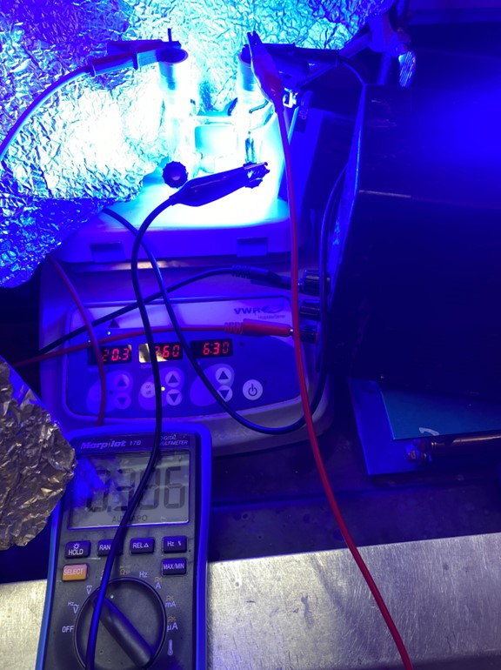
Figure S165. Three-electrode setup for cathode potential measurement.
Cathode potential measurement. Following General Procedure C, ethyl 4-chlorobenzoate (31.3 μL, 0.2 mmol, 1.0 equiv.), B₂Pin₂ (203.2 mg, 0.8 mmol, 4.0 equiv.), pyridine (6.6 μL, 0.08 mmol, 0.4 equiv.) and PTCDA-en-functionalized (0.006 mmol, 0.03 equiv.) carbon felt cathode were combined in the cathodic chamber of an H-cell equipped with an additional reference electrode (Ag/AgCl). NaClO₄ (0.10 M in MeCN) and MeCN (4 mL) were added to both chambers. Then the reaction was stirred at a constant cell potential of 1.8 V at 22 ℃ for 16 h under blue Kessil LED irradiation (40 W). During the course of the reaction, the potential difference between the cathode and the reference electrode was measured at indicated time points using a multimeter (Figure S165). The potential dropped from −0.249 V to −1.209 V in the first 45 min, before stabilizing around −0.956 V (~ −0.65 V vs. SHE, Figure S166) for the remainder of the reaction, which was sufficiently negative to reduce PTCDA-en (Figure S55).
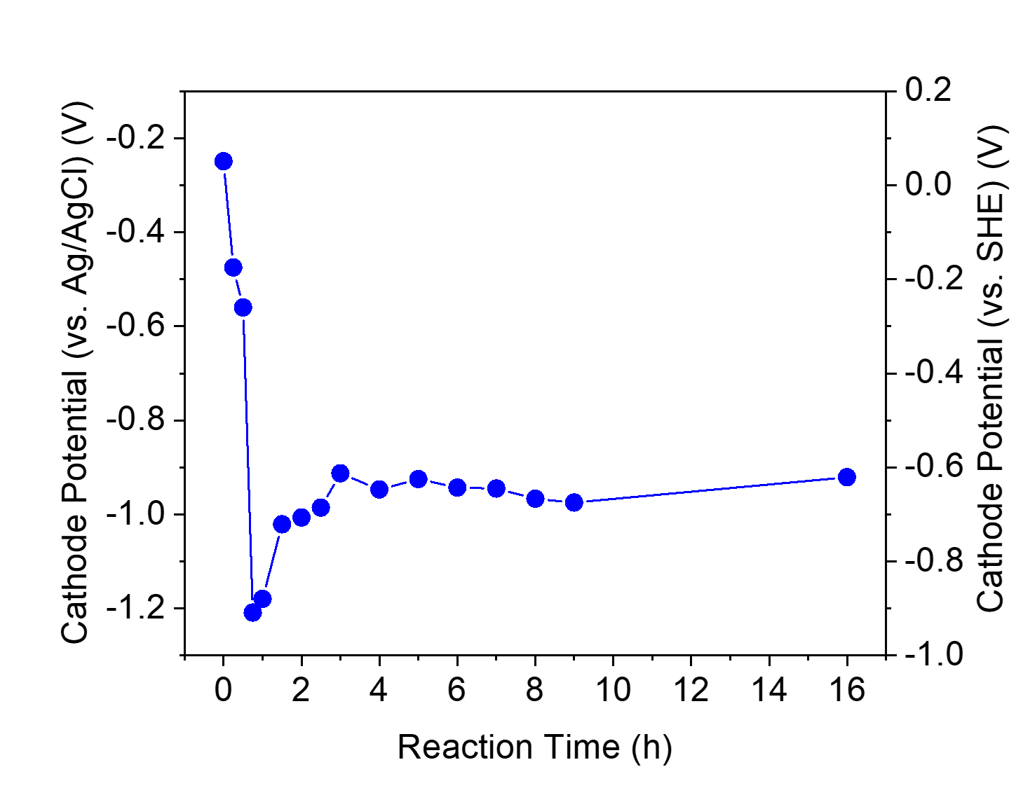
Figure S166. Cathode potential change over the course of the model reaction. Note that the reference electrode (Ag/AgCl) has been measured to be approximately +0.31 V vs. SHE in 0.1 M NaClO₄ in MeCN.

Additional CV characterizations of PTCDA-en.
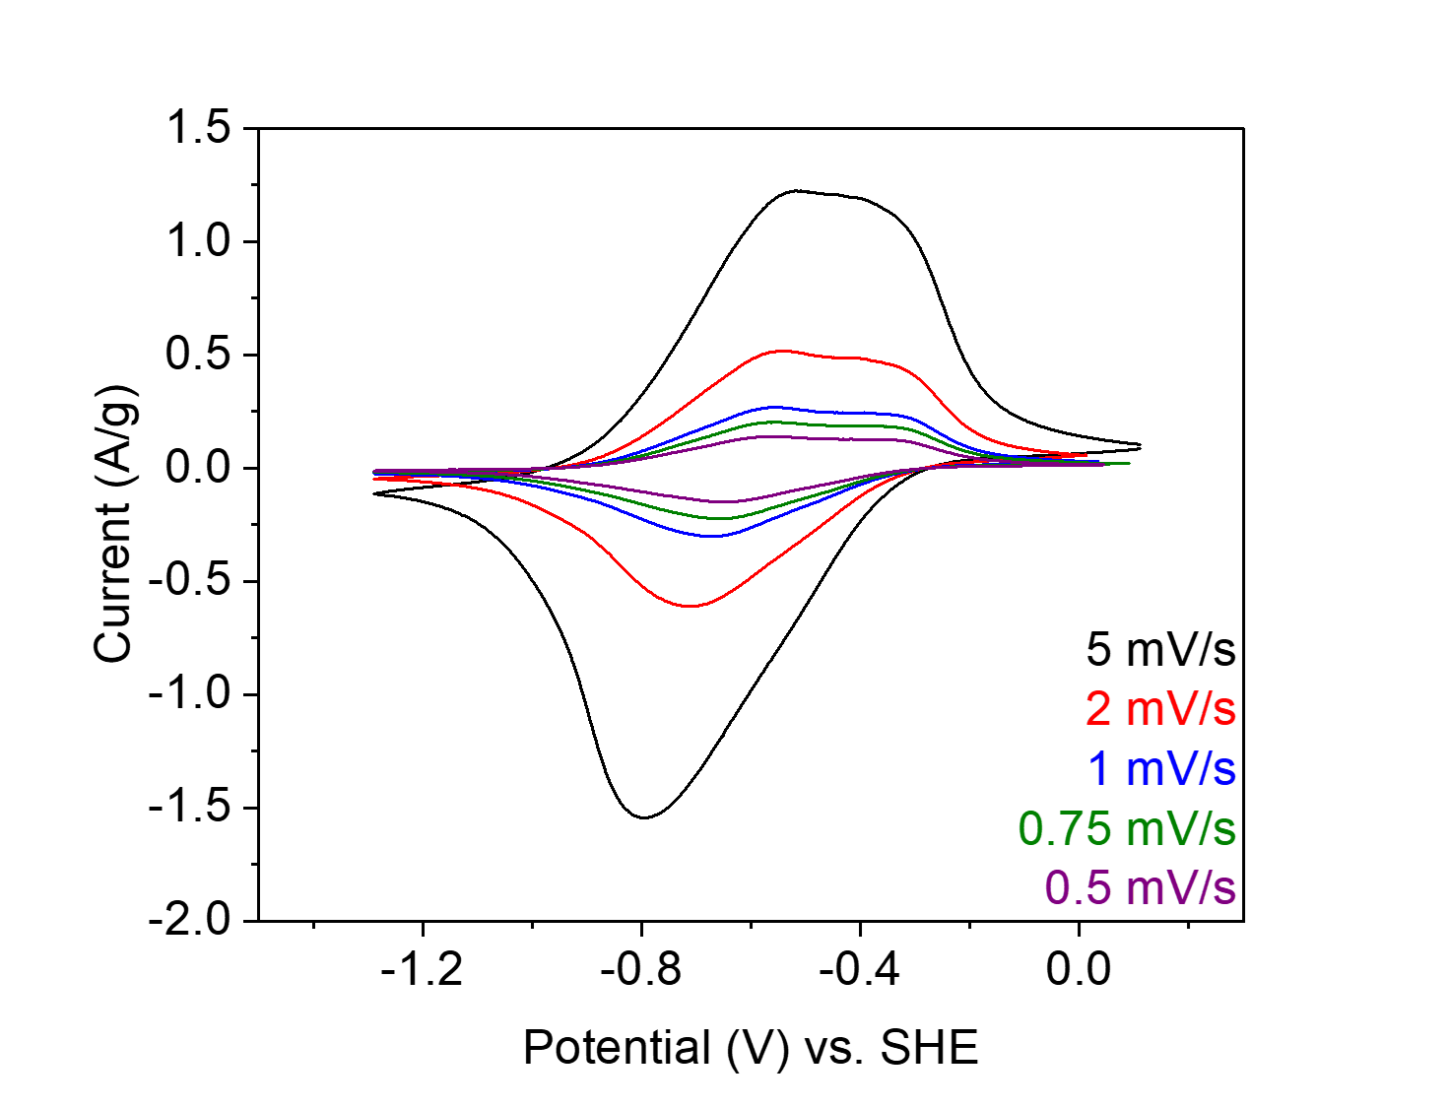
Figure S167. CVs of PTCDA-en in 0.1 M NaClO₄ in MeCN at different scan rates (5 mV s⁻¹, black; 2 mV s⁻¹, red; 1 mV s⁻¹, blue; 0.75 mV s⁻¹, olive; 0.5 mV s⁻¹, purple).
Determination of diffusion limitations. The following analysis was performed according to the literature.^{7,9} The following equation (eq. S1) was used over a range of potentials employed in CV experiments to determine the contribution of surface-controlled kinetics (𝑖 ∝ ν) and diffusion-limited kinetics (𝑖 ∝ ν^{1/2}) to the total current.

𝑖(𝑉) = 𝑘₁𝜈 + 𝑘₂𝜈^{1/2} (eq. S1)

where k₁ is an experimentally determined constant related to the surface-limited current contribution, k₂ is an experimentally determined constant relating to the diffusion-limited current, and 𝜈 is the scan rate of the CV experiment. Integration of the diffusion-limited current term relative to the total integrated current provides the percentage of the charge arising from diffusion-limited processes. Note that CV experiments were performed at 5 different slow scan rates (Figure S167; 5 mV s⁻¹, 2 mV s⁻¹, 1 mV s⁻¹, 0.75 mV s⁻¹, and 0.5 mV s⁻¹).

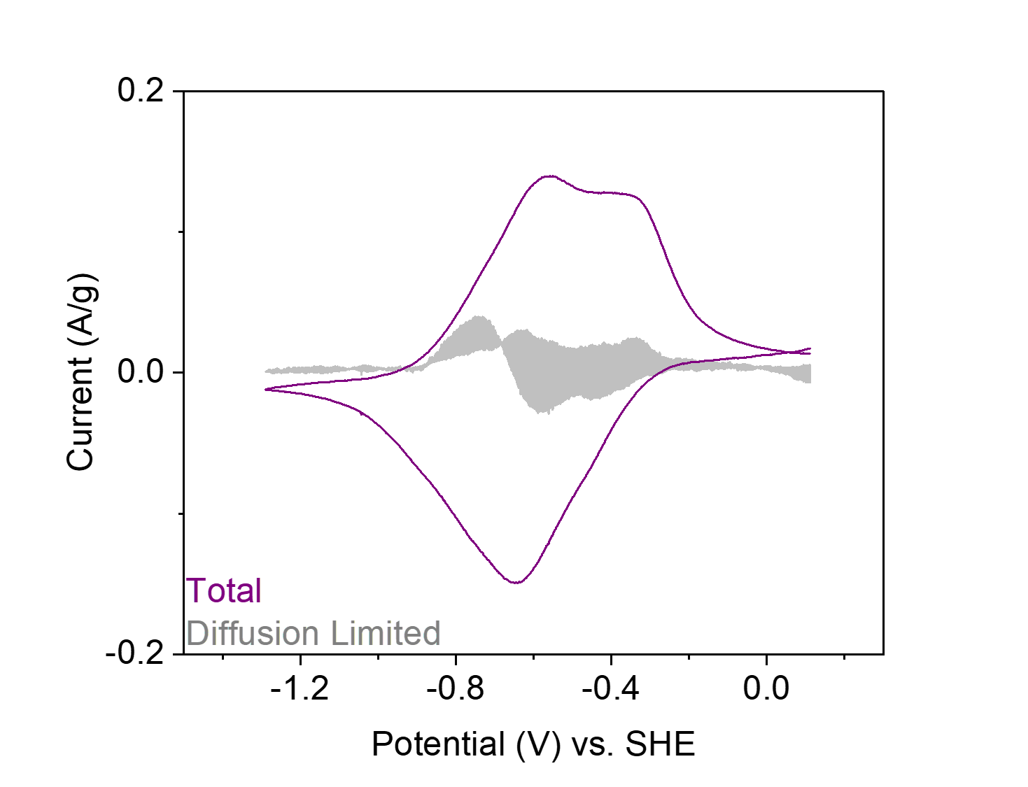
Figure S168. CV at 0.5 mV s⁻¹ of PTCDA-en in 0.1 M NaClO₄ in MeCN, in which the purple line represents the total current and the grey region represents current arising from diffusion-limited processes, calculated from eq. S1.

UV-Vis studies of PTCDA-di^{i}PrAn.

Figure S169. Electrochemical generation of PTCDA-di^{i}PrAn radical anion (PTCDA-di^{i}PrAn^{·−}) in MeCN. Countercations (Na⁺) are omitted for clarity.
General Procedure F: electrochemical generation of PTCDA-di^{i}PrAn^{·−} in MeCN. In a N₂-filled glovebox, an oven-dried custom-made H-type divided cell was equipped with a stir bar on each side, a carbon felt cathode, and a Zn plate anode (Figure S137). The cathodic chamber was charged with PTCDA-di^{i}PrAn (7.10 mg, 0.01 mmol) and NaClO₄ (49 mg, 0.40 mmol, for a final concentration of 0.10 M in MeCN), while the anodic chamber was charged with NaClO₄ (49 mg, 0.40 mmol, for a final concentration of 0.10 M in MeCN). Then, anhydrous degassed MeCN (4.0 mL) was added to each chamber. Subsequently, the cell was sealed and allowed to stir at a constant cell potential of 1.6 V at 22 ℃. Aliquots (0.2 mL) were taken from the cathodic chamber at indicated time points and diluted with additional MeCN (4.0 mL), before being analyzed by UV-Vis absorption spectroscopy. After 5 min, PTCDA-di^{i}PrAn has been completely converted to PTCDA-di^{i}PrAn^{·−} (Figure S171). The UV-Vis absorption spectra of PTCDA-di^{i}PrAn^{·−} in MeCN are consistent with those reported in the literature.^{19–21}

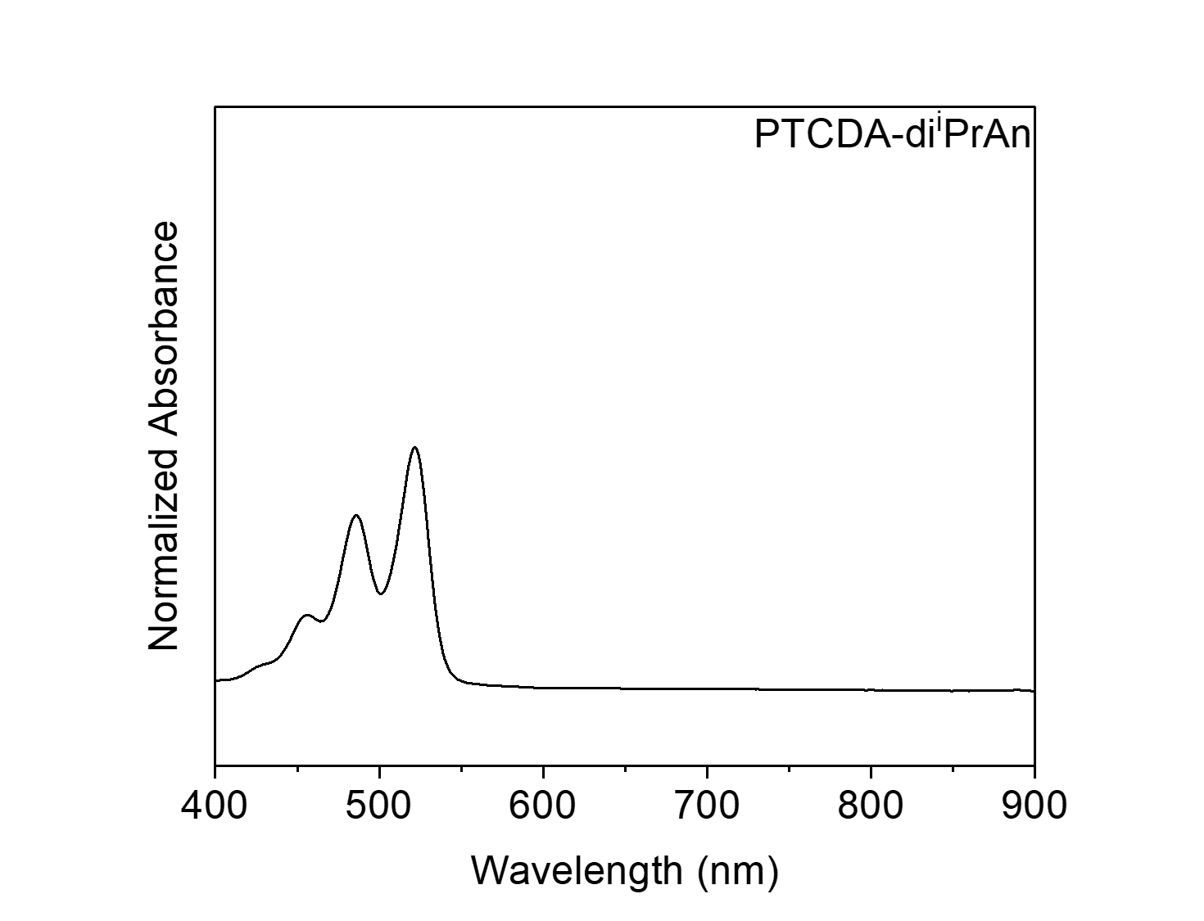
Figure S170. UV-Vis absorption spectrum of PTCDA-di^{i}PrAn in MeCN.
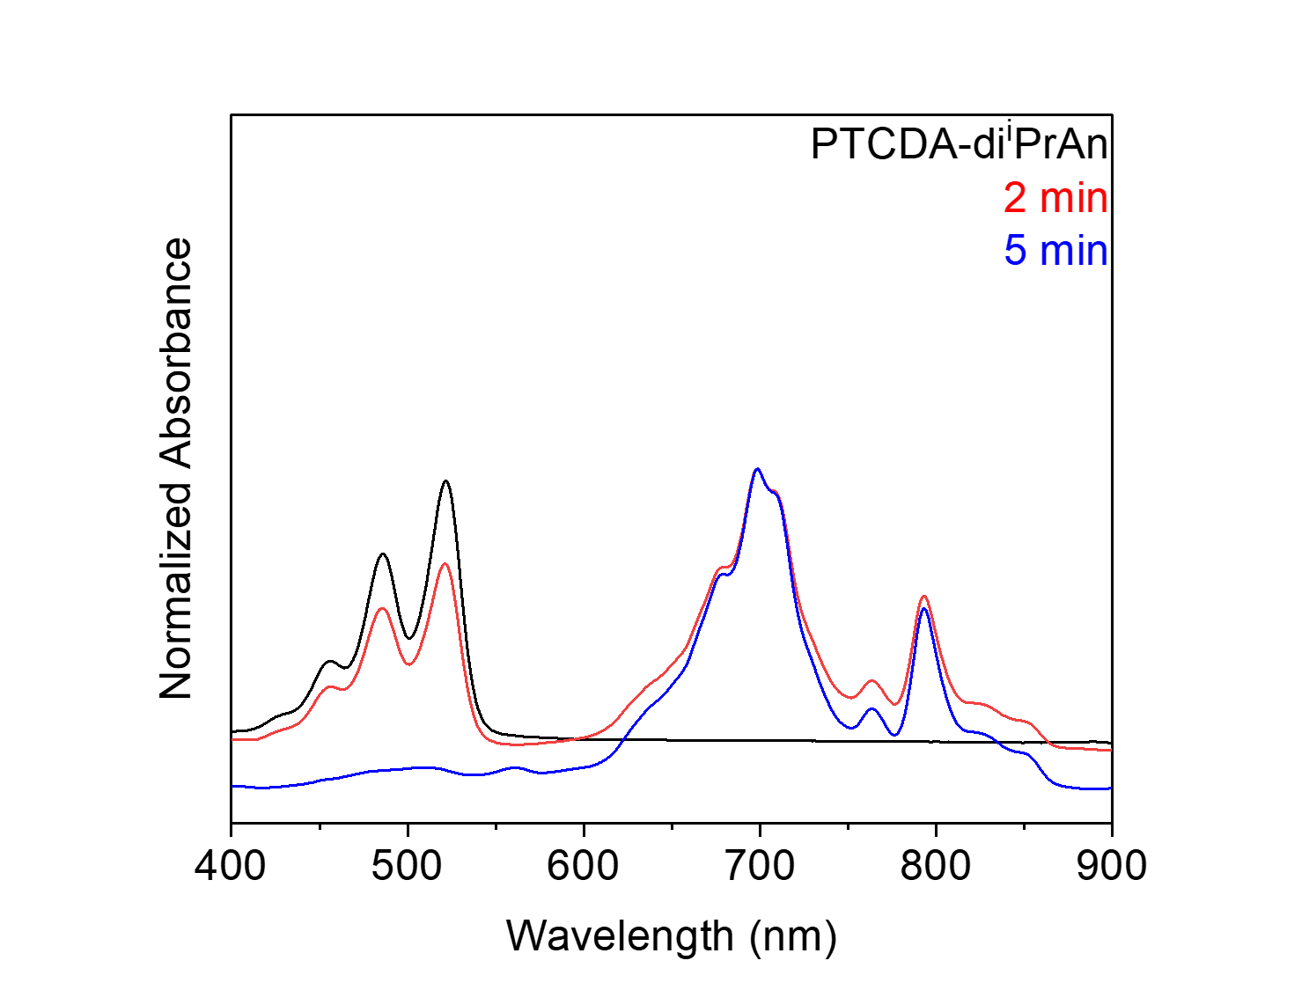
Figure S171. UV-Vis absorption spectra of the electrochemical generation of PTCDA-di^{i}PrAn^{·−} in MeCN. Note that after 5 min, PTCDA-di^{i}PrAn (black) has been completely converted to PTCDA-di^{i}PrAn^{·−} (blue).

Figure S172. Electrochemical generation of PTCDA-di^{i}PrAn dianion (PTCDA-di^{i}PrAn²⁻) in MeCN. Countercations (Na⁺) are omitted for clarity.
General Procedure G: electrochemical generation of PTCDA-di^{i}PrAn²⁻ in MeCN. In a N₂-filled glovebox, an oven-dried custom-made H-type divided cell was equipped with a stir bar on each side, a carbon felt cathode, and a Zn plate anode (Figure S137). The cathodic chamber was charged with PTCDA-di^{i}PrAn (7.10 mg, 0.01 mmol) and NaClO₄ (49 mg, 0.40 mmol, for a final concentration of 0.10 M in MeCN), while the anodic chamber was charged with NaClO₄ (49 mg, 0.40 mmol, for a final concentration of 0.10 M in MeCN). Then, anhydrous degassed MeCN (4.0 mL) was added to each chamber. Subsequently, the cell was sealed and allowed to stir at a constant cell potential of 1.6 V at 22 ℃. Aliquots (0.2 mL) were taken from the cathodic chamber at indicated time points and diluted with additional MeCN (4.0 mL), before being analyzed by UV-Vis absorption spectroscopy. After 2 h, PTCDA-di^{i}PrAn has been completely converted to PTCDA-di^{i}PrAn²⁻ (Figure S173). The UV-Vis absorption spectra of PTCDA-di^{i}PrAn²⁻ in MeCN are consistent with those reported in the literature.^{20,21}

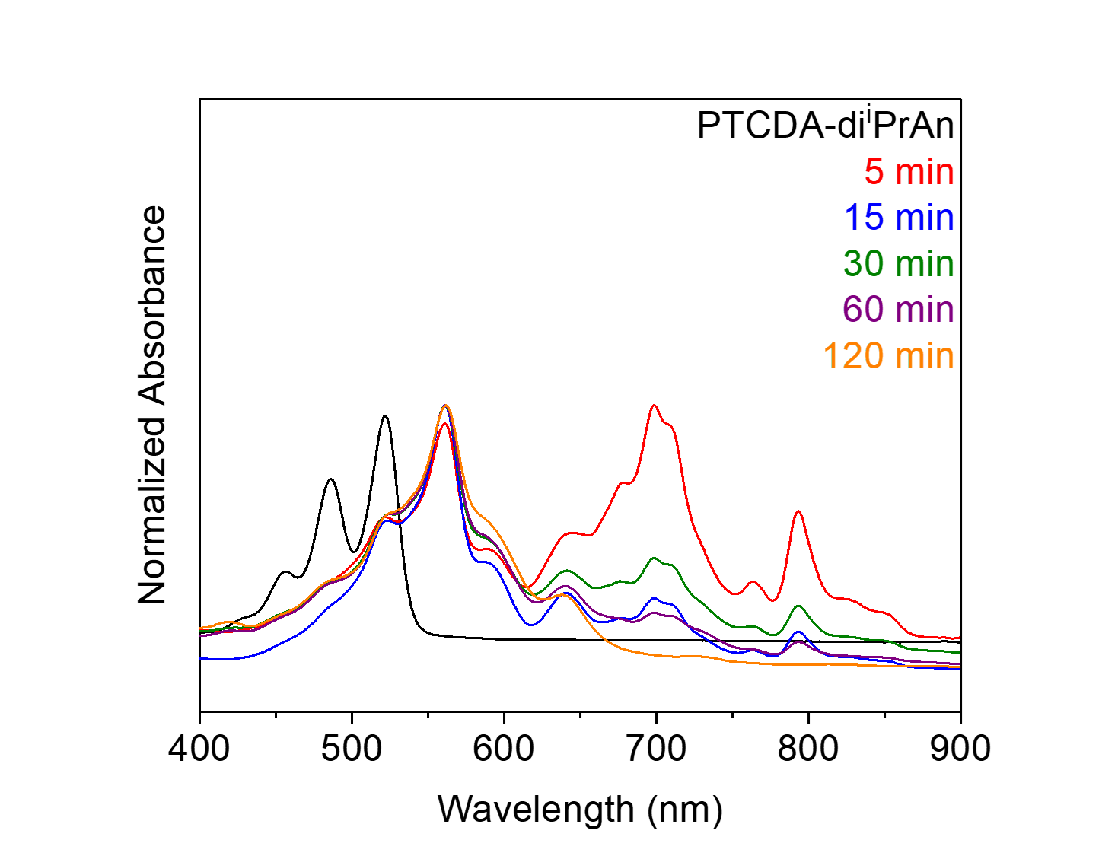
Figure S173. UV-Vis absorption spectra of the electrochemical generation of PTCDA-di^{i}PrAn²⁻ in MeCN. Note that after 2 h, PTCDA-di^{i}PrAn (black) has been completely converted to PTCDA-di^{i}PrAn²⁻ (orange).
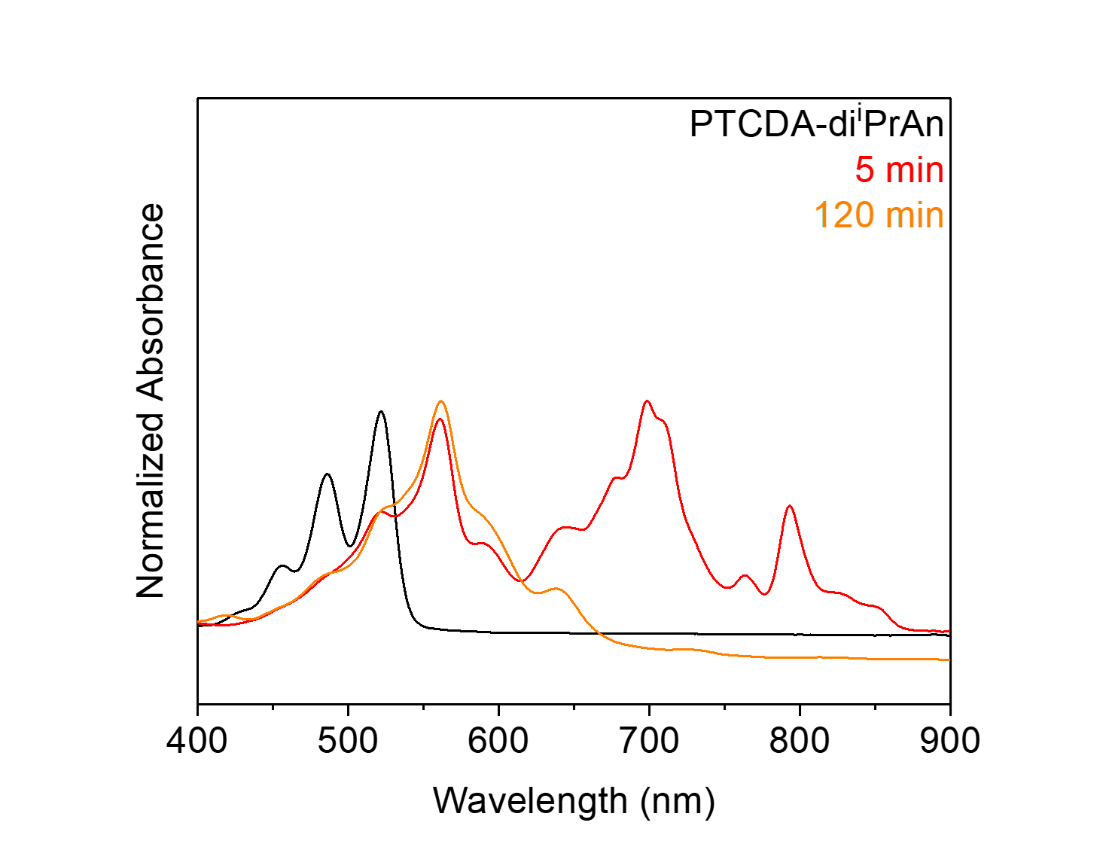
Figure S174. UV-Vis absorption spectra of PTCDA-di^{i}PrAn (black), the electrogenerated PTCDA-di^{i}PrAn^{·−} (red) and PTCDA-di^{i}PrAn²⁻ (orange) in MeCN.

Figure S175. Electrochemical generation of PTCDA-di^{i}PrAn radical anion (PTCDA-di^{i}PrAn^{·−}) in DMF. Countercations (Na⁺) are omitted for clarity.
Electrochemical generation of PTCDA-di^{i}PrAn^{·−} in DMF. Following General Procedure F, except DMF was used as the solvent. After 5 min, PTCDA-di^{i}PrAn was completely converted to PTCDA-di^{i}PrAn^{·−} (Figure S177). The UV-Vis absorption spectra of PTCDA-di^{i}PrAn^{·−} in DMF are consistent with those reported in the literature.^{19–21}

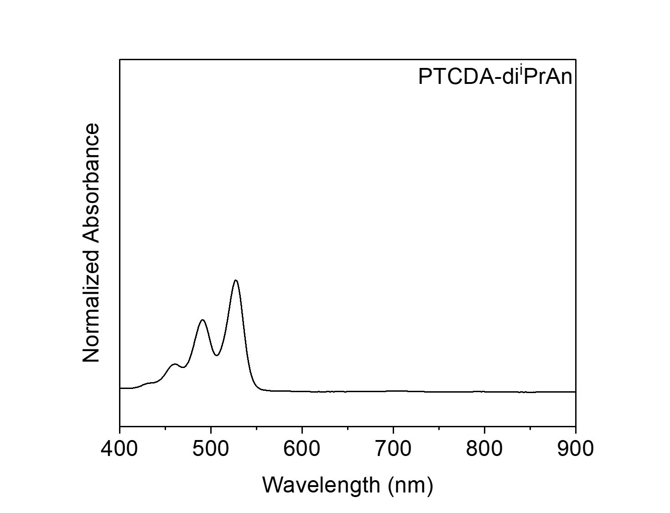
Figure S176. UV-Vis absorption spectrum of PTCDA-di^{i}PrAn in DMF.
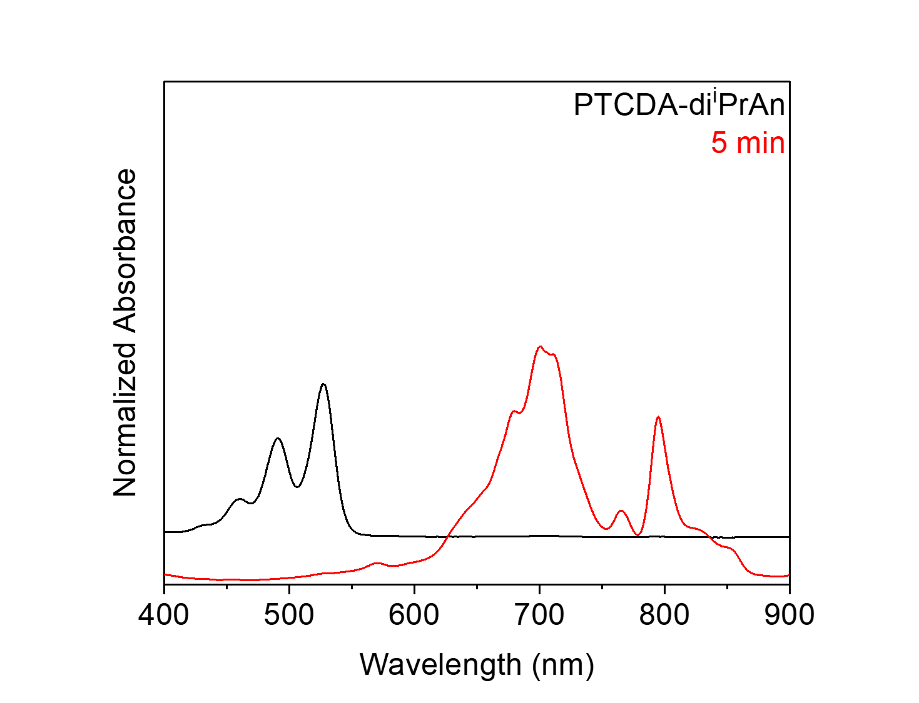
Figure S177. UV-Vis absorption spectra of the electrochemical generation of PTCDA-di^{i}PrAn^{·−} in DMF. Note that after 5 min, PTCDA-di^{i}PrAn (black) has been completely converted to PTCDA-di^{i}PrAn^{·−} (red).

Figure S178. Electrochemical generation of PTCDA-di^{i}PrAn dianion (PTCDA-di^{i}PrAn²⁻) in DMF. Countercations (Na⁺) are omitted for clarity.
Electrochemical generation of PTCDA-di^{i}PrAn²⁻ in DMF. Following General Procedure G, except DMF was used as the solvent. After 2 h, PTCDA-di^{i}PrAn was completely converted to PTCDA-di^{i}PrAn²⁻ (Figure S179). The UV-Vis absorption spectra of PTCDA-di^{i}PrAn²⁻ in DMF are consistent with those reported in the literature.^{20,21}

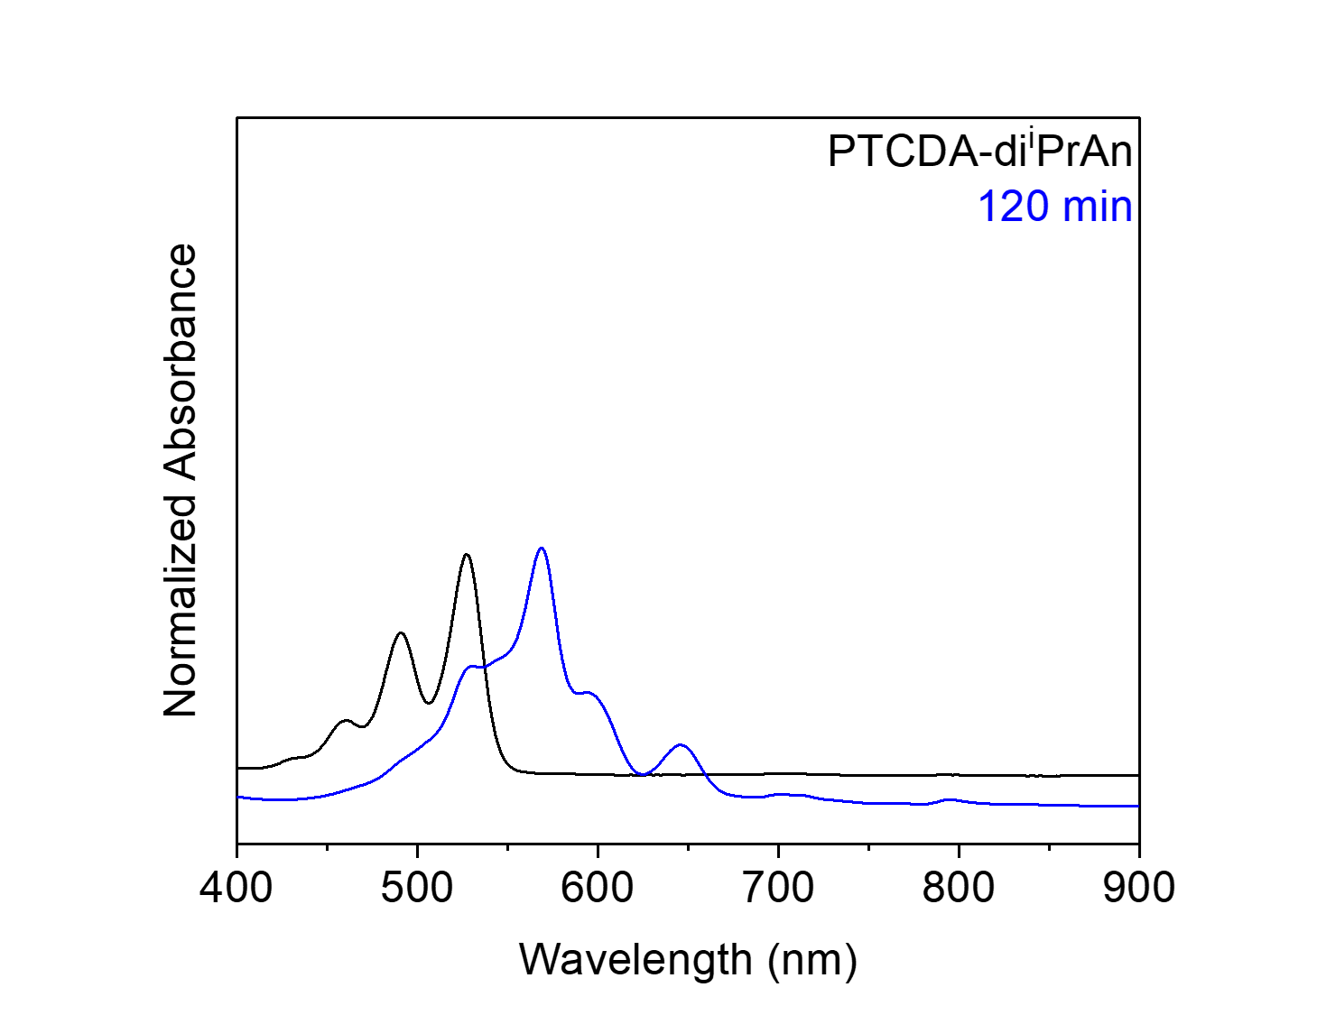
Figure S179. UV-Vis absorption spectra of the electrochemical generation of PTCDA-di^{i}PrAn²⁻ in DMF. Note that after 2 h, PTCDA-di^{i}PrAn (black) has been completely converted to PTCDA-di^{i}PrAn²⁻ (blue).
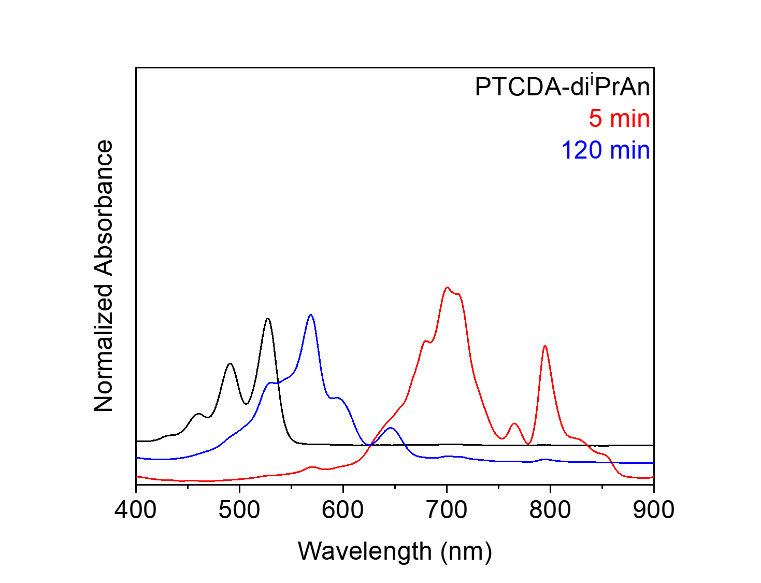
Figure S180. UV-Vis absorption spectra of PTCDA-di^{i}PrAn (black), the electrogenerated PTCDA-di^{i}PrAn^{·−} (red) and PTCDA-di^{i}PrAn²⁻ (blue) in DMF.

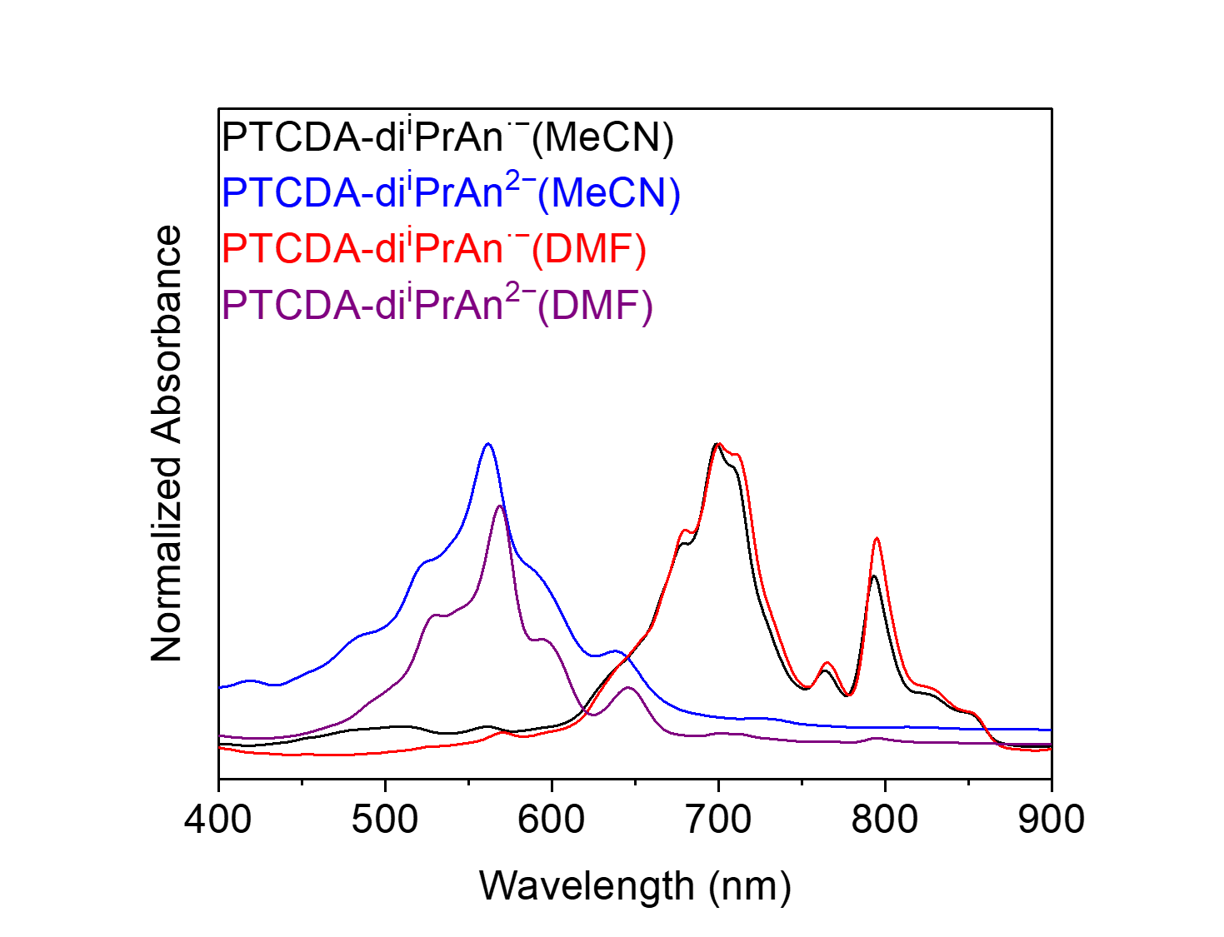
Figure S181. UV-Vis absorption spectra of the electrogenerated PTCDA-di^{i}PrAn^{·−} (MeCN, black; DMF, red) and PTCDA-di^{i}PrAn²⁻ (MeCN, blue; DMF, purple). The electrogenerated PTCDA-di^{i}PrAn^{·−} and PTCDA-di^{i}PrAn²⁻ have very similar absorption spectra in DMF and MeCN.

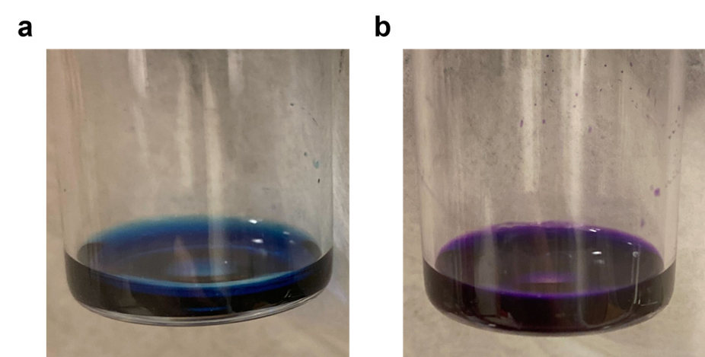
Figure S182. The electrogenerated (a) PTCDA-di^{i}PrAn^{·−} and (b) PTCDA-di^{i}PrAn²⁻.
As discussed below, PTCDA-di^{i}PrAn^{·−} and PTCDA-di^{i}PrAn²⁻ can also be generated using tetrakis(dimethylamino)ethylene (TDAE), a chemical reductant. Similar to electrochemical reduction, PTCDA-di^{i}PrAn^{·−} can be cleanly generated using 1 equiv. of TDAE in both MeCN (Figure S184) and DMF (Figure S190), whereas PTCDA-di^{i}PrAn²⁻ can be cleanly generated using 200 equiv. of TDAE in MeCN (Figure S188), or 3300 equiv. of TDAE in DMF (Figure S194).
Figure S183. Chemical generation of PTCDA-di^{i}PrAn radical anion (PTCDA-di^{i}PrAn^{·−}) in MeCN using TDAE. Countercations (TDAE²⁺) are omitted for clarity.
General Procedure H: chemical generation of PTCDA-di^{i}PrAn^{·−} in MeCN. In a N₂-filled glovebox, a 20 mL scintillation vial was charged with PTCDA-di^{i}PrAn (7.10 mg, 0.01 mmol, 1.0 equiv.) and anhydrous degassed MeCN (8.0 mL). Subsequently, TDAE (2.3 μL, 0.01 mmol, 1.0 equiv.) was added, and the solution instantly turned blue. The solution was thoroughly swirled, and aliquots (0.2 mL) were taken from the solution and diluted with additional MeCN (4.0 mL), before being analyzed by UV-Vis absorption spectroscopy, which revealed complete conversion of PTCDA-di^{i}PrAn to PTCDA-di^{i}PrAn^{·−}. Note that adding substoichiometric amounts of TDAE (1.2 μL, 0.005 mmol, 0.50 equiv., or 1.7 μL, 0.0075 mmol, 0.75 equiv.) also results in complete detectable conversion of PTCDA-di^{i}PrAn to PTCDA-di^{i}PrAn^{·−} (Figure S184).

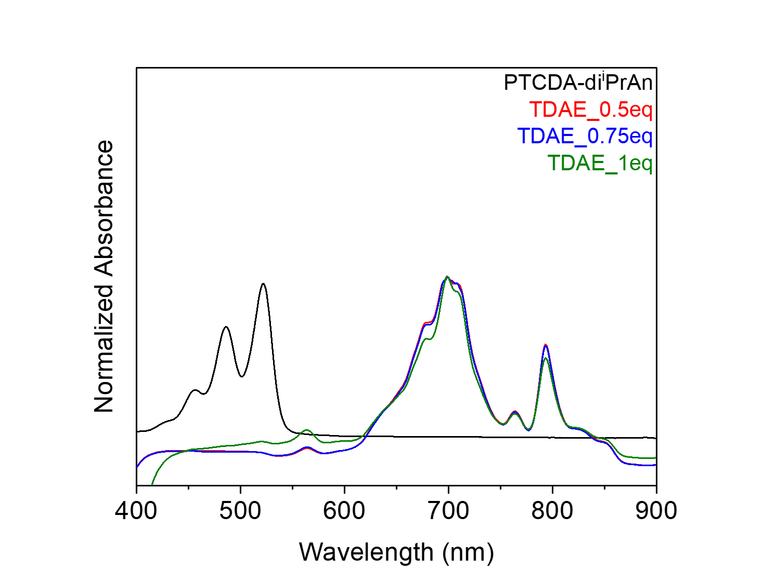
Figure S184. UV-Vis absorption spectra of the chemical generation of PTCDA-di^{i}PrAn^{·−} in MeCN using TDAE. Note that adding 0.50 equiv. (red), 0.75 equiv. (blue), and 1.0 equiv. (olive) of TDAE all results in the complete detectable conversion of PTCDA-di^{i}PrAn (black) to PTCDA-di^{i}PrAn^{·−}.

Figure S185. Chemical generation of PTCDA-di^{i}PrAn dianion (PTCDA-di^{i}PrAn²⁻) in MeCN using TDAE. Countercations (TDAE²⁺) are omitted for clarity.
Chemical generation of PTCDA-di^{i}PrAn²⁻ in MeCN. In a N₂-filled glovebox, a 20 mL scintillation vial was charged with PTCDA-di^{i}PrAn (7.10 mg, 0.01 mmol, 1.0 equiv.) and anhydrous degassed MeCN (8.0 mL). Subsequently, TDAE (465 μL, 2.00 mmol, 200 equiv.) was added, and the solution instantly turned purple. The solution was thoroughly swirled, and aliquots (0.2 mL) were taken from the solution and diluted with additional MeCN (4.0 mL), before being analyzed by UV-Vis absorption spectroscopy, which revealed complete conversion of PTCDA-di^{i}PrAn to PTCDA-di^{i}PrAn²⁻ (Figure S186a). Note that adding less than 200 equiv. of TDAE results in a mixture of PTCDA-di^{i}PrAn^{·−} and PTCDA-di^{i}PrAn²⁻ (Figure S186b).

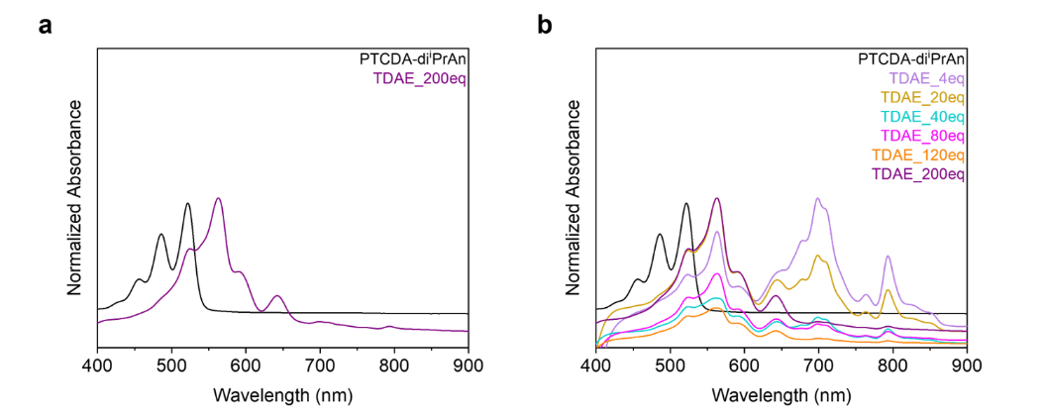
Figure S186. UV-Vis absorption spectra of the chemical generation of PTCDA-di^{i}PrAn²⁻ in MeCN using TDAE. Note that (a) adding 200 equiv. of TDAE results in the complete conversion of PTCDA-di^{i}PrAn (black) to PTCDA-di^{i}PrAn²⁻ (purple), and (b) adding less than 200 equiv. of TDAE results in a mixture of PTCDA-di^{i}PrAn^{·−} and PTCDA-di^{i}PrAn²⁻.

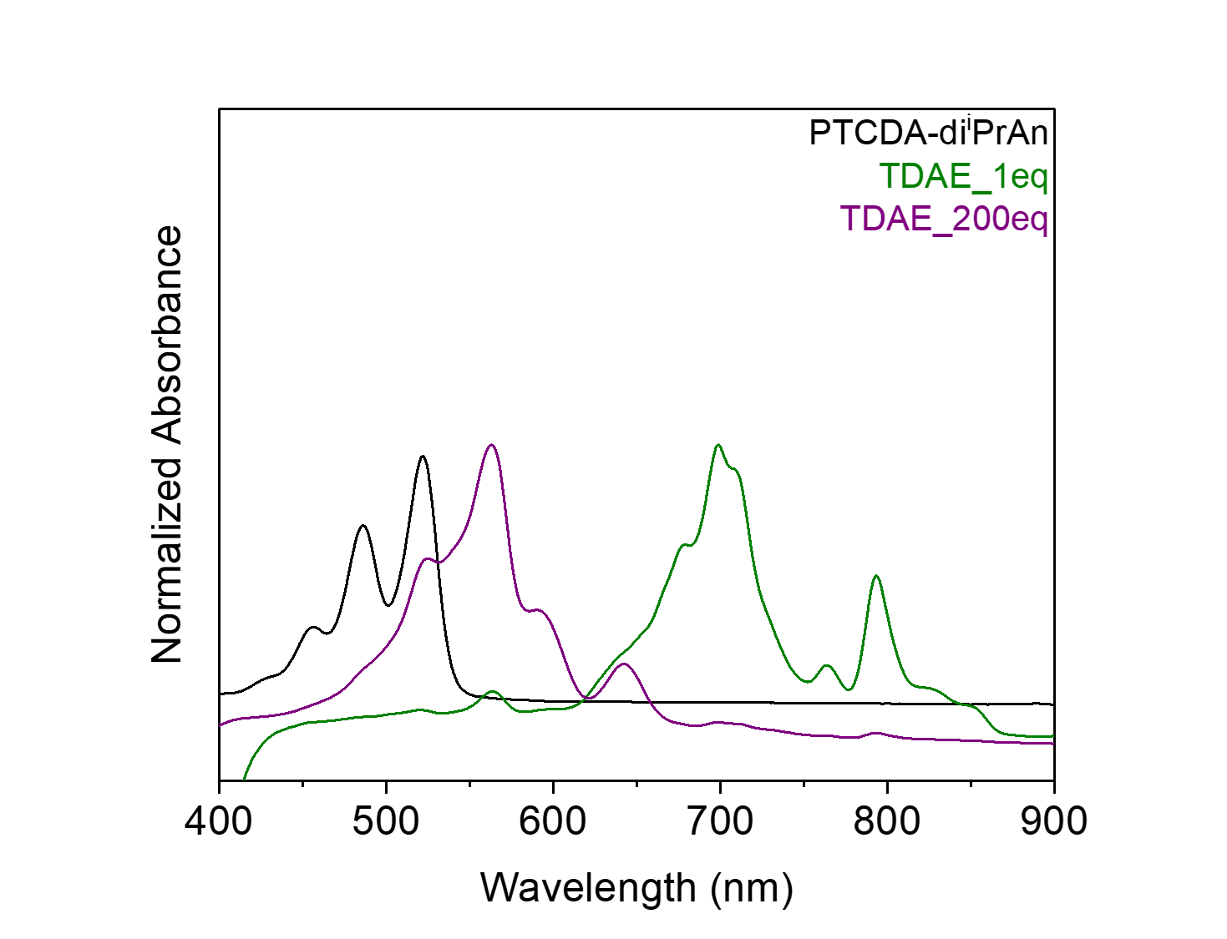
Figure S187. UV-Vis absorption spectra of the chemical generation of PTCDA-di^{i}PrAn^{·−} (olive) and PTCDA-di^{i}PrAn²⁻ (purple) in MeCN using TDAE.

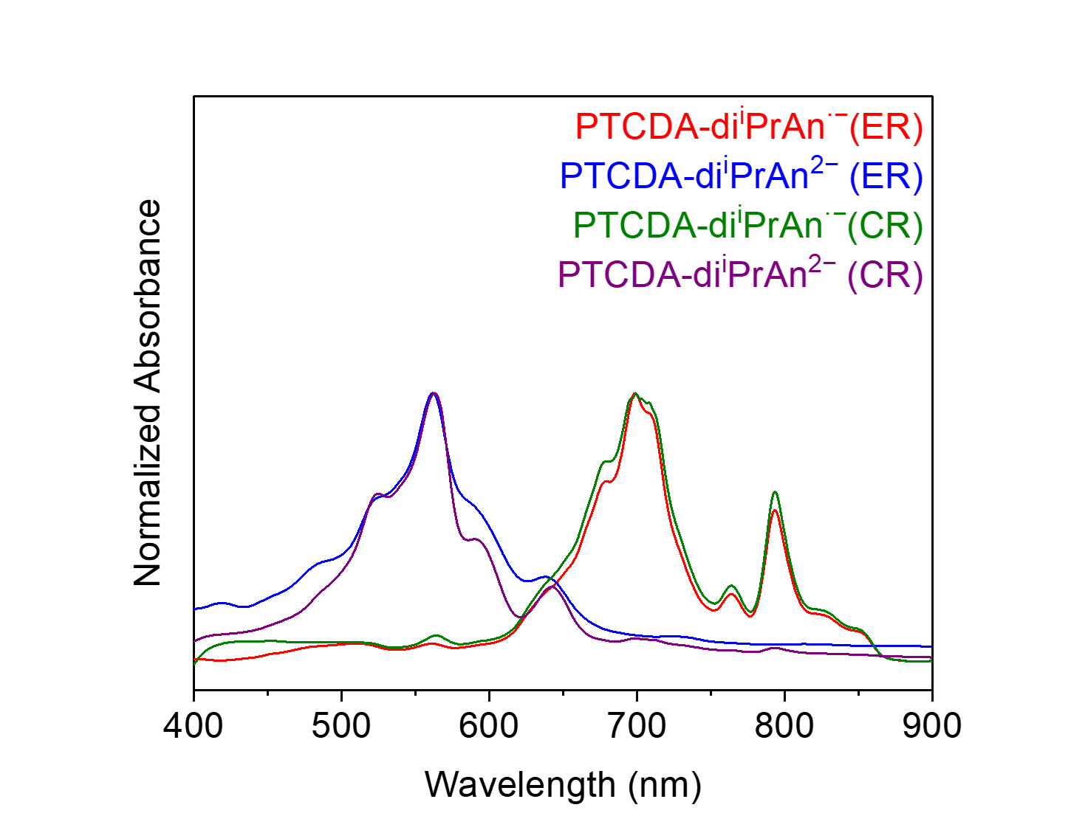
Figure S188. UV-Vis absorption spectra of the electrogenerated PTCDA-di^{i}PrAn^{·−} (red) and PTCDA-di^{i}PrAn²⁻ (blue), and the chemically generated PTCDA-di^{i}PrAn^{·−} (olive) and PTCDA-di^{i}PrAn²⁻ (purple) in MeCN. ER = electrochemically reduced, and CR = chemically reduced. The electrogenerated PTCDA-di^{i}PrAn^{·−} and PTCDA-di^{i}PrAn²⁻ have very similar absorption spectra compared to those generated chemically using TDAE as the reductant, indicating that similar species are formed in these processes (electrochemical reduction and chemical reduction).

Figure S189. Chemical generation of PTCDA-di^{i}PrAn radical anion (PTCDA-di^{i}PrAn^{·−}) in DMF using TDAE. Countercations (TDAE²⁺) are omitted for clarity.
Chemical generation of PTCDA-di^{i}PrAn^{·−} in DMF. Following General Procedure H, except DMF was used as the solvent. UV-Vis absorption spectrum revealed the complete detectable conversion of PTCDA-di^{i}PrAn to PTCDA-di^{i}PrAn^{·−} (Figure S190).
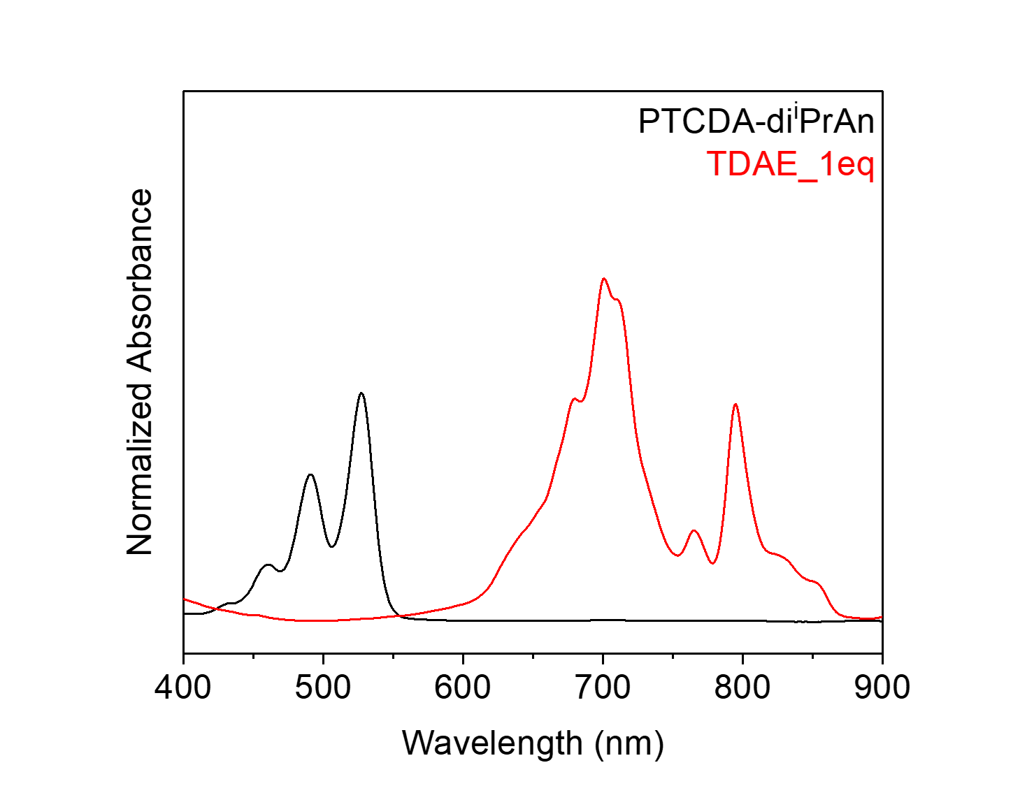
Figure S190. UV-Vis absorption spectra of the chemical generation of PTCDA-di^{i}PrAn^{·−} in DMF using TDAE.

Figure S191. Chemical generation of PTCDA-di^{i}PrAn dianion (PTCDA-di^{i}PrAn²⁻) in DMF using TDAE. Countercations (TDAE²⁺) are omitted for clarity.
Chemical generation of PTCDA-di^{i}PrAn²⁻ in DMF. In a N₂-filled glovebox, a 20 mL scintillation vial was charged with PTCDA-di^{i}PrAn (7.10 mg, 0.01 mmol, 1.0 equiv.) and anhydrous degassed DMF (8.0 mL). Subsequently, TDAE (7.68 mL, 33.00 mmol, 3300 equiv.) was added, and the solution instantly turned purple. The solution was thoroughly swirled, and aliquots (0.2 mL) were taken from the solution and diluted with additional DMF (4.0 mL), before being analyzed by UV-Vis absorption spectroscopy, which revealed complete conversion of PTCDA-di^{i}PrAn to PTCDA-di^{i}PrAn²⁻ (Figure S192a). Note that adding less than 3300 equiv. of TDAE results in a mixture of PTCDA-di^{i}PrAn^{·−} and PTCDA-di^{i}PrAn²⁻ (Figure S192b).
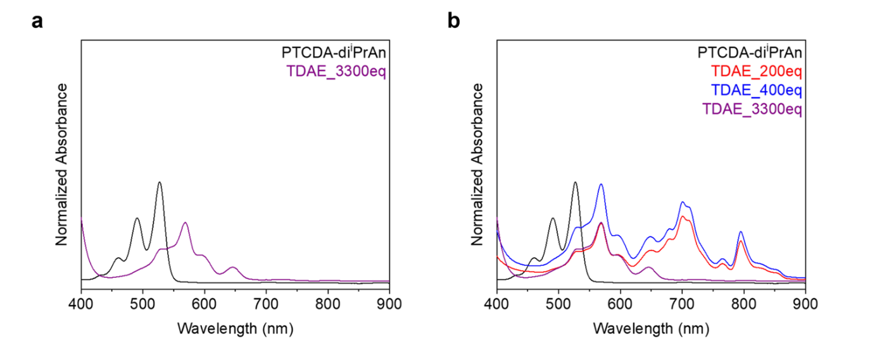
Figure S192. UV-Vis absorption spectra of the chemical generation of PTCDA-di^{i}PrAn²⁻ in DMF using TDAE. Note that (a) adding 3300 equiv. of TDAE results in the complete conversion of PTCDA-di^{i}PrAn (black) to PTCDA-di^{i}PrAn²⁻ (purple), and (b) adding less than 3300 equiv. of TDAE results in a mixture of PTCDA-di^{i}PrAn^{·−} and PTCDA-di^{i}PrAn²⁻.
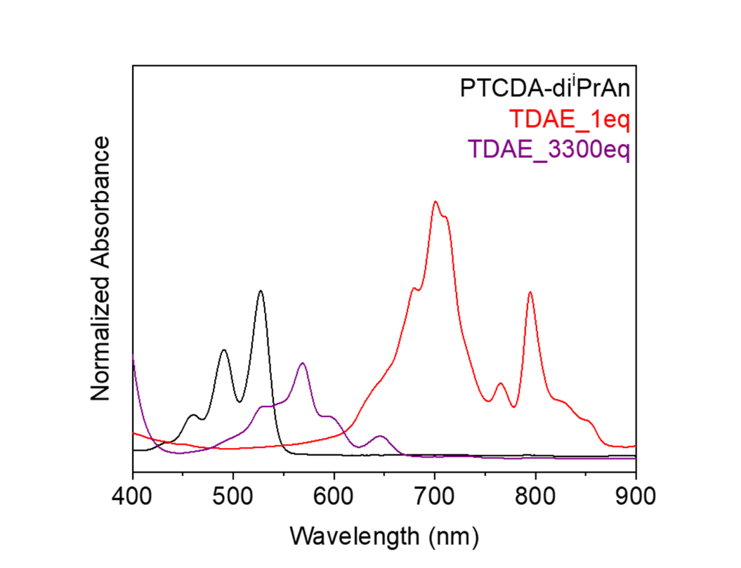
Figure S193. UV-Vis absorption spectra of the chemical generation of PTCDA-di^{i}PrAn^{·−} (red) and PTCDA-di^{i}PrAn²⁻ (purple) in DMF using TDAE.
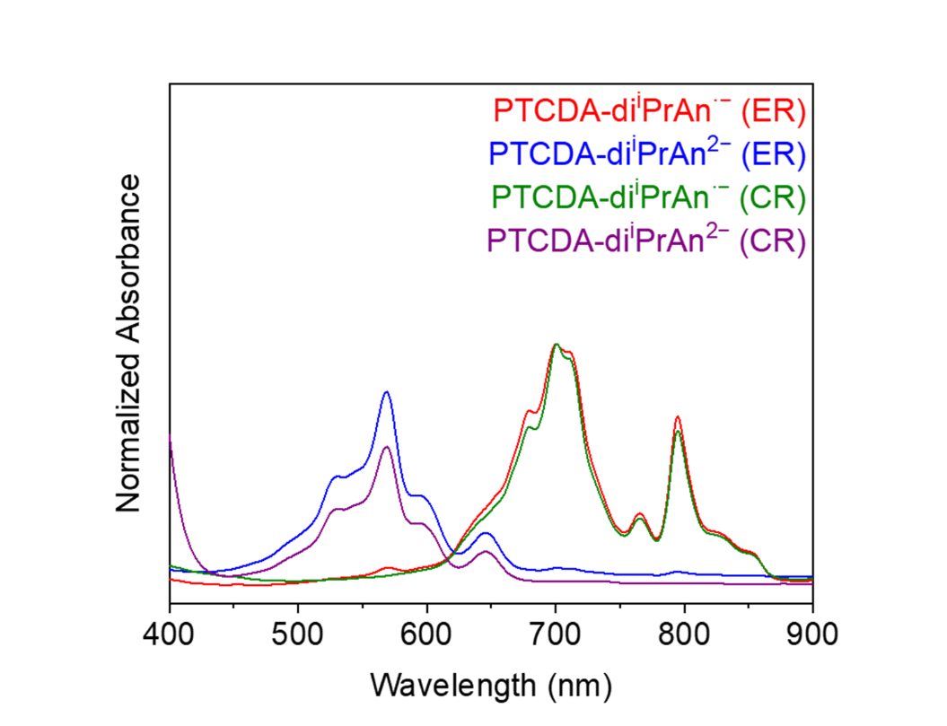
Figure S194. UV-Vis absorption spectra of the electrogenerated PTCDA-di^{i}PrAn^{·−} (red) and PTCDA-di^{i}PrAn²⁻ (blue), and the chemically generated PTCDA-di^{i}PrAn^{·−} (olive) and PTCDA-di^{i}PrAn²⁻ (purple) in DMF. ER = electrochemically reduced, and CR = chemically reduced. The electrogenerated PTCDA-di^{i}PrAn^{·−} and PTCDA-di^{i}PrAn²⁻ have very similar absorption spectra compared to those generated chemically using TDAE as the reductant, indicating that similar species are formed in these processes (electrochemical reduction and chemical reduction).
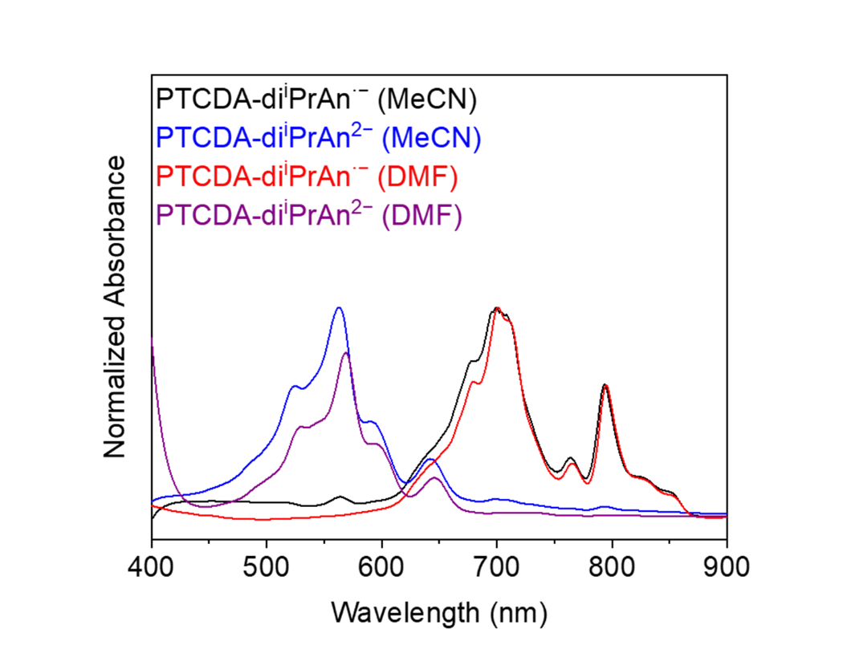
Figure S195. UV-Vis absorption spectra of the chemically generated PTCDA-di^{i}PrAn^{·−} (MeCN, black; DMF, red) and PTCDA-di^{i}PrAn²⁻ (MeCN, blue; DMF, purple). The chemically generated PTCDA-di^{i}PrAn^{·−} and PTCDA-di^{i}PrAn²⁻ have very similar absorption spectra in DMF and MeCN.

UV-Vis studies of PTCDA-en.

Figure S196. Chemical generation of PTCDA-en radical anion (PTCDA-en^{·−}) in DMF using TDAE. Countercations (TDAE²⁺) are omitted for clarity.
A complicating factor is the poor solubility of reduced PTCDA-en in the reaction solvent (MeCN), which is helpful for catalysis (to keep the polymer grafted to the electrode surface) but hinders spectroscopic characterization. Similarly, while electrochemical reduction can be employed to cleanly reduce PTCDA-di^{i}PrAn to the corresponding monoanion (PTCDA-di^{i}PrAn^{·−}) or dianion (PTCDA-di^{i}PrAn²⁻) in both MeCN and DMF, as confirmed by UV-Vis spectroscopy (Figure S181),^{19–21} this is more challenging for PTCDA-en, which must be grafted to a carbon electrode to be electrochemically reduced. To overcome the latter issue, we turned to chemical reduction using TDAE. While PTCDA-en remains insoluble upon treatment with TDAE in MeCN, it dissolves in DMF, allowing for clean access to the solubilized PTCDA-en^{·−} (Figure S197) and PTCDA-en²⁻ (Figure S199) for spectroscopic characterization.
Chemical generation of PTCDA-en^{·−} in DMF. In a N₂-filled glovebox, a 20 mL scintillation vial was charged with PTCDA-en (41.6 mg, 0.10 mmol, 1.0 equiv.) and anhydrous degassed DMF (8.0 mL). Subsequently, TDAE (23.3 μL, 0.10 mmol, 1.0 equiv.) was added, and the solution instantly turned dark greenish blue. The solution was thoroughly swirled, and aliquots (0.2 mL) were taken from the solution and diluted with additional DMF (4.0 mL), before being analyzed by UV-Vis absorption spectroscopy, which revealed the generation of a species that shares similar spectroscopic features to PTCDA-di^{i}PrAn^{·−} (Figure S197). Note that unreduced PTCDA-en has minimal solubility in DMF and MeCN, thus solution-state UV-Vis of the unreduced PTCDA-en could not be obtained (see Figure S50 for the solid-state UV-Vis absorption spectrum of PTCDA-en dispersed in BaSO₄).

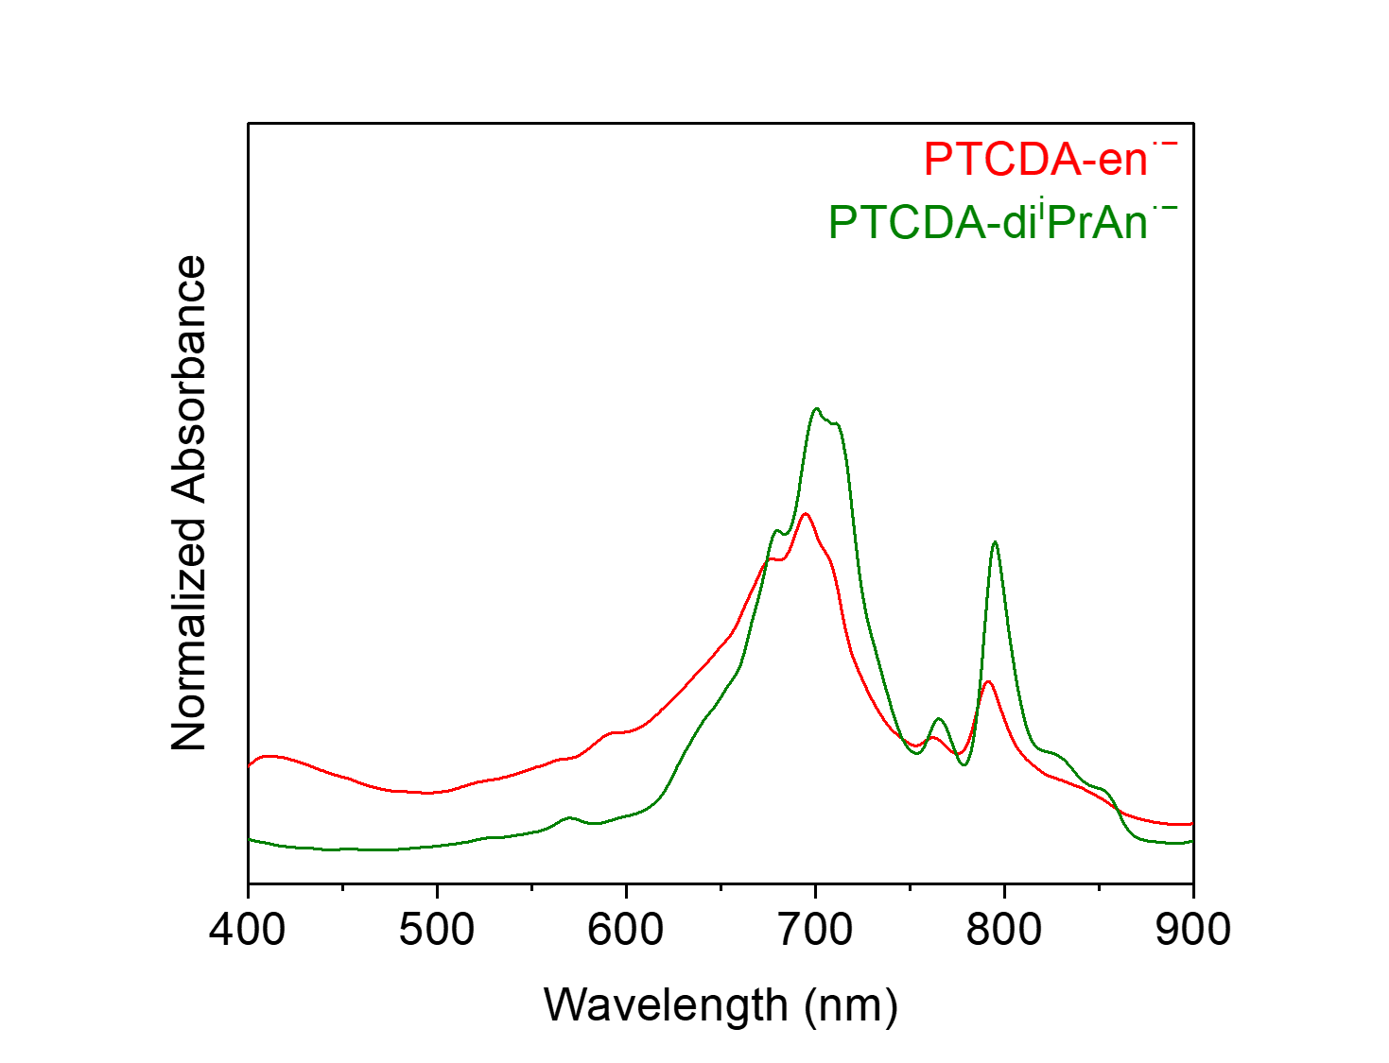
Figure S197. UV-Vis absorption spectrum of the chemically generated PTCDA-en^{·−} (red) in DMF. Note that it shares similar spectroscopic features to PTCDA-di^{i}PrAn^{·−} (olive) in DMF.

Figure S198. Chemical generation of PTCDA-en dianion (PTCDA-en²⁻) in DMF using TDAE. Countercations (TDAE²⁺) are omitted for clarity.
Chemical generation of PTCDA-en²⁻ in DMF. In a N₂-filled glovebox, a 20 mL scintillation vial was charged with PTCDA-en (2.5 mg, 0.006 mmol, 1.0 equiv.) and anhydrous degassed DMF (2.0 mL). Subsequently, TDAE (280 μL, 1.20 mmol, 200 equiv.) was added, and the solution instantly turned purple. The solution was thoroughly swirled, and aliquots (0.2 mL) were taken from the solution and diluted with additional DMF (4.0 mL), before being analyzed by UV-Vis absorption spectroscopy, which revealed the generation of a species that shares similar spectroscopic features to PTCDA-di^{i}PrAn²⁻ (Figure S199). Note that unreduced PTCDA-en has minimal solubility in DMF and MeCN, thus solution-state UV-Vis of the unreduced PTCDA-en could not be obtained (see Figure S50 for the solid-state UV-Vis absorption spectrum of PTCDA-en dispersed in BaSO₄).

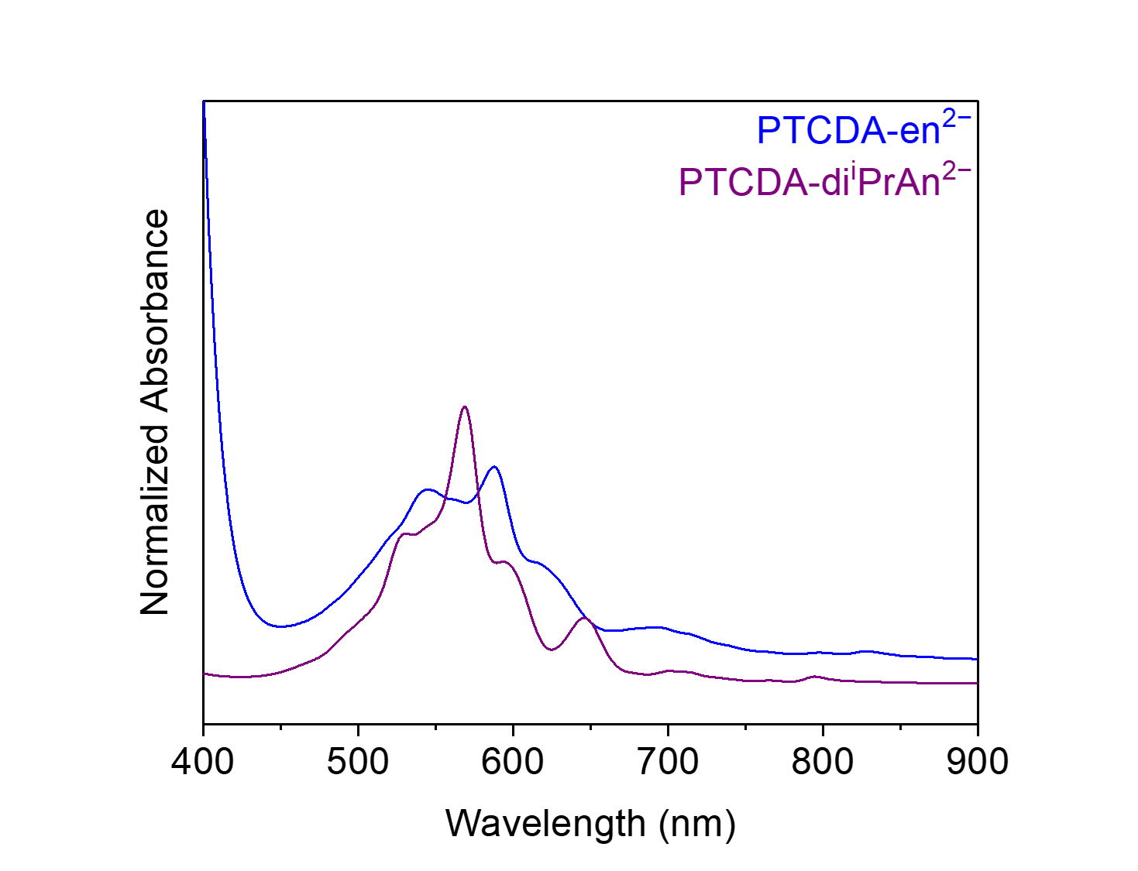
Figure S199. UV-Vis absorption spectrum of the chemically generated PTCDA-en²⁻ (blue) in DMF. Note that it shares similar spectroscopic features to PTCDA-di^{i}PrAn²⁻ (purple) in DMF.
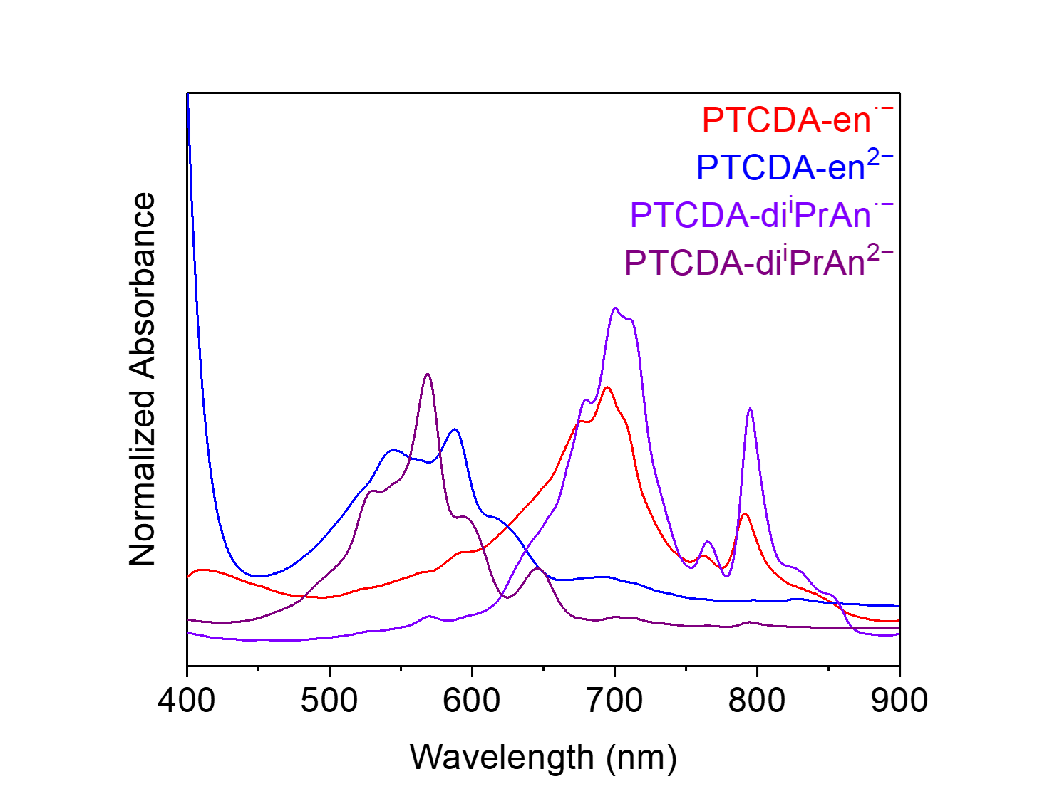
Figure S200. UV-Vis absorption spectra of the chemically generated PTCDA-en^{·−} (red) and PTCDA-en²⁻ (blue) in DMF. Note that PTCDA-en^{·−} shares similar spectroscopic features to PTCDA-di^{i}PrAn^{·−} (violet), and PTCDA-en²⁻ shares similar spectroscopic features to PTCDA-di^{i}PrAn²⁻ (purple) in DMF.

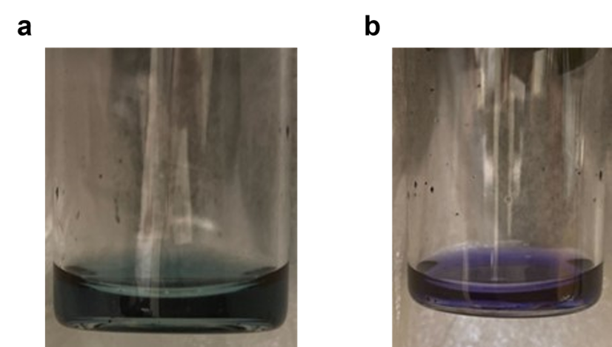
Figure S201. The chemically generated (a) PTCDA-en^{·−} and (b) PTCDA-en²⁻.
UV-Vis analysis reveals that the species generated by treating a suspension of PTCDA-en in DMF with TDAE are spectroscopically similar to those generated from PTCDA-di^{i}PrAn. Hence, it is plausible to conclude that PTCDA-en^{·−} (spectroscopically similar to PTCDA-di^{i}PrAn^{·−}) can be generated by treating a suspension of PTCDA-en in DMF with 1.0 equiv. of TDAE (Figure S197), and PTCDA-en²⁻ (spectroscopically similar to PTCDA-di^{i}PrAn²⁻) can be generated by treating a suspension of PTCDA-en in DMF with 200 equiv. of TDAE (Figure S199).

Solubility studies of PTCDA-en.

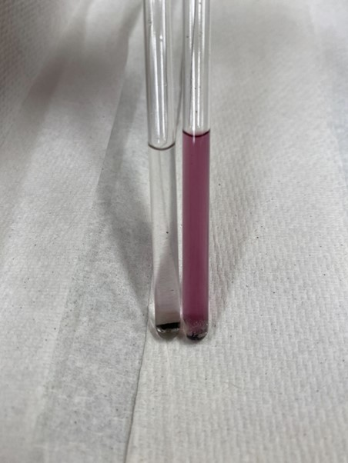
Figure S202. NMR samples of PTCDA-en alone in CD₃CN (left) and PTCDA-en treated with 200 equiv. of TDAE in CD₃CN (right). Note that solids can be seen at the bottom of the NMR tubes.
Solubility test. In a N₂-filled glovebox, a 20 mL scintillation vial was charged with PTCDA-en (2.5 mg, 0.006 mmol, 1.0 equiv.) and anhydrous degassed CD₃CN (2.0 mL). Subsequently, TDAE (280 μL, 1.20 mmol, 200 equiv.) was added, and the solution instantly turned purple. The solution was then thoroughly swirled, transferred to an air-free NMR tube and analyzed by ¹H NMR.
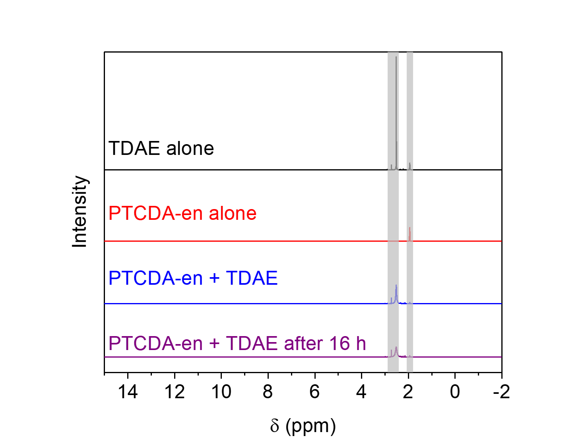
Figure S203. ¹H NMR (400 MHz, CD₃CN) spectra of PTCDA-en and PTCDA-en²⁻. TDAE and CD₃CN signals are highlighted in grey. Note that both PTCDA-en and PTCDA-en²⁻ have minimal solubility in CD₃CN.

UV-Vis studies of PTCDA-TPAPA.

Figure S204. Chemical reduction of PTCDA-TPAPA in DMF using TDAE (1.0 equiv.). Countercations (TDAE²⁺) are omitted for clarity.
Chemical reduction of PTCDA-TPAPA in DMF. In a N₂-filled glovebox, a 20 mL scintillation vial was charged with PTCDA-TPAPA (54.9 mg, 0.10 mmol, 1.0 equiv.) and anhydrous degassed DMF (8.0 mL). Subsequently, TDAE (23.3 μL, 0.10 mmol, 1.0 equiv.) was added, and the solution instantly turned dark purple. The solution was thoroughly swirled, and aliquots (0.2 mL) were taken from the solution and diluted with additional DMF (4.0 mL), before being analyzed by UV-Vis absorption spectroscopy, which revealed the generation of species that resemble a mixture of PTCDA-di^{i}PrAn^{·−} and PTCDA-di^{i}PrAn²⁻ (Figure S205). Note that unreduced PTCDA-TPAPA has minimal solubility in DMF and MeCN, thus solution-state UV-Vis of the unreduced PTCDA-TPAPA could not be obtained (see Figure S102 for the solid-state UV-Vis absorption spectrum of PTCDA-TPAPA dispersed in BaSO₄).
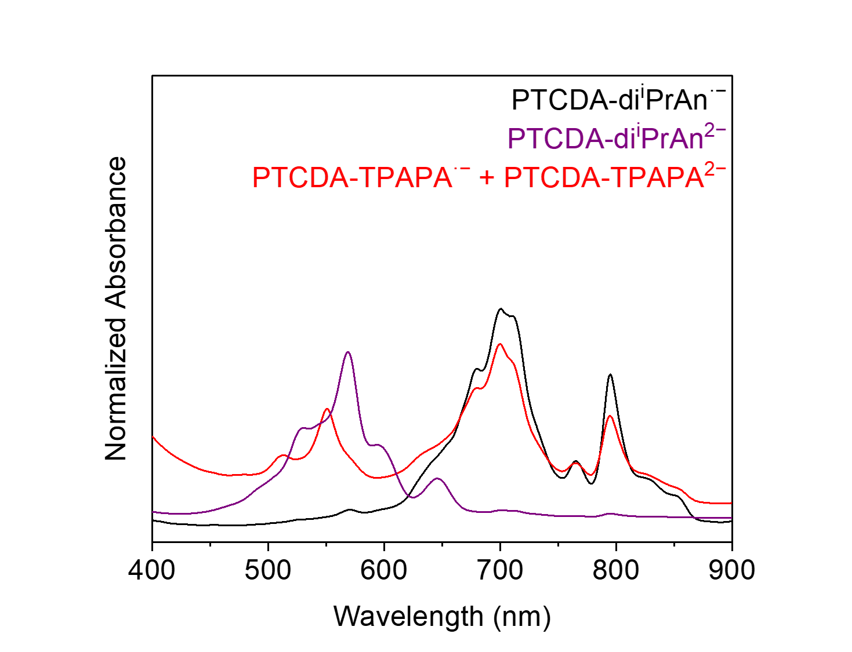
Figure S205. UV-Vis absorption spectrum of the chemically reduced (with 1.0 equiv. of TDAE) PTCDA-TPAPA (red) in DMF. Note that it spectroscopically resembles a mixture of PTCDA-di^{i}PrAn^{·−} (black) and PTCDA-di^{i}PrAn²⁻ (purple) in DMF.

Figure S206. Chemical reduction of PTCDA-TPAPA in DMF using TDAE (200 equiv.). Countercations (TDAE²⁺) are omitted for clarity.
Chemical reduction of PTCDA-TPAPA in DMF. In a N₂-filled glovebox, a 20 mL scintillation vial was charged with PTCDA-TPAPA (3.3 mg, 0.006 mmol, 1.0 equiv.) and anhydrous degassed DMF (2.0 mL). Subsequently, TDAE (280 μL, 1.20 mmol, 200 equiv.) was added, and the solution instantly turned dark purple. The solution was thoroughly swirled, and aliquots (0.2 mL) were taken from the solution and diluted with additional DMF (4.0 mL), before being analyzed by UV-Vis absorption spectroscopy, which revealed the generation of a species that shares similar spectroscopic features to PTCDA-di^{i}PrAn²⁻ (Figure S207). Note that unreduced PTCDA-TPAPA has minimal solubility in DMF and MeCN, thus solution-state UV-Vis of the unreduced PTCDA-TPAPA could not be obtained (see Figure S102 for the solid-state UV-Vis absorption spectrum of PTCDA-TPAPA dispersed in BaSO₄).
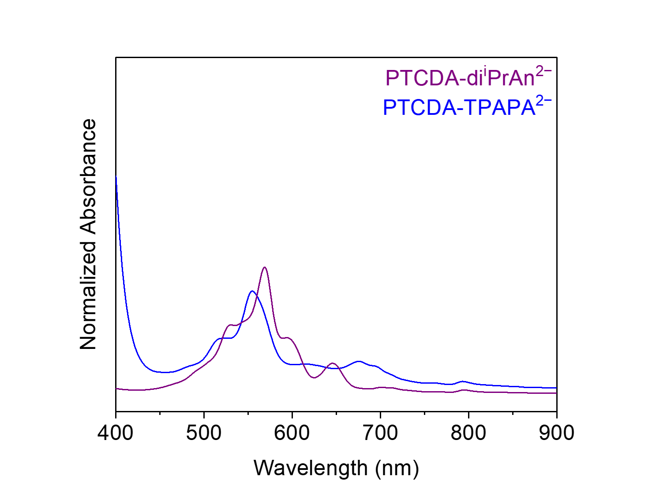
Figure S207. UV-Vis absorption spectrum of the chemically reduced (with 200 equiv. of TDAE) PTCDA-TPAPA²⁻ (blue) in DMF. Note that it shares similar spectroscopic features to PTCDA-di^{i}PrAn²⁻ (purple) in DMF.
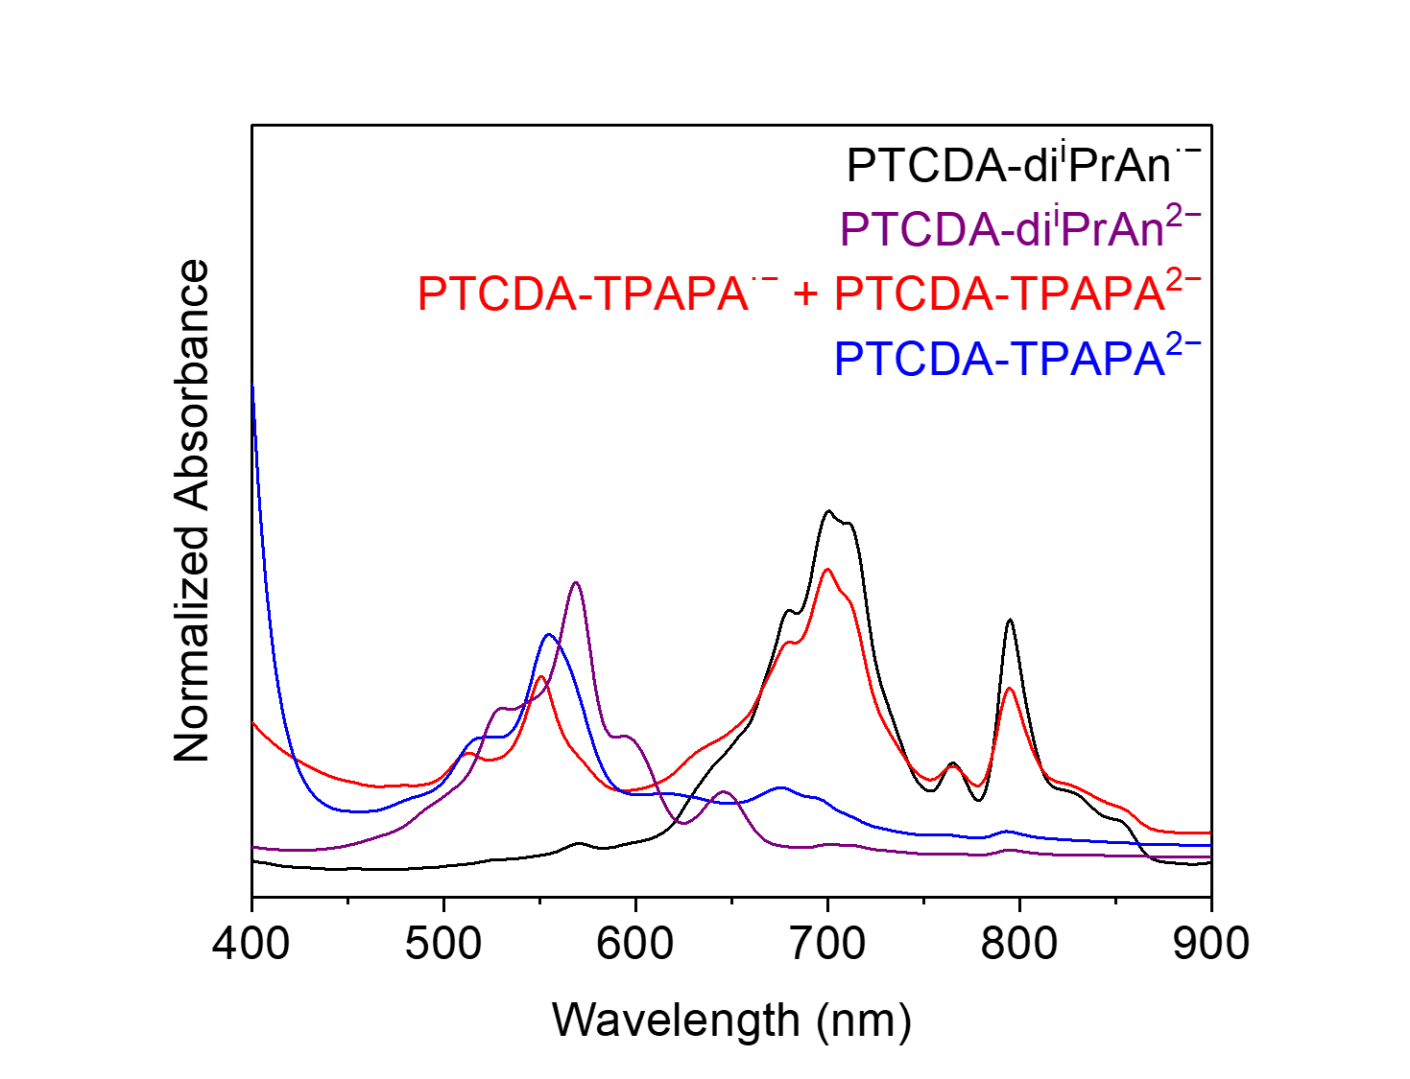
Figure S208. UV-Vis absorption spectra of the chemically reduced PTCDA-TPAPA in DMF. UV-Vis absorption spectra of PTCDA-di^{i}PrAn^{·−} (black) and PTCDA-di^{i}PrAn²⁻ (purple) in DMF are included for comparison.

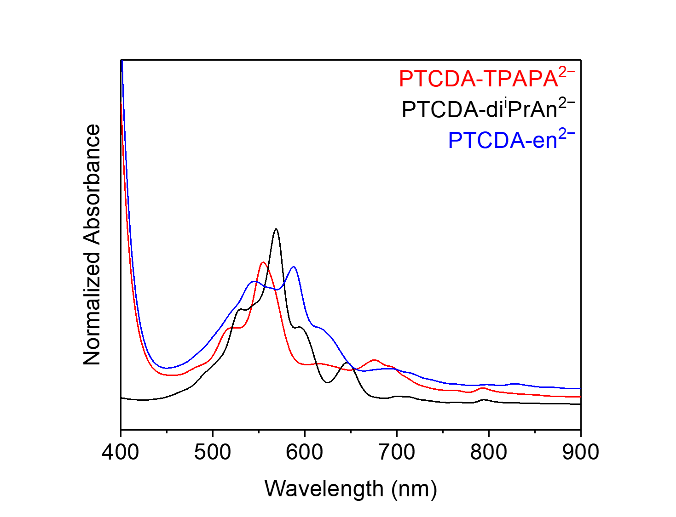
Figure S209. UV-Vis absorption spectra of PTCDA-TPAPA²⁻ (red), PTCDA-di^{i}PrAn²⁻ (black), and PTCDA-en²⁻ (blue) in DMF.

Photophysical measurements.
Transient absorption (TA) measurements were performed with an automated TA spectrometer (HELIOS, Ultrafast Systems), driven by the Yb:KGW amplifier (PHAROS-SP, Light Conversion) operating at 8 kHz. Tunable narrowband pump pulses with ~200 fs duration were generated with an optical parameter amplifier equipped with second harmonic module (ORPHEUS and LYRA-SH, Light Conversion). Pump wavelengths were generally selected to match the peak absorption of species detected in steady-state UV-Vis absorption measurements, or to match the peak wavelength of irradiation of the light sources used for electrophotochemical reactions. A portion of the fundamental was separated to generate a white light continuum probe pulse ranging from 450 nm to 915 nm using 1 cm sapphire. TA spectra were collected in shot-to-shot fashion, with the pump polarization typically set to magic angle relative to the probe.
In the transient anisotropy experiment, the full TA dynamics were measured twice, with the polarization of the pump pulse tuned using half-wave plates to be either perpendicular ($T_{⊥}$) or parallel ($T_{∥}$) to that of the probe. The polarization memory was then quantified as the anisotropy $χ=\left(T_{∥}-T_{⊥}\right)/\left(T_{∥}+2T_{⊥}\right)$, determined individually for each probe wavelength, with a value of 0.4 indicating no change in signal polarization and 0 pointing to complete depolarization. Depolarization may arise from molecular rotation, changes in electronic state, or energy migration to a new site with different orientation.
The pump-probe time delay in all measurements was set by a mechanical delay stage from −3 to 7600 ps. The sample was sealed in a 2 mm path length cuvette (Hellma, HL110-2-40) with a Teflon stopper. A magnetic stirrer (Ultrafast Systems) was used to prevent photobleaching of the sample. After every experiment, the steady-state UV-Vis absorption was carefully checked, and we confirmed that there was no degradation of the sample. All TA measurements were carried out using chemically reduced perylenediimides (PDIs); control experiments on PTCDA-di^{i}PrAn revealed identical dynamics for electrochemically generated species.

Transient absorption (TA) measurements of PTCDA-di^{i}PrAn.
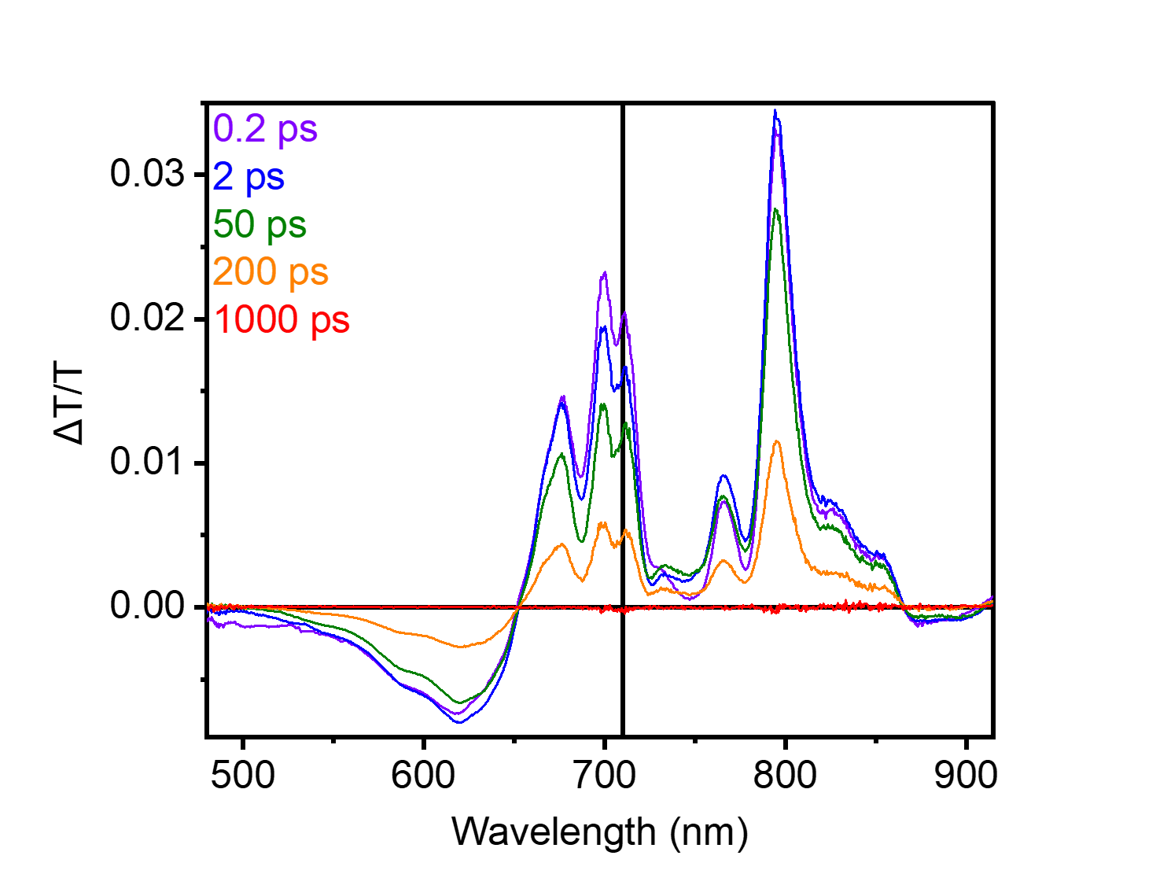
Figure S210. TA spectra of PTCDA-di^{i}PrAn^{·−} in MeCN. Pump at 710 nm (vertical black line).
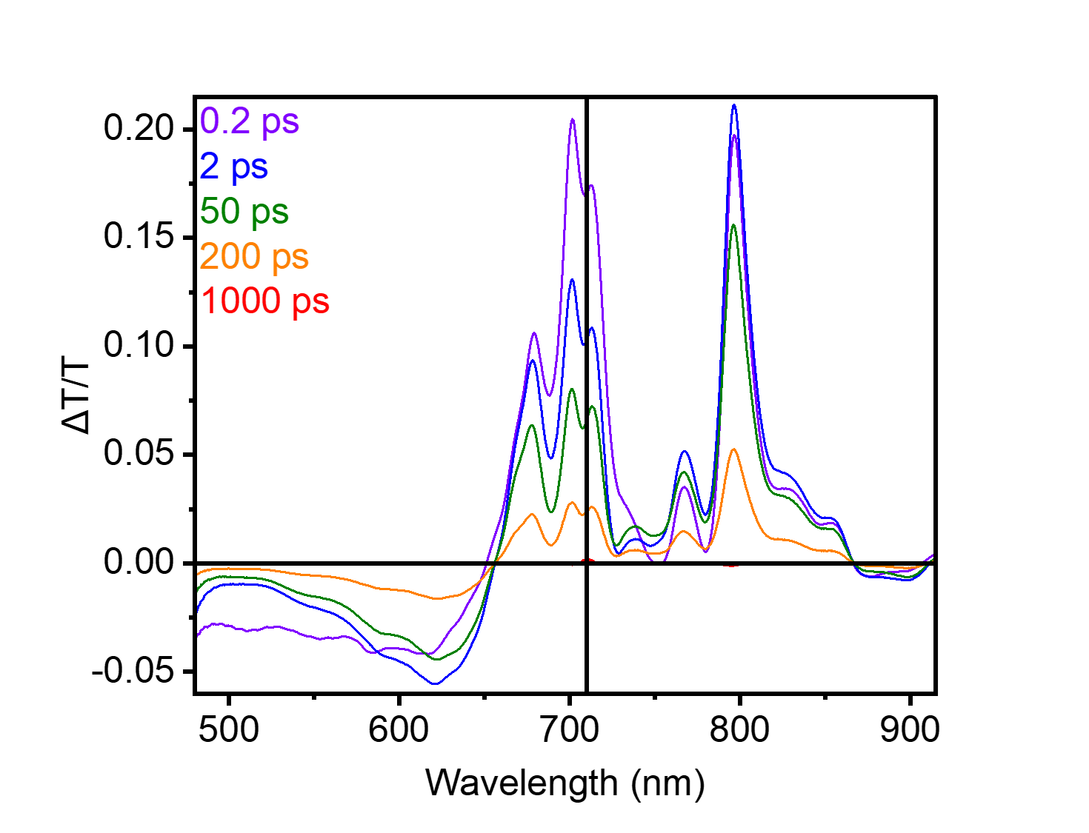
Figure S211. TA spectra of PTCDA-di^{i}PrAn^{·−} in DMF. Pump at 710 nm (vertical black line).

We first investigated whether solvent has a significant impact on the photophysics of PTCDA-di^{i}PrAn^{·−} detectable in TA. The spectral shapes and relaxation timescales of PTCDA-di^{i}PrAn^{·−} in MeCN (Figure S210) and DMF (Figure S211) are both consistent with prior studies¹⁹ and closely match each other. Accordingly, we consider our spectroscopic measurements in DMF to provide a good representation of the reaction conditions in MeCN.

Transient absorption (TA) measurements of PTCDA-en.

Note: due to the limited solubility of reduced PTCDA-en species in MeCN, all TA measurements for this polymer were conducted in DMF. All TA measurements were carried out using chemically reduced PTCDA-en for simplicity.
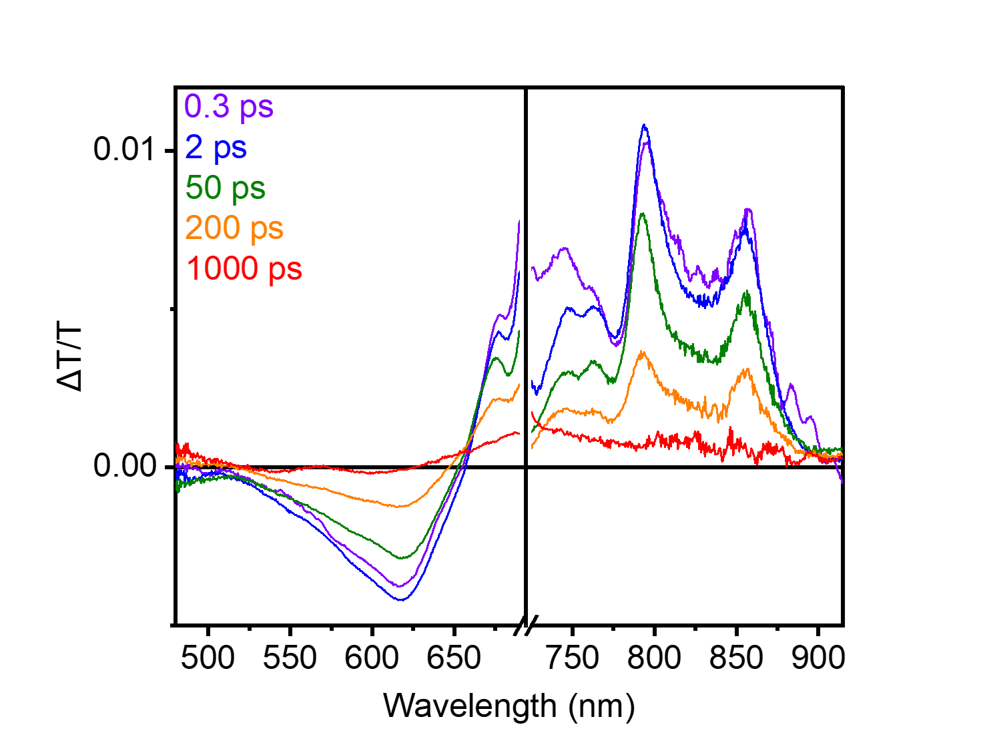
Figure S212. TA spectra of PTCDA-en^{·−} in DMF. Pump at 710 nm (vertical black line).

As in PTCDA-di^{i}PrAn^{·−}, the signal is dominated by the complex ground-state bleach structure, with a strong but featureless photoinduced absorption on the short-wavelength side (Figure S212). The initial photoexcited state is likewise nearly fully decayed within 200 ps. Aside from spectral shifts, the primary difference between the photophysics observed in PTCDA-en^{·−} and in PTCDA-di^{i}PrAn^{·−} is the persistence of weak TA signal onto the nanosecond timescale, which may point to PTCDA-en^{·−} being a more suitable photocatalyst under a diffusive mechanism than the widely studied PTCDA-di^{i}PrAn^{·−}.²⁰

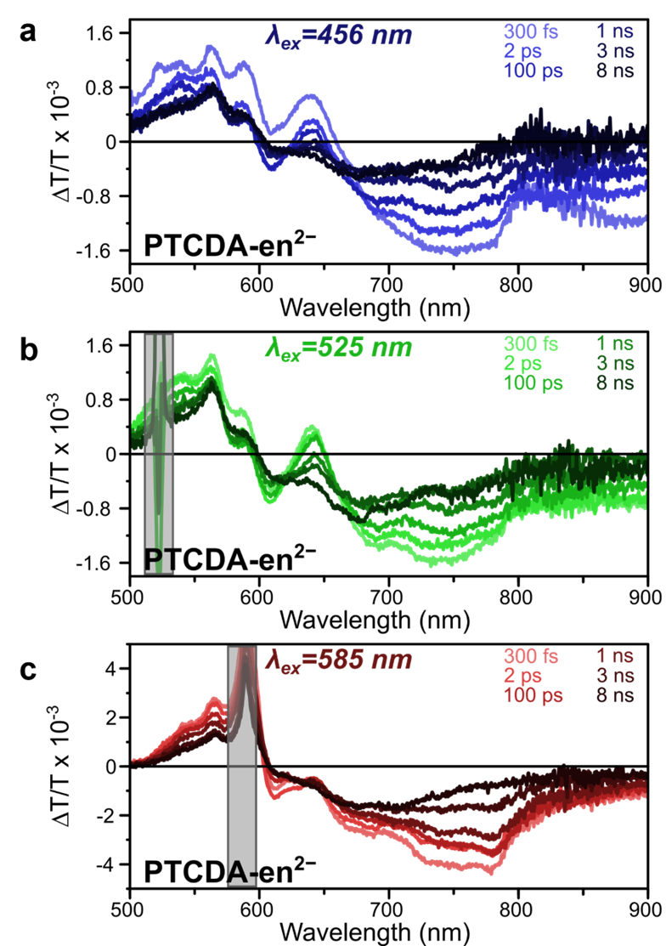
Figure S213. TA spectra of PTCDA-en²⁻ excited at (a) 456 nm, (b) 525 nm, and (c) 585 nm in DMF. Strong pump scatter due to limited solubility is covered by the grey box. The same characteristic spectral features are observed in all cases, pointing to no major changes in the decay pathway for resonant (585 nm) vs. above-gap (456 nm) excitation. However, the slight rebalancing of spectral shapes as a function of pump wavelength points to heterogeneity in the system, with catalytic sites exhibiting different electronic coupling accessed at different wavelengths. The slightly enhanced reaction yield for excitation at 456 nm may be consistent with the initial photoexcited state, characterized by a positive band at 640 nm and a negative band at 750 nm, being the catalytically active species. However, the ultrafast electron transfer shown by the quenching measurements (main text Figure 4h–j) means this role cannot be directly determined.

To probe the origin of the slight wavelength dependence of yield determined in our reaction optimization (main text Table 1a), we measured the TA spectra of PTCDA-en²⁻ under three different excitation wavelengths (Figure S213). The same characteristic spectral features under all excitation wavelengths were observed, pointing to the presence of identical photoexcited states. Therefore, there is unlikely to be a unique decay pathway that is responsible for the enhanced yield under 456 nm excitation. However, we observed a rebalancing between the relative spectral weights of key features, most evident in the positive band at 640 nm and the negative band at 750 nm, that may correlate with the reaction behavior. Such pump wavelength-dependent spectral shapes may be interpreted through subtle changes in the relative intensities and linewidths of peaks in the ground-state bleaching region. The latter corresponds to the UV-Vis absorption of the PDI sites in the ensemble that have been photoexcited, and such variation points to a degree of electronic heterogeneity in the polymer, with some PDI sites more reactive than others.

Transient absorption (TA) measurements of PTCDA-TPAPA.

Note: due to the limited solubility of reduced PTCDA-TPAPA species in MeCN, all TA measurements for this polymer were conducted in DMF. All TA measurements were carried out using chemically reduced PTCDA-TPAPA for simplicity.
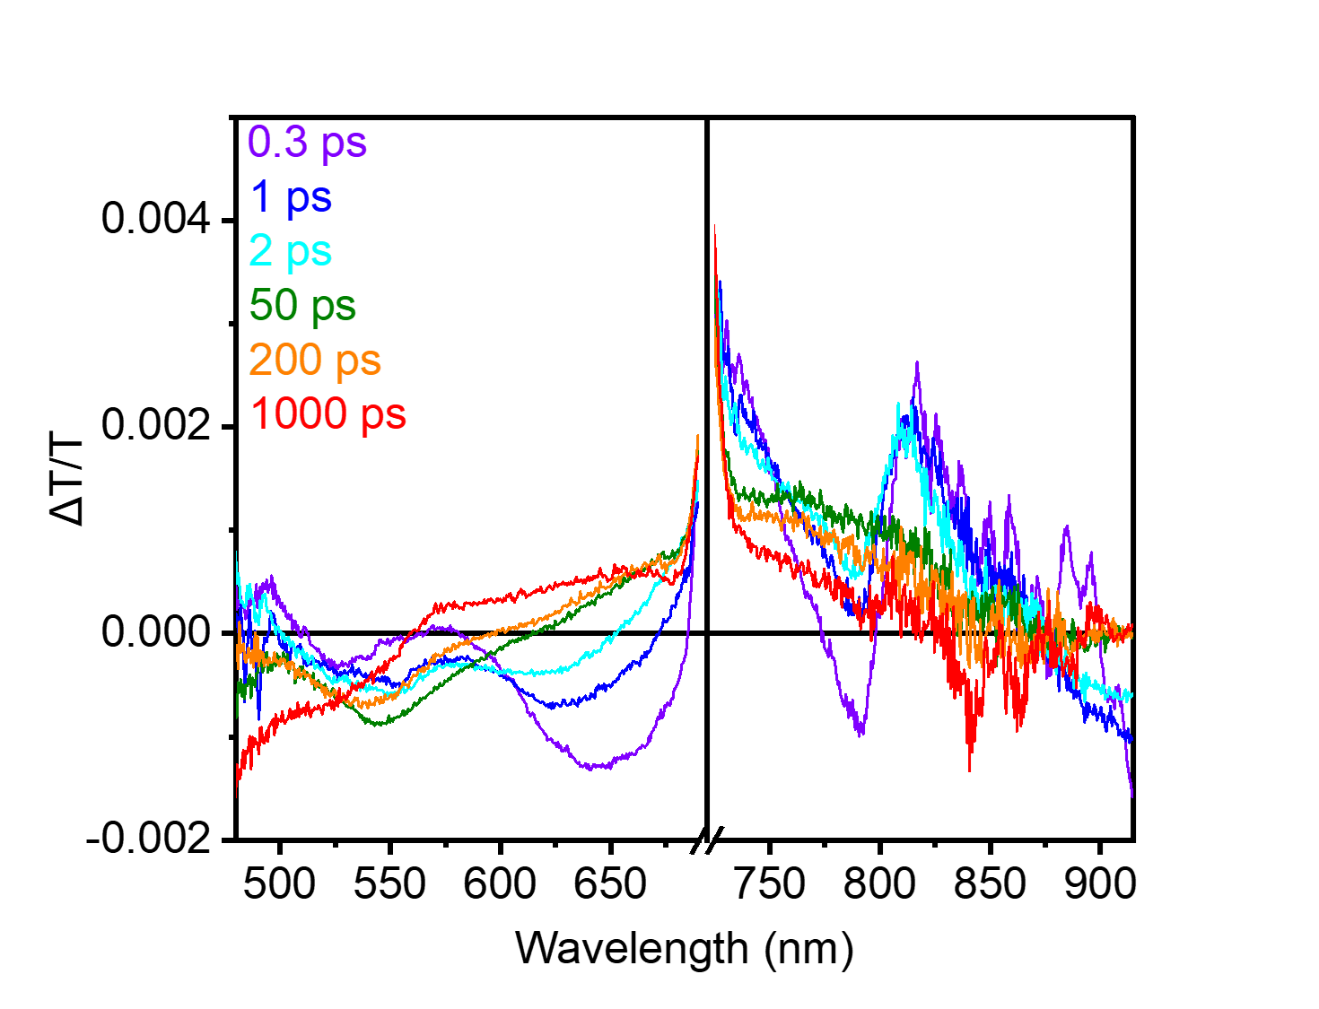
Figure S214. TA spectra of PTCDA-TPAPA^{·−} in DMF. Pump at 710 nm (vertical black line).

While the TA spectra of PTCDA-en^{·−} closely resemble those of PTCDA-di^{i}PrAn^{·−}, the spectra of PTCDA-TPAPA^{·−} significantly diverge (Figure S214). There is both a broader and more complex photoinduced absorption underlying the entire spectrum, pointing to a distorted electronic structure relative to PTCDA-di^{i}PrAn^{·−}, and a much more rapid evolution of the electronic state into a distinct long-lived species. While this result may, as in the case of PTCDA-en^{·−}, suggest that there is a prospect for diffusive photocatalysis driven by this unknown metastable state, it also shows that the conjugated structure of PTCDA-TPAPA may result in a significant increase in alternative decay channels. Consequently, the reduced PDI sites in PTCDA-TPAPA do not simply behave as isolated PDI units.

NMR spectra of products.
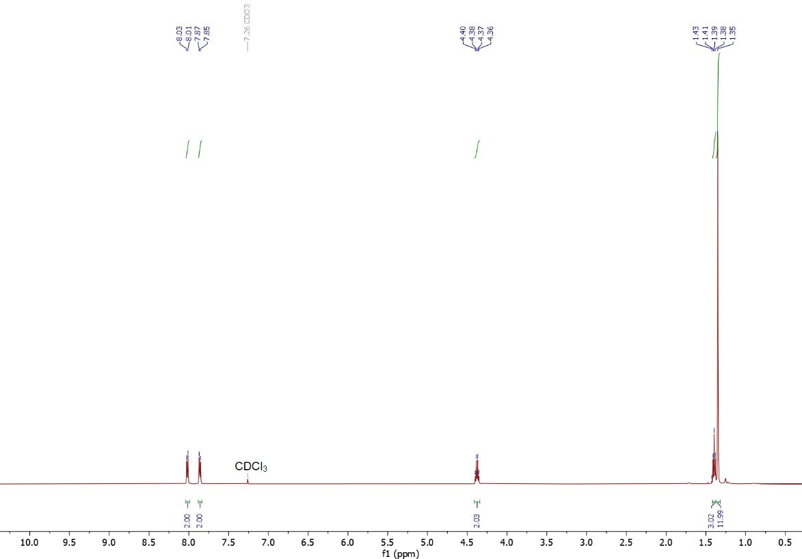
Figure S215. ¹H NMR (500 MHz, CDCl₃) spectrum of 1.

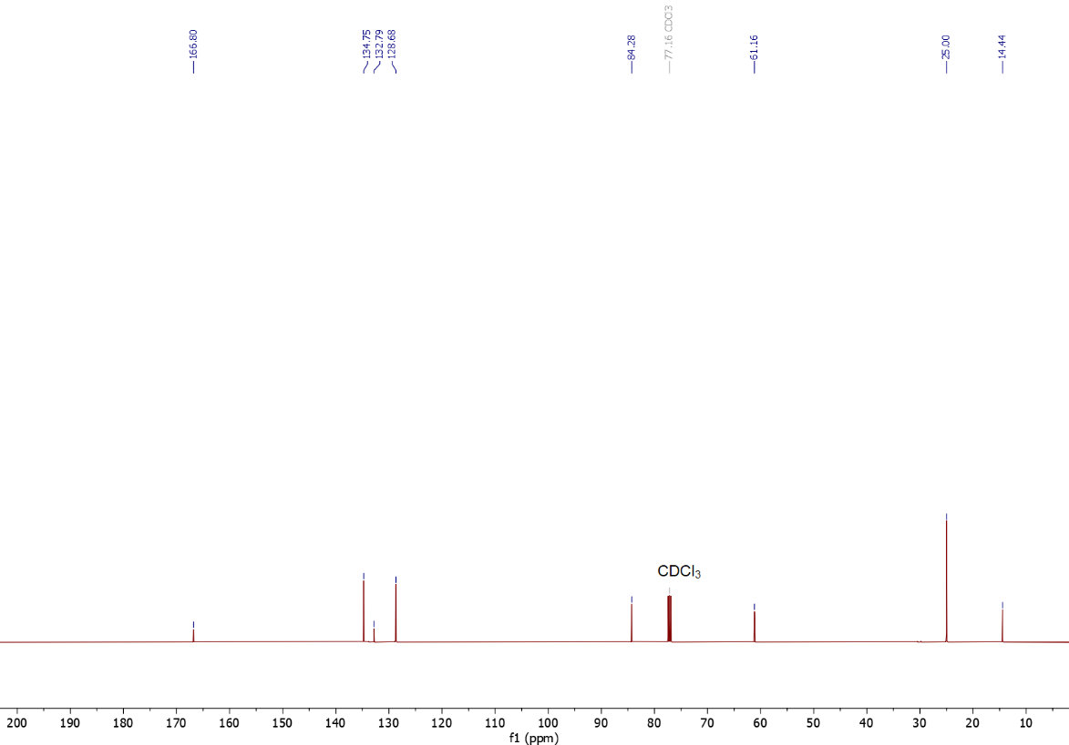
Figure S216. ¹³C NMR (126 MHz, CDCl₃) spectrum of 1.
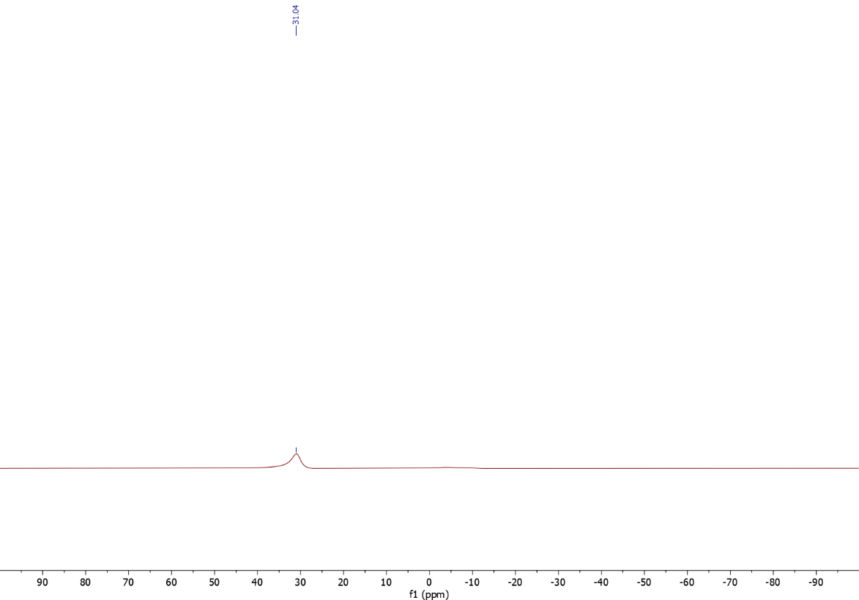
Figure S217. ¹¹B NMR (160 MHz, CDCl₃) spectrum of 1.
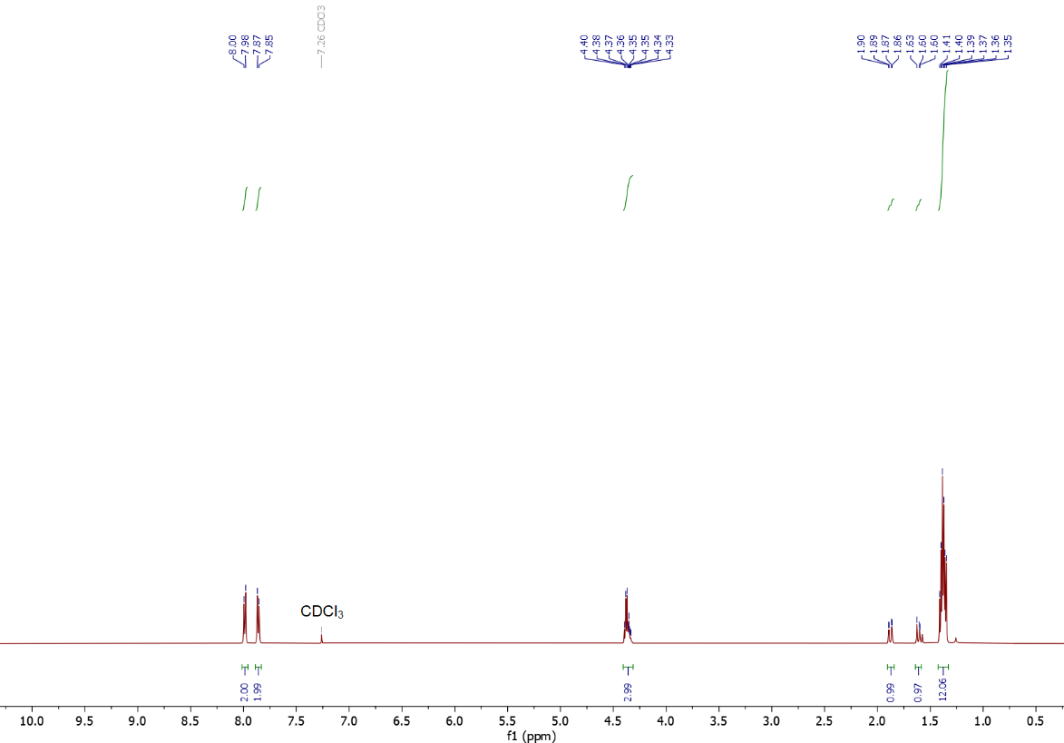
Figure S218. ¹H NMR (500 MHz, CDCl₃) spectrum of 1a.

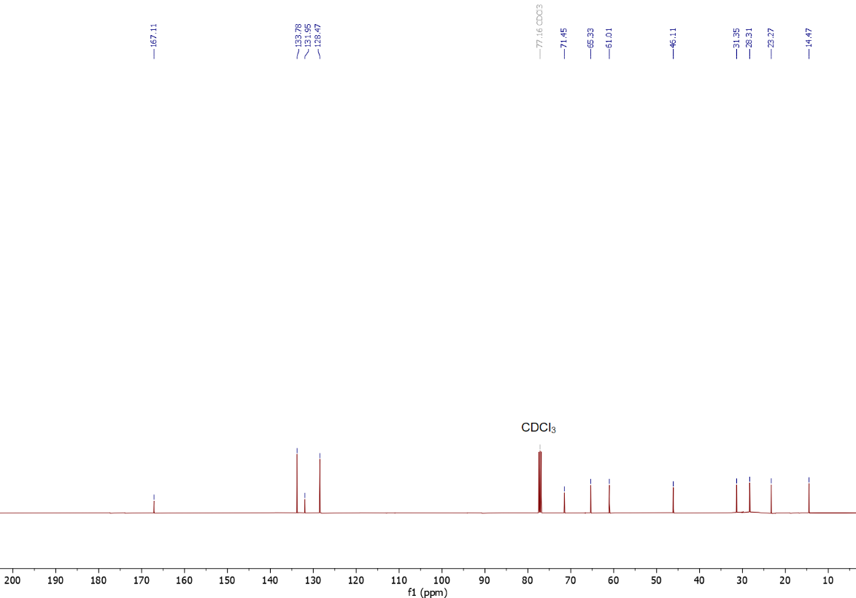
Figure S219. ¹³C NMR (126 MHz, CDCl₃) spectrum of 1a.
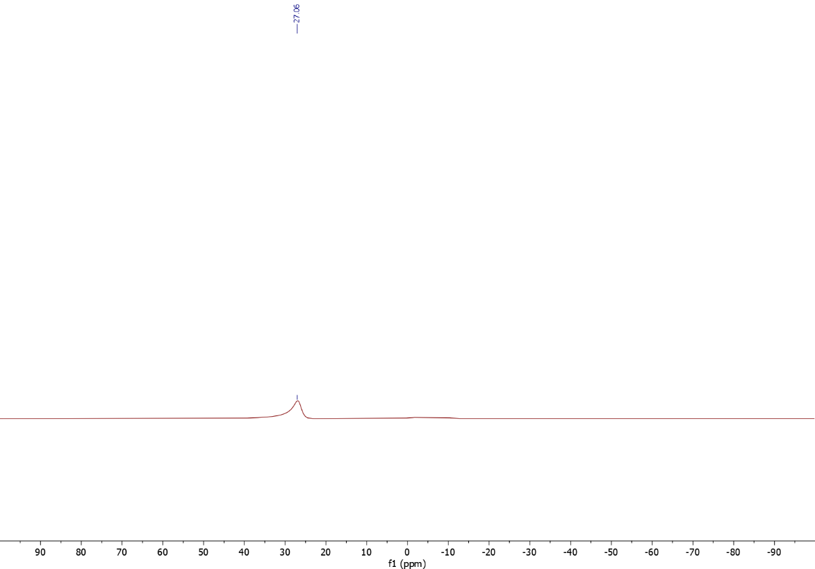
Figure S220. ¹¹B NMR (160 MHz, CDCl₃) spectrum of 1a.
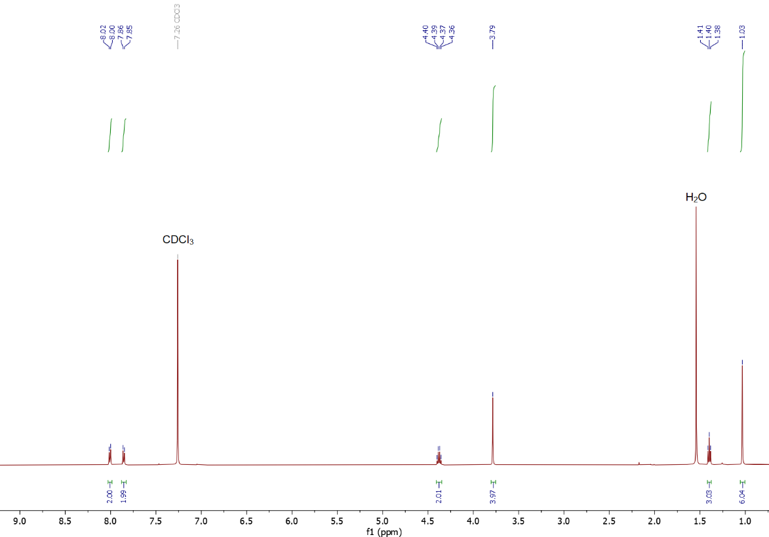
Figure S221. ¹H NMR (500 MHz, CDCl₃) spectrum of 1b.

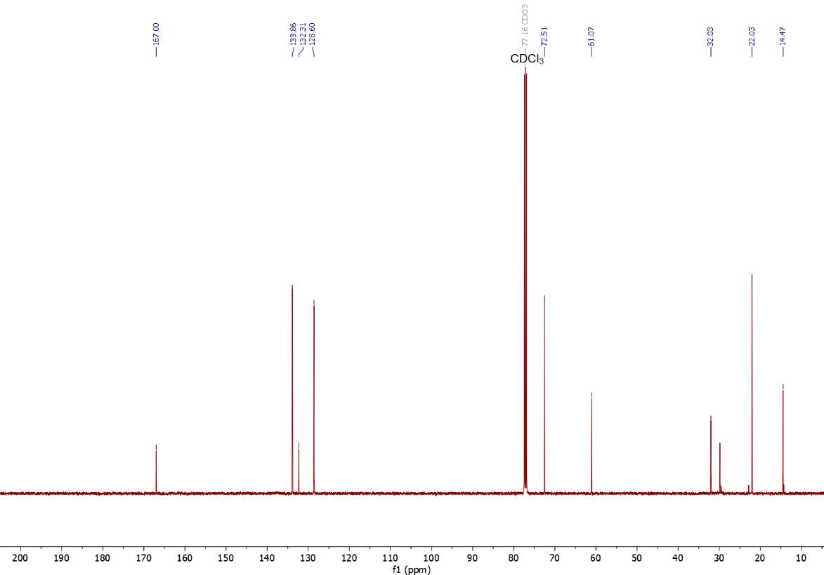
Figure S222. ¹³C NMR (126 MHz, CDCl₃) spectrum of 1b.
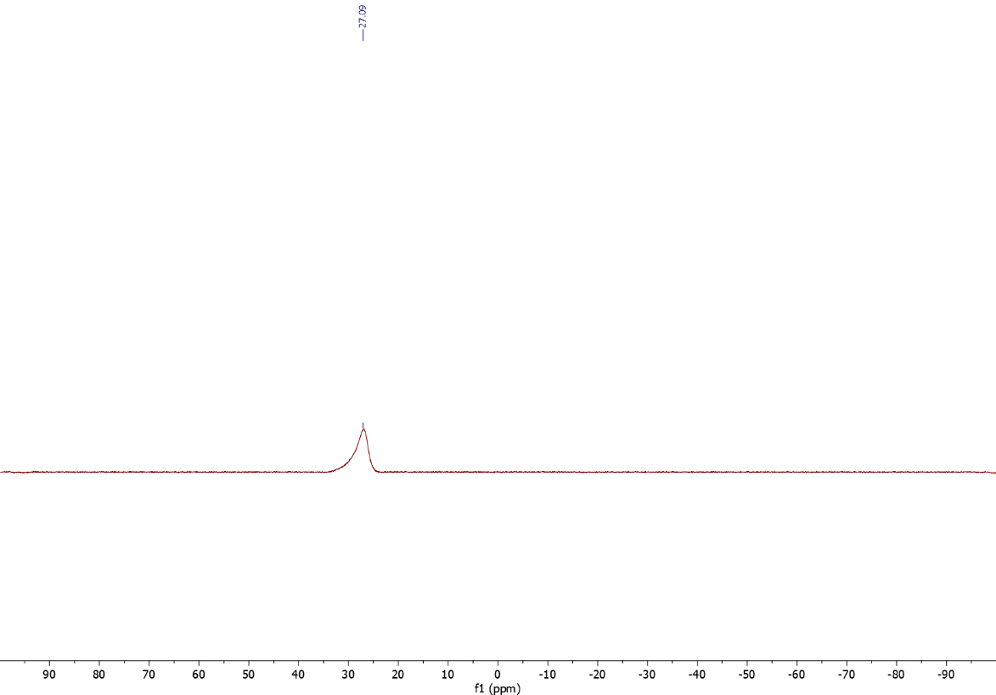
Figure S223. ¹¹B NMR (160 MHz, CDCl₃) spectrum of 1b.
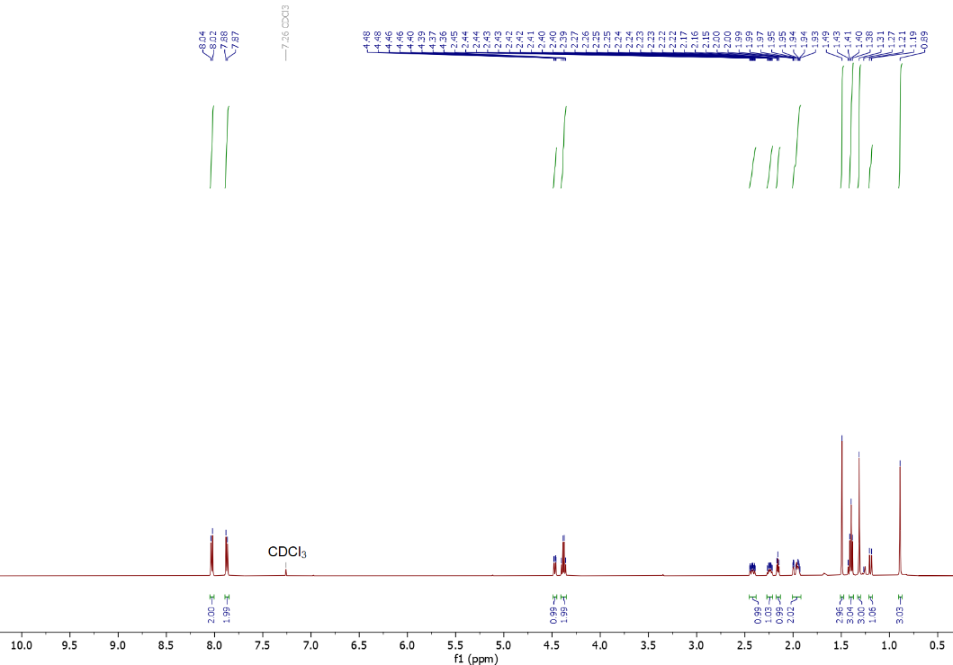
Figure S224. ¹H NMR (500 MHz, CDCl₃) spectrum of 1c.

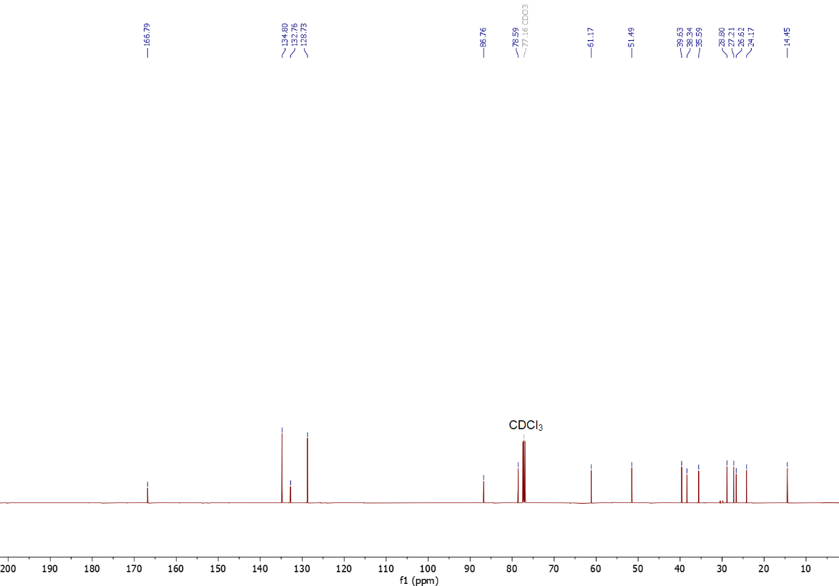
Figure S225. ¹³C NMR (126 MHz, CDCl₃) spectrum of 1c.
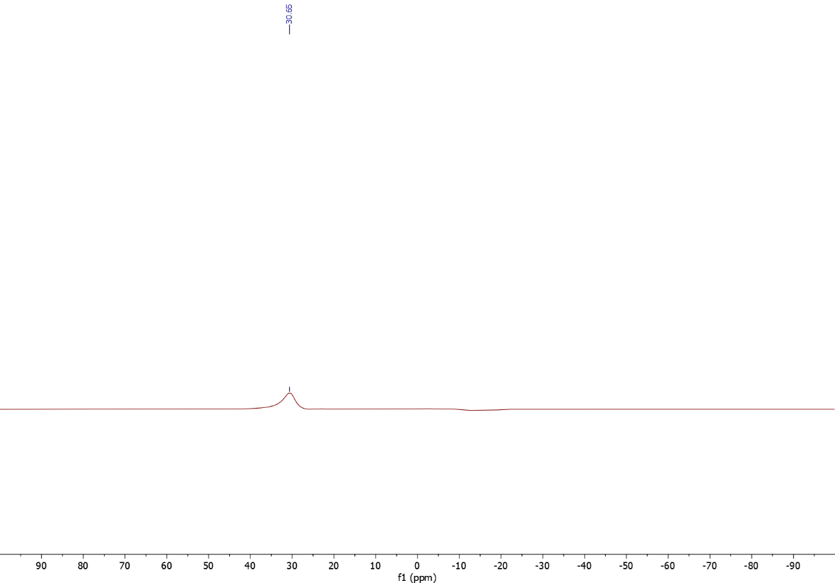
Figure S226. ¹¹B NMR (160 MHz, CDCl₃) spectrum of 1c.
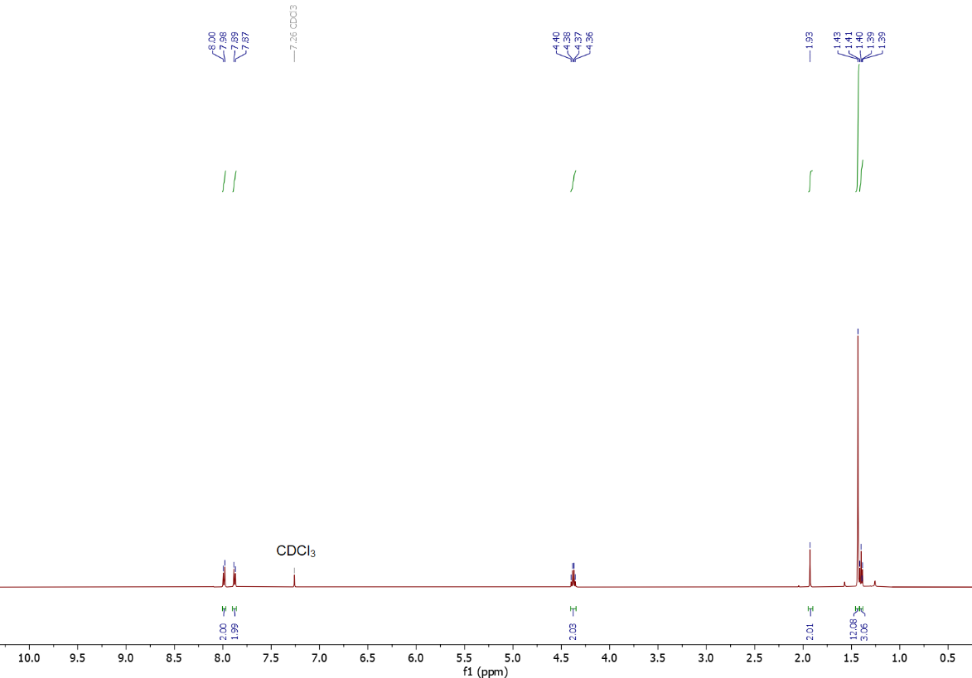
Figure S227. ¹H NMR (500 MHz, CDCl₃) spectrum of 1d.

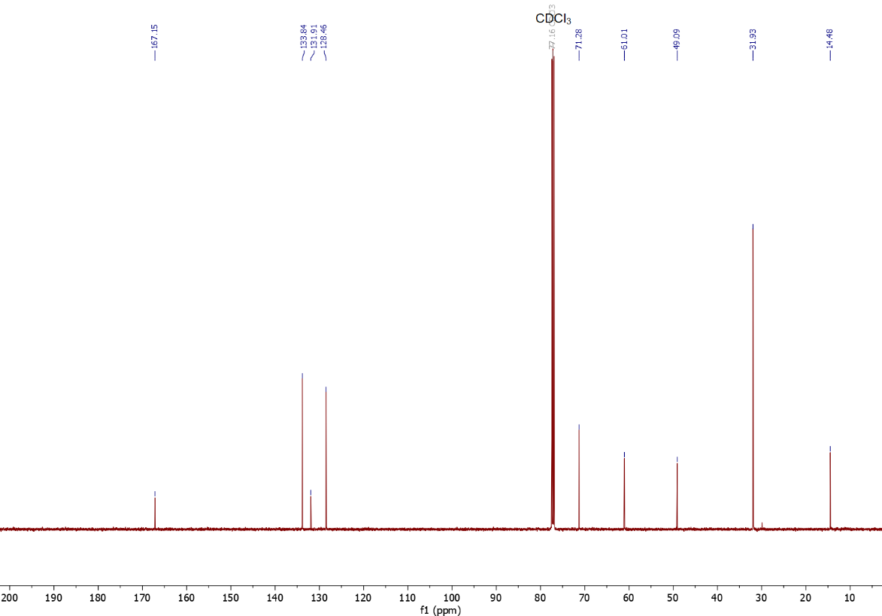
Figure S228. ¹³C NMR (126 MHz, CDCl₃) spectrum of 1d.
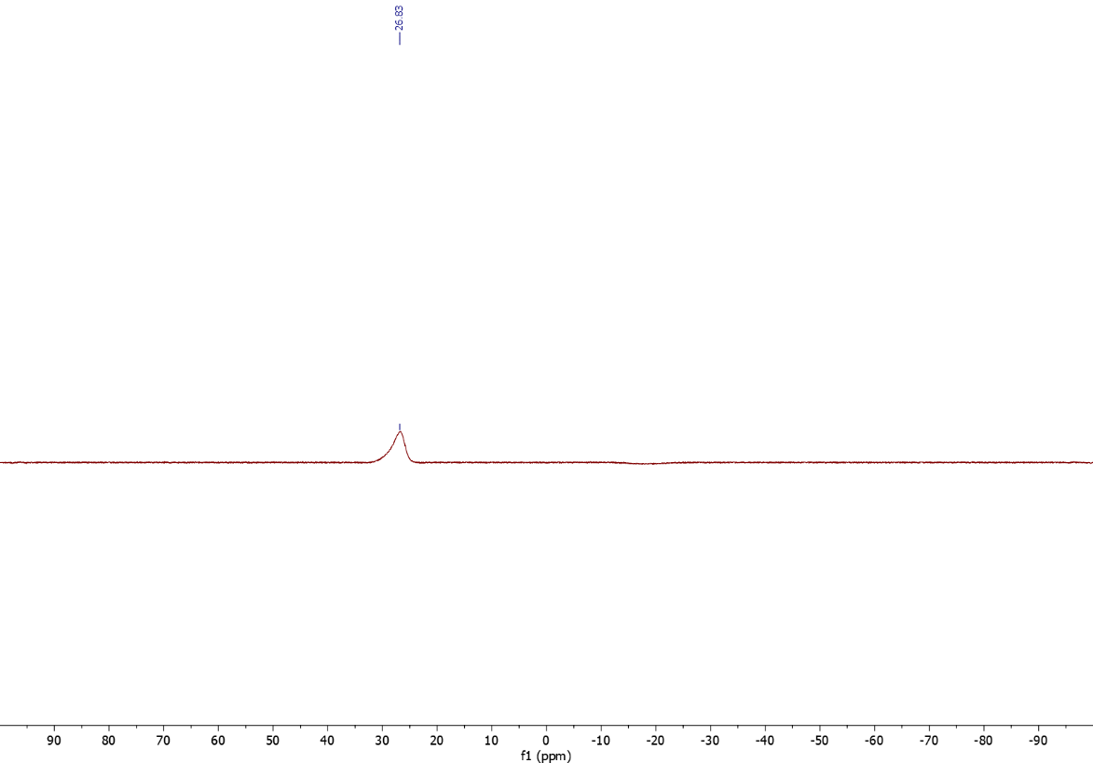
Figure S229. ¹¹B NMR (160 MHz, CDCl₃) spectrum of 1d.
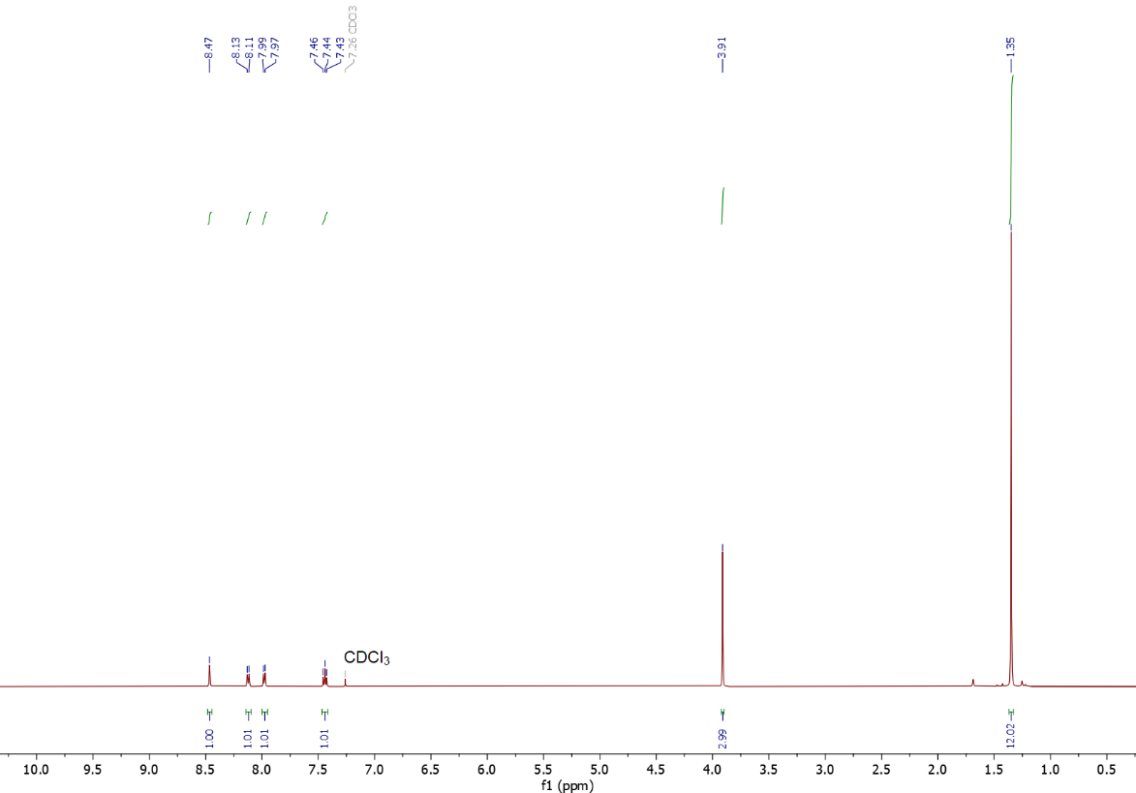
Figure S230. ¹H NMR (500 MHz, CDCl₃) spectrum of 2.

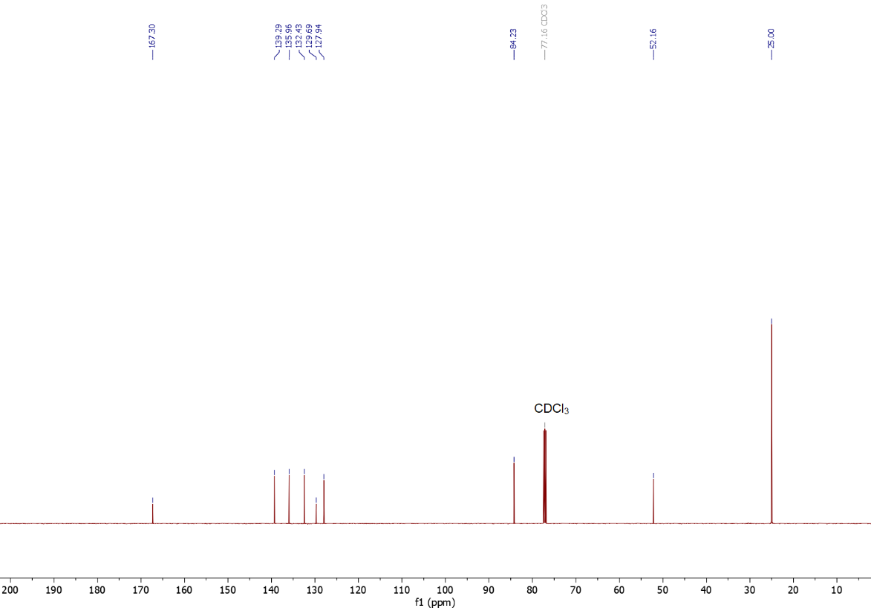
Figure S231. ¹³C NMR (126 MHz, CDCl₃) spectrum of 2.
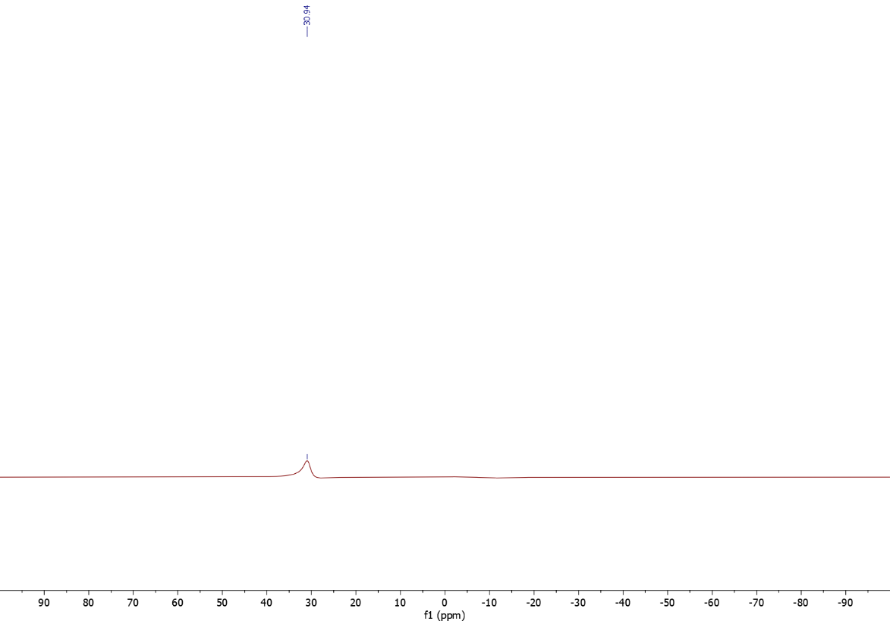
Figure S232. ¹¹B NMR (160 MHz, CDCl₃) spectrum of 2.
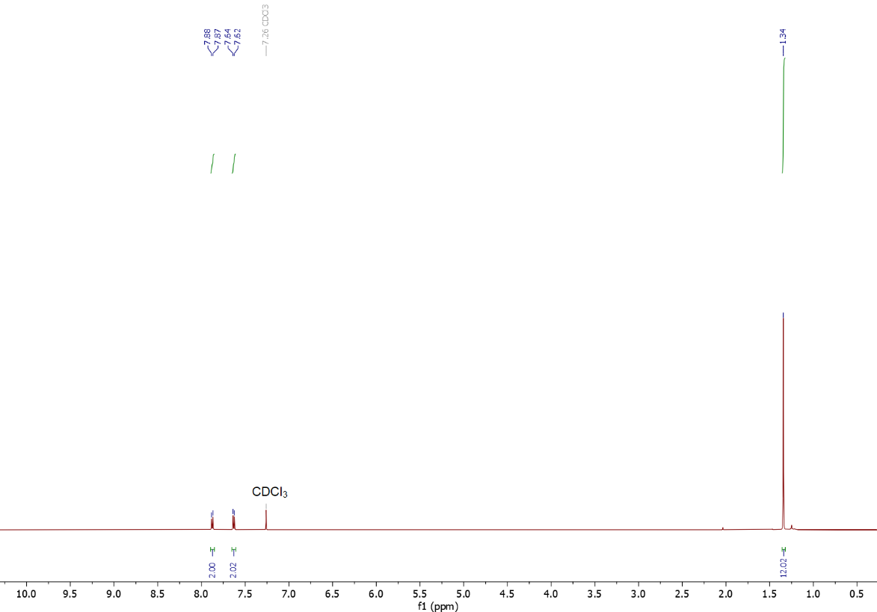
Figure S233. ¹H NMR (500 MHz, CDCl₃) spectrum of 3.

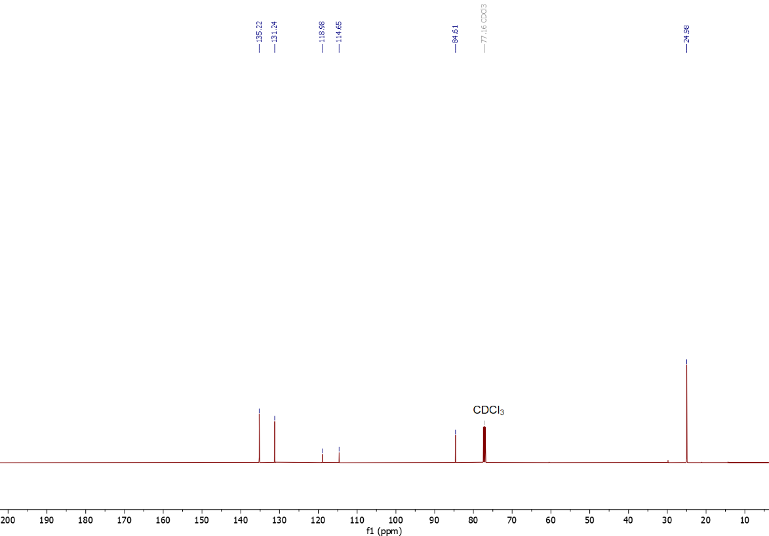
Figure S234. ¹³C NMR (126 MHz, CDCl₃) spectrum of 3.
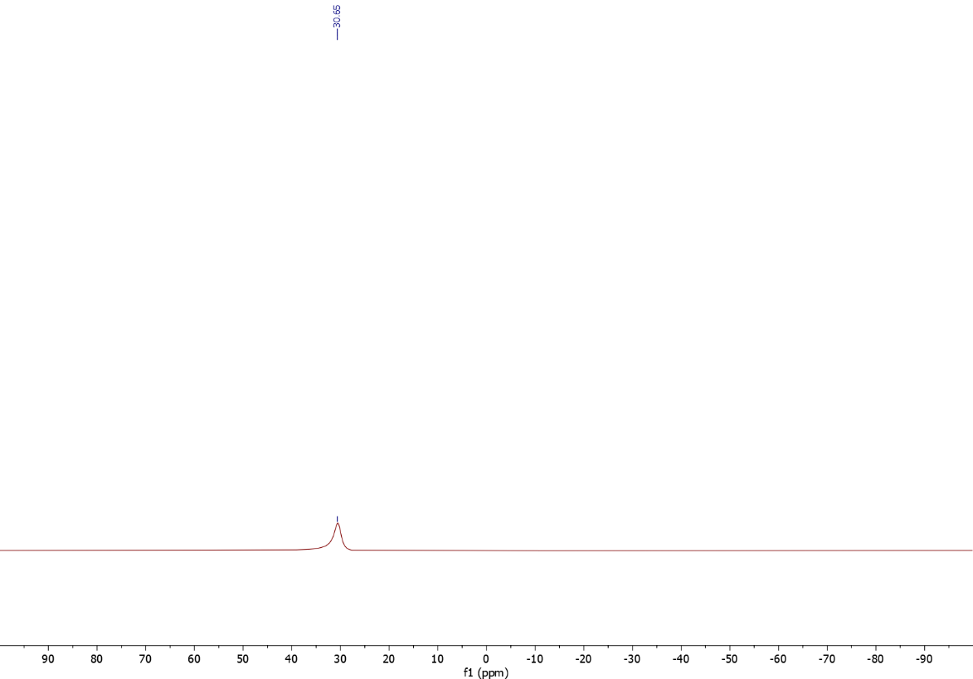
Figure S235. ¹¹B NMR (160 MHz, CDCl₃) spectrum of 3.
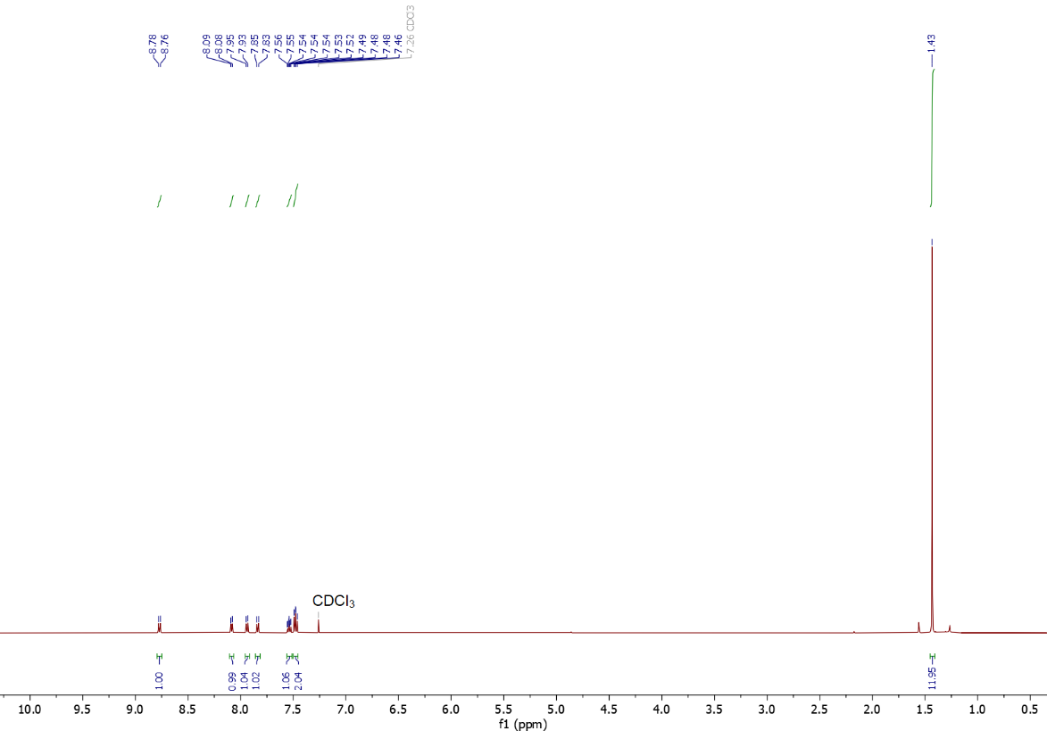
Figure S236. ¹H NMR (500 MHz, CDCl₃) spectrum of 4.

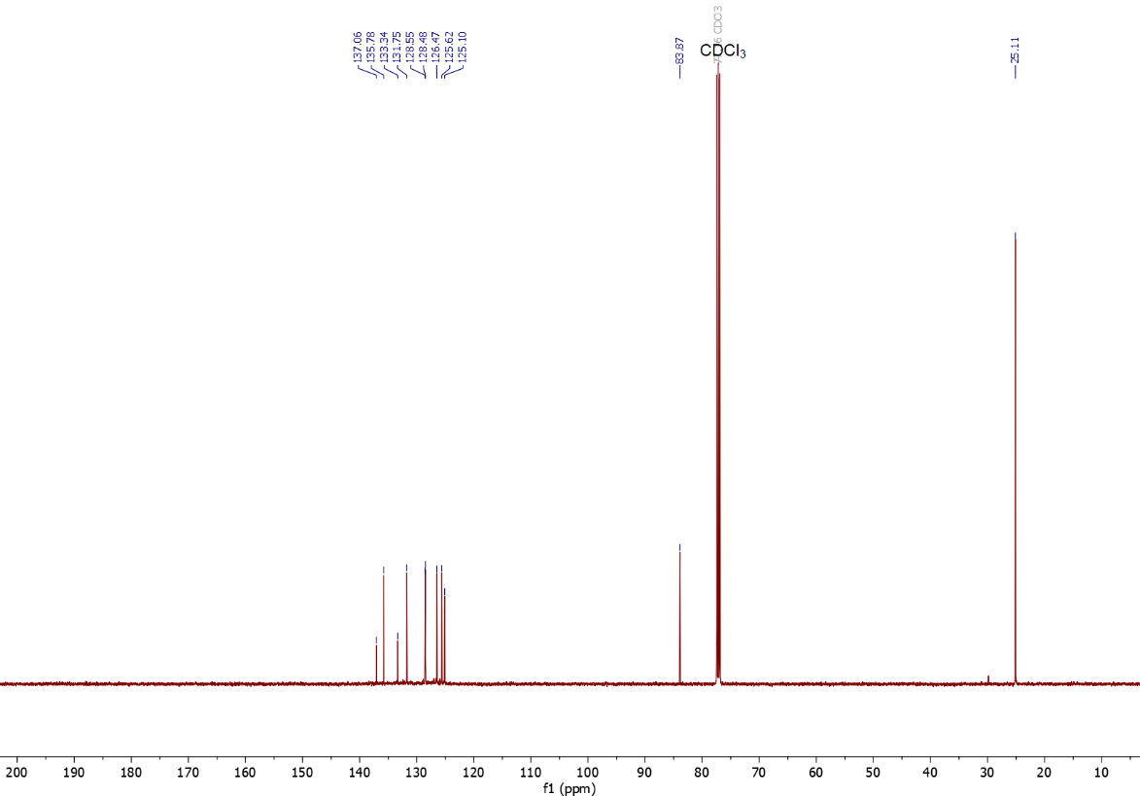
Figure S237. ¹³C NMR (126 MHz, CDCl₃) spectrum of 4.
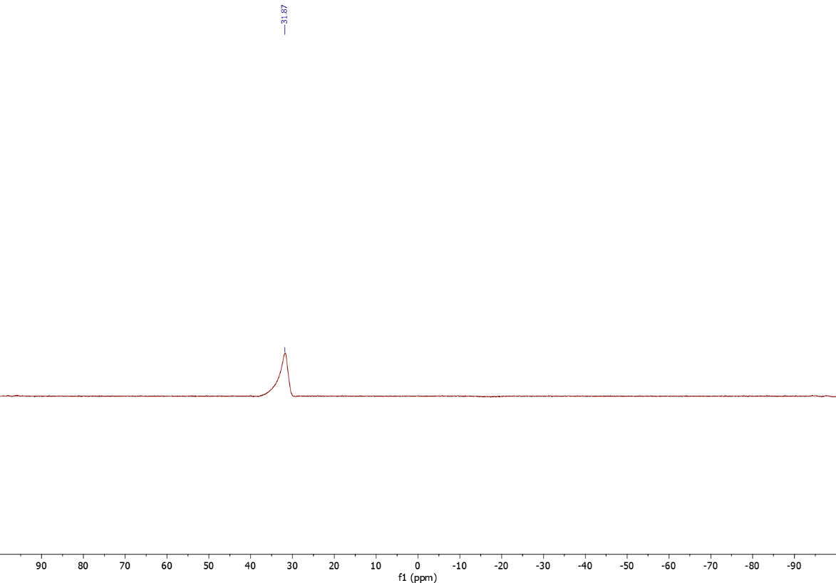
Figure S238. ¹¹B NMR (160 MHz, CDCl₃) spectrum of 4.
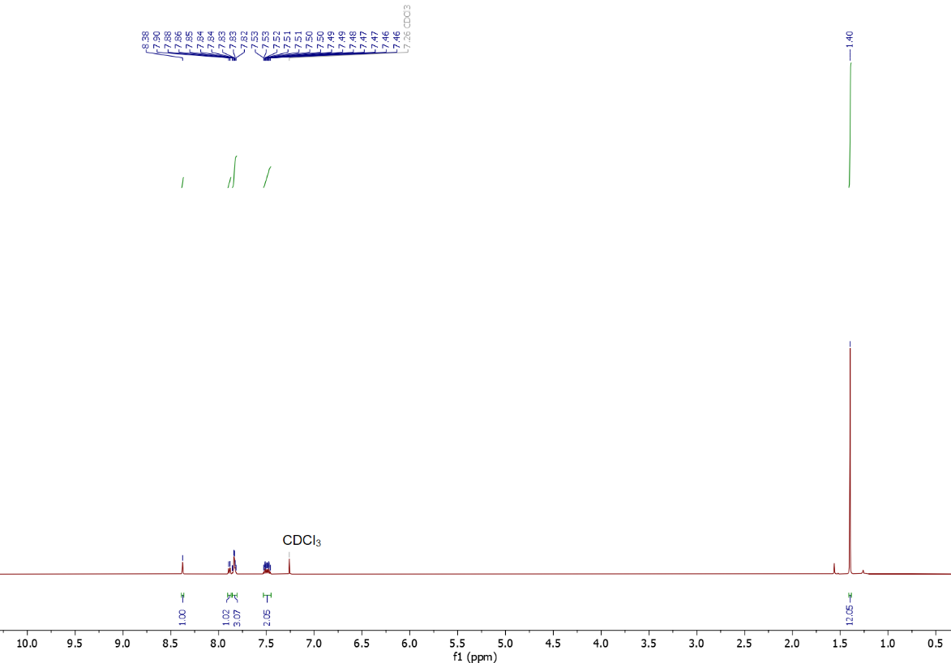
Figure S239. ¹H NMR (500 MHz, CDCl₃) spectrum of 5.

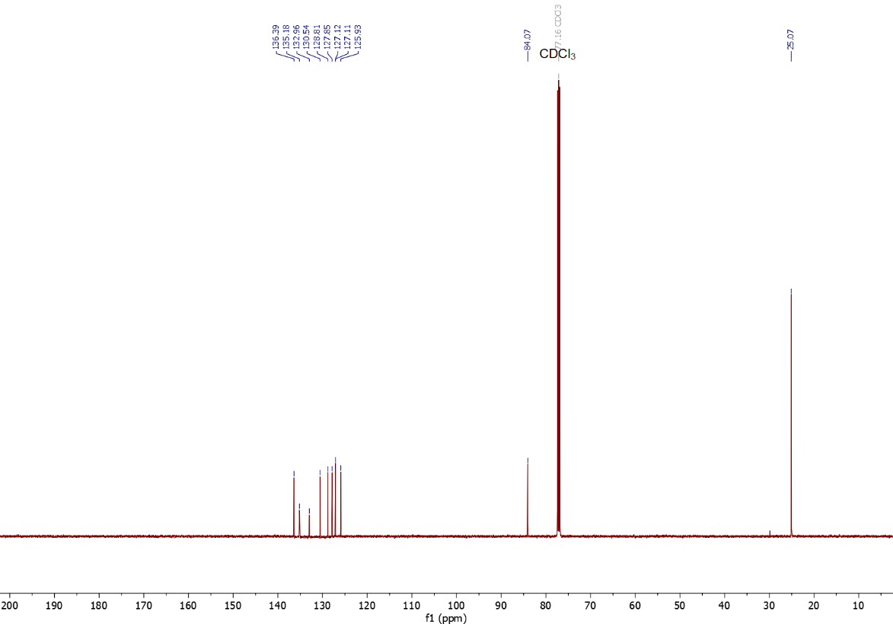
Figure S240. ¹³C NMR (126 MHz, CDCl₃) spectrum of 5.
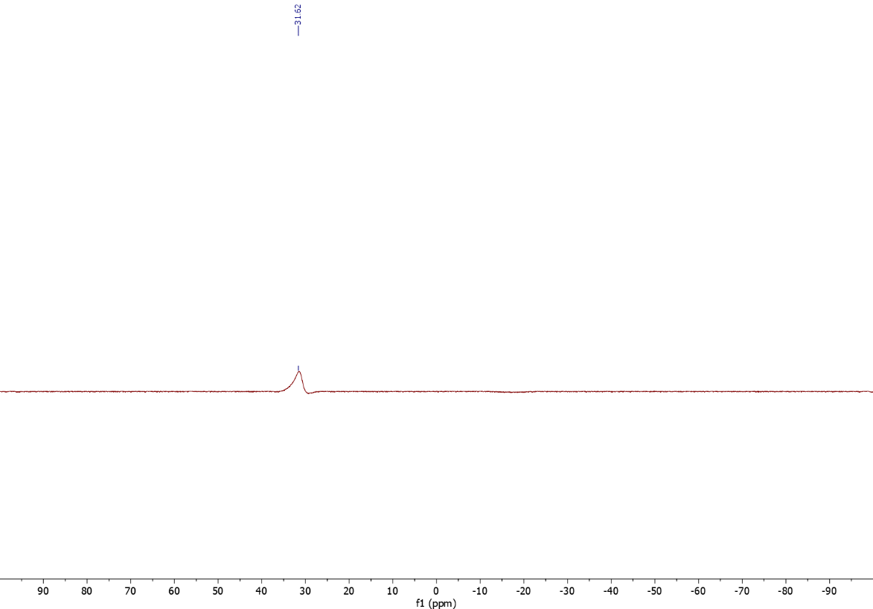
Figure S241. ¹¹B NMR (160 MHz, CDCl₃) spectrum of 5.
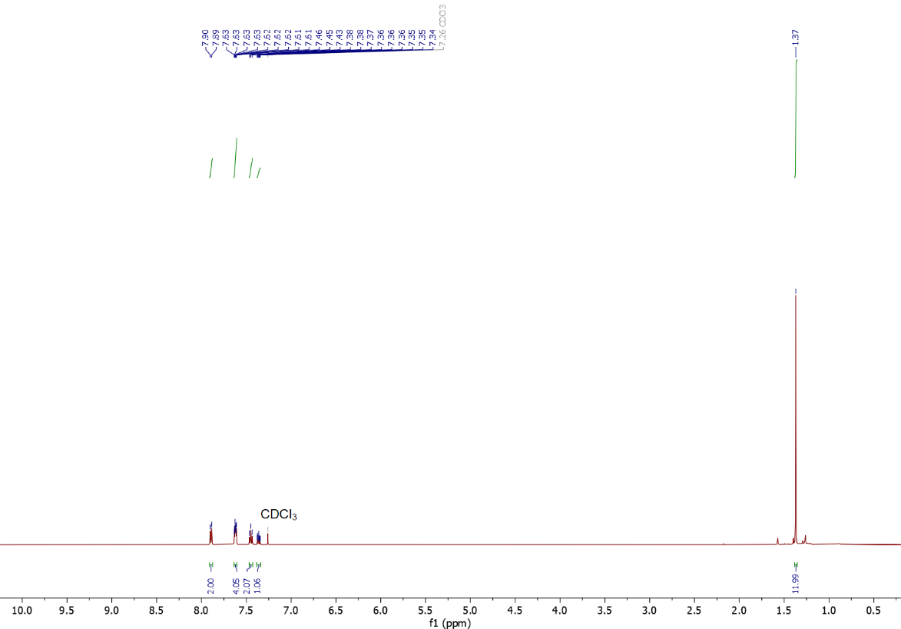
Figure S242. ¹H NMR (500 MHz, CDCl₃) spectrum of 6.

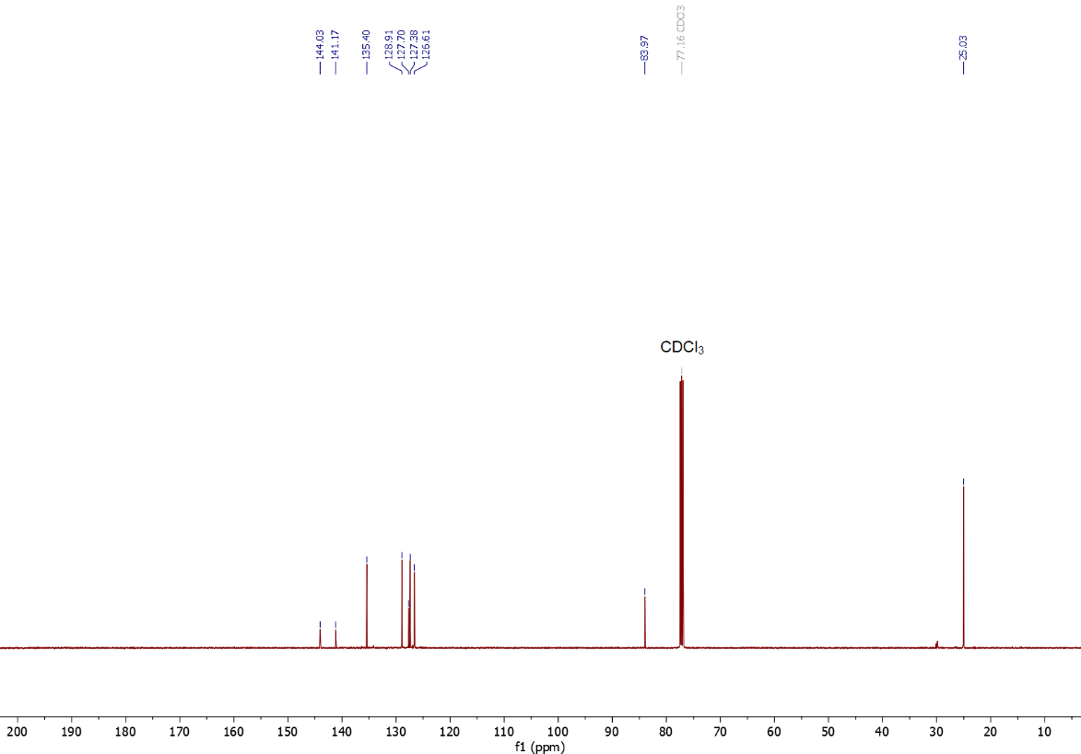
Figure S243. ¹³C NMR (126 MHz, CDCl₃) spectrum of 6.
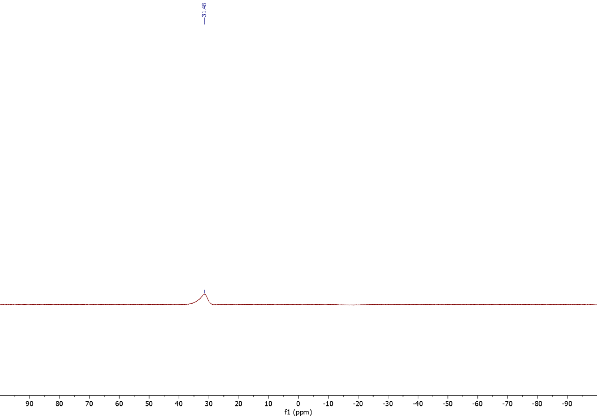
Figure S244. ¹¹B NMR (160 MHz, CDCl₃) spectrum of 6.
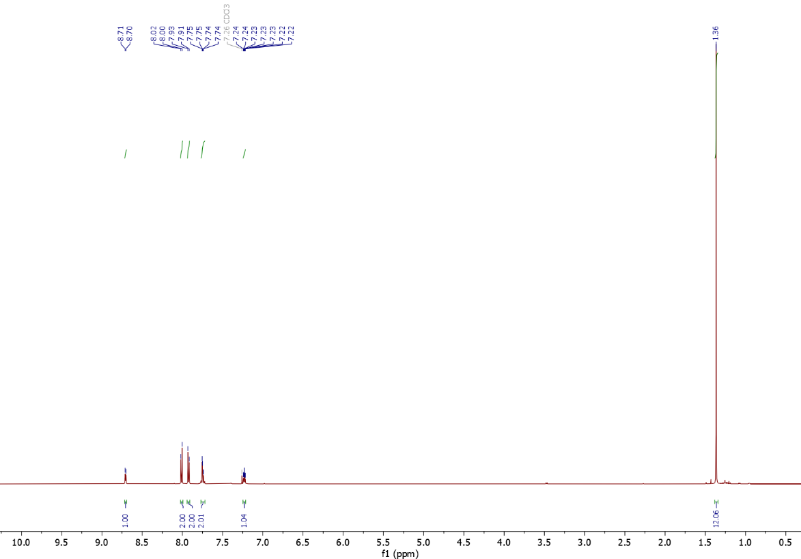
Figure S245. ¹H NMR (500 MHz, CDCl₃) spectrum of 7.

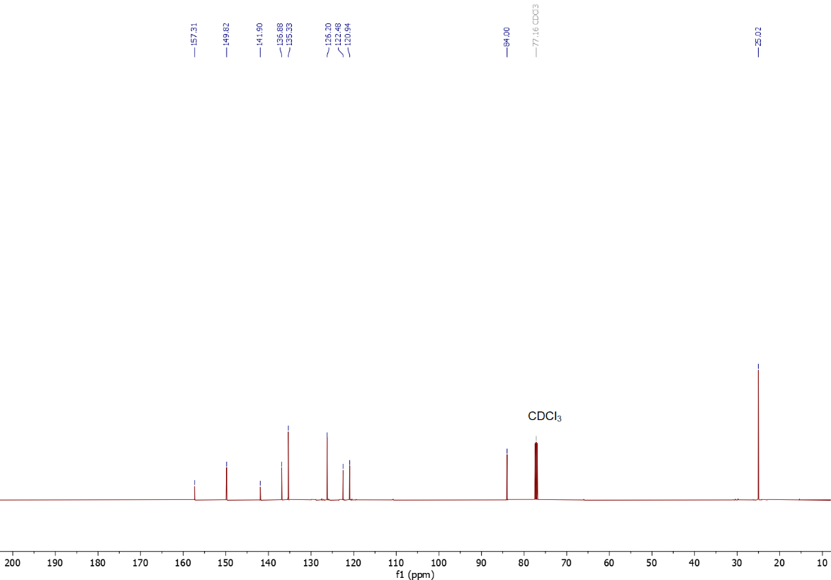
Figure S246. ¹³C NMR (126 MHz, CDCl₃) spectrum of 7.
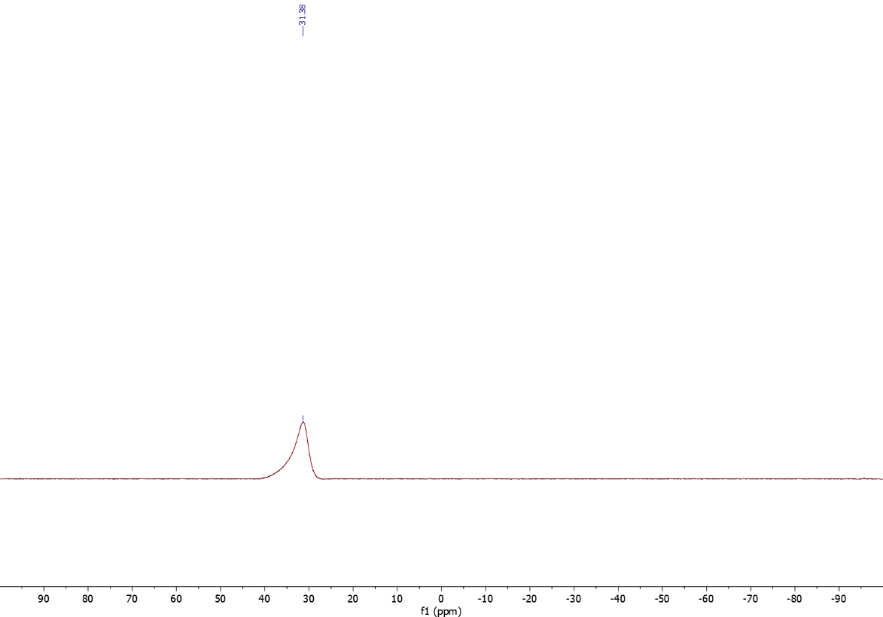
Figure S247. ¹¹B NMR (160 MHz, CDCl₃) spectrum of 7.
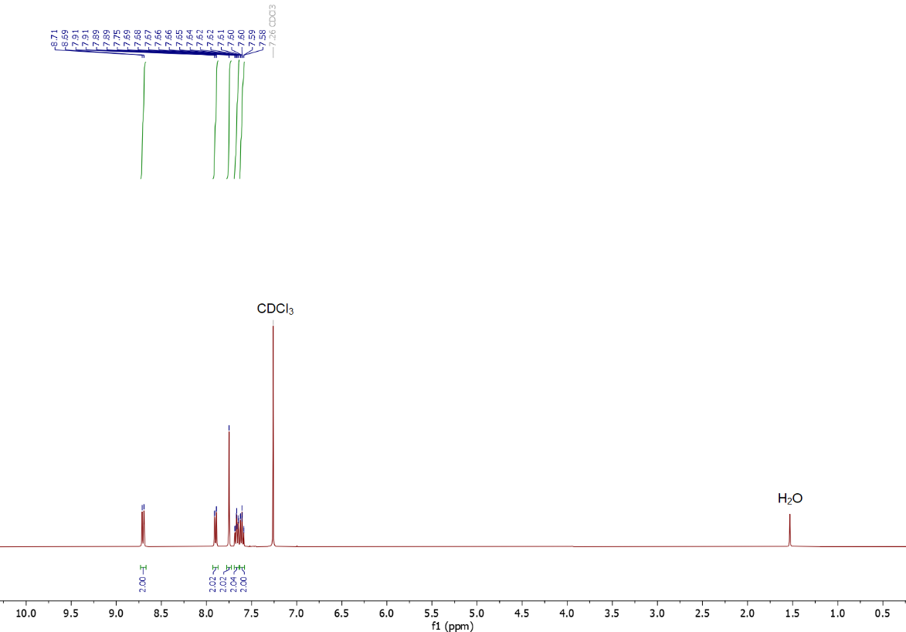
Figure S248. ¹H NMR (400 MHz, CDCl₃) spectrum of 8.
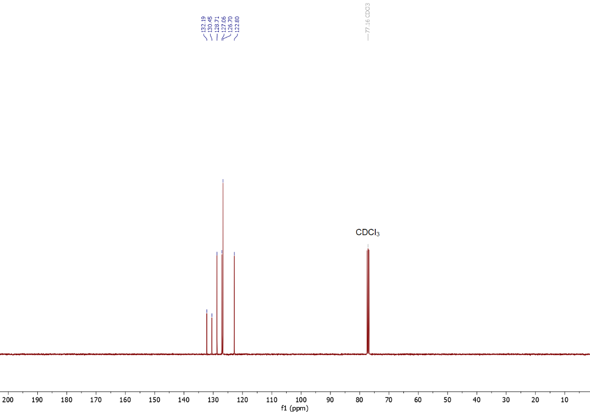
Figure S249. ¹³C NMR (101 MHz, CDCl₃) spectrum of 8.
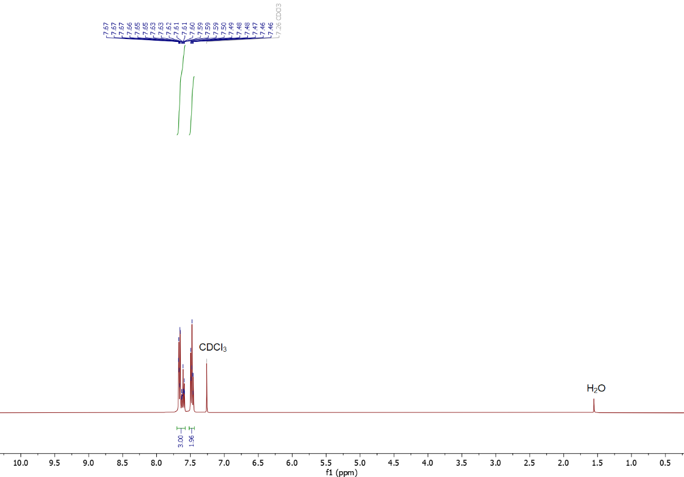
Figure S250. ¹H NMR (400 MHz, CDCl₃) spectrum of 9.
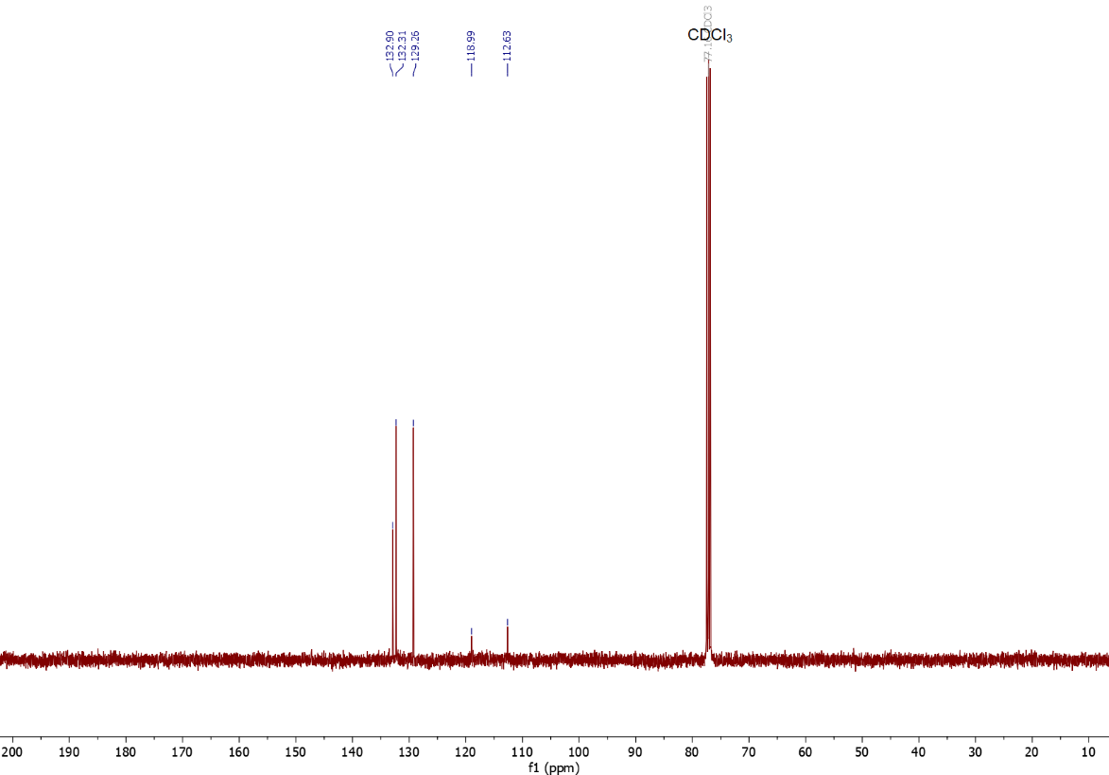
Figure S251. ¹³C NMR (101 MHz, CDCl₃) spectrum of 9.
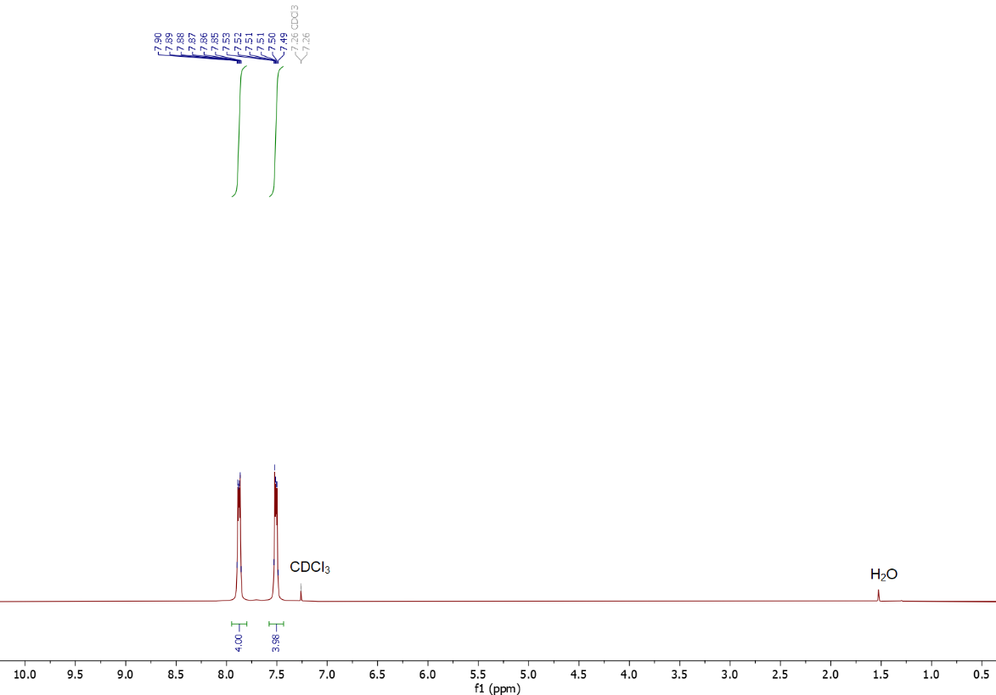
Figure S252. ¹H NMR (400 MHz, CDCl₃) spectrum of 10.
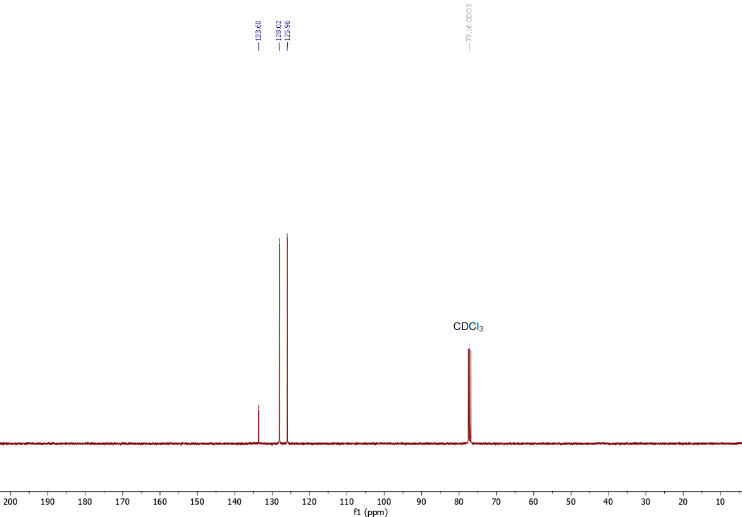
Figure S253. ¹³C NMR (101 MHz, CDCl₃) spectrum of 10.

References.
1. Kim, J. et al. Zinc bromide: a general mediator for the ionothermal synthesis of microporous polymers via cyclotrimerization reactions. J. Mater. Chem. A 11, 17159–17166 (2023).
2. Li, H. et al. Three-Dimensional Tetrathiafulvalene-Based Covalent Organic Frameworks for Tunable Electrical Conductivity. J. Am. Chem. Soc. 141, 13324–13329 (2019).
3. Peng, S.-Q. et al. Flexible Porous Polynorbornenes with Alkene Linkage for Decolorizing the Highly Reactive Triisocyanate in Ethyl Acetate. Chem. Mater. 34, 5184–5193 (2022).
4. Ahmad, I., Mahmood, J. & Baek, J. Scalable Synthesis of Tetrapodal Octaamine. Eur. J. Org. Chem. 2019, 2335–2338 (2019).
5. Regar, R., Mehra, K. S., Bhowal, R. & Sankar, J. Electronic Modulation of Terrylene Diimides Leading to Core‐Twisting, Tunable Emission and Intermolecular Interactions. Eur. J. Org. Chem. 2019, 6278–6284 (2019).
6. Cowper, N. G. W., Chernowsky, C. P., Williams, O. P. & Wickens, Z. K. Potent Reductants via Electron-Primed Photoredox Catalysis: Unlocking Aryl Chlorides for Radical Coupling. J. Am. Chem. Soc. 142, 2093–2099 (2020).
7. Gannett, C. N., Kim, J., Tirtariyadi, D., Milner, P. J. & Abruña, H. D. Investigation of ion-electrode interactions of linear polyimides and alkali metal ions for next generation alternative-ion batteries. Chem. Sci. 13, 9191–9201 (2022).
8. Robb, M. J., Newton, B., Fors, B. P. & Hawker, C. J. One-Step Synthesis of Unsymmetrical N -Alkyl- N ′-aryl Perylene Diimides. J. Org. Chem. 79, 6360–6365 (2014).
9. Kim, J., Shirke, Y. & Milner, P. J. Flexible Backbone Effects on the Redox Properties of Perylenediimide-Based Polymers. ACS Appl. Mater. Interfaces 16, 48713–48721 (2024).
10. Xie, L. & Wang, Z. Nickel‐Catalyzed Cross‐Coupling of Aryltrimethylammonium Iodides with Organozinc Reagents. Angew. Chem. Int. Ed. 50, 4901–4904 (2011).
11. Webb, E. W. et al. Room-Temperature Copper-Mediated Radiocyanation of Aryldiazonium Salts and Aryl Iodides via Aryl Radical Intermediates. J. Am. Chem. Soc. 145, 6921–6926 (2023).
12. Xing, B., Ni, C. & Hu, J. Hypervalent Iodine(III)‐Catalyzed Balz–Schiemann Fluorination under Mild Conditions. Angew. Chem. Int. Ed. 57, 9896–9900 (2018).
13. Rieth, A. J., Gonzalez, M. I., Kudisch, B., Nava, M. & Nocera, D. G. How Radical Are “Radical” Photocatalysts? A Closed-Shell Meisenheimer Complex Is Identified as a Super-Reducing Photoreagent. J. Am. Chem. Soc. 143, 14352–14359 (2021).
14. Lai, Y., Halder, A., Kim, J., Hicks, T. J. & Milner, P. J. Electroreductive Radical Borylation of Unactivated (Hetero)Aryl Chlorides Without Light by Using Cumulene‐Based Redox Mediators. Angew. Chem. Int. Ed. 62, e202310246 (2023).
15. Liu, X., Xu, B. & Su, W. Ni-Catalyzed Deoxygenative Borylation of Phenols Via O-Phenyl-uronium Activation. ACS Catal. 12, 8904–8910 (2022).
16. Korvinson, K. A. et al. Catalytic Reductions Without External Hydrogen Gas: Broad Scope Hydrogenations with Tetrahydroxydiboron and a Tertiary Amine. Adv. Synth. Catal. 362, 166–176 (2020).
17. Zheng, S., Yu, C. & Shen, Z. Ethyl Cyanoacetate: A New Cyanating Agent for the Palladium-Catalyzed Cyanation of Aryl Halides. Org. Lett. 14, 3644–3647 (2012).
18. Zhou, M.-J., Zhang, L., Liu, G., Xu, C. & Huang, Z. Site-Selective Acceptorless Dehydrogenation of Aliphatics Enabled by Organophotoredox/Cobalt Dual Catalysis. J. Am. Chem. Soc. 143, 16470–16485 (2021).
19. Zeman, C. J., Kim, S., Zhang, F. & Schanze, K. S. Direct Observation of the Reduction of Aryl Halides by a Photoexcited Perylene Diimide Radical Anion. J. Am. Chem. Soc. 142, 2204–2207 (2020).
20. Ghosh, I., Ghosh, T., Bardagi, J. I. & König, B. Reduction of aryl halides by consecutive visible light-induced electron transfer processes. Science 346, 725–728 (2014).
21. Li, H. & Wenger, O. S. Photophysics of Perylene Diimide Dianions and Their Application in Photoredox Catalysis. Angew. Chem. Int. Ed. 61, e202110491 (2022).

