Design, synthesis and antiviral activity of coumarin derivatives containing 1,3,4- oxadiazole/thidiazole
Yuzhi Hu¹, Zhiling Sun¹ Wei Zeng¹, Yujiao Qiu¹, Zhiyuan Xu^{2,}*, Jing Zhang^{2,}*, Gang Feng^{2,}*
1 State Key Laboratory of Green Pesticide, Center for R&D of Fine Chemicals of Guizhou University, Guiyang, 550025, China.
2 Environment and Plant Protection Institute, Chinese Academy of Tropical Agricultural Science, Haikou 571101, China
*Corresponding author (Tel.: 86-898-66969260; Fax: 86-898-66969211; E-mail: feng8513@sina.com, zh-jing99@163.com)

¹H NMR, ¹³C NMR, ¹⁹F NMR and HRMS spectrum of the title compounds
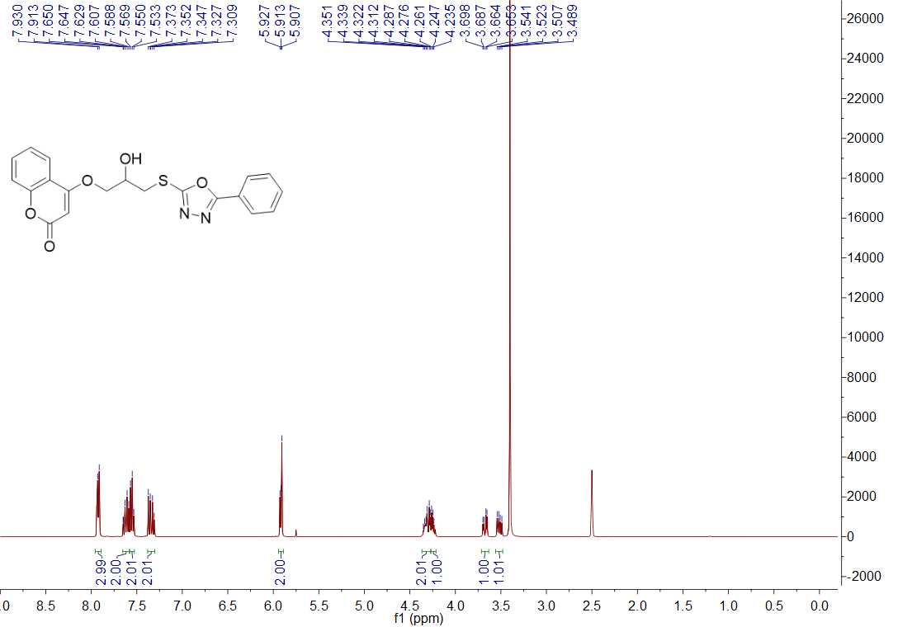

Fig. 1 ¹H NMR spectrum of title compound H1

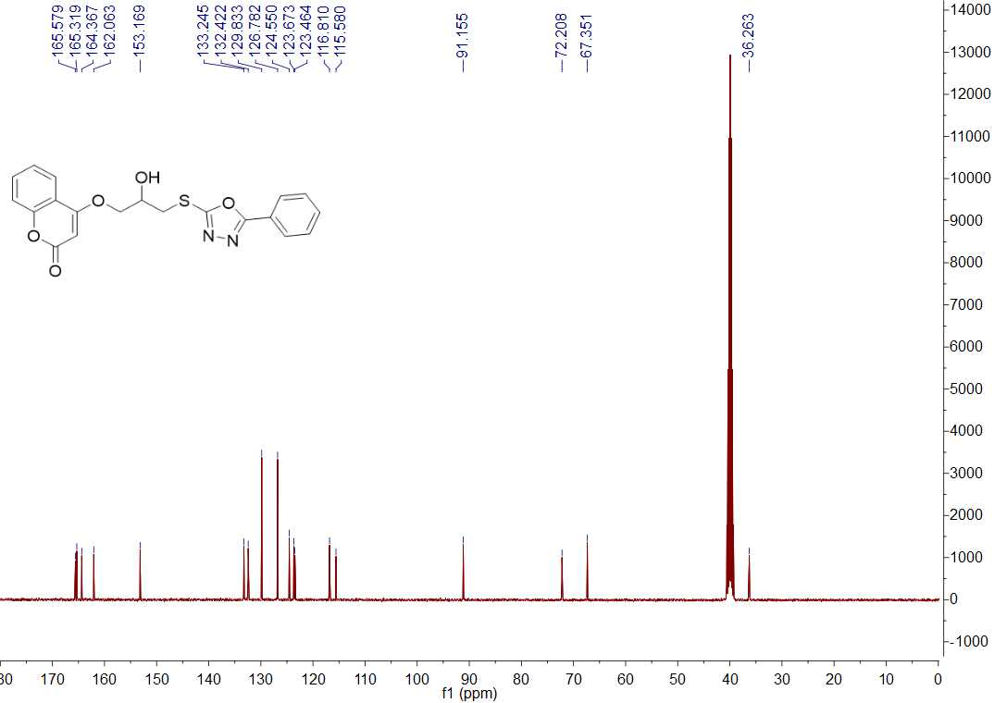

Fig. 2 ¹³C NMR spectrum of title compound H1

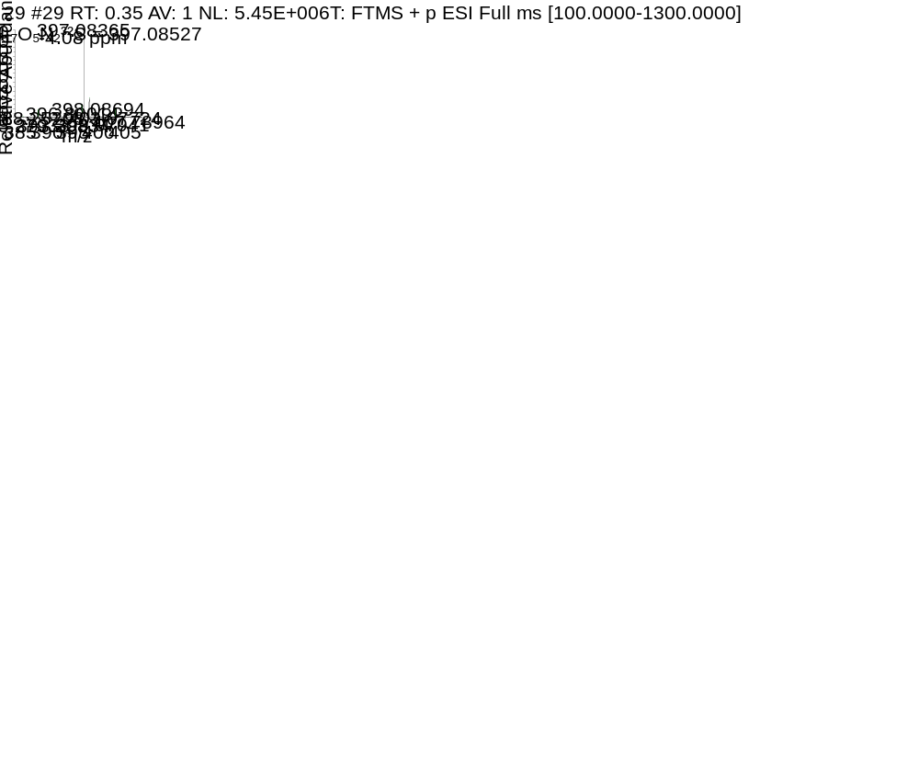
Fig. 3 HRMS spectrum of title compound H1
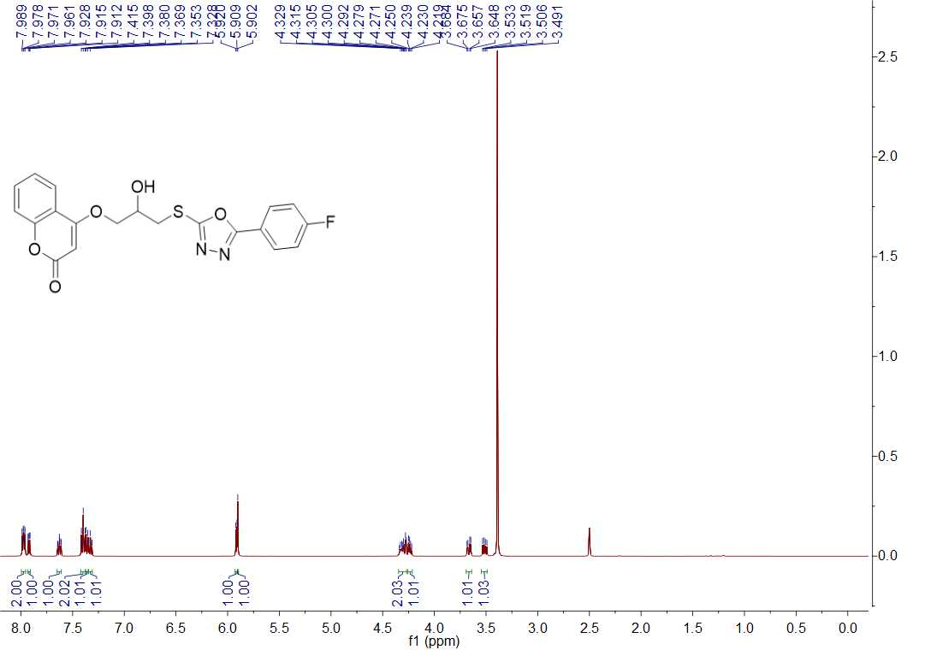
Fig. 4 ¹H NMR spectrum of title compound H2
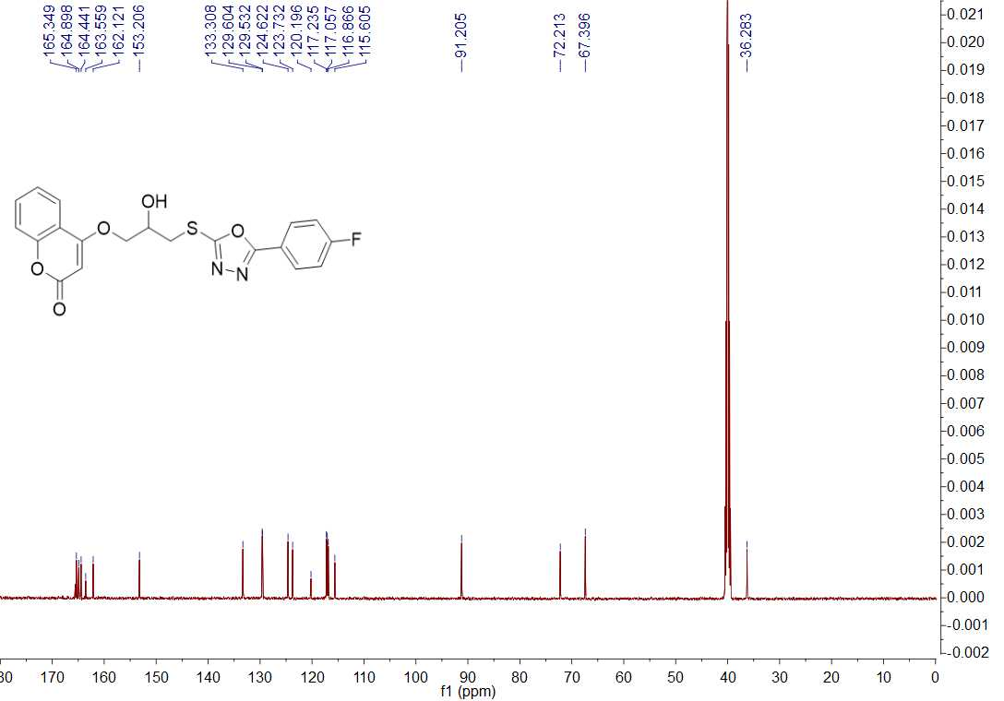

Fig. 5 ¹³C NMR spectrum of title compound H2
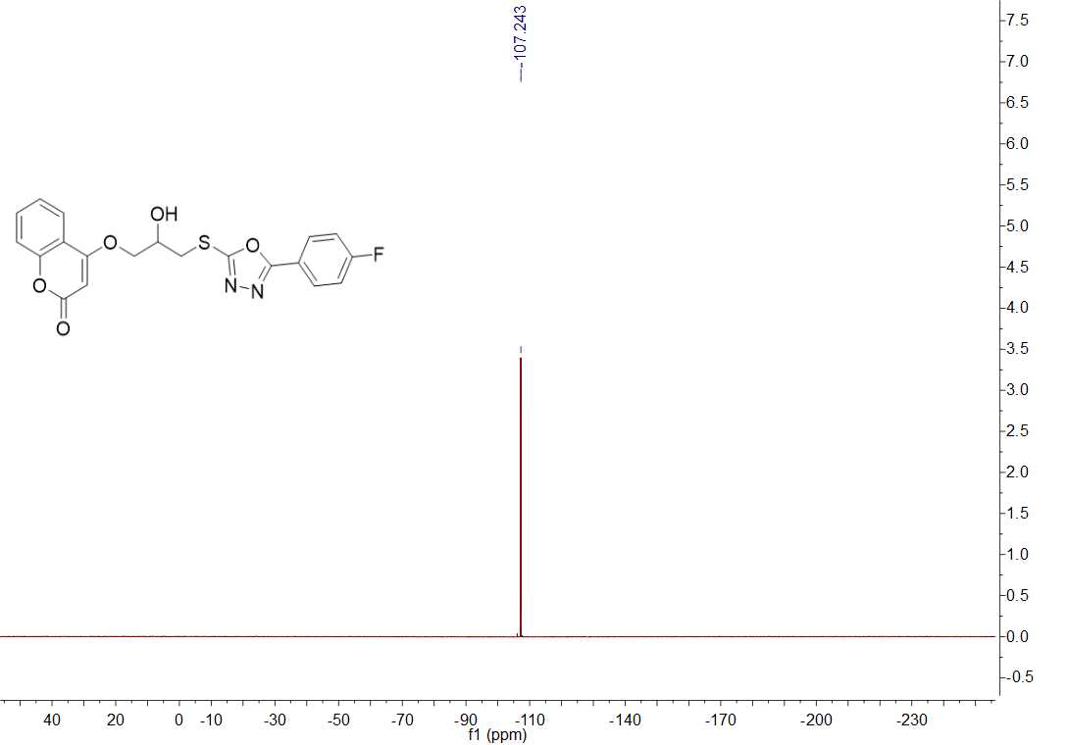
Fig. 6 ¹⁹F NMR spectrum of title compound H2

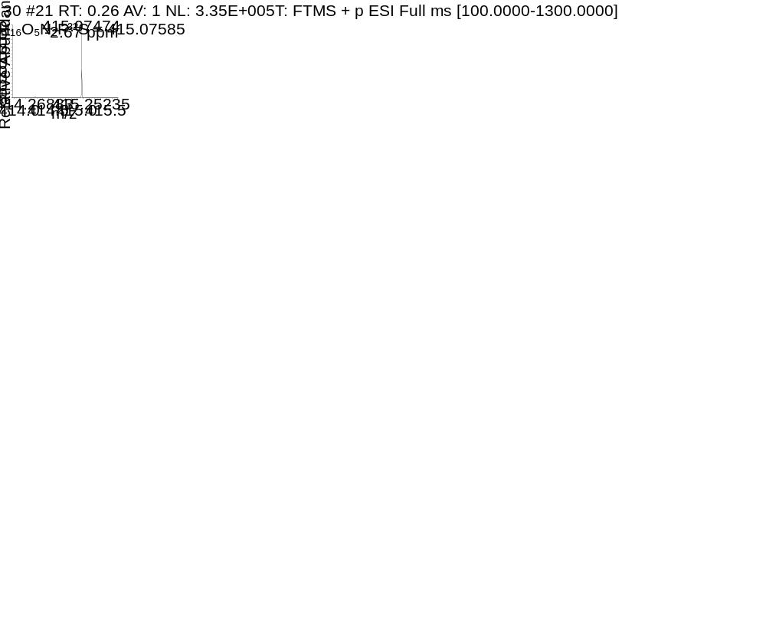
Fig. 7 HRMS spectrum of title compound H2
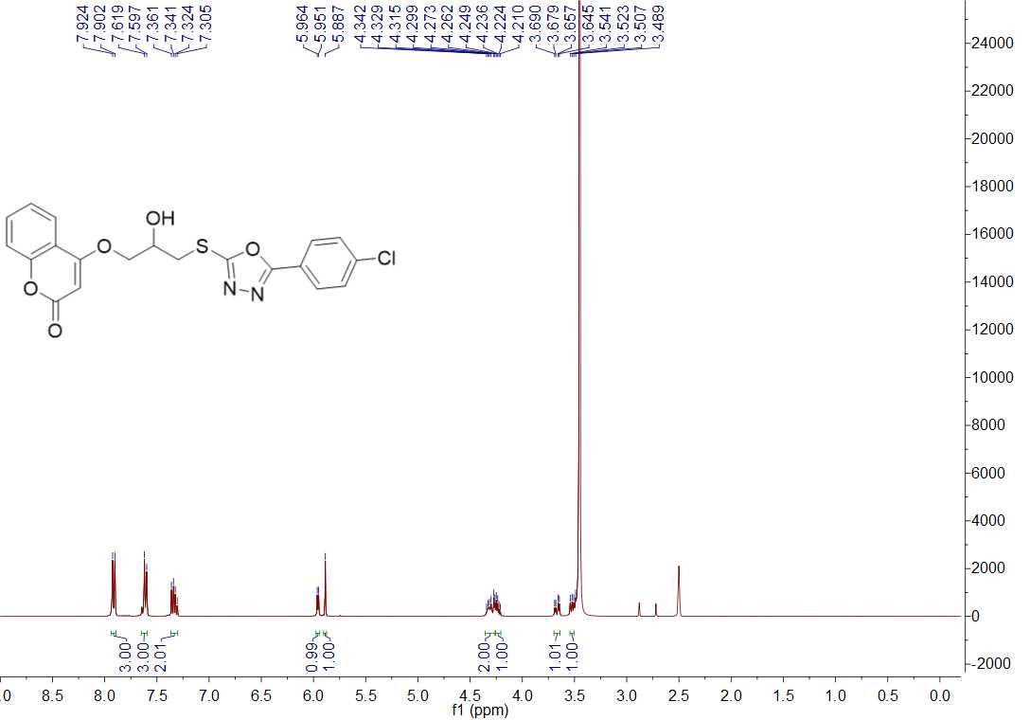
Fig. 8 ¹H NMR spectrum of title compound H3
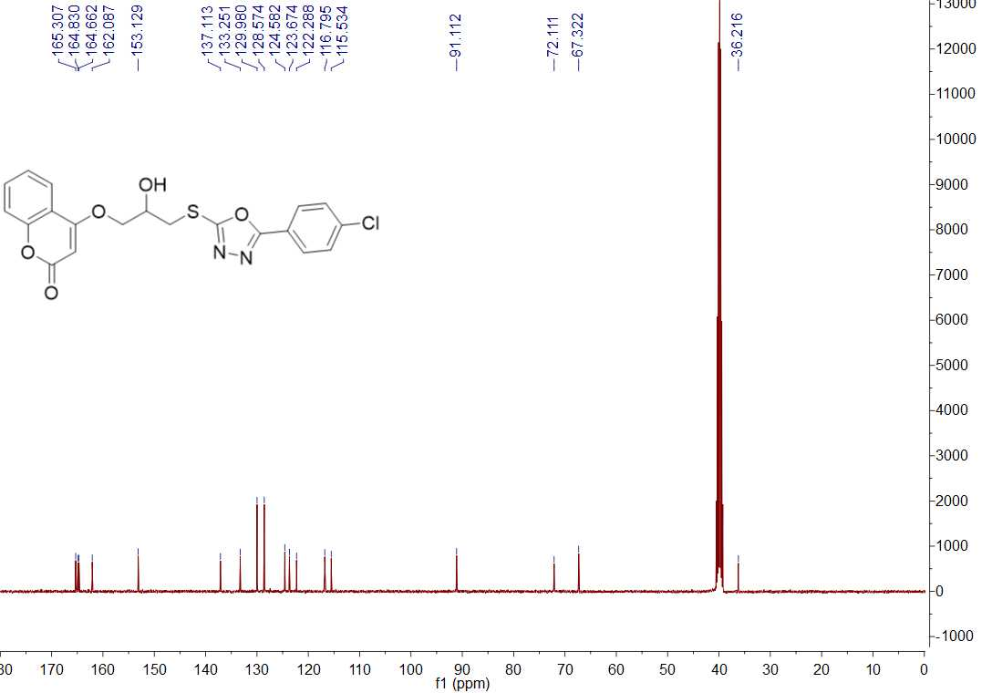
Fig. 9 ¹³C NMR spectrum of title compound H3
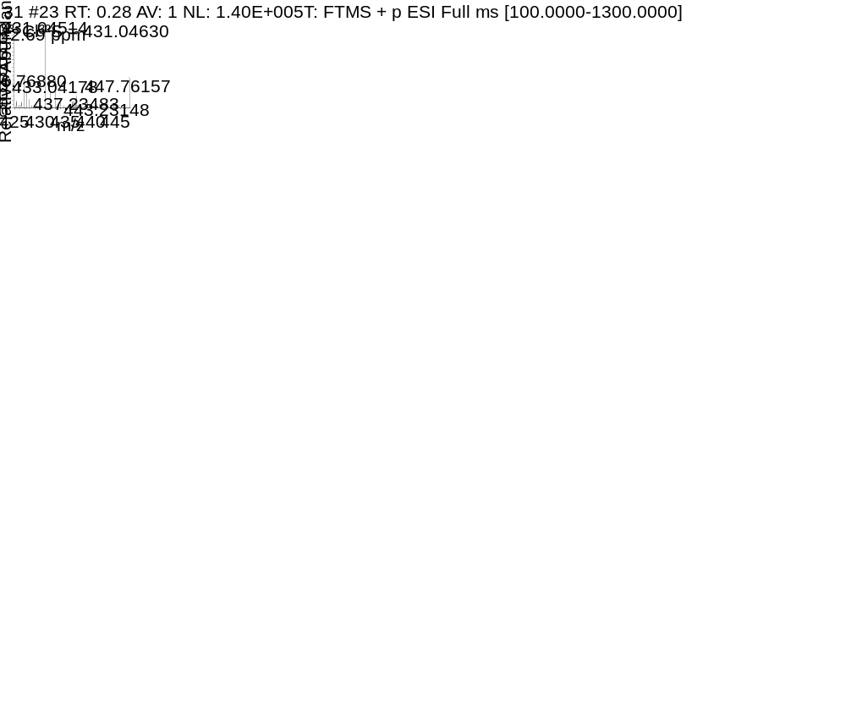
Fig. 10 HRMS spectrum of title compound H3
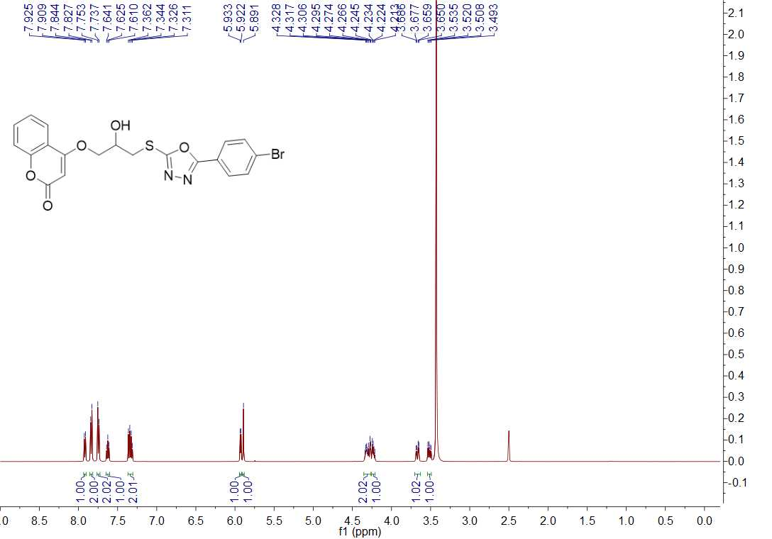
Fig. 11 ¹H NMR spectrum of title compound H4
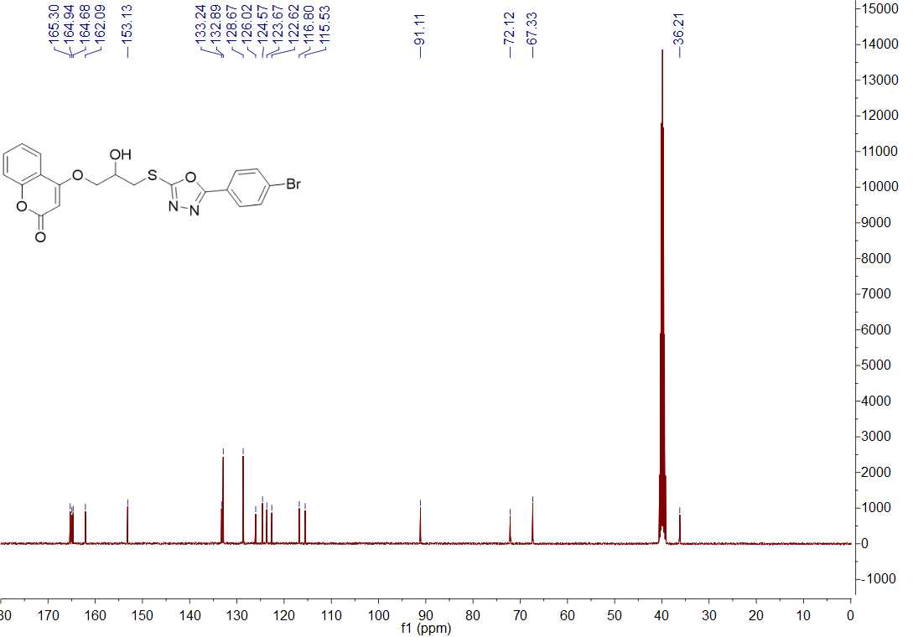
Fig. 12 ¹³C NMR spectrum of title compound H4
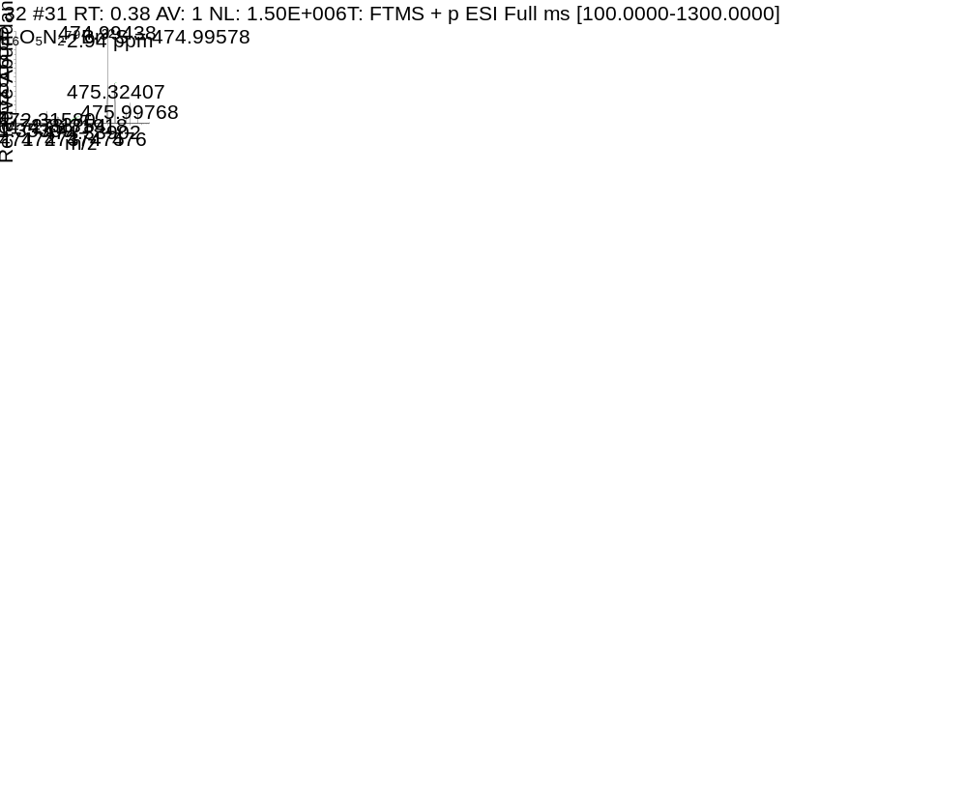
Fig. 13 HRMS spectrum of title compound H4
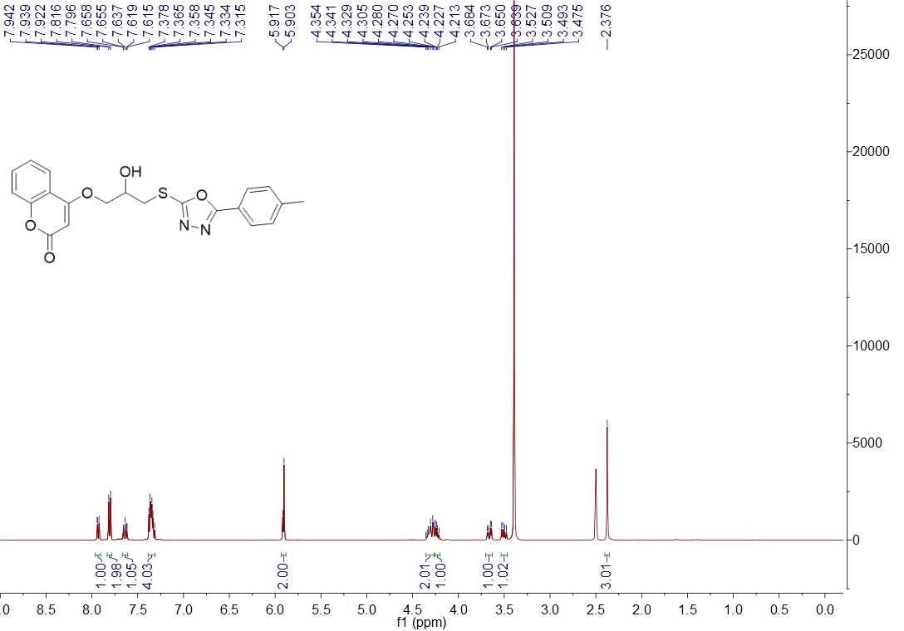
Fig. 14 ¹H NMR spectrum of title compound H5
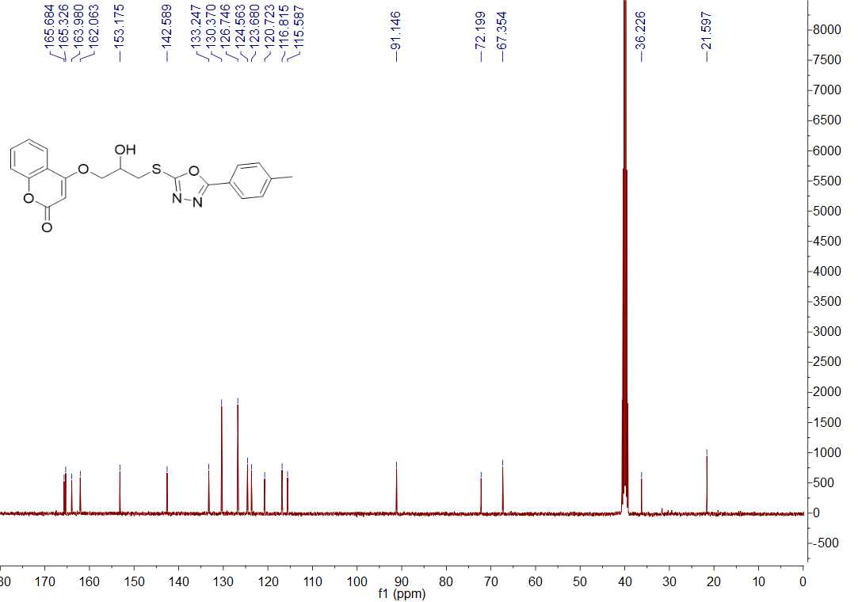
Fig. 15 ¹³C NMR spectrum of title compound H5
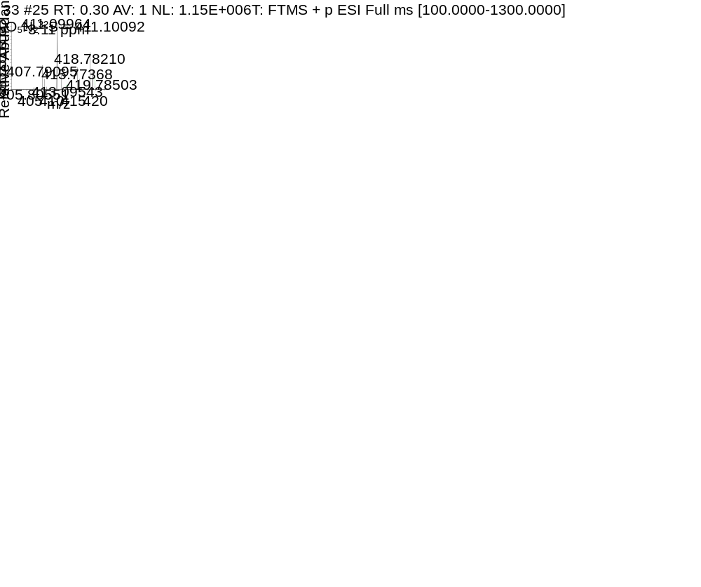
Fig. 16 HRMS spectrum of title compound H5
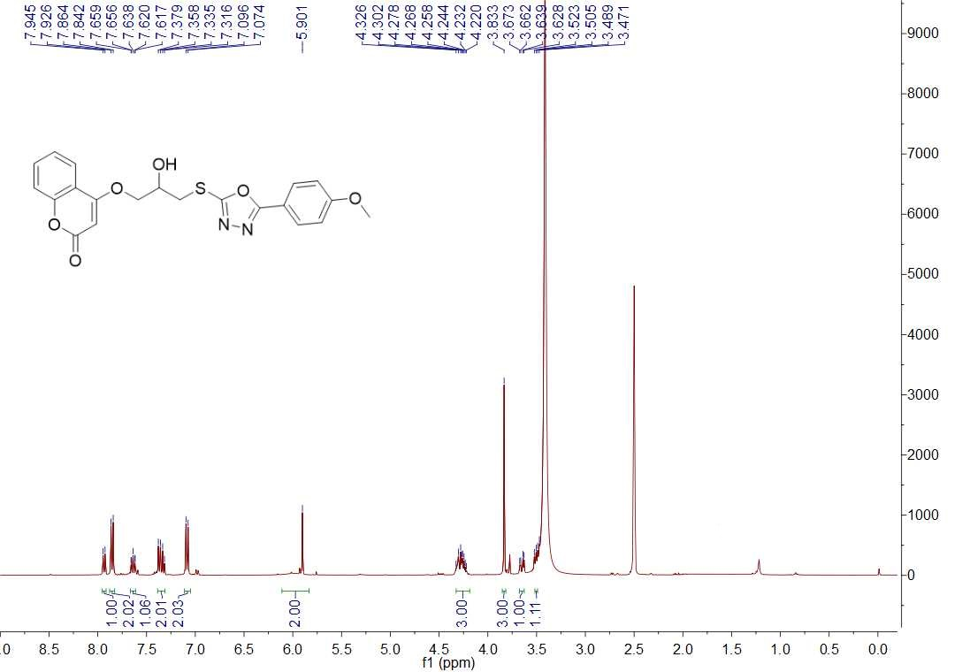
Fig. 17 ¹H NMR spectrum of title compound H6
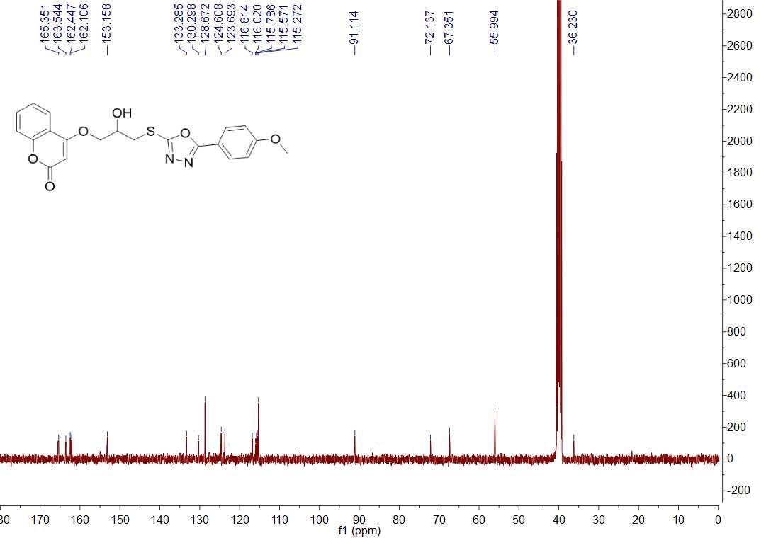
Fig. 18 ¹³C NMR spectrum of title compound H6
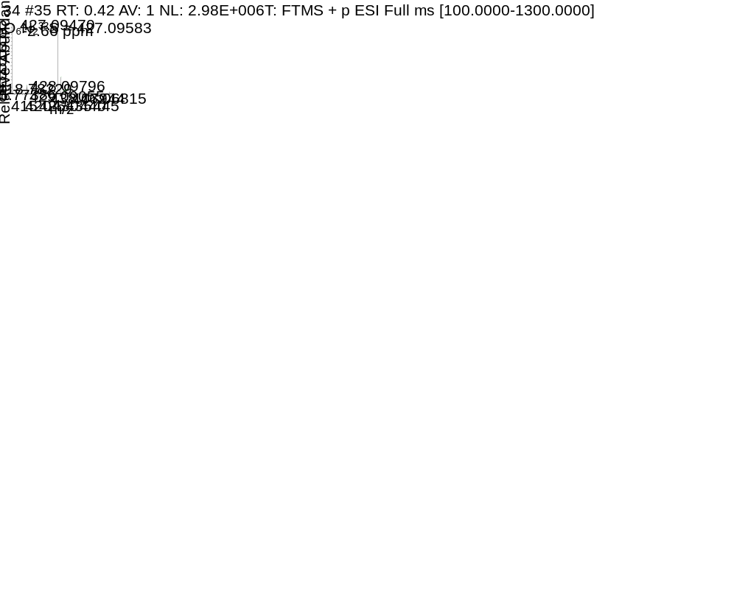
Fig. 19 HRMS spectrum of title compound H6
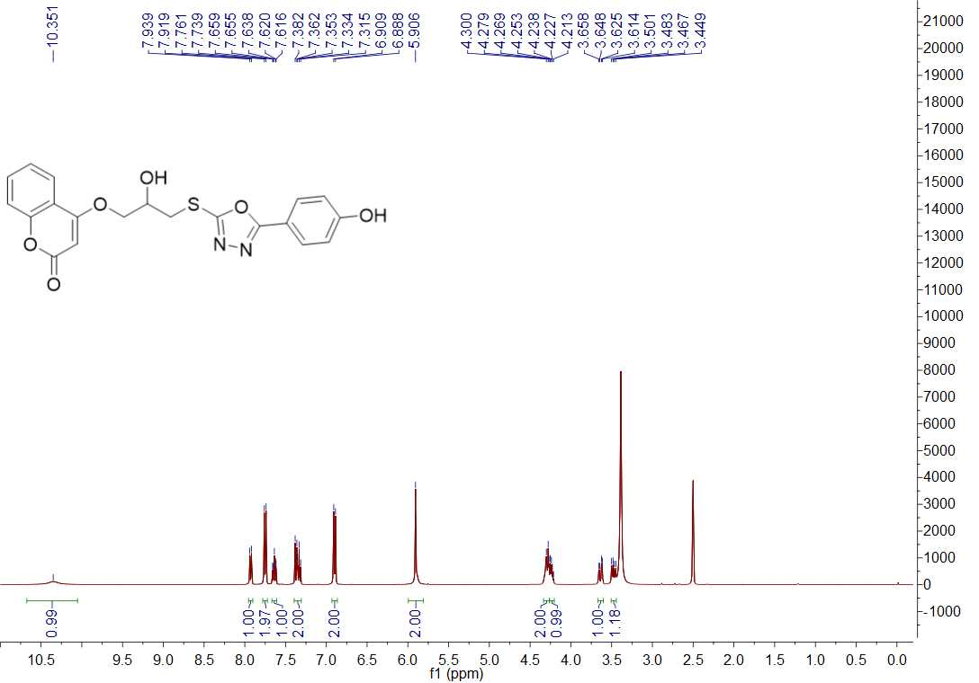
Fig. 20 ¹H NMR spectrum of title compound H7
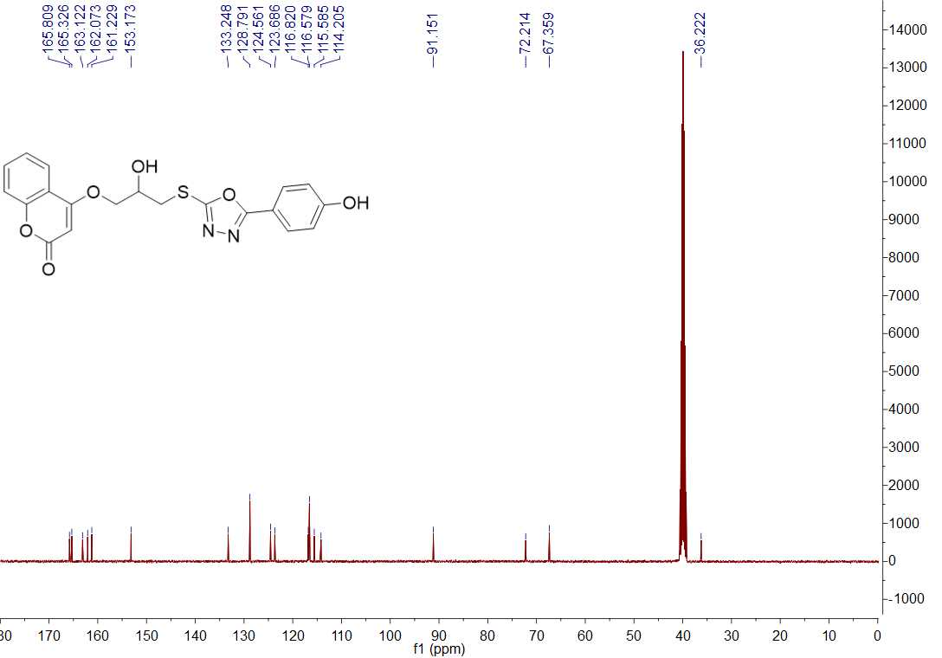
Fig. 21 ¹³C NMR spectrum of title compound H7
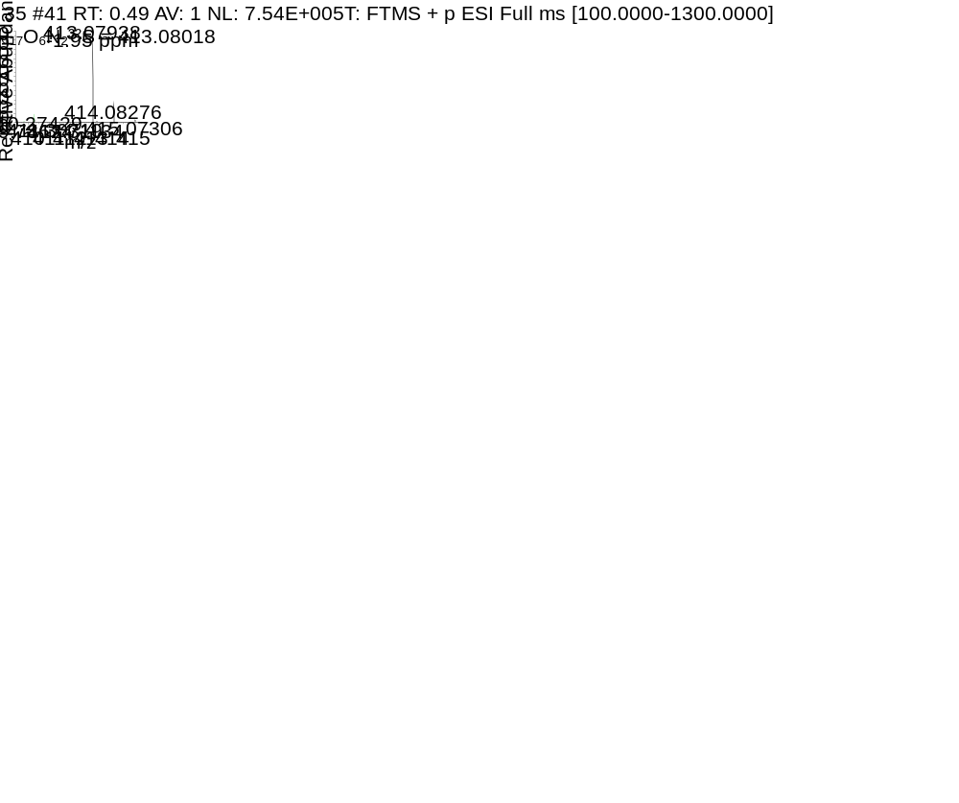
Fig. 22 HRMS spectrum of title compound H7
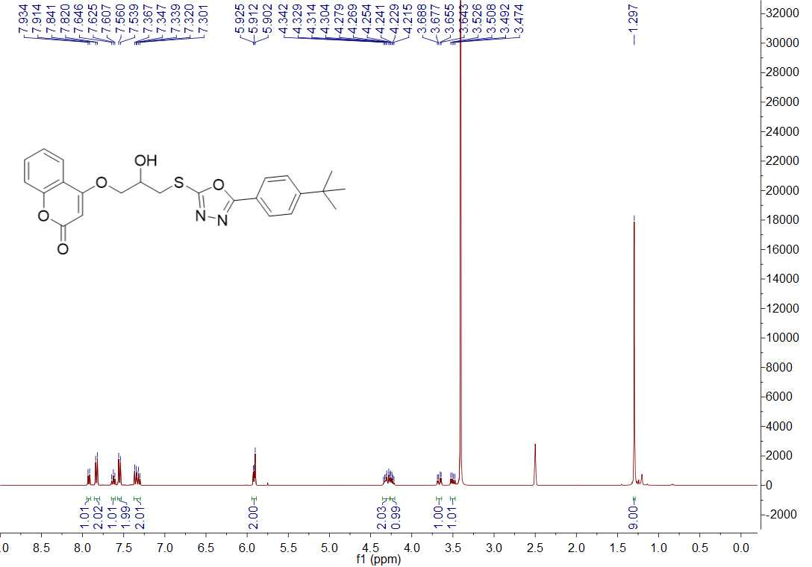
Fig. 23 ¹H NMR spectrum of title compound H8
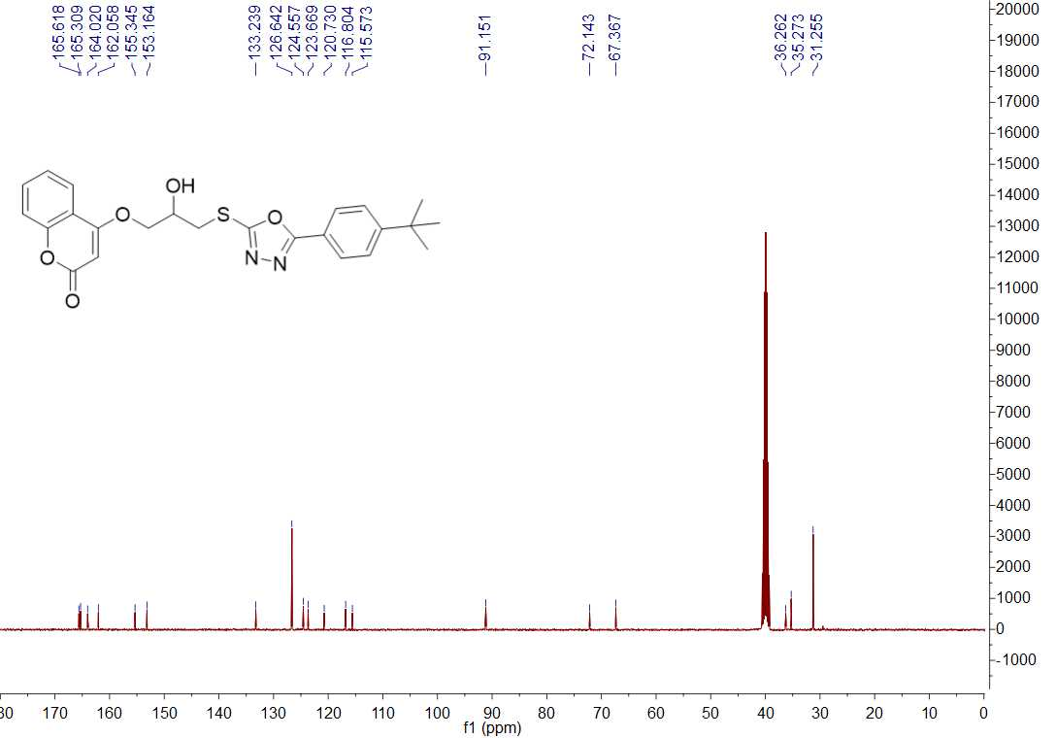
Fig. 24 ¹³C NMR spectrum of title compound H8
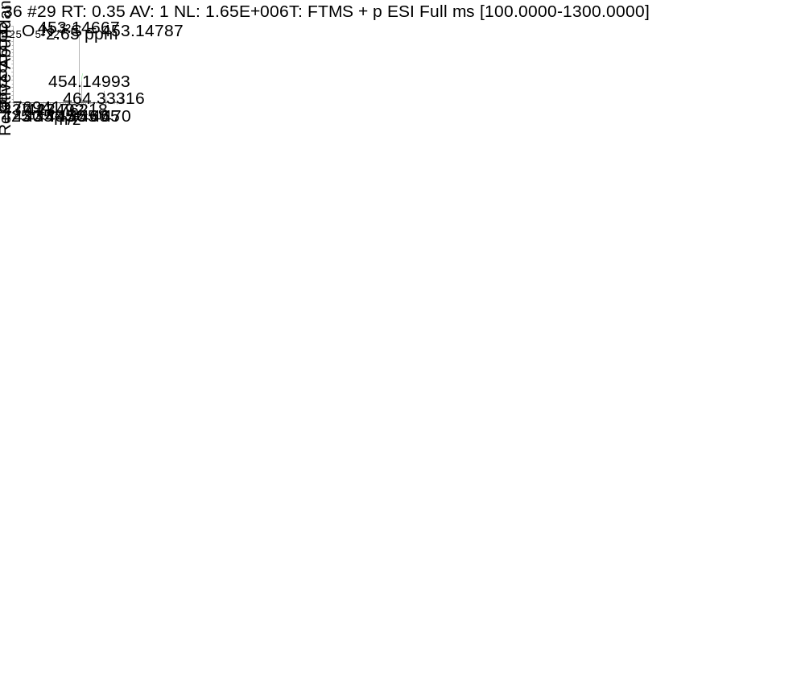
Fig. 25 HRMS spectrum of title compound H8
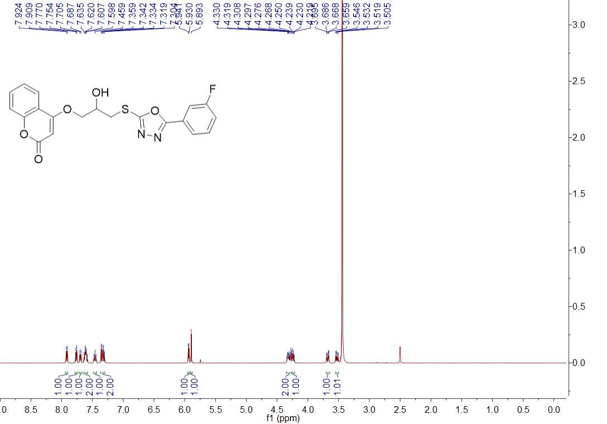
Fig. 26 ¹H NMR spectrum of title compound H9
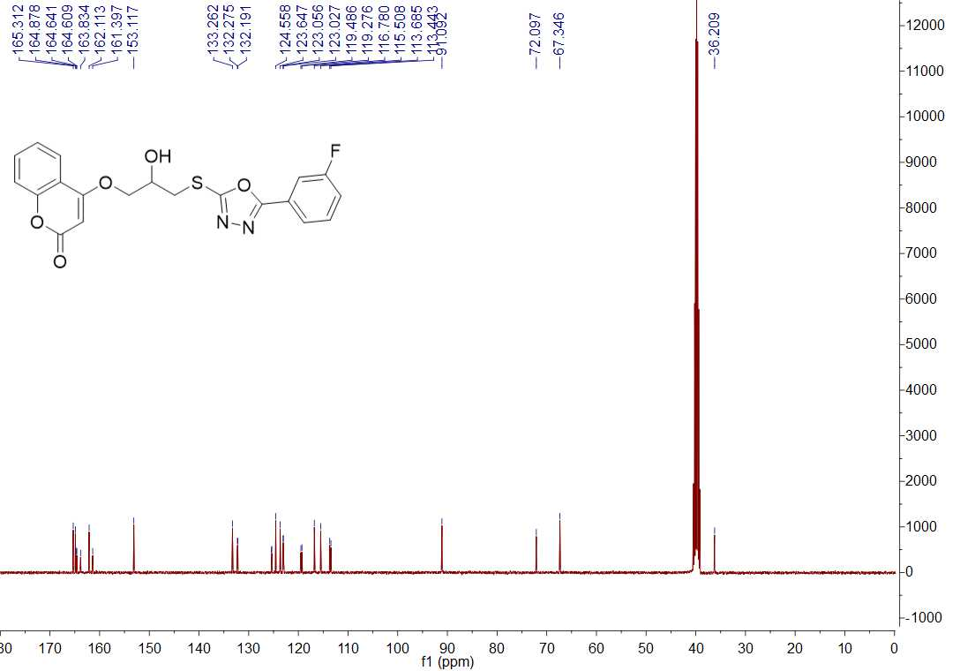
Fig. 27 ¹³C NMR spectrum of title compound H9
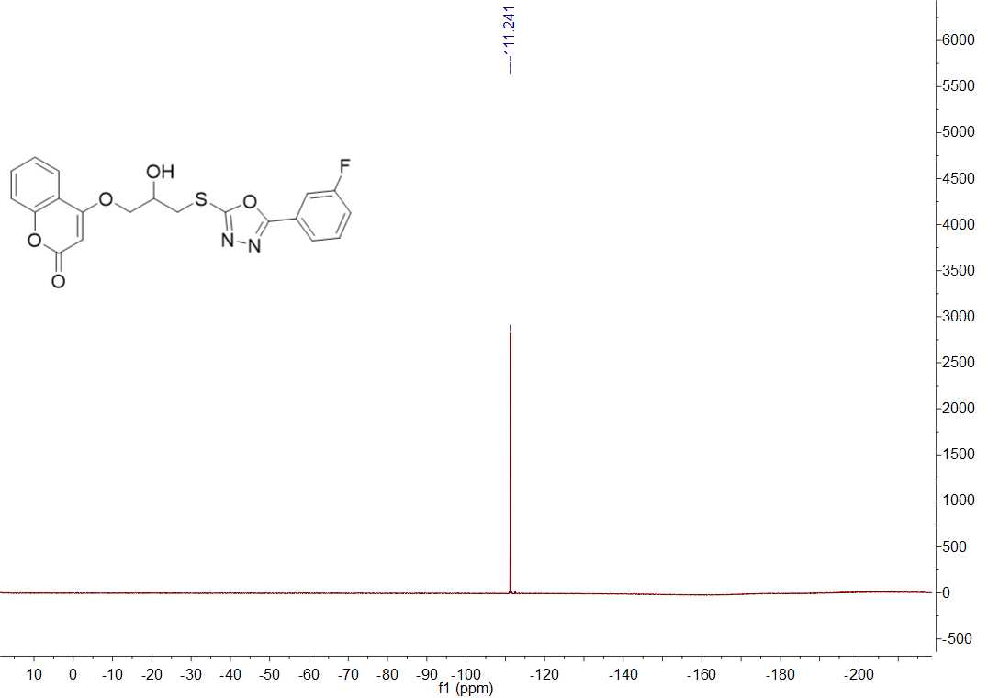
Fig. 28 ¹⁹F NMR spectrum of title compound H9
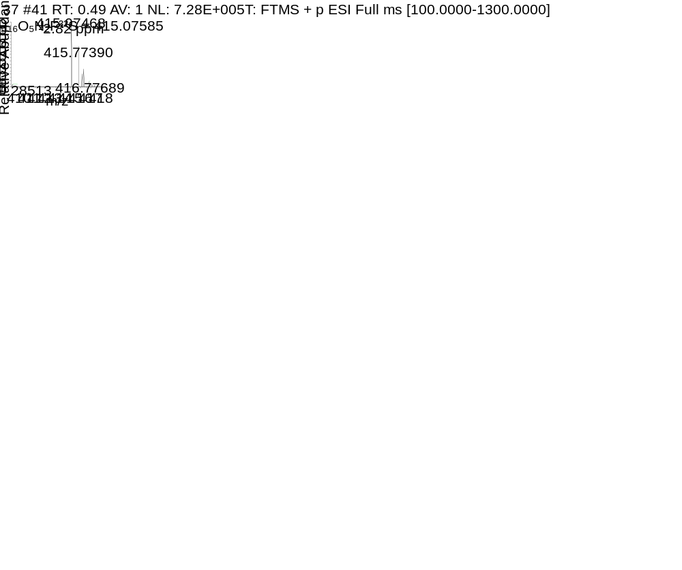
Fig. 29 HRMS spectrum of title compound H9
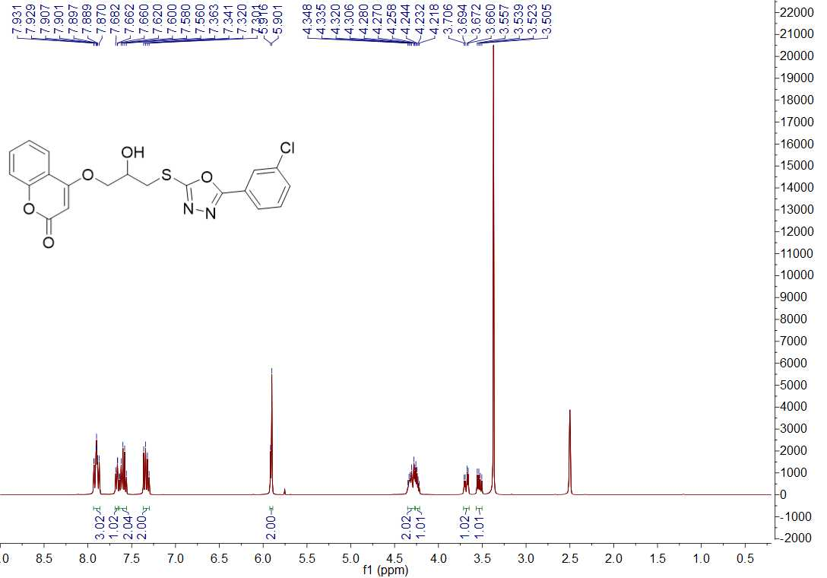
Fig. 30 ¹H NMR spectrum of title compound H10
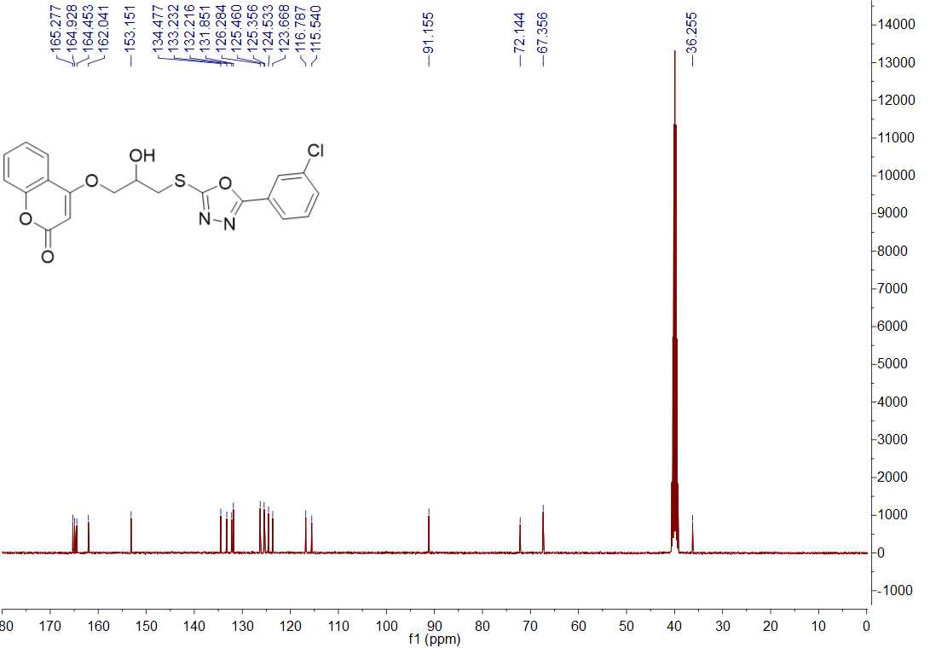
Fig. 31 ¹³C NMR spectrum of title compound H10
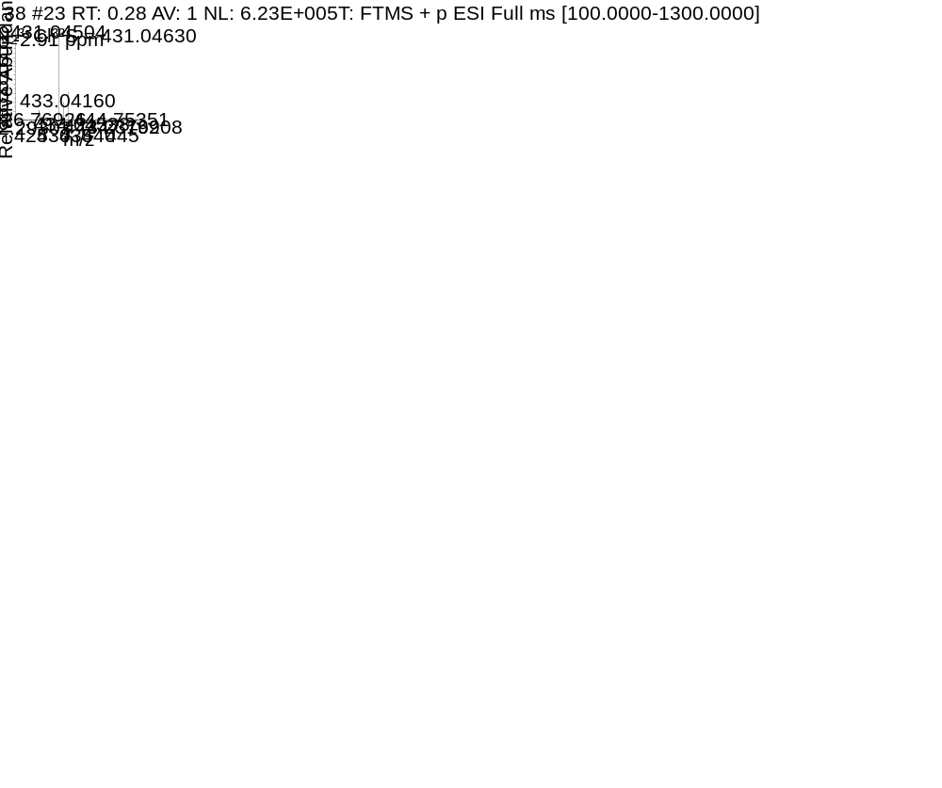
Fig. 32 HRMS spectrum of title compound H10
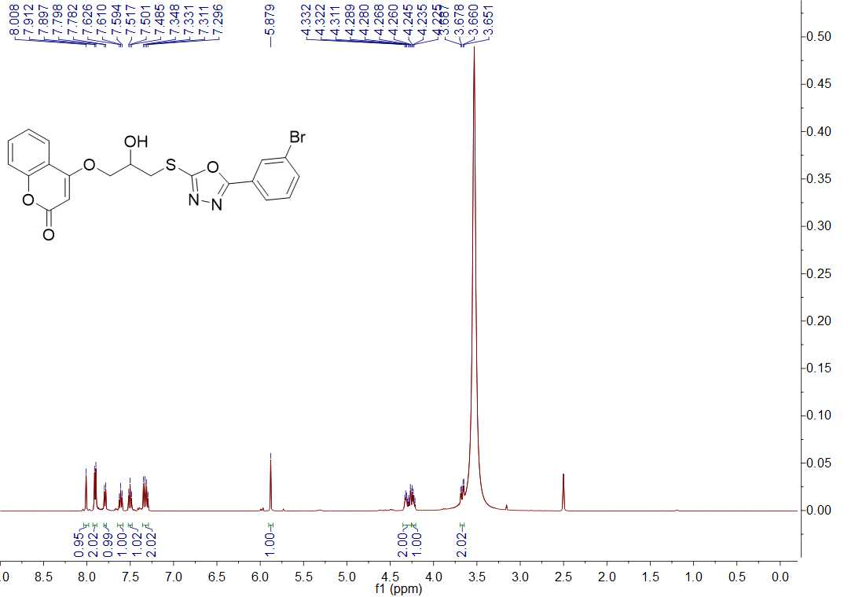
Fig. 33 ¹H NMR spectrum of title compound H11
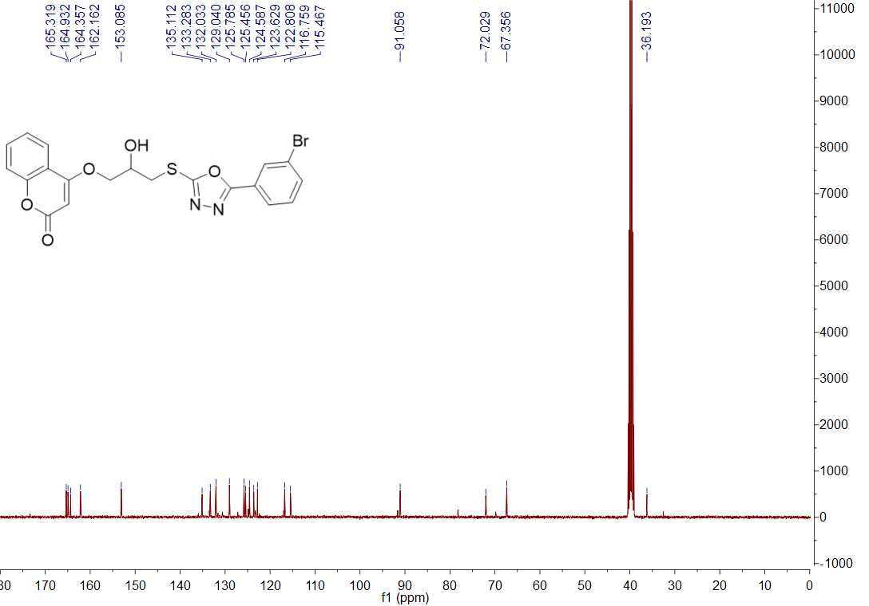
Fig. 34 ¹³C NMR spectrum of title compound H11
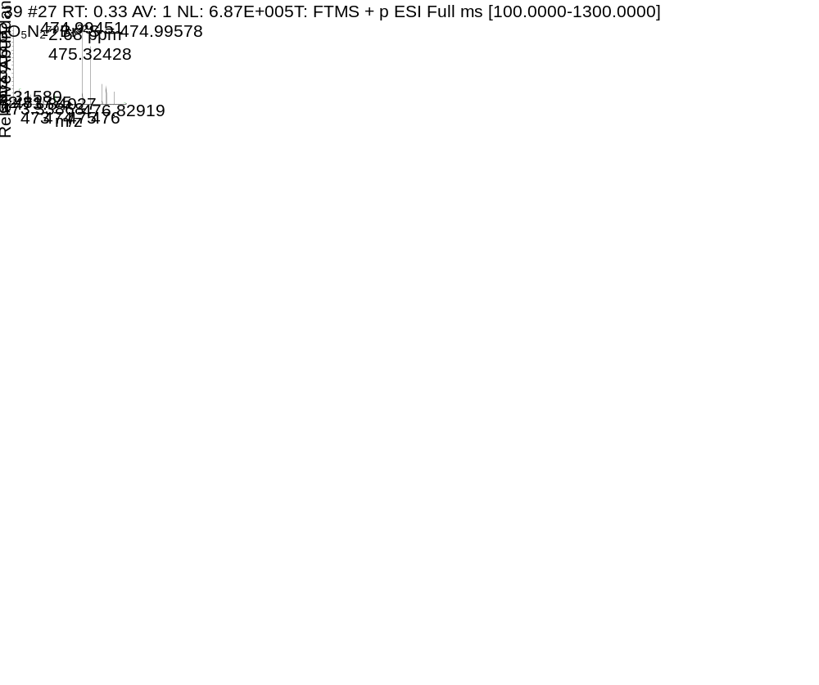
Fig. 35 HRMS spectrum of title compound H11
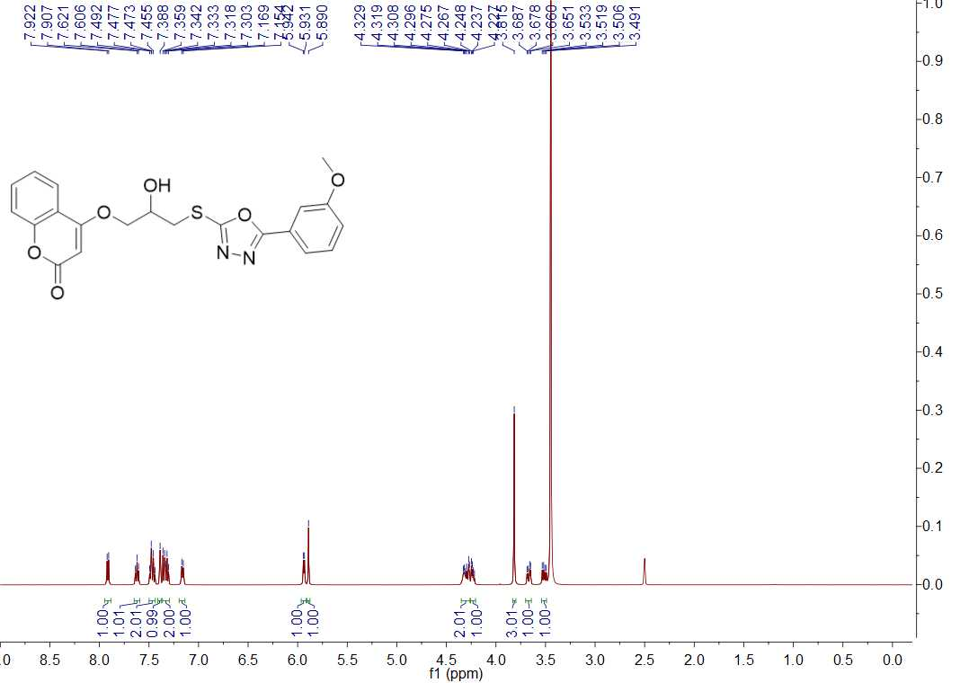
Fig. 36 ¹H NMR spectrum of title compound H12
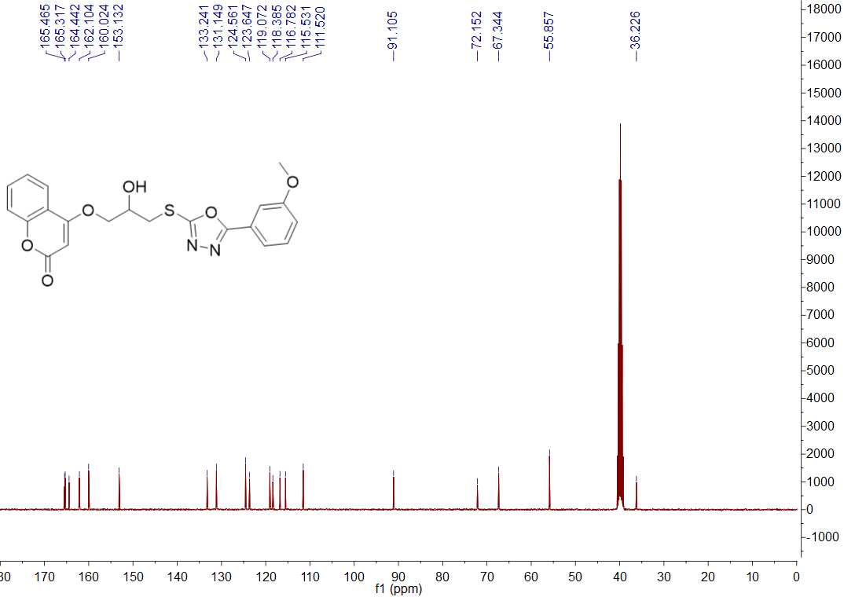
Fig. 37 ¹³C NMR spectrum of title compound H12
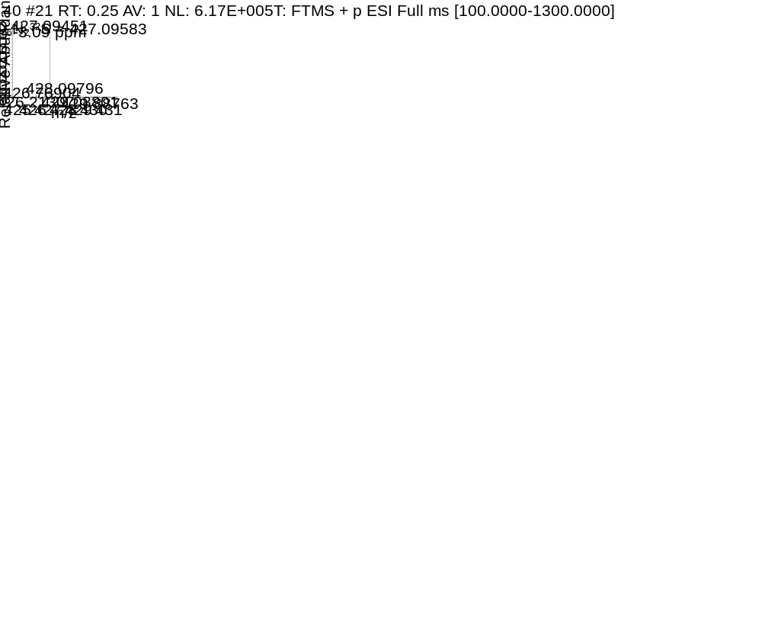
Fig. 38 HRMS spectrum of title compound H12
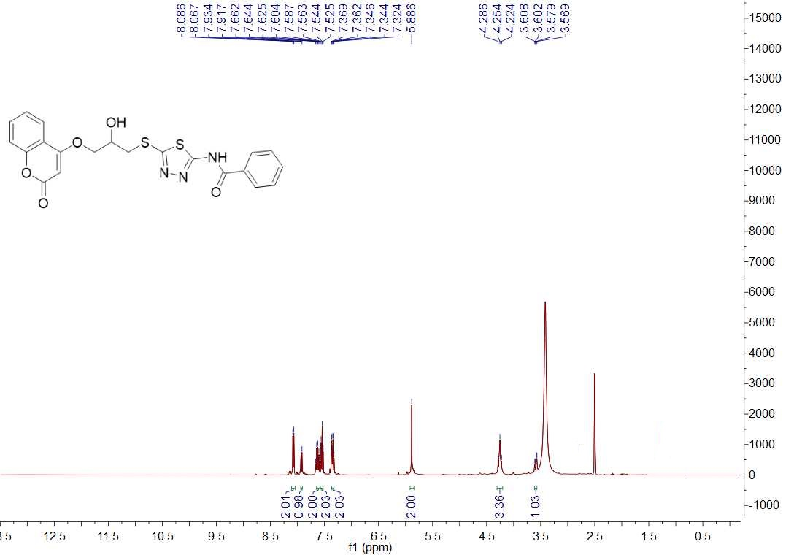
Fig. 39 ¹H NMR spectrum of title compound Y1
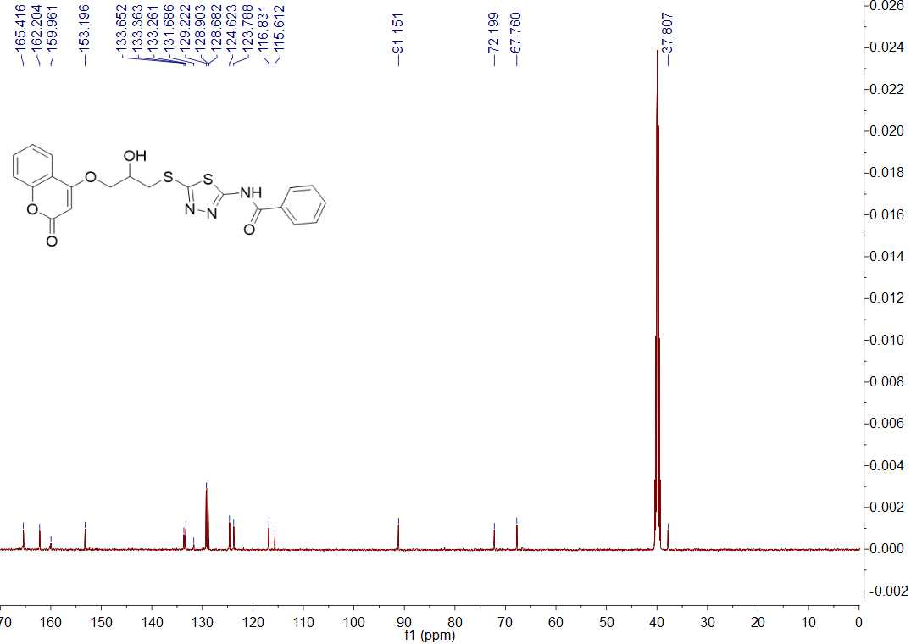
Fig. 40 ¹³C NMR spectrum of title compound Y1
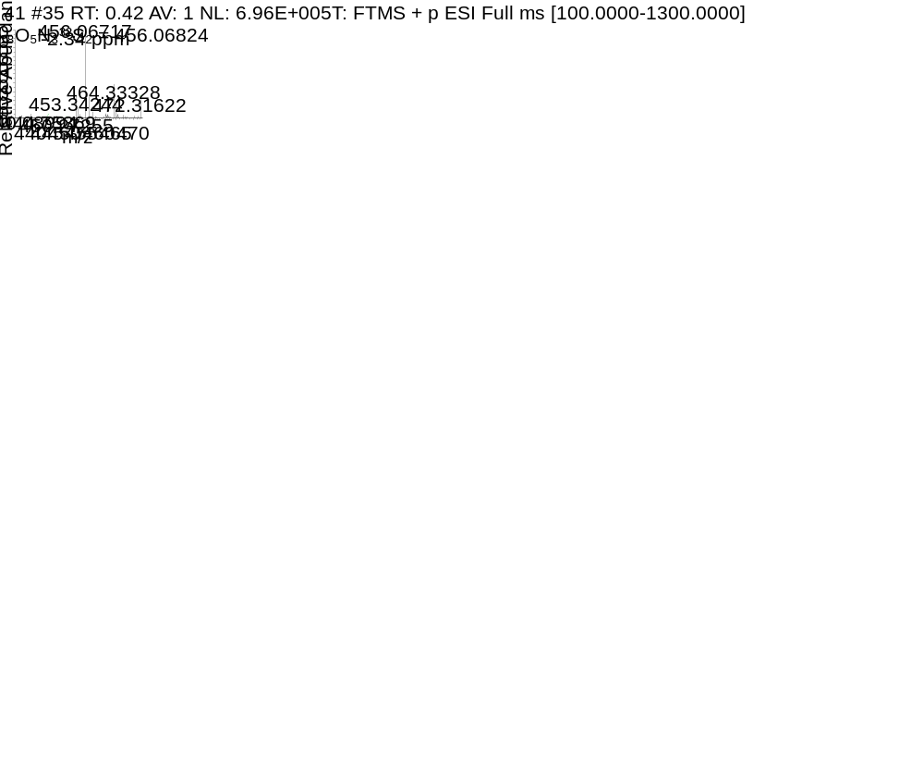
Fig. 41 HRMS spectrum of title compound Y1
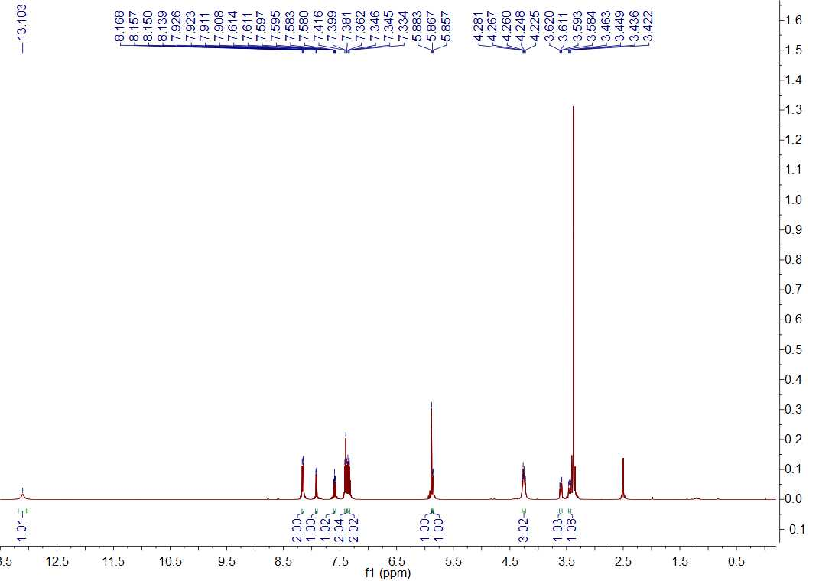
Fig. 42 ¹H NMR spectrum of title compound Y2
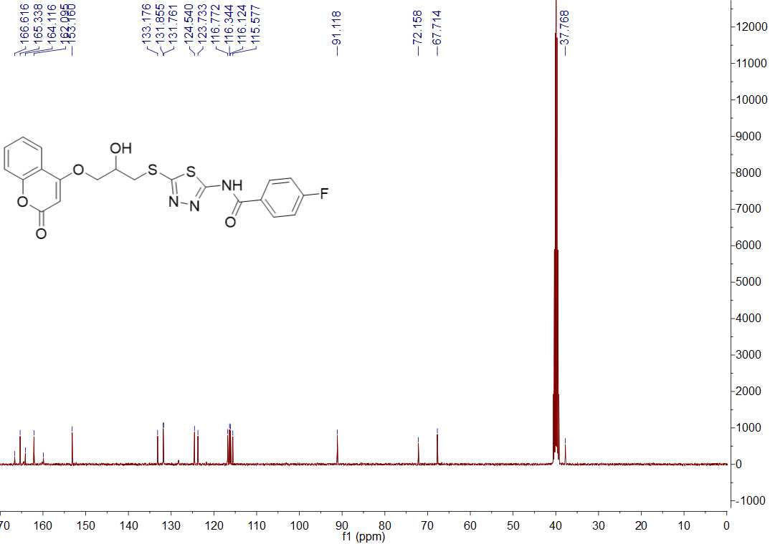
Fig. 43 ¹³C NMR spectrum of title compound Y2
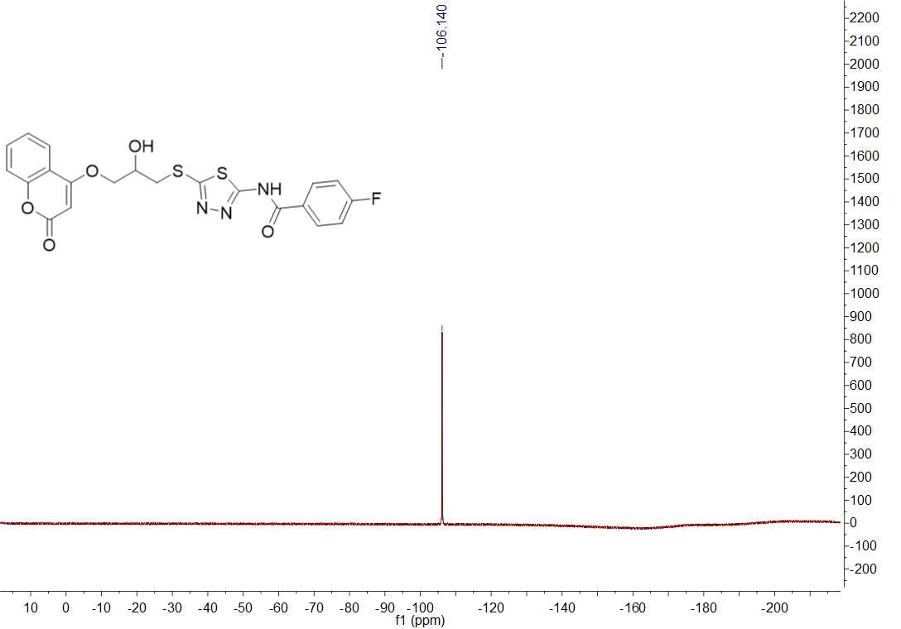
Fig. 44 ¹⁹F NMR spectrum of title compound Y2

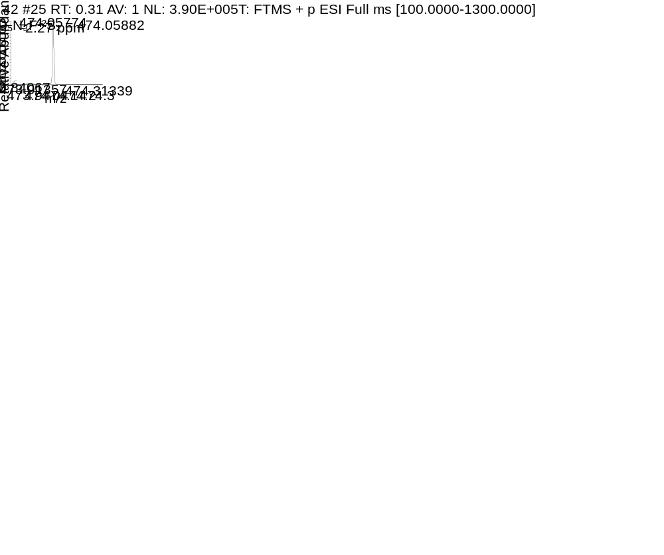
Fig. 45 HRMS spectrum of title compound Y2
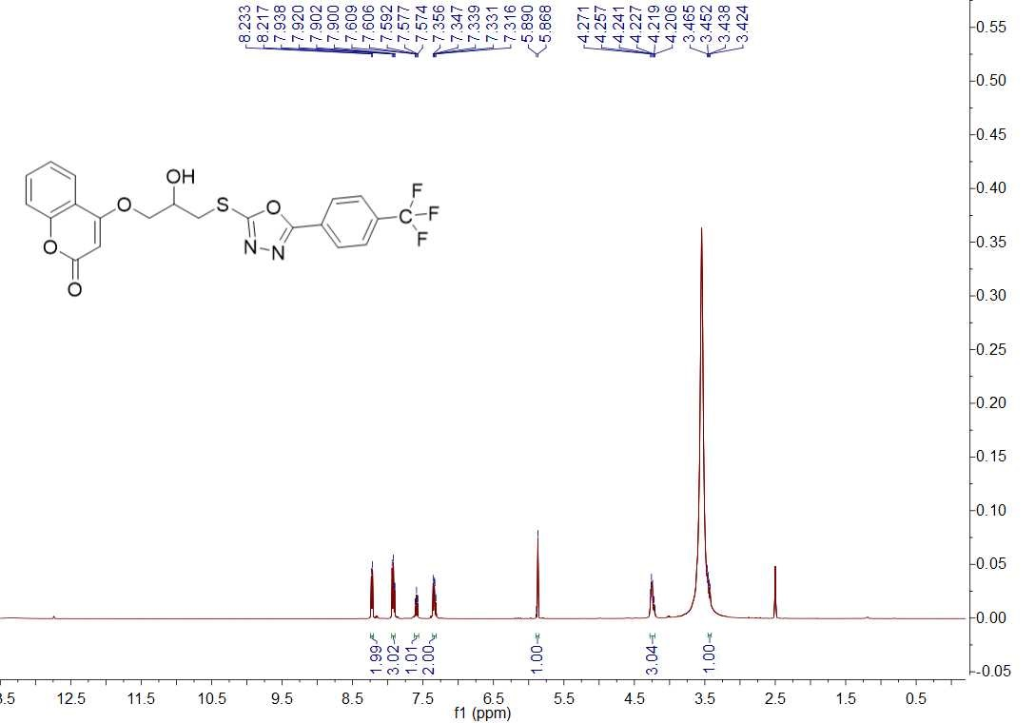
Fig. 46 ¹H NMR spectrum of title compound Y3
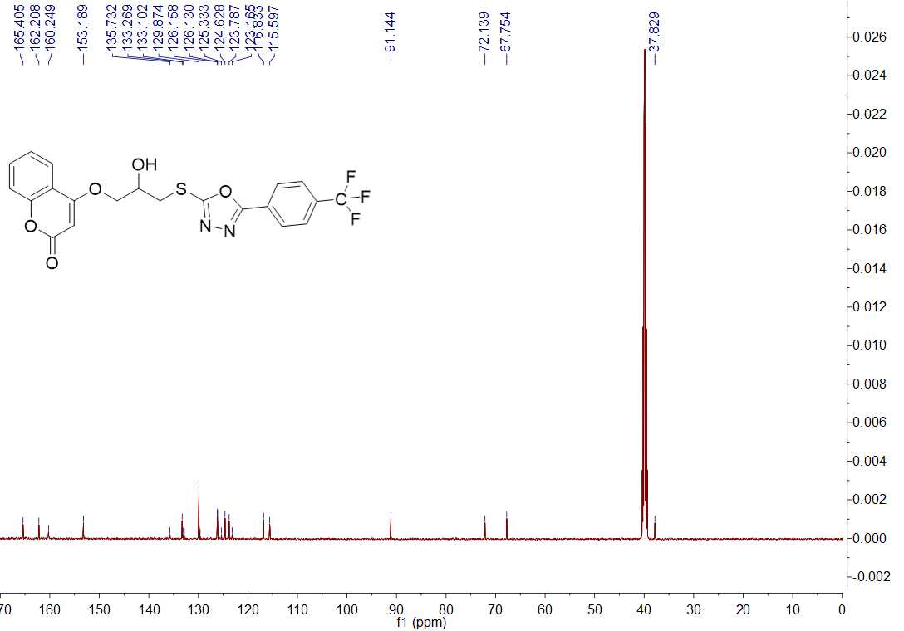
Fig. 47 ¹³C NMR spectrum of title compound Y3
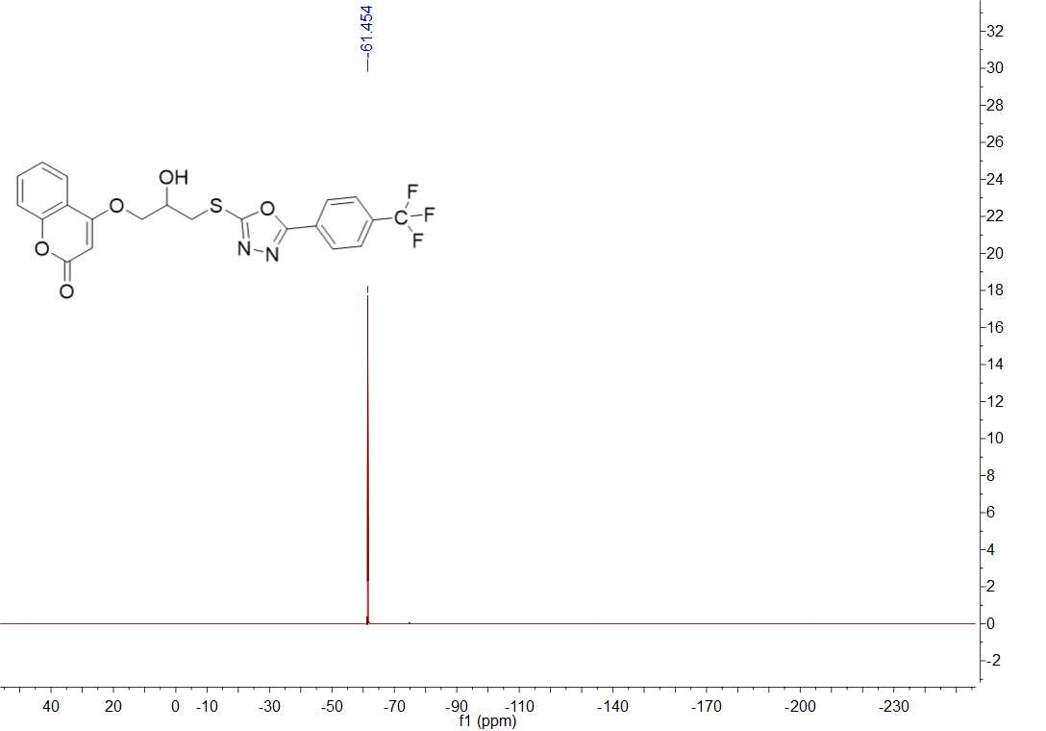
Fig. 48 ¹⁹F NMR spectrum of title compound Y3
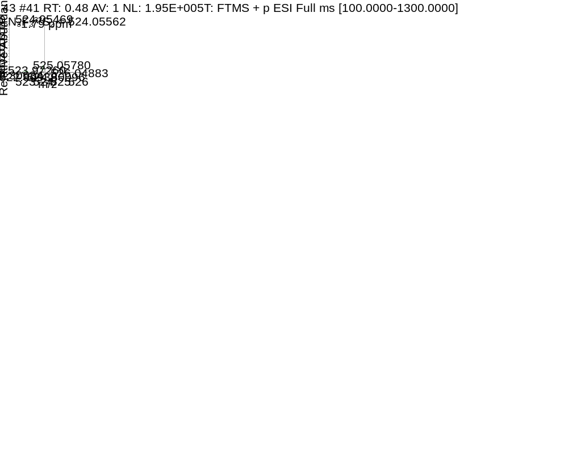
Fig. 49 HRMS spectrum of title compound Y3
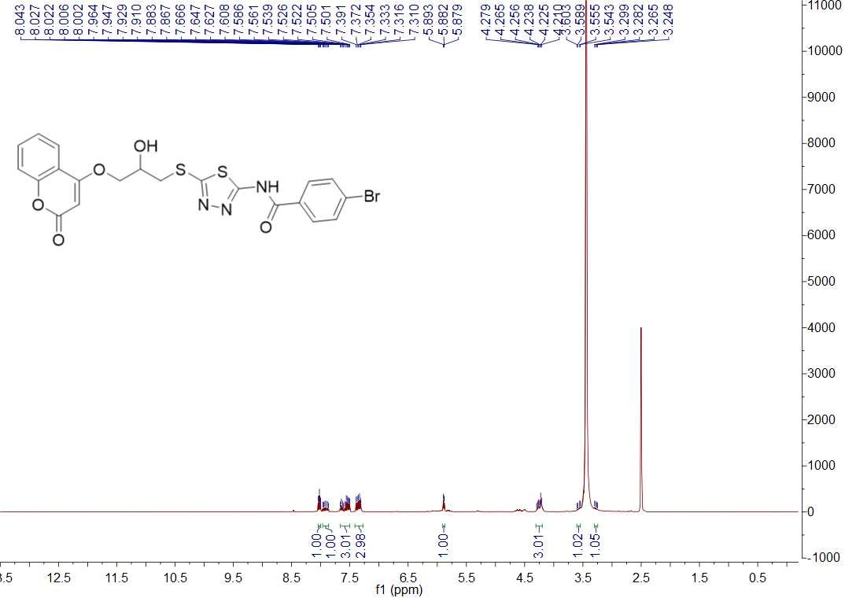
Fig. 50 ¹H NMR spectrum of title compound Y4
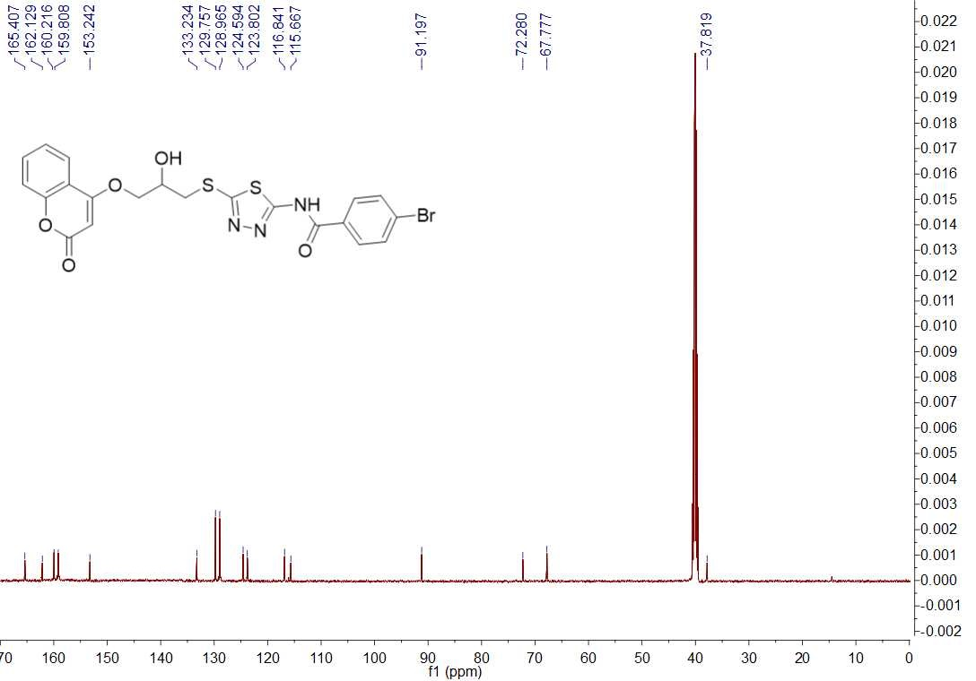
Fig. 51 ¹³C NMR spectrum of title compound Y4
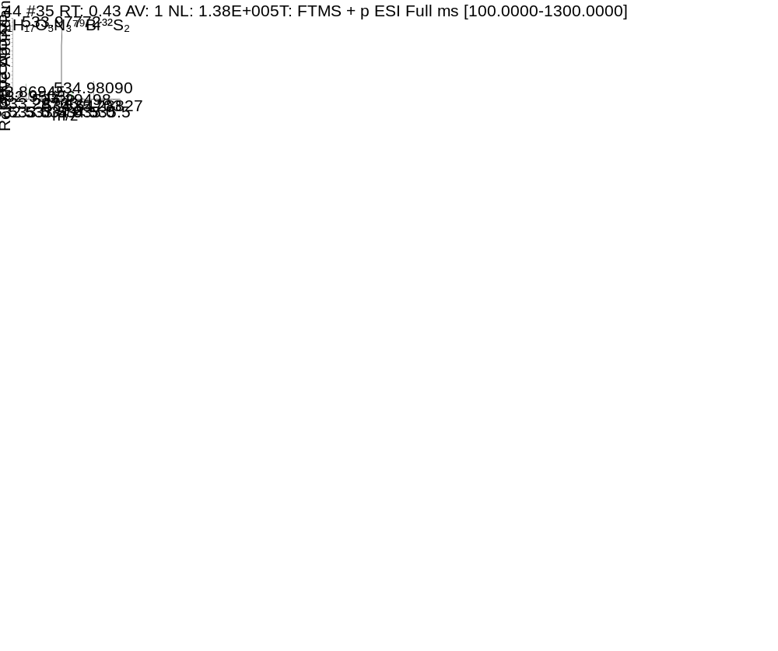
Fig. 52 HRMS spectrum of title compound Y4

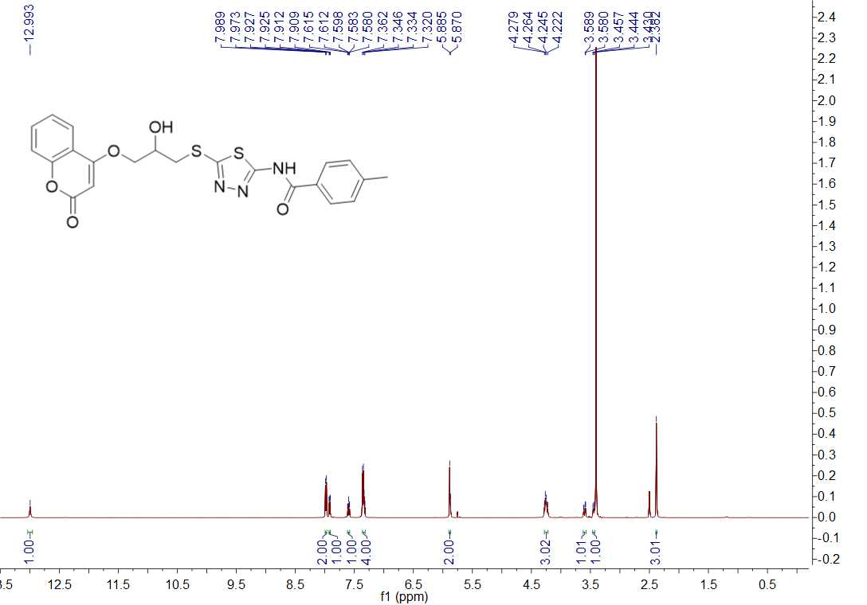
Fig. 53 ¹H NMR spectrum of title compound Y5
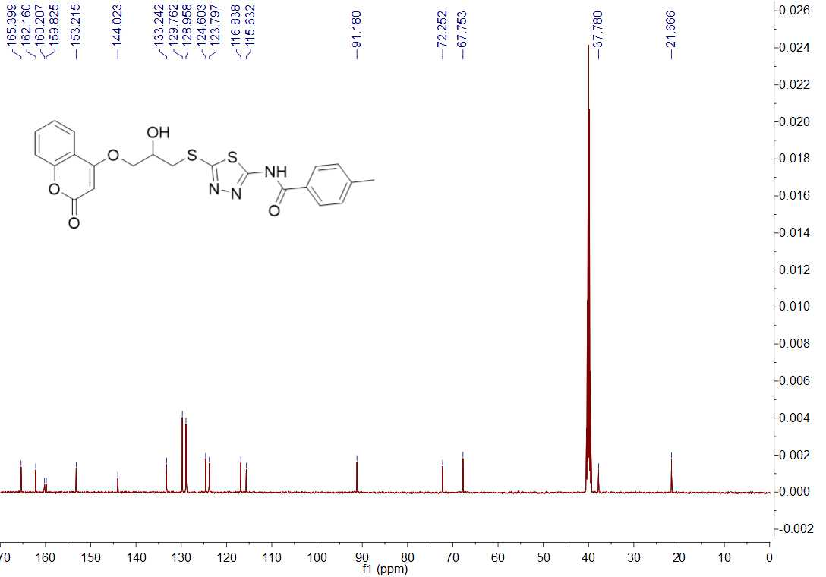
Fig. 54 ¹³C NMR spectrum of title compound Y5
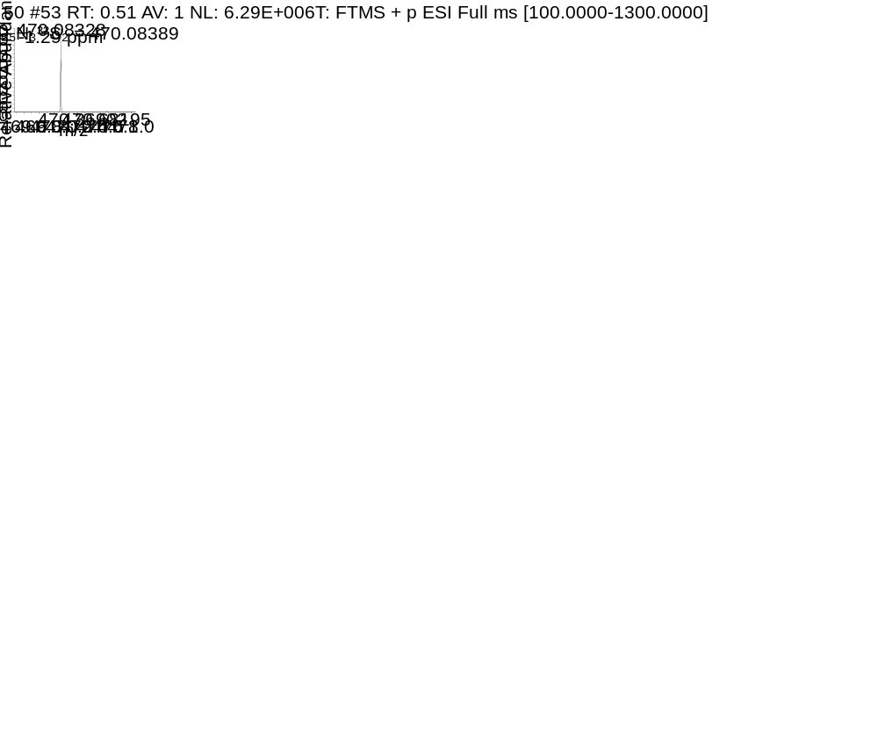
Fig. 55 HRMS spectrum of title compound Y5
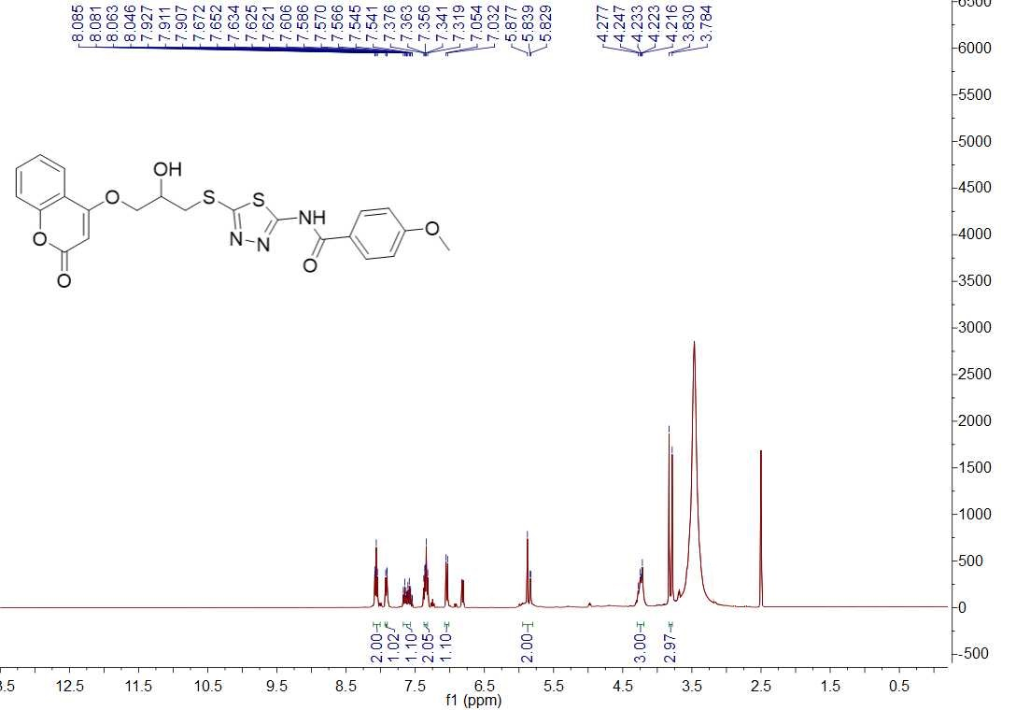
Fig. 55 ¹H NMR spectrum of title compound Y6
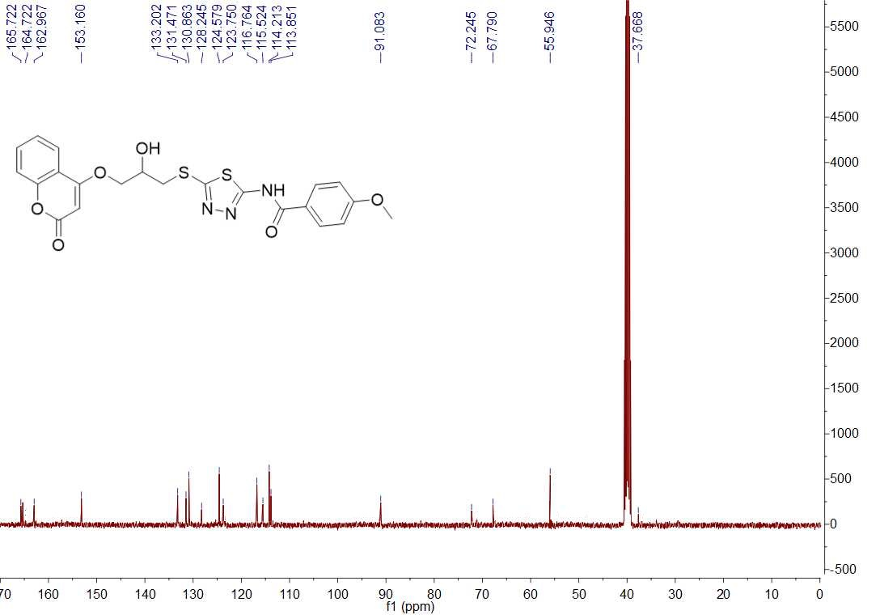
Fig. 56 ¹³C NMR spectrum of title compound Y6
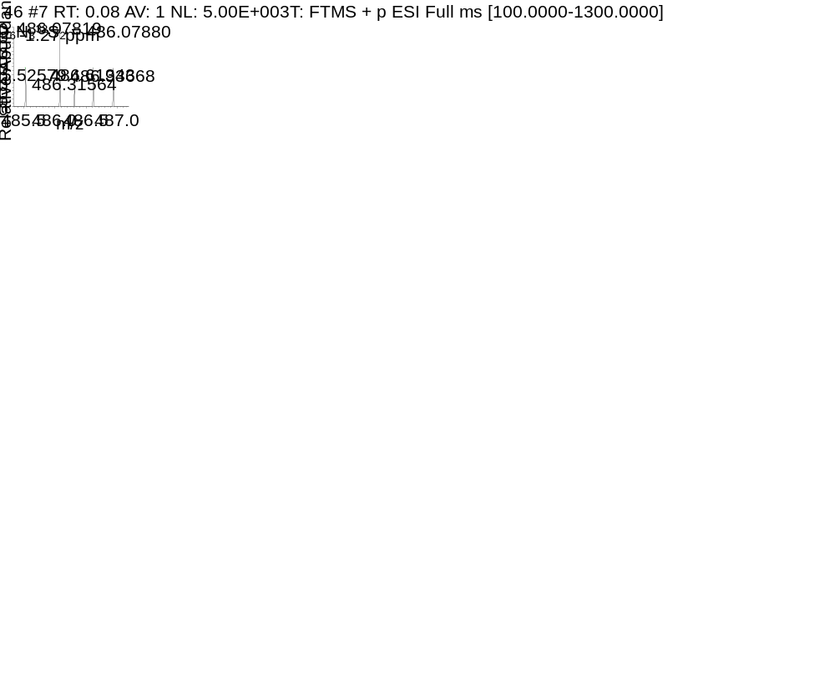
Fig. 57 HRMS spectrum of title compound Y6

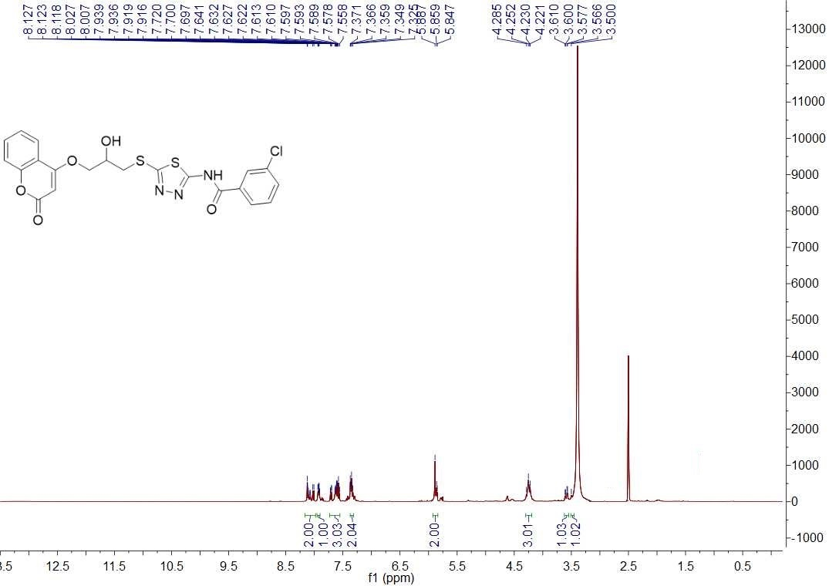
Fig. 59 ¹H NMR spectrum of title compound Y7
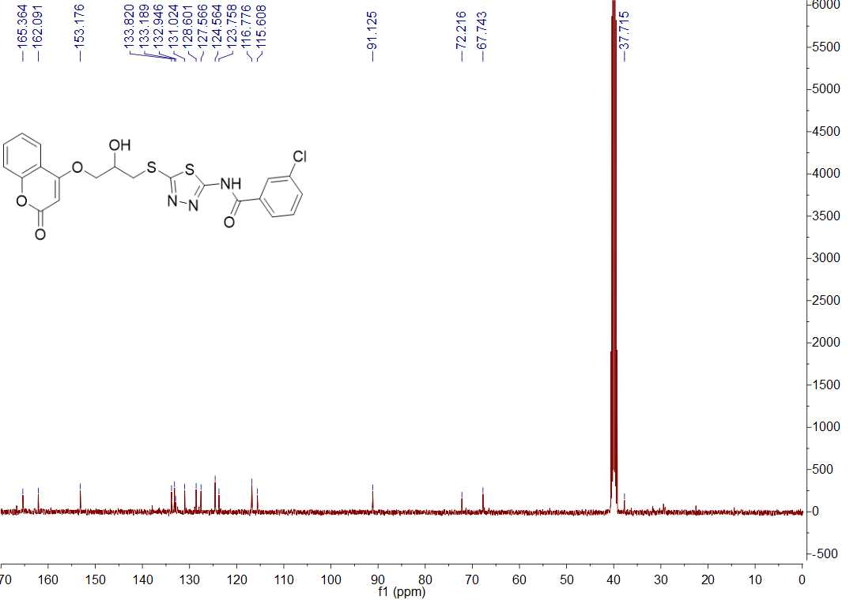
Fig. 60 ¹³C NMR spectrum of title compound Y7
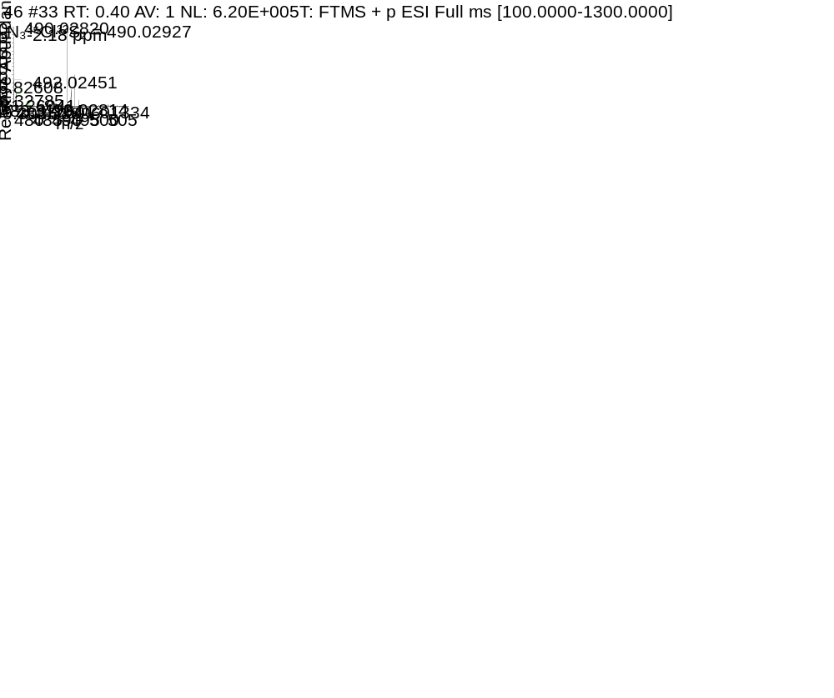
Fig. 61 HRMS spectrum of title compound Y7
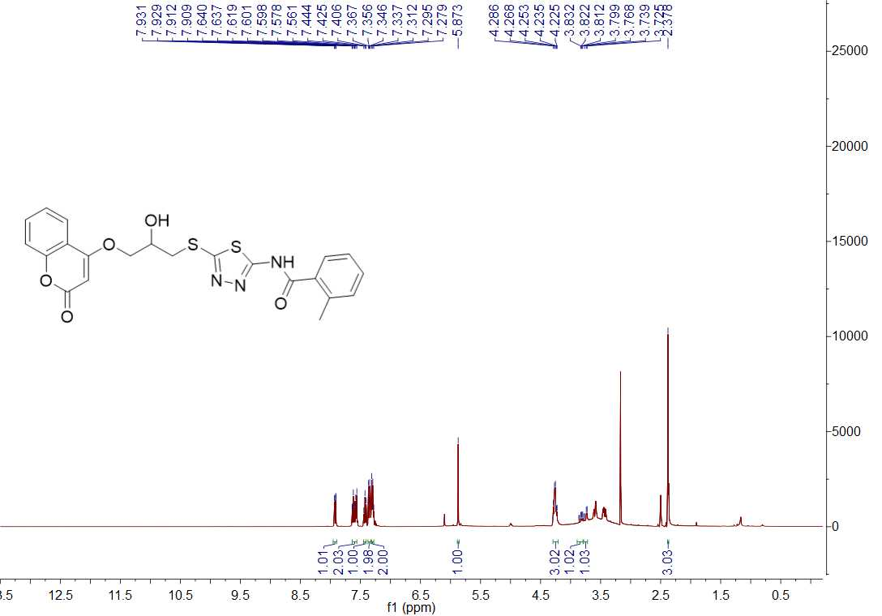
Fig. 62 ¹H NMR spectrum of title compound Y8
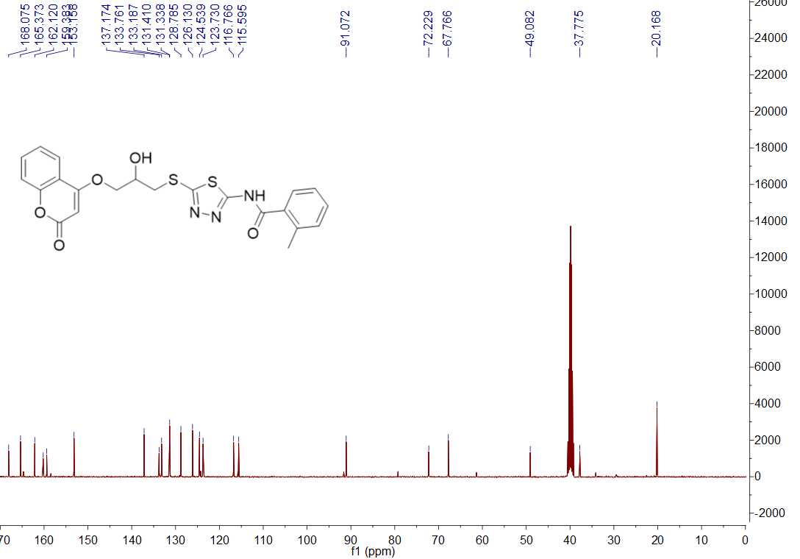
Fig. 63 ¹³C NMR spectrum of title compound Y8
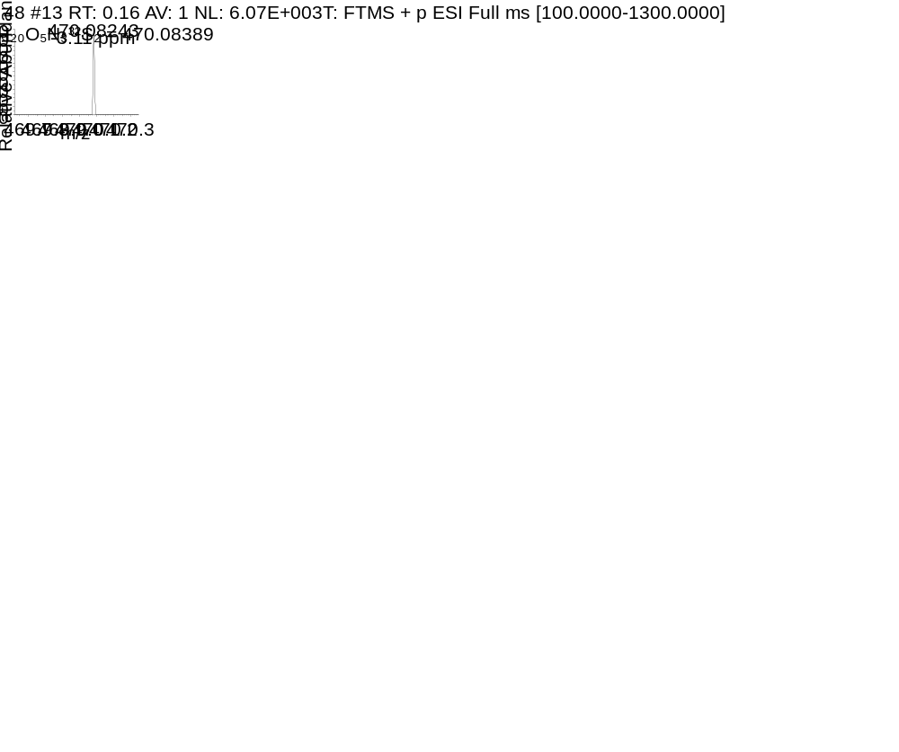
Fig. 64 HRMS spectrum of title compound Y8
Fig. 65 ¹H NMR spectrum of title compound Y9
Fig. 66 ¹³C NMR spectrum of title compound Y9
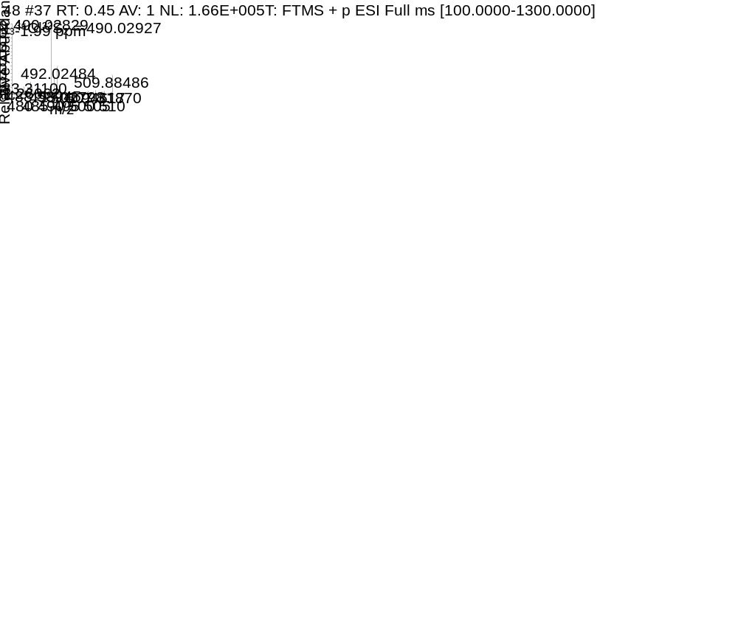
Fig. 67 HRMS spectrum of title compound Y9

