Table S1. Primers used in this study

Primer | Sequence(5’->3’) | Purpose
SAPV-756F | AGTCAAGCAGATGCCAGTC | Virus detection
SAPV-1305R | TTCACAAGAAACTCGCCAC | Virus detection
SAPV-5306F | CATACACACTACGGACGGATAG | Virus detection
SAPV-5851R | GAAACACTTCTCGTTGCTGTC | Virus detection
SAPV-10019F | ACTTATGCTTGGAATGGTTGCTA | 3’RACE
SAPV-9886F | AGGACTTCGGTTAGGGCTCGA | 3’RACE
SAPV-438R | ACGAGCCAAATCTCGTGCAG | 5’RACE
SAPV-634R | CTTTGAAAGGCTCAGCTTGTAC | 5’RACE
SAPV-001F | CAAATTATACCGAAAATTCTCTGA | Fragment1 amplification
SAPV-1280R | AGCATTGAGTGAATTGCTAGC | Fragment1 amplification
SAPV-1260F | GCTAGCAATTCACTCAATGCT | Fragment2 amplification
SAPV-2645R | ATGGTTGGCGAAATCATGC | Fragment2 amplification
SAPV-2611F | ACCATAATCATCCTCAGCATG | Fragment3 amplification
SAPV-3927R | TCTGTAGGCGACATCATGC | Fragment3 amplification
SAPV-3908F | TGCATGATGTCGCCTACAG | Fragment4 amplification
SAPV-5273R | CAAAACCAGCGTCATGCT | Fragment4 amplification
SAPV-5230F | ATTTGGAAGTGCGTTCTCGA | Fragment5 amplification
SAPV-6436R | TGTACAAGGCTACATCATCG | Fragment5 amplification
SAPV-6506F | CACAATCGTCGATGATGTAGC | Fragment6 amplification
SAPV-7864R | CTGATAGAAACCCATCAGCG | Fragment6 amplification
SAPV-7829F | CGCTGATGGGTTTCTATCAG | Fragment7 amplification
SAPV-9151R | GATCTGATGGCTCCTGATC
SAPV-9113F | GACATTTGTATCTCGCTGAAGATC | Fragment8 amplification
SAPV-10365R | GTCTTCCGTTCTATATATAAATACACAG

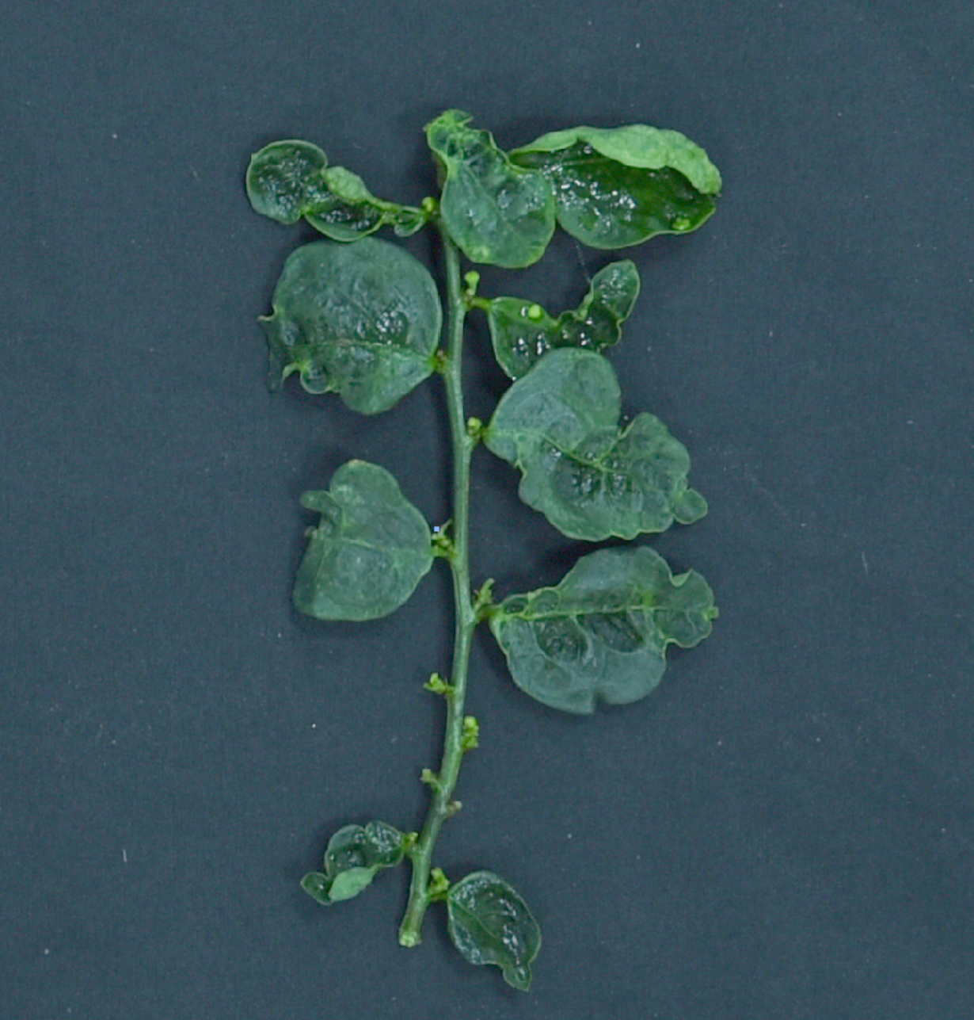
Figure S1. leaves of Sauropus androgynus showing plant viral disease symptoms.

Figure S2. Full-genome amplification and 5’/3’ terminal detection of SAPV1.

Figure S3. Evolutionary placements of SAPV in the family Potyviridae. The maximum likelihood (ML) Phylogenetic tree was inferred from the RdRp domain of different members in each genus within the family Potyviridae. RdRp domain sequence of the Barley yellow dwarf virus (genus: Luteovirus, family: Tombusviridae) was chosen as the outgroup. The substitution model used is LG+G4. The bar represents the number of substitutions per site (0.7)

