SUPPLEMENTARY RESULTS

Figure 1. Sequence, structure and major immunogenic region (mir) of hnRNP-D and hnRNP-DL. A, Schematic representation of hnRNP-D (isoform p45), hnRNP-DL and the different recombinant hnRNP-DL variants studied. The main structural features are highlighted. Mir-region is the major immunogenic region, RBD1 and RBD2 are RNA-binding domains 1 and 2, Gly-rich is the C-terminal glycine-rich region of the proteins. B, Global amino acid sequence alignment of hnRNP-D and hnRNP-DL1 (isoform 1). HnRNP-D and -DL share 89.1% similarity by sequence[1]. Regions “mir”, “RBD1”, “RBD2” and “Gly-rich” are highlighted.

Figure 2. Characterisation of autoantibodies against, A, citrullinated α-hnRNP-DL_{mir} (cit-DL), B, α-hnRNP-DL_{mir} (DL) and C, ∆OD between cit-DL and DL (ΔDL) determined by ELISA in sera of other diseases (n=127; MS n=20, reA n=7, Sclero n=20, Sjö n=20, PsA n=20, MB n=20, OA n=20). The dotted lines mark the cutoff vs. other diseases (except systemic lupus erythematosus) or healthy controls with 98% specificity each. OD, optical density; nm, nano meter; vs., versus; MS, multiple sclerosis; reA, reactive arthritis; Sclero, scleroderma; Sjö, Sjögren´s syndrome; PsA, psoriasis arthritis; MB, ankylosing spondylitis; OA. Osteoarthritis
Table 1. Mann Whitney U-test of (cit) α-hnRNP-DL_{mir}-OD signals of seropositive and seronegative data sets of RA-cohorts.
cohort | Mann Whitney U Test | cit-DL |  | DL
 |  | seropos. | seroneg. | seropos. | seroneg.
LURA | median | 0,5480, n=81 | 0,1120, n=25 | 0,06600, n=81 | 0,05700, n=25
 | P value | <0,0001 |  | 0,6801
 | P value summary | **** |  | ns
EIRA | median | 0,7175, n=202 | 0,2403, n=202 | 0,1105, n=202 | 0,1200, n=202
 | P value | <0,0001 |  | 0,2672
 | P value summary | **** |  | ns
Predict | median | 0,8478, n=86 | 0,5255, n=41 | 0,07650, n=86 | 0,06500, n=41
 | P value | <0,0001 |  | 0,2693
 | P value summary | **** |  | ns

Table 2. Mann Whitney U-test of cit α-hnRNP-DL_{mir}-OD signals of seronegative data sets of RA-cohorts and data sets of other inflammatory diseases.
Mann Whitney Test | Cit-DL
 | seroneg. EIRA | other diseases
median | 0,2403, n=202 | 0,1455, n=127
P value | 0,0005
P value summary | ***
 | seroneg. Predict | other diseases
median | 0,5255, n=41 | 0,1455, n=127
P value | <0,0001
P value summary | ****
 | seroneg. LURA | other diseases
median | 0,1120, n=25 | 0,1455, n=127
P value | 0,2168
P value summary | ns

A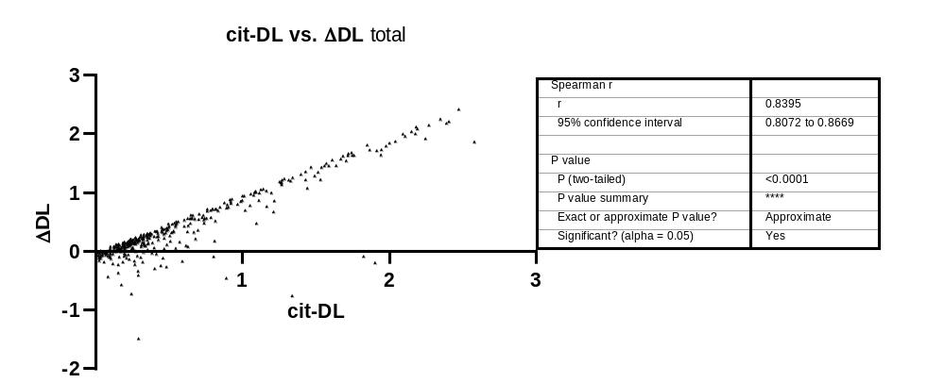

B
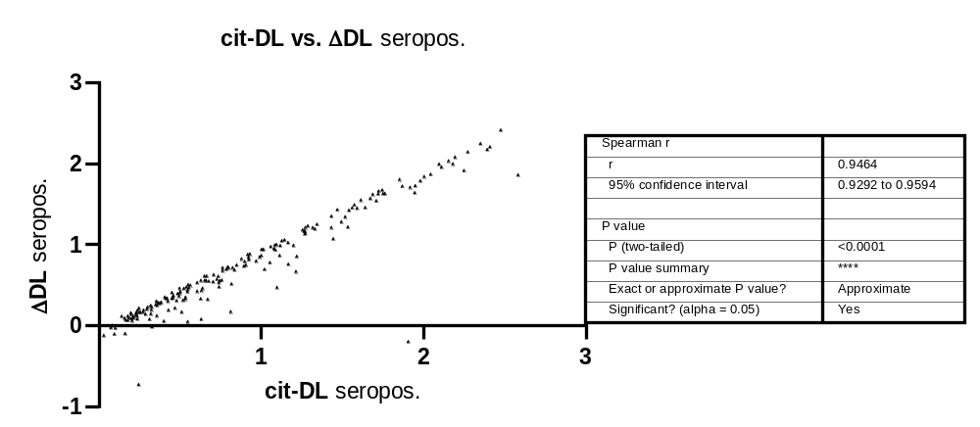

C
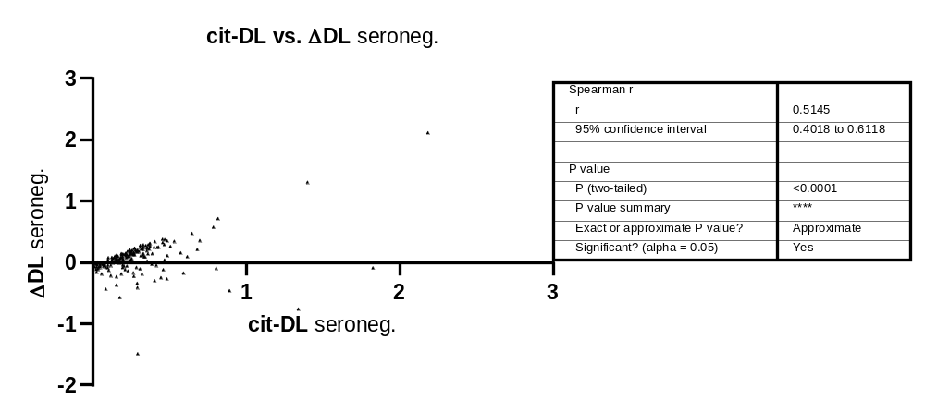

D
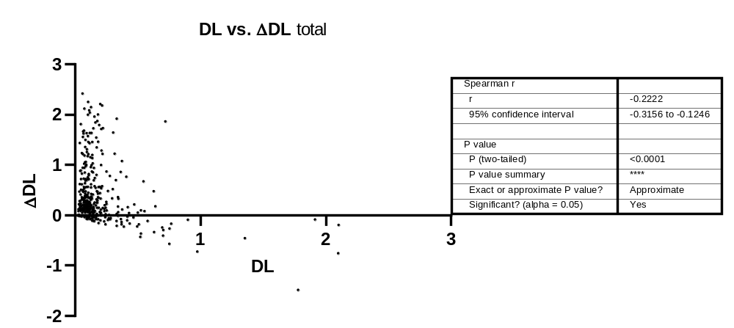

E
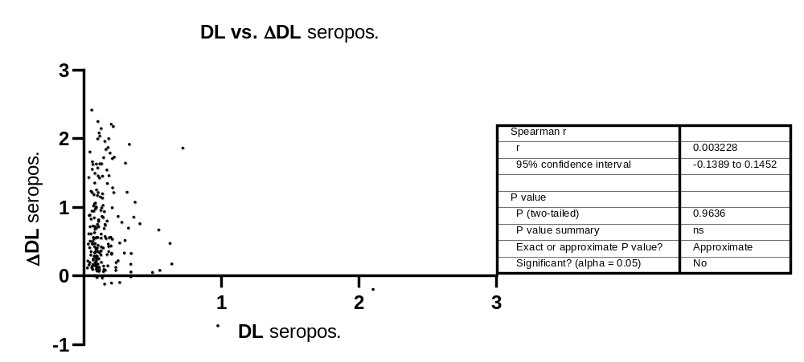

F
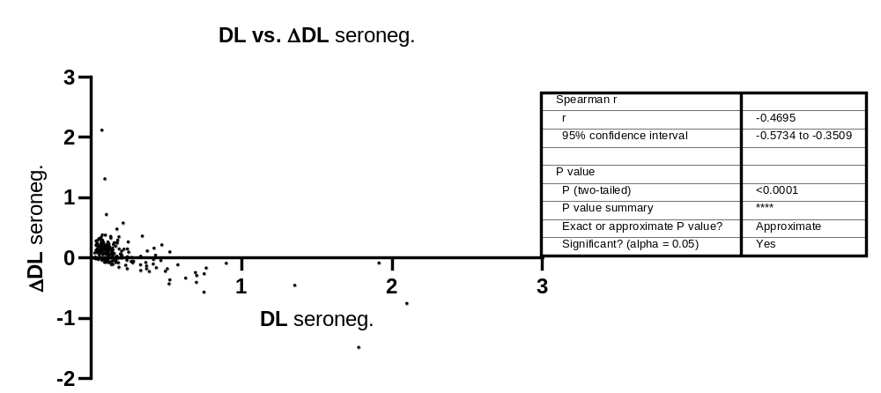

Figure 3. XY-Plot and Spearman Correlation of citrullinated or native α-hnRNP-DL_{mir} versus ΔhnRNP-DL_{mir} for the early RA cohort EIRA (A/D; n=404), the seropositive EIRA sera (B/E; n=202) and the seronegative EIRA sera (C/F; n=202).
Table 3. Spearman correlation of the early RA sera of the EIRA cohort (n=404). The results are given as R value (left of slash) with the corresponding p-value (right of slash).
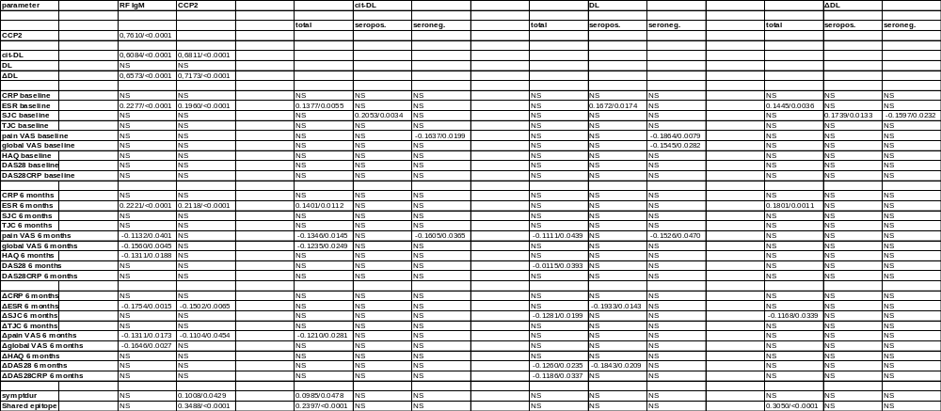
cit-DL, α-citrullinated hnRNP-DL_{mir}; DL, α-hnRNP-DL_{mir}; ΔDL, difference between optical density of cit-DL and DL; RA, rheumatoid arthritis; RF, rheumatoid factor; CCP2, second generation anti-cyclic citrullinated peptide test; CRP, C-Reactive Protein; ESR, erythrocyte sedimentation rate; SJC, swollen joint count; TJC, tender joint count; VAS, visual analog scale; HAQ, Health Assessment Questionnaire Disability Index; DAS28, disease activity score-28; symptdur, symptom duration; seopos., RF IgM and/or α-CCP2 positive; seroneg., RF IgM and α-CCP2 negative; NS, not significant

Table 4. Spearman correlation of the 242 EIRA sera treated with MTX (α-CCP2 positive n=133, α-CCP2 negative n=109). The results are given as R value (left of slash) with the corresponding p-value (right of slash).
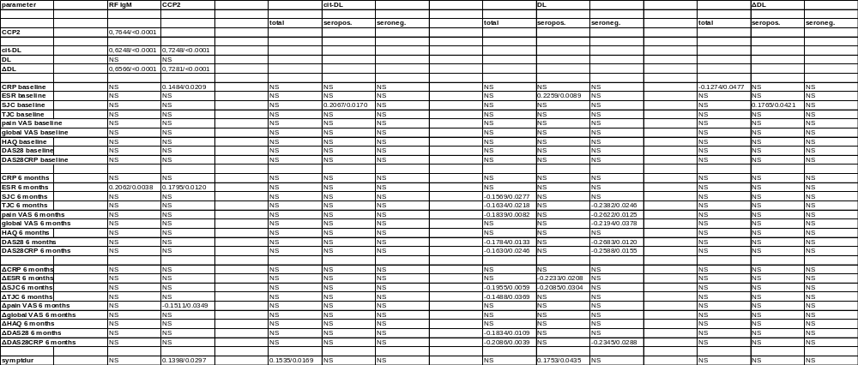
cit-DL, α-citrullinated hnRNP-DL_{mir}; DL, α-hnRNP-DL_{mir}; ΔDL, difference between optical density of cit-DL and DL; RA, rheumatoid arthritis; RF, rheumatoid factor; CCP2, second generation anti-cyclic citrullinated peptide test; CRP, C-Reactive Protein; ESR, erythrocyte sedimentation rate; SJC, swollen joint count; TJC, tender joint count; VAS, visual analog scale; HAQ, Health Assessment Questionnaire Disability Index; DAS28, disease activity score-28; symptdur, symptom duration; seopos., RF IgM and/or α-CCP2 positive; seroneg., RF IgM and α-CCP2 negative; NS, not significant

Table 5. Spearman correlation of the established RA sera of the Predict cohort (n=94; RF IgM and/or α-CCP2 positive n=64, RF IgM and α-CCP2 negative n=30). The results are given as R value (left of slash) with the corresponding p-value (right of slash).
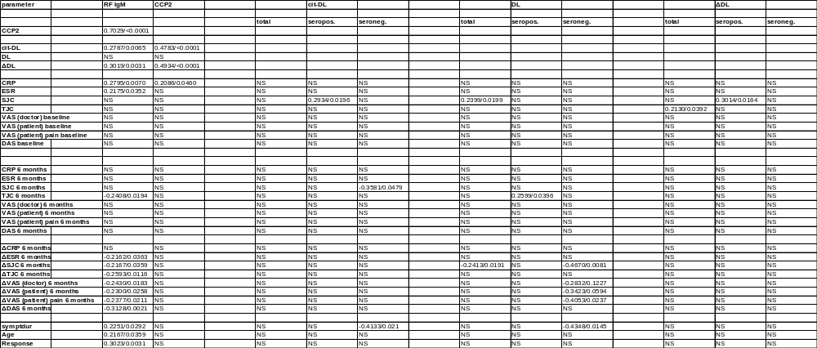
cit-DL, α-citrullinated hnRNP-DL_{mir}; DL, α-hnRNP-DL_{mir}; ΔDL, difference between optical density of cit-DL and DL; RA, rheumatoid arthritis; RF, rheumatoid factor; CCP2, second generation anti-cyclic citrullinated peptide test; CRP, C-Reactive Protein; ESR, erythrocyte sedimentation rate; SJC, swollen joint count; TJC, tender joint count; VAS, visual analog scale; DAS28, disease activity score-28; symptdur, symptom duration; seopos., RF IgM and/or α-CCP2 positive; seroneg., RF IgM and α-CCP2 negative; NS, not significant

Table 6. ROC analysis of native hnRNP-DL_{mir} of MTX-treated EIRA patients (n=192; seropositive n=93, seronegative n=99)
Total n=192
Area under the ROC curve
Area | 0,5893
Std. Error | 0,05318
95% confidence interval | 0,4850 to 0,6935
P value | 0,1159
Data
Controls (DL_nonR) | 31
Patients (DL_R) | 161

 | Sensitivity % | 95% Cl | Specificity % | 95% CI | Likelihood Ratio
> 0.1540 | 42,86 | 35,47% to 50,58% | 80,65 | 63,72% to 90,81% | 2,214
> 0.1588 | 42,24 | 34,87% to 49,96% | 80,65 | 63,72% to 90,81% | 2,182
> 0.1630 | 41,61 | 34,28% to 49,34% | 80,65 | 63,72% to 90,81% | 2,150
> 0.1650 | 40,99 | 33,69% to 48,71% | 80,65 | 63,72% to 90,81% | 2,118
> 0.1678 | 40,37 | 33,10% to 48,09% | 80,65 | 63,72% to 90,81% | 2,086
> 0.1703 | 39,75 | 32,52% to 47,46% | 80,65 | 63,72% to 90,81% | 2,054
> 0.1718 | 39,13 | 31,93% to 46,84% | 80,65 | 63,72% to 90,81% | 2,022
> 0.1730 | 38,51 | 31,34% to 46,21% | 80,65 | 63,72% to 90,81% | 1,990
> 0.1748 | 37,89 | 30,76% to 45,58% | 80,65 | 63,72% to 90,81% | 1,958
> 0.1758 | 37,27 | 30,18% to 44,95% | 80,65 | 63,72% to 90,81% | 1,925
> 0.1768 | 36,65 | 29,60% to 44,32% | 80,65 | 63,72% to 90,81% | 1,893
> 0.1795 | 36,02 | 29,01% to 43,69% | 80,65 | 63,72% to 90,81% | 1,861
> 0.1830 | 35,40 | 28,44% to 43,05% | 80,65 | 63,72% to 90,81% | 1,829
> 0.1865 | 34,78 | 27,86% to 42,42% | 80,65 | 63,72% to 90,81% | 1,797
> 0.1935 | 34,16 | 27,28% to 41,78% | 80,65 | 63,72% to 90,81% | 1,765
> 0.1998 | 33,54 | 26,71% to 41,14% | 80,65 | 63,72% to 90,81% | 1,733
> 0.2020 | 32,92 | 26,13% to 40,50% | 80,65 | 63,72% to 90,81% | 1,701
> 0.2038 | 32,30 | 25,56% to 39,86% | 80,65 | 63,72% to 90,81% | 1,669
> 0.2048 | 32,30 | 25,56% to 39,86% | 83,87 | 67,37% to 92,91% | 2,002
> 0.2058 | 31,68 | 24,99% to 39,22% | 83,87 | 67,37% to 92,91% | 1,964
> 0.2068 | 30,43 | 23,85% to 37,93% | 83,87 | 67,37% to 92,91% | 1,887
> 0.2078 | 29,81 | 23,29% to 37,28% | 83,87 | 67,37% to 92,91% | 1,848
> 0.2088 | 29,19 | 22,72% to 36,63% | 83,87 | 67,37% to 92,91% | 1,810
> 0.2103 | 28,57 | 22,16% to 35,99% | 83,87 | 67,37% to 92,91% | 1,771
> 0.2120 | 27,95 | 21,59% to 35,33% | 83,87 | 67,37% to 92,91% | 1,733
> 0.2158 | 27,33 | 21,03% to 34,68% | 83,87 | 67,37% to 92,91% | 1,694
> 0.2200 | 26,71 | 20,48% to 34,03% | 83,87 | 67,37% to 92,91% | 1,656
> 0.2215 | 26,09 | 19,92% to 33,37% | 83,87 | 67,37% to 92,91% | 1,617
> 0.2283 | 25,47 | 19,36% to 32,71% | 83,87 | 67,37% to 92,91% | 1,579
> 0.2380 | 24,22 | 18,26% to 31,39% | 83,87 | 67,37% to 92,91% | 1,502
> 0.2428 | 23,60 | 17,71% to 30,73% | 83,87 | 67,37% to 92,91% | 1,463
> 0.2455 | 22,98 | 17,16% to 30,06% | 83,87 | 67,37% to 92,91% | 1,425
> 0.2480 | 22,36 | 16,61% to 29,40% | 83,87 | 67,37% to 92,91% | 1,386
> 0.2498 | 22,36 | 16,61% to 29,40% | 87,10 | 71,15% to 94,87% | 1,733
> 0.2513 | 22,36 | 16,61% to 29,40% | 90,32 | 75,10% to 96,65% | 2,311
> 0.2608 | 21,74 | 16,07% to 28,73% | 90,32 | 75,10% to 96,65% | 2,246
> 0.2703 | 21,12 | 15,52% to 28,06% | 90,32 | 75,10% to 96,65% | 2,182
> 0.2740 | 20,50 | 14,98% to 27,39% | 90,32 | 75,10% to 96,65% | 2,118
> 0.2780 | 19,88 | 14,45% to 26,71% | 90,32 | 75,10% to 96,65% | 2,054
> 0.2873 | 19,25 | 13,91% to 26,03% | 90,32 | 75,10% to 96,65% | 1,990
> 0.2983 | 18,63 | 13,38% to 25,35% | 90,32 | 75,10% to 96,65% | 1,925
> 0.3028 | 18,01 | 12,84% to 24,67% | 90,32 | 75,10% to 96,65% | 1,861
> 0.3148 | 17,39 | 12,32% to 23,99% | 90,32 | 75,10% to 96,65% | 1,797
> 0.3285 | 16,77 | 11,79% to 23,30% | 90,32 | 75,10% to 96,65% | 1,733
> 0.3323 | 16,15 | 11,27% to 22,61% | 90,32 | 75,10% to 96,65% | 1,669
> 0.3328 | 15,53 | 10,74% to 21,92% | 90,32 | 75,10% to 96,65% | 1,605
> 0.3378 | 14,91 | 10,23% to 21,22% | 90,32 | 75,10% to 96,65% | 1,540
> 0.3430 | 14,29 | 9,712% to 20,52% | 90,32 | 75,10% to 96,65% | 1,476
> 0.3445 | 13,66 | 9,200% to 19,82% | 90,32 | 75,10% to 96,65% | 1,412
> 0.3555 | 13,04 | 8,692% to 19,12% | 90,32 | 75,10% to 96,65% | 1,348
> 0.3683 | 12,42 | 8,187% to 18,41% | 90,32 | 75,10% to 96,65% | 1,284
> 0.3713 | 11,80 | 7,687% to 17,70% | 90,32 | 75,10% to 96,65% | 1,219
> 0.3800 | 11,18 | 7,190% to 16,98% | 90,32 | 75,10% to 96,65% | 1,155
> 0.3985 | 10,56 | 6,698% to 16,26% | 90,32 | 75,10% to 96,65% | 1,091
> 0.4133 | 9,938 | 6,210% to 15,53% | 90,32 | 75,10% to 96,65% | 1,027
> 0.4193 | 9,317 | 5,727% to 14,80% | 90,32 | 75,10% to 96,65% | 0,9627
> 0.4605 | 8,696 | 5,250% to 14,07% | 90,32 | 75,10% to 96,65% | 0,8986
> 0.5048 | 8,075 | 4,779% to 13,32% | 90,32 | 75,10% to 96,65% | 0,8344
> 0.5175 | 7,453 | 4,315% to 12,58% | 90,32 | 75,10% to 96,65% | 0,7702
> 0.5358 | 7,453 | 4,315% to 12,58% | 93,55 | 79,28% to 98,85% | 1,155
> 0.5495 | 6,832 | 3,858% to 11,82% | 93,55 | 79,28% to 98,85% | 1,059
> 0.5663 | 6,211 | 3,408% to 11,05% | 93,55 | 79,28% to 98,85% | 0,9627
> 0.6030 | 5,590 | 2,969% to 10,28% | 93,55 | 79,28% to 98,85% | 0,8665
> 0.6288 | 5,590 | 2,969% to 10,28% | 96,77 | 83,81% to 99,83% | 1,733
> 0.6663 | 4,969 | 2,539% to 9,498% | 96,77 | 83,81% to 99,83% | 1,540
> 0.7028 | 4,348 | 2,122% to 8,702% | 96,77 | 83,81% to 99,83% | 1,348
> 0.7125 | 3,727 | 1,719% to 7,891% | 96,77 | 83,81% to 99,83% | 1,155
> 0.7370 | 3,106 | 1,334% to 7,063% | 96,77 | 83,81% to 99,83% | 0,9627
> 0.7533 | 2,484 | 0,9703% to 6,213% | 96,77 | 83,81% to 99,83% | 0,7702
> 0.7605 | 1,863 | 0,5079% to 5,335% | 96,77 | 83,81% to 99,83% | 0,5776
> 0.8710 | 1,242 | 0,2207% to 4,416% | 96,77 | 83,81% to 99,83% | 0,3851
> 1.538 | 0,6211 | 0,03186% to 3,434% | 96,77 | 83,81% to 99,83% | 0,1925
> 2.102 | 0,000 | 0,000% to 2,330% | 96,77 | 83,81% to 99,83% | 0,000

seropositive n=93
Area under the ROC curve
Area | 0,5308
Std. Error | 0,08058
95% confidence interval | 0,3728 to 0,6887
P value | 0,7069
Data
Controls (DL_seropos_nonR) | 15
Patients (DL_seropos_R) | 78

 | Sensitivity % | 95% Cl | Specificity % | 95% CI | Likelihood Ratio
> 0.2058 | 29,49 | 20,52% to 40,38% | 80,00 | 54,81% to 92,95% | 1,474
> 0.2078 | 28,21 | 19,43% to 39,03% | 80,00 | 54,81% to 92,95% | 1,410
> 0.2088 | 26,92 | 18,34% to 37,68% | 80,00 | 54,81% to 92,95% | 1,346
> 0.2103 | 25,64 | 17,26% to 36,31% | 80,00 | 54,81% to 92,95% | 1,282
> 0.2153 | 24,36 | 16,19% to 34,94% | 80,00 | 54,81% to 92,95% | 1,218
> 0.2205 | 23,08 | 15,13% to 33,56% | 80,00 | 54,81% to 92,95% | 1,154
> 0.2283 | 21,79 | 14,08% to 32,16% | 80,00 | 54,81% to 92,95% | 1,090
> 0.2425 | 19,23 | 12,02% to 29,33% | 80,00 | 54,81% to 92,95% | 0,9615
> 0.2638 | 19,23 | 12,02% to 29,33% | 86,67 | 62,12% to 97,63% | 1,442
> 0.2863 | 17,95 | 11,00% to 27,90% | 86,67 | 62,12% to 97,63% | 1,346
> 0.2983 | 16,67 | 10,01% to 26,46% | 86,67 | 62,12% to 97,63% | 1,250
> 0.3028 | 15,38 | 9,026% to 24,99% | 86,67 | 62,12% to 97,63% | 1,154
> 0.3148 | 14,10 | 8,061% to 23,51% | 86,67 | 62,12% to 97,63% | 1,058
> 0.3285 | 12,82 | 7,115% to 22,02% | 86,67 | 62,12% to 97,63% | 0,9615
> 0.3373 | 11,54 | 6,191% to 20,50% | 86,67 | 62,12% to 97,63% | 0,8654
> 0.3430 | 10,26 | 5,289% to 18,95% | 86,67 | 62,12% to 97,63% | 0,7692
> 0.3445 | 8,974 | 4,415% to 17,38% | 86,67 | 62,12% to 97,63% | 0,6731
> 0.3770 | 7,692 | 3,573% to 15,78% | 86,67 | 62,12% to 97,63% | 0,5769
> 0.4545 | 6,410 | 2,769% to 14,14% | 86,67 | 62,12% to 97,63% | 0,4808
> 0.5230 | 5,128 | 2,012% to 12,46% | 86,67 | 62,12% to 97,63% | 0,3846
> 0.5495 | 3,846 | 1,048% to 10,71% | 86,67 | 62,12% to 97,63% | 0,2885
> 0.5903 | 2,564 | 0,4556% to 8,875% | 86,67 | 62,12% to 97,63% | 0,1923
> 0.6743 | 2,564 | 0,4556% to 8,875% | 93,33 | 70,18% to 99,66% | 0,3846
> 0.8483 | 1,282 | 0,06576% to 6,911% | 93,33 | 70,18% to 99,66% | 0,1923
> 1.540 | 0,000 | 0,000% to 4,694% | 93,33 | 70,18% to 99,66% | 0,000

seronegative n=99
Area under the ROC curve
Area | 0,6423
Std. Error | 0,06894
95% confidence interval | 0,5072 to 0,7774
P value | 0,0724
Data
Controls (DL_seroneg_nonR) | 16
Patients (DL_seroneg_R) | 83

 | Sensitivity % | 95% Cl | Specificity % | 95% CI | Likelihood Ratio
> 0.1365 | 50,60 | 40,06% to 61,09% | 81,25 | 56,99% to 93,41% | 2,699
> 0.1415 | 49,40 | 38,91% to 59,94% | 81,25 | 56,99% to 93,41% | 2,635
> 0.1458 | 48,19 | 37,76% to 58,78% | 81,25 | 56,99% to 93,41% | 2,570
> 0.1470 | 46,99 | 36,62% to 57,62% | 81,25 | 56,99% to 93,41% | 2,506
> 0.1490 | 45,78 | 35,49% to 56,45% | 81,25 | 56,99% to 93,41% | 2,442
> 0.1508 | 44,58 | 34,36% to 55,27% | 81,25 | 56,99% to 93,41% | 2,378
> 0.1520 | 42,17 | 32,12% to 52,91% | 81,25 | 56,99% to 93,41% | 2,249
> 0.1540 | 42,17 | 32,12% to 52,91% | 87,50 | 63,98% to 97,78% | 3,373
> 0.1608 | 40,96 | 31,01% to 51,71% | 87,50 | 63,98% to 97,78% | 3,277
> 0.1703 | 39,76 | 29,91% to 50,52% | 87,50 | 63,98% to 97,78% | 3,181
> 0.1748 | 38,55 | 28,81% to 49,31% | 87,50 | 63,98% to 97,78% | 3,084
> 0.1785 | 37,35 | 27,72% to 48,10% | 87,50 | 63,98% to 97,78% | 2,988
> 0.1850 | 36,14 | 26,63% to 46,88% | 87,50 | 63,98% to 97,78% | 2,892
> 0.1968 | 34,94 | 25,56% to 45,66% | 87,50 | 63,98% to 97,78% | 2,795
> 0.2058 | 33,73 | 24,48% to 44,42% | 87,50 | 63,98% to 97,78% | 2,699
> 0.2095 | 31,33 | 22,36% to 41,94% | 87,50 | 63,98% to 97,78% | 2,506
> 0.2168 | 30,12 | 21,31% to 40,69% | 87,50 | 63,98% to 97,78% | 2,410
> 0.2313 | 28,92 | 20,27% to 39,43% | 87,50 | 63,98% to 97,78% | 2,313
> 0.2428 | 27,71 | 19,23% to 38,16% | 87,50 | 63,98% to 97,78% | 2,217
> 0.2455 | 26,51 | 18,20% to 36,89% | 87,50 | 63,98% to 97,78% | 2,120
> 0.2480 | 25,30 | 17,19% to 35,60% | 87,50 | 63,98% to 97,78% | 2,024
> 0.2505 | 25,30 | 17,19% to 35,60% | 93,75 | 71,67% to 99,68% | 4,048
> 0.2608 | 24,10 | 16,17% to 34,31% | 93,75 | 71,67% to 99,68% | 3,855
> 0.2703 | 22,89 | 15,17% to 33,01% | 93,75 | 71,67% to 99,68% | 3,663
> 0.2750 | 21,69 | 14,18% to 31,70% | 93,75 | 71,67% to 99,68% | 3,470
> 0.3058 | 20,48 | 13,20% to 30,38% | 93,75 | 71,67% to 99,68% | 3,277
> 0.3328 | 19,28 | 12,23% to 29,04% | 93,75 | 71,67% to 99,68% | 3,084
> 0.3493 | 18,07 | 11,27% to 27,70% | 93,75 | 71,67% to 99,68% | 2,892
> 0.3683 | 16,87 | 10,32% to 26,34% | 93,75 | 71,67% to 99,68% | 2,699
> 0.3713 | 15,66 | 9,388% to 24,98% | 93,75 | 71,67% to 99,68% | 2,506
> 0.3800 | 14,46 | 8,468% to 23,59% | 93,75 | 71,67% to 99,68% | 2,313
> 0.4033 | 13,25 | 7,564% to 22,19% | 93,75 | 71,67% to 99,68% | 2,120
> 0.4193 | 12,05 | 6,678% to 20,78% | 93,75 | 71,67% to 99,68% | 1,928
> 0.4648 | 10,84 | 5,810% to 19,34% | 93,75 | 71,67% to 99,68% | 1,735
> 0.5175 | 9,639 | 4,965% to 17,88% | 93,75 | 71,67% to 99,68% | 1,542
> 0.5525 | 9,639 | 4,965% to 17,88% | 100,0 | 80,64% to 100,0%
> 0.6048 | 8,434 | 4,145% to 16,40% | 100,0 | 80,64% to 100,0%
> 0.6663 | 7,229 | 3,355% to 14,89% | 100,0 | 80,64% to 100,0%
> 0.7028 | 6,024 | 2,600% to 13,34% | 100,0 | 80,64% to 100,0%
> 0.7280 | 4,819 | 1,890% to 11,75% | 100,0 | 80,64% to 100,0%
> 0.7533 | 3,614 | 0,9852% to 10,10% | 100,0 | 80,64% to 100,0%
> 0.7605 | 2,410 | 0,4281% to 8,366% | 100,0 | 80,64% to 100,0%
> 1.434 | 1,205 | 0,06180% to 6,514% | 100,0 | 80,64% to 100,0%

Table 7. Negative CN_{DL}-index of MTX-treated EIRA patients n=192 (Resp. n=161, non-Resp. n=31)
ΔDL_Responder  N=27 | ΔDL_nonResponder  N=4
-0,759 | -0,3705
-0,729 | -0,199
-0,5745 | -0,1225
-0,41 | -0,032
-0,3395
-0,3
-0,27
-0,2325
-0,2145
-0,186
-0,184
-0,175
-0,14
-0,118
-0,091
-0,0835
-0,08
-0,0765
-0,0635
-0,0435
-0,032
-0,024
-0,0185
-0,0155
-0,0145
-0,0095
-0,007

Cutoff = -0.2010 33% Sensitivity/ 75% Specificity
Cutoff = -0.3710 15% Sensitivity/ 100% Specificity

Table 8. ROC analysis of native hnRNP-DL_{mir} of Enbrel®-treated Predict patients (n=94; seropositive n=63, seronegative n=31)
Total n=192
Area under the ROC curve
Area | 0,5246
Std. Error | 0,06190
95% confidence interval | 0,4033 to 0,6459
P value | 0,6995
Data
Controls (DL_nonR) | 31
Patients (DL_R) | 63

 | Sensitivity % | 95% Cl | Specificity % | 95% CI | Likelihood Ratio
> 0.1118 | 23,81 | 14,99% to 35,64% | 80,65 | 63,72% to 90,81% | 1,230
> 0.1153 | 22,22 | 13,73% to 33,91% | 80,65 | 63,72% to 90,81% | 1,148
> 0.1178 | 22,22 | 13,73% to 33,91% | 83,87 | 67,37% to 92,91% | 1,378
> 0.1213 | 20,63 | 12,48% to 32,17% | 83,87 | 67,37% to 92,91% | 1,279
> 0.1245 | 19,05 | 11,25% to 30,41% | 83,87 | 67,37% to 92,91% | 1,181
> 0.1270 | 19,05 | 11,25% to 30,41% | 87,10 | 71,15% to 94,87% | 1,476
> 0.1308 | 17,46 | 10,04% to 28,62% | 87,10 | 71,15% to 94,87% | 1,353
> 0.1358 | 17,46 | 10,04% to 28,62% | 90,32 | 75,10% to 96,65% | 1,804
> 0.1443 | 15,87 | 8,857% to 26,81% | 90,32 | 75,10% to 96,65% | 1,640
> 0.1558 | 12,70 | 6,577% to 23,11% | 90,32 | 75,10% to 96,65% | 1,312
> 0.1638 | 12,70 | 6,577% to 23,11% | 93,55 | 79,28% to 98,85% | 1,968
> 0.1703 | 12,70 | 6,577% to 23,11% | 96,77 | 83,81% to 99,83% | 3,937
> 0.1740 | 12,70 | 6,577% to 23,11% | 100,0 | 88,97% to 100,0%
> 0.1985 | 9,524 | 4,438% to 19,26% | 100,0 | 88,97% to 100,0%
> 0.2263 | 7,937 | 3,438% to 17,27% | 100,0 | 88,97% to 100,0%
> 0.2373 | 6,349 | 2,497% to 15,22% | 100,0 | 88,97% to 100,0%
> 0.2515 | 4,762 | 1,298% to 13,09% | 100,0 | 88,97% to 100,0%
> 0.2753 | 3,175 | 0,5641% to 10,86% | 100,0 | 88,97% to 100,0%
> 0.2930 | 1,587 | 0,08142% to 8,459% | 100,0 | 88,97% to 100,0%

seropositive n=63
Area | 0,5785
Std. Error | 0,08150
95% confidence interval | 0,4187 to 0,7382
P value | 0,3515
Data
Controls (DL_seropos_nonR) | 16
Patients (DL_seropos_R) | 47

 | Sensitivity % | 95% Cl | Specificity % | 95% CI | Likelihood Ratio
< 0.02575 | 2,128 | 0,1091% to 11,11% | 100,0 | 80,64% to 100,0%
< 0.02625 | 4,255 | 0,7561% to 14,25% | 100,0 | 80,64% to 100,0%
< 0.02800 | 6,383 | 2,195% to 17,16% | 100,0 | 80,64% to 100,0%
< 0.03025 | 6,383 | 2,195% to 17,16% | 93,75 | 71,67% to 99,68% | 1,021
< 0.03375 | 8,511 | 3,359% to 19,93% | 93,75 | 71,67% to 99,68% | 1,362
< 0.03700 | 8,511 | 3,359% to 19,93% | 87,50 | 63,98% to 97,78% | 0,6809
< 0.03775 | 12,77 | 5,985% to 25,17% | 87,50 | 63,98% to 97,78% | 1,021
< 0.03850 | 14,89 | 7,407% to 27,69% | 87,50 | 63,98% to 97,78% | 1,191
< 0.03925 | 17,02 | 8,886% to 30,14% | 87,50 | 63,98% to 97,78% | 1,362
< 0.03975 | 19,15 | 10,42% to 32,54% | 87,50 | 63,98% to 97,78% | 1,532
< 0.04225 | 21,28 | 11,99% to 34,90% | 87,50 | 63,98% to 97,78% | 1,702
< 0.04725 | 23,40 | 13,60% to 37,22% | 87,50 | 63,98% to 97,78% | 1,872
< 0.05075 | 25,53 | 15,25% to 39,51% | 87,50 | 63,98% to 97,78% | 2,043
< 0.05200 | 25,53 | 15,25% to 39,51% | 81,25 | 56,99% to 93,41% | 1,362
< 0.05275 | 27,66 | 16,94% to 41,76% | 81,25 | 56,99% to 93,41% | 1,475
< 0.05375 | 31,91 | 20,40% to 46,17% | 81,25 | 56,99% to 93,41% | 1,702
< 0.05475 | 34,04 | 22,17% to 48,33% | 81,25 | 56,99% to 93,41% | 1,816

seronegative n=31
Area under the ROC curve
Area | 0,6479
Std. Error | 0,1014
95% confidence interval | 0,4493 to 0,8466
P value | 0,1605
Data
Controls (DL_seroneg_nonR) | 15
Patients (DL_seroneg_R) | 16

 | Sensitivity % | 95% Cl | Specificity % | 95% CI | Likelihood Ratio
> 0.08225 | 50,00 | 28,00% to 72,00% | 80,00 | 54,81% to 92,95% | 2,500
> 0.08475 | 43,75 | 23,10% to 66,82% | 80,00 | 54,81% to 92,95% | 2,188
> 0.09550 | 43,75 | 23,10% to 66,82% | 86,67 | 62,12% to 97,63% | 3,281
> 0.1065 | 37,50 | 18,48% to 61,36% | 93,33 | 70,18% to 99,66% | 5,625
> 0.1143 | 31,25 | 14,16% to 55,60% | 93,33 | 70,18% to 99,66% | 4,688
> 0.1233 | 25,00 | 10,18% to 49,50% | 93,33 | 70,18% to 99,66% | 3,750
> 0.1320 | 25,00 | 10,18% to 49,50% | 100,0 | 79,61% to 100,0%
> 0.1560 | 18,75 | 6,592% to 43,01% | 100,0 | 79,61% to 100,0%
> 0.1985 | 12,50 | 2,221% to 36,02% | 100,0 | 79,61% to 100,0%
> 0.2263 | 6,250 | 0,3206% to 28,33% | 100,0 | 79,61% to 100,0%

Figure 4. High baseline titer against α-hnRNP-DL_{mir} (DL) is rather present in 6-month EULAR Responder RA patients who had received MTX or α-TNF inhibitor therapy (Enbrel®). A-C, Citrullinated α-hnRNP-DL_{mir} (citDL) (A), α-hnRNP-DL_{mir} (DL) (B) and ∆ OD between citDL and DL (ΔDL) (C) were measured by ELISA in patient sera from the EIRA cohort treated with MTX (n=192) with 161 EULAR Responder and 31 EULAR non-Responder among 6 months. The evaluation was done according to the cutoff versus other diseases. D, α-DL were measured by ELISA in patient sera from the Predict cohort treated with α-TNF inhibitor therapy with 6-month EULAR response data (n=94, responder n=63, non-Responder n=31). Based on the signals, a response-cutoff (dotted line, OD 0.174) was determined, from which only responders are recognized as positive.
OD, optical density; nm, nano meter; RA, rheumatoid arthritis; SLE, systemic lupus erythematosus; MTX, Methotrexate; Resp., 6-month EULAR Responder

MATERIAL AND METHODS

Patient sera.
A total of 1010 sera were evaluated, including patients with early RA (EIRA cohort n=404), newly diagnosed RA cohort investigated in lung involvement (LURA cohort n=106), established rheumatoid arthritis (Predict cohort n=127), systemic lupus erythematosus (n=89), multiple sclerosis (n=20), reactive arthritis (n=7), scleroderma (n=20), Sjögren´s syndrome (n=20), psoriasis arthritis (n=20), ankylosing spondylitis (n=20), osteoarthritis (n=20), people at risk for developing RA (Risk-RA cohort from Sweden n=62; Risk-RA from Erlangen n=9) and healthy control subjects (n=86). The sera were derived from the serum bank of the 2nd Department of Medicine-Centre of Rheumatic Diseases, Hiezing Hospital (Vienna, Austria) and of the Department of Rheumatology at the Charité Universitätsmedizin (Berlin, Germany). Early RA sera from the Swedish EIRA[2] and LURA[3] cohort and Risk-RA patients (aCCP2-positive healthy subjects with musculoskeletal symptoms) were provided by the early arthritis clinic of Karolinska University Hospital in Stockholm, Sweden. Further we obtained sera from Risk-RA also from the Institute of Rheumatology and Immunology of the University of Erlangen, Germany.
All patients with RA fulfilled the 1987 revised criteria of the American College of Rheumatology[4]. All patients with SLE met the 1982 criteria of the ACR[5], and all patients with MCTD met the criteria described by Alarcon-Segovia and Villarreal[6].

Mice sera.
A total of 153 mice sera were evaluated. SKG Zymosan model (n=16; King's College, London, England), MRL/lpr (n=20), MRL lpr MyD88 ^{-/-} (n=20), MRL/lpr TLR7^{-/-} (n=7), MRL/lpr TLR9^{-/-} (n=4), MRL/lpr TLR7/9^{-/-} (n=7, all 5 from Yale University School of Medicine, New Haven), C57BL/6 lpr (n=12), C57BL/6 lpr SIGIRR/ TIR8^{-/-} (n=12, both from Medical Policlinics, University Munich), C57BL/6 (n=10), C57BL/6 +R848 (n=10, both from University Hospital of Zurich, Zurich, Switzerland), Balb/c IL-1Ra^{-/-} (n=35, Radboud University Medical Center 272, Experimental Rheumatology Nijmegen, The Netherlands).

Cell lines.
HEp-2 cell slides were supplied by Generic Assays (ANA HEp-2 plus Kit; Generic Assays, Dahlewitz, Germany), IL1α-, TNFα- and non-stimulated HeLa whole cell extracts and IL6- and non-stimulated HepG2 whole cell extract were obtained by Active Motif (Carlsbad, USA). 10 µg cell extract per lane were separated on a SDS-gel and transferred to a nitrocellulose membrane.

Protein Macroarray.
Screening for novel autoantigens in RA was performed on hEX1 protein macroarrays derived from cDNA of human fetal brain [7] (available from https://proteinarrays.bio oder engine - the biomarker company, Hennigsdorf, Germany). Screening was carried out as described by the manufacturer. Briefly, protein macroarrays were incubated with blocking buffer (3% (w/v) milk powder in TBST (500 mM NaCl, 20 mM Tris-HCl, pH 7.5, 0.05% Tween 20) for 1 h at room temperature followed by overnight incubation at 4°C with patient serum (1:50 dilution in blocking buffer). Subsequently, arrays were washed three times for 20 min each, in TBST-T (TBS with 0.05% Triton X-100) and incubated 2 h at room temperature with an alkaline phosphatase (AP)-conjugated goat α-human IgG antibody (A9544, Sigma-Aldrich, St. Louis, USA) in blocking buffer for 2 h. Following three washes for 20 min in TBST-T, the arrays were incubated for 10 min in AP-buffer (1 mM MgCl₂, 100 mM Tris–Cl, pH 9.5) and finally 5 min in 0.125 mM Attophos (Roche, Basel, Switzerland) in AP-buffer. Arrays were illuminated with long-wave UV light (460nm) and images were taken using a CCD camera (Fuji LAS 1000, Tokyo, Japan). Image analysis was performed with AIDA software (Raytest, Berlin, Germany). The manufacturer has defined the cutoff values according to Aida program. Each filter has an individual cutoff level defined by signals of individual dots without expression vector and dots without bacteria.
Positive positions on the arrays were scored and correlated with clone data provided by the manufacturer.

Cloning, expression, and purification of recombinant fusion proteins.
Recombinant JKTBP (UniProt NP_112740.1) was expressed in two bacterial clones with different variants of JKTBP1 (amino acid 81-420 or 120-420). The AUF1p45, cloned in pTrcHis vector (Life technologies; Carlsbad, USA) was a kind gift by Gary Brewer (School of medicine, Wake Forest University, USA). The AUF1 p45 plasmid includes the longest transcript variant of AUF1 (UniProt NP_112738.1) and consists of 322 amino acids (45 kDa). For expression, the AUF1p45 plasmid was transformed into expression strain BL21 (DE3) pLysS cells (Merck Millipore; Darmstadt, Germany, USA) according to the manufacturer's protocol.
The cDNA clone of JKTBP1 was obtained from (IRAUp969E0262D, Source BioScience, Nottingham, United Kingdom. The polymerase chain reaction was performed, using the oligonucleotides
primer 1: GACGACGACAAGATGGAGGTCCCGCCCAG and
primer 2: GAGGAGAAGCCCGGTTAGTATGGCTGGTAATTG as primers (Biolegio, Nijmegan, Netherlands). The JKTBP1 sequence was cloned using pET-30 Ek/LIC vector kit (Merck Millipore, Billerica, USA). Insert sequences were checked by sequencing (LGC Genomics, Berlin, Germany).
For protein expression, 1L LB medium (containing antibiotics corresponding to the carrying expression vector) was inoculated with 5mL overnight culture of the expression strain (E. coli LysS or -SCS1) and incubated at 37°C with shaking until optical density of the solution was within the range of OD₆₀₀ 0.4-0.6. Fusion protein expression was induced by adding IPTG to a final concentration of 1 mM. After 4 hours the bacterial cells were pelleted at 20.000 g for 10 minutes and stored at
-20°C.
All proteins were expressed as His-tag fusions proteins and purified by HisPur Cobalt Resin (Thermo Fisher Scientific, Rockford, USA) in a batch process corresponding to the manufacturer's protocol under denaturing conditions (JKTBP/ AUF1) or rather under native conditions (hnRNP-B1).

Enzyme-linked immunosorbent assay (ELISA).
ELISA plates (Nunc 96-well Nunc Maxisorp; Nalgene Nunc International, Rochester, NY, 1 µg protein/ well) were coated with recombinant proteins in PBS by passive adsorption at 4°C, overnight. For sample background control plates were incubated with coating buffer only.
After washing three times with washing buffer (0.1% Tween20 in PBS, pH 7.4, 300 µL/well) and blocking with blocking buffer (5% nonfat dried milk in PBS, pH 7.4, 200 µL/well) for 90 minutes while shaking, the plates were then incubated with sera (1:200 dilution in 1.5% BSA in PBS, pH 7.4, 100 µL/well) for 60 minutes, shaking. On each plate a secondary antibody control (only serum dilution buffer) was present. Plates were washed four times with washing buffer and incubated shaking with secondary antibody (P021402-02, Dako Agilent Pathology Solutions, Santa Clara, USA, diluted 1:5000 in 5% nonfat dried milk in PBS, pH 7.4, 100 µL/well) for 45 minutes. Afterwards the plates were washed five times with washing buffer. Then they were incubated with 3.3`,5.5`-Tetramethylbenzidin (TMB, Seramun, Heidesee, Germany) for 5 minutes (100 µL/well) and stopped with 0.5 M H₂SO₄ (100 µL/well). The resulting color reaction (from blue to yellow) was quantified with a SpectraFluor reader (Tecan; Maennedorf, Switzerland) at 450 nm and 620 nm as reference.
Each sample was quantified as mean of triplicate measurements. The difference between antigen mean value and sample background mean value, each corrected using mean value of the secondary antibody control, resulted in the net values which were used for evaluation according to the antigen-specific cutoff. The cutoff values (dotted lines) were determined by ROC analysis performed using GraphPad Prism version 8.0.0 for Windows (GraphPad Software, San Diego, California USA, www.graphpad.com) vs. other diseases (except SLE) or healthy controls with 98% specificity each. This threshold served for qualitative (positive/ negative) assessment of patient sera. These calculations were used for all ELISA analyses in human and mice.
The “Ratio mean OD positive” (Table 2) reflects the level of the positive signals in each mouse model and was calculated as the quotient of the mean value of the positive signals and the diagnostic cutoff.
To determine serum-reactivity against the citrullinated forms of the antigens by ELISA, the coated antigens were citrullinated in vitro by incubating for 3 hours at 55°C with 60 mU per well rabbit PAD (Sigma; St. Louis, USA) in 100 mM Tris, 5 mM DTT and 10 mM CaCl₂, while the control wells were incubated only with citrullination buffer. Afterwards, ELISA-experiments were carried out as described above
For detection of rheumatoid factor and reactivity against cyclic citrullinated peptides commercial ELISA kits (Euroimmun, Lübeck, Germany) were applied according to the manufacturer's protocol.
To ensure reproducibility between assays, all tests were performed with the same lot of antigen, enzyme, and TMB substrate. A cit-DL/DL-positive control serum was diluted analogously to the samples and carried with each assay. Furthermore, a secondary antibody control was included with each test, where the serum dilution buffer was incubated to allow detection of the non-specific secondary antibody background signal. The positive control and the secondary antibody control had to be within the valid range (+/-10%) to assure that the measurement is correct.

Statistical analysis
For statistical analysis Mann-Whitney test, Spearman correlation test or ROC calculation were performed. All calculations and graphs were prepared using GraphPAD Prism (GraphPad Software, San Diego, California USA, www.graphpad.com).

Immunoaffinity purification of antibodies.
Autoantibodies to hnRNP-DL (amino acid 81-420) and AUF1 p45 were affinity-purified from 10 RA patients by ELISA-elution technique. Antigen preparation was performed as described in section Enzyme-linked immunosorbent assay. The blocked plates were incubated overnight at 4°C with sera diluted 1:25 in PBS with 1,5% BSA, pH 7.4. Elution of antigen-bound antibodies was performed by incubation and shaking in 0,2 M Glycin-HCl pH 2.4 for 10 minutes. The eluate was neutralized with 1:7 elution volume 1 M Tris, pH 8.8 and immediately dialyzed against PBS, pH 7.4.

Indirect Immunofluorescence microscopy.
Commercial HEp-2 cell slides (ANA HEp-2 plus; Generic Assays, Dahlewitz, Germany) were used for immunofluorescence analysis. Slides were incubated with affinity-purified α-AUF1p45 and α-JKTBP antibodies (undiluted in PBS) or rabbit α-RCK/p54 [8] antibodies (1:500; University of Florida, Gainesville, Florida, USA) overnight at 4°C in a moist chamber. After washing, slides were incubated with α-human IgG- FITC antibody (ANA HEp-2 plus; Generic Assays, Dahlewitz, Germany) or polyclonal goat α-rabbit IgG (H+L)-Cy3 (1:50, 111-165-144, Dianova; Hamburg, Germany) antibodies.
HeLa cells were plated and exposed 1h to 0,5 M sodium arsenite [9] and afterwards incubated with the respective primary antibodies (affinity-purified α-JKTBP antibody, undiluted in PBS; rabbit α-human AUF1 peptide antibody [10], 1:1000; mouse α-ATXN2 antibody [11], 1:200; mouse α-hnRNP-A2/B1, 1:500, Acris Antibodies, San Diego, USA). For immunofluorescence analysis, corresponding FITC- and Cy3-coupled, secondary antibodies were used as previously described[12].
Preparations were analyzed with a LSM510 fluorescence microscope (Carl Zeiss; Jena, Germany) fitted with the appropriate filter sets for FITC and Cy3.

Immunohistochemical analysis.
We analyzed an α-JKTBP antibody (ARP4085_T100; Aviva Systems Biology; San Diego, USA) in 1:50 dilution on a tissue microarray (TMA, Provitro, Berlin, Germany) with paraffin sections of human synovial tissue from patients with rheumatoid arthritis (n=10), osteoarthritis (n=12) and from healthy donors (n=4). Immunostaining of the antibody was performed according to the manufacturer’s protocol. For visualization, the Novolink™ Polymer Detection System (RE-7140-CE; Leica Biosystems, Nussloch, Germany) was used. Slides were analyzed with a CX41 microscope (Olympus, Tokyo, Japan).

Preparation of synovial tissue.
Synovial tissue was collected from a patient with rheumatoid arthritis (joint biopsies, Department of Rheumatology and Clinical Immunology, Charité, Berlin). Lysis of synovial tissue was performed in M-PER Mammalian Protein Extraction Reagent. (78501; Thermo Fisher Scientific Inc., Rockford, IL USA) with protease inhibitor cocktail (P8340; Sigma, St. Luis, USA), 100 µM Na3VO4, 150 mM NaCl, and 1 mM DTT, followed by mechanical homogenization with an Ultra Turrax (T25; IKA, Staufen, Germany) three times for 1 minute. After centrifugation (1 minute, 17000 g) the supernatant was collected. To enhance solubility of proteins the pellet was homogenized three times for 1 minute with ultrasound (VibraCell; Sonics and Materials, Danbury, USA) in 8 M Urea. 10 µg of each, the supernatant and the pellet homogenate, were separated together in one lane on an SDS-gel and transferred on a nitrocellulose membrane.

Gel electrophoresis, immunoblotting and immune detection.
Total protein was measured using the Bradford assay (Roth, Karlsruhe, Germany). Equal amounts of protein in sample buffer [13] were separated on 12.5% SDS minigels with 4% stacking gel in SDS running buffer (25 mM Tris, 0.2 M Glycine, 0.1% (w/v) SDS) for 40-50 min at 25 mA in a gel apparatus (Mighty Small II, Amersham Pharmacia, Uppsala, Sweden). Afterwards, proteins were transferred to nitrocellulose membranes (BA85; Schleicher & Schuell, Dassel, Germany) using a tank blot system (TE22; Hoefer, Holliston, USA) with tankblot buffer (15 mM Tris, 0.1 mM glycine) for 1 h and 400 mA with stirring and water cooling. After protein transfer, the Western blot was blocked for 1 hour in blocking solution (3% w/v non-fat dried milk in PBS, pH 7.4) and incubated with an α-JKTBP antibody (ARP40586_P050; 1:500; Aviva Systems Biology, San Diego, USA), JKTBP-specific rabbit antibody serum (peptide motif MEDMNEYSNIEEFAEGSK, contained in all JKTBP isoforms, 1:100, Thermo Fisher Scientific, Rockford, USA) or an α-deiminated arginine antibody (ABAP Kit; 1:500; Modiquest, Oss, Netherlands) diluted in blocking solution overnight at 4°C. After washing three times for 10 minutes with washing buffer (PBS, pH 7.4, 0.05% Triton X-100) the blot was incubated for 1 hour with secondary antibody (rabbit or mouse horse radish peroxidase conjugate, Dako Agilent Pathology Solutions, Santa Clara, USA) 1:1000 diluted in 3% w/v non-fat dried milk in washing buffer. After washing five times for five minutes with washing buffer, chemiluminescence detection was performed with Roti Lumin substrate (Roth, Karlsruhe, Germany) according to the manufacturer's instructions.

Global sequence alignment.
With the help of the program "Needle", which can be accessed online via the EMBOSS website [14] (http://www.ebi.ac.uk/Tools/psa/emboss_needle/), we performed a global sequence alignment by Needleman-Wunsch algorithm [1]. The amino acid sequences of the two hnRNP proteins hnRNP-D (isoform A, 355 AS) and hnRNP-DL (isoform 1, 420 AS) were analyzed for homologous sequence regions.

REFERENCES
1. Needleman SB, Wunsch CD. A general method applicable to the search for similarities in the amino acid sequence of two proteins. Journal of molecular biology. 1970;48(3):443-53.
2. Stolt P, Bengtsson C, Nordmark B, Lindblad S, Lundberg I, Klareskog L, et al. Quantification of the influence of cigarette smoking on rheumatoid arthritis: results from a population based case-control study, using incident cases. Ann Rheum Dis. 2003;62(9):835-41.
3. Reynisdottir G, Karimi R, Joshua V, Olsen H, Hensvold AH, Harju A, et al. Structural changes and antibody enrichment in the lungs are early features of anti-citrullinated protein antibody-positive rheumatoid arthritis. Arthritis Rheumatol. 2014;66(1):31-9.
4. Arnett FC, Edworthy SM, Bloch DA, McShane DJ, Fries JF, Cooper NS, et al. The American Rheumatism Association 1987 revised criteria for the classification of rheumatoid arthritis. Arthritis Rheum. 1988;31(3):315-24.
5. Tan EM, Cohen AS, Fries JF, Masi AT, McShane DJ, Rothfield NF, et al. The 1982 revised criteria for the classification of systemic lupus erythematosus. Arthritis Rheum. 1982;25(11):1271-7.
6. Alarcón-Segovia D, Cardiel MH. Comparison between 3 diagnostic criteria for mixed connective tissue disease. Study of 593 patients. J Rheumatol. 1989;16(3):328-34.
7. Büssow K, Cahill D, Nietfeld W, Bancroft D, Scherzinger E, Lehrach H, et al. A method for global protein expression and antibody screening on high-density filters of an arrayed cDNA library. Nucleic acids research. 1998;26(21):5007-8.
8. Lian S, Fritzler MJ, Katz J, Hamazaki T, Terada N, Satoh M, et al. Small interfering RNA-mediated silencing induces target-dependent assembly of GW/P bodies. Mol Biol Cell. 2007;18(9):3375-87.
9. Nonhoff U, Ralser M, Welzel F, Piccini I, Balzereit D, Yaspo ML, et al. Ataxin-2 interacts with the DEAD/H-box RNA helicase DDX6 and interferes with P-bodies and stress granules. Mol Biol Cell. 2007;18(4):1385-96.
10. Skriner K, Hueber W, Süleymanoglu E, Höfler E, Krenn V, Smolen J, et al. AUF1, the regulator of tumor necrosis factor alpha messenger RNA decay, is targeted by autoantibodies of patients with systemic rheumatic diseases. Arthritis Rheum. 2008;58(2):511-20.
11. Kaehler C, Isensee J, Nonhoff U, Terrey M, Hucho T, Lehrach H, et al. Ataxin-2-like is a regulator of stress granules and processing bodies. PloS one. 2012;7(11):e50134.
12. Welzel F, Kaehler C, Isau M, Hallen L, Lehrach H, Krobitsch S. FOX-2 dependent splicing of ataxin-2 transcript is affected by ataxin-1 overexpression. PloS one. 2012;7(5):e37985.
13. Laemmli UK. Cleavage of structural proteins during the assembly of the head of bacteriophage T4. Nature. 1970;227(5259):680-5.
14. Rice P, Longden I, Bleasby A. EMBOSS: the European Molecular Biology Open Software Suite. Trends Genet. 2000;16(6):276-7.

