Supplementary Table 4. Analysis of knowledge gap checklist.

Code | Measures | 1 | 2 | 3 | 4 | 5
Code | Measures | Very high Importance | Importance | Moderate importance | Low importance | Not importance
1 | Announcement of emergency | 31 | 1
2 | Launching a public health website for guidelines and information | 25 | 6 | 1
3 | Establishing a “Coronavirus Task Force” or Expert board | 30 | 1 | 1
4 | Control the speed of fake news and false information | 28 | 4
5 | Conducting training programs | 30 | 2
6 | Fine for violating Quarantine, isolation, social distancing, or any other Govt. regulation | 20 | 10 | 1 |  | 1
7 | The sanction was given for persons with speculative hoarding and resaling | 29 | 2 | 1
8 | Encourage NGOs to raise funds and food banks for poor and vulnerable households | 22 | 10
9 | Government financial assistance for citizens /taxpayer | 21 | 8 | 2 |  | 1
10 | Equal protection for immigrants/ foreigners | 25 | 7
11 | Exemption /reduction/Extension for paying tax or reduced interest rate | 29 | 1 | 2
12 | Regulation and Stabilization of food prices and daily necessities | 18 | 12 | 1 | 1
13 | Enable open access to surveillance data that will allow independent analysis by the researcher | 27 | 5
14 | A regular survey of public knowledge, awareness, and practice regarding the whole-of-government response to the pandemic | 16 | 10 | 3 | 2 | 1
15 | Develop dashboards, repositories, and infographics to graphically visualize information and data | 29 | 2 | 1
16 | Use social media for community-based research focusing on knowledge, attitudes, and practice | 29 | 3
8 | Encourage NGOs to raise funds and food banks for poor and vulnerable households | 22 | 10
9 | Government financial assistance for citizens /taxpayer | 21 | 8 | 2 |  | 1
10 | Equal protection for immigrants/ foreigners | 25 | 7
11 | Exemption /reduction/Extension for paying tax or reduced interest rate | 29 | 1 | 2
12 | Regulation and Stabilization of food prices and daily necessities | 18 | 12 | 1 | 1
13 | Enable open access to surveillance data that will allow independent analysis by the researcher | 27 | 5
14 | A regular survey of public knowledge, awareness, and practice regarding the whole-of-government response to the pandemic | 16 | 10 | 3 | 2 | 1
15 | Develop dashboards, repositories, and infographics to graphically visualize information and data | 29 | 2 | 1
16 | Use social media for community-based research focusing on knowledge, attitudes, and practice | 29 | 3
55 | An epidemiological investigation using the F0-F5 evaluation system | 28 | 3 | 1
56 | Using contact-tracing app | 26 | 6
57 | Using medical declaration when having respiratory symptoms or close contact with the new confirmed patient | 25 | 6 |  | 1
58 | Isolation for all confirmed cases (F0) | 28 | 1 |  |  | 3
59 | Disinfect the workplace place of the new detected patient | 18 | 11 |  | 1 | 2
60 | Closure of the workplace place of the new detected patient | 24 | 7 | 1
61 | The Isolation/quarantine for patients with respiratory symptoms (flu-like illness) | 29 | 2 |  |  | 1
62 | The Isolation/quarantine for suspected cases with negative RT-PCR (who had contact with confirmed patients or came from hot spots) | 21 | 8 | 1 | 1 | 1
63 | Guide-lines for community service (public transportation, food delivery, postal, volunteer services) | 26 | 6
64 | Protection of hospital at outpatient units | 24 | 6 | 2
65 | Protection of healthcare workers | 25 | 5 | 1 |  | 1
66 | Guide-lines for each type of health worker to prevent cross-transmission | 31 | 1
67 | Guidelines for performing aerosol generation | 25 | 5 | 2
68 | Guidelines regarding the reuse of masks/PPE for healthcare workers | 26 | 5 | 1
69 | Guidelines on disposal of dead bodies | 23 | 9
70 | Guidelines on disposal of dead bodies | 25 | 7

Annex 1: IDI-Guideline-scope and magnitude of the health and health service challenges
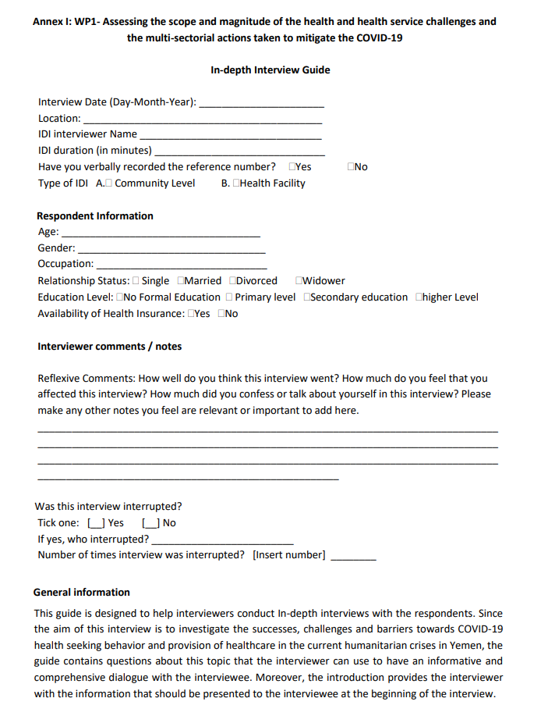
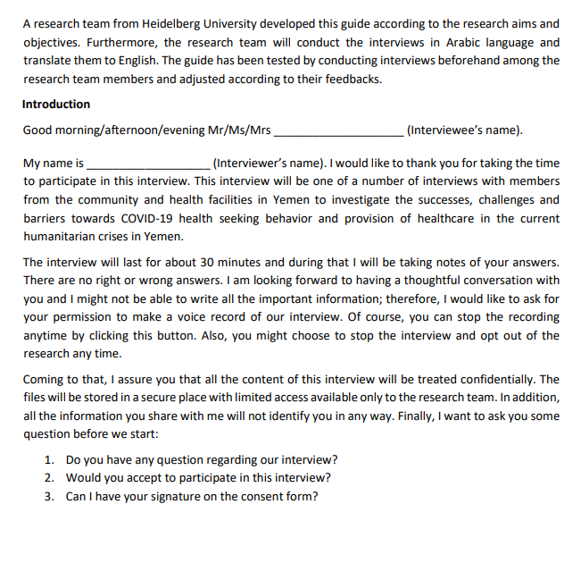
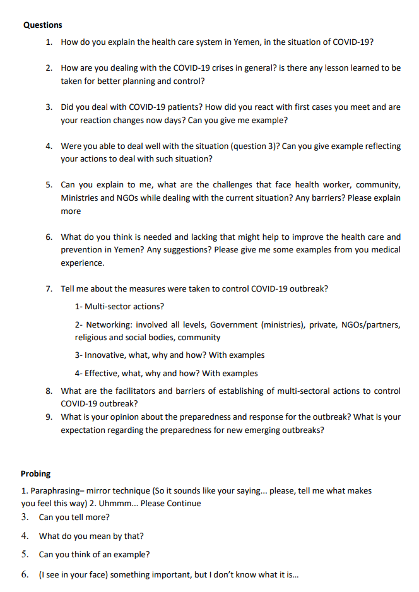
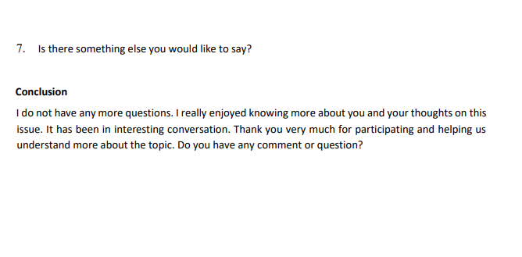
Annex 2: Checklist for COVID-19 mitigation

