Multifunctional Cellulose-Based Adsorbent from Waste Wood Wool for Heavy Metal Removal and Bacterial Disinfection: Insights into Adsorption Behavior, and DFT Calculations

Table S1. Adsorption isotherm models and their parameter values
Metal Ion |  | Langmuir Model |  |  | Freundlich Model
Pb(II) | Adsorbent | q_{max}  (mg/g) | R² | k_{f} |  | 1/n | R²
 | CU | 89.22 | 0.9998 | 75.1882 |  | 1.00245 | 0.9966
 | CU-MBT | 185.18 | 0.9995 | 291.5076 |  | 0.95343 | 0.9930
Cd(II) | CU | 103.09 | 0.9981 | 59.4169 |  | 0.64021 | 0.9713
 | CU-MBT | 178.57 | 0.9997 | 353.0693 |  | 0.18697 | 0.78706
Hg(II) | CU | 80.64 | 0.9974 | 429.0619 |  | 1.02516 | 0.9887
 | CU-MBT | 140.84 | 0.9980 | 55.2471 |  | 0.78890 | 0.9618

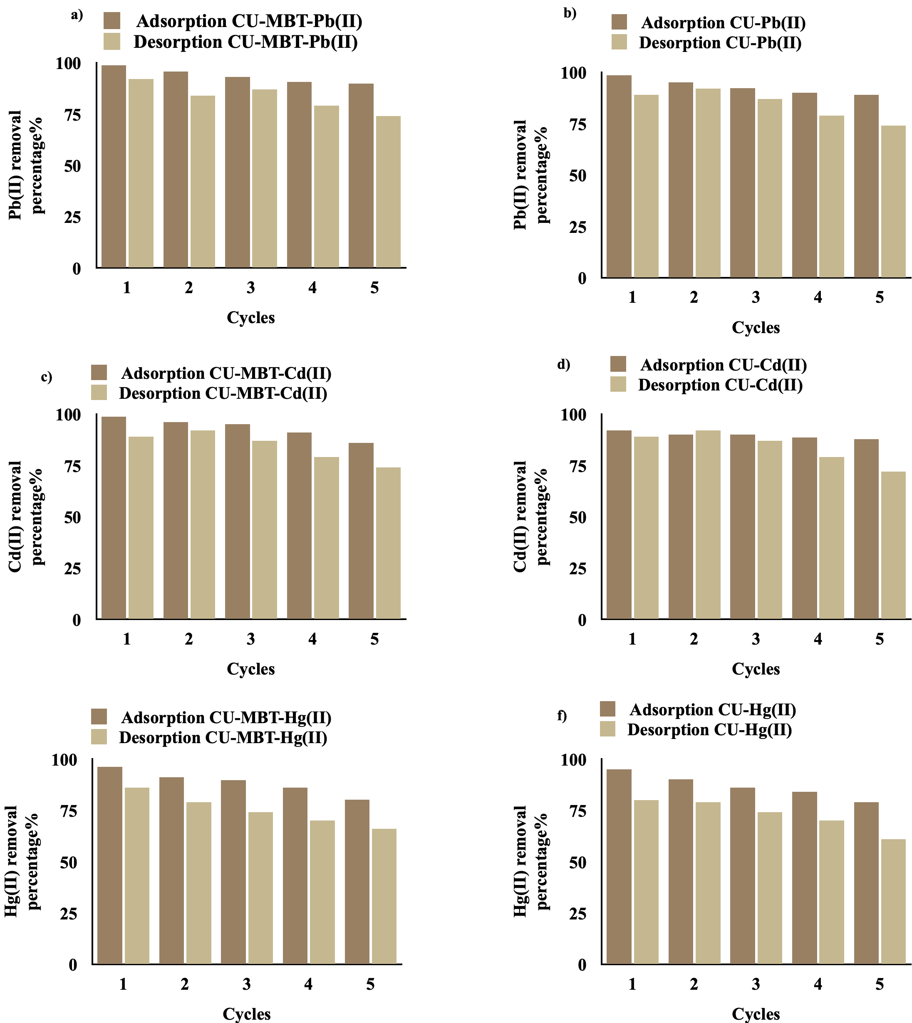
Fig S1. (a-f) Recyclability study for CU and CU-MBT

Table S2. Effect of common anions on adsorption of Hg(II), Pb(II), and Cd(II) ions
Coexisting ions | Coexisting ions concentration (mg/l) |  |  | Amount adsorbed  (mg/g)
 |  | Pb(II) | Cd(II) |  | Hg(II)
Sulphate | 10 | 9.1 | 11.42 |  | 9.02
 | 30 | 9.31 | 11.21 |  | 9.26
 | 50 | 9.43 | 11.32 |  | 9.21
Phosphate | 2 | 9.11 | 11.43 |  | 9.23
 | 5 | 9.14 | 11.42 |  | 9.34
 | 10 | 9.02 | 11.53 |  | 9.26
Bicarbonate | 50 | 9.26 | 11.42 |  | 9.31
 | 100 | 9.34 | 11.53 |  | 9.26
 | 200 | 9.42 | 11.45 |  | 9.14
Nitrate | 10 | 9.31 | 11.48 |  | 9.26
 | 30 | 9.44 | 11.46 |  | 9.21
Silicate | 10 | 9.26 | 11.58 |  | 9.41
 | 20 | 9.41 | 11.49 |  | 9.26
 | 50 | 9.62 | 11.35 |  | 9.47
Chloride | 100 | 9.22 | 11.15 |  | 9.26
 | 200 | 9.34 | 11.26 |  | 9.42
 | 300 | 9.49 | 11.51 |  | 9.46
Arsenate | 0.2 | 9.37 | 11.28 |  | 9.28
 | 0.5 | 9.46 | 11.47 |  | 9.04
 | 1 | 9.58 | 11.21 |  | 9.26

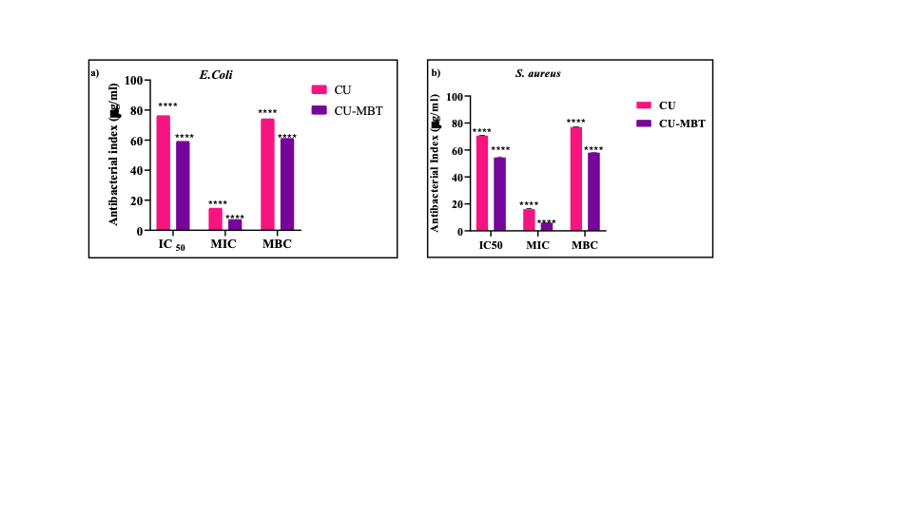Fig. S2. Antibacterial activity of CU and CU-MBT against a) E.coli b) S. aureus
Table S3. Zone of inhibition of CU and CU-MBT against S. aureus and E.coli
Concentration (ppm) | E. coli |  | S. aureus
Concentration (ppm) | CU | CU-MBT | CU | CU-MBT
10 | 1.32 ± 0.11 | 2.5 ± 0.2 | 0.45 ± 0.01 | 2.22 ± 0.15
50 | 1.51 ± 0.2 | 3.4 ± 0.2 | 0.54 ± 0.02 | 2.65 ± 0.05
100 | 1.61 ± 0.15 | 4.5± 0.2 | 0.92 ± 0.01 | 3.62 ± 0.20
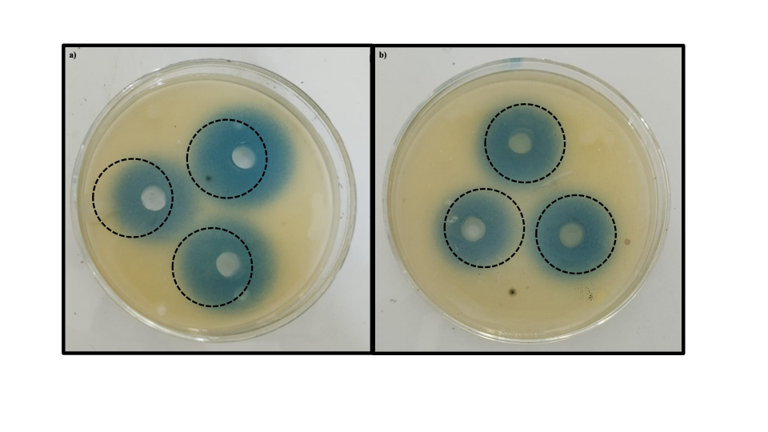
Fig. S3. Zone of inhibition against a) E.coli b) S. aureus

Table S4. Application of CU-MBT to Hg(II), Pb(II), and Cd(II). contaminated real water
Parameters | Before Adsorption | After Adsorption
pH | 7.9 | 7.01
TDS | 1498mg/l | 1301mg/l
Alkali | 500 mg/l | 428 mg/l
Cadmium | 2.05 ppm | 0.051 ppm
Lead | 2.11 ppm | 0.03 ppm
Mercury | 2.12 ppm | 0.056 ppm
Manganese | 2.01 ppm | 0.101 ppm
Zinc | 2.05 ppm | 0.212 ppm
Iron | 2.89 ppm | 2.721 ppm
Copper | 2.02 ppm | 0.056 ppm
Nickel | 2.01 ppm | 0.121 ppm

Table S5: Energetic parameters, FMOs and Global reactivity descriptors of cellulose and cellulose-MBT

Parameters | CU | CU- MBT
Total Energy (keV) | -35.306 keV | -65.806 keV
Dipole Moment (debye) | 5.0397 | 2.9892
HOMO (eV) | -7.3954 | -0.25875
LUMO (eV) | -0.7749 | -0.07154
Energy gap (eV) | 6.6205 | 5.0940
Electron affinity(A) (eV) | 0.7749 | 1.9466
Ionization Potential (I) (eV) | 7.3954 | 7.0406
Electronegativity ( χ) (eV) | 4.0852 | 4.4936
Chemical potential(µ)(eV) | -4.0852 | -4.4936
Chemical hardness (Ƞ) (eV) | 3.3102 | 2.5469
Chemical Softness (S) (eV⁻¹) | 0.1511 | 0.1963
Global Electrophilicity index (ω) (eV) | 2.5208 | 3.9639

