Supplementary Table 1. Change in heart rate from baseline to follow up according to ivabradine treatment and achieved heart rate
 | Group 1  Iva-/HR70+  (N=109) | Group 2  Iva-/HR70-  (N=73) | Group 3  Iva+/HR70+  (N=35) | Group 4  Iva+/HR70-  (N=38) | P-value
Baseline heart rate, bpm | 92 [79-104] | 81 [74-89] | 97 [89-109] | 98 [88-109] | <0.001
At first year follow-up
Follow-up heart rate, bpm | 80 [75-87] | 64 [58-67] | 81 [75-88] | 62 [57-68] | <0.001
Heart rate reduction, n (%) | 71 (65.1%) | 68 (93.2%) | 26 (74.3%) | 36 (94.7%) | <0.001
Heart rate changeª, bpm | -7 [-22 to -2] | -18 [-27 to -11] | -17 [-25 to -2] | -32.5 [-47 to -25] | <0.001
At second year follow-up | N=84 | N=60 | N=30 | N=32
Follow-up heart rate, bpm | 74 [68-84] | 67 [59-76] | 74.5 [66-85] | 69 [60-76] | 0.001
Heart rate reduction, n (%) | 65 (77.4%) | 46 (76.7%) | 26 (86.7%) | 29 (90.6%) | 0.271
Heart rate changeª, bpm | -12 [-27 to -3] | -13 [-25 to -1] | -23.5 [-40 to -12] | -29.5 [-44 to -14] | <0.001
ª Change in heart rate between the follow up and the baseline.
HR, heart rate.

Supplementary Table 2. Medication at baseline and follow-up according to ivabradine treatment and achieved heart rate
 | Group 1  Iva-/HR70+  (N=109) | Group 2  Iva-/HR70-  (N=73) | Group 3  Iva+/HR70+  (N=35) | Group 4  Iva+/HR70-  (N=38) | Total  (N=255) | P-value
At baseline, n (%)
Beta-blocker | 100 (91.7%) | 69 (94.5%) | 30 (85.7%) | 30 (78.9%) | 229 (89.8%) | 0.058
Daily dose ≥25% | 49 (47.1%) | 24 (34.8%) | 15 (48.4%) | 13 (40.6%) | 101 (42.8%) | 0.382
Daily dose ≥50% | 13 (12.5%) | 8 (11.6%) | 4 (12.9%) | 1 (3.1%) | 26 (11.0%) | 0.503
ACEi or ARB | 92 (84.4%) | 61 (83.6%) | 23 (65.7%) | 33 (86.8%) | 209 (82.0%) | 0.059
Daily dose ≥25% | 68 (73.9%) | 37 (60.7%) | 17 (73.9%) | 11 (33.3%) | 133 (63.6%) | <0.001
Daily dose ≥50% | 28 (30.4%) | 14 (23.0%) | 6 (26.1%) | 5 (15.2%) | 53 (25.4%) | 0.353
ARNI | 7 (6.4%) | 3 (4.1%) | 6 (17.1%) | 2 (5.3%) | 18 (7.1%) | 0.123
Daily dose ≥25% | 6 (85.7%) | 3 (100.0%) | 4 (66.7%) | 2 (100.0%) | 15 (83.3%) | 0.691
Daily dose ≥50% | 2 (28.6%) | 1 (33.3%) | 1 (16.7%) | 0 (0.0%) | 4 (22.2%) | 1.000
ACEi or ARB or ARNI | 99 (90.8%) | 63 (86.3%) | 29 (82.9%) | 35 (92.1%) | 226 (88.6%) | 0.457
Daily dose ≥25% | 74 (74.7%) | 39 (61.9%) | 21 (72.4%) | 13 (37.1%) | 147 (65.0%) | 0.001
Daily dose ≥50% | 30 (30.3%) | 15 (23.8%) | 7 (24.1%) | 5 (14.3%) | 57 (25.2%) | 0.301
MRA | 87 (79.8%) | 55 (75.3%) | 32 (91.4%) | 36 (94.7%) | 210 (82.4%) | 0.030
Daily dose ≥50% | 46 (52.9%) | 23 (41.8%) | 17 (53.1%) | 20 (55.6%) | 106 (50.5%) | 0.510
Ivabradine | 4 (3.7%) | 0 (0.0%) | 17 (48.6%) | 18 (47.4%) | 39 (15.3%) | <0.001
Daily dose ≥ 50% | 4 (100.0%) | 0 (0.0%) | 15 (88.2%) | 13 (72.2%) | 32 (82.1%) | 0.391
SGLT2i | 4 (3.7%) | 1 (1.4%) | 0 (0.0%) | 1 (2.6%) | 6 (2.4%) | 0.774
At 1-year follow-up, n (%)
Beta-blocker | 104 (95.4%) | 69 (94.5%) | 26 (74.3%) | 31 (81.6%) | 230 (90.2%) | 0.001
Daily dose ≥25% | 68 (65.4%) | 29 (42.0%) | 14 (53.8%) | 21 (67.7%) | 132 (57.4%) | 0.012
Daily dose ≥50% | 32 (30.8%) | 10 (14.5%) | 6 (23.1%) | 3 (9.7%) | 51 (22.2%) | 0.022
ACEi or ARB | 54 (49.5%) | 36 (49.3%) | 8 (22.9%) | 14 (36.8%) | 112 (43.9%) | 0.025
Daily dose ≥25% | 31 (57.4%) | 24 (66.7%) | 5 (62.5%) | 7 (50.0%) | 67 (59.8%) | 0.692
Daily dose ≥50% | 14 (25.9%) | 12 (33.3%) | 0 (0.0%) | 1 (7.1%) | 27 (24.1%) | 0.096
ARNI | 48 (44.0%) | 34 (46.6%) | 23 (65.7%) | 22 (57.9%) | 127 (49.8%) | 0.098
Daily dose ≥25% | 40 (83.3%) | 25 (73.5%) | 20 (87.0%) | 15 (68.2%) | 100 (78.7%) | 0.314
Daily dose ≥50% | 20 (41.7%) | 11 (32.4%) | 7 (30.4%) | 10 (45.5%) | 48 (37.8%) | 0.612
ACEi or ARB or ARNI | 102 (93.6%) | 70 (95.9%) | 31 (88.6%) | 36 (94.7%) | 239 (93.7%) | 0.542
Daily dose ≥25% | 71 (69.6%) | 49 (70.0%) | 25 (80.6%) | 22 (61.1%) | 167 (69.9%) | 0.388
Daily dose ≥50% | 34 (33.3%) | 23 (32.9%) | 7 (22.6%) | 11 (30.6%) | 75 (31.4%) | 0.711
MRA | 74 (67.9%) | 50 (68.5%) | 31 (88.6%) | 33 (86.8%) | 188 (73.7%) | 0.016
Daily dose ≥50% | 29 (39.2%) | 14 (28.0%) | 12 (38.7%) | 14 (42.4%) | 69 (36.7%) | 0.504
Ivabradine | 0 (0.0%) | 0 (0.0%) | 35 (100.0%) | 38 (100.0%) | 73 (28.6%) | <0.001
Daily dose ≥ 50% | 0 (0.0%) | 0 (0.0%) | 30 (85.7%) | 29 (76.3%) | 59 (80.8%) | 0.380
SGLT2i | 4 (3.7%) | 0 (0.0%) | 0 (0.0%) | 4 (10.5%) | 8 (3.1%) | 0.021
At 2-year follow-up, n (%) | N=84 | N=60 | N=30 | N=32 | N=206
Beta-blocker | 80 (95.2%) | 55 (91.7%) | 23 (76.7%) | 26 (81.2%) | 184 (89.3%) | 0.012
Daily dose ≥25% | 54 (67.5%) | 21 (38.2%) | 14 (60.9%) | 19 (73.1%) | 108 (58.7%) | 0.002
Daily dose ≥50% | 31 (38.8%) | 8 (14.5%) | 8 (34.8%) | 5 (19.2%) | 52 (28.3%) | 0.012
ACEi or ARB | 32 (38.1%) | 28 (46.7%) | 6 (20.0%) | 11 (34.4%) | 77 (37.4%) | 0.101
Daily dose ≥25% | 24 (75.0%) | 19 (67.9%) | 5 (83.3%) | 7 (63.6%) | 55 (71.4%) | 0.779
Daily dose ≥50% | 12 (37.5%) | 5 (17.9%) | 1 (16.7%) | 3 (27.3%) | 21 (27.3%) | 0.353
ARNI | 45 (53.6%) | 29 (48.3%) | 21 (70.0%) | 21 (65.6%) | 116 (56.3%) | 0.156
Daily dose ≥25% | 36 (80.0%) | 17 (58.6%) | 18 (85.7%) | 19 (90.5%) | 90 (77.6%) | 0.040
Daily dose ≥50% | 27 (60.0%) | 9 (31.0%) | 11 (52.4%) | 11 (52.4%) | 58 (50.0%) | 0.108
ACEi or ARB or ARNI | 77 (91.7%) | 57 (95.0%) | 27 (90.0%) | 32 (100.0%) | 193 (93.7%) | 0.278
Daily dose ≥25% | 60 (77.9%) | 36 (63.2%) | 23 (85.2%) | 26 (81.2%) | 145 (75.1%) | 0.079
Daily dose ≥50% | 39 (50.6%) | 14 (24.6%) | 12 (44.4%) | 14 (43.8%) | 79 (40.9%) | 0.023
MRA | 50 (59.5%) | 39 (65.0%) | 23 (76.7%) | 28 (87.5%) | 140 (68.0%) | 0.022
Daily dose ≥50% | 17 (34.0%) | 10 (25.6%) | 8 (34.8%) | 10 (35.7%) | 45 (32.1%) | 0.784
Ivabradine | 2 (2.4%) | 1 (1.7%) | 26 (86.7%) | 23 (71.9%) | 52 (25.2%) | <0.001
Daily dose ≥ 50% | 2 (100.0%) | 1 (100.0%) | 22 (84.6%) | 17 (73.9%) | 42 (80.8%) | 0.731
SGLT2i | 7 (8.3%) | 2 (3.3%) | 0 (0.0%) | 4 (12.5%) | 13 (6.3%) | 0.121
ACEi, angiotensin converting enzyme inhibitor- ARB, angiotensin receptor blocker- ARNI, angiotensin receptor neprilysin inhibitor- HR, achieved heart rate- MRA, mineralocorticoid receptor antagonist.

Supplementary Table 3. Medication at baseline and follow-up according to LVRR at 1-year
 | LVRR  (N=134) | Non-LVRR  (N=121) | P-value
At baseline, n (%)
Beta-blocker | 126 (94.0%) | 103 (85.1%) | 0.032
Daily dose ≥25% | 63 (48.5%) | 38 (35.8%) | 0.069
Daily dose ≥50% | 14 (10.8%) | 12 (11.3%) | 1.000
ACEi or ARB | 113 (84.3%) | 96 (79.3%) | 0.383
Daily dose ≥25% | 79 (69.9%) | 54 (56.2%) | 0.057
Daily dose ≥50% | 34 (30.1%) | 19 (19.8%) | 0.122
ARNI | 9 (6.7%) | 9 (7.4%) | 1.000
Daily dose ≥25% | 7 (77.8%) | 8 (88.9%) | 1.000
Daily dose ≥50% | 2 (22.2%) | 2 (22.2%) | 1.000
ACEi or ARB or ARNI | 121 (90.3%) | 105 (86.8%) | 0.492
Daily dose ≥25% | 85 (70.2%) | 62 (59.0%) | 0.105
Daily dose ≥50% | 36 (29.8%) | 21 (20.0%) | 0.126
MRA | 110 (82.1%) | 100 (82.6%) | 1.000
Daily dose ≥50% | 64 (58.2%) | 42 (42.0%) | 0.028
Ivabradine | 27 (20.1%) | 12 (9.9%) | 0.036
Daily dose ≥ 50% | 24 (88.9%) | 8 (66.7%) | 0.172
SGLT2i | 3 (2.2%) | 3 (2.5%) | 1.000
At 1-year follow-up, n (%)
Beta-blocker | 126 (94.0%) | 104 (86.0%) | 0.051
Daily dose ≥25% | 79 (62.7%) | 53 (51.0%) | 0.097
Daily dose ≥50% | 32 (25.4%) | 19 (18.3%) | 0.256
ACEi or ARB | 60 (44.8%) | 52 (43.0%) | 0.871
Daily dose ≥25% | 39 (65.0%) | 28 (53.8%) | 0.314
Daily dose ≥50% | 20 (33.3%) | 7 (13.5%) | 0.026
ARNI | 68 (50.7%) | 59 (48.8%) | 0.848
Daily dose ≥25% | 54 (79.4%) | 46 (78.0%) | 1.000
Daily dose ≥50% | 28 (41.2%) | 20 (33.9%) | 0.509
ACEi or ARB or ARNI | 128 (95.5%) | 111 (91.7%) | 0.324
Daily dose ≥25% | 93 (72.7%) | 74 (66.7%) | 0.387
Daily dose ≥50% | 48 (37.5%) | 27 (24.3%) | 0.040
MRA | 97 (72.4%) | 91 (75.2%) | 0.713
Daily dose ≥50% | 41 (42.3%) | 28 (30.8%) | 0.138
Ivabradine | 49 (36.6%) | 24 (19.8%) | 0.005
Daily dose ≥50% | 41 (83.7%) | 18 (75.0%) | 0.528
SGLT2i | 7 (5.2%) | 1 (0.8%) | 0.069
ACEi, angiotensin converting enzyme inhibitor- ARB, angiotensin receptor blocker- ARNI, angiotensin receptor neprilysin inhibitor- LVRR, left ventricular reverse remodeling- MRA, mineralocorticoid receptor antagonist.

Supplementary Table 4. Univariate and multivariate logistic regression analysis for independent predictors of baseline related to left ventricular reverse remodeling
 | Univariate analysis |  |  | Multivariate analysis
 | OR | 95% CI | P-value | OR | 95% CI | P-value
Age <65 year | 1.39 | 0.83-2.35 | 0.215
Male | 0.50 | 0.30-0.84 | 0.008 | 0.49 | 0.26-0.90 | 0.022
BMI < 25 | 0.96 | 0.59-1.59 | 0.884
NT-proBNP ≥1739 pg/mL | 0.92 | 0.56-1.52 | 0.749
eGFR <60 ml/min/1.73m² | 1.06 | 0.54-2.11 | 0.860
Hb < 10g/dL | 0.47 | 0.20-1.11 | 0.086 | 0.80 | 0.29-2.21 | 0.661
Hypertension | 1.97 | 1.19-3.26 | 0.008 | 1.43 | 0.80-2.55 | 0.228
Diabetes | 1.34 | 0.78-2.28 | 0.285
Systolic BP, per 10mmHg | 1.15 | 0.99-1.32 | 0.063 | 1.06 | 0.89-1.25 | 0.516
Diastolic BP, per 10mmHg | 1.32 | 1.06-1.64 | 0.013
Heart rate, per 10bpm | 1.30 | 1.12-1.50 | 0.001 | 1.10 | 0.93-1.30 | 0.270
LVEDD ≥ 55 mm | 1.12 | 0.41-3.07 | 0.833
LVEF, per 10% | 0.84 | 0.44-1.62 | 0.611
QRS duration >120 ms | 0.61 | 0.35-1.06 | 0.079 | 0.65 | 0.34-1.24 | 0.194
Ivabradine maintained | 2.33 | 1.32-4.11 | 0.004 | 2.83 | 1.39-5.75 | 0.004
Beta-blocker maintained | 2.91 | 1.32-6.40 | 0.008 | 3.76 | 1.46-9.67 | 0.006
Beta-blocker dose ≥ 50% | 1.52 | 0.80-2.89 | 0.197
ACEi/ARB/ARNI dose ≥ 50% | 1.87 | 1.06-3.28 | 0.030 | 1.82 | 0.95-3.47 | 0.071
MRA dose ≥ 50% | 1.65 | 0.90-3.00 | 0.103
Reduction in heart rate at follow up, per 10bpm | 1.26 | 1.10-1.44 | 0.001
* Only variables with P < 0.10 in the univariable model were included in the multivariable model
Abbreviations as in Table 1. ACEi, angiotensin converting enzyme inhibitor- ARB, angiotensin receptor blocker- ARNI, angiotensin receptor neprilysin inhibitor- CI, confidence interval- LVRR, left ventricular reverse remodeling- OR, odds ratio.
Supplementary Figure 1. Kaplan-Meier curves for clinical events among four groups according to ivabradine treatment and achieved heart rate
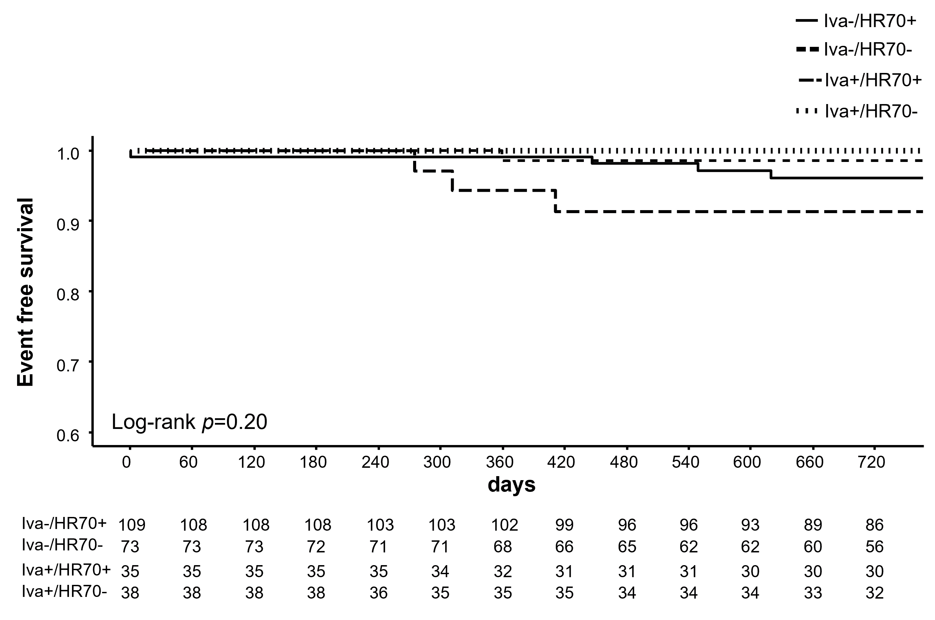

Groups were divided based on the administration of ivabradine and achieved HR at 1-year :
Group 1 (Iva-/HR70+), achieved HR ≥ 70 bpm without ivabradine-
Group 2 (Iva-/HR70-), achieved HR < 70 bpm without ivabradine-
Group 3 (Iva+/HR70+), achieved HR ≥ 70 bpm with ivabradine-
Group 4 (Iva+/HR70-), achieved HR < 70 bpm with ivabradine.

