Supplementary Information
Pump-locked random lasers using artificial intelligence
Junhua Tong¹, Xiaoyu Shi², Zhiyang Xu², Naeem Iqbal², Kun Ge², Tianrui Zhai^{2,*}
¹College of Mathematics and physics, Beijing University of Chemical Technology, Beijing 100029, China
²School of Physics and Optoelectronic Engineering, Beijing University of Technology, Beijing 100124, China
*Email: trzhai@bjut.edu.cn

CONTENTS
- Design and fabrication process of random lasers
- Schematic diagram of mode selection of random lasers using our intelligence control system
3. The GIFs of optimization process for target modes in Fig. 4 (open as Microsoft Word)
1. Design and fabrication process of random lasers.
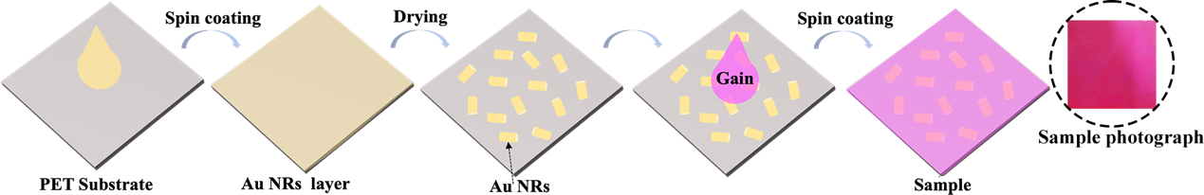
Fig. S1 Sample preparation process and sample photograph.
The disordered system is a polymer film fabricated by dye-doped PMMA with scattering nanoparticles. Herein, a typical laser dye RhB is used as gain material, while Au NRs with diameter and length about 25 and 50 nm act as scatterers. The fabrication process is illustrated in Fig. S1. Firstly, the Au NRs (0.02 mg/mL) was spin-coated on the flexible PET substrate at a speed of 1800 r/min for 40s. Secondly, the RhB (6 mg/mL) and PMMA (200 mg/mL) were mixed with a volume ratio of 1:1 under magnetic stirring for 20 min. Then, spin coating the mixture on the Au NRs layer at a speed of 1800 r/min for 40 s. Thirdly, heat the structure at 70 °C for 20 min for solidification. Finally, the disordered system is obtained, which is uniform as shown in sample photograph. The solvent here was dichloromethane.
2. Schematic diagram of mode selection of random lasers using our intelligence control system.
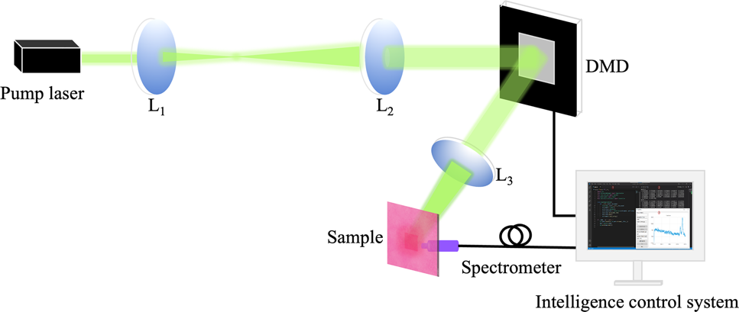
Fig. S2 The diagram of experimental setup for mode selection using intelligent control system.
A doubled Q-switched Nd:YAG laser (532 nm, 5-7 ns, 10 Hz) is employed as the pump source. The lens 1(L₁) and lens 2 (L₂) are used for expanding and collimating of pump beam, respectively. The DMD is used to shape the pump profile based on the feedback of grayscale of image. The modulated pump light is reflected to lens 3 (L₃). The lens 3 is used to adjust the size of pump profile. The modulated pump pattern incident on the sample and the reflected emission light was collected by an optical fiber spectrometer (Ocean Optics HR4000) with a spectral resolution of 0.02 nm. The pump power was controlled by pump voltage. The pump source, digital micromirror device (DMD) and high-resolution spectrometer are linked using the self-development software.
3. The GIFs of optimization process for target modes in Figure 4. The corresponding videos (MP4) have also uploaded.
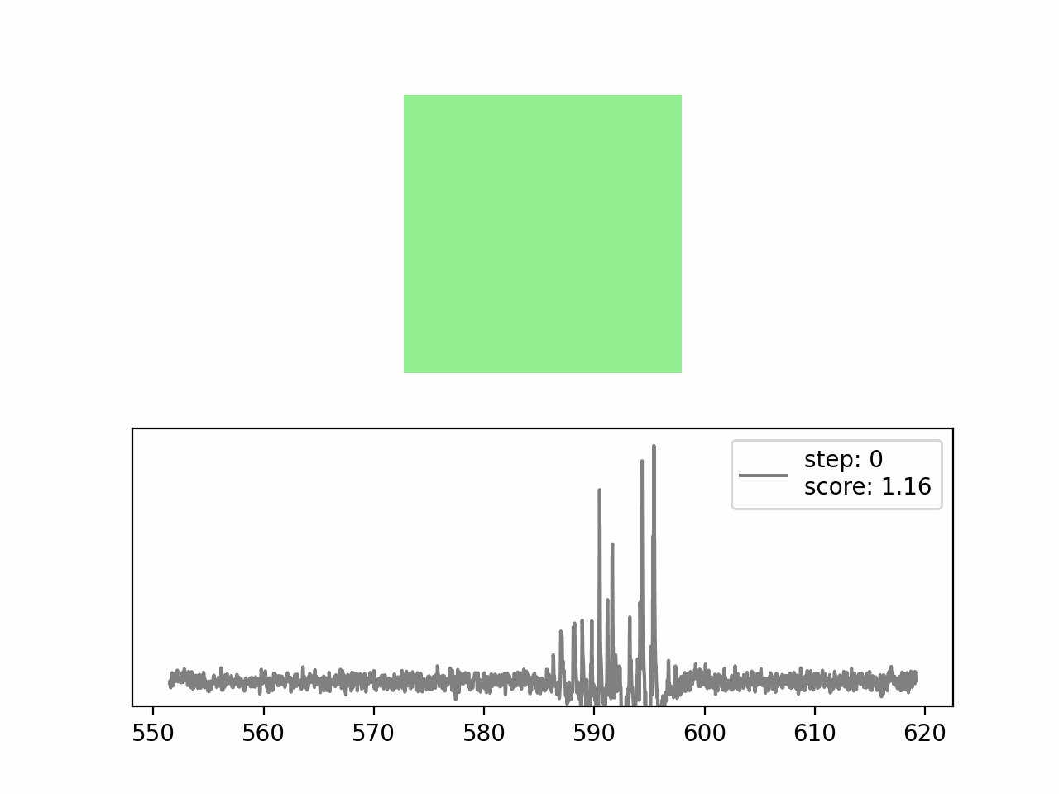The GIF of optimization process for single mode at 591.5 nm (λ₁).
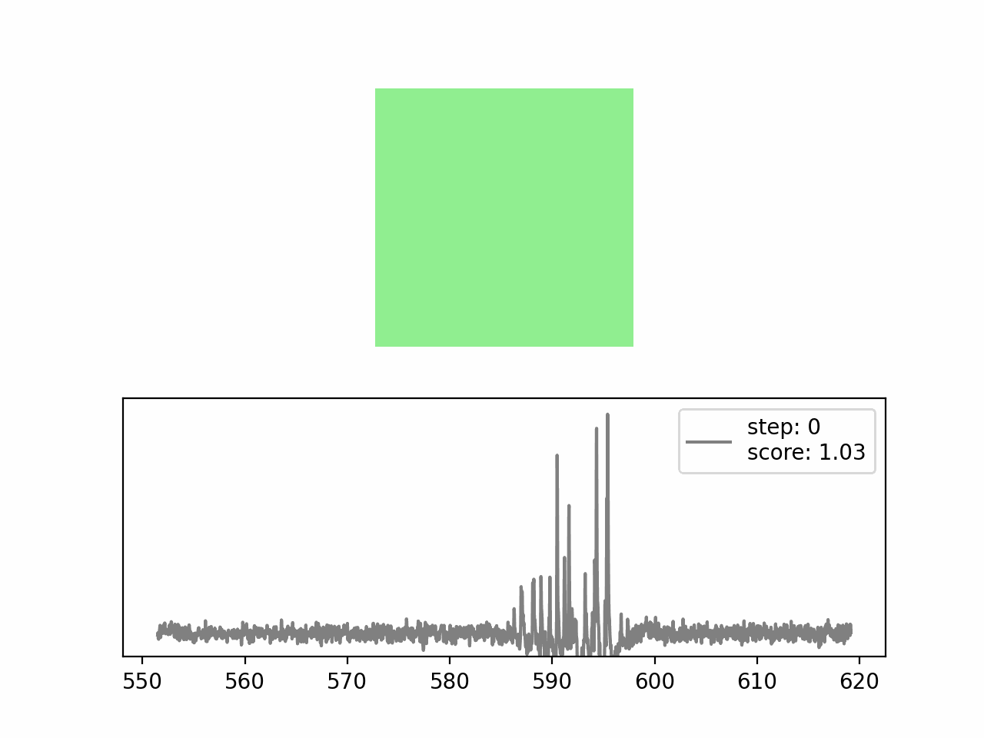
The GIF of optimization process for single mode at 594.0 nm (λ₂).
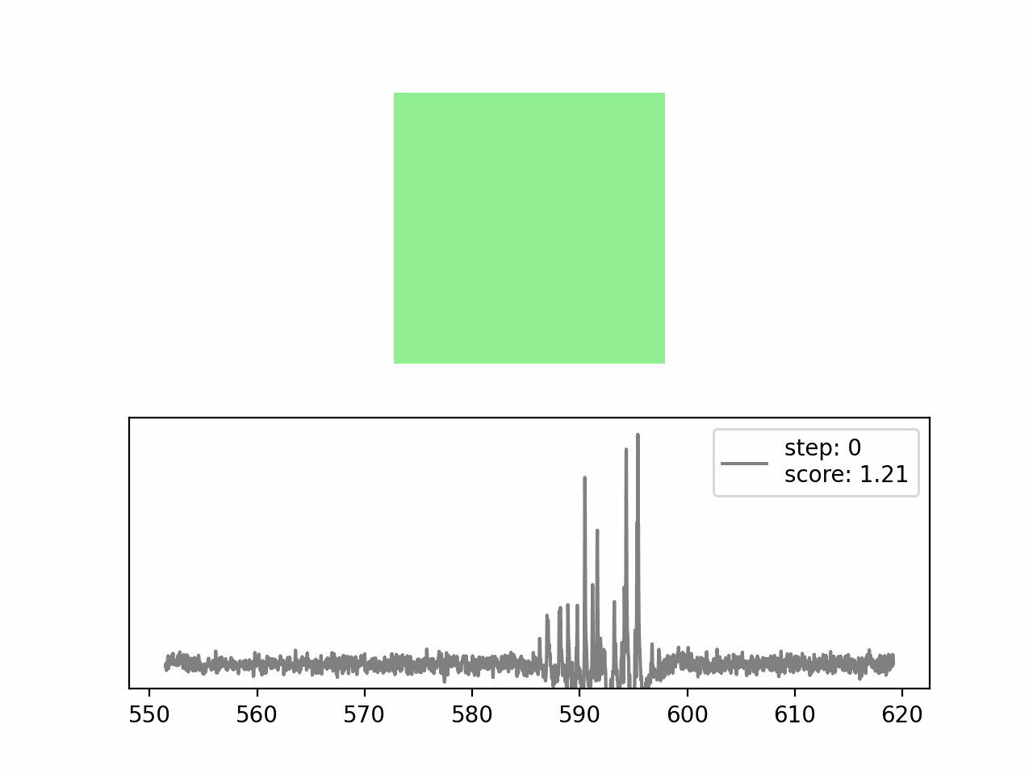The GIF of optimization process for two modes (λ₁ & λ₂) simultaneously.

