Appendix
Schedule 1 Characteristic metabolic pathways of MH group compared with CN group
Pathway-name | Total | Hits | Pvalue | Compound-name
Central carbon metabolism in cancer | 37 | 7 | 0.0001 | Oxalacetic acid; L-Tryptophan; Fumaric acid; L-Histidine; L-Malic acid; Isocitric acid; Fructose 1,6-bisphosphate
Citrate cycle (TCA cycle) | 20 | 5 | 0.0004 | Oxalacetic acid; Fumaric acid; L-Malic acid; Isocitric acid; Oxalosuccinic acid
Glucagon signaling pathway | 26 | 5 | 0.0013 | Oxalacetic acid; Fumaric acid; L-Malic acid; Isocitric acid; Fructose 1,6-bisphosphate
Renal cell carcinoma | 3 | 2 | 0.0031 | Fumaric acid; L-Malic acid
Phenylalanine tyrosine and tryptophan biosynthesis | 34 | 5 | 0.0044 | L-Tryptophan; Fructose 1,6-bisphosphate; Indole; Shikimic acid; L-Arogenate
Synaptic vesicle cycle | 12 | 3 | 0.0060 | Serotonin; Acetylcholine ; Dopamine
Pyruvate metabolism | 31 | 4 | 0.0170 | Oxalacetic acid; Fumaric acid; L-Malic acid; Acetylphosphate
Pathways in cancer | 31 | 4 | 0.0170 | Fumaric acid; L-Malic acid; all-trans-Retinoic acid; Dehydroepiandrosterone
Taste transduction | 32 | 4 | 0.0190 | Sucrose; L-Malic acid; Serotonin; Acetylcholine
Neuroactive ligand-receptor interaction | 52 | 5 | 0.0258 | Serotonin; Acetylcholine ; Dopamine; Sphingosine 1-phosphate; Palmitoylethanolamide
Fc gamma R-mediated phagocytosis | 8 | 2 | 0.0259 | Arachidonic acid; Sphingosine 1-phosphate
African trypanosomiasis | 8 | 2 | 0.0259 | L-Tryptophan; L-Kynurenine
ABC transporters | 138 | 9 | 0.0341 | Sucrose; D-Ribose; L-Histidine; N-Acetyl-D-glucosamine; D-Xylose; Uridine; Guanosine; 2'-Deoxyadenosine; Ciliatine
cAMP signaling pathway | 25 | 3 | 0.0460 | Serotonin; Acetylcholine ; Dopamine
Serotonergic synapse | 42 | 4 | 0.0462 | L-Tryptophan; Arachidonic acid; 5-Hydroxy-L-tryptophan; Serotonin

Schedule 2 Characteristic metabolic pathways of HLP group compared with CN group
Pathway-name | Total | Hits | Pvalue | Compound-name
Neuroactive ligand-receptor interaction | 52 | 6 | 0.0030 | Thyroxine; Acetylcholine ; 12-Keto-tetrahydro-leukotriene B4; Dopamine; Sphingosine 1-phosphate; Palmitoylethanolamide
Tyrosine metabolism | 78 | 7 | 0.0057 | L-Tyrosine; 4-Hydroxycinnamic acid; Thyroxine; Dopamine; (R)-3-(4-Hydroxyphenyl)lactate; Beta-Tyrosine; 3,4-Dihydroxymandelic acid
beta-Alanine metabolism | 32 | 4 | 0.0114 | L-Histidine; Dihydrouracil; Anserine; Quinolinic acid
ABC transporters | 138 | 9 | 0.0142 | Sucrose; Choline; L-Histidine; N-Acetyl-D-glucosamine; Uridine; Guanosine; 2'-Deoxyadenosine; Betaine; Methyl beta-D-galactoside
Cocaine addiction | 7 | 2 | 0.0149 | L-Tyrosine; Dopamine
Central carbon metabolism in cancer | 37 | 4 | 0.0189 | Oxoglutaric acid; L-Methionine; L-Tyrosine; L-Histidine
Fc gamma R-mediated phagocytosis | 8 | 2 | 0.0195 | Arachidonic acid; Sphingosine 1-phosphate
Amphetamine addiction | 9 | 2 | 0.0247 | L-Tyrosine; Dopamine
Alcoholism | 10 | 2 | 0.0303 | L-Tyrosine; Dopamine
Prolactin signaling pathway | 11 | 2 | 0.0363 | L-Tyrosine; Dopamine
Protein digestion and absorption | 47 | 4 | 0.0413 | L-Methionine; L-Tyrosine; L-Histidine; Ethylmethylacetic acid
Synaptic vesicle cycle | 12 | 2 | 0.0428 | Acetylcholine ; Dopamine
Dopaminergic synapse | 12 | 2 | 0.0428 | L-Tyrosine; Dopamine
Cholinergic synapse | 12 | 2 | 0.0428 | Choline; Acetylcholine

Schedule 3 Characteristic metabolic pathways after comparison between HLP group and MH group
Pathway-name | Total | Hits | Pvalue | Compound-name
Central carbon metabolism in cancer | 37 | 8 | 0.0000 | L-Glutamic acid; Succinic acid; L-Glutamine; L-Methionine; L-Tryptophan; L-Tyrosine; Fumaric acid; Fructose 1,6-bisphosphate
Arginine biosynthesis | 23 | 5 | 0.0002 | L-Glutamic acid; L-Glutamine; Ornithine; Fumaric acid; N-Acetylglutamic acid
Cocaine addiction | 7 | 3 | 0.0004 | L-Glutamic acid; L-Tyrosine; Dopamine
Phenylalanine metabolism | 60 | 7 | 0.0005 | Succinic acid; L-Tyrosine; Fumaric acid; 2-Hydroxycinnamic acid; N-Acetyl-L-phenylalanine; Phenylacetylglutamine; Phenylethylamine
Amphetamine addiction | 9 | 3 | 0.0010 | L-Glutamic acid; L-Tyrosine; Dopamine
GABAergic synapse | 9 | 3 | 0.0010 | L-Glutamic acid; Succinic acid; L-Glutamine
Lysine degradation | 50 | 6 | 0.0010 | Succinic acid; Pipecolic acid; Glutaric acid; L-2-Hydroxyglutaric acid; Glutarate semialdehyde; (S)-5-Amino-3-oxohexanoate
Alcoholism | 10 | 3 | 0.0014 | L-Glutamic acid; L-Tyrosine; Dopamine
Tyrosine metabolism | 78 | 7 | 0.0023 | Succinic acid; L-Tyrosine; Fumaric acid; Dopamine; Beta-Tyrosine; 2-Hydroxy-3-(4-hydroxyphenyl)propenoic acid; 3,4-Dihydroxymandelic acid
Alanine, aspartate and glutamate metabolism | 28 | 4 | 0.0040 | L-Glutamic acid; Succinic acid; L-Glutamine; Fumaric acid
Protein digestion and absorption | 47 | 5 | 0.0047 | L-Glutamic acid; L-Glutamine; L-Methionine; L-Tryptophan; L-Tyrosine
Aminoacyl-tRNA biosynthesis | 52 | 5 | 0.0073 | L-Glutamic acid; L-Glutamine; L-Methionine; L-Tryptophan; L-Tyrosine
Phenylalanine, tyrosine and tryptophan biosynthesis | 34 | 4 | 0.0081 | L-Tryptophan; L-Tyrosine; Quinate; Fructose 1,6-bisphosphate
Citrate cycle (TCA cycle) | 20 | 3 | 0.0111 | Succinic acid; Fumaric acid; Oxalosuccinic acid
Glutamatergic synapse | 8 | 2 | 0.0143 | L-Glutamic acid; L-Glutamine
ABC transporters | 138 | 8 | 0.0158 | L-Glutamic acid; L-Glutamine; Ornithine; Sucrose; Choline; Phthalic acid; Ciliatine; Methyl beta-D-galactoside
Long-term depression | 9 | 2 | 0.0181 | L-Glutamic acid; Arachidonic acid
Glucagon signaling pathway | 26 | 3 | 0.0228 | Succinic acid; Fumaric acid; Fructose 1,6-bisphosphate
Prolactin signaling pathway | 11 | 2 | 0.0268 | L-Tyrosine; Dopamine
Gap junction | 11 | 2 | 0.0268 | L-Glutamic acid; Dopamine
D-Arginine and D-ornithine metabolism | 11 | 2 | 0.0268 | Ornithine; 5-Amino-2-oxopentanoic acid
Linoleic acid metabolism | 28 | 3 | 0.0278 | Arachidonic acid; 13-L-Hydroperoxylinoleic acid; 13S-hydroxyoctadecadienoic acid
Mineral absorption | 29 | 3 | 0.0305 | L-Glutamine; L-Methionine; L-Tryptophan
Synaptic vesicle cycle | 12 | 2 | 0.0317 | L-Glutamic acid; Dopamine
Dopaminergic synapse | 12 | 2 | 0.0317 | L-Tyrosine; Dopamine
Pyruvate metabolism | 31 | 3 | 0.0363 | Succinic acid; Fumaric acid; Acetylphosphate
D-Glutamine and D-glutamate metabolism | 13 | 2 | 0.0369 | L-Glutamic acid; L-Glutamine
beta-Alanine metabolism | 32 | 3 | 0.0394 | Anserine; Ureidopropionic acid; Quinolinic acid

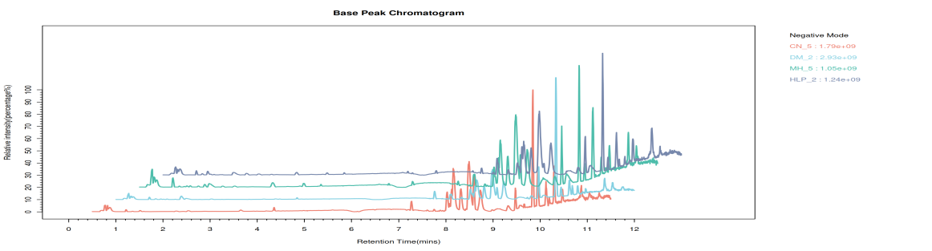
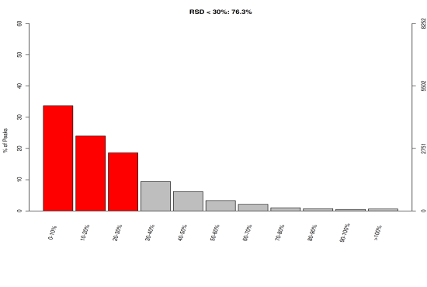
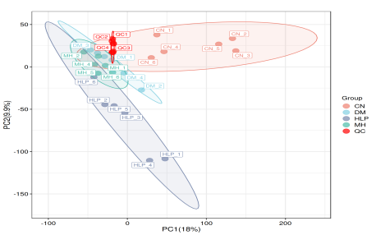
Figure A1 Anion base peak chromatogram (A); Anion QA results-RSD dion(B); QC sample PCA score map (C)
A
B
C
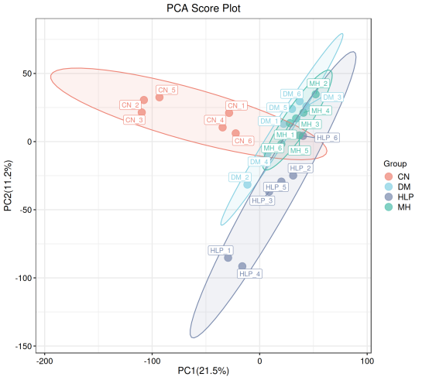
Figure A2 Negative ion principal component analysis diagram
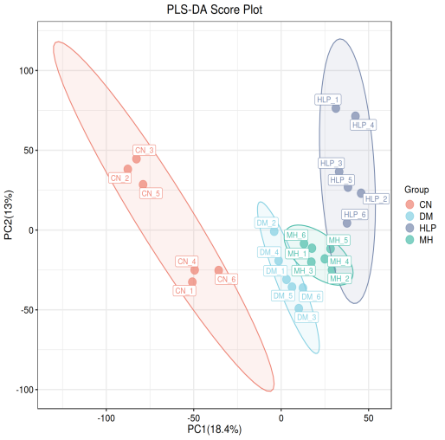
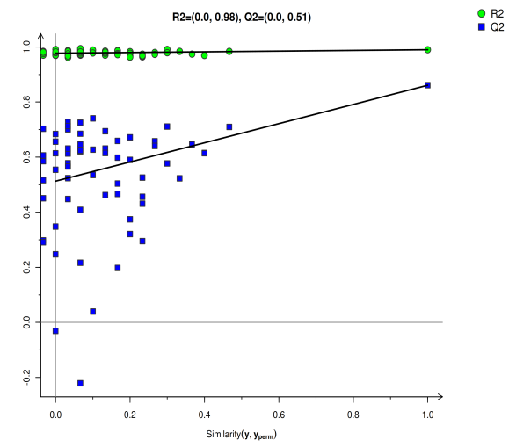
Figure A3 OPLS-DA score Chart for ions (A); OPLS-DA replacement test chart for negative ions (B)
A
B

