Supplementary materials for
Genetic neurocognitive profile of autism unveiled with gene transcription
Yingxing Zhang¹, Fangfang Li², Hongli Wu², Wei Du², Jianhua Shu², Anqing Wang³, Chunsheng Xu³, Chuanfu Li³, Ya Wang^{1*}, Sheng Hu^{2,4,5*}
¹ Child Healthcare Department, Anhui Provincial Children’s Hospital, Hefei, Anhui, 230022, PR China
² School of Medical Information Engineering, Anhui University of Chinese Medicine; Hefei, Anhui, 230012, PR China
³ Medical Imaging Center, First Affiliated Hospital of Anhui University of Chinese Medicine, Hefei, Anhui, 230601, PR China
⁴ Medical Imaging Center, Department of Electronic Engineering and Information Science, University of Science and Technology of China, Hefei, Anhui, 230026, PR China
⁵ Institute of Advanced Technology, University of Science and Technology of China, Hefei, Anhui, 230000, PR China
* Correspondence Author:
Sheng Hu, School of Medical Information Engineering, Anhui University of Chinese Medicine; Hefei, Anhui, 230012, PR China
Email: hushengustc@163.com
Ya Wang, Anhui Hospital Affiliated to the Children's Hospital of Fudan University, Hefei, Anhui, 230022, PR China
Email: aywangyaya@163.com

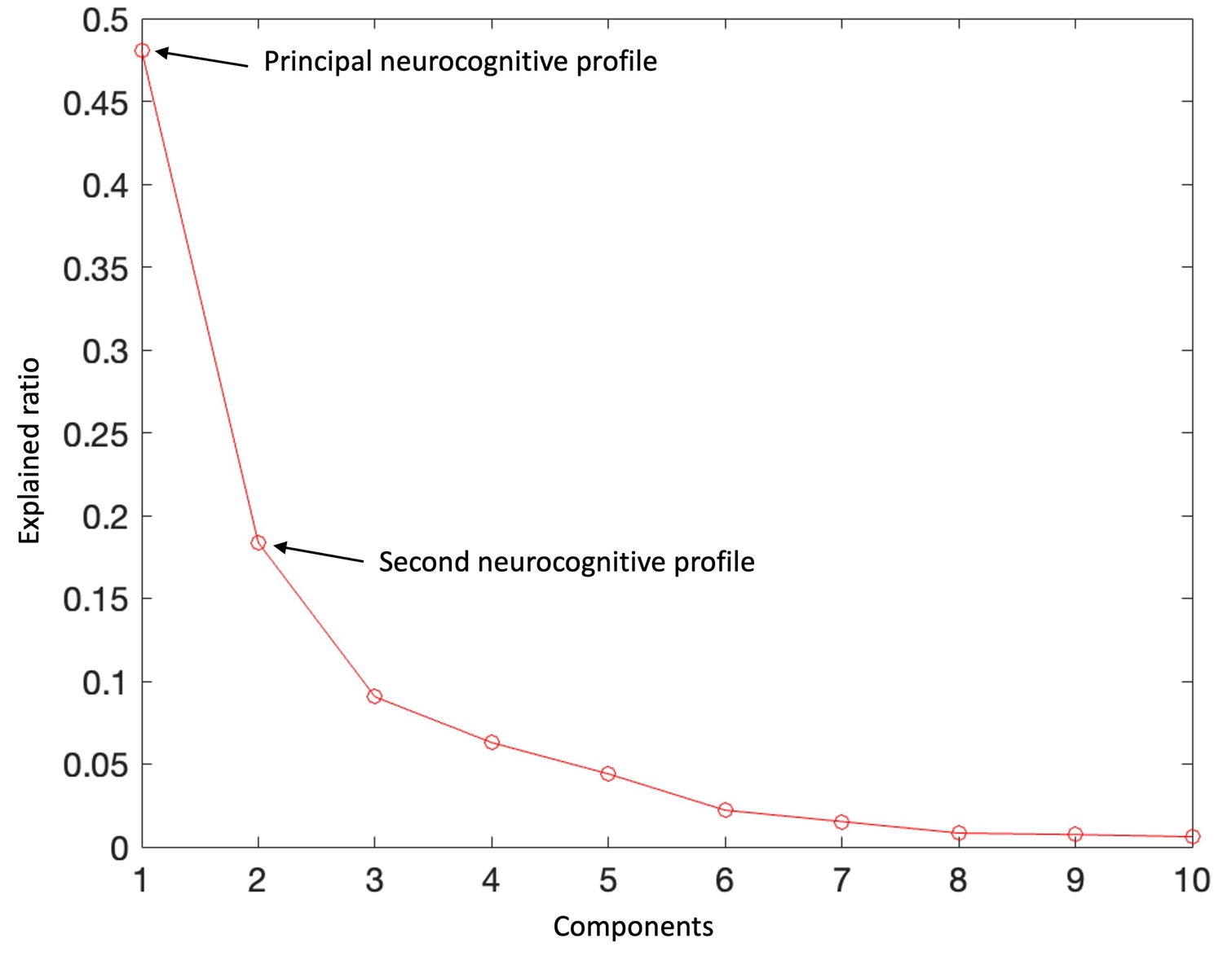
Supplementary Fig. 1 The percentage of variance in the response variables explained by the components in the principal component analysis. The variables of the first and second explained ratios were selected as principal and second neurocognitive profiles, respectively.

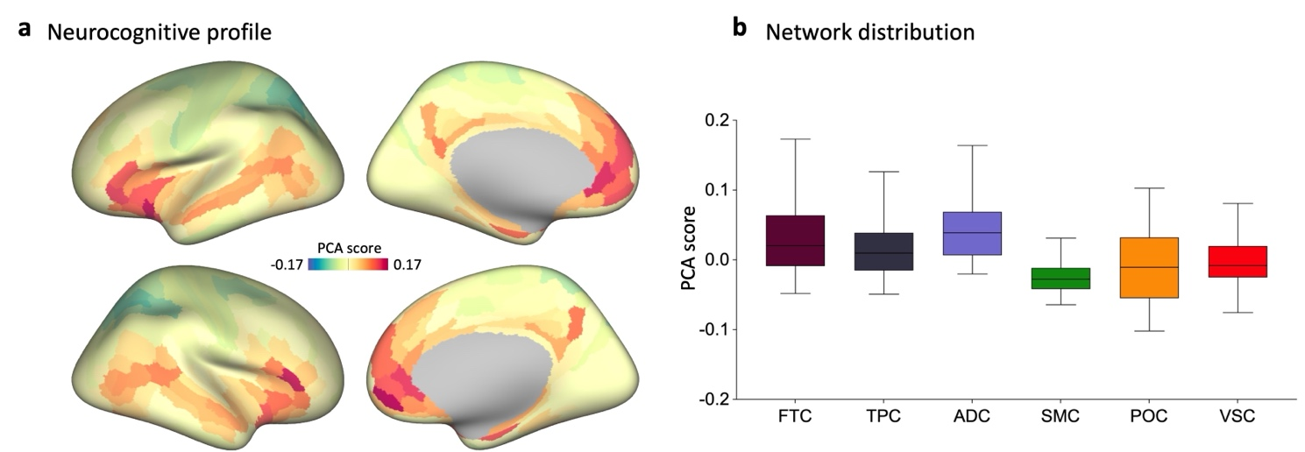
Supplementary Fig. 2 The second neurocognitive profile. a, The second neurocognitive profile demonstrates higher PCA scores in the FTC, TPC, and posterior cingulate cortex while exhibiting lower PCA scores in the SMC, POC, and VSC. b, The network distribution of the second neurocognitive profile. FTC, frontal cortex; TPC, temporal cortex; ADC, auditory cortex; SMC, sensorimotor cortex; POC, posterior cortex; VSC, visual cortex.

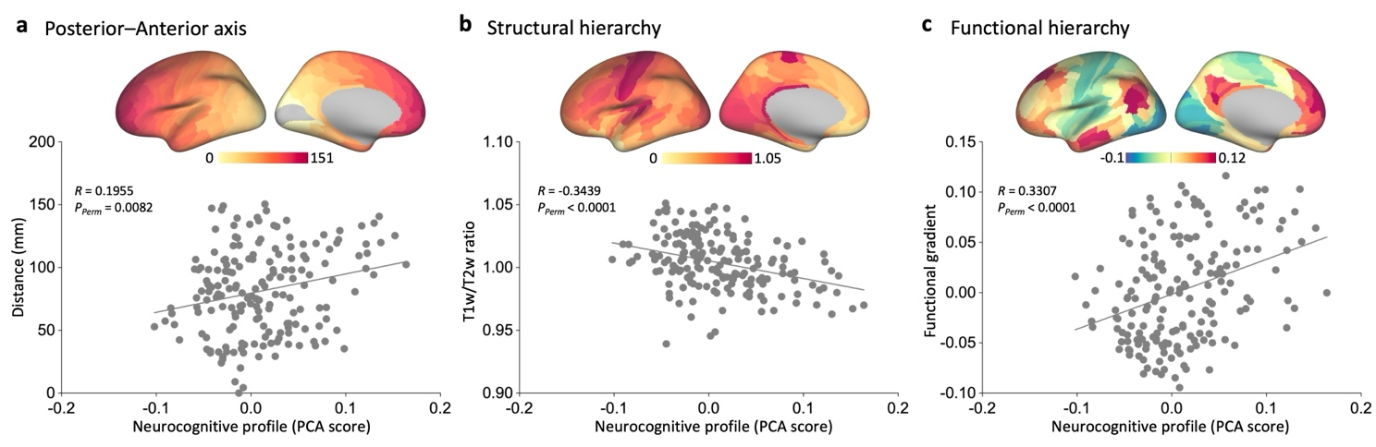
Supplementary Fig. 3 The second neurocognitive profile reflects cortical hierarchical properties. a, The neurocognitive profile reflects the posterior-anterior axis. The spatial correlation was calculated between the neurocognitive profile and geodesic distance (R = 0.1955, P_{Perm} = 0.0082). The geodesic distance was defined as the Euclidean distance between each cortical parcel from the HCP_MMP1.0 atlas and the early visual cortex. b, The neurocognitive profile reflects structural hierarchy. The spatial correlation was calculated between the neurocognitive profile and the T1w/T2w ratio (R = -0.3439, P_{Perm} < 0.0001). The averaged T1w/T2w ratio map of the left hemisphere cortex was averaged from the individual T1w/T2w ratio maps across 1113 subjects from the HCP. c, The neurocognitive profile reflects functional hierarchy. The spatial correlation was calculated between the neurocognitive profile and functional gradient (R = 0.3307, P_{Perm} < 0.0001). We applied the diffusion map embedding on a group-averaged FC matrix computed from the 1,084 HCP participants to generate the functional gradient. The statistical significance of spatial correlation was evaluated using a permutation test with 10000 times. HCP, human connectome project; FC, functional connectivity.

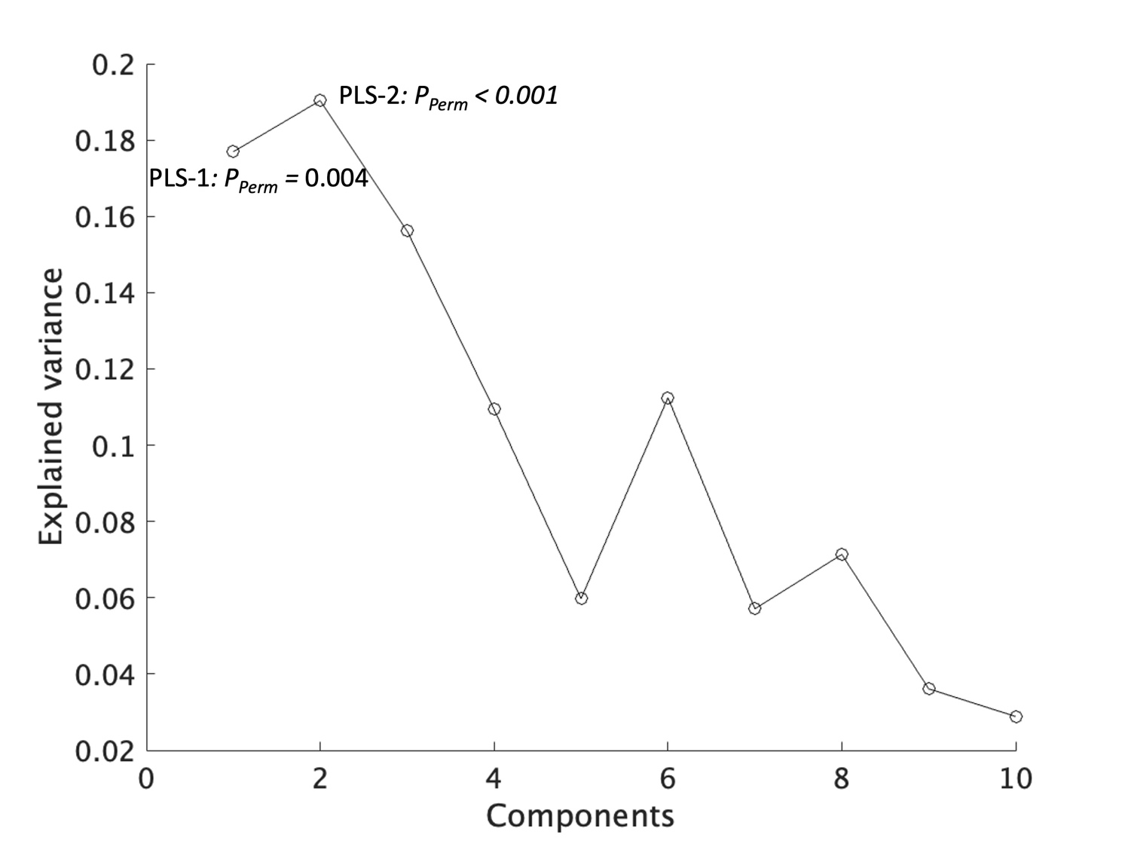
Supplementary Fig. 4 The percentage of variance in the response variables explained by the components in the partial least square regression analysis. The significance level was determined by a permutation test (N = 10,000) with spatial autocorrelation corrected. PLS, partial least squares.

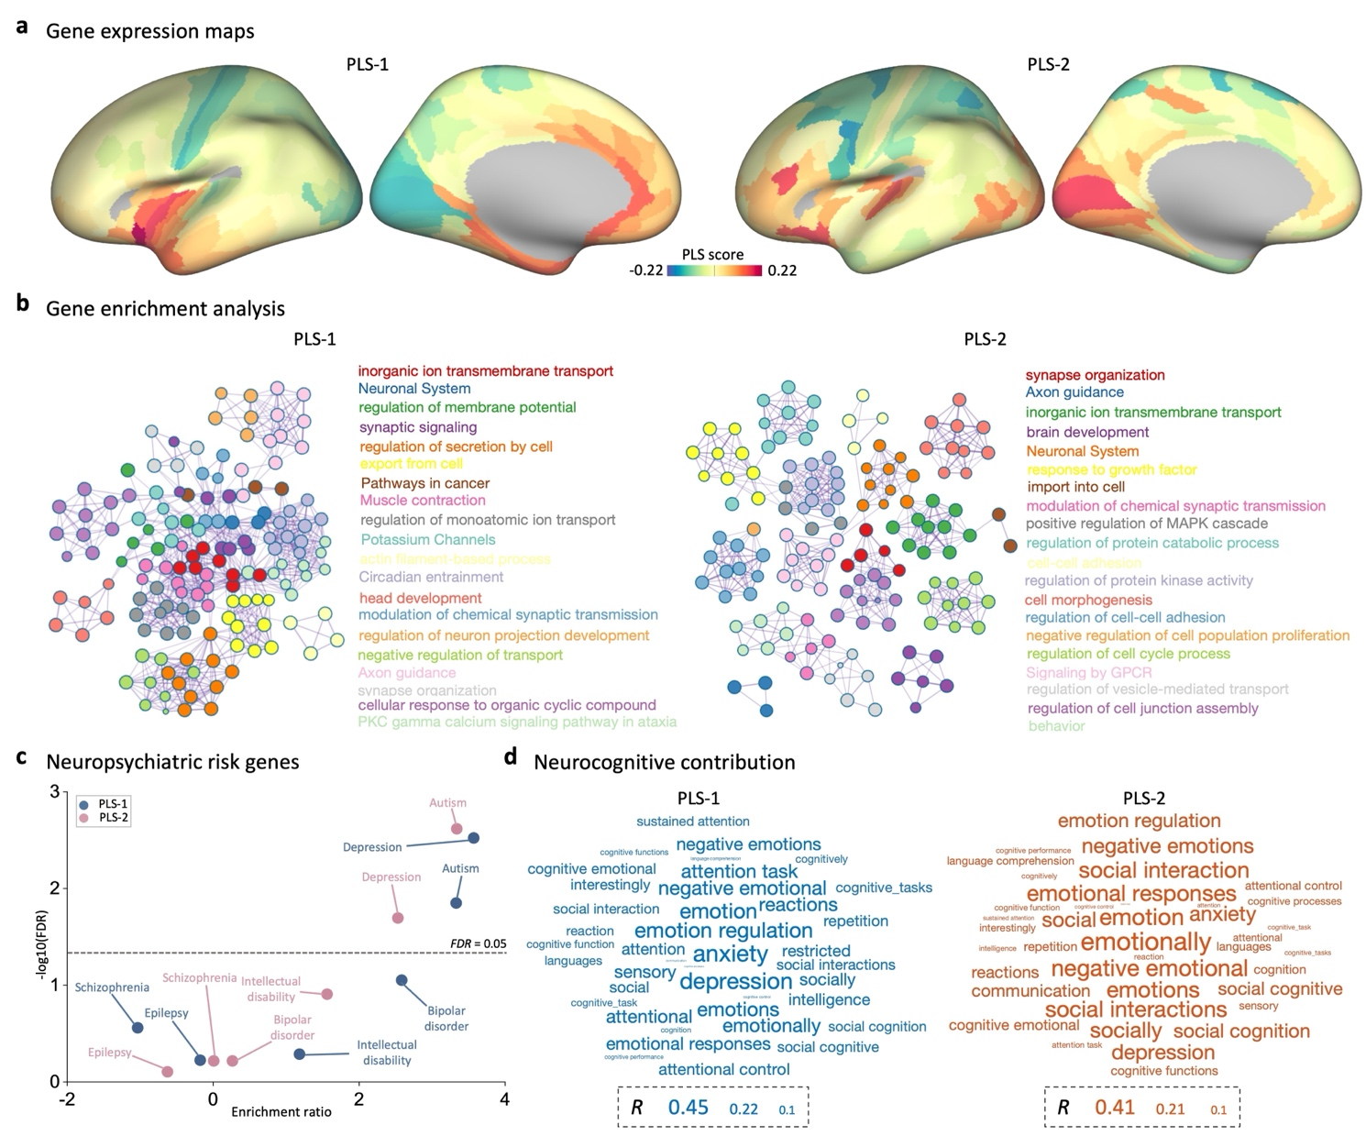
Supplementary Fig. 5 Associations between second neurocognitive profile and gene expression. a, Gene expression map derived based on the local maximum correlation. The color scale indicates the score for PLS-1 and PLS-2, namely, the weighted average expression level of 10027. b, Enrichment network showing the intra- and intercluster similarities of enriched annotations. Each term is represented by a node, where its size represents the number of input genes included in that term, and its color represents its cluster identity. c, Specific analysis. Both PLS-1 and PLS-2 are enriched for risk genes of ASD and depression. A bootstrapped permutation test (N = 10000) was used to evaluate the significance of the observed ER, followed by FDR correction for multiple comparisons. The dotted line indicates FDR = 0.05. ER, enrichment ratio, FDR, false discovery rate. d, Neurocognitive terms contribute to the weighted gene expression of PLS-1 and PLS-2. The contribution of each neurocognitive term to weighted gene expression of PLS components was calculated as the Pearson correlation between the term’s functional association map and PLS score. The font size of a given cognitive term corresponds to the correlation coefficient between the term’s functional association map and PLS score.
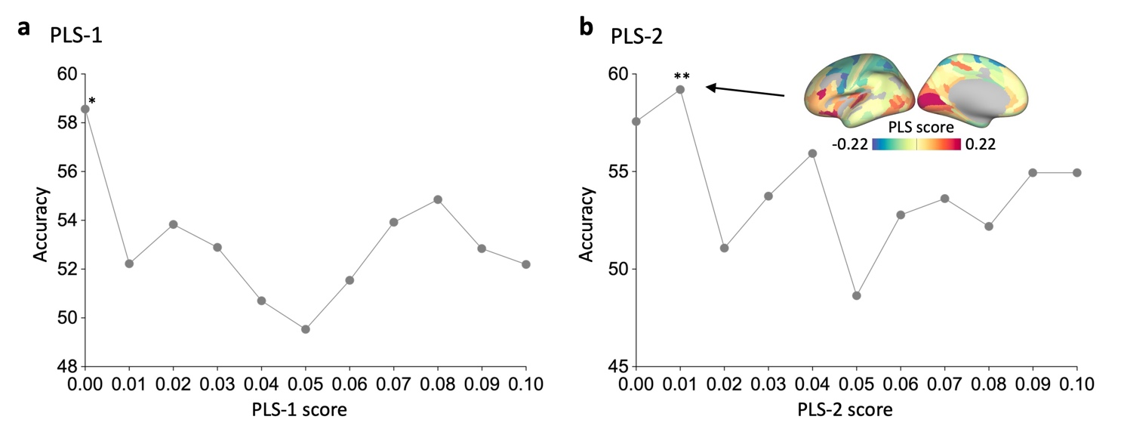
Supplementary Fig. 6 Identifying topographic networks of phenotypic heterogeneity in ASD for the second neurocognitive profile. a, The SVM classification accuracy of PLS-1. b, The SVM classification accuracy of PLS-2. We set a range of thresholds (from 0 to |0.1|) with a step of 0.01 for the PLS score to identify the topographic networks of phenotypic heterogeneity in ASD. We began by applying a threshold to the PLS scores, which allowed us to generate a topographic network. Based on the topographic network, the functional features that are ReHo calculated from a large-scare fMRI dataset of ASD. Finally, these features feed into the SVM classification model for distinguishing ASD patients from healthy controls. *, P < 0.05; **, P < 0.01.

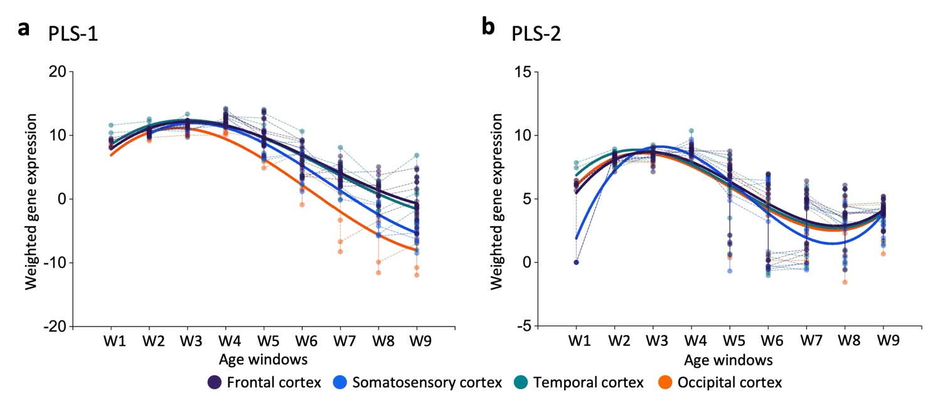
Supplementary Fig. 7 Developmental spatiotemporal trajectory of gene-neurocognition for the second neurocognitive profile. a, The spatiotemporal trajectory of PLS-1. b, The spatiotemporal trajectory of PLS-2. Dots represent cortical samples at a given time point color-coded by lobes; The colored lines are the third-order polynomial regression across the time window, thereby showing the overall trajectory.

Supplementary Table 1 Specific terms are related to phenotypic heterogeneity in ASD
Terms | anxiety, attention task, attention, attentional control, attentional, cognition, cognitive control, cognitive emotional, cognitive function, cognitive functions, cognitive performance, cognitive processes, cognitive_task, cognitive_tasks, cognitively, communication, depression, emotion regulation, emotion, emotional responses, emotionally, emotions, intelligence, interestingly, language comprehension, languages, negative emotional, negative emotions, reaction, reactions, repetition, restricted, sensory, social cognition, social cognitive, social interaction, social interactions, social, socially, sustained attention

