eTable 1. Modified Healthy Lifestyle Score component definitions
Healthy lifestyle factor | Definition | Self-reported UK Biobank field identifier
No current smoking | Smoking status was defined as current or no current smoking (previous and never). | 20116
Regular physical activity | ≥ 150 minutes moderate-to-vigorous activity or ≥ 75 minutes vigorous activity per week;  OR ≥ 5 days moderate activity or ≥ 1 day vigorous activity a week. | 884, 894, 904, 914, 22038, 22039
Moderate alcohol  consumption | Alcohol consumption  Women: >0 and ≤ 14g/day  Men: >0 and ≤ 28g/day | 20117, 1558, 1568, 1578, 1588, 1598, 1608, 5364, 4407, 4418, 4429, 4440, 4451, 4462
Healthy diet | Healthy diet patterns were adapted from the American Heart Association Guidelines.  At least 2 of the following 3 healthy food groups:  1. Total fruit and vegetable intake: ≥ 4.5 pieces or servings per day. 3 tablespoons of vegetables were considered one serving  2. Total fish intake: ≥ 2 times per week  3. Meat intake: < 2 times intake of processed meat AND < 5 times intake of red meat per week | 1309, 1319, 1289, 1299, 1329, 1339, 1349, 1369, 1379, 1389
Healthy body mass index | > 18.5 and ≤ 30 kg/m² | 21001
Healthy sleep | At least 3 of the following 5 healthy sleep factors:  1. Chronotype preference: definitely a “morning” person OR more a “morning” than “evening” person  2. Sleep duration: 7–8h/day  3. Insomnia symptoms: never/rarely  4. Information on snoring: no  5. Daytime sleepiness: never/rarely OR sometimes | 1160, 1180, 1200, 1210, 1220

eTable 2. Sources of information for outcomes in UK Biobank
 | ICD-10 diagnosis | Self-report*
Type 2 Diabetes | E11, E12, E13, E14 | 1223
Coronary Heart Disease | I20, I21, I22, I23, I24, I25 | 1066
Ischemic Stroke | I63 | 1081
Hemorrhagic Stroke | I60, I61, I62 | 1081
Other and unspecified Stroke | I67, I68 | 1081
ICD, International Classification of Disease.
*Numbers refer to data codes used in UK Biobank Field 20002.

eTable 3. Associations between components of the modified Healthy Lifestyle Score and cardiometabolic outcomes
 |  | CMM |  |  | CMDs
 |  | 0 | 1 | p | 0 | 1 | p
Sleep | Cases (person-years) | 4,520 (35,889) | 8,868 (73,155) |  | 16,063 (114,007) | 38,318 (281,971)
 | Model 0* | Reference | 0.94 (0.90-0.97) | <0.001 | Reference | 0.94 (0.92-0.96) | <0.001
 | Model 1† | Reference | 0.94 (0.91-0.97) | <0.001 | Reference | 0.94 (0.92-0.95) | <0.001
 | Model 2‡ | Reference | 0.95 (0.92-0.99) | 0.008 | Reference | 0.95 (0.93-0.96) | <0.001
Diet | Cases (person-years) | 7,281 (59,340) | 6,107 (49,703) |  | 29,332 (212,195) | 25,049 (183,783)
 | Model 0* | Reference | 1.00 (0.96-1.03) | 0.903 | Reference | 0.98 (0.97-1.00) | 0.037
 | Model 1† | Reference | 0.99 (0.96-1.03) | 0.594 | Reference | 0.98 (0.96-0.99) | 0.005
 | Model 2‡ | Reference | 0.99 (0.95-1.02) | 0.405 | Reference | 0.97 (0.96-0.99) | 0.002
Smoking | Cases (person-years) | 1,909 (15,589) | 11,479 (93,454) |  | 7,090 (51,257) | 47,291 (344,721)
 | Model 0* | Reference | 1.02 (0.98-1.07) | 0.346 | Reference | 1.00 (0.98-1.03) | 0.953
 | Model 1† | Reference | 1.00 (0.95-1.05) | 0.940 | Reference | 0.97 (0.95-1.00) | 0.023
 | Model 2‡ | Reference | 0.99 (0.94-1.04) | 0.621 | Reference | 0.97 (0.95-1.00) | 0.030
Alcohol consumption | Cases (person-years) | 7,439 (60,408) | 5,949 (48,636) |  | 28,845 (210,588) | 25,536 (185,390)
 | Model 0* | Reference | 1.01 (0.97-1.04) | 0.654 | Reference | 1.04 (1.03-1.06) | <0.001
 | Model 1† | Reference | 0.94 (0.90-0.97) | <0.001 | Reference | 0.98 (0.96-1.00) | 0.014
 | Model 2‡ | Reference | 0.95 (0.92-0.98) | 0.003 | Reference | 0.99 (0.97-1.01) | 0.184
BMI | Cases (person-years) | 6,487 (50,841) | 6,901 (58,202) |  | 20,187 (140,654) | 34,194 (255,324)
 | Model 0* | Reference | 0.88 (0.85-0.91) | <0.001 | Reference | 0.89 (0.87-0.90) | <0.001
 | Model 1† | Reference | 0.88 (0.85-0.91) | <0.001 | Reference | 0.87 (0.86-0.89) | <0.001
 | Model 2‡ | Reference | 0.90 (0.87-0.94) | <0.001 | Reference | 0.91 (0.89-0.92) | <0.001
Physical activity | Cases (person-years) | 4,170 (32,828) | 9,218 (76,216) |  | 14,484 (102,255) | 39,897 (293,723)
 | Model 0* | Reference | 0.91 (0.88-0.94) | <0.001 | Reference | 0.93 (0.91-0.95) | <0.001
 | Model 1† | Reference | 0.91 (0.87-0.94) | <0.001 | Reference | 0.92 (0.91-0.94) | <0.001
 | Model 2‡ | Reference | 0.93 (0.89-0.96) | <0.001 | Reference | 0.94 (0.92-0.96) | <0.001
*Model 0: Cox proportional regression without adjustment.
†Model 1: Cox proportional regression adjusted for age, sex, race, and recruitment assessment center.
‡Model 2: Cox proportional regression adjusted for Model 1, socioeconomic status, education, family history of cardiometabolic multimorbidity, and medication history.
Cardiometabolic diseases refer to the presence of at least one of the following conditions: type 2 diabetes, coronary heart disease, or stroke.

eTable 4. Associations between the genetic risk score and cardiometabolic outcomes
 | Genetic risk score |  |  |  |  | p-trend | Per unit of index
 | Low (≤3) |  | Intermediate (4-6) |  | High (≥7) | p-trend | Per unit of index
Cardiometabolic multimorbidity
Cases (person-years) | 540 (4,335) |  | 7,698 (62,685) |  | 4,851 (39,719)
Model 0* | Reference |  | 0.92 (0.84-1.01) |  | 0.90 (0.83-0.99) | 0.062 | 0.97 (0.94-1.00)
Model 1† | Reference |  | 0.93 (0.85-1.02) |  | 0.93 (0.85-1.02) | 0.366 | 0.99 (0.95-1.02)
Model 2‡ | Reference |  | 0.94 (0.86-1.03) |  | 0.93 (0.85-1.02) | 0.271 | 0.98 (0.95-1.01)
Cardiometabolic diseases
Cases (person-years) | 2,157 (15,864) |  | 31,273 (228,456) |  | 19,819 (143,481)
Model 0* | Reference |  | 0.99 (0.95-1.04) |  | 1.01 (0.96-1.05) | 0.127 | 1.01 (1.00-1.03)
Model 1† | Reference |  | 1.01 (0.96-1.05) |  | 1.03 (0.98-1.07) | 0.033 | 1.02 (1.00-1.03)
Model 2‡ | Reference |  | 1.01 (0.97-1.06) |  | 1.03 (0.99-1.08) | 0.025 | 1.02 (1.00-1.03)
*Model 0: Cox proportional regression without adjustment.
†Model 1: Cox proportional regression adjusted for age, sex, race, and recruitment assessment center.
‡Model 2: Cox proportional regression adjusted for Model 1, socioeconomic status, education, family history of cardiometabolic multimorbidity, and medication history.
Cardiometabolic diseases refer to the presence of at least one of the following conditions: type 2 diabetes, coronary heart disease, or stroke.

eTable 5. Subgroup analysis for the associations between the modified Healthy Lifestyle Score and Cardiometabolic Outcomes
 | Cardiometabolic Multimorbidity |  |  | Cardiometabolic Diseases
 | Cases(person-years) | HR (95%CI) | p for interaction | Cases (person-years) | HR (95%CI) | p for interaction
Age
<65 | 8,030 (66,144) | 0.96 (0.94-0.98) | 0.968 | 37,560 (278,123) | 0.97 (0.96-0.98) | 0.040
≥65 | 5,358 (42,900) | 0.96 (0.94-0.98) |  | 16,821 (117,855) | 0.96 (0.95-0.97)
Sex
female | 4,530 (38,341) | 0.93 (0.91-0.96) | 0.080 | 22,712 (171,417) | 0.95 (0.94-0.96) | 0.006
male | 8,858 (70,703) | 0.96 (0.94-0.97) |  | 31,669 (224,561) | 0.96 (0.95-0.97)
Race
white British | 11,623 (95,259) | 0.95 (0.94-0.97) | 0.283 | 48,148 (351,943) | 0.96 (0.96-0.97) | 0.830
non-white British | 1,765 (13,784) | 0.97 (0.93-1.01) |  | 6,233 (44,034) | 0.96 (0.94-0.98)
Education
others | 10,544 (85,448) | 0.95 (0.94-0.97) | 0.130 | 40,234 (291,027) | 0.96 (0.96-0.97) | 0.798
higher education | 2,844 (23,595) | 0.97 (0.94-1.00) |  | 14,147 (104,951) | 0.96 (0.95-0.97)
Family history of CMM
without | 10,383 (85,334) | 0.95 (0.94-0.97) | 0.651 | 44,340 (325,024) | 0.96 (0.95-0.97) | 0.253
with | 3,005 (23,709) | 0.95 (0.92-0.98) |  | 10,041 (70,954) | 0.97 (0.95-0.98)
Abbreviations: CMM, Cardiometabolic multimorbidity; HR, hazard ratio; CI, confidence interval.
All HRs (95% CIs) were adjusted for age, sex, race, recruitment assessment center, socioeconomic status, education, family history of cardiometabolic multimorbidity, and medication history.
*Higher education refers to a college/university degree or other professional qualification.
Cardiometabolic diseases refer to the presence of at least one of the following conditions: type 2 diabetes, coronary heart disease, or stroke.

eTable 6.1. Associations between the modified healthy lifestyle score and cardiometabolic outcomes after further adjusting for body mass index.
 | Modified Healthy Lifestyle Score
 | 0-1 | 2 | 3 | 4 | 5 | 6 | p-trend | Per unit of index
Cardiometabolic multimorbidity
Cases (person-years) | 710 (5,456) | 1,935 (15,096) | 3,336 (26,737) | 3,872 (31,905) | 2,665 (22,414) | 870 (7,436)
Model 3* | Reference | 1.00 (0.92-1.09) | 0.97 (0.89-1.05) | 0.91 (0.84-0.99) | 0.89 (0.82-0.96) | 0.86 (0.78-0.95) | <0.001 | 0.96 (0.95-0.98)
Cardiometabolic diseases
Cases (person-years) | 2,008 (13,703) | 6,078 (42,737) | 12,078 (85,797) | 16,002 (116,969) | 13,186 (98,695) | 5,029 (38,078)
Model 3* | Reference | 0.98 (0.93-1.03) | 0.97 (0.93-1.02) | 0.92 (0.88-0.96) | 0.90 (0.85-0.94) | 0.88 (0.84-0.93) | <0.001 | 0.97 (0.96-0.98)
*Model 3: Cox proportional regression adjusted for Model 2, and body mass index.
Cardiometabolic diseases refer to the presence of at least one of the following conditions: type 2 diabetes, coronary heart disease, or stroke.

eTable 6.2 Associations between the modified healthy lifestyle score and cardiometabolic outcomes after further adjusting for waist-to-hip ratio.
 | Modified Healthy Lifestyle Score
 | 0-1 | 2 | 3 | 4 | 5 | 6 | p-trend | Per unit of index
Cardiometabolic multimorbidity
Cases (person-years) | 710 (5,456) | 1,935 (15,096) | 3,336 (26,737) | 3,872 (31,905) | 2,665 (22,414) | 870 (7,436)
Model 3* | Reference | 1.00 (0.92-1.09) | 0.97 (0.89-1.05) | 0.91 (0.84-0.99) | 0.89 (0.82-0.96) | 0.86 (0.78-0.95) | <0.001 | 0.96 (0.95-0.98)
Cardiometabolic diseases
Cases (person-years) | 2,008 (13,703) | 6,078 (42,737) | 12,078 (85,797) | 16,002 (116,969) | 13,186 (98,695) | 5,029 (38,078)
Model 3* | Reference | 0.98 (0.93-1.03) | 0.97 (0.93-1.02) | 0.92 (0.88-0.96) | 0.90 (0.85-0.94) | 0.88 (0.84-0.93) | <0.001 | 0.97 (0.96-0.98)
*Model 3: Cox proportional regression adjusted for Model 2, and waist-to-hip ratio.
Cardiometabolic diseases refer to the presence of at least one of the following conditions: type 2 diabetes, coronary heart disease, or stroke.

eTable 7. Associations between the modified Healthy Lifestyle Score and Cardiometabolic Outcomes after recategorizing the healthy lifestyle score.
 | Modified Healthy Lifestyle Score
 | 0-2 | 3-4 | 5-6 | p-trend | Per unit of index
Cardiometabolic multimorbidity
Cases (person-years) | 2,645 (20,552) | 7,208 (58,642) | 3,535 (29,850)
Model 0* | Reference | 0.93 (0.89-0.98) | 0.88 (0.83-0.92) | <0.001 | 0.94 (0.91-0.96)
Model 1† | Reference | 0.90 (0.86-0.94) | 0.82 (0.78-0.87) | <0.001 | 0.91 (0.88-0.93)
Model 2‡ | Reference | 0.92 (0.88-0.97) | 0.85 (0.81-0.90) | <0.001 | 0.92 (0.90-0.95)
Cardiometabolic diseases
Cases (person-years) | 8,086 (56,439) | 28,080 (202,765) | 18,215 (136,773)
Model 0* | Reference | 0.96 (0.93-0.98) | 0.91 (0.88-0.93) | <0.001 | 0.95 (0.94-0.96)
Model 1† | Reference | 0.92 (0.90-0.94) | 0.85 (0.83-0.87) | <0.001 | 0.92 (0.91-0.93)
Model 2‡ | Reference | 0.94 (0.92-0.96) | 0.88 (0.86-0.91) | <0.001 | 0.94 (0.93-0.95)
*Model 0: Cox proportional regression without adjustment.
†Model 1: Cox proportional regression adjusted for age, sex, race, and recruitment assessment center.
‡Model 2: Cox proportional regression adjusted for Model 1, socioeconomic status, education, family history of cardiometabolic multimorbidity, and medication history.
Cardiometabolic diseases refer to the presence of at least one of the following conditions: type 2 diabetes, coronary heart disease, or stroke.

eTable 8. Associations between the modified Healthy Lifestyle Score and Cardiometabolic outcomes after excluding incident cases occurred in the first 2 years of follow-up.
 | Modified Healthy Lifestyle Score |  |  |  |  |  | p-trend | Per unit of index
 | 0-1 | 2 | 3 | 4 | 5 | 6 | p-trend | Per unit of index
Cardiometabolic multimorbidity
Cases (person-years) | 630 (5368) | 1,768 (14,931) | 3,046 (26,428) | 3,575 (31,584) | 2,466 (22,202) | 814 (7,374)
Model 0* | Reference | 1.03 (0.94-1.13) | 0.99 (0.91-1.08) | 0.95 (0.87-1.03) | 0.92 (0.84-1.00) | 0.89 (0.80-0.99) | <0.001 | 0.97 (0.95-0.98)
Model 1† | Reference | 0.99 (0.91-1.09) | 0.93 (0.85-1.02) | 0.89 (0.81-0.97) | 0.84 (0.77-0.92) | 0.81 (0.73-0.90) | <0.001 | 0.95 (0.94-0.97)
Model 2‡ | Reference | 0.99 (0.91-1.09) | 0.95 (0.87-1.03) | 0.90 (0.83-0.99) | 0.86 (0.78-0.94) | 0.84 (0.76-0.94) | <0.001 | 0.96 (0.94-0.97)
Cardiometabolic diseases
Cases (person-years) | 1,718 (13,394) | 5,310 (41,913) | 10,604 (84,284) | 14,140 (115,075) | 11,790 (97,233) | 4,533 (37,552)
Model 0* | Reference | 1.00 (0.95-1.05) | 0.99 (0.94-1.04) | 0.94 (0.89-0.99) | 0.92 (0.88-0.97) | 0.92 (0.87-0.97) | <0.001 | 0.98 (0.97-0.98)
Model 1† | Reference | 0.96 (0.91-1.02) | 0.94 (0.90-0.99) | 0.88 (0.83-0.92) | 0.85 (0.81-0.89) | 0.83 (0.79-0.88) | <0.001 | 0.96 (0.95-0.97)
Model 2‡ | Reference | 0.97 (0.92-1.02) | 0.96 (0.91-1.01) | 0.90 (0.85-0.94) | 0.88 (0.83-0.92) | 0.87 (0.82-0.92) | <0.001 | 0.97 (0.96-0.97)
*Model 0: Cox proportional regression without adjustment.
†Model 1: Cox proportional regression adjusted for age, sex, race, and recruitment assessment center.
‡Model 2: Cox proportional regression adjusted for Model 1, socioeconomic status, education, family history of cardiometabolic multimorbidity, and medication history.
Cardiometabolic diseases refer to the presence of at least one of the following conditions: type 2 diabetes, coronary heart disease, or stroke.

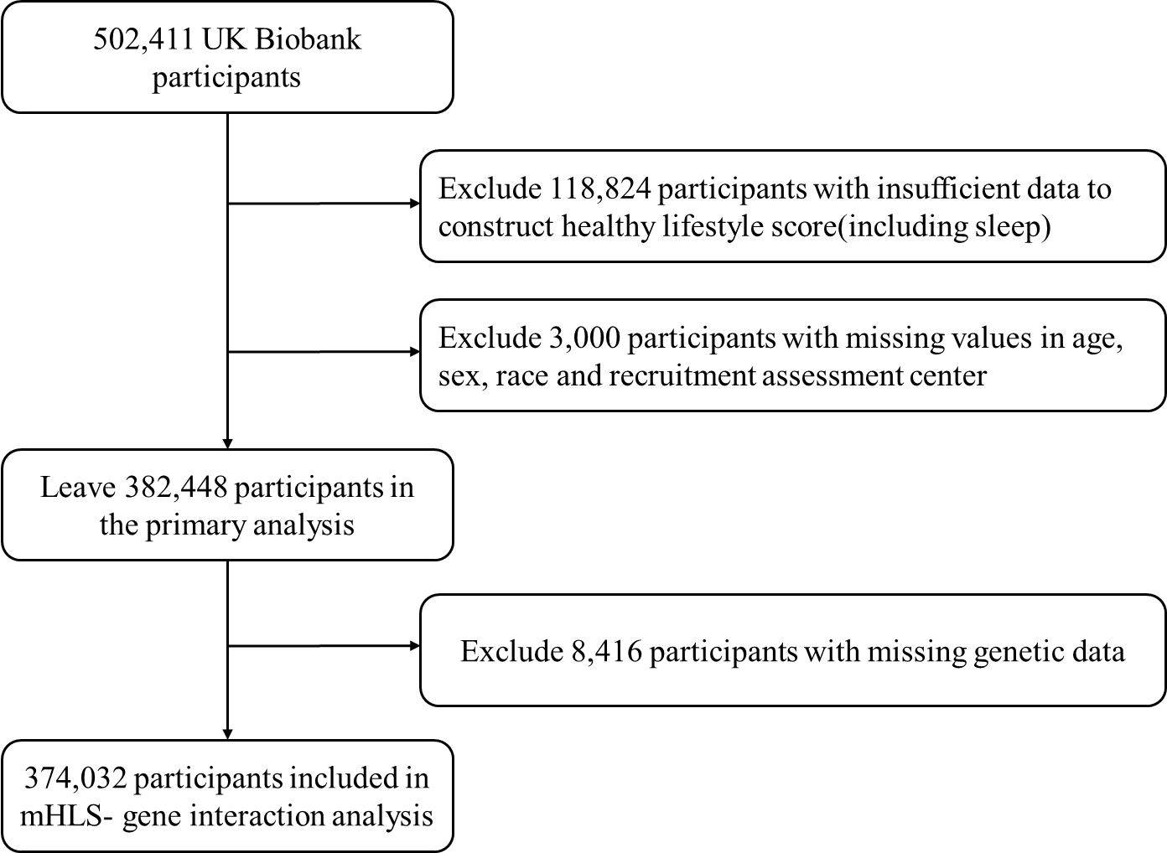

eFigure1. Flow chart of the included UK Biobank participants

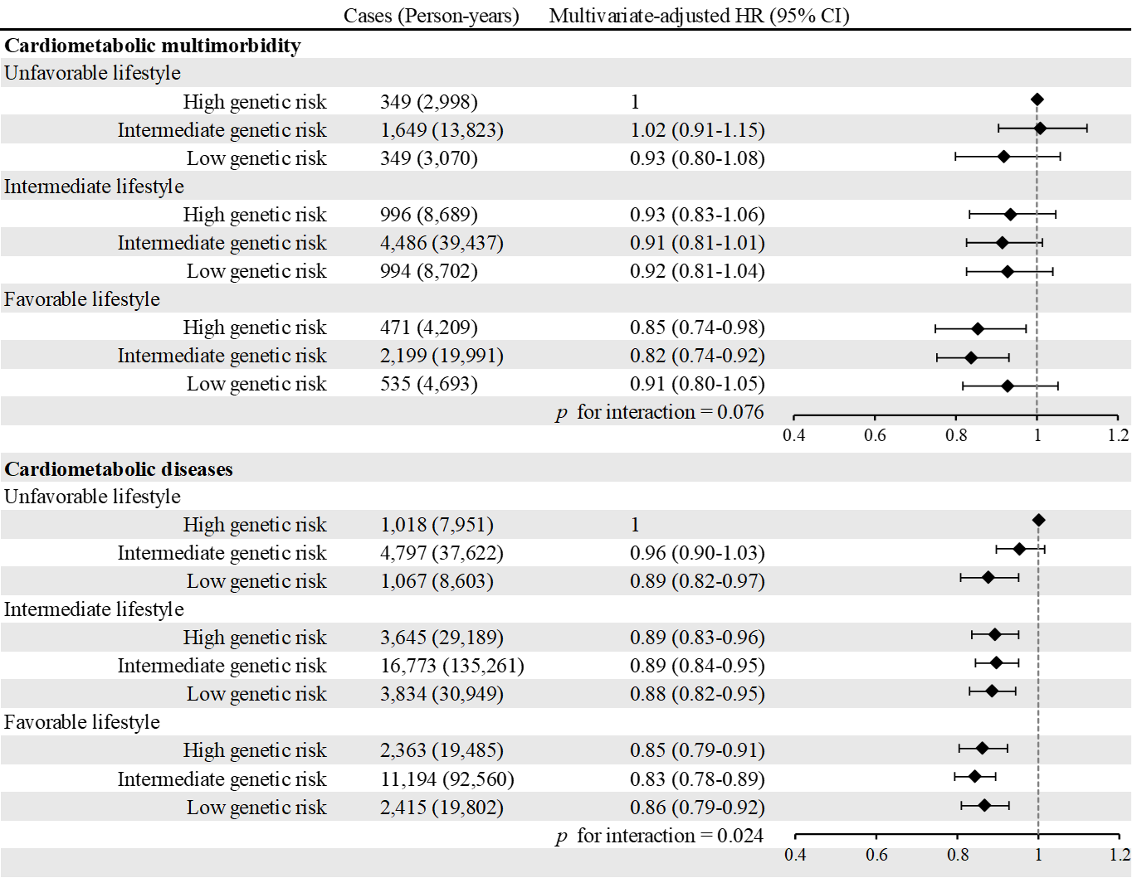

eFigure2. Risk of cardiometabolic outcomes according to the modified Healthy Lifestyle score and genetic risk after excluding incident cases occurred in the first 2 years of follow-up.
Abbreviations: HR, hazard ratio; CI, confidence interval; All HRs (95% CIs) were adjusted for age, sex, race, recruitment assessment center, socioeconomic status, education, family history of cardiometabolic multimorbidity, and medication history.
Cardiometabolic diseases refer to the presence of at least one of the following conditions: type 2 diabetes, coronary heart disease, or stroke.

