Supplementary Information for
Intermediates of Forming Transition Metal Dichalcogenide Heterostructures Revealed by Machine Learning Simulations
Luneng Zhao, Hongsheng Liu, Yuan Chang, Xiaoran Shi, Junfeng Gao, Jijun Zhao, and Feng Ding
Corresponding authors: Junfeng Gao, jfgao@dlut.edu.cn and Feng Ding, gniding@gmail.com

The supplementary materials provide further details to substantiate the findings presented in the main manuscript. We include assessments of the precision of the machine learning potential (MLP) developed for our simulations, extended discussions on the unique intermediate structures identified during transition metal dichalcogenide (TMD) growth, and additional simulation results exploring the kinetics of metal atom embedding and exchange. Lastly, we discuss potential applications of the SMMS intermediate structure in electronic devices.

Validation of MLP Accuracy

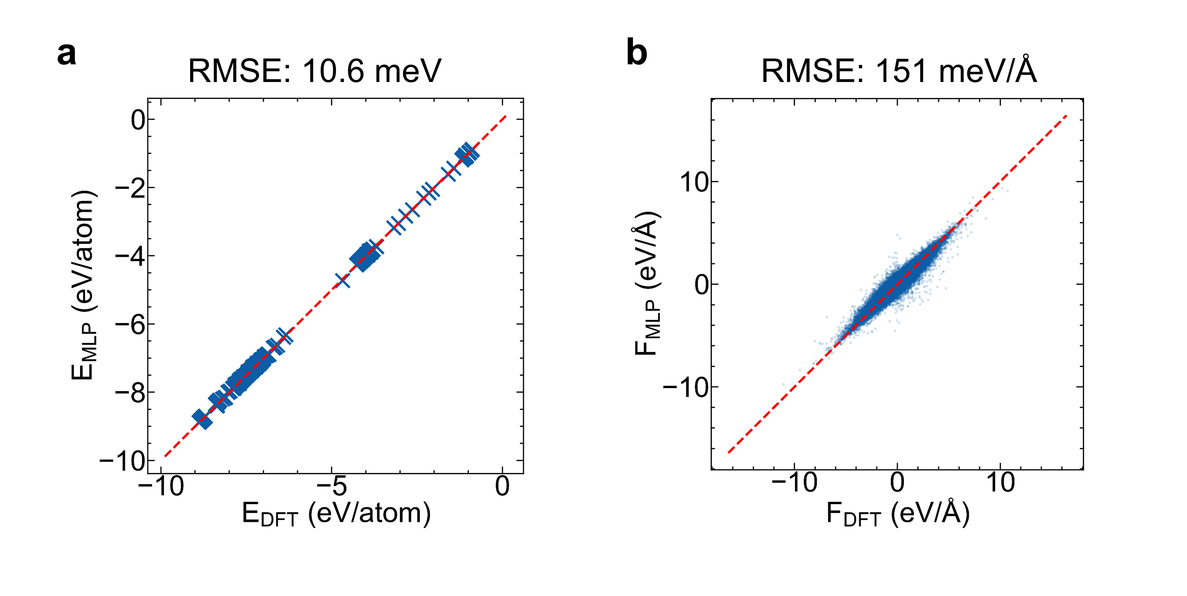

FIG. S1: Comparison of MLP predictions with DFT calculations. (a) Correlation between MLP-predicted energies and DFT-calculated energies per atom. The root mean square error (RMSE) is 10.6 meV/atom. (b) Correlation between MLP-predicted forces and DFT-calculated forces. The RMSE is 151 meV/Å. The red dashed lines represent perfect correlation.
Our MLP model was developed through an iterative active learning process, encompassing 17 cycles of refinement. The initial training set comprised a diverse collection of MoS₂ alloy configurations and metal cluster embeddings, sampled from VASP on-the-fly machine learning molecular dynamics simulations. Throughout the iterations, we continuously enriched the dataset with Monte Carlo generated structures and other relevant configurations. Each iteration involved sampling 100,000 data points, with a 50% probability of including new data to accelerate model optimization. We employed a learning rate of 1e-4 during this process.
To rigorously assess the MLP's accuracy and reliability for simulating TMD heterostructure growth, we reserved 10% of the overall dataset as a test set. FIG. S1 presents a comparison between MLP predictions and DFT calculations. As shown in FIG. S1(a), our model achieves remarkable accuracy in energy prediction, with a RMSE of 10.6 meV per atom [1]. FIG. S1(b) further demonstrates the MLP's high precision in predicting atomic forces, with a RMSE of 151 meV/Å. These outstanding results not only validate the model's accuracy but also establish a solid foundation for subsequent MD simulations. Notably, our MLP outperforms several existing machine learning force fields in key aspects, providing a powerful tool for exploring the intricacies of TMD heterostructure growth mechanisms.

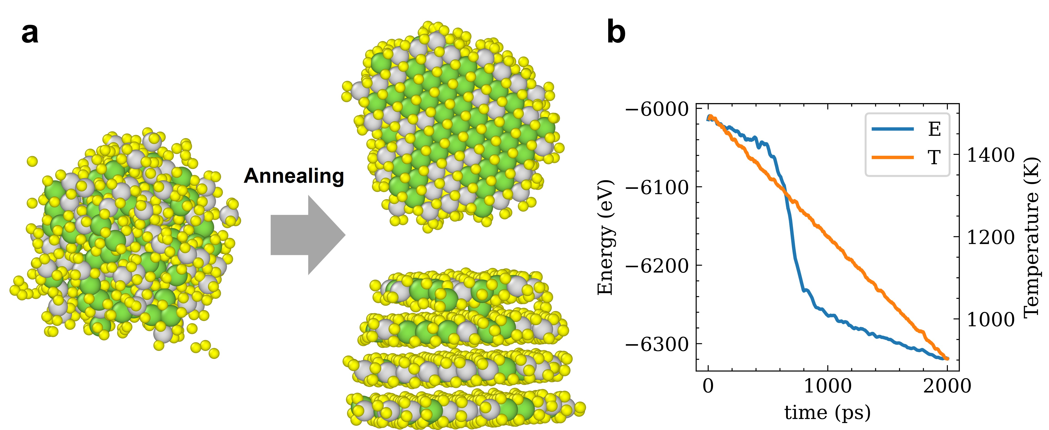

FIG. S2: Formation of ordered TMD layers through annealing simulation. (a) Snapshots depicting the evolution from an initial random mixture of Mo, W, and S atoms (left, ratio 1:1:4) to ordered TMD layers after annealing. (b) Time evolution of system energy (E, blue line) and temperature (T, orange line) during the 2 ns annealing process, illustrating the formation of stable TMD structures. Note: The data has been smoothed using a low-pass filter for clarity.

To validate the MLP's capability in describing growth processes, we conducted simulated annealing experiments. FIG. S2 illustrates the results of these simulations. As shown in FIG. S2(a), we started with a random mixture of Mo, W, and S atoms (left image) and observed their evolution into ordered TMD layers after annealing (right images, showing top and side views). This transformation demonstrates the MLP's ability to accurately capture the self-assembly process of TMD structures.
FIG. S2(b) presents the evolution of the system energy (E, blue line) and temperature (T, orange line) during the 2 ns annealing process. The decreasing energy trend, coupled with temperature fluctuations, indicates the formation of stable TMD structures. It's worth noting that a low-pass filter was applied to smooth the results, enhancing the clarity of the overall trends. These annealing simulations validate our MLP's effectiveness in modeling TMD growth.

Stability Analysis of SMMS Intermediate Structures

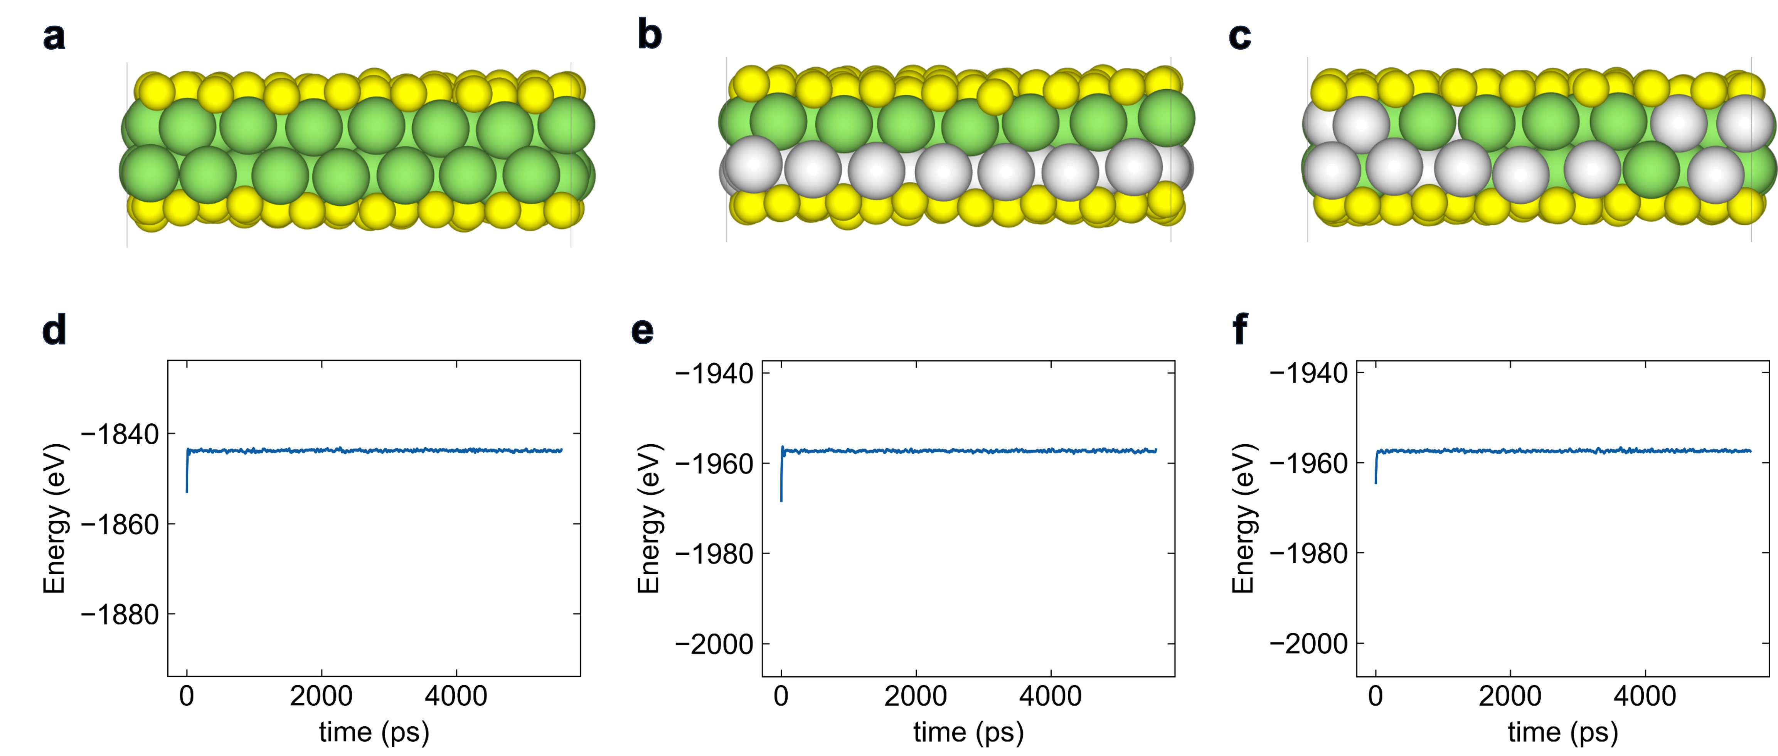

FIG S3: Stability analysis of SMMS intermediate structures. (a-c) Atomic configurations of (a) SMoMoS, (b) SMoWS, and (c) alloyed S(Mo_{0.5}W_{0.5})(W_{0.5}Mo_{0.5})S structures. (d-f) Corresponding energy evolution during 5500ps MLPMD simulations at 1100 K for (d) SMoMoS, (e) SMoWS, and (f) alloyed S(Mo_{0.5}W_{0.5})(W_{0.5}Mo_{0.5})S structures, demonstrating their long-term stability. Note: The data has been smoothed using a low-pass filter for clarity.

To further validate the stability of the key intermediate structures identified in our study, we employed our machine learning potential to conduct NVT molecular dynamics simulations. FIG S3 presents the results of these simulations for three crucial structures: SMoMoS (Fig. S3(a)), SMoWS (Fig. S3(a)), and the alloyed S(Mo_{0.5}W_{0.5})(W_{0.5}Mo_{0.5})S (Fig. S3(a)). The corresponding energy evolution during 5 ns MLPMD simulations at 1100 K is displayed in FIG S3(d-f) for SMoMoS, SMoWS, and the alloyed SMMS structure, respectively. The remarkably stable energy profiles observed for all three structures throughout the extended simulation period provide strong evidence of their long-term stability. This stability persists even at the elevated temperature of 1100 K, which is representative of typical growth conditions for TMD materials.

Validation of the formation of SMoMoS

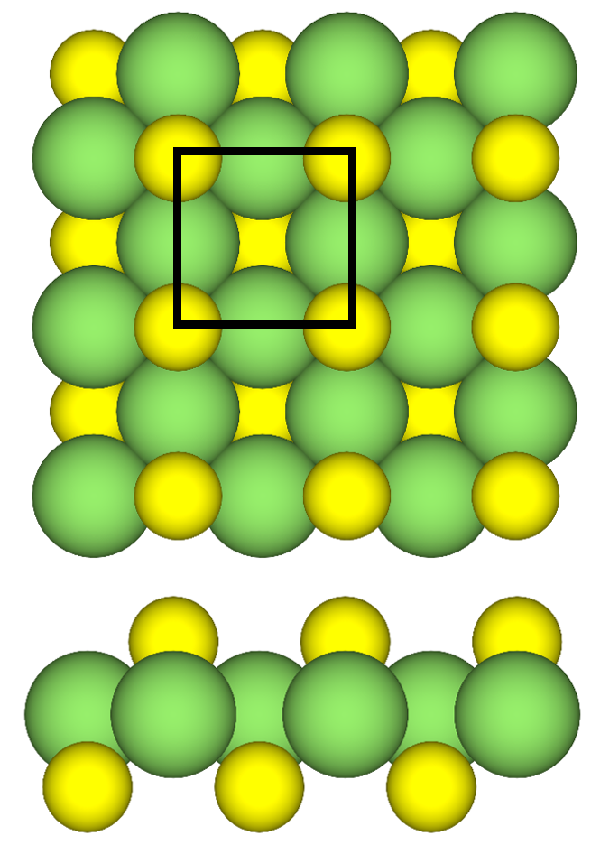
FIG. S4: Structure from MatHub-2d (id:MatHub2d-1817-Mo₂S₂).

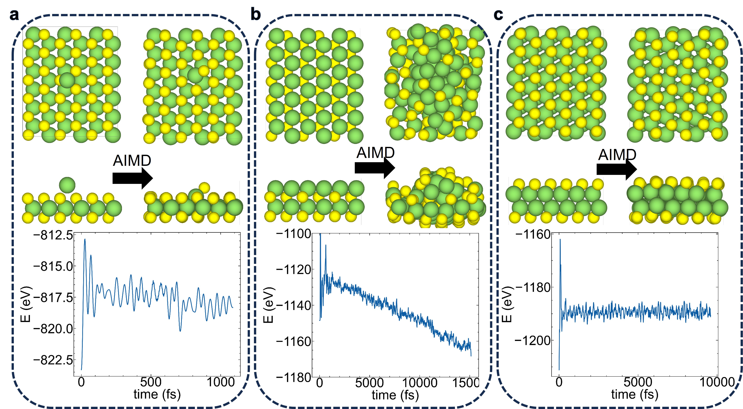
FIG. S5: AIMD simulations validating SMoMoS formation and stability at 1100 K. (a) Single Mo atom embedding into MoS₂ (~1000 fs). Top: Initial and final configurations. Bottom: Energy-time curve showing abrupt decrease at ~700 fs. (b) Mo atom layer embedding into MoS₂(~15 ps). Top: Initial and final states. Bottom: Energy-time curve during embedding process. (c) SMoMoS structure stability(~10 ps). Top: Initial and final states. Bottom: Energy-time curve demonstrating structural stability.

FIG. S5 presents the results of our ab initio molecular dynamics (AIMD) simulations conducted at 1100 K to validate the formation and stability of the SMoMoS structure. These simulations provide crucial insights into the behavior of Mo atoms on MoS₂ surfaces and the formation mechanism of the SMoMoS intermediate structure.
FIG. S5(a) illustrates the embedding process of a single Mo atom into an MoS₂ layer. We initially positioned a Mo atom 2.3 Å above the MoS₂ surface and imparted it with a downward velocity of 5 Å/ps, corresponding to a kinetic energy of approximately 0.12 eV. This energy is comparable to the thermal energy of atoms at 1100 K. To accurately simulate thermal conditions, we sampled the initial velocities of all atoms from a Boltzmann distribution at 1100 K. The simulation was performed using the NVE (constant number of particles, volume, and energy) ensemble to capture the system's natural evolution without external temperature control. The top images show the initial and final atomic configurations, while the bottom graph depicts the energy evolution over time. Despite the relatively low initial kinetic energy, the Mo atom rapidly embeds itself into the MoS₂ layer within approximately 700 fs, as evidenced by the abrupt energy decrease. This embedding process releases about 1.45 eV of energy (validated by DFT calculations), demonstrating a strong thermodynamic driving force for Mo incorporation into the MoS₂ structure.
FIG. S5(b) extends our investigation to the behavior of a Mo atom layer on MoS₂. The simulation runs for approximately 15,000 fs, allowing us to observe the long-term evolution of the system. The top images show the initial configuration with a layer of Mo atoms on the MoS₂ surface, and the final state where multiple Mo atoms have embedded into the MoS₂ layer. The bottom graph illustrates the gradual decrease in system energy as Mo atoms progressively embed into the MoS₂ structure. This energy reduction, significantly lower than the initial configuration, further confirms the thermodynamic favorability of Mo incorporation.
FIG. S5(c) focuses on the stability of the formed SMoMoS structure over an extended period of about 10,000 fs. The top images demonstrate that the SMoMoS structure remains intact throughout the simulation, with no significant structural changes observed. The bottom graph shows a stable energy curve over time, confirming the structural integrity and thermodynamic stability of the SMoMoS intermediate.
These AIMD simulations serve as a robust validation of our Machine Learning Potential (MLP) results, confirming the accuracy and reliability of our MLP in predicting the behavior of Mo atoms on MoS₂ surfaces.

SMMS Intermediate Structures to Bilayer TMDs

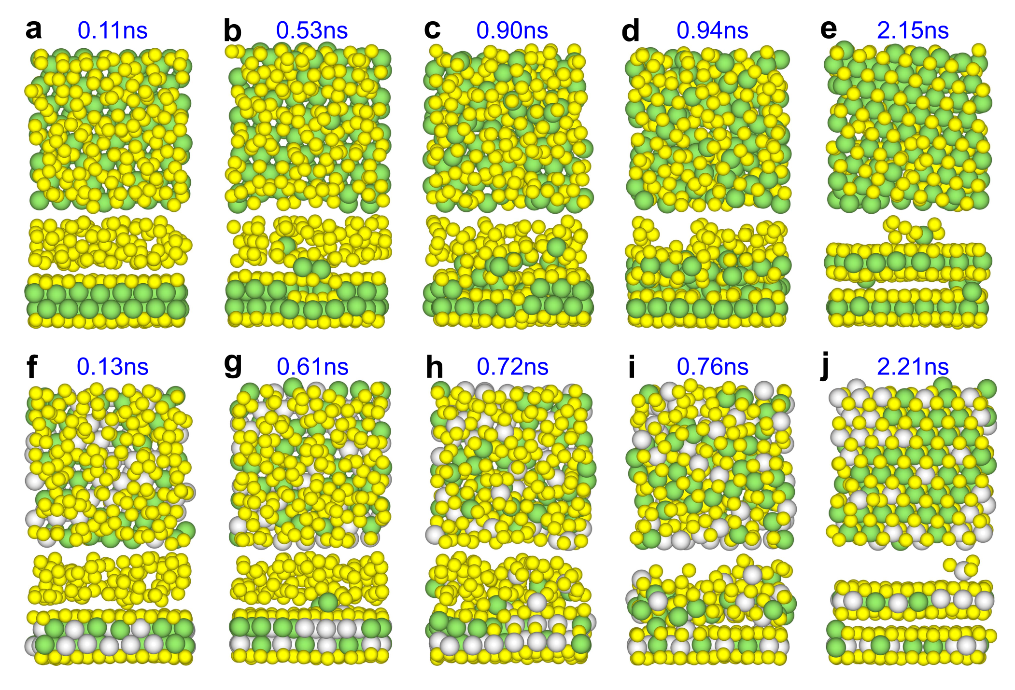

FIG. S6: (a-e) MLPMD simulation of the growth of bilayer MoS₂ structure by depositing S atoms on the SMoMoS intermediate phase. (f-j) MLPMD simulation of the growth of alloyed Mo_{x}W_{1-x}S₂/Mo_{1-x}W_{x}S₂ heterostructure by depositing S atoms on the alloyed SMMS intermediate phase.

Simulation of MOCVD TMDs Growth

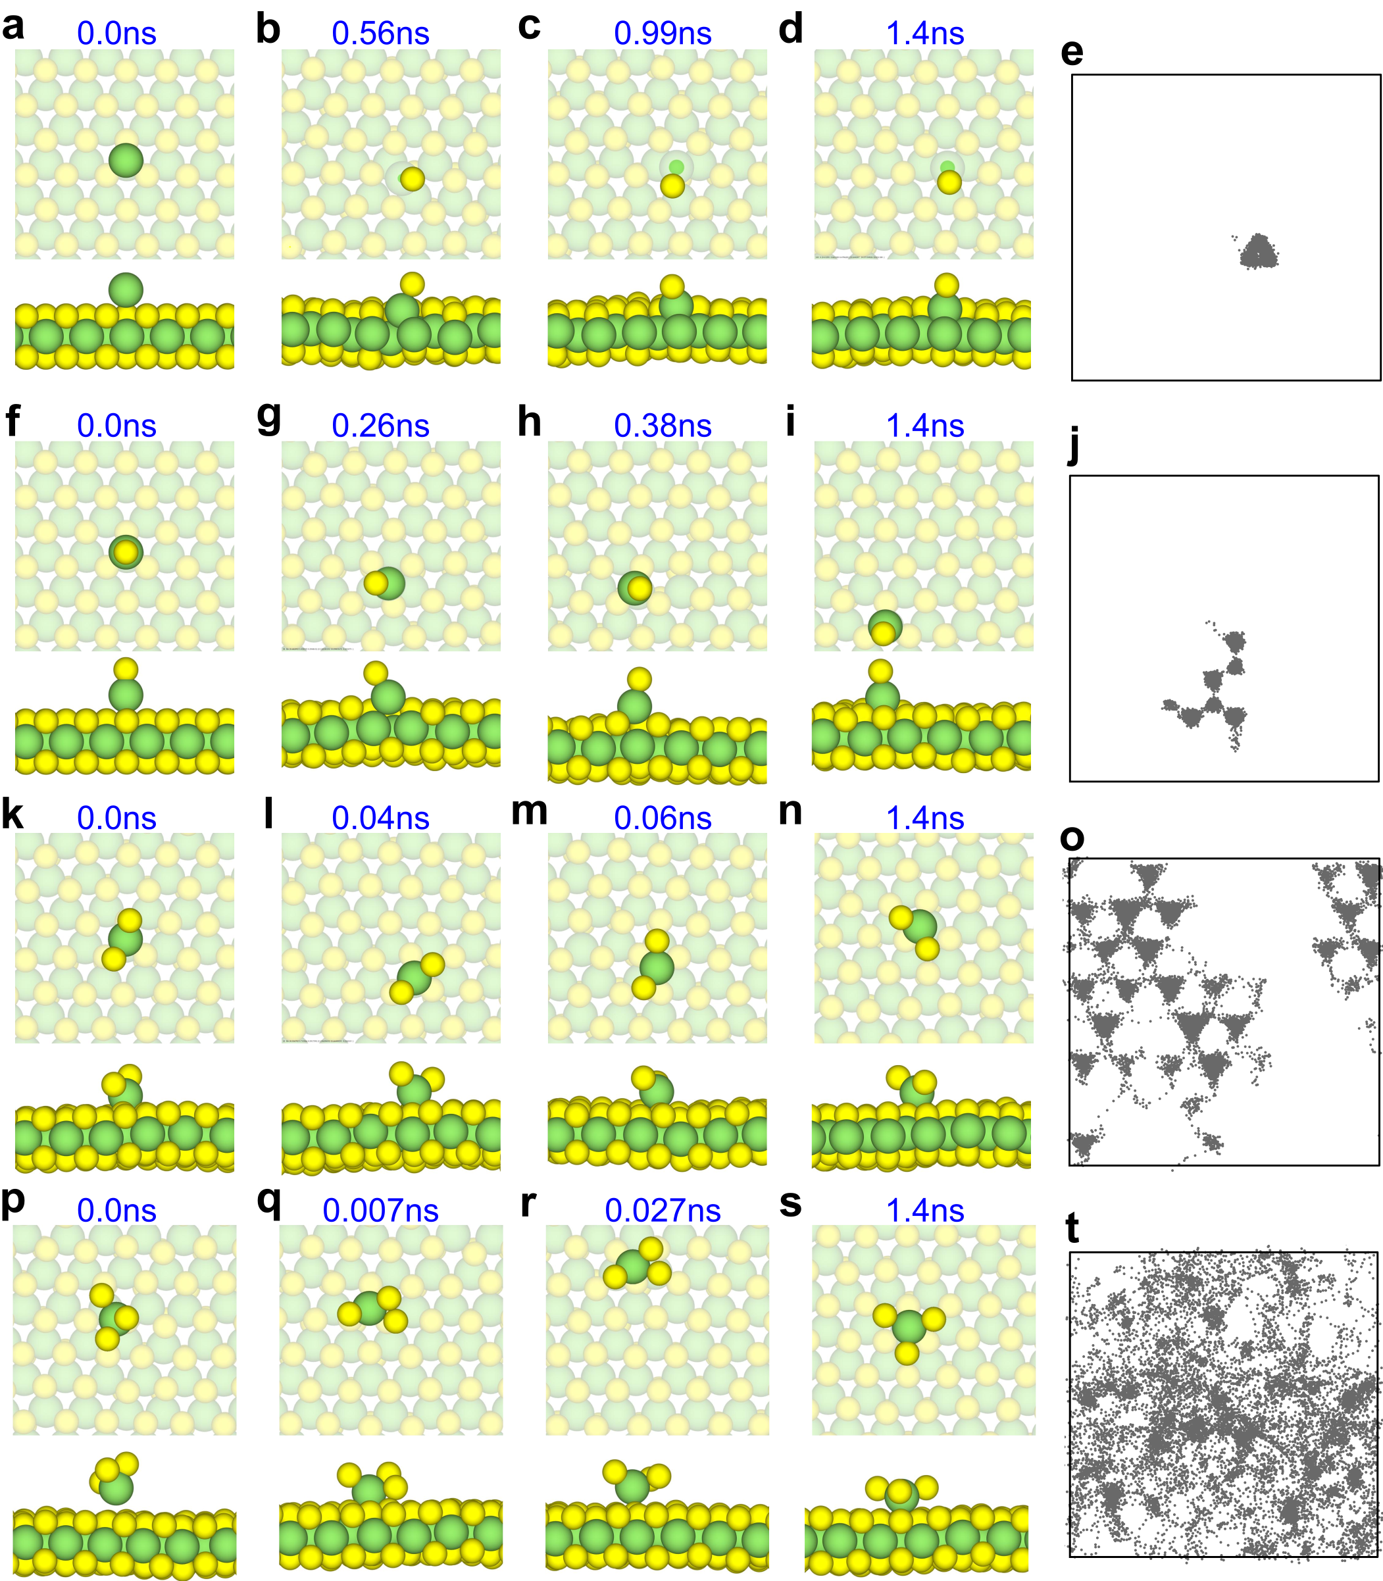
FIG. S7: MLPMD simulations of various Mo-based clusters on MoS₂: (a-d) Single Mo atom deposition; (e) Mo atom trajectory on the xy plane; (f-j) Mo-S cluster; (k-o) Mo-S₂ cluster; (p-t) Mo-S₃ cluster.

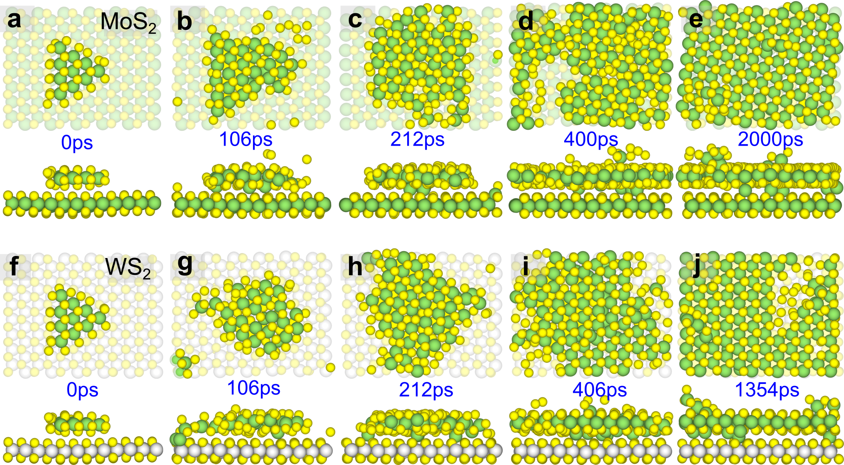
FIG. S8: The growth of the second layer of MoS₂ on MoS₂ and WS₂ monolayer substrates through sequential MD simulations. For the MoS₂ substrate: (a-e). In comparison, for the WS₂ substrate: (f-j).

Electronic Properties of the SMMS Contact with MoS₂
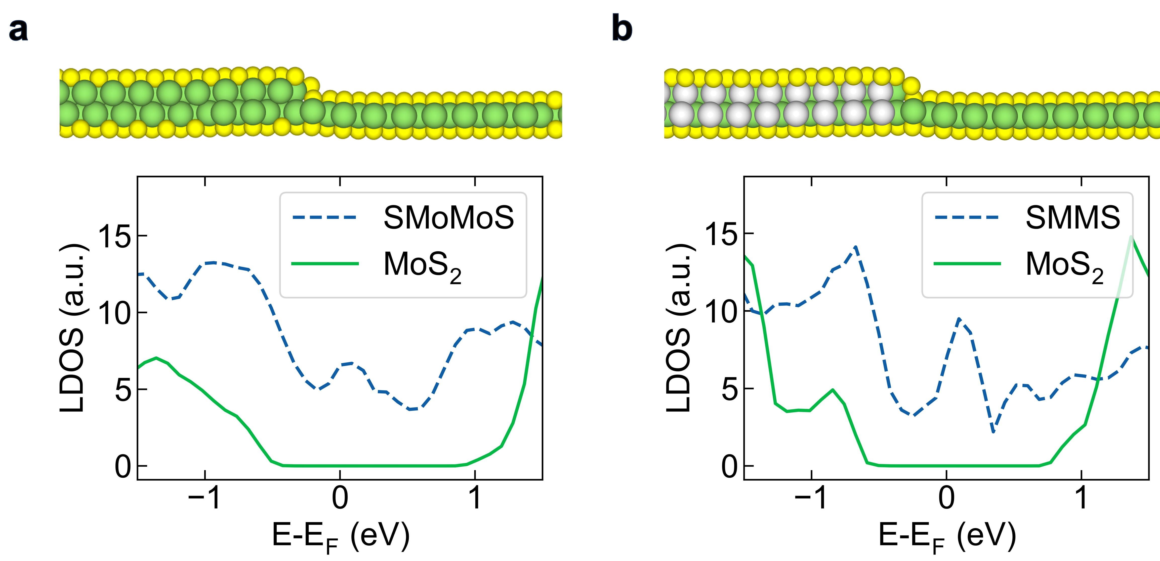
FIG. S9: Local density of states (LDOS) at the interface of TMD heterostructures calculated using PBE functional. (a) LDOS of the SMoMoS-MoS₂ interface. (b) LDOS of the alloyed SMMS-MoS₂ interface. Top panels show the atomic configurations of the interfaces, with yellow spheres representing S atoms, green spheres representing Mo atoms, and white spheres representing W atoms. Bottom panels display the calculated LDOS, where the blue dashed lines represent the LDOS of the intermediate structures (SMoMoS or SMMS), and the green solid lines represent the LDOS of MoS₂. The Fermi level is set to 0 eV.

To investigate the electronic properties and potential applications of the identified intermediate structures, we constructed heterostructures and calculated the p-type Schottky barrier height(SBH) using the PBE functional [2]. Figure S4 presents the local density of states (LDOS) at the interfaces of these TMD heterostructures.
FIG. S9(a) shows the LDOS of the SMoMoS-MoS₂ interface, while FIG. S9(b) displays the LDOS of the alloyed SMMS-MoS₂ interface. The top panels illustrate the atomic configurations of these interfaces, with yellow, green, and white spheres representing S, Mo, and W atoms, respectively. In the bottom panels, the calculated LDOS is presented, where blue dashed lines represent the LDOS of the intermediate structures (SMoMoS or SMMS), and green solid lines represent the LDOS of MoS₂. The Fermi level is set to 0 eV.
Analysis of these LDOS profiles reveals the formation of p-type Schottky barriers at both interfaces. For the SMoMoS-MoS₂ interface (FIG. S9(a)), we estimate a SBH of approximately 0.5 eV. In contrast, the alloyed SMMS-MoS₂ interface (FIG. S9(b)) exhibits a slightly higher barrier of about 0.6 eV. These findings are significant as they suggest that these intermediate structures, particularly SMoMoS, could potentially serve as low-resistance contacts for MoS₂-based electronic devices. The relatively low SBHs indicate favorable charge transport characteristics, which could be advantageous for various applications in nanoelectronics and optoelectronics utilizing TMD heterostructures.

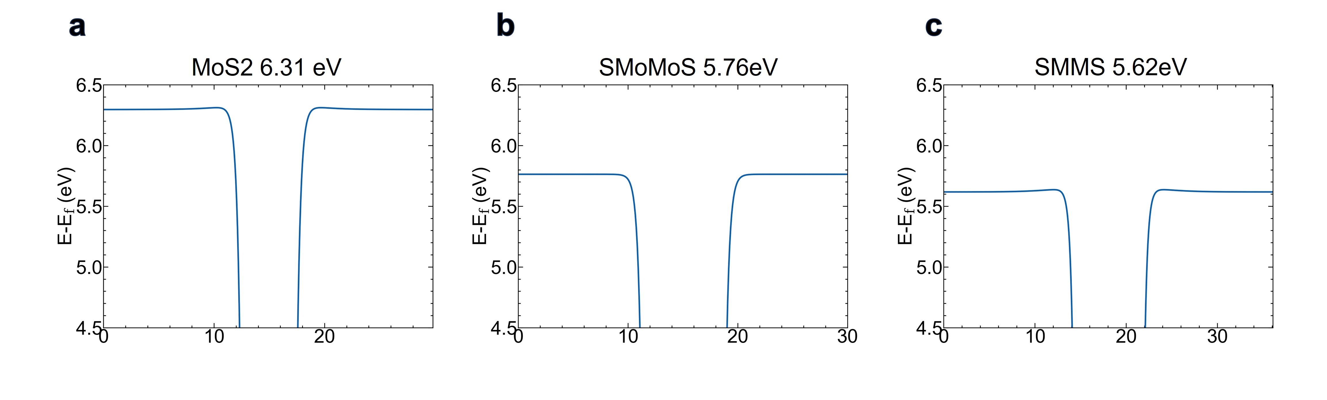

FIG. S10: Work function calculations using HSE06 functional for different structures. (a) MoS₂ monolayer with a ionization energy of 6.31 eV. (b) SMoMoS intermediate structure with a work function of 5.76 eV. (c) Alloyed SMMS structure with a work function of 5.62 eV. The plots show the planar-averaged electrostatic potential as a function of position perpendicular to the layer, demonstrating the potential difference between vacuum level and Fermi level.
To further validate our findings on the electronic properties of the intermediate structures and their potential applications, we performed more accurate work function calculations using the HSE06 functional. FIG. S10 presents these results for different structures. The MoS₂ monolayer exhibits a ionization energy of 6.31 eV (FIG. S10(a)), serving as our reference. The SMoMoS intermediate structure shows a lower work function of 5.76 eV (FIG. S10(b)), while the alloyed SMMS structure has a work function of 5.62 eV (FIG. S10(c)). Using these values, we can calculate the p-type SBH by subtracting the metal-like intermediate structure's work function from that of MoS₂. This yields a SBH of 0.55 eV for the SMoMoS-MoS₂ interface and 0.69 eV for the SMMS-MoS₂ interface. These results align well with our previous LDOS analysis and provide more precise quantification of the barrier heights. The relatively low SBH values, particularly for the SMoMoS-MoS₂ interface, further support the potential of these intermediate structures as favorable electrical contacts in MoS₂-based devices, potentially enabling efficient hole injection or extraction in electronic and optoelectronic applications.

References

[1] J. D. Morrow, J. L. A. Gardner, and V. L. Deringer, How to Validate Machine-Learned Interatomic Potentials, The Journal of Chemical Physics 158, 121501 (2023).
[2] R. T. Tung, The Physics and Chemistry of the Schottky Barrier Height, Applied Physics Reviews 1, 011304 (2014).

