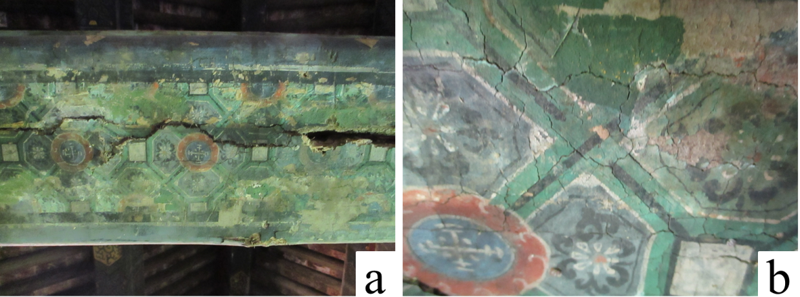
Figure S1. The photos of the colored drawings in the Altar of Agriculture, a) overview of the colored drawings, b) the local of the colored drawings
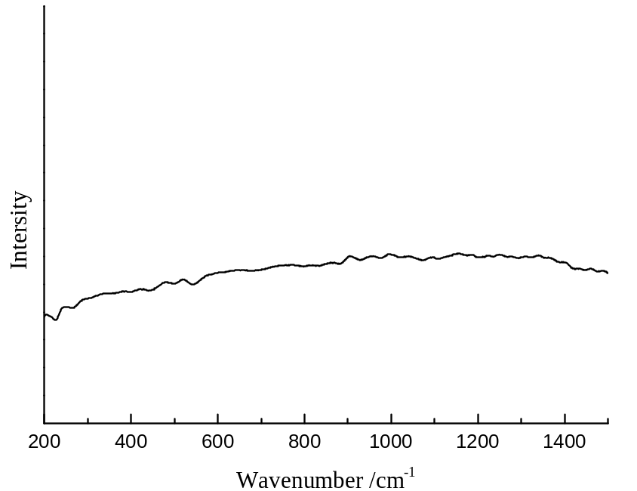
Figure S2 The Raman sptectra of the green area

