Table S1. A two-factor non-parametric statistical analysis of global incidence, prevalence, mortality, and DALYs for HIV co-infected with M/XDR-TB by gender: An analysis from 1990 to 2021.
 |  | F value | p value
HIV and MDR-TB co-infection
prevalence
 | year | 58.258 | 0.002
 | sex | 3.738 | 0.053
incidence
 | year | 61.347 | 0.001
 | sex | 1.183 | 0.277
deaths
 | year | 61.794 | 0.001
 | sex | 0.858 | 0.354
DALYs
 | year | 60.952 | 0.001
 | sex | 1.559 | 0.212
HIV and XDR-TB co-infection
prevalence
 | year | 52.279 | 0.010
 | sex | 7.320 | 0.007
incidence
 | year | 50.280 | 0.016
 | sex | 9.087 | 0.003
deaths
 | year | 50.250 | 0.016
 | sex | 9.339 | 0.002
DALYs
 | year | 51.933 | 0.011
 | sex | 7.989 | 0.005
Note: HIV, Human Immunodeficiency Virus; M/XDR-TB, Multidrug/Extensively Drug-Resistant Tuberculosis; DALYs,Disability-Adjusted Life Years.

Table S2. Global temporal trends of HIV and M/XDR-TB co-infection from 1990 to 2021
Measure |  | Sex | AAPC | 95%CI |  | P
 |  |  |  | Lower CI | Upper CI
MDR-TB
 | ASPR | Both | 9.102 | 8.308 | 9.902 | < 0.001
 |  | Female | 9.556 | 9.041 | 10.074 | < 0.001
 |  | Male | 8.864 | 8.241 | 9.491 | < 0.001
 | ASIR | Both | 9.030 | 8.540 | 9.522 | < 0.001
 |  | Female | 9.520 | 8.964 | 10.078 | < 0.001
 |  | Male | 8.499 | 7.995 | 9.005 | < 0.001
 | ASDR | Both | 9.163 | 8.510 | 9.819 | < 0.001
 |  | Female | 9.764 | 8.907 | 10.627 | < 0.001
 |  | Male | 8.630 | 8.121 | 9.141 | < 0.001
 | ASR of DALYs | Both | 9.040 | 8.366 | 9.718 | < 0.001
 |  | Female | 9.548 | 8.677 | 10.427 | < 0.001
 |  | Male | 8.512 | 8.001 | 9.026 | < 0.001
XDR-TB | ASPR | Both | 18.444 | 16.368 | 20.558 | < 0.001
 |  | Female | 19.43 | 16.819 | 22.099 | < 0.001
 |  | Male | 17.84 | 16.055 | 19.653 | < 0.001
 | ASIR | Both | 19.041 | 17.376 | 20.729 | < 0.001
 |  | Female | 20.343 | 17.951 | 22.784 | < 0.001
 |  | Male | 18.377 | 17.118 | 19.649 | < 0.001
 | ASDR | Both | 15.365 | 14.283 | 16.458 | < 0.001
 |  | Female | 16.524 | 15.494 | 17.562 | < 0.001
 |  | Male | 14.613 | 13.555 | 15.682 | < 0.001
 | ASR of DALYs | Both | 41.22 | 35.104 | 47.613 | < 0.001
 |  | Female | 42.246 | 36.314 | 48.437 | < 0.001
 |  | Male | 40.572 | 34.39 | 47.039 | < 0.001
Note: AAPC, Average annual percent change; CI, Confidence interval; ASPR, age-standardized prevalence rate; ASIR, age-standardized incidence rate; ASDR, age-standardized deaths rate; ASR, age-standardized rate; M/XDR-TB, Multidrug/Extensively Drug-Resistant Tuberculosis; DALYs,Disability-Adjusted Life Years.

Table S3. Temporal trends of HIV and DR-TB co-infection across SDI quintiles from 1990 to 2021
Measure |  | Sex | AAPC | 95%CI |  | P
 |  |  |  | Lower CI | Upper CI
MDR-TB | ASPR
 |  | High SDI | -2.547 | -2.770 | -2.322 | < 0.001
 |  | High-middle SDI | 8.666 | 7.986 | 9.349 | < 0.001
 |  | Middle SDI | 10.157 | 9.598 | 10.718 | < 0.001
 |  | Low-middle SDI | 9.897 | 8.993 | 10.809 | < 0.001
 |  | Low SDI | 7.443 | 6.370 | 8.527 | < 0.001
 | ASIR
 |  | High SDI | -3.163 | -3.793 | -2.529 | < 0.001
 |  | High-middle SDI | 9.111 | 8.032 | 10.202 | < 0.001
 |  | Middle SDI | 9.283 | 8.520 | 10.051 | < 0.001
 |  | Low-middle SDI | 9.898 | 8.448 | 11.367 | < 0.001
 |  | Low SDI | 7.691 | 7.218 | 8.166 | < 0.001
 | ASDR
 |  | High SDI | -5.070 | -5.613 | -4.524 | < 0.001
 |  | High-middle SDI | 7.329 | 6.295 | 8.374 | < 0.001
 |  | Middle SDI | 11.577 | 10.540 | 12.624 | < 0.001
 |  | Low-middle SDI | 10.801 | 9.921 | 11.688 | < 0.001
 |  | Low SDI | 7.614 | 6.119 | 9.131 | < 0.001
 | ASR of DALYs
 |  | High SDI | -5.348 | -5.866 | -4.828 | < 0.001
 |  | High-middle SDI | 7.261 | 6.256 | 8.276 | < 0.001
 |  | Middle SDI | 11.449 | 10.450 | 12.457 | < 0.001
 |  | Low-middle SDI | 10.291 | 9.402 | 11.188 | < 0.001
 |  | Low SDI | 7.364 | 5.969 | 8.778 | < 0.001
XDR-TB | ASPR
 |  | High SDI | 9.206 | 8.845 | 9.567 | < 0.001
 |  | High-middle SDI | 19.891 | 18.494 | 21.304 | < 0.001
 |  | Middle SDI | 17.604 | 16.346 | 18.876 | < 0.001
 |  | Low-middle SDI | 20.858 | 18.633 | 23.124 | < 0.001
 |  | Low SDI | 17.394 | 16.039 | 18.765 | < 0.001
 | ASIR
 |  | High SDI | 10.548 | 8.921 | 12.200 | < 0.001
 |  | High-middle SDI | 20.778 | 19.393 | 22.179 | < 0.001
 |  | Middle SDI | 17.119 | 15.654 | 18.602 | < 0.001
 |  | Low-middle SDI | 21.026 | 18.913 | 23.177 | < 0.001
 |  | Low SDI | 19.318 | 17.144 | 21.532 | < 0.001
 | ASDR
 |  | High SDI | 5.382 | 4.574 | 6.196 | < 0.001
 |  | High-middle SDI | 15.087 | 13.381 | 16.819 | < 0.001
 |  | Middle SDI | 16.117 | 14.892 | 17.354 | < 0.001
 |  | Low-middle SDI | 19.019 | 17.008 | 21.064 | < 0.001
 |  | Low SDI | 14.723 | 13.437 | 16.024 | < 0.001
 | ASR of DALYs
 |  | High SDI | 29.569 | 21.834 | 37.794 | < 0.001
 |  | High-middle SDI | 43.652 | 36.838 | 50.805 | < 0.001
 |  | Middle SDI | 39.153 | 34.945 | 43.493 | < 0.001
 |  | Low-middle SDI | 40.099 | 34.090 | 46.378 | < 0.001
 |  | Low SDI | 38.090 | 31.303 | 45.228 | < 0.001
Note: nnual percent change; CI, Confidence interval; SDI, Socio-demographic Index; ASPR, age-standardized prevalence rate; ASIR, age-standardized incidence rate; ASDR, age-standardized deaths rate; ASR, age-standardized rate; HIV, Human Immunodeficiency Virus; M/XDR-TB, Multidrug/Extensively Drug-Resistant Tuberculosis; DALYs,Disability-Adjusted Life Years.

Table S4. Statistics and prediction of HIV co-infection with MDR-TB ASR based on the BAPC model
 | Prevalence (per 100 000) |  | Incidence (per 100 000) |  | Deaths (per 100 000) |  | DALYs (per 100 000)
 | mean | sd | mean | sd | mean | sd | mean | sd
1990 | 5.19E-07 | 9.94E-09 | 3.66E-07 | 8.29E-09 | 1.40E-07 | 4.92E-09 | 7.63E-06 | 3.81E-08
1991 | 1.30E-06 | 1.55E-08 | 8.29E-07 | 1.23E-08 | 2.53E-07 | 6.34E-09 | 1.43E-05 | 5.16E-08
1992 | 2.19E-06 | 2.00E-08 | 1.39E-06 | 1.59E-08 | 4.42E-07 | 8.58E-09 | 2.51E-05 | 6.78E-08
1993 | 3.14E-06 | 2.38E-08 | 2.01E-06 | 1.90E-08 | 7.29E-07 | 1.12E-08 | 4.11E-05 | 8.62E-08
1994 | 4.11E-06 | 2.70E-08 | 2.69E-06 | 2.18E-08 | 1.13E-06 | 1.40E-08 | 6.32E-05 | 1.06E-07
1995 | 5.05E-06 | 2.97E-08 | 3.44E-06 | 2.45E-08 | 1.64E-06 | 1.68E-08 | 9.16E-05 | 1.27E-07
1996 | 6.29E-06 | 3.29E-08 | 4.41E-06 | 2.76E-08 | 2.23E-06 | 1.96E-08 | 1.25E-04 | 1.47E-07
1997 | 7.96E-06 | 3.67E-08 | 5.61E-06 | 3.09E-08 | 2.82E-06 | 2.19E-08 | 1.57E-04 | 1.64E-07
1998 | 9.78E-06 | 4.04E-08 | 6.93E-06 | 3.41E-08 | 3.49E-06 | 2.42E-08 | 1.95E-04 | 1.81E-07
1999 | 1.15E-05 | 4.34E-08 | 8.17E-06 | 3.67E-08 | 4.25E-06 | 2.66E-08 | 2.36E-04 | 1.97E-07
2000 | 1.27E-05 | 4.53E-08 | 9.12E-06 | 3.85E-08 | 4.91E-06 | 2.84E-08 | 2.71E-04 | 2.10E-07
2001 | 1.37E-05 | 4.67E-08 | 9.90E-06 | 3.99E-08 | 5.49E-06 | 2.98E-08 | 3.01E-04 | 2.20E-07
2002 | 1.47E-05 | 4.80E-08 | 1.07E-05 | 4.11E-08 | 5.99E-06 | 3.09E-08 | 3.28E-04 | 2.28E-07
2003 | 1.55E-05 | 4.91E-08 | 1.13E-05 | 4.20E-08 | 6.36E-06 | 3.15E-08 | 3.47E-04 | 2.33E-07
2004 | 1.62E-05 | 4.96E-08 | 1.17E-05 | 4.24E-08 | 6.54E-06 | 3.17E-08 | 3.57E-04 | 2.34E-07
2005 | 1.64E-05 | 4.96E-08 | 1.18E-05 | 4.22E-08 | 6.56E-06 | 3.15E-08 | 3.58E-04 | 2.33E-07
2006 | 1.62E-05 | 4.90E-08 | 1.16E-05 | 4.14E-08 | 6.30E-06 | 3.06E-08 | 3.44E-04 | 2.27E-07
2007 | 1.57E-05 | 4.78E-08 | 1.10E-05 | 4.01E-08 | 5.89E-06 | 2.93E-08 | 3.22E-04 | 2.18E-07
2008 | 1.50E-05 | 4.64E-08 | 1.03E-05 | 3.85E-08 | 5.48E-06 | 2.80E-08 | 3.00E-04 | 2.08E-07
2009 | 1.43E-05 | 4.49E-08 | 9.67E-06 | 3.70E-08 | 5.04E-06 | 2.67E-08 | 2.76E-04 | 1.99E-07
2010 | 1.37E-05 | 4.37E-08 | 9.11E-06 | 3.57E-08 | 4.54E-06 | 2.51E-08 | 2.50E-04 | 1.87E-07
2011 | 1.31E-05 | 4.25E-08 | 8.64E-06 | 3.45E-08 | 4.12E-06 | 2.37E-08 | 2.27E-04 | 1.77E-07
2012 | 1.24E-05 | 4.10E-08 | 8.10E-06 | 3.32E-08 | 3.74E-06 | 2.24E-08 | 2.06E-04 | 1.68E-07
2013 | 1.16E-05 | 3.94E-08 | 7.53E-06 | 3.18E-08 | 3.41E-06 | 2.13E-08 | 1.88E-04 | 1.60E-07
2014 | 1.09E-05 | 3.80E-08 | 7.02E-06 | 3.05E-08 | 3.13E-06 | 2.02E-08 | 1.72E-04 | 1.52E-07
2015 | 1.04E-05 | 3.70E-08 | 6.67E-06 | 2.95E-08 | 2.95E-06 | 1.95E-08 | 1.62E-04 | 1.46E-07
2016 | 1.02E-05 | 3.62E-08 | 6.47E-06 | 2.89E-08 | 2.79E-06 | 1.88E-08 | 1.53E-04 | 1.41E-07
2017 | 9.88E-06 | 3.55E-08 | 6.30E-06 | 2.83E-08 | 2.63E-06 | 1.82E-08 | 1.44E-04 | 1.36E-07
2018 | 9.62E-06 | 3.48E-08 | 6.15E-06 | 2.78E-08 | 2.50E-06 | 1.76E-08 | 1.36E-04 | 1.32E-07
2019 | 9.39E-06 | 3.42E-08 | 5.99E-06 | 2.73E-08 | 2.38E-06 | 1.71E-08 | 1.29E-04 | 1.28E-07
2020 | 9.13E-06 | 3.35E-08 | 5.79E-06 | 2.67E-08 | 2.24E-06 | 1.65E-08 | 1.21E-04 | 1.24E-07
2021 | 8.69E-06 | 3.26E-08 | 5.55E-06 | 2.60E-08 | 2.13E-06 | 1.61E-08 | 1.15E-04 | 1.20E-07
2022 | 9.41E-06 | 1.29E-06 | 5.98E-06 | 7.23E-07 | 2.21E-06 | 1.99E-07 | 1.28E-04 | 1.50E-05
2023 | 9.24E-06 | 2.07E-06 | 5.88E-06 | 1.13E-06 | 2.13E-06 | 3.11E-07 | 1.25E-04 | 2.21E-05
2024 | 9.07E-06 | 3.04E-06 | 5.79E-06 | 1.63E-06 | 2.06E-06 | 4.48E-07 | 1.22E-04 | 3.12E-05
2025 | 8.91E-06 | 4.15E-06 | 5.70E-06 | 2.21E-06 | 1.99E-06 | 5.99E-07 | 1.20E-04 | 4.15E-05
2026 | 8.75E-06 | 5.34E-06 | 5.61E-06 | 2.84E-06 | 1.93E-06 | 7.61E-07 | 1.17E-04 | 5.27E-05
2027 | 8.60E-06 | 6.62E-06 | 5.53E-06 | 3.51E-06 | 1.88E-06 | 9.29E-07 | 1.15E-04 | 6.46E-05
2028 | 8.44E-06 | 7.94E-06 | 5.44E-06 | 4.21E-06 | 1.82E-06 | 1.10E-06 | 1.13E-04 | 7.70E-05
2029 | 8.26E-06 | 9.28E-06 | 5.34E-06 | 4.93E-06 | 1.77E-06 | 1.27E-06 | 1.11E-04 | 8.97E-05
2030 | 8.08E-06 | 1.06E-05 | 5.24E-06 | 5.66E-06 | 1.72E-06 | 1.45E-06 | 1.08E-04 | 1.03E-04
2031 | 7.88E-06 | 1.20E-05 | 5.13E-06 | 6.39E-06 | 1.66E-06 | 1.62E-06 | 1.06E-04 | 1.15E-04
Note: sd, Standard Deviation; BAPC, Bayesian Age-Period-Cohort Model; ASPR, age-standardized prevalence rate; ASIR, age-standardized incidence rate; ASDR, age-standardized deaths rate; ASR, age-standardized rate; HIV, Human Immunodeficiency Virus; XDR-TB, Extensively Drug-Resistant Tuberculosis; DALYs,Disability-Adjusted Life Years.

Table S5. Statistics and prediction of HIV co-infection with XDR-TB ASR based on the BAPC model
 | Prevalence (per 100 000) |  | Incidence (per 100 000) |  | Deaths (per 100 000) |  | DALYs (per 100 000)
 | mean | sd | mean | sd | mean | sd | mean | sd
1990 | 8.98E-10 | 2.06E-10 | 7.39E-10 | 1.84E-10 | 1.66E-10 | 7.71E-11 | 2.42E-12 | 3.06E-12
1991 | 1.66E-09 | 2.75E-10 | 1.44E-09 | 2.58E-10 | 3.93E-10 | 1.34E-10 | 8.43E-11 | 5.84E-11
1992 | 3.05E-09 | 3.55E-10 | 2.76E-09 | 3.48E-10 | 9.30E-10 | 2.19E-10 | 2.90E-09 | 7.83E-10
1993 | 5.45E-09 | 4.61E-10 | 5.20E-09 | 4.66E-10 | 2.16E-09 | 3.29E-10 | 9.24E-08 | 4.07E-09
1994 | 9.33E-09 | 6.15E-10 | 9.40E-09 | 6.37E-10 | 4.77E-09 | 4.76E-10 | 2.79E-07 | 7.04E-09
1995 | 1.52E-08 | 8.22E-10 | 1.62E-08 | 8.85E-10 | 9.54E-09 | 7.18E-10 | 5.62E-07 | 9.95E-09
1996 | 2.39E-08 | 1.09E-09 | 2.61E-08 | 1.20E-09 | 1.68E-08 | 1.03E-09 | 9.46E-07 | 1.28E-08
1997 | 3.61E-08 | 1.41E-09 | 3.96E-08 | 1.54E-09 | 2.62E-08 | 1.32E-09 | 1.37E-06 | 1.53E-08
1998 | 5.17E-08 | 1.77E-09 | 5.64E-08 | 1.91E-09 | 3.74E-08 | 1.62E-09 | 1.85E-06 | 1.76E-08
1999 | 6.91E-08 | 2.11E-09 | 7.66E-08 | 2.31E-09 | 5.13E-08 | 1.97E-09 | 2.69E-06 | 2.11E-08
2000 | 8.69E-08 | 2.42E-09 | 9.87E-08 | 2.70E-09 | 6.68E-08 | 2.31E-09 | 3.52E-06 | 2.39E-08
2001 | 1.05E-07 | 2.72E-09 | 1.22E-07 | 3.06E-09 | 8.22E-08 | 2.62E-09 | 4.26E-06 | 2.61E-08
2002 | 1.25E-07 | 3.02E-09 | 1.46E-07 | 3.43E-09 | 9.80E-08 | 2.91E-09 | 5.09E-06 | 2.83E-08
2003 | 1.45E-07 | 3.31E-09 | 1.71E-07 | 3.77E-09 | 1.14E-07 | 3.19E-09 | 5.94E-06 | 3.04E-08
2004 | 1.64E-07 | 3.56E-09 | 1.94E-07 | 4.06E-09 | 1.29E-07 | 3.43E-09 | 6.67E-06 | 3.19E-08
2005 | 1.79E-07 | 3.74E-09 | 2.12E-07 | 4.28E-09 | 1.45E-07 | 3.66E-09 | 7.68E-06 | 3.39E-08
2006 | 1.91E-07 | 3.88E-09 | 2.21E-07 | 4.36E-09 | 1.51E-07 | 3.73E-09 | 7.86E-06 | 3.41E-08
2007 | 2.02E-07 | 4.01E-09 | 2.28E-07 | 4.41E-09 | 1.56E-07 | 3.79E-09 | 8.17E-06 | 3.45E-08
2008 | 2.12E-07 | 4.12E-09 | 2.32E-07 | 4.45E-09 | 1.61E-07 | 3.84E-09 | 8.53E-06 | 3.50E-08
2009 | 2.21E-07 | 4.19E-09 | 2.32E-07 | 4.42E-09 | 1.60E-07 | 3.80E-09 | 8.40E-06 | 3.45E-08
2010 | 2.25E-07 | 4.23E-09 | 2.31E-07 | 4.39E-09 | 1.58E-07 | 3.76E-09 | 8.34E-06 | 3.41E-08
2011 | 2.27E-07 | 4.23E-09 | 2.31E-07 | 4.36E-09 | 1.57E-07 | 3.71E-09 | 8.26E-06 | 3.37E-08
2012 | 2.27E-07 | 4.21E-09 | 2.29E-07 | 4.32E-09 | 1.53E-07 | 3.64E-09 | 8.13E-06 | 3.32E-08
2013 | 2.26E-07 | 4.18E-09 | 2.26E-07 | 4.27E-09 | 1.47E-07 | 3.53E-09 | 7.71E-06 | 3.22E-08
2014 | 2.25E-07 | 4.14E-09 | 2.23E-07 | 4.21E-09 | 1.42E-07 | 3.44E-09 | 7.47E-06 | 3.15E-08
2015 | 2.24E-07 | 4.11E-09 | 2.20E-07 | 4.15E-09 | 1.38E-07 | 3.36E-09 | 7.23E-06 | 3.08E-08
2016 | 2.24E-07 | 4.09E-09 | 2.18E-07 | 4.11E-09 | 1.34E-07 | 3.28E-09 | 7.00E-06 | 3.01E-08
2017 | 2.24E-07 | 4.08E-09 | 2.15E-07 | 4.06E-09 | 1.29E-07 | 3.18E-09 | 6.59E-06 | 2.90E-08
2018 | 2.24E-07 | 4.07E-09 | 2.13E-07 | 4.03E-09 | 1.25E-07 | 3.11E-09 | 6.43E-06 | 2.85E-08
2019 | 2.23E-07 | 4.07E-09 | 2.10E-07 | 4.00E-09 | 1.19E-07 | 3.03E-09 | 6.11E-06 | 2.76E-08
2020 | 2.19E-07 | 4.01E-09 | 2.03E-07 | 3.92E-09 | 1.10E-07 | 2.88E-09 | 5.53E-06 | 2.62E-08
2021 | 2.10E-07 | 4.73E-09 | 1.95E-07 | 4.58E-09 | 1.02E-07 | 3.30E-09 | 5.14E-06 | 2.51E-08
2022 | 2.02E-07 | 1.30E-08 | 1.88E-07 | 1.29E-08 | 9.45E-08 | 9.07E-09 | 5.39E-06 | 2.46E-06
2023 | 1.95E-07 | 2.37E-08 | 1.81E-07 | 2.36E-08 | 8.75E-08 | 1.62E-08 | 5.07E-06 | 5.14E-06
2024 | 1.87E-07 | 3.59E-08 | 1.73E-07 | 3.58E-08 | 8.12E-08 | 2.39E-08 | 4.78E-06 | 8.08E-06
2025 | 1.80E-07 | 4.89E-08 | 1.66E-07 | 4.87E-08 | 7.53E-08 | 3.15E-08 | 4.51E-06 | 1.11E-05
2026 | 1.73E-07 | 6.25E-08 | 1.59E-07 | 6.20E-08 | 6.99E-08 | 3.89E-08 | 4.26E-06 | 1.42E-05
2027 | 1.67E-07 | 7.63E-08 | 1.53E-07 | 7.54E-08 | 6.50E-08 | 4.60E-08 | 4.04E-06 | 1.73E-05
2028 | 1.61E-07 | 9.03E-08 | 1.46E-07 | 8.88E-08 | 6.04E-08 | 5.26E-08 | 3.82E-06 | 2.03E-05
2029 | 1.55E-07 | 1.04E-07 | 1.40E-07 | 1.02E-07 | 5.62E-08 | 5.86E-08 | 3.62E-06 | 2.32E-05
2030 | 1.49E-07 | 1.18E-07 | 1.34E-07 | 1.15E-07 | 5.22E-08 | 6.41E-08 | 3.42E-06 | 2.59E-05
2031 | 1.43E-07 | 1.31E-07 | 1.28E-07 | 1.27E-07 | 4.86E-08 | 6.90E-08 | 3.24E-06 | 2.85E-05
Note: sd, Standard Deviation; BAPC, Bayesian Age-Period-Cohort Model; ASPR, age-standardized prevalence rate; ASIR, age-standardized incidence rate; ASDR, age-standardized deaths rate; ASR, age-standardized rate; HIV, Human Immunodeficiency Virus; XDR-TB, Extensively Drug-Resistant Tuberculosis; DALYs,Disability-Adjusted Life Years.

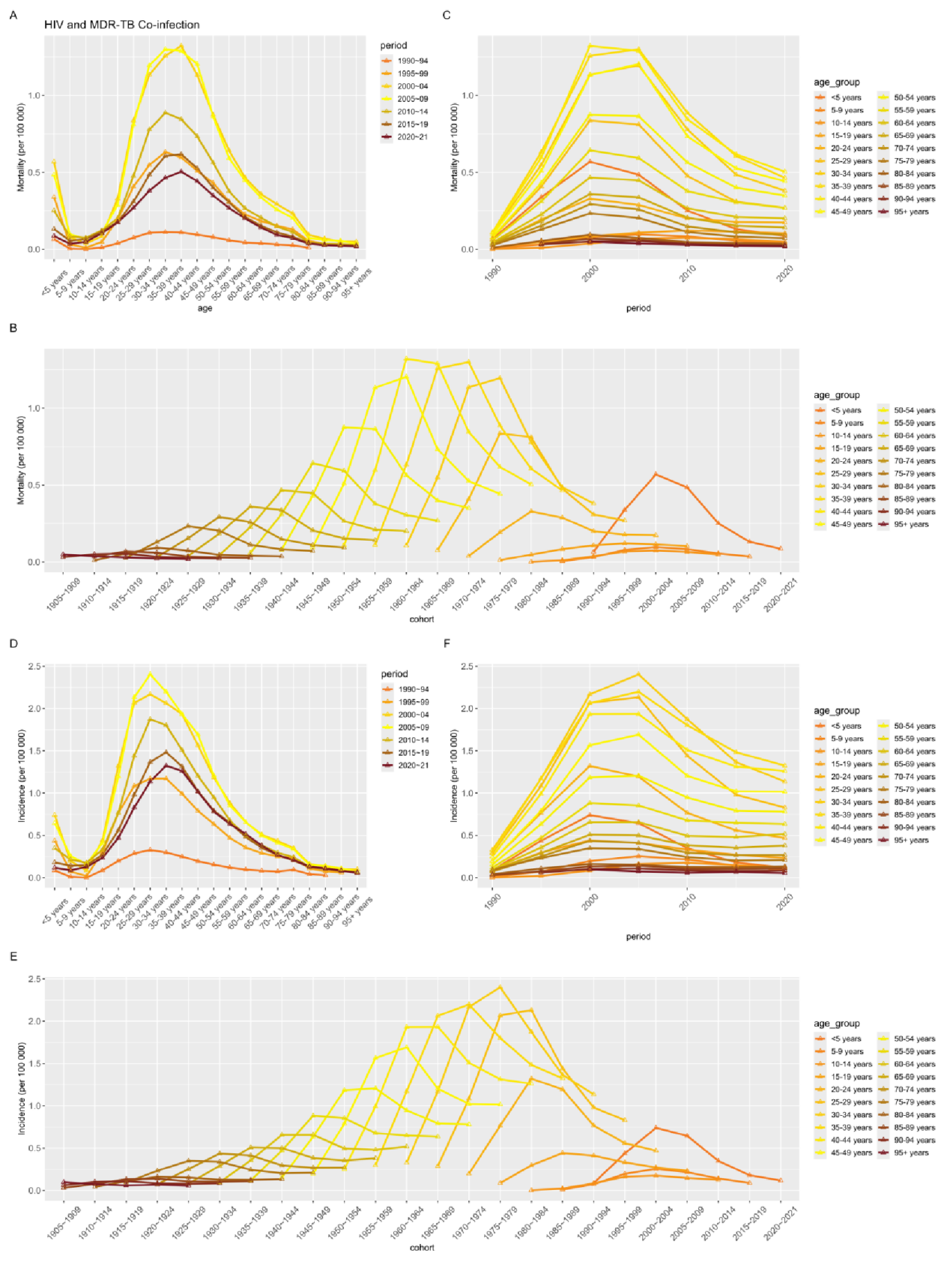
Figure S1 The global analysis of age, period, and cohort effects on the Incidence(A-C) and Mortality(D-F) rates of HIV and MDR-TB co-infection.
Note: MDR-TB, Multidrug Drug-Resistant Tuberculosis.
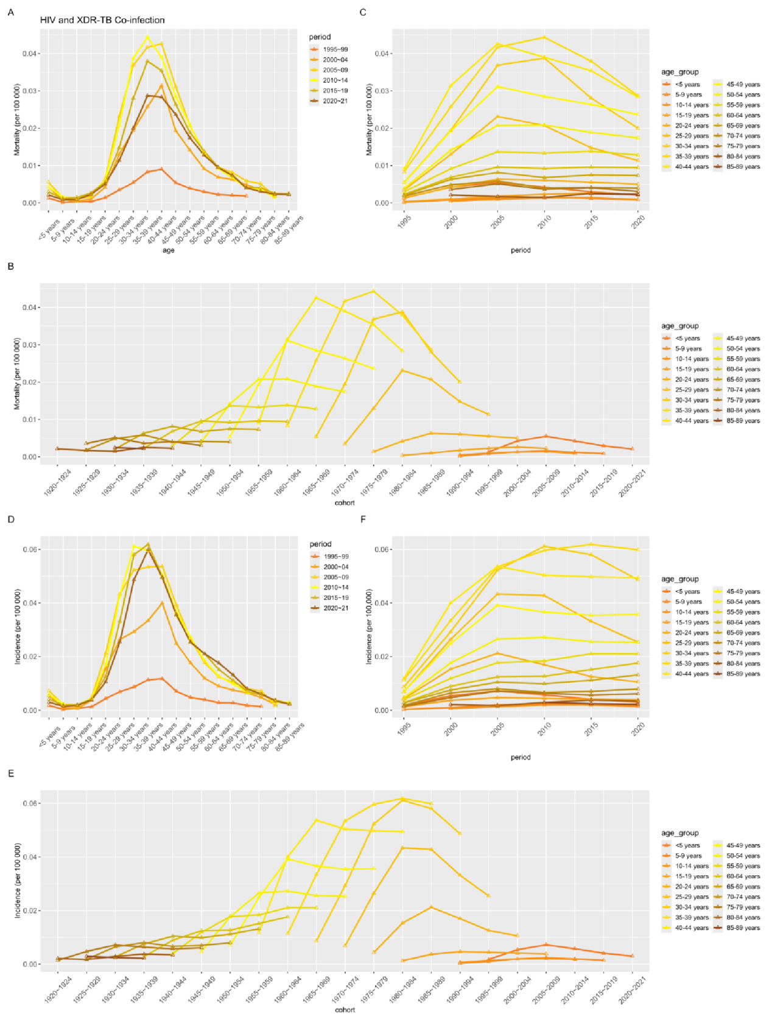
Figure S2 The global analysis of age, period, and cohort effects on the Incidence(A-C) and Mortality(D-F) rates of HIV and XDR-TB co-infection.
Note: XDR-TB, Extensively Drug-Resistant Tuberculosis.

