Supplementary Materials for

Fallowed agricultural lands dominate anthropogenic dust sources in California.

Adeyemi A. Adebiyi¹, Md. Minhazul Kibria¹, John Abatzoglou², Paul Ginoux³, Satyendra Pandey¹, Alexandra Heaney⁴, Shu-Hua Chen⁵, Akintomide A. Akinsanola^{6,7}

¹Department of Life and Environmental Sciences, University of California Merced, CA, USA
²Department of Management of Complex Systems, University of California Merced, CA, USA
³NOAA/OAR Geophysical Fluid Dynamics Laboratory, Princeton, NJ, USA
⁴Herbert Wertheim School of Public Health, University of California San Diego, San Diego, CA, USA
⁵Department of Land, Air and Water Resources, University of California Davis, Davis, CA, USA
⁶Department of Earth and Environmental Sciences, University of Illinois Chicago, Chicago, IL, USA
⁷Environmental Science Division, Argonne National Laboratory, Lemont, IL, USA

Figure S- 1: Example of dust from the agricultural-dominated Central Valley. The figure shows satellite images from NASA WorldView, dust optical depth obtained from MODIS (see Method), and measurements of coarse-mode particulate matter (PM10-PM2.5) from the EPA station at Fresno.

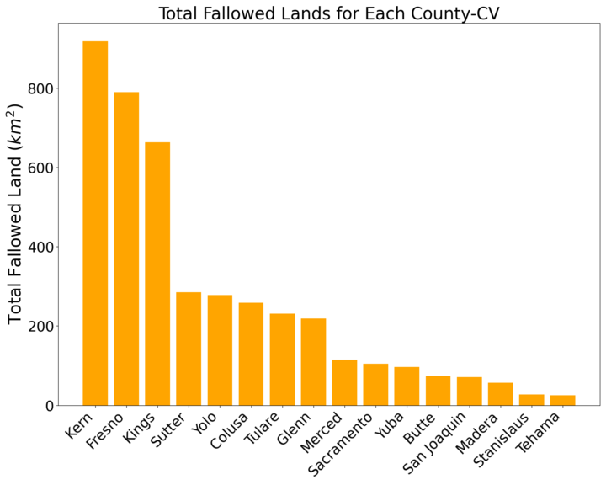
Figure S- 2: Total fallowed lands per county in Central Valley.

Figure S- 3: Same as Fig. 2b but for each year.
Figure S- 4: Monthly distribution of the percentage difference between fallowed land and non-fallowed land areas for (a) land surface temperature, (b) soil moisture, and (c) normalized difference vegetation index.

Figure S- 5: Like Fig. 3a, but for each month

Figure S- 6: Similar to Fig. 4a but as a function of months.
Figure S- 7: Spatial distribution of the assigned categories for crop types that are planned before they are fallowed.

Figure S- 8: Same as Fig. 4d but for each crop types

Figure S- 9: (a) The correlation between dust mass obtained from IMPROVE stations at Fresno and Sequoia (brown line), and Yosemite (red line). (b) The wind rose at Fresno.

Figure S- 10: (a) Same as Fig. 5e, and (b) for locations and days with dust load greater than 0.3 g/m³.

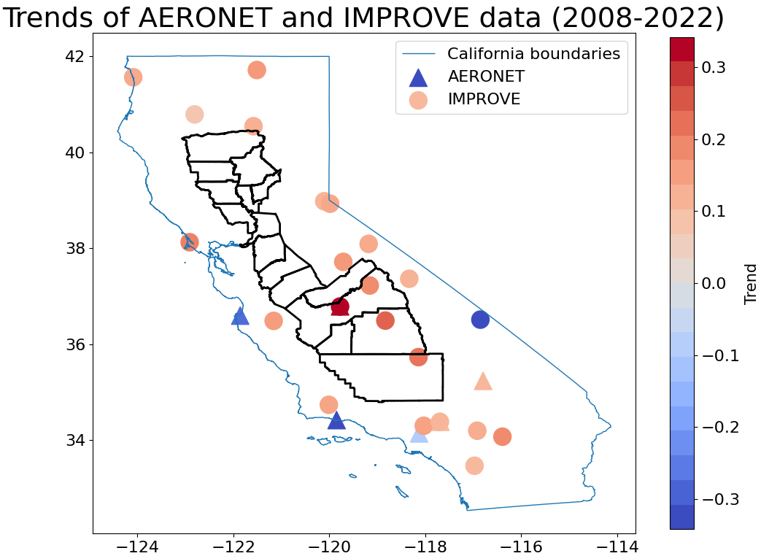
Figure S- 11: Trends (per year) in AERONET and IMPROVE aerosol data.

Table 1: Showing the assigned category for crop types used as part of analysis in Fig. 4d and fig. S-6. The table excludes non-crop land cover types such Barren, Forest, Urban, Grassland, Water, Wetlands, and other Unclassified land covers such as Clouds and Perennial Ice.
CDL Value | CDL Crop Types | Assigned Category
72 | Citrus | Citrus_Subtropical
211 | Olives | Citrus_Subtropical
212 | Oranges | Citrus_Subtropical
215 | Avocados | Citrus_Subtropical
1 | Corn | Corn_Cotton
2 | Cotton | Corn_Cotton
12 | Sweet Corn | Corn_Cotton
13 | Pop or Orn Corn | Corn_Cotton
66 | Cherries | Deciduous_Fruits_Nuts
67 | Peaches | Deciduous_Fruits_Nuts
68 | Apples | Deciduous_Fruits_Nuts
71 | Other Tree Crops | Deciduous_Fruits_Nuts
74 | Pecans | Deciduous_Fruits_Nuts
75 | Almonds | Deciduous_Fruits_Nuts
76 | Walnuts | Deciduous_Fruits_Nuts
77 | Pears | Deciduous_Fruits_Nuts
204 | Pistachios | Deciduous_Fruits_Nuts
210 | Prunes | Deciduous_Fruits_Nuts
217 | Pomegranates | Deciduous_Fruits_Nuts
218 | Nectarines | Deciduous_Fruits_Nuts
220 | Plums | Deciduous_Fruits_Nuts
223 | Apricots | Deciduous_Fruits_Nuts
26 | Dbl Crop WinWht/Soybeans | Double_Field_Grain
225 | Dbl Crop WinWht/Corn | Double_Field_Grain
226 | Dbl Crop Oats/Corn | Double_Field_Grain
228 | Dbl Crop Triticale/Corn | Double_Field_Grain
230 | Dbl Crop Lettuce/Durum Wht | Double_Field_Grain
231 | Dbl Crop Lettuce/Cantaloupe | Double_Field_Grain
232 | Dbl Crop Lettuce/Cotton | Double_Field_Grain
233 | Dbl Crop Lettuce/Barley | Double_Field_Grain
234 | Dbl Crop Durum Wht/Sorghum | Double_Field_Grain
235 | Dbl Crop Barley/Sorghum | Double_Field_Grain
236 | Dbl Crop WinWht/Sorghum | Double_Field_Grain
237 | Dbl Crop Barley/Corn | Double_Field_Grain
238 | Dbl Crop WinWht/Cotton | Double_Field_Grain
239 | Dbl Crop Soybeans/Cotton | Double_Field_Grain
240 | Dbl Crop Soybeans/Oats | Double_Field_Grain
241 | Dbl Crop Corn/Soybeans | Double_Field_Grain
254 | Dbl Crop Barley/Soybeans | Double_Field_Grain
4 | Sorghum | Field_Crops
5 | Soybeans | Field_Crops
6 | Sunflower | Field_Crops
10 | Peanuts | Field_Crops
11 | Tobacco | Field_Crops
29 | Millet | Field_Crops
30 | Speltz | Field_Crops
31 | Canola | Field_Crops
32 | Flaxseed | Field_Crops
33 | Safflower | Field_Crops
34 | Rape Seed | Field_Crops
35 | Mustard | Field_Crops
38 | Camelina | Field_Crops
41 | Sugarbeets | Field_Crops
45 | Sugarcane | Field_Crops
56 | Hops | Field_Crops
21 | Barley | Grain_Hay
22 | Durum Wheat | Grain_Hay
23 | Spring Wheat | Grain_Hay
24 | Winter Wheat | Grain_Hay
25 | Other Small Grains | Grain_Hay
27 | Rye | Grain_Hay
28 | Oats | Grain_Hay
39 | Buckwheat | Grain_Hay
205 | Triticale | Grain_Hay
69 | Grapes | Grapes
36 | Alfalfa | Irrigated_Pasture
37 | Other Hay/Non Alfalfa | Irrigated_Pasture
58 | Clover/Wildflowers | Irrigated_Pasture
59 | Sod/Grass Seed | Irrigated_Pasture
60 | Switchgrass | Irrigated_Pasture
224 | Vetch | Irrigated_Pasture
3 | Rice | Rice
64 | Shrubland | Shrubland
152 | Shrubland | Shrubland
14 | Mint | Truck_Crops_Berries
42 | Dry Beans | Truck_Crops_Berries
43 | Potatoes | Truck_Crops_Berries
44 | Other Crops | Truck_Crops_Berries
46 | Sweet Potatoes | Truck_Crops_Berries
47 | Misc Vegs & Fruits | Truck_Crops_Berries
48 | Watermelons | Truck_Crops_Berries
49 | Onions | Truck_Crops_Berries
50 | Cucumbers | Truck_Crops_Berries
51 | Chick Peas | Truck_Crops_Berries
52 | Lentils | Truck_Crops_Berries
53 | Peas | Truck_Crops_Berries
54 | Tomatoes | Truck_Crops_Berries
55 | Caneberries | Truck_Crops_Berries
57 | Herbs | Truck_Crops_Berries
206 | Carrots | Truck_Crops_Berries
207 | Asparagus | Truck_Crops_Berries
208 | Garlic | Truck_Crops_Berries
209 | Cantaloupes | Truck_Crops_Berries
213 | Honeydew Melons | Truck_Crops_Berries
214 | Broccoli | Truck_Crops_Berries
216 | Peppers | Truck_Crops_Berries
219 | Greens | Truck_Crops_Berries
221 | Strawberries | Truck_Crops_Berries
222 | Squash | Truck_Crops_Berries
227 | Lettuce | Truck_Crops_Berries
229 | Pumpkins | Truck_Crops_Berries
242 | Blueberries | Truck_Crops_Berries
243 | Cabbage | Truck_Crops_Berries
244 | Cauliflower | Truck_Crops_Berries
245 | Celery | Truck_Crops_Berries
246 | Radishes | Truck_Crops_Berries
247 | Turnips | Truck_Crops_Berries
248 | Eggplants | Truck_Crops_Berries
249 | Gourds | Truck_Crops_Berries
250 | Cranberries | Truck_Crops_Berries

