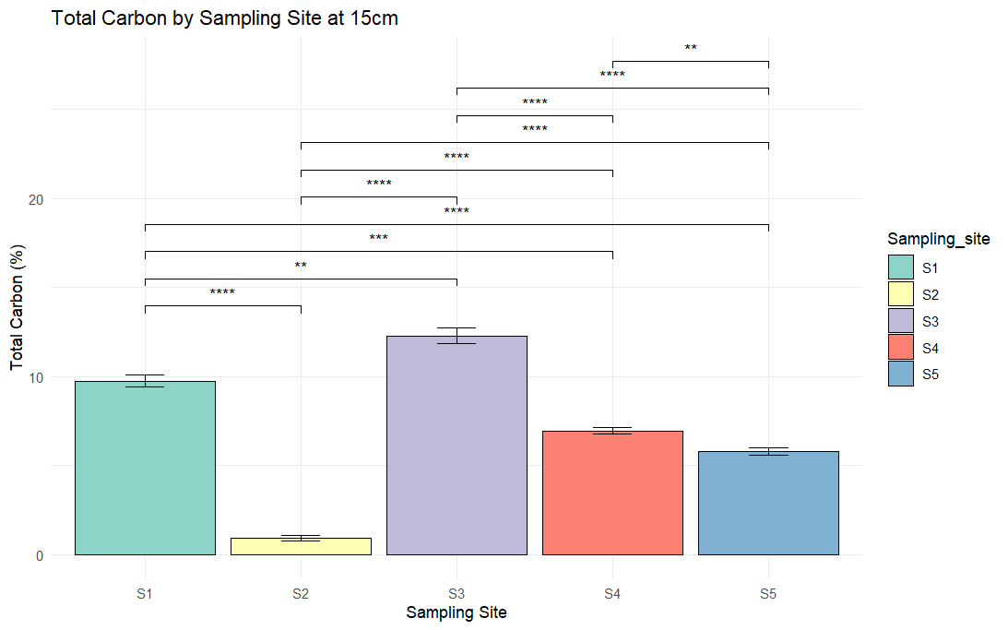
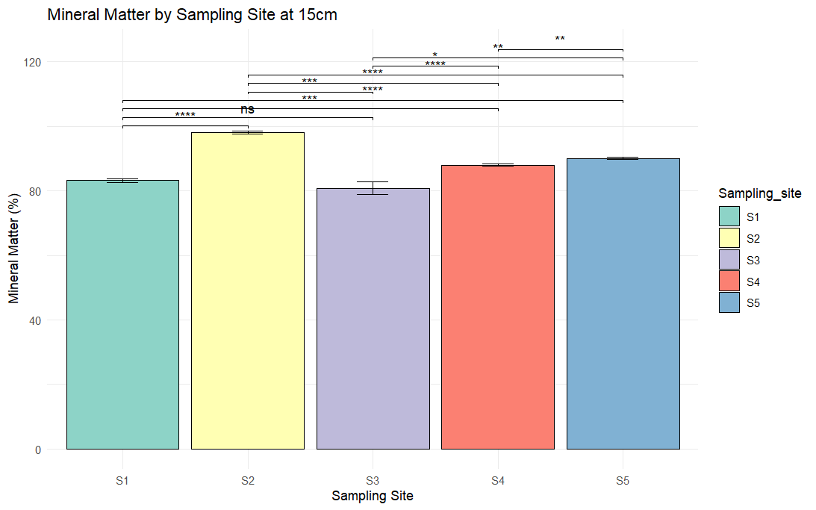
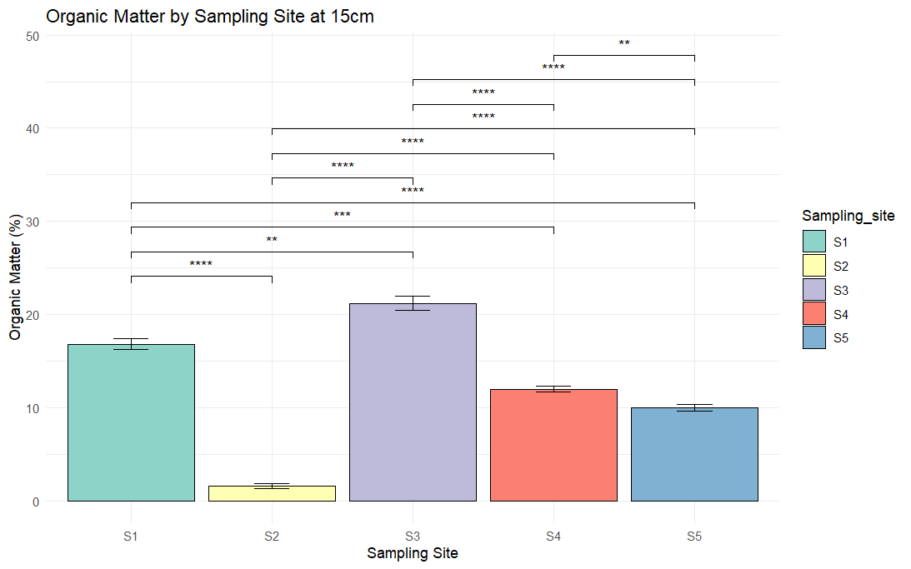
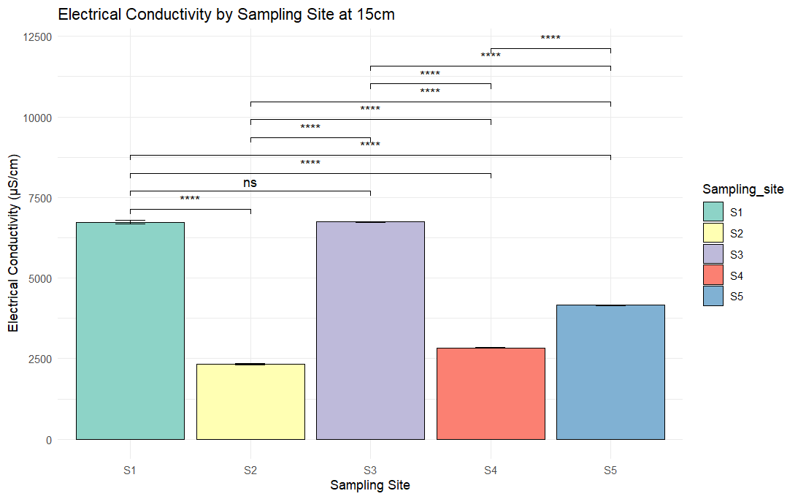
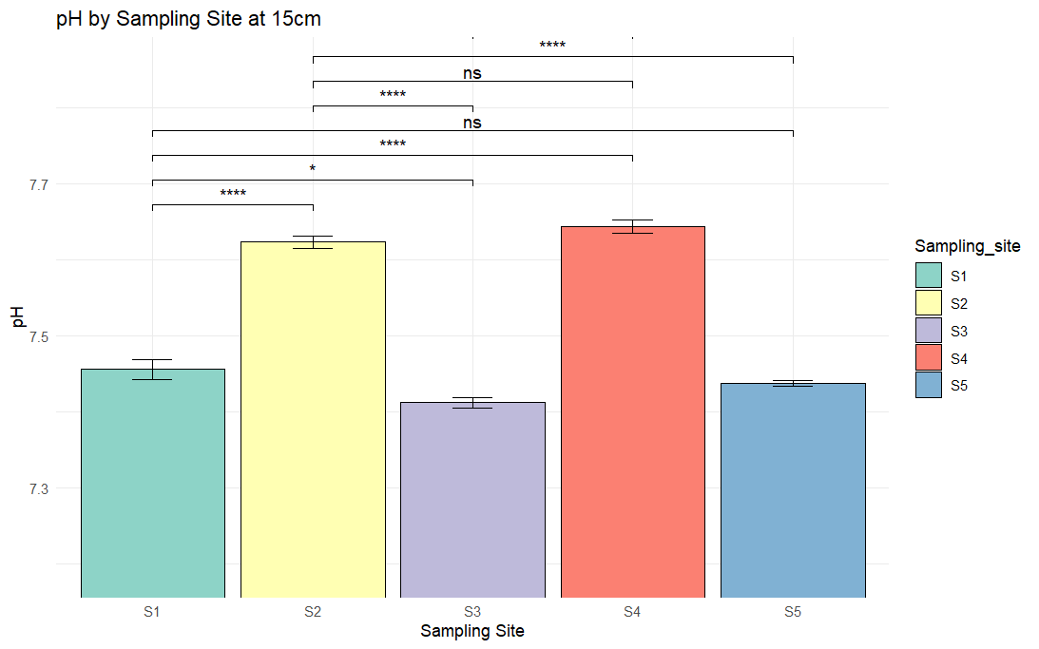
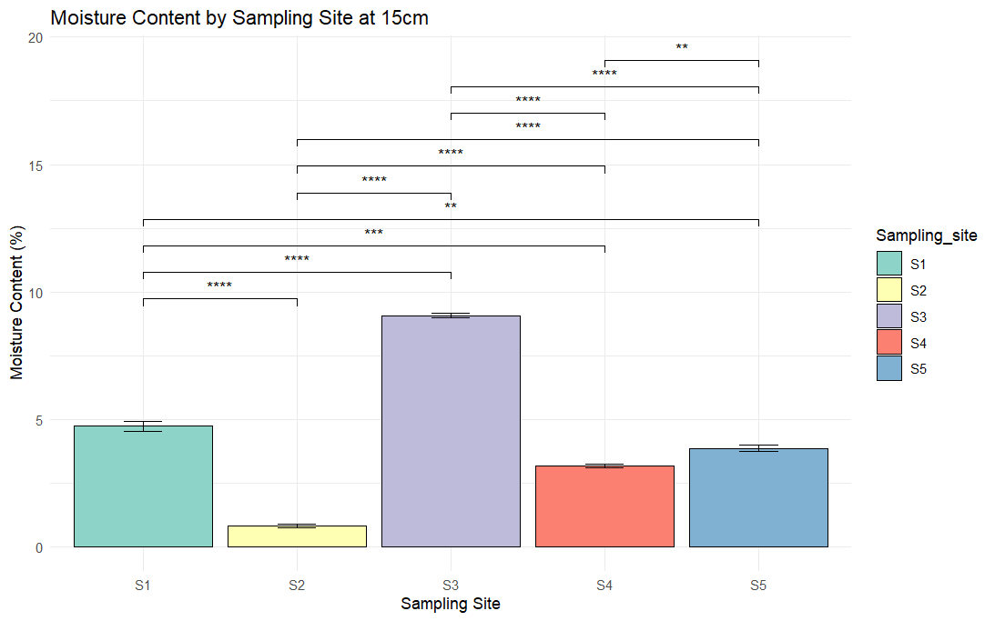
F
E
D
C
B
A

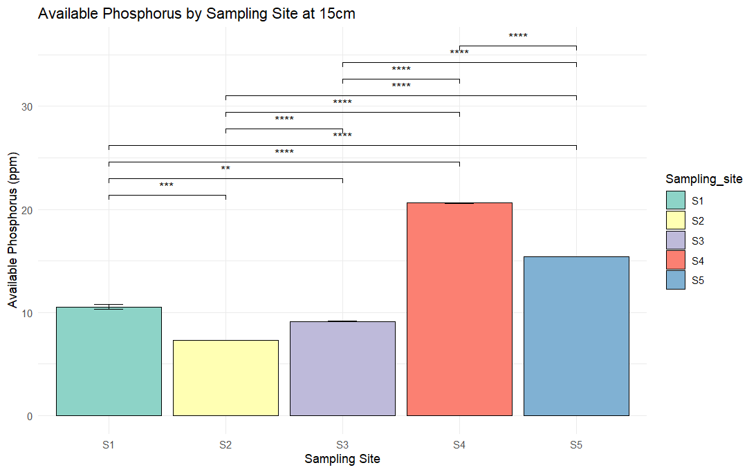
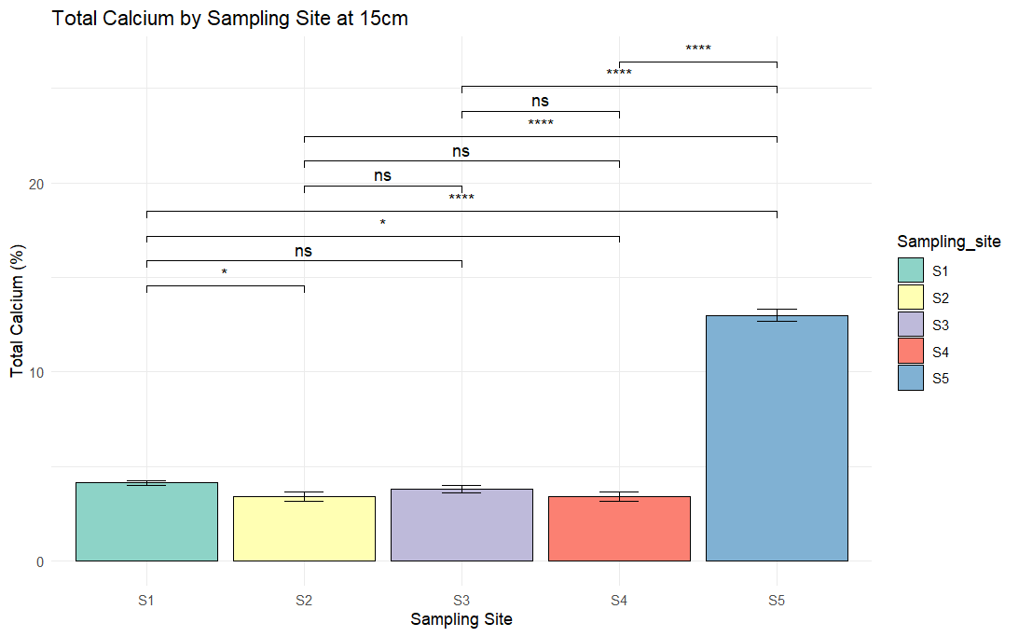
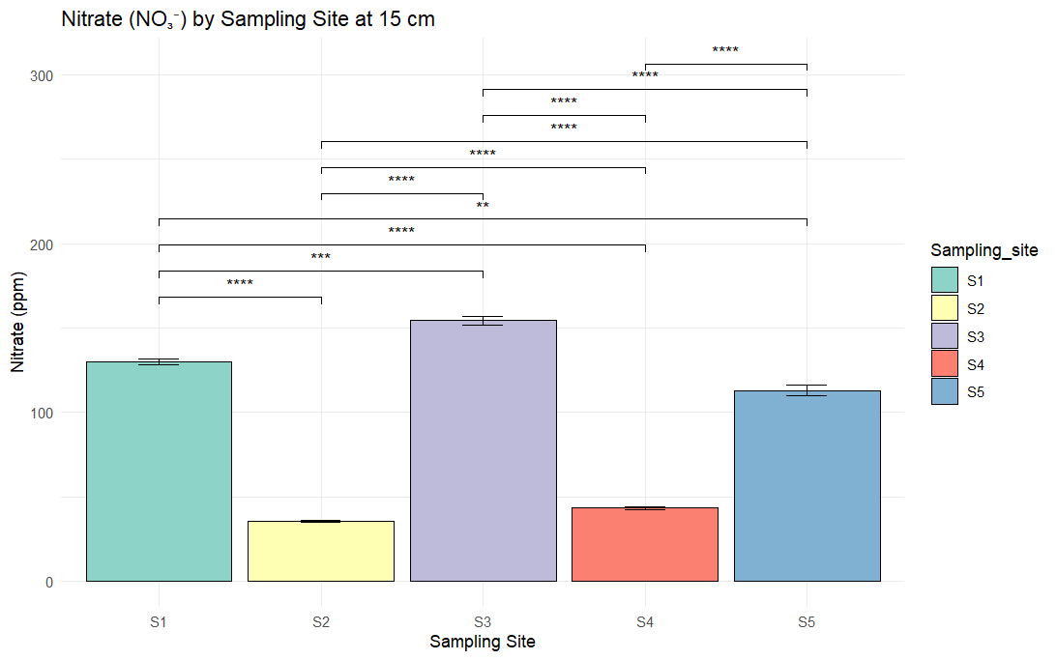
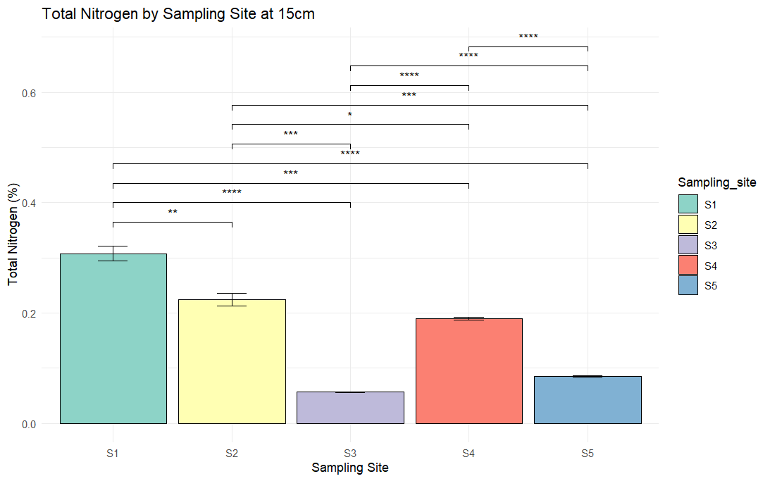
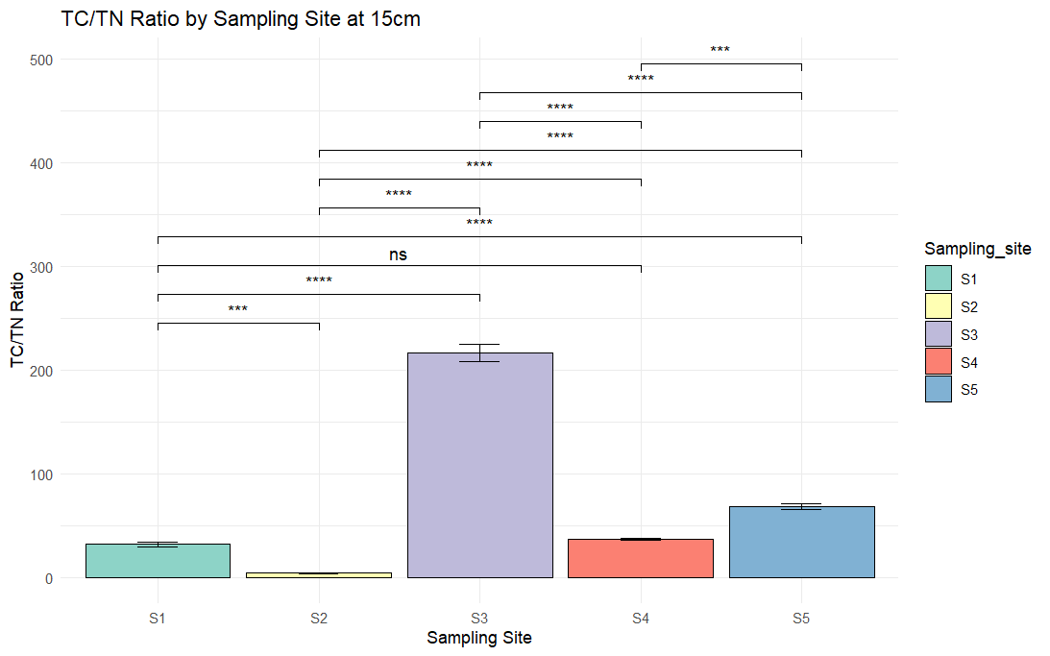
K
J
I
H
G
Additional file 2 Soil properties of sample sites. Each value is the mean ± SD of five replicate profiles per site. A Percentage of moisture content within each site. B pH of soil samples of 5 sampling sites at 15cm. C EC of soil samples. D Percentage of organic matter (OM) in soil samples at 0-15cm of depth. E Mineral matter content within each site. F Total carbon (TC) percentage content of soil samples at 15 depths. G Total nitrogen percentage at each site. H The average nitrate at each site. I Ratio C:N in soil samples within each site. J Total calcium percentage content in different sites. K Average available phosphorus within each site.

