Developing serum proteomics based prediction models of disease progression in ADPKD

Supplementary Methods 2
eGFR Slope Calculations 2
Proteomic Data 2
Screening Proteome (Screening Cohort) 2
Validation Proteome (Internal/Temporal and External Cohorts) 2
Characteristics of Screening Proteome 3
Enrichment Analyses 3
Enrichment of Screening Proteome 3
Enrichment of Selected Features and Patients 3
References 3
Supplementary Figures 4
Figure S1: Flow chart of study cohorts 4
Figure S2: Characteristics of Screening Cohort’s proteome consisting of ADPKD patients 5
Figure S3: PCA of enriched GO:BP terms in ADPKD proteome 6
Figure S4: Model accuracy across test folds 7
Figure S5: Distribution of hemoglobin beta subunit (HBB) levels across the used cohorts 8
Figure S6: Validation of the predictive models 9
Figure S7: Predictions of the latest eGFR values per patient 10
Figure S8: Principal Component Analysis (PCA) plots of the Screening Proteome 11
Figure S9: Principal Component Analysis (PCA) plots of the Validation Proteome 11
Supplementary Tables 12
Table S1: Additional clinical characteristics of Screening and Internal/Temporal Cohorts (SC and ITC, respectively) 12
Table S2: Summary of the enriched terms in ADPKD proteome 12
Table S3: Summary of the parent enriched GO:BP terms from Table S2 12
Table S4: Summary of the enriched terms of selected features (LIMMA and LASSO sets) 12
Table S5: Summary of the enriched terms in the protein clusters described in Figure 1 12
Table S6: Summary of the parent enriched GO:BP terms from Table S5 12
Table S7: Characteristics of patients clusters in Figure 1 12
Table S8: Summary of the generated Proteome Model from Screening Cohort (SC) 12
Table S9: Comparison of the generated models from Screening Cohort (SC) 13
Table S10: Summary of the generated Proteome4 Model from Screening Cohort (SC) 14
Table S11: Sample and patient sizes of three cohorts in Figure S6A-D 14
Table S12: Correlation table representing the relation among proteins and eGFR slope in Screening Cohort (SC) 14
Table S13: Comparison of the Proteome Model to Models with CST3 from Screening Cohort (SC) 15

Supplementary Methods
All the analyses were performed within the statistical environment R (version 4.3.2). Figures were also generated in R with the ggplot2 (version 3.4.4), ggpubr (version 0.6.0) and ComplexHeatmap (version 2.18.0) packages.

eGFR Slope Calculations
In the German AD(H)PKD registry (Screening and Internal/Temporal Cohorts), 1758 eGFR measurements from 252 patients were removed due to interventions. More specifically, 1713 measurements from 241 patients were removed due to Tolvaptan usage. The rest of the removals were due to dialysis (n_{measurement}=4 from n_{patients}=3), nephrectomy (n_{measurement}=30 from n_{patients}=6), kidney transplants (n_{measurement}=11 from n_{patients}=2) and the minimum threshold of 3 eGFR measurements per patient (n_{measurement}=601 from n_{patients}=477).
In the DIPAK study (External Cohort), 258 eGFR measurements from 55 patients were removed due to Tolvaptan administration. While dialysis, nephrectomy, and kidney transplant led to no removal, the minimum threshold of 3 eGFR measurements resulted in the removal of 29 eGFR measurements from 19 patients.
Remaining 5371 eGFR measurements from 578 patients in the German AD(H)PKD registry (SC and ITC) and 1194 eGFR measurements from 180 patients in the In DIPAK study (EC) were used for calculating the eGFR slope. Finally, eGFR slopes that were greater than 5 or below -10 mL/min/1·73m² per year were removed from further analyses.

Proteomic Data
Samples were prepared following a modified SP3 protocol¹ performed on a Chronect Robotic RSI automated liquid handling system (AxelSemrau) for Screening Cohort (SC), an Integra Assist plus (Integra) for Internal/Temporal Cohort (ITC), and a Miocrolab Star M (Hamilton) for External Cohort (EC), foregoing the peptide cleanup on the second day. Instead, beads were removed after acidification and samples either cleaned by using mixed-mode StageTips for SC,² or directly loaded onto Evotips following the recommended vendor protocol for ITC and EC.
Samples were analyzed on either an EASY 1200 nLC coupled to a Q Exactive HFx (both Thermo Scientific) for SC or an Evosep One (Evosep) coupled to an Orbitrap Exploris 480 with FAIMS pro (both Thermo Scientific) for ITC and EC.

Screening Proteome (Screening Cohort)
Samples were injected onto an in-house packed 40 cm pulled tip column (75 µm inner diameter, filled with 2·7 µm Poroshell EC120 C18, Agilent). Separation took place on a 30 min gradient running 0·1 % formic acid (eluent A) against 80 % acetonitrile, 0·1 % formic acid (eluent B). Gradient started at 8 % B and increased to 35 % over 30 min followed by washing and equilibration to standard conditions, all with a constant flow of 250 nl/min. The mass spectrometer was operated in data-independent acquisition covering the mass range between 350 and 1200 m/z with 15 variable windows. Each cycle, a single MS1 scan with 45k resolution was followed by MS2 scans at 30k resolution using stepped NCE of 25·5, 27, and 30. For library generation, a pool was generated from all samples and high pH fractionated on an 1 h gradient using an Infinity 1260 LC (Agilent). Resulting 48 fractions were concatenated into a total of 24 samples and analyzed on the identical setup used for sample analysis. The library was build using Spectronaut 14.7 using standard settings for library building in directDIA using the Human Uniprot reference proteome including isoforms (downloaded 04.01.2021). It contained 9643 precursors from 2346 proteins. Finally, samples were searched against the library using DIA-NN 1.7.12³ using the same FASTA file. Standard settings were used with the additional “—report-lib-info” command line input.
Protein Groups (PG) were quantified with the Diann package (version 1.0.1). There were 776 PGs identified in the raw data. Filtering q-value (≤0·01) followed by removal of PGs containing more than 80% NAs resulted in the data containing 398 PGs. These steps were followed by data normalization (justvsn from vsn package, version 3.70.0) and imputation (sampling from the 5th percentile of the data). After removal of outliers (n=7), batch effect correction (ComBat function from sva package, version 3.50.0) was performed (Figure S8).

Validation Proteome (Internal/Temporal and External Cohorts)
Samples were injected using the 60 SPD chromatography method and the FAIMS set to -50 V compensation voltage with inner and outer electrode temperature kept constant at 99·5 °C and 85 °C, respectively. The mass spectrometer resolution of both MS1 and MS2 were set to 15k resolution and was running in data independent acquisition mode with 30 % normalized collision energy. The mass range from 400 to 880 m/z was covered in 30 staggered windows of 16 m/z each, resulting in effectively 8 m/z windows after deconvolution using ProteoWizard.⁴ For library generation, a pool was generated from all samples and high pH fractionated on an 1 h gradient using an Infinity 1260 LC (Agilent). Resulting 48 fractions were concatenated into 12 samples and analyzed on the identical setup used for sample analysis but running the mass spectrometer in DDA. MS1 resolution was set to 60k, MS2 resolution to 15k with 20 s using 30 % normalized collision energy and 1·4 Th isolation width. The library was afterwards build using Fragpipe 16.0 and its predefined library building workflow with standard parameters and the Human Uniprot reference proteome including isoforms (downloaded 04.01.2021). Afterwards, the resulting library was combined with two other HpH serum libraries to increase analytical depth. The resulting library contained 18461 precursors from 1727 proteins. Finally, samples were searched against the library using DIA-NN 1.8.1³ with reannotation activated using the same FASTA as for library building and the additional command line “—report-lib-info”.
Filtering q-value (≤0·01) resulted in identified 731 PGs. Then, the removal of PGs containing more than 80% NAs resulted in the final data containing 338 PGs. These steps were followed by data normalization (justvsn from vsn package, version 3.70.0) and imputation (sampling from the 5th percentile of the data). After removal of outliers (n=5), batch effect correction was performed (Figure S9) (ComBat function from sva package, version 3.50.0).

Characteristics of Screening Proteome
The mass distribution of the proteins corresponding to 398 PGs identified in Screening Proteome were compared with the mass distribution of all known human proteins in UniprotKB (as of February 2024). Masses were calculated by mw function from Peptides package (version 2.4.6) and density plots comparing these distributions were generated. All detected proteins and the remaining 257 samples were used to generate a PCA and a heatmap, in which patients were sorted according to their eGFR and PGs were clustered distance to 1-correlation (Pearson) and method to average.

Enrichment Analyses
All functional enrichment analyses were performed with gconvert (to convert protein IDs to ENSG IDs) and gost (to obtain functional enrichment) functions from gprofiler2 package (version 0.2.2). To identify enriched parent GO:BP terms, calculateSimMatrix (to calculate similarity score of enriched terms) and reduceSimMatrix (to calculate semantic similarity score) function from rrvgo package (version 1.14.1) were utilized.

Enrichment of Screening Proteome
To evaluate the functions represented by our approach, the detected 398 PGs were subjected to an enrichment analysis, with false discovery rate (FDR) adjusted p-value of 0·001. Then, by calculating semantic similarity scores, the clustering of similar terms and simplified visualization of the functional space of our proteome were accomplished.

Enrichment of Selected Features and Patients
First, PGs identified by the LIMMA and wLASSO procedure (LIMMA and LASSO set) were subjected to functional enrichment with FDR adjusted p-value of 0·1 and background was assigned to all detected PGs.
Second, a heatmap was generated. Both proteins and samples were clustered by assigning distance to 1-correlation (Pearson) and method to average. Protein clusters were subjected to the functional enrichment as described above. Patient clusters and their characteristics were compared by using two different tests. While continuous variables (such as age, eGFR and slope) were compared among the clusters by t-test with Bonferroni adjustment (t_test function from rstatix package version 0.7.2), categorical variables (such as sex) were compared to the whole cohort by proportions test (prop.test function from stats package version 4.3.2).

References
1 Hughes CS, Moggridge S, Müller T, Sorensen PH, Morin GB, Krijgsveld J. Single-pot, solid-phase-enhanced sample preparation for proteomics experiments. Nature Protocols 2018 14:1 2018; 14: 68–85.
2 Rappsilber J, Mann M, Ishihama Y. Protocol for micro-purification, enrichment, pre-fractionation and storage of peptides for proteomics using StageTips. Nature Protocols 2007 2:8 2007; 2: 1896–906.
3 Demichev V, Messner CB, Vernardis SI, Lilley KS, Ralser M. DIA-NN: neural networks and interference correction enable deep proteome coverage in high throughput. Nature Methods 2019 17:1 2019; 17: 41–4.
4 Chambers MC, MacLean B, Burke R, et al. A cross-platform toolkit for mass spectrometry and proteomics. Nature Biotechnology 2012 30:10 2012; 30: 918–20.

Supplementary Figures
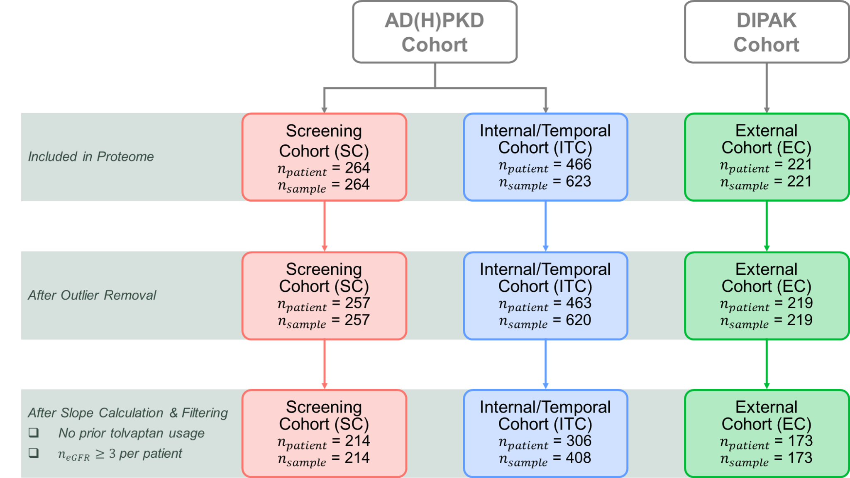

Figure S1: Flow chart of study cohorts. Blood samples derived from patients with ADPKD from the German AD(H)PKD registry contained in the Screening Cohort (SC) or Internal/Temporal Cohort (ITC) were used for proteome mass spectrometry analysis. Similarly, the External Cohort (EC) derived from the DIPAK Cohort was used. Further removal of samples and patients were performed based on quality controls, Tolvaptan usage, and amount of eGFR measurement. Details can be found in Supplementary Methods, section eGFR Slope Calculations. The final datasets contained 214 (SC), 306 (ITS) and 173 (EC) patients respectively and were used for model generation and validation.

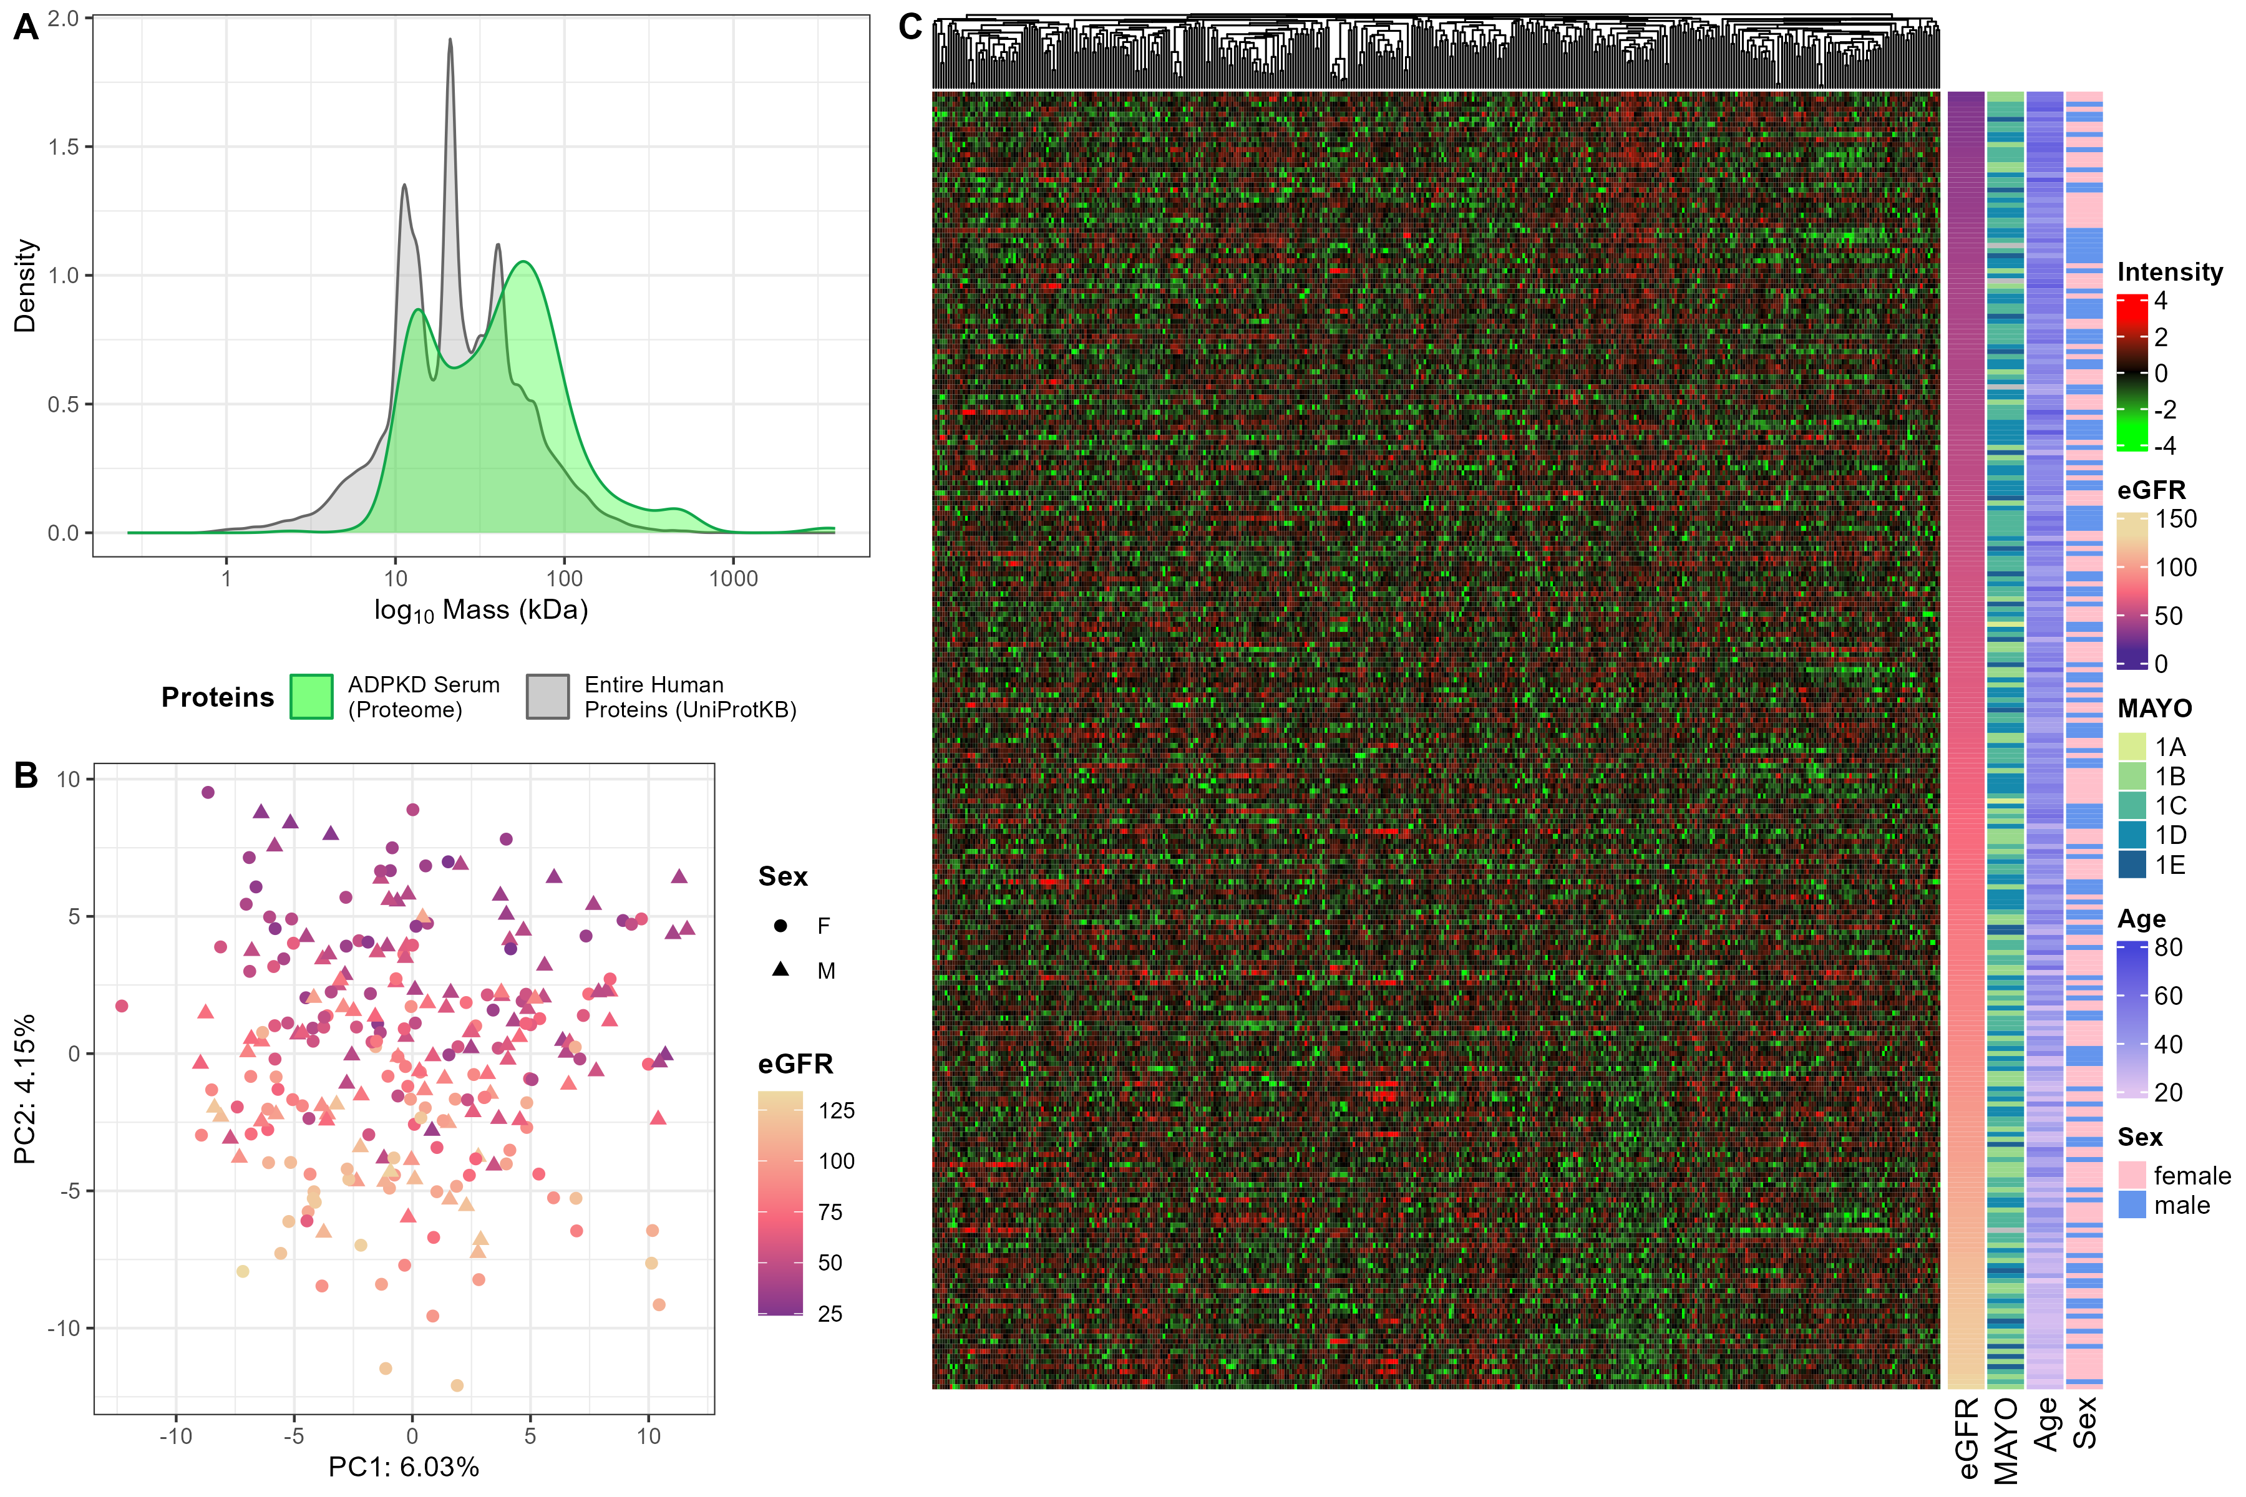

Figure S2: Characteristics of Screening Cohort’s proteome consisting of ADPKD patients. A) Density plot comparing the distribution of detected proteins in patients with ADPKD (green) to the distribution of entire human proteins (gray). B) Principal Component Analysis (PCA) plot of the detected proteins in ADPKD samples. Each point represents an individual sample, and the data points are color-coded by eGFR. Females and males are represented as circles and triangles, respectively. C) Heatmap of detected proteins (n=398, in columns) and samples (n = 257, in rows), and corresponding clinical parameters. The samples were sorted in decreasing order according to eGFR.

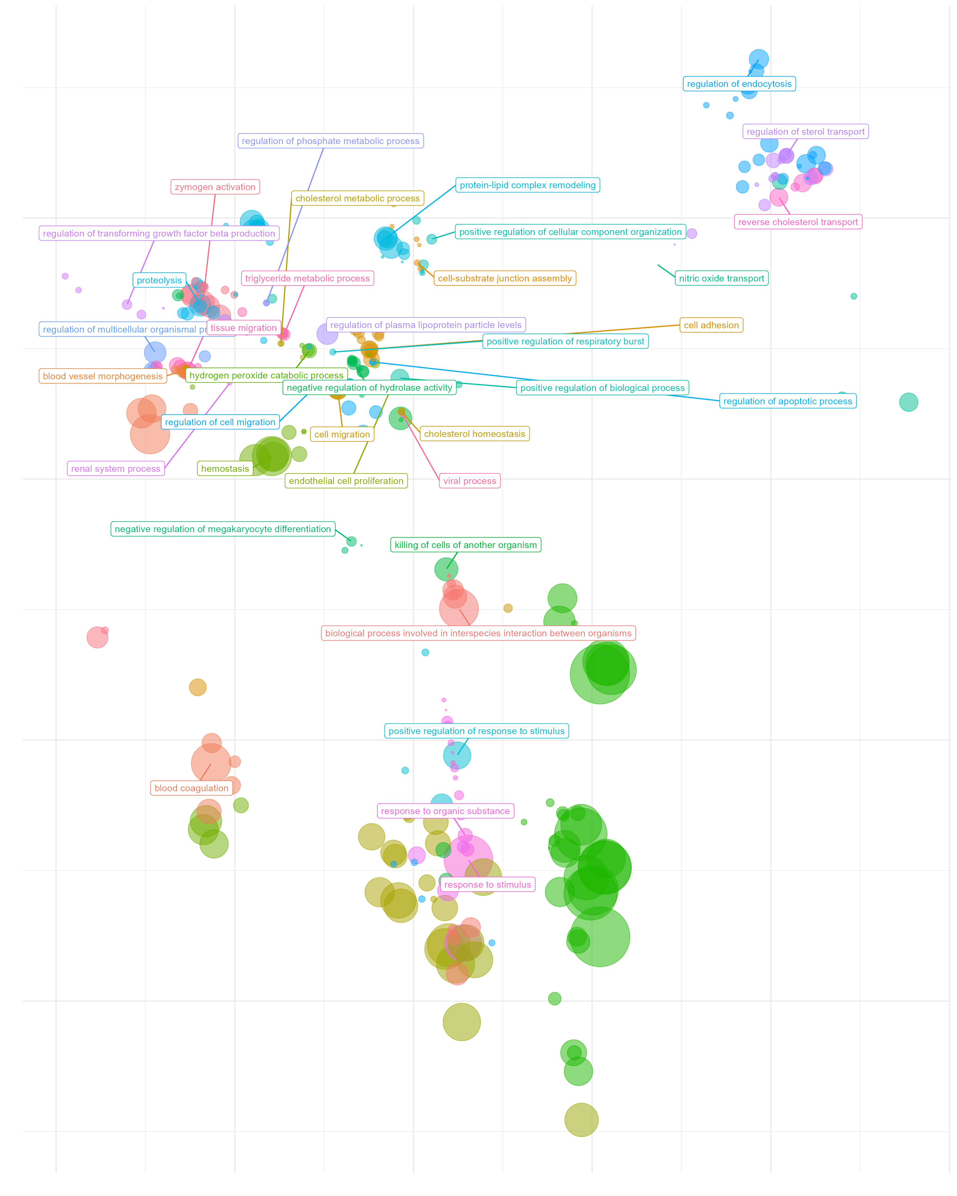

Figure S3: PCA of enriched GO:BP terms in ADPKD proteome. The generated similarity matrix of enriched GO:BP terms were subjected to PCA. The x- and y-axis are PC2 and PC1 respectively. Bubbles were color coded according to the parent terms listed in Table S3.

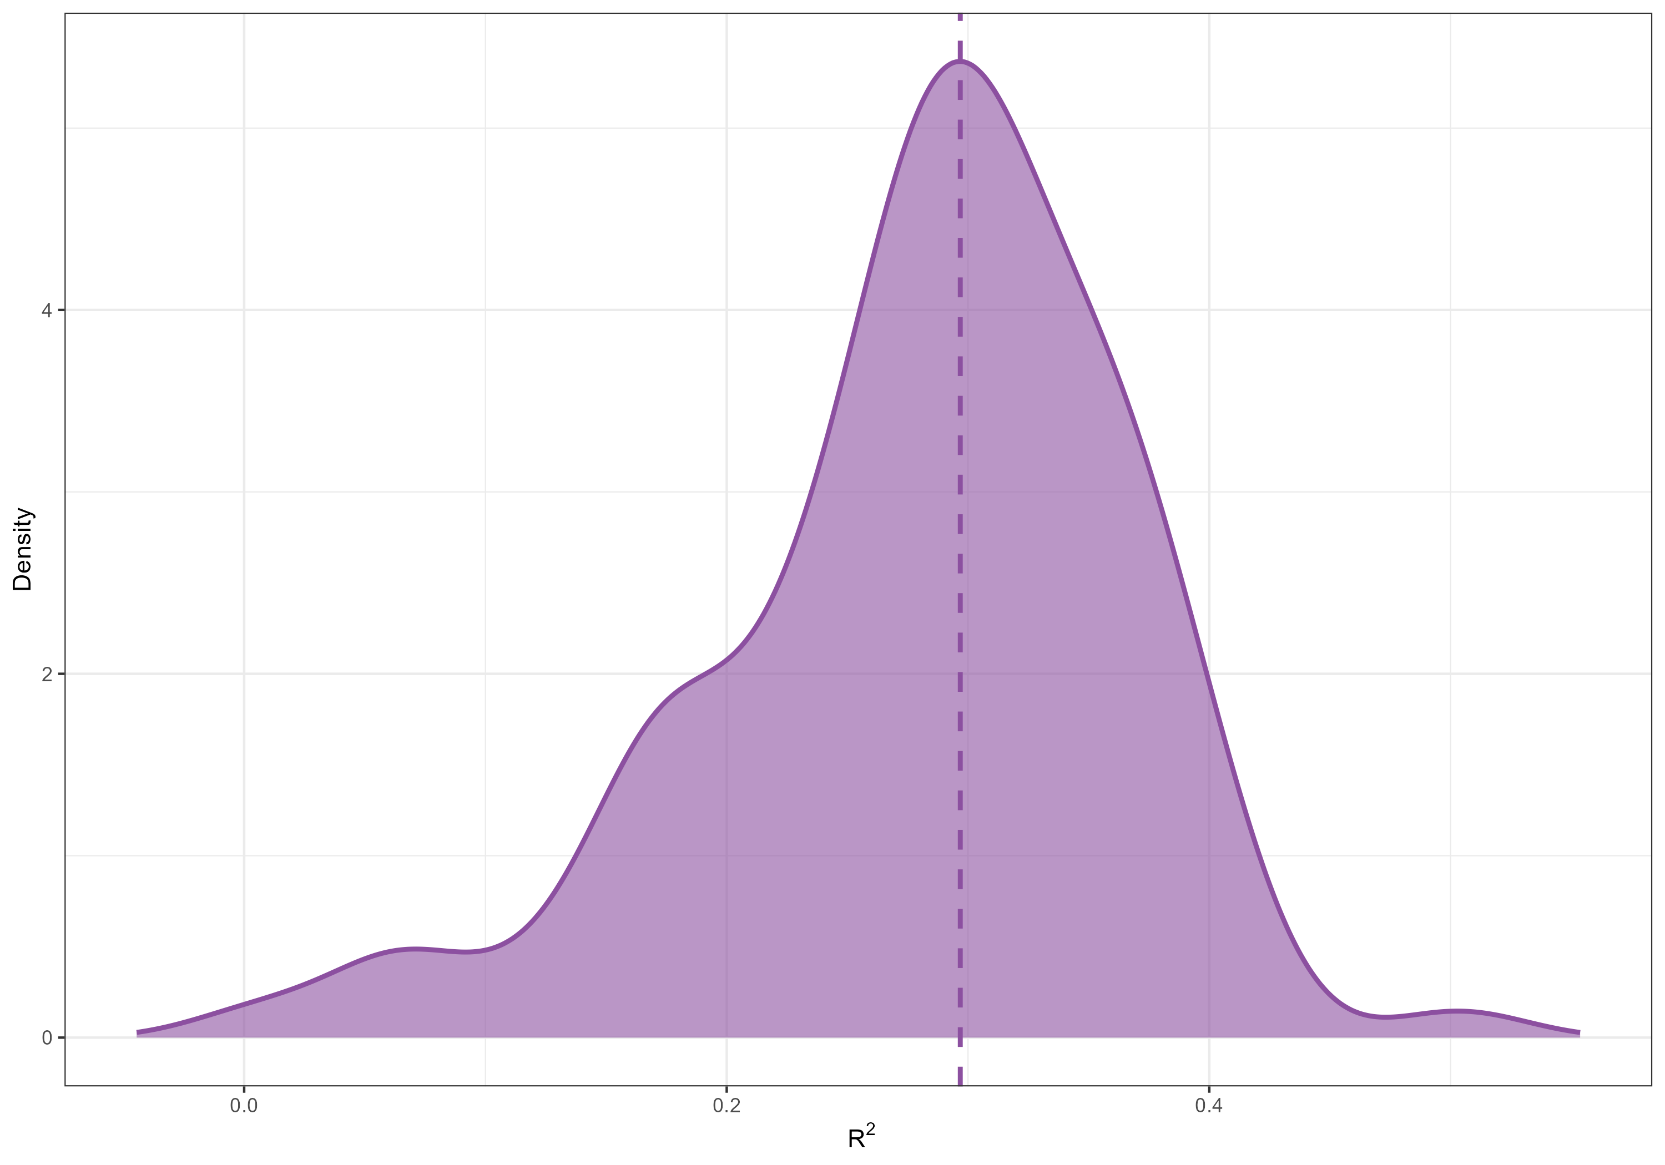

Figure S4: Model accuracy across test folds. Density plot illustrating the performance of linear regression (LR) models based on R² values in the test subsets of cross-validation (CV) folds. The dashed line represents the median R² value across the 100 tested models.

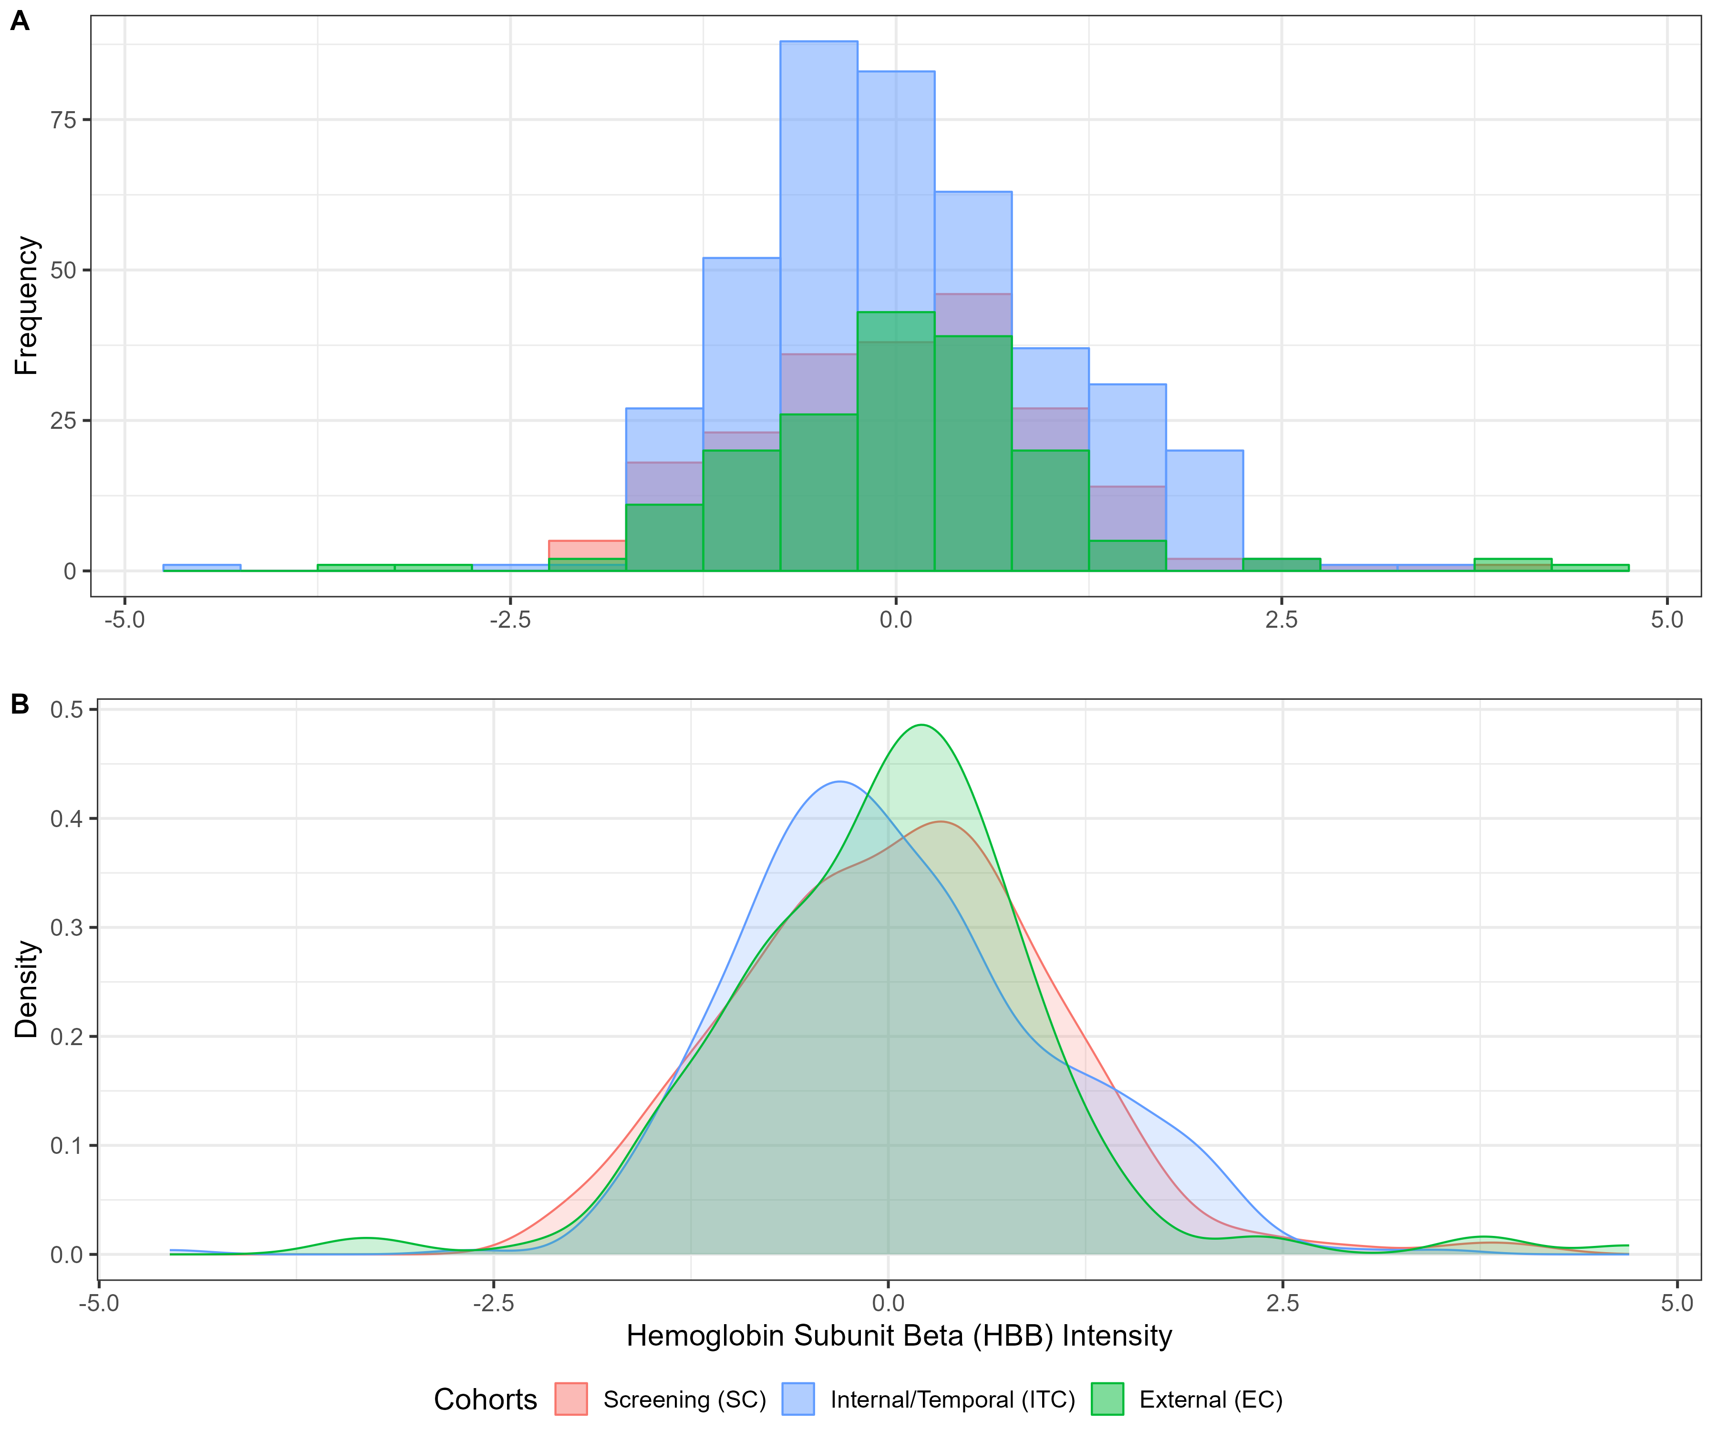

Figure S5: Distribution of hemoglobin beta subunit (HBB) levels across the used cohorts. A) Histogram depicting the frequency distribution of HBB levels within the three cohorts, highlighting the variations in distribution patterns. B) Density plot providing a smoothed representation of the HBB distribution, allowing for a clearer visualization of the distribution differences between the cohorts.

Figure S6: Validation of the predictive models. (A-D) Predicted slope comparison to observed slope with models, which were built in Screening Cohort (SC, red) and validated on Internal/Temporal (ITC, blue) and External (EC, green) Cohorts. Slope predictions made by A) Proteome, B) Combined, C) Combined Genotype and D) Proteome4 Models. The Patient Category legend indicates whether the patients included in the proteome of Screening Cohort (iSCP) but were sampled at different time points in ITC or were newly recruited (nSCP). The asterisks on the points indicate whether the samples were coming from patients who had or have been on somatostatin analogues for polycystic liver disease. (E-H) Predicted slope comparison by different models for the same patients across different time points (SC and ITC). E) Proteome, F) Combined, G) Combined Genotype and H) Proteome4 Models. Each line indicates one patient and points on those lines indicate different sampling times. Color-coded for the maximum time difference between those points.

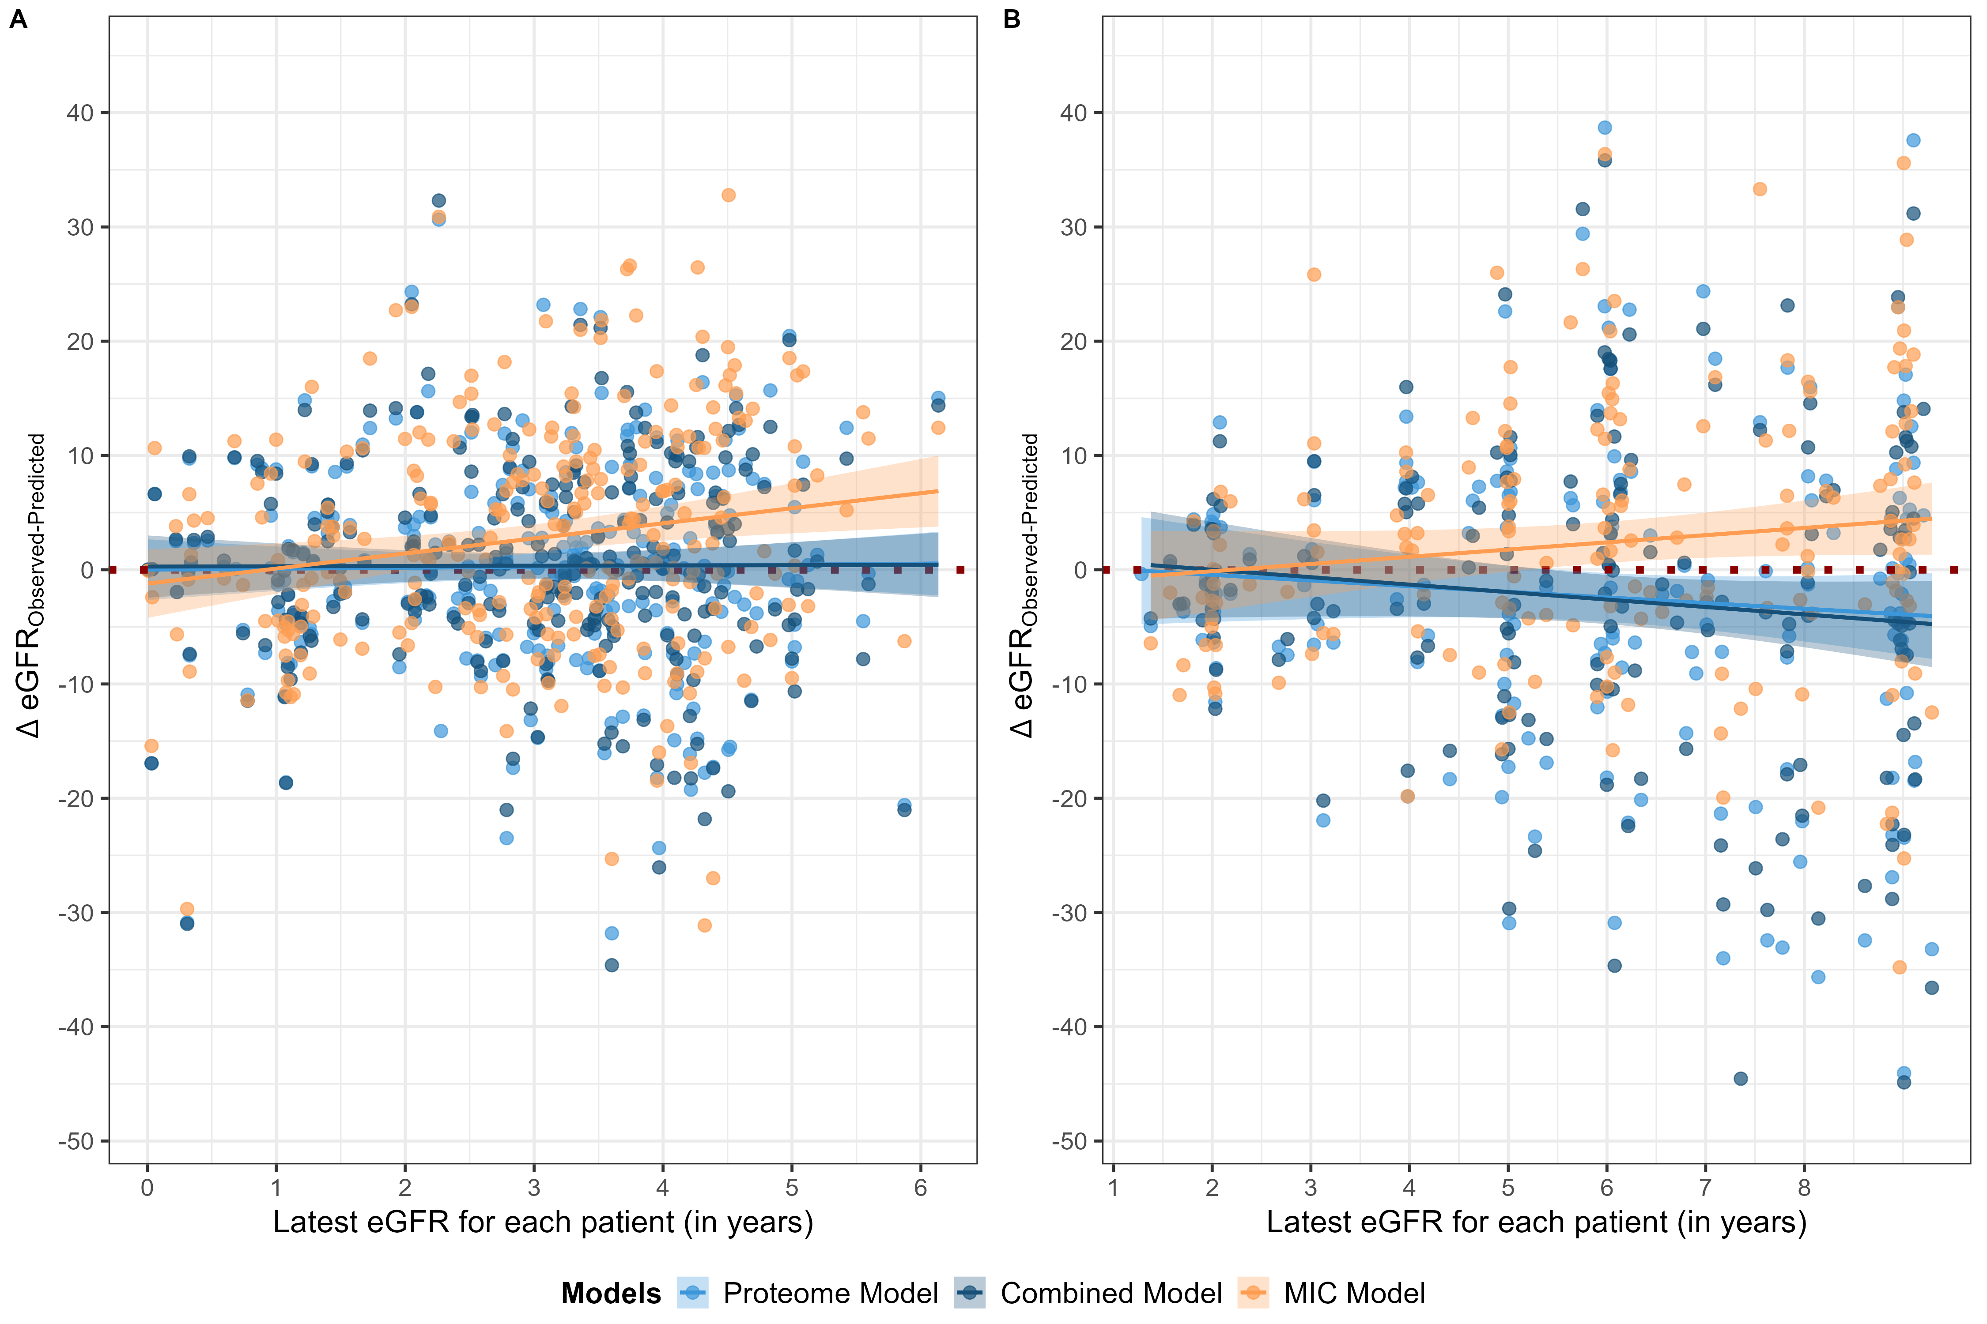

Figure S7: Predictions of the latest eGFR values per patient. In A) Internal/Temporal Cohort (ITC) and B) External Cohort (EC). Predictions, fitted lines and confidence intervals were color coded according to used models.
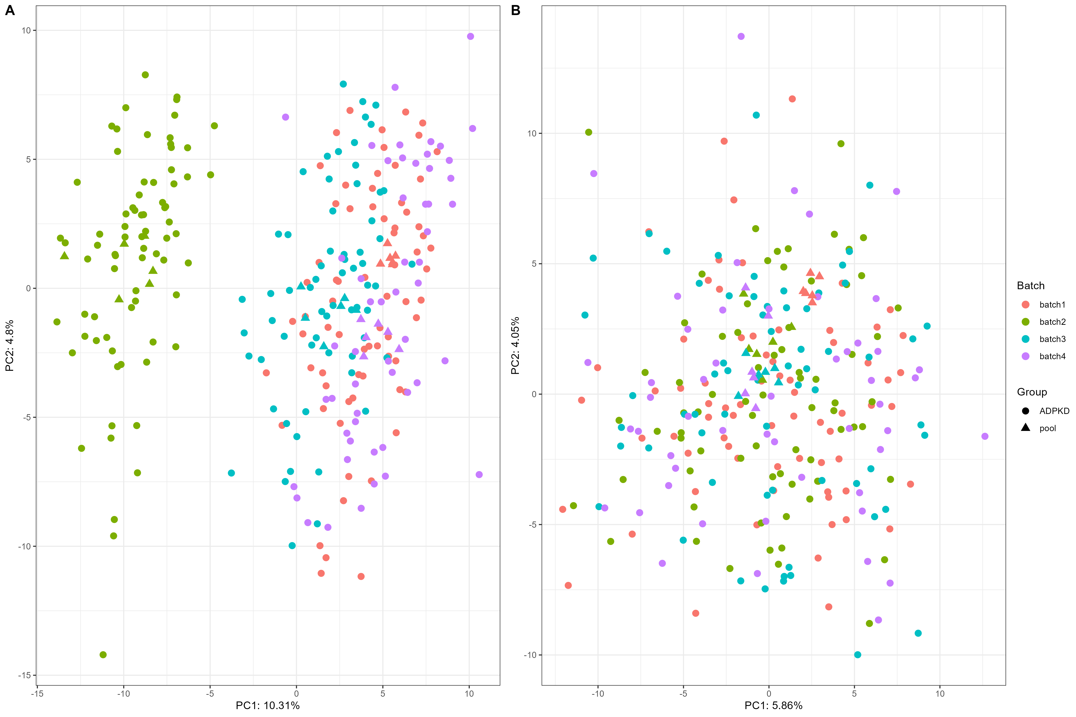

Figure S8: Principal Component Analysis (PCA) plots of the Screening Proteome. The PCA plots illustrate the variance within the proteome of Screening Cohort. A depicts the cohort prior to batch effect correction, exhibiting discernible clustering influenced by batch effects. In contrast, B displays the cohort post-batch effect correction, demonstrating more consistent clustering and reduced batch-related variability. This confirms the effectiveness of the correction process.
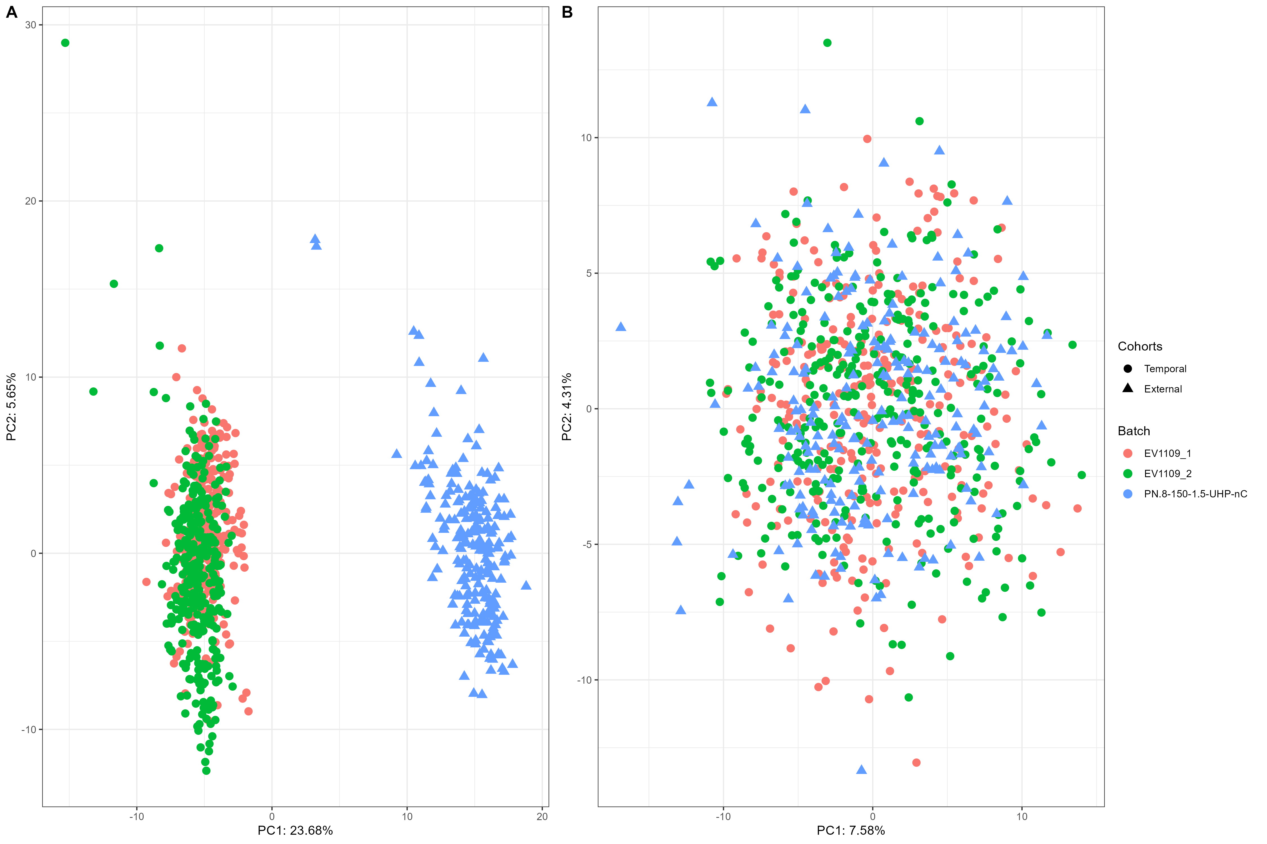

Figure S9: Principal Component Analysis (PCA) plots of the Validation Proteome. The PCA plots illustrate the variance within the proteome of Internal/Temporal and External Cohorts (ITC and EC). A depicts the cohort prior to batch effect correction, exhibiting discernible clustering influenced by batch effects. In contrast, B displays the cohort post-batch effect correction, demonstrating more consistent clustering and reduced batch-related variability. This confirms the effectiveness of the correction process.

Supplementary Tables

Table S1: Additional clinical characteristics of Screening and Internal/Temporal Cohorts (SC and ITC, respectively). Urological complications were defined as hematuria, flank pain, cyst infection and kidney stones.
 | Screening Cohort (SC) | Internal/Temporal Cohort (ITC)
Patients, n | 214 | 408
Positive family history for ADPKD, n (%) | 91·59 | 81·62
Arterial hypertension, n | 152 | 161
No hypertension | 22 | 22
<35 years of age | 66 | 75
≥35 years of age | 61 | 63
Unknown age | 3 | 1
Urological complications, n | 214 | 407
No Urological complications | 61 | 188
<35 years of age | 83 | 121
≥35 years of age | 68 | 96
Unknown age | 2 | 2

Table S2: Summary of the enriched terms in ADPKD proteome.

Table S3: Summary of the parent enriched GO:BP terms from Table S2.

Table S4: Summary of the enriched terms of selected features (LIMMA and LASSO sets).

Table S5: Summary of the enriched terms in the protein clusters described in Figure 1.

Table S6: Summary of the parent enriched GO:BP terms from Table S5.

Table S7: Characteristics of patients clusters in Figure 1. Comparison of clusters in terms of sex, age, eGFR and slope can be found in the last four rows. Clusters were compared to the Screening Cohort for sex distribution. IQR = Interquartile Range. Significance was denoted as stars (*<0·05, **<0·01, ***<0·001), ns = not significant.
 |  | Patient Cluster 1 | Patient Cluster 2 | Patient Cluster 3
Patients, n |  | 72 | 69 | 73
Sex | Female | 58 | 25 | 38
Sex | Male | 14 | 44 | 35
MAYO  Class | 1A-1B | 36 | 18 | 10
MAYO  Class | 1C | 18 | 26 | 31
MAYO  Class | 1D-1E | 17 | 24 | 32
Age (years), median (IQR) |  | 36·89 (21·04) | 47·18 (17·49) | 50·51 (10·77)
eGFR (ml/min/1·73m²), median (IQR) |  | 97·38 (28·93) | 68·89 (24·28) | 44·54 (16·25)
Slope, median (IQR) |  | -1·35(2·13) | -2·48 (2·74) | -3·87 (3·1)
Significant difference in sex between clusters to the cohort |  | *** | ** | ns
Significant difference among age from clusters |  | 2**, 3*** | 1**, 3*** | 1***, 2***
Significant difference among eGFR from clusters |  | 2***, 3*** | 1***,3*** | 1***, 2***
Significant difference among eGFR slope from clusters |  | 2***, 3*** | 1***,3*** | 1***, 2***

Table S8: Summary of the generated Proteome Model from Screening Cohort (SC). β = Estimates, CI = Confidence interval, p = p-value, SERPINF1 = Endothelial Plasminogen Activator Inhibitor (Serpin F1), GPX3 = Glutathione Peroxidase 3, AFM = Afamin, FERMT3 = FERM Domain Containing Kindlin-3, CFHR1 = Complement Factor H Related 1, RARRES2 = Retinoic Acid Receptor Responder 2.
 | Proteome Model
Predictors | β | CI | p
(Intercept) | -2·77 | -3·04 – -2·49 | <0·001
SERPINF1 | -0·58 | -0·91 – -0·25 | 0·001
GPX3 | 0·71 | 0·42 – 1·00 | <0·001
AFM | 0·38 | 0·10 – 0·65 | 0·008
FERMT3 | -0·47 | -0·74 – -0·19 | 0·001
CFHR1 | -0·35 | -0·62 – -0·07 | 0·014
RARRES2 | -0·36 | -0·66 – -0·05 | 0·021
Observations | 214
R² / R² adjusted | 0·318 / 0·298

Table S9: Comparison of the generated models from Screening Cohort (SC). β = Estimates, CI = Confidence interval, p = p-value, SERPINF1 = Endothelial Plasminogen Activator Inhibitor (Serpin F1), GPX3 = Glutathione Peroxidase 3, AFM = Afamin, FERMT3 = FERM Domain Containing Kindlin-3, CFHR1 = Complement Factor H Related 1, RARRES2 = Retinoic Acid Receptor Responder 2, Age in years, eGFR in ml/min/1·73m², MAYO [Mid] = MAYO Class 1C, MAYO [More] = MAYO Class 1D-1E, PKD1 [NT] = PKD1 non-truncating mutations, PKD1 [T] = PKD1 truncating mutations.
 | Proteome Model |  |  |  | Clinical Model |  |  | Clinical Genotype Model |  |  | Combined Model |  |  | Combined Genotype Model
Predictors | β | CI | p |  | β | CI | p | β | CI | p | β | CI | p | β | CI | p
(Intercept) | -2·71 | -3·10 – -2·31 |  | <0·001 | -7·76 | -12·31 – -3·20 | 0·001 | -3·72 | -8·87 – 1·43 | 0·155 | -4·78 | -9·75 – 0·19 | 0·059 | -2·38 | -7·91 – 3·15 | 0·395
SERPINF1 | -0·53 | -1·01 – -0·05 |  | 0·029 |  |  |  |  |  |  | -0·22 | -0·75 – 0·32 | 0·427 | -0·22 | -0·75 – 0·31 | 0·418
GPX3 | 0·69 | 0·31 – 1·08 |  | 0·001 |  |  |  |  |  |  | 0·42 | -0·04 – 0·89 | 0·075 | 0·41 | -0·06 – 0·88 | 0·090
AFM | 0·46 | 0·07 – 0·84 |  | 0·020 |  |  |  |  |  |  | 0·28 | -0·13 – 0·69 | 0·180 | 0·24 | -0·17 – 0·65 | 0·255
FERMT3 | -0·52 | -0·90 – -0·14 |  | 0·008 |  |  |  |  |  |  | -0·48 | -0·87 – -0·09 | 0·016 | -0·39 | -0·78 – 0·01 | 0·055
CFHR1 | -0·35 | -0·75 – 0·05 |  | 0·087 |  |  |  |  |  |  | -0·30 | -0·72 – 0·11 | 0·152 | -0·23 | -0·65 – 0·19 | 0·276
RARRES2 | -0·54 | -0·98 – -0·11 |  | 0·014 |  |  |  |  |  |  | -0·46 | -0·90 – -0·02 | 0·041 | -0·38 | -0·82 – 0·07 | 0·095
Age |  |  |  |  | 0·04 | -0·02 – 0·10 | 0·145 | 0·00 | -0·06 – 0·06 | 0·995 | 0·02 | -0·04 – 0·08 | 0·584 | -0·01 | -0·08 – 0·06 | 0·778
Sex [Male] |  |  |  |  | -0·42 | -1·26 – 0·42 | 0·323 | -0·53 | -1·34 – 0·29 | 0·203 | -0·46 | -1·31 – 0·38 | 0·280 | -0·52 | -1·36 – 0·32 | 0·222
eGFR |  |  |  |  | 0·05 | 0·03 – 0·08 | <0·001 | 0·04 | 0·01 – 0·06 | 0·003 | 0·03 | -0·01 – 0·06 | 0·113 | 0·02 | -0·01 – 0·05 | 0·248
MAYO [1C] |  |  |  |  | -0·48 | -1·59 – 0·63 | 0·391 | -0·46 | -1·54 – 0·62 | 0·399 | -0·19 | -1·30 – 0·92 | 0·734 | -0·20 | -1·31 – 0·90 | 0·716
MAYO [1D-1E] |  |  |  |  | -0·82 | -2·12 – 0·47 | 0·210 | -1·02 | -2·30 – 0·25 | 0·113 | -0·54 | -1·84 – 0·77 | 0·415 | -0·69 | -2·00 – 0·62 | 0·296
PKD1 [NT] |  |  |  |  |  |  |  | -1·70 | -2·97 – -0·43 | 0·009 |  |  |  | -1·11 | -2·42 – 0·20 | 0·095
PKD1 [T] |  |  |  |  |  |  |  | -1·41 | -2·44 – -0·39 | 0·007 |  |  |  | -0·97 | -2·03 – 0·09 | 0·074
Observations | 114 |  |  |  | 114 |  |  | 114 |  |  | 114 |  |  | 114
R² / R² adjusted | 0·342 / 0·305 |  |  |  | 0·288 / 0·255 |  |  | 0·346 / 0·303 |  |  | 0·385 / 0·319 |  |  | 0·408 / 0·331

Table S10: Summary of the generated Proteome4 Model from Screening Cohort (SC). β = Estimates, CI = Confidence interval, p = p-value, SERPINF1 = Endothelial Plasminogen Activator Inhibitor (Serpin F1), GPX3 = Glutathione Peroxidase 3, AFM = Afamin, CFHR1 = Complement Factor H Related 1.
 | Proteome4 Model
Predictors | β | CI | p
(Intercept) | -2·78 | -3·06 – -2·49 | <0·001
SERPINF1 | -0·68 | -1·00 – -0·37 | <0·001
GPX3 | 0·68 | 0·38 – 0·98 | <0·001
AFM | 0·39 | 0·11 – 0·68 | 0·007
CFHR1 | -0·31 | -0·59 – -0·02 | 0·033
Observations | 214
R² / R² adjusted | 0·265 / 0·251

Table S11: Sample and patient sizes of three cohorts in Figure S6A-D. SC = Screening Cohort, ITC = Internal/Temporal Cohort, EC = External Cohort.
 |  | Proteome Model | Combined Model | Combined Genotype Model
SC | Sample Size | 214 | 212 | 114
SC | Patient Size | 214 | 212 | 114
ITC | Sample Size | 408 | 392 | 169
ITC | Patient Size | 306 | 292 | 114
EC | Sample Size | 173 | 169 | 158
EC | Patient Size | 173 | 169 | 158

Table S12: Correlation table representing the relation among proteins and eGFR slope in Screening Cohort (SC). SERPINF1 = Endothelial Plasminogen Activator Inhibitor (Serpin F1), GPX3 = Glutathione Peroxidase 3, AFM = Afamin, FERMT3 = FERM Domain Containing Kindlin-3, CFHR1 = Complement Factor H Related 1, RARRES2 = Retinoic Acid Receptor Responder 2, CST3 = Cystatin-C, slope = annual eGFR decline.
 | GPX3 | SERPINF1 | AFM | CFHR1 | FERMT3 | RARRES2 | CST3 | Slope
GPX3 | 1·00 | -0·30 | 0·08 | -0·17 | 0·14 | -0·15 | -0·39 | 0·40
SERPINF1 | -0·30 | 1·00 | 0·12 | 0·19 | -0·12 | 0·38 | 0·40 | -0·36
AFM | 0·08 | 0·12 | 1·00 | -0·03 | 0·00 | 0·00 | -0·19 | 0·16
CFHR1 | -0·17 | 0·19 | -0·03 | 1·00 | -0·02 | -0·05 | 0·30 | -0·23
FERMT3 | 0·14 | -0·12 | 0·00 | -0·02 | 1·00 | -0·09 | -0·05 | -0·11
RARRES2 | -0·15 | 0·38 | 0·00 | -0·05 | -0·09 | 1·00 | 0·13 | -0·25
CST3 | -0·39 | 0·40 | -0·19 | 0·30 | -0·05 | 0·13 | 1·00 | -0·38
Slope | 0·40 | -0·36 | 0·16 | -0·23 | -0·11 | -0·25 | -0·38 | 1·00

Table S13: Comparison of the Proteome Model to Models with CST3 from Screening Cohort (SC). β = Estimates, CI = Confidence interval, p = p-value, SERPINF1 = Endothelial Plasminogen Activator Inhibitor (Serpin F1), GPX3 = Glutathione Peroxidase 3, AFM = Afamin, FERMT3 = FERM Domain Containing Kindlin-3, CFHR1 = Complement Factor H Related 1, RARRES2 = Retinoic Acid Receptor Responder 2, CST3 = Cystatin C.
 | Proteome Model |  |  | Model 1 |  |  | Model 2 |  |  | Model 3 |  |  | Model 4
Predictors | β | CI | p | β | CI | p | β | CI | p | β | CI | p | β | CI | p
(Intercept) | -2·77 | -3·04 – -2·49 | <0·001 | -2·76 | -3·04 – -2·49 | <0·001 | -2·76 | -3·04 – -2·49 | <0·001 | -2·72 | -3·00 – -2·44 | <0·001 | -2·76 | -3·04 – -2·49 | <0·001
SERPINF1 | -0·58 | -0·91 – -0·25 | 0·001 | -0·52 | -0·86 – -0·17 | 0·004 |  |  |  | -0·58 | -0·94 – -0·23 | 0·001 | -0·48 | -0·83 – -0·13 | 0·007
GPX3 | 0·71 | 0·42 – 1·00 | <0·001 | 0·65 | 0·35 – 0·96 | <0·001 | 0·69 | 0·39 – 1·00 | <0·001 |  |  |  | 0·64 | 0·33 – 0·94 | <0·001
AFM | 0·38 | 0·10 – 0·65 | 0·008 | 0·31 | 0·03 – 0·60 | 0·031 | 0·23 | -0·05 – 0·51 | 0·106 | 0·34 | 0·05 – 0·64 | 0·022 | 0·32 | 0·03 – 0·60 | 0·028
FERMT3 | -0·47 | -0·74 – -0·19 | 0·001 | -0·46 | -0·73 – -0·18 | 0·001 | -0·43 | -0·71 – -0·15 | 0·003 | -0·40 | -0·68 – -0·11 | 0·006 | -0·46 | -0·73 – -0·19 | 0·001
CFHR1 | -0·35 | -0·62 – -0·07 | 0·014 |  |  |  | -0·33 | -0·61 – -0·04 | 0·024 | -0·32 | -0·61 – -0·03 | 0·033 | -0·29 | -0·57 – -0·01 | 0·046
RARRES2 | -0·36 | -0·66 – -0·05 | 0·021 | -0·32 | -0·62 – -0·02 | 0·038 | -0·51 | -0·80 – -0·23 | 0·001 | -0·39 | -0·70 – -0·07 | 0·015 | -0·36 | -0·66 – -0·06 | 0·019
CST3 |  |  |  | -0·38 | -0·70 – -0·06 | 0·021 | -0·45 | -0·77 – -0·13 | 0·006 | -0·49 | -0·82 – -0·16 | 0·003 | -0·31 | -0·64 – 0·02 | 0·068
Observations | 214 |  |  | 214 |  |  | 214 |  |  | 214 |  |  | 214
R² / R² adjusted | 0·318 / 0·298 |  |  | 0·315 / 0·296 |  |  | 0·304 / 0·284 |  |  | 0·273 / 0·251 |  |  | 0·329 / 0·306

