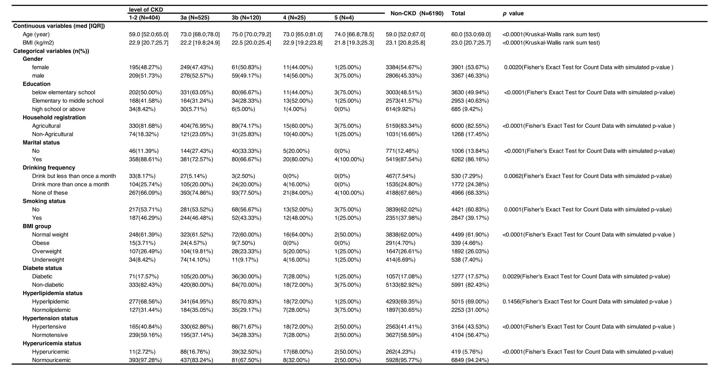
Abbreviations: IQR, Interquartile range; BMI, body mass index; CKD stage 1-2：eGFR ≥ 60 ml/min/1.73m² but previously diagnosed with CKD, CKD stage 3a: 45≤ eGFR <60 ml/min/1.73m², CKD stage 3b: 30≤ eGFR <45 ml/min/1.73m², CKD stage 4-5: eGFR<30 ml/min/1.73m²; BMI: underweight: <18.5kg/m², normal weight: 18.5--25kg/m², overweight: 25--30kg/m², obesity: ≥30 kg/m²

Table 1: Demographic characters of different CKD stages

.

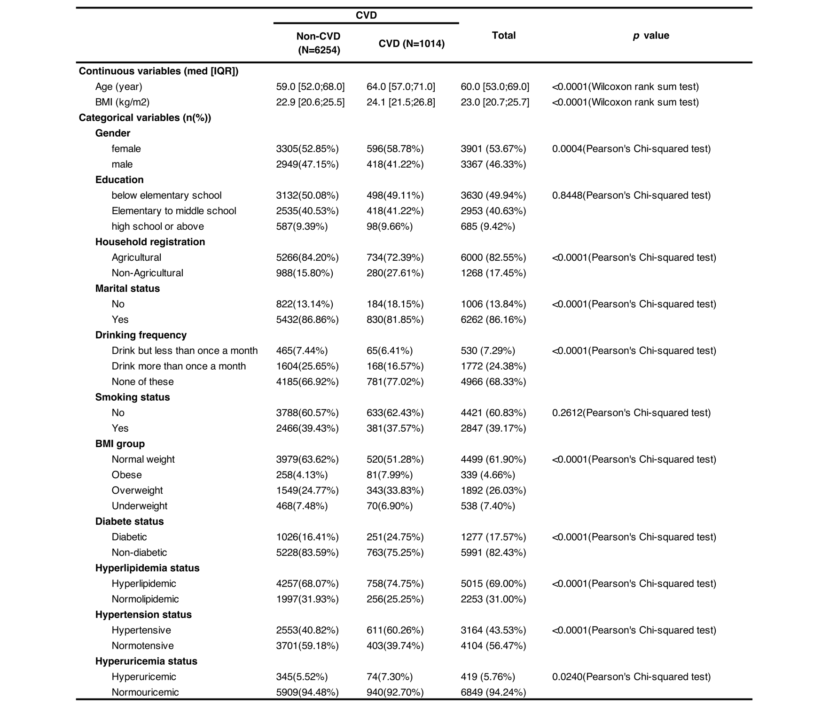
Table 2: Demographic characters of different CVD stages

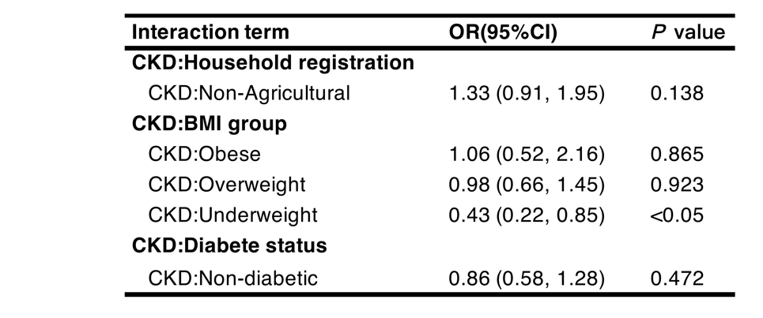
Table 3: Analysis of CKD-related interactions affecting the occurrence of CVD
Logistic regression analysis was used for interaction terms

