Table 1 Physical data of synthesized compounds
Sr. No. | Molecular Formula | Molecular Weight | M.P.  °C | %  Yield | Elemental Analysis  R= Required, F= Found
 |  |  |  |  |  | %C | %H | %N
5K1 | C₃₃H₃₇O₅N₅S | 615.74 | 237 | 79 | R  F | 64.37  64.21 | 6.06  5.97 | 11.37  11.23
5K2 | C₃₃H₄₁O₄N₅S | 603.77 | 248 | 73 | R  F | 65.65  65.49 | 6.84  6.75 | 11.60  11.46
5K3 | C₃₂H₃₀O₂N₈S | 590.70 | 261 | 84 | R  F | 65.07  61.97 | 5.12  4.91 | 18.97  18.76
5K4 | C₃₂H₂₉O₂N₅S | 547.67 | 277 | 81 | R  F | 70.18  69.97 | 5.34  5.29 | 12.79  12.66
5K5 | C₂₈H₃₂O₄N₈S | 576.67 | 243 | 77 | R  F | 58.32  58.23 | 5.59  5.48 | 19.43  19.28
5K6 | C₂₆H₂₉O₄N₉S | 563.63 | 273 | 88 | R  F | 55.40  55.33 | 5.19  5.11 | 22.37  22.27
5K7 | C₃₄H₄₁O₆N₅S | 647.78 | 289 | 64 | R  F | 63.04  62.97 | 6.38  6.31 | 10.81  10.65
5K8 | C₃₅H₃₅O₃N₆SCl | 655.21 | 262 | 58 | R  F | 64.16  63.92 | 5.38  5.29 | 12.83  12.72
5K9 | C₂₉H₃₄O₃N₆S | 546.68 | 255 | 72 | R  F | 63.71  63.62 | 6.27  6.23 | 15.37  15.30
5K10 | C₂₈H₃₂O₄N₄S | 520.64 | 283 | 74 | R  F | 64.59  64.43 | 6.20  6.12 | 10.76  10.62
5K11 | C₃₂H₃₄O₂N₄S₃ | 602.83 | 249 | 63 | R  F | 63.76  63.66 | 5.68  5.63 | 9.29  9.21
5K12 | C₃₆H₃₆O₅N₄S | 636.76 | 284 | 69 | R  F | 67.90  67.77 | 5.70  5.66 | 8.80  8.75
5K13 | C₂₇H₂₆O₂N₁₂S | 582.64 | 280 | 71 | R  F | 55.66  55.60 | 4.50  4.44 | 28.85  28.77
5K14 | C₂₇H₂₆O₂N₁₂S₂ | 614.70 | 254 | 67 | R  F | 52.76  52.72 | 4.26  4.19 | 27.34  27.28

Table 2 Antibacterial activity of Various N-halogenated coupling compounds derivatives

Compounds | IC₅₀ ± SEM (µM)  E.coli PDF-Ni | MIC ± SEM (µg/ml)
Compounds | IC₅₀ ± SEM (µM)  E.coli PDF-Ni | E.coli | B.subtilis
5K1 | 21 | 24 | 27
5K2 | 16 | 26 | 32
5K3 | 18 | 17 | 22
5K4 | 26 | 20 | 31
5K5 | 26 | 12 | 14
5K6 | 36 | 18 | 29
5K7 | 27 | 22 | 30
5K8 | 17 | 11 | 13
5K9 | 27 | 24 | 21
5K10 | 33 | 27 | 35
5K11 | 25 | 21 | 23
5K12 | 32 | 26 | 22
5K13 | 28 | 23 | 24
5K14 | 23 | 20 | 26
Ciprofloxacin | ND | 25 | 46
Table 3 Structure Activity Relationship strategy of Various N-halogenated coupling compounds derivatives
Sr. No | Active M-X bond (effective for SARª) | Bond distance  (M-X)^{b} | E_{HOMO}  (ev) | E_{LUMO} (ev) | Band gap  (ev)^{c} | Total Energy (Kcal/mol)^{d}
5K1 | 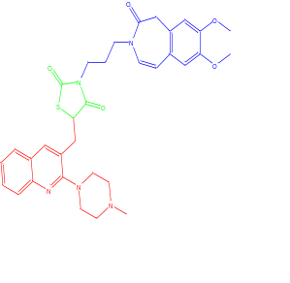 | N-N= 4.856 Å | -9.709 | -1.924 | 7.785 | 10.7497
5K2 | 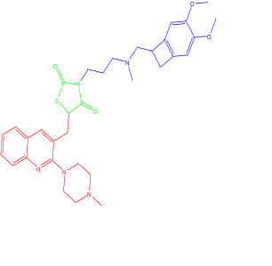 | N-N= 4.846 Å | -6.337 | -1.702 | 4.635 | 9.7119
5K3 | 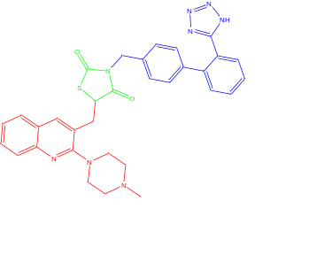 | N-C= 2.407 Å | -9.936 | -1.219 | 8.117 | 60.2123
5K4 | 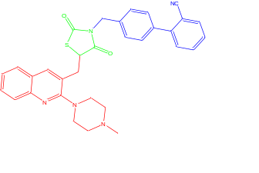 | N-C= 2.407 Å | -11.032 | -3.116 | 7.916 | 59.5064
5K5 | 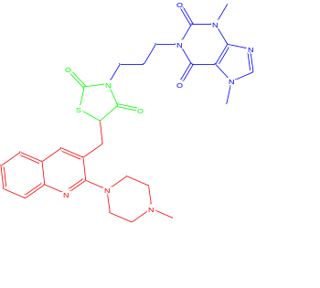 | N-N= 4.856 Å | -9.683 | -1.815 | 7.868 | 9.7119
5K6 | 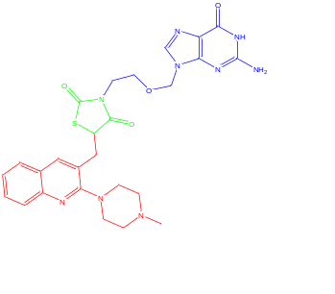 | N-N= 5.958 Å | -6.914 | 3.025 | 9.939 | 5.4093
5K7 | 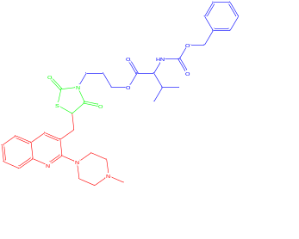 | N-N= 7.551 Å | -10.616 | 0.214 | 10.83 | 3.6987
5K8 | 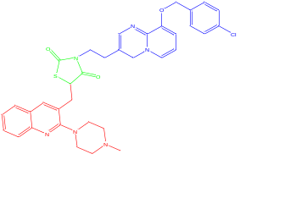 | N-C= 3.80 Å | -7.929 | 0.350 | 8.279 | 15.3975
5K9 | 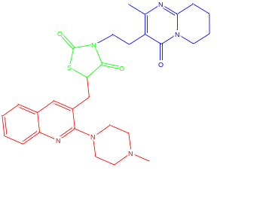 | N-C= 3.742 Å | - 8.257 | 1.286 | 9.543 | 33.2340
5K10 | 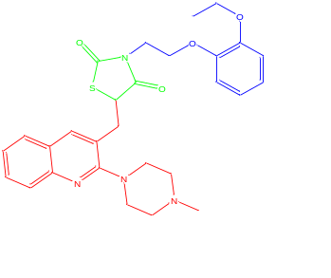 | N-C= 4.697 Å | -10.917 | 1.10 | 12.017 | 11.3975
5K11 | 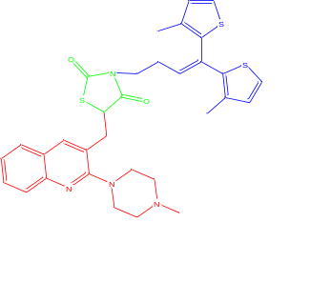 | N-C= 3.742 Å | -7.089 | 0.059 | 7.148 | 34.1183
5K12 | 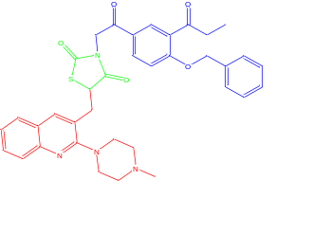 | N-C= 3.122 Å | -10.664 | -4.338 | 6.326 | 34.7356
5K13 | 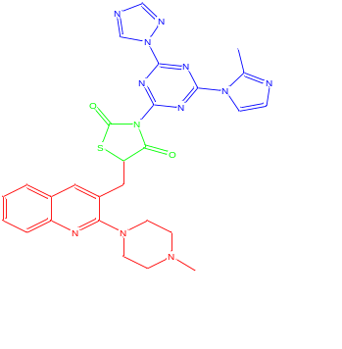 | N-C= 1.277 Å | -6.723 | -0.833 | 7.556 | 69.5690
5K14 | 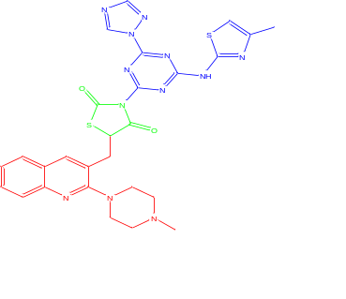 | N-C= 1.277 Å | -6.414 | 1.649 | 8.063 | 67.0825
Ciprofloxacin

