Novel growth models of three valuable timber species from the Brazilian Atlantic Forest
João Paulo Bispo Santos^{a,c}, Angélica Faria de Resendeª, Allana Katiussya Silva Pereiraª, Miguel Luiz Menezes Freitas^{d}; Mark S. Ashton^{e}, Florencia Montagnini^{e}, Pedro Henrique Santin Brancalion^{a,f}, Daniel Piotto^{g}; Ricardo Ribeiro Rodrigues^{a,f}; Vinicius Castro Souza^{b,c}
ª Department of Forest Sciences, “Luiz de Queiroz” College of Agriculture, University of São Paulo, Av. Pádua Dias 11, Piracicaba 13418-900, SP, Brazil
^{b} Department of Biological Sciences, “Luiz de Queiroz” College of Agriculture, University of São Paulo, Av. Pádua Dias 11, Piracicaba 13418-900, SP, Brazil
^{c} Department of Plant Biology, State University of Campinas (UNICAMP), University City Zeferino Vaz, Campinas 13083-862, SP, Brazil
^{d} Institute of Environmental Research – IPA, Horto Street 931, Luiz Antônio 02377-000, SP, Brazil
^{e} The Forest School at Yale School of the Environment, New Haven, CT 06511, USA
^{f} Re.green, Praça Santos Dumont, 70—4th Floor, Gávea, Rio de Janeiro 22470-060, RJ, Brazil
^{g} Training Center in Agroforestry Sciences, Federal University of Southern Bahia, Itabuna 45613-204, BA, Brazil
Corresponding author: bisposjp@gmail.com; j264731@dac.unicamp.br

Supplementary material
Supplementary material 2 | Data binning and raw data approach comparison
As discussed in the main text, regression models are typically constructed by fitting linear or nonlinear regressions directly to log-transformed raw data. However, even when the dependent variable is log-transformed, this approach can introduce a regression dilution bias that underestimates the regression slope. Using stem diameter (D) and total height (Ht) data from each species, our preliminary analysis showed that fitting nonlinear least squares regression using binned data instead of raw data to model the relationship between D:Age and Ht:D (on a log-log scale) yielded much less systematically biased estimates of D and Ht for all species-specific growth models (see orange lines in Figure S1). Specifically, the model fitted to raw data tended to overestimate D and Ht for small trees and underestimate D and Ht for large trees.
We compared the performance of the binned approach and the raw data approach by fitting the best-fitting models of each species using these approaches. Specifically, we (i) binned the database into a training set (60% of the data) and a validation set with the remaining 40% of the data randomly selected using a size-stratified random sampling approach. We then (ii) used the training data set to model the relationship between D:Age and Ht:D using each of the two modeling approaches(i.e., raw and binned data approaches). For all models fitted to the above modeling approaches, the data binning approach reduced the systematic bias in the model predictions compared to the traditional raw data approach (Figure S1). Specifically, the data binning approach was able to better estimate the true scaling coefficient of the D:Age and Ht:D relationships.

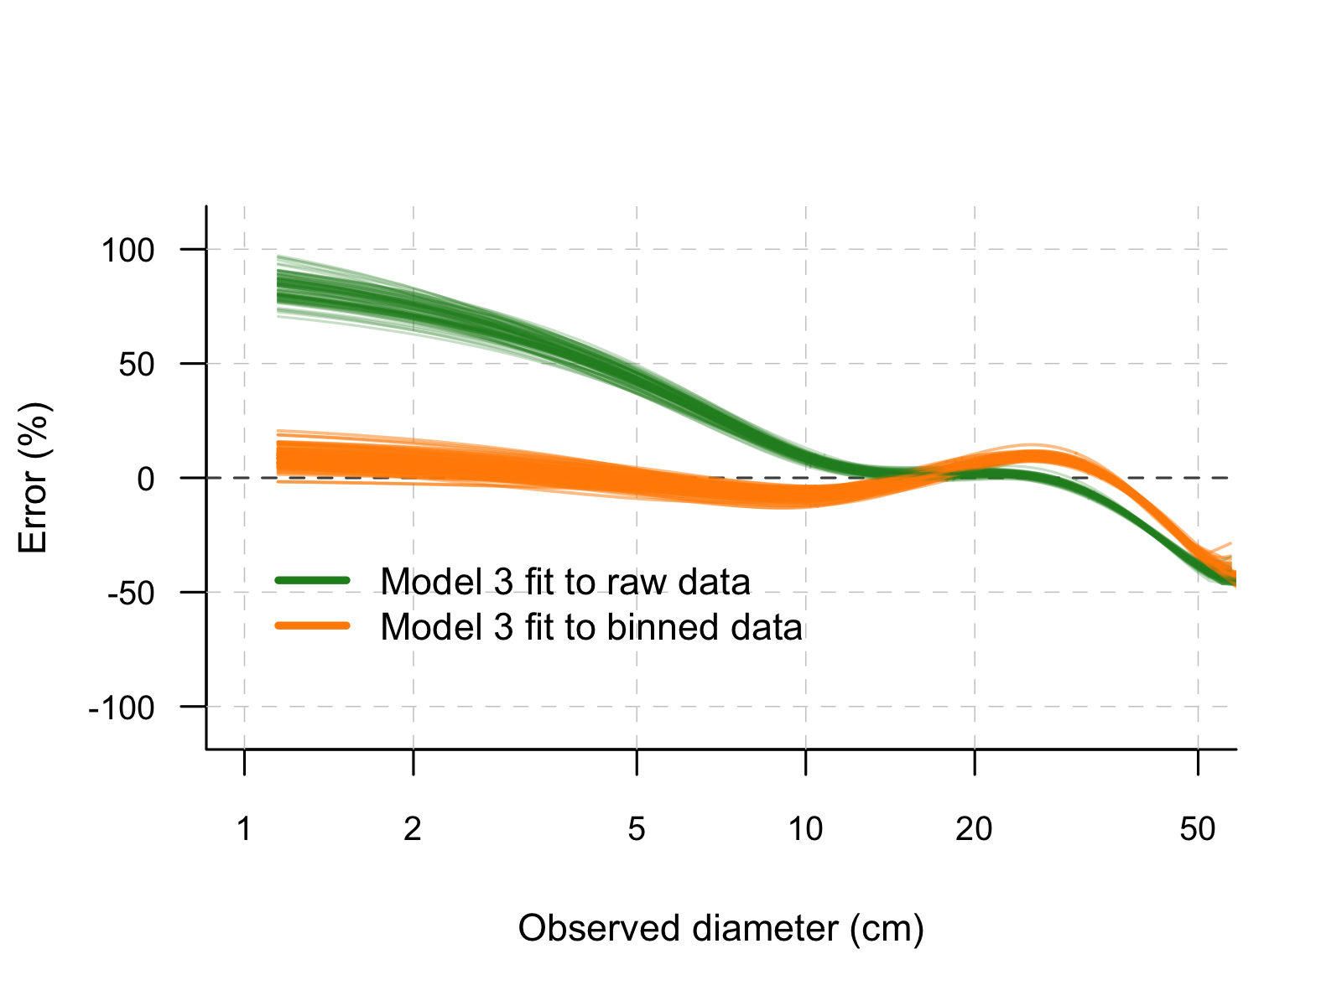
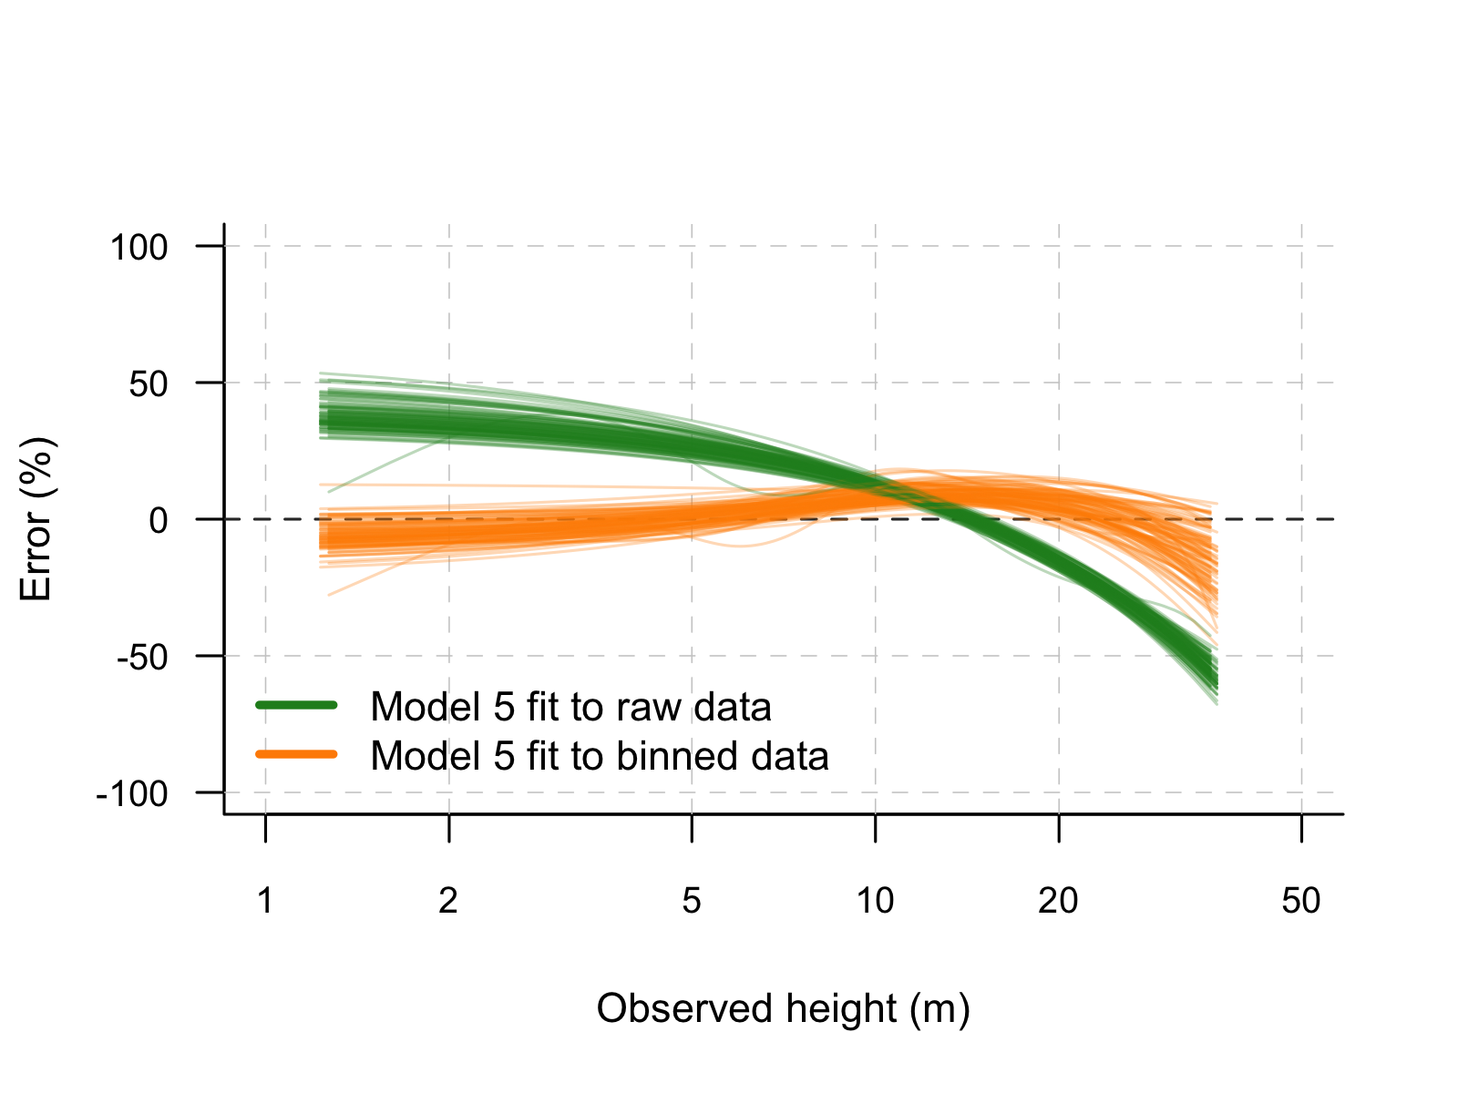
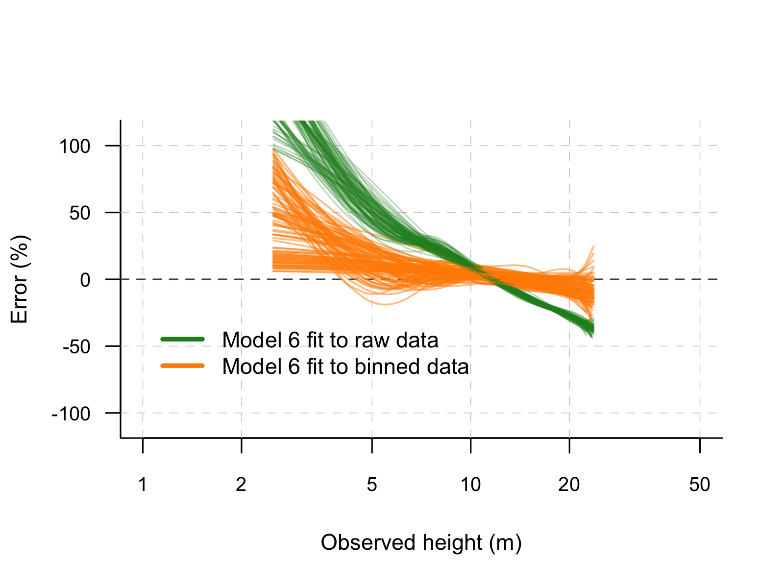
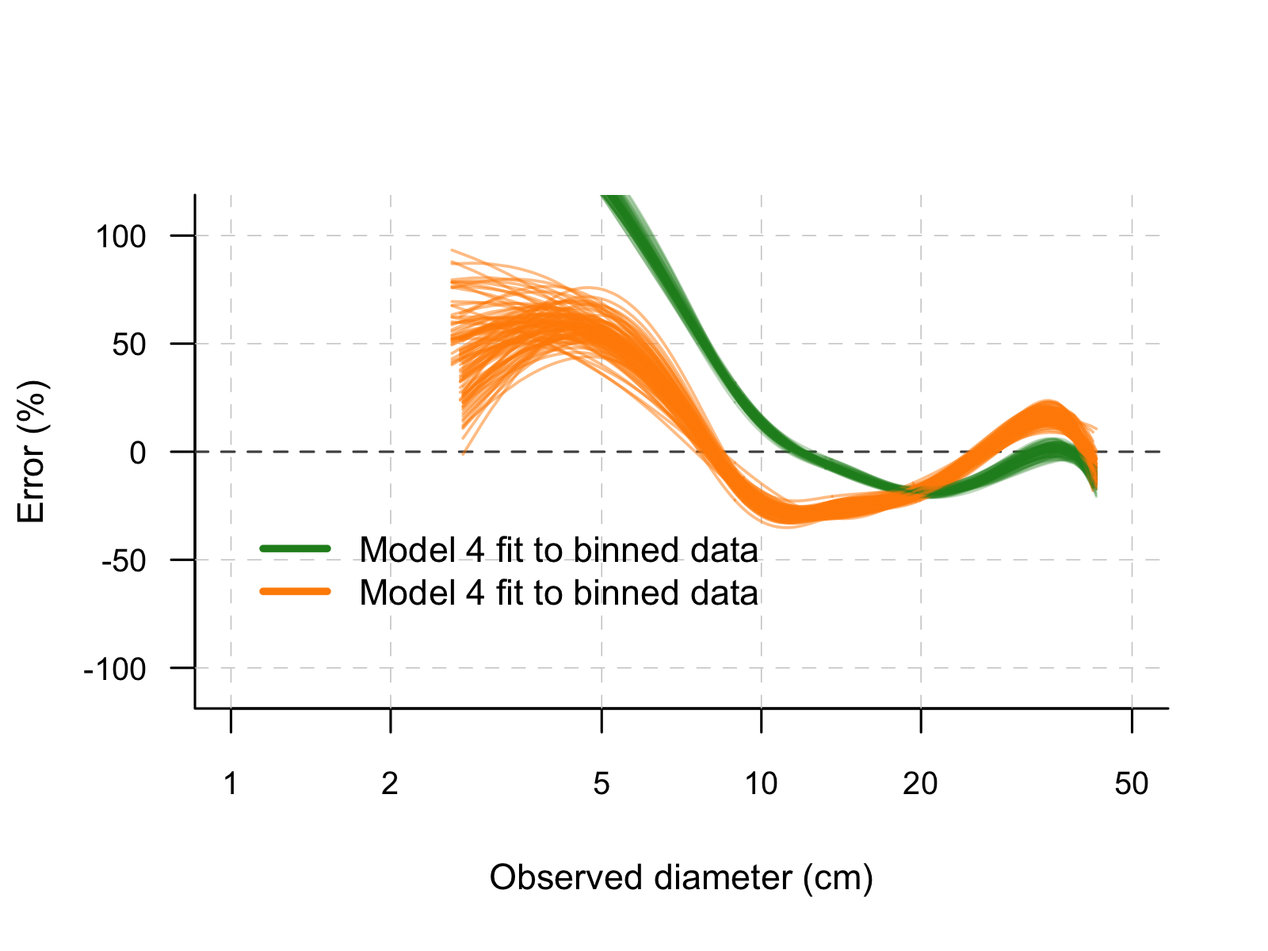
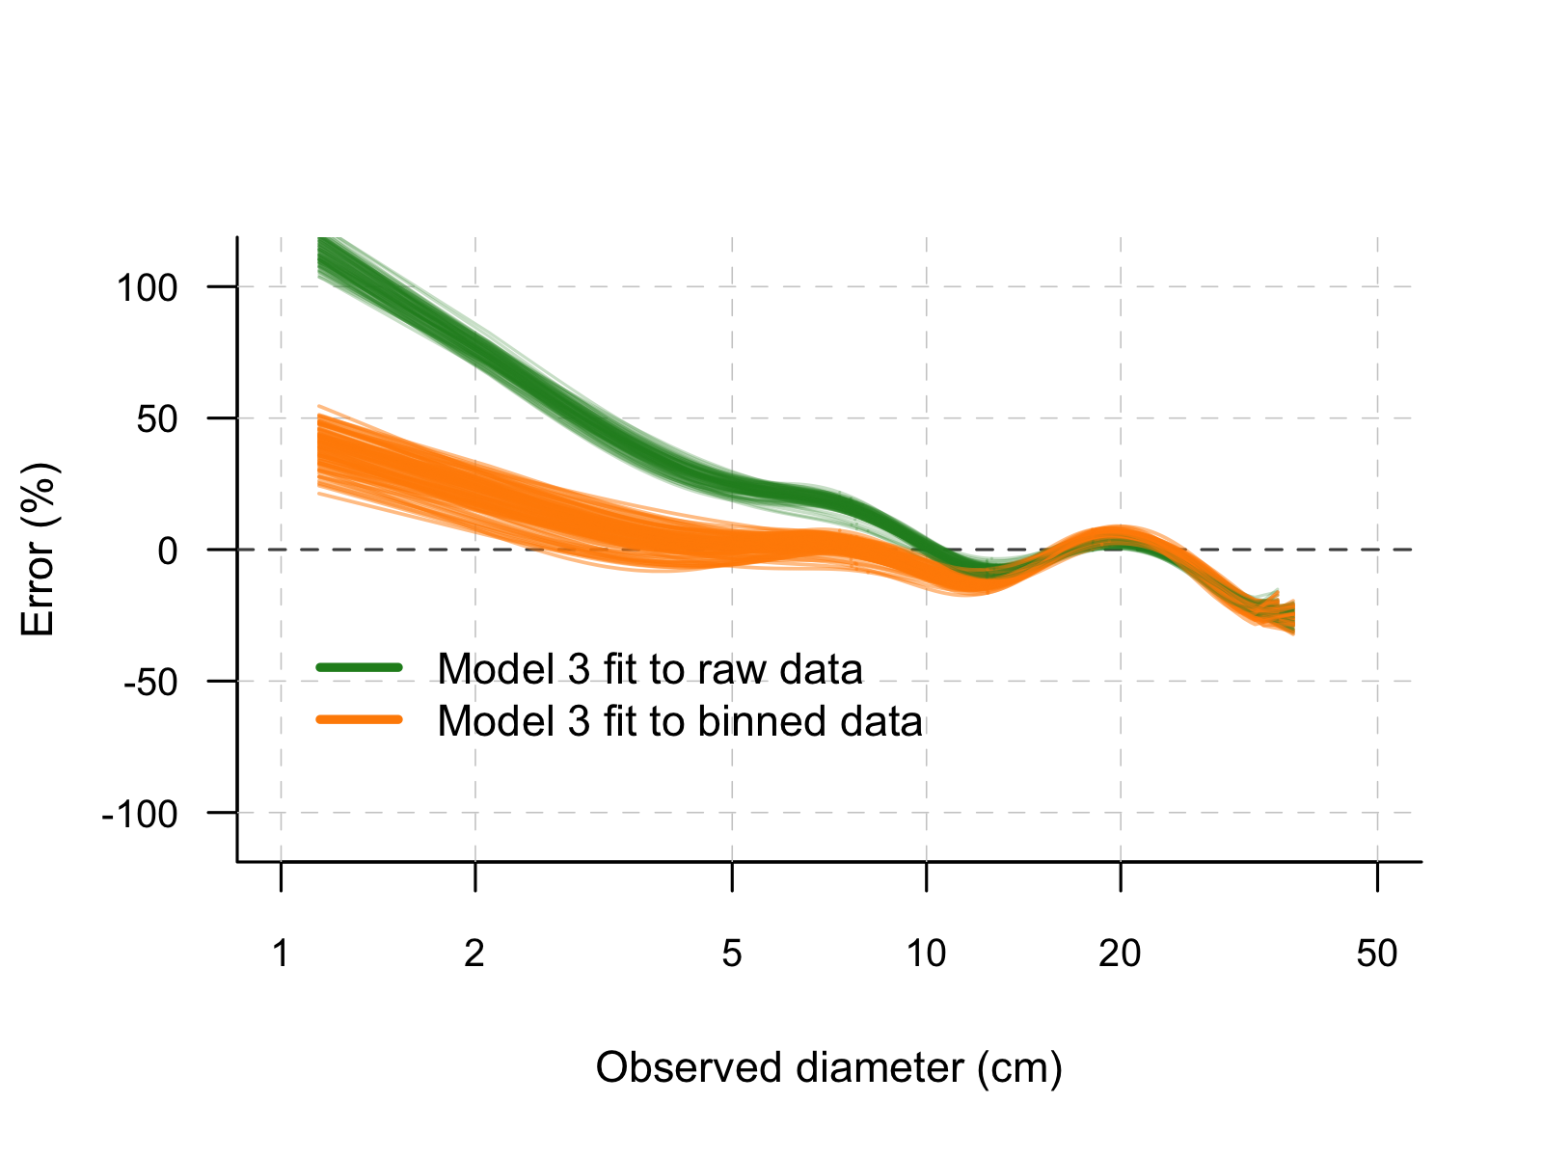
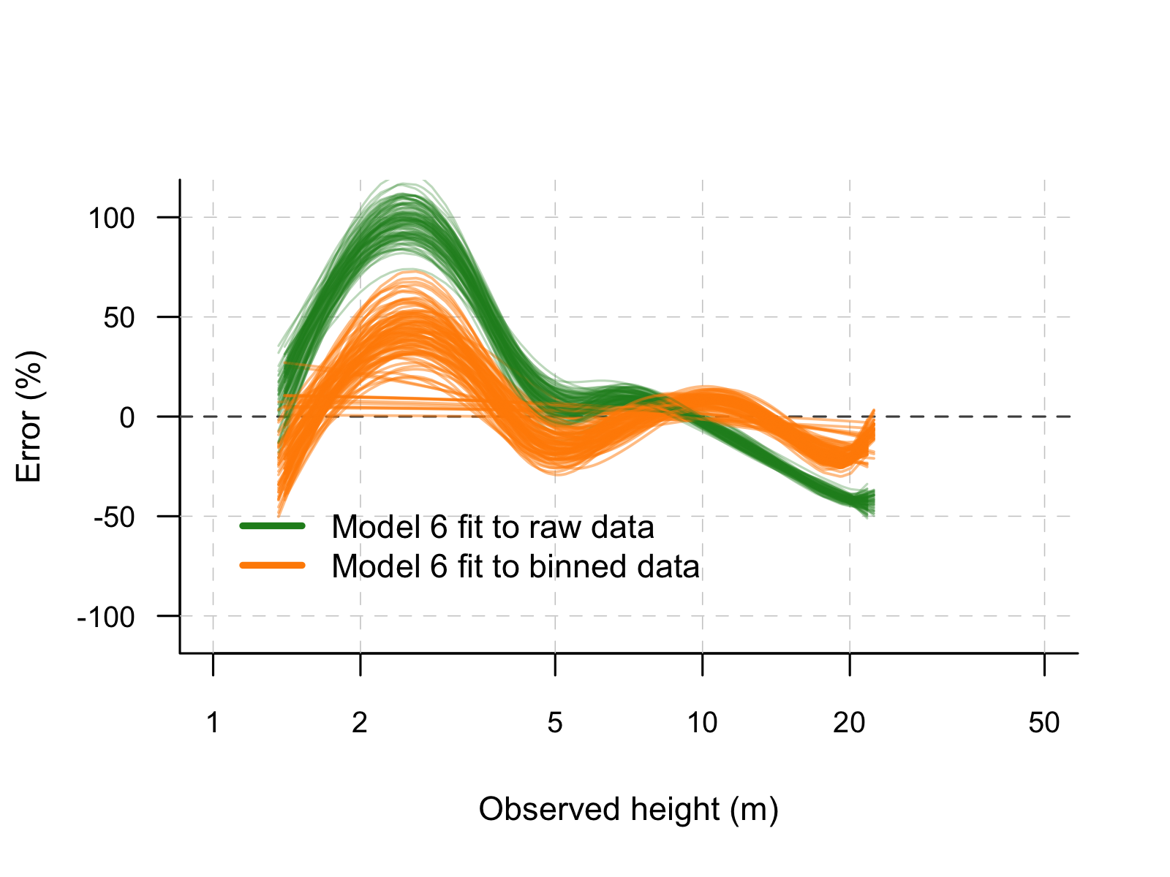
Figure S1 – Relative error as a function of tree size for the two modeling approaches (i.e., raw and binned data) used to fit diameter and total tree height growth models. Panels a-b) Cariniana legalis, c-d) Dalbergia nigra; e-f) Zeyheria tuberculosa. Relative errors were calculated for a random subset of trees, corresponding to 40% of the data, used exclusively for model validation. This randomization procedure was repeated 100 times to avoid the randomization procedure in step (i) having an undue effect on the model evaluation process, and at each iteration regression splines were used to illustrate how the magnitude of the relative errors varies as a function of tree size for each modeling approach.
(a)
(b)
(c)
(d)
(e)
(f)

