Supplementary Figures and Tables

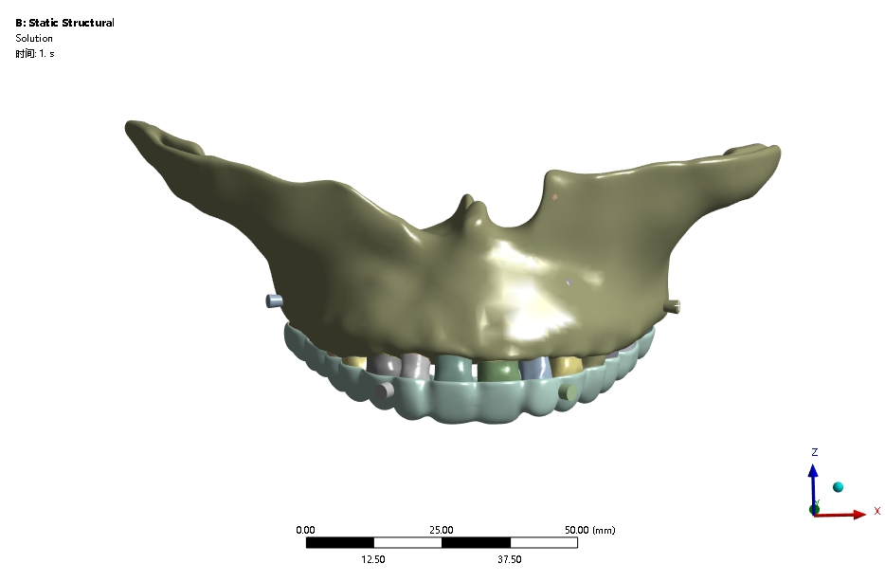
Supplementary Figure 1. The constructed three-dimensional finite element model

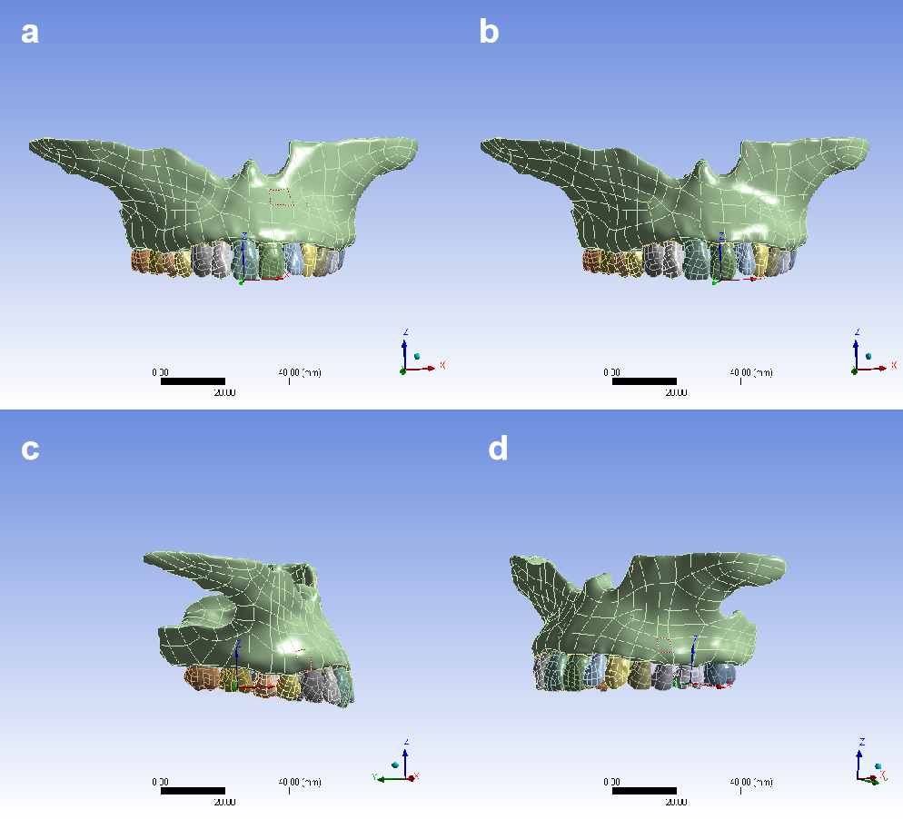
Supplementary Figure 2. Establishment of coordinate system. (a) right central incisor (b) left central incisor (c) right first molar (d) left first molar

Supplementary Table 1. The process of maxillary second molar distalization from the beginning to the desired position (a distance of 2.0 mm)
Teeth | Step 1 | Step 2 | Step 3 | Step 4 | Step 5 | Step 6 | Step 7 | Step 8 | Step 9
Second molars | 0.3 mm | 0.3 mm | 0.3 mm | 0.3 mm | 0.3 mm | 0.3 mm | 0.2 mm | 0 | ...
First molars | 0 | 0 | 0 | 0.3 mm | 0.3 mm | 0.3 mm | 0.3 mm | 0.3 mm | ...
Second premolars | 0 | 0 | 0 | 0 | 0 | 0 | 0 | 0.3 mm | ...
Tips: ①the Step 1, 2, 4, 5, and 8 were simulated utilizing the FEM and demonstrated in this study; ②Prior to the commencement of bilateral first molar movement (Step 4), the patient underwent a Cone Beam Computed Tomography (CBCT) scan and a digital model capture again in anticipation of mini-screw implantation. Additionally, the patient wore Class II elastics as a preparatory device before the mini-screws were implanted.

