Fairbairn et al. Supplement S1

Site summary statistics
Table 1 Summary statistics of 86 sites acoustically monitored in Munich, Germany. Week refers to the specific week number of the year when recordings started; days is the total number of days recorded. For vegetation volume and NDVI, only the values in the 100m buffer are shown. Biodiversity metrics include species richness, vocal activity rate (VAR), and Shannon diversity index.
site | week | days | vegetation volume | NDVI | richness | VAR | Shannon
1 | 14 | 7 | 1.65 | 0.23 | 28 | 92.29 | 2.61
2 | 14 | 7 | 2.07 | 0.35 | 29 | 105.86 | 2.44
3 | 14 | 7 | 1.53 | 0.25 | 20 | 59.43 | 2.43
5 | 14 | 7 | 0.36 | 0.27 | 39 | 161 | 2.69
6 | 14 | 7 | 2.49 | 0.3 | 23 | 61.14 | 2.12
7 | 14 | 7 | 2.02 | 0.39 | 35 | 100.57 | 2.9
8 | 14 | 7 | 2.92 | 0.45 | 39 | 190.29 | 2.79
9 | 14 | 6.96 | 1.37 | 0.46 | 42 | 224.62 | 2.9
11 | 14 | 7 | 4.9 | 0.42 | 27 | 122.71 | 2.13
12 | 14 | 7 | 3.18 | 0.47 | 37 | 160.57 | 2.62
13 | 14 | 7 | 2.19 | 0.44 | 32 | 106.71 | 2.44
14 | 14 | 7 | 1.48 | 0.36 | 40 | 165.57 | 2.78
16 | 14 | 7 | 11.02 | 0.7 | 38 | 273 | 2.76
17 | 14 | 7 | 7.93 | 0.61 | 26 | 78.29 | 2.59
18 | 14 | 5 | 8.11 | 0.59 | 42 | 158 | 2.94
19 | 14 | 7 | 10.34 | 0.67 | 42 | 193.86 | 2.92
21 | 14 | 7 | 12.55 | 0.71 | 38 | 271.57 | 2.72
24 | 14 | 7 | 4.26 | 0.55 | 45 | 272.86 | 2.94
25 | 29 | 7 | 0.18 | 0.12 | 8 | 25.86 | 1.26
26 | 27 | 6 | 1.15 | 0.2 | 9 | 24 | 1.06
27 | 31 | 7 | 1.49 | 0.25 | 9 | 7.14 | 1.72
28 | 31 | 7 | 1.15 | 0.25 | 23 | 34 | 2.59
29 | 27 | 7 | 1.04 | 0.28 | 26 | 83.43 | 2.17
30 | 29 | 7 | 1.9 | 0.27 | 8 | 9.71 | 1.41
31 | 27 | 7 | 0.73 | 0.23 | 18 | 47 | 1.78
32 | 29 | 3.83 | 2.25 | 0.35 | 23 | 44.35 | 2.8
33 | 31 | 7 | 2.28 | 0.53 | 34 | 97 | 2.81
34 | 31 | 7 | 0.67 | 0.23 | 5 | 2 | 1.55
35 | 27 | 7 | 0.92 | 0.26 | 28 | 56 | 2.36
36 | 29 | 7 | 1.07 | 0.63 | 27 | 42.71 | 2.82
37 | 27 | 7 | 1.89 | 0.5 | 36 | 111.86 | 3.05
39 | 31 | 7 | 1.06 | 0.58 | 39 | 71.43 | 2.97
40 | 27 | 7 | 2.01 | 0.27 | 15 | 68.86 | 1.16
41 | 29 | 6 | 3.47 | 0.34 | 21 | 39 | 2.31
42 | 31 | 7 | 0.44 | 0.31 | 19 | 20.29 | 2.42
43 | 31 | 7 | 1.89 | 0.32 | 29 | 47.57 | 3
44 | 27 | 7 | 2.38 | 0.38 | 29 | 58.57 | 2.83
45 | 29 | 3.83 | 2.57 | 0.37 | 15 | 44.61 | 1.84
46 | 27 | 7 | 0.49 | 0.36 | 36 | 133.29 | 2.2
47 | 29 | 3.83 | 1.35 | 0.34 | 20 | 109.57 | 2.38
48 | 31 | 5 | 3.07 | 0.42 | 19 | 22.2 | 2.54
49 | 27 | 7 | 0.87 | 0.32 | 24 | 75.43 | 2.38
50 | 31 | 7 | 0.29 | 0.43 | 29 | 68 | 2.54
51 | 29 | 7 | 1.35 | 0.4 | 36 | 121.14 | 2.9
52 | 29 | 7 | 0.59 | 0.48 | 44 | 111.29 | 2.98
53 | 31 | 7 | 0.03 | 0.24 | 17 | 34.43 | 1.95
54 | 27 | 7 | 4.62 | 0.68 | 48 | 272.43 | 2.83
55 | 29 | 3.83 | 8.57 | 0.51 | 16 | 40.43 | 2.26
56 | 31 | 7 | 2.75 | 0.3 | 15 | 15.29 | 2.44
57 | 27 | 7 | 4.16 | 0.41 | 23 | 70.14 | 2.22
58 | 27 | 7 | 4.67 | 0.48 | 27 | 69.14 | 2.53
59 | 29 | 3.83 | 4.18 | 0.49 | 28 | 93.13 | 2.52
60 | 31 | 7 | 3.48 | 0.48 | 26 | 75.71 | 2.71
62 | 31 | 7 | 2.3 | 0.44 | 32 | 84 | 2.7
63 | 27 | 7 | 2.92 | 0.58 | 30 | 148 | 2.68
64 | 31 | 7 | 0.68 | 0.46 | 20 | 33.86 | 2.18
65 | 27 | 6.83 | 2.71 | 0.59 | 38 | 168.29 | 2.79
66 | 29 | 7 | 2.1 | 0.45 | 40 | 168.86 | 2.95
67 | 29 | 6.58 | 6.01 | 0.62 | 32 | 118.48 | 2.81
68 | 31 | 7 | 0.23 | 0.34 | 7 | 7.14 | 1.49
70 | 29 | 7 | 6.56 | 0.5 | 17 | 44.14 | 2.15
71 | 31 | 7 | 9.27 | 0.58 | 20 | 54.57 | 2.53
72 | 27 | 5 | 6.22 | 0.51 | 34 | 212.4 | 2.42
73 | 31 | 7 | 2.02 | 0.47 | 27 | 38.14 | 2.91
74 | 27 | 7 | 3.14 | 0.48 | 33 | 113.86 | 2.39
75 | 29 | 7 | 3.18 | 0.42 | 30 | 93.71 | 2.8
76 | 29 | 3.67 | 2.53 | 0.47 | 33 | 118.64 | 2.94
77 | 29 | 2.58 | 5.35 | 0.59 | 22 | 82.84 | 2.76
78 | 31 | 7 | 11.09 | 0.64 | 26 | 59.43 | 2.58
79 | 27 | 7 | 6.09 | 0.59 | 37 | 154.29 | 2.8
80 | 31 | 7 | 6.71 | 0.63 | 29 | 41.43 | 2.79
81 | 27 | 7 | 0.53 | 0.4 | 33 | 94.71 | 2.73
82 | 29 | 3.83 | 4.94 | 0.55 | 10 | 13.04 | 2.03
83 | 31 | 7 | 2.04 | 0.63 | 35 | 73.29 | 2.79
86 | 29 | 3.83 | 12.88 | 0.7 | 20 | 78.26 | 2.55
87 | 31 | 7 | 8.25 | 0.45 | 9 | 5 | 2
88 | 27 | 7 | 2.93 | 0.32 | 16 | 33.86 | 1.21
89 | 27 | 7 | 7.64 | 0.67 | 35 | 201.86 | 2.67
91 | 31 | 7 | 5.89 | 0.56 | 31 | 37.57 | 2.95
92 | 31 | 6 | 2.73 | 0.46 | 23 | 48.67 | 2.11
94 | 29 | 3.83 | 9.95 | 0.62 | 27 | 119.22 | 2.49
95 | 31 | 7 | 10.75 | 0.7 | 23 | 60 | 2.4
96 | 27 | 7 | 8.85 | 0.6 | 35 | 128.57 | 2.9
97 | 31 | 7 | 0.93 | 0.47 | 18 | 27.57 | 2.07
98 | 27 | 7 | 6.81 | 0.69 | 33 | 134.43 | 2.58
99 | 29 | 6.54 | 8.99 | 0.66 | 21 | 68.03 | 2.29

Correlation of mean NDVI and log mean vegetation volume.
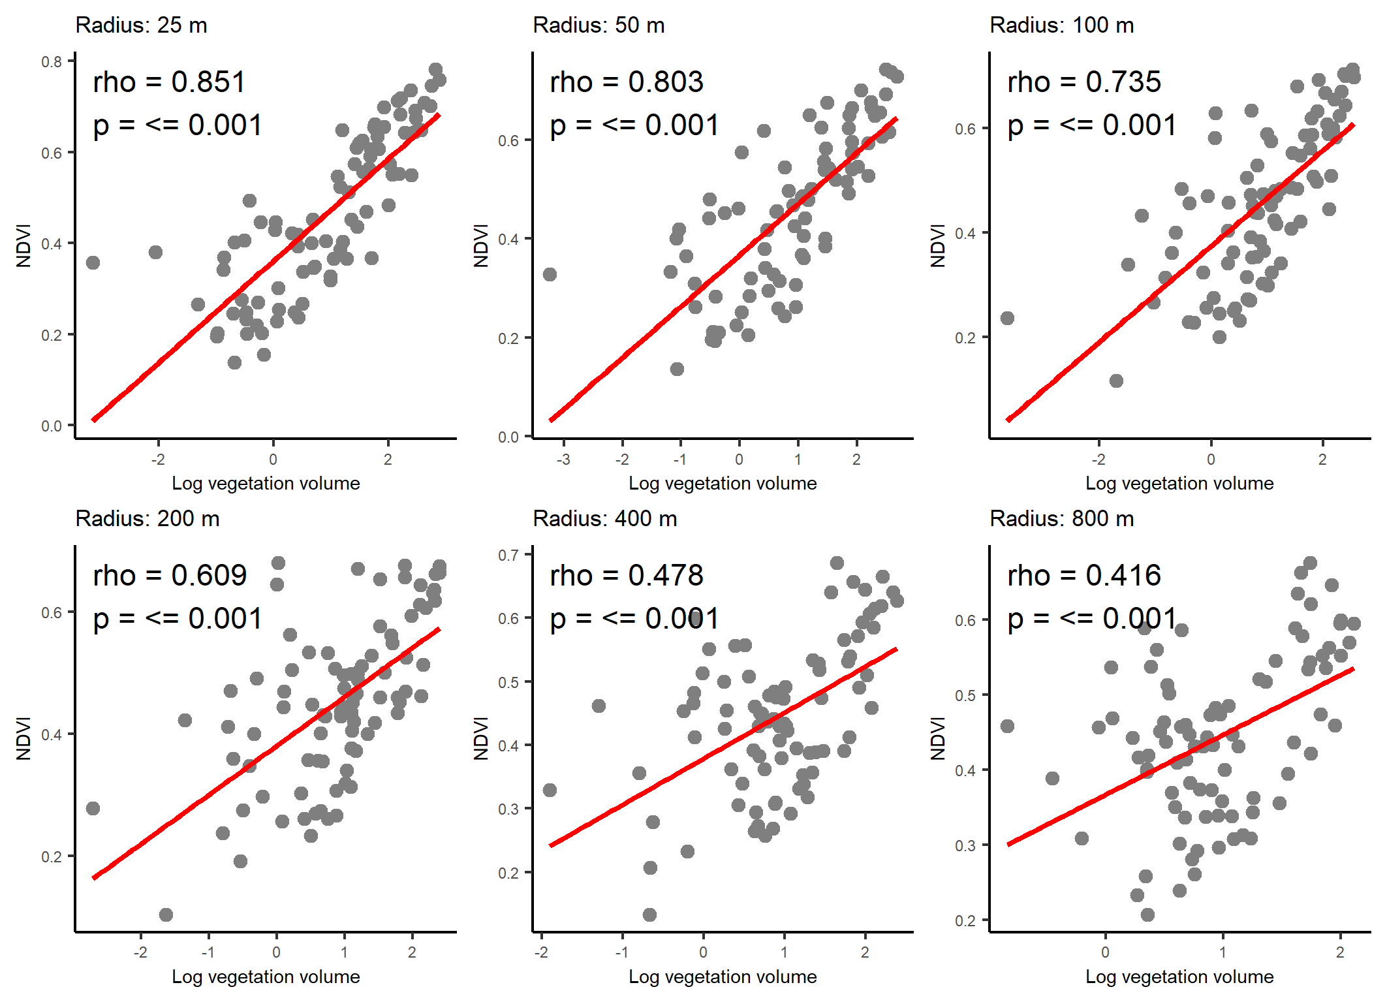
Fig. 1 Relationship between log-transformed vegetation volume and Normalized Difference Vegetation Index (NDVI) at six different spatial scales (radii: 25m, 50m, 100m, 200m, 400m, and 800m). Red lines indicate linear regression fits. Spearman's rank correlation coefficients (rho) and corresponding p-values are displayed in the top-left corner of each subplot

Species detected in Munich, Germany from 86 sites
Table 2 Species found via acoustic monitoring and automatic identification with BirdNET on 86 sites in Munich, Germany. N sites is the number of sites the species was detected on. Min, mean, sd, and max vocal activity rate (VAR) are presented. Dominant habitat is also presented.
 |  | VAR
scientific name | n sites | min | mean ± sd | max | total | habitat
Accipiter nisus | 3 | 0.60 | 2.34 ± 1.51 | 3.29 | 7.02 | Forest
Actitis hypoleucos | 22 | 0.14 | 0.44 ± 0.47 | 2.43 | 9.68 | Wetland
Aegithalos caudatus | 27 | 0.14 | 0.9 ± 1.16 | 5.43 | 24.4 | Forest
Alauda arvensis | 3 | 3.86 | 5.94 ± 1.9 | 7.57 | 17.8 | Grassland
Alcedo atthis | 5 | 0.14 | 0.43 ± 0.23 | 0.71 | 2.16 | Riverine
Anas crecca | 10 | 0.29 | 0.37 ± 0.12 | 0.57 | 3.69 | Wetland
Anas platyrhynchos | 9 | 0.29 | 1.06 ± 0.82 | 2.86 | 9.55 | Wetland
Anser anser | 15 | 0.14 | 1.52 ± 2.03 | 7.71 | 22.8 | Wetland
Anthus trivialis | 54 | 0.14 | 1.04 ± 1.58 | 11.14 | 56.3 | Woodland
Apus apus | 59 | 0.14 | 7.04 ± 10.68 | 51.57 | 415 | Human Modified
Ardea cinerea | 40 | 0.14 | 0.61 ± 0.38 | 1.57 | 24.5 | Wetland
Branta canadensis | 1 | 0.29 | 0.29 ± NA | 0.29 | 0.29 | Grassland
Buteo buteo | 24 | 0.29 | 0.92 ± 0.91 | 4.29 | 22.1 | Grassland
Carduelis carduelis | 71 | 0.26 | 6.83 ± 9.52 | 44.14 | 485 | Woodland
Certhia brachydactyla | 68 | 0.14 | 5.5 ± 6.82 | 38.14 | 374 | Forest
Certhia familiaris | 6 | 0.43 | 0.94 ± 0.69 | 2.14 | 5.66 | Forest
Charadrius dubius | 4 | 0.14 | 0.35 ± 0.24 | 0.57 | 1.41 | Wetland
Chloris chloris | 65 | 0.14 | 7.19 ± 9.27 | 43.71 | 468 | Woodland
Ciconia ciconia | 3 | 0.14 | 0.52 ± 0.36 | 0.86 | 1.57 | Grassland
Coccothraustes coccothraustes | 66 | 0.29 | 2.12 ± 2.16 | 9.13 | 140 | Forest
Columba livia | 37 | 0.17 | 0.85 ± 1.33 | 7.29 | 31.5 | Human Modified
Columba oenas | 11 | 0.29 | 1.05 ± 0.98 | 3.29 | 11.5 | Woodland
Columba palumbus | 64 | 0.14 | 3.06 ± 4 | 24.30 | 196 | Woodland
Corvus corax | 7 | 0.14 | 0.25 ± 0.06 | 0.29 | 1.77 | Forest
Corvus cornix | 53 | 0.29 | 4.98 ± 5.29 | 32.00 | 264 | Human Modified
Corvus corone | 78 | 0.29 | 2.87 ± 2.38 | 11.71 | 224 | Human Modified
Corvus frugilegus | 65 | 0.29 | 2.89 ± 4.69 | 28.71 | 188 | Grassland
Corvus monedula | 4 | 0.14 | 1.29 ± 1.91 | 4.14 | 5.14 | Human Modified
Curruca curruca | 3 | 0.14 | 0.24 ± 0.08 | 0.29 | 0.71 | Shrubland
Cyanistes caeruleus | 66 | 0.14 | 4.67 ± 7.2 | 38.86 | 308 | Forest
Delichon urbicum | 23 | 0.14 | 1.78 ± 2.8 | 11.86 | 40.9 | Human Modified
Dendrocopos major | 74 | 0.29 | 6.61 ± 7.13 | 31.00 | 489 | Woodland
Dendrocoptes medius | 6 | 0.29 | 0.45 ± 0.28 | 1.00 | 2.72 | Woodland
Dryobates minor | 9 | 0.14 | 0.37 ± 0.19 | 0.71 | 3.29 | Forest
Dryocopus martius | 10 | 0.14 | 0.56 ± 0.49 | 1.57 | 5.58 | Forest
Emberiza citrinella | 8 | 0.29 | 13.43 ± 22 | 56.60 | 107 | Shrubland
Erithacus rubecula | 61 | 0.29 | 4.45 ± 4.71 | 22.80 | 272 | Forest
Falco tinnunculus | 30 | 0.14 | 1.56 ± 1.72 | 7.14 | 46.9 | Shrubland
Ficedula hypoleuca | 22 | 0.29 | 0.68 ± 0.49 | 2.14 | 15 | Forest
Fringilla coelebs | 39 | 0.14 | 5.52 ± 10.19 | 47.57 | 215 | Forest
Fulica atra | 29 | 0.29 | 1.41 ± 3.79 | 21.00 | 41 | Wetland
Gallinula chloropus | 25 | 0.14 | 0.64 ± 0.5 | 2.01 | 15.9 | Wetland
Garrulus glandarius | 39 | 0.14 | 1.02 ± 0.95 | 4.00 | 39.6 | Forest
Hirundo rustica | 10 | 0.20 | 1.03 ± 0.88 | 2.57 | 10.3 | Human Modified
Larus michahellis | 8 | 0.14 | 0.46 ± 0.29 | 1.04 | 3.71 | Human Modified
Lophophanes cristatus | 15 | 0.17 | 0.72 ± 1 | 3.86 | 10.8 | Woodland
Motacilla alba | 15 | 0.14 | 2.23 ± 2.94 | 11.29 | 33.4 | Human Modified
Motacilla cinerea | 27 | 0.14 | 0.64 ± 0.5 | 2.09 | 17.2 | Riverine
Motacilla flava | 3 | 0.29 | 1 ± 0.71 | 1.71 | 3 | Grassland
Muscicapa striata | 35 | 0.14 | 1.46 ± 1.33 | 6.43 | 50.9 | Forest
Nycticorax nycticorax | 15 | 0.29 | 0.94 ± 0.8 | 3.00 | 14.1 | Wetland
Oriolus oriolus | 3 | 0.57 | 0.62 ± 0.08 | 0.71 | 1.86 | Woodland
Parus major | 64 | 0.14 | 7.09 ± 10.84 | 36.43 | 454 | Woodland
Passer domesticus | 11 | 0.14 | 1.74 ± 1.76 | 5.71 | 19.1 | Human Modified
Passer montanus | 12 | 0.17 | 3.46 ± 5.01 | 16.71 | 41.5 | Woodland
Periparus ater | 13 | 0.26 | 4.92 ± 7.28 | 21.86 | 64 | Forest
Phasianus colchicus | 20 | 0.29 | 1.43 ± 3.04 | 13.94 | 28.6 | Human Modified
Phoenicurus ochruros | 36 | 0.14 | 2.8 ± 3.89 | 18.86 | 101 | Human Modified
Phoenicurus phoenicurus | 17 | 0.14 | 0.97 ± 1.19 | 4.14 | 16.5 | Woodland
Phylloscopus collybita | 59 | 0.17 | 8.78 ± 11.76 | 46.00 | 518 | Forest
Pica pica | 46 | 0.14 | 3.35 ± 4.03 | 14.73 | 154 | Human Modified
Picus viridis | 78 | 0.14 | 4.11 ± 4.04 | 20.86 | 321 | Forest
Poecile palustris | 46 | 0.14 | 1.62 ± 1.67 | 6.57 | 74.4 | Forest
Prunella modularis | 3 | 0.57 | 1.1 ± 0.58 | 1.71 | 3.31 | Forest
Pyrrhula pyrrhula | 12 | 0.29 | 1.52 ± 2.13 | 7.29 | 18.3 | Forest
Rallus aquaticus | 6 | 0.20 | 0.69 ± 0.93 | 2.57 | 4.15 | Wetland
Regulus ignicapilla | 18 | 0.29 | 0.96 ± 1.1 | 4.71 | 17.3 | Forest
Regulus regulus | 6 | 0.29 | 2.64 ± 3.48 | 9.43 | 15.8 | Forest
Serinus serinus | 9 | 0.14 | 1.59 ± 3.91 | 12.00 | 14.3 | Forest
Sitta europaea | 47 | 0.14 | 5.41 ± 9.91 | 47.00 | 254 | Forest
Spinus spinus | 15 | 0.29 | 0.52 ± 0.55 | 2.43 | 7.86 | Forest
Streptopelia decaocto | 29 | 0.29 | 2.09 ± 3.79 | 18.71 | 60.7 | Human Modified
Strix aluco | 39 | 0.43 | 4.44 ± 3.2 | 13.00 | 173 | Forest
Sturnus vulgaris | 2 | 0.29 | 0.43 ± 0.2 | 0.57 | 0.86 | Human Modified
Sylvia atricapilla | 46 | 0.14 | 5.47 ± 10.3 | 44.20 | 252 | Woodland
Sylvia borin | 3 | 0.40 | 0.66 ± 0.42 | 1.14 | 1.98 | Woodland
Tachybaptus ruficollis | 1 | 2.86 | 2.86 ± NA | 2.86 | 2.86 | Wetland
Tringa nebularia | 3 | 0.14 | 0.37 ± 0.21 | 0.57 | 1.1 | Wetland
Tringa ochropus | 33 | 0.14 | 0.53 ± 0.42 | 2.14 | 17.3 | Wetland
Troglodytes troglodytes | 20 | 0.14 | 3.6 ± 3.57 | 13.29 | 72 | Forest
Turdus merula | 64 | 0.14 | 4.81 ± 6.92 | 26.14 | 308 | Forest
Turdus philomelos | 62 | 0.29 | 0.87 ± 0.79 | 5.14 | 54.1 | Forest
Turdus pilaris | 32 | 0.14 | 1.11 ± 1.64 | 8.14 | 35.4 | Forest
Turdus viscivorus | 12 | 0.29 | 2.56 ± 7.56 | 26.57 | 30.7 | Forest
Upupa epops | 9 | 0.29 | 0.49 ± 0.2 | 0.86 | 4.43 | Grassland
Vanellus vanellus | 5 | 0.40 | 1.88 ± 2.35 | 6.00 | 9.4 | Wetland

ANOVA results from linear models for radius selection analyses
Table 3 ANOVA results from linear models for three diversity metrics (vocal activity rate (VAR), species richness, and Shannon diversity) and log mean vegetation volume and mean NDVI at six distance radii (25m, 50m, 100m, 200m, 400m, 800m) from 86 observation points in Munich, Germany.
radius | diversity metric | vegetation volume | covariates | adjusted R2
25 | richness | F_{1,82}=7.34; p=0.008 | week F_{1,82}=26.59; p≤0.001  distance F_{1,82}=23.59; p≤0.001 | 0.39
 | VAR | F_{1,82}=14.1; p≤0.001 | week F_{1,82}=51.44; p≤0.001  distance F_{1,82}=8.18; p=0.005 | 0.45
 | Shannon | F_{1,82}=10.58; p=0.002 | week F_{1,82}=4.18; p=0.044  distance F_{1,82}=13.09; p≤0.001 | 0.23
50 | richness | F_{1,82}=7.98; p=0.006 | week F_{1,82}=26.78; p≤0.001  distance F_{1,82}=23.76; p≤0.001 | 0.4
 | VAR | F_{1,82}=14.64; p≤0.001 | week F_{1,82}=51.73; p≤0.001  distance F_{1,82}=8.22; p=0.005 | 0.46
 | Shannon | F_{1,82}=15.22; p≤0.001 | week F_{1,82}=4.39; p=0.039  distance F_{1,82}=13.75; p≤0.001 | 0.26
100 | richness | F_{1,82}=8.90; p=0.004 | week F_{1,82}=27.05; p≤0.001  distance F_{1,82}=24; p≤0.001 | 0.4
 | VAR | F_{1,82}=13.02; p≤0.001 | week F_{1,82}=50.86; p≤0.001  distance F_{1,82}=8.09; p=0.006 | 0.45
 | Shannon | F_{1,82}=16.28; p≤0.001 | week F_{1,82}= 4.43; p=0.038  distance F_{1,82}=13.9; p≤0.001 | 0.27
200 | richness | F_{1,82}=5.39; p=0.02 | week F_{1,82}=26.01; p≤0.001  distance F_{1,82}=23.08; p≤0.001 | 0.38
 | VAR | F_{1,82}=8.4; p=0.005 | week F_{1,82}=48.39; p≤0.001  distance F_{1,82}=7.69; p=0.007 | 0.42
 | Shannon | F_{1,82}=9.36; p=0.003 | week F_{1,82}=4.12; p=0.046  distance F_{1,82}=12.92; p=0.003 | 0.22
400 | richness | F_{1,82}=5.6; p=0.02 | week F_{1,82}=26.07; p≤0.001  distance F_{1,82}=23.13; p≤0.001 | 0.38
 | VAR | F_{1,82}=9.14; p=0.003 | week F_{1,82}=48.78; p≤0.001  distance F_{1,82}=7.76; p=0.007 | 0.42
 | Shannon | F_{1,82}=6.1; p=0.016 | week F_{1,82}=3.97; p=0.05  distance F_{1,82}=12.46; p≤0.001 | 0.19
800 | richness | F_{1,82}=5.72; p=0.02 | week F_{1,82}=26.17; p≤0.001  distance F_{1,82}=23.16; p≤0.001 | 0.38
 | VAR | F_{1,82}=7.53; p=0.007 | week F_{1,82}=47.92; p≤0.001  distance F_{1,82}=7.62; p=0.007 | 0.41
 | Shannon | F_{1,82}=4.01; p=0.048 | week F_{1,82}=3.88; p=0.052  distance F_{1,82}=12.17; p≤0.001 | 0.17
radius | diversity metric | NDVI | covariates | adjusted R2
25 | richness | F1,82=8.31; p=0.005 | week F1,82=26.87; p≤0.001  distance F1,82=23.85; p≤0.001 | 0.4
 | VAR | F1,82=17.06; p≤0.001 | week F1,82=53.02; p≤0.001  distance F1,82=8.43; p=0.005 | 0.47
 | Shannon | F_{1,82}=14.33; p≤0.001 | week F_{1,82}=4.35; p=0.04  distance F_{1,82}=13.62; p≤0.001 | 0.26
50 | richness | F1,82=15.35; p≤0.001 | week F1,82=28.97; p≤0.001  distance F1,82=25.71; p≤0.001 | 0.44
 | VAR | F1,82=24.69; p≤0.001 | week F1,82=57.11; p≤0.001  distance F1,82=9.08; p=0.003 | 0.51
 | Shannon | F_{1,82}=25.13; p≤0.001 | week F_{1,82}=4.83; p=0.031  distance F_{1,82}=15.15; p≤0.001 | 0.33
100 | richness | F1,82=23.16; p≤0.001 | week F1,82=31.29; p≤0.001  distance F1,82=27.77; p≤0.001 | 0.48
 | VAR | F1,82=30.8; p≤0.001 | week F1,82=60.38; p≤0.001  distance F1,82=9.6; p=0.003 | 0.53
 | Shannon | F_{1,82}=28.76; p≤0.001 | week F_{1,82}=5; p=0.028  distance F_{1,82}=15.67; p≤0.001 | 0.35
200 | richness | F1,82=19.77; p≤0.001 | week F1,82=30.29; p≤0.001  distance F1,82=26.87; p≤0.001 | 0.47
 | VAR | F1,82=20.05; p≤0.001 | week F1,82=54.62; p≤0.001  distance F1,82=8.69; p=0.004 | 0.49
 | Shannon | F_{1,82}=20.69; p≤0.001 | week F_{1,82}=4.63; p≤0.034  distance F_{1,82}=14.52; p≤0.001 | 0.3
400 | richness | F1,82=14.87; p≤0.001 | week F1,82=28.8; p≤0.001  distance F1,82=25.56; p≤0.001 | 0.44
 | VAR | F1,82=9.75; p=0.002 | week F1,82=49.11; p≤0.001  distance F1,82=7.81; p=0.006 | 0.43
 | Shannon | F_{1,82}=12.45; p=0.001 | week F_{1,82}=4.26; p=0.042  distance F_{1,82}=13.36; p≤0.001 | 0.24
800 | richness | F1,82=13.51; p≤0.001 | week F1,82=28.42; p≤0.001  distance F1,82=13.19; p≤0.001 | 0.43
 | VAR | F_{1,82}=5.43; p=0.022 | week F_{1,82}=46.8; p≤0.001  distance F_{1,82}=7.44; p=0.008 | 0.4
 | Shannon | F_{1,82}=10.88; p=0.001 | week F_{1,82}=4.19; p=0.044  distance F_{1,82}=13.14; p≤0.001 | 0.23

Predictive modelling
Table 4: ANOVA results from a linear mixed effects models for predicting three diversity metrics based on NDVI and the covariates of recording week and distance to the city centre.
model | variable | F and p value | adjusted r-squared
richness | week | F_{1,65}=22.81; p≤0.001 | 0.49
 | distance | F_{1,65}=21.70; p≤0.001
 | NDVI | F_{1,65}=23.74; p≤0.001
VAR | week | F_{1,65}=48.53; p≤0.001 | 0.54
 | distance | F_{1,65}=5.14; p=0.003
 | NDVI | F_{1,65}=29.23; p≤0.001
Shannon | week | F_{1,65}=3.84; p=0.054 | 0.37
 | distance | F_{1,65}=12.77; p≤0.001
 | NDVI | F_{1,65}=25.52; p≤0.001

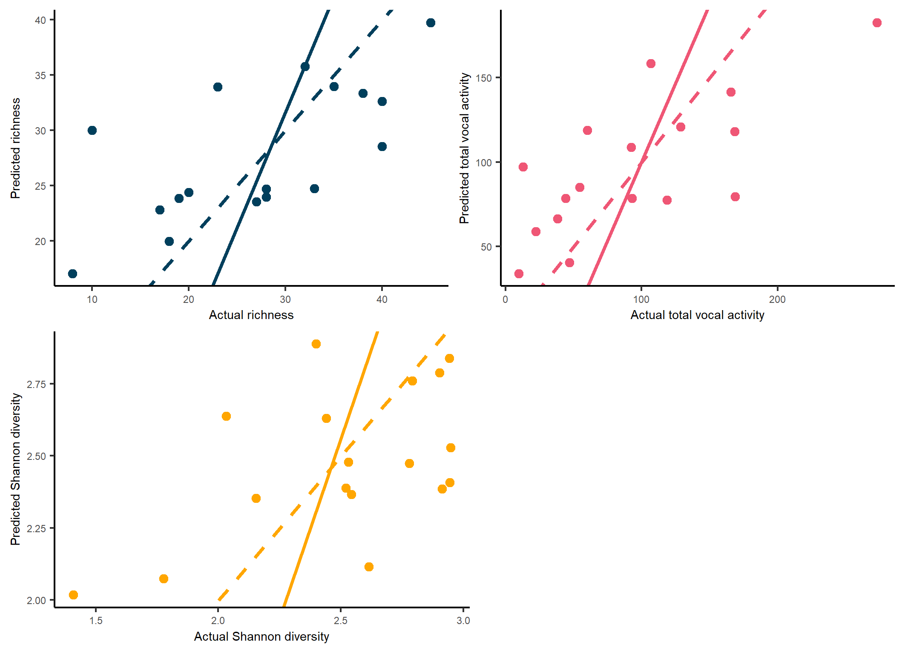
Fig. 2 Predicted versus actual plots for models predicting four bird diversity metrics across the city of Munich, Germany. The solid lines represent the Standardized (reduced) major axis model II linear regression, and the dashed lines represent the perfect correlation of 45 degrees with an intercept of 0 and slope of 1
Table 5: Reduced major axis regression for actual vs predicted results of predictive models for 17 predictions. R is the Pearson correlation coefficient. Two and one-tailed parametric p-values.
Variable | r | r² | 2-tailed p-value | 1-tailed p-value
richness | 0.68 | 0.46 | 0.002 | 0.001
VAR | 0.73 | 0.53 | 0.001 | 0.000
Shannon diversity | 0.53 | 0.28 | 0.028 | 0.014

