Supplementary Material

Novel antioxidant peptides from tiger nut (Cyperus esculentus L.): Purification, characterization, and cytoprotective functions on HepG2 and Caco-2 cells
Yu Quan, Lin Chen, Meiqi Fan, Xia Zhao*, Jianxiong Hao*
College of Food Science and Biology, Hebei University of Science and Technology, Shijiazhuang 050018, China
*Corresponding authors.
Tel./fax: +03 11 81668463.
E-mail addresses: cauhjx@163.com (J. Hao); zhaoxiaspkx@163.com (X. Zhao).
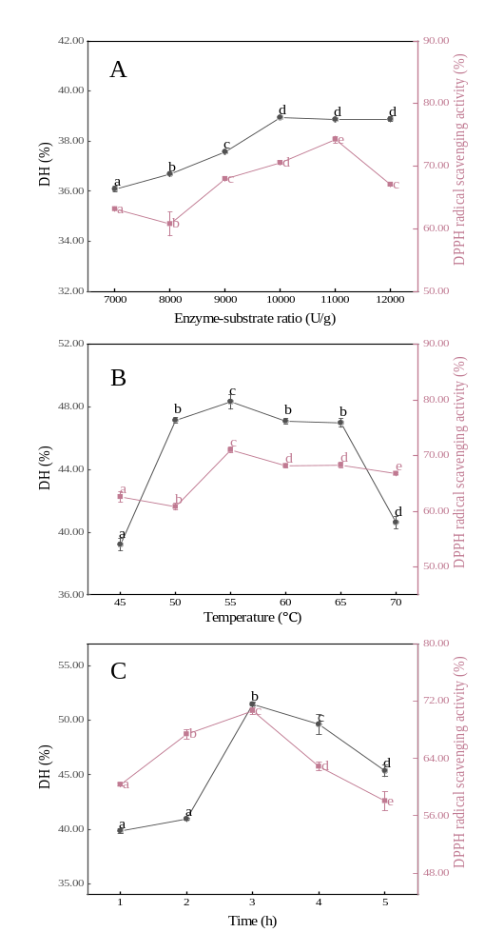
Fig. S1. Degree of hydrolysis (DH) and DPPH radical scavenging activity of tiger nut peptides with different enzyme-substrate ratios (A), temperatures (B), and times (C). Values with different letters differ significantly (p < 0.05).
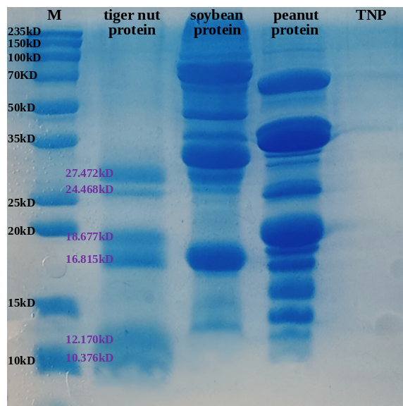
Fig. S2. SDS-PAGE of proteins and tiger nut peptides (TNP).
Table S1. Single factor experimental design for preparation of tiger nut peptides.
Number | Enzyme-substrate  ratio (U/g) | Hydrolysis  Temperature (℃) | Hydrolysis  Time (h)
1 | 7000 | 55 | 3
2 | 8000 | 55 | 3
3 | 9000 | 55 | 3
4 | 10000 | 55 | 3
5 | 11000 | 55 | 3
6 | 12000 | 55 | 3
7 | 10000 | 45 | 3
8 | 10000 | 50 | 3
9 | 10000 | 55 | 3
10 | 10000 | 60 | 3
11 | 10000 | 65 | 3
12 | 10000 | 70 | 3
13 | 10000 | 55 | 1
14 | 10000 | 55 | 2
15 | 10000 | 55 | 3
16 | 10000 | 55 | 4
17 | 10000 | 55 | 5

