Supplementary Materials
Cloning and expression of chromate reductase (BparChR) from Bacillus paramycoides strain S48 for chromium bioremediation
Kalsoom Kalsoom^{a,b,c}, Salah Ud Din^{a,b}, Esma Ceylan^{b}, Fariha Hasanª, Samiullah Khanª, Malik Badshahª, , Sabriye Çanakçi^{b}, Ali Osman Belduz^{b,2}, Aamer Ali Shah^{a,1}

ª Department of Microbiology, Faculty of Biological Sciences, Quaid-i-Azam University, Islamabad 45320, Pakistan.
^{b} Department of Biology, Karadeniz Technical University, Trabzon, Turkey.
^{c} Department of Microbiology, Faculty of Biological Sciences, University of Swabi, Anbar, Swabi, Pakistan.

Runing Title: Chromate reductase from Bacillus paramycoides for chromium remediation

Corresponding author:
- Prof. Dr. Aamer Ali Shah
Department of Microbiology, Faculty of Biological Sciences,
Quaid-i-Azam University, Islamabad 45320, Pakistan.
E-mail: alishah@qau.edu.pk

- Prof. Dr. Ali Osman Belduz
Department of Biology, Karadeniz Technical University, Trabzon, Turkiye.
E-mail: belduz@ktu.edu.tr

Figure S1A and B. FTIR analysis

A

B
Figure S1A and B. The Fourier Transform Infra-Red (FT-IR) absorption pattern of B. paramycoides S48 (A) S48 Cr treated (B) S48 Cr untreated

Figure S2. Kinetics parameter
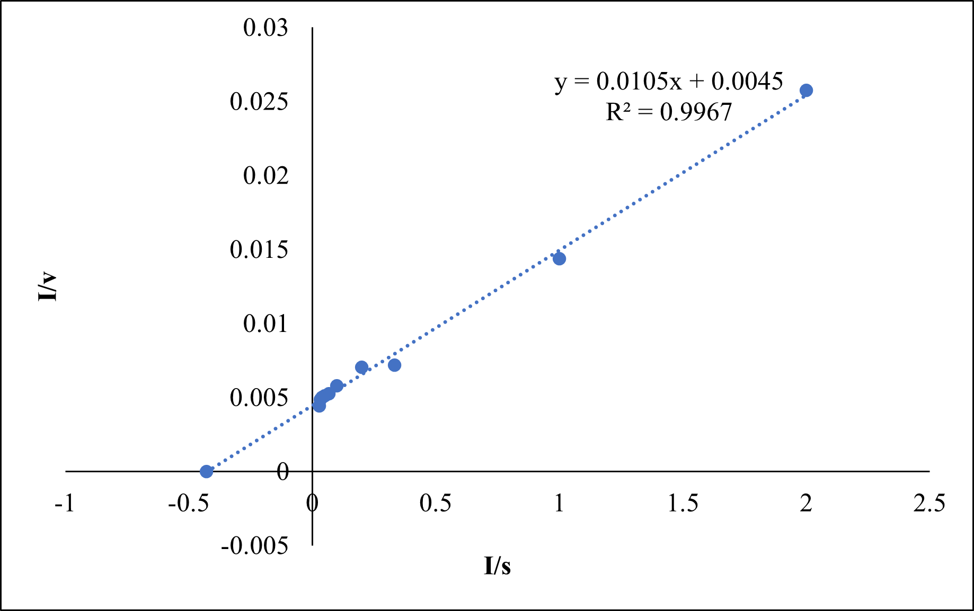
Figure S2. Kinetics profile of chromate reductase from B. paramycoides S48 using potassium dichromate as substrate

S1. Experimental Design

Plackett Burman Design for optimizing of nutritional factors
Placket-Burman (PBD) (Design Expert 10.1 software) was used to figure out the most important nutritional elements influencing enzyme production. A total of 11 components were optimized by PBD which included Na₂HPO_{4,} yeast extract, MgSO₄ .7H₂O, KH₂PO₄, CaCl₂, NaCl, sucrose, K₂Cr₂O₇, Na₂HPO₄, K₂HPO₄, and (NH₄)₂SO₄)] to optimize the composition of production medium for maximum enzyme production. Design Expert 7 software was used to run 15 sets with various concentrations of compounds. The fermentation was conducted at 35 °C and 150 rpm. The crude enzyme activity was determined after 24 h intervals up to maximum 72 h and results were recorded in order to find out specific activity (U/mg) of chromium reductase. All experiments were carried out in triplicates.
The design was mathematically modelled using the first-order polynomial equation listed below (Eq. 1).
$\text{Y = }β_{0 }+ \sum{β_{i}X_{i}}$(Eq.1)
Where Y represents specific activity (U/mg) of chromium reductase of the predicted response; $β_{0, }$exhibited the intercept; $β_{i}$, linear coefficient of the model; while $X_{i},$ described the level of independent variable. Factors having p-value<0.05 for the production of chromate reductase were regarded as important and further optimized by central composite design (CCD)

Central Composite Design (CDC) Experiment
The optimum reading of factors, their significant effect, and their interaction with one another was determined for enzyme production. Four significant factors (KH₂PO₄, K₂Cr₂O₇, Sucrose, yeast extract and MgSO₄.7H₂O) obtained from PBD were further analyzed through Central Composite design (CCD) in order to achieve a more extended optimization for high enzyme yield. Specific activity of the enzyme was evaluated using second order polynomial equation and multiple regressions were used for fitting data listed below (Eq. 2).
$Y= β_{0}+ \sum_{i=1}^{6}{β_{i}X_{i}}+ \sum_{i=1}^{6}{β_{ii}}X_{i}^{2}+ \sum_{i<j=2}^{6}{β_{ij}}X_{i}X_{j}$(Eq.2)
In this equation Y, X_{i},$β_{i}$,$β_{ii}$,$β_{ij}$, $β_{0}$ are representing the specific activity, significant independent variables, linear regression coefficients, quadratic regression coefficients, interactive regression coefficients and a constant term, respectively. The model suitability was assessed using ANOVA.

Table S1. Placket Burman design of factors with specific enzyme activity (U/mg) of B. paramycoides strain S48 as a response.
Run No | Factor Na₂HPO₄ % | Factor KH₂PO₄ | Factor C MgSO₄.7H2O% | Factor CaCl2% | Factor NaCl% | Factor sucrose % | Factor K₂Cr₂O₇ % | Factor NaH₂PO₄ % | Factor K₂HPO₄ % | Factor Yeast extract % | Factor K(NH₄)₂SO₄ % | Response 1 specific activity U/mg
1 | 0.4 | 0.1 | 0.01 | 0.01 | 0.02 | 0.5 | 0.01 | 0.1 | 0.3 | 0.3 | 0.3 | 240.07
2 | 0.4 | 0.5 | 0 | 0.04 | 0.02 | 0.5 | 0.01 | 0.3 | 0.3 | 1.3 | 0.5 | 210.01
3 | 0.6 | 0.3 | 0.03 | 0.03 | 0.04 | 1 | 0.02 | 0.2 | 0.4 | 1.05 | 0.4 | 60.162
4 | 0.8 | 0.5 | 0.04 | 0.01 | 0.02 | 0.5 | 0.03 | 0.1 | 0.5 | 1.3 | 0.3 | 83.93
5 | 0.8 | 0.1 | 0.04 | 0.04 | 0.06 | 0.5 | 0.01 | 0.1 | 0.5 | 0.8 | 0.5 | 266.04
6 | 0.4 | 0.1 | 0.04 | 0.01 | 0.06 | 1.5 | 0.01 | 0.3 | 0.5 | 1.3 | 0.3 | 296.32
7 | 0.4 | 0.5 | 0.04 | 0.01 | 0.08 | 1.5 | 0.03 | 0.1 | 0.3 | 0.8 | 0.5 | 196.39
8 | 0.8 | 0.1 | 0.04 | 0.04 | 0.02 | 1.5 | 0.03 | 0.3 | 0.3 | 0.8 | 0.3 | 305.33
9 | 0.8 | 0.5 | 0.01 | 0.01 | 0.02 | 1.5 | 0.01 | 0.3 | 0.5 | 0.8 | 0.5 | 220.85
10 | 0.4 | 0.5 | 0.01 | 0.04 | 0.08 | 0.5 | 0.03 | 0.3 | 0.5 | 0.8 | 0.3 | 80.495
11 | 0.4 | 0.1 | 0.01 | 0.04 | 0.02 | 1.5 | 0.03 | 0.1 | 0.5 | 1.3 | 0.5 | 197.49
12 | 0.6 | 0.5 | 0.03 | 0.03 | 0.04 | 1 | 0.02 | 0.2 | 0.4 | 1.05 | 0.4 | 106.88
13 | 0.6 | 0.3 | 0.03 | 0.03 | 0.04 | 1 | 0.02 | 0.2 | 0.4 | 1.05 | 0.4 | 105.09
14 | 0.8 | 0.5 | 0.01 | 0.04 | 0.06 | 1.5 | 0.01 | 0.1 | 0.3 | 1.3 | 0.3 | 149.39
15 | 0.8 | 0.1 | 0.01 | 0.01 | 0.06 | 0.5 | 0.03 | 0.3 | 0.3 | 1.3 | 0.5 | 107.35

Table S2. ANOVA of B. paramycoides strain S48 for Placket-Burman Design
Source | Sum of square | Df | Mean square | F value | p-value probe> F
Model | 65474.78 | 10 | 6547.48 | 12.11 | 0.0320
A-Na₂HPO₄ | 642.69 | 1 | 642.69 | 1.19 | 0.3553
B-KH₂PO₄ | 18533.99 | 1 | 18533.99 | 34.28 | 0.0099
C-MgSO₄.7H₂O | 10946.10 | 1 | 10946.10 | 20.25 | 0.0205
D-CaCl₂ | 339.99 | 1 | 339.99 | 0.63 | 0.4857
E-NaCl | 2180.55 | 1 | 2180.55 | 4.03 | 0.1382
F-sucrose | 11902.13 | 1 | 11902.13 | 22.01 | 0.0183
G-K₂Cr₂O₇ | 14121.19 | 1 | 14121.19 | 26.12 | 0.0145
H-NaH₂PO₄ | 632.16 | 1 | 632.16 | 1.17 | 0.3587
K₂HPO₄ | 335.51 | 1 | 335.51 | 0.62 | 0.4884
Yeast Extract | 5840.46 | 1 | 5840.46 | 10.80 | 0.0462

Table S3. CCD for B. paramycoides strain S48 showed significant factors with specific enzyme activity (U/mg) as a response
S.No | Factor 1  KH₂PO₄% | Factor  2K₂Cr₂O₇% | Factor 3 sucrose | Factor 4 MgSO₄. 7H₂07H20 | Response Specific  Activity
1 | 0.10 | 0.01 | 2.00 | 0.53 | 545.993
2 | 0.20 | 0.01 | 2.00 | 0.53 | 543.614
3 | 0.20 | 0.02 | 1.00 | 0.06 | 355.134
4 | 0.20 | 0.01 | 1.50 | 0.41 | 484.383
5 | 0.20 | 0.01 | 2.00 | 0.53 | 232.155
6 | 0.20 | 0.01 | 2.50 | 0.53 | 545.156
7 | 0.20 | 0.01 | 2.00 | 0.53 | 530.135
8 | 0.20 | 0.01 | 2.00 | 0.53 | 350.879
9 | 0.30 | 0.01 | 2.00 | 1.00 | 379.947
10 | 0.40 | 0.01 | 1.50 | 0.53 | 483.266
11 | 0.10 | 0.02 | 2.50 | 1.00 | 173.723
12 | 0.20 | 0.03 | 2.00 | 0.53 | 130.879
13 | 0.20 | 0.01 | 2.00 | 0.53 | 401.259
14 | 0.20 | 0.01 | 2.00 | 1.47 | 483.983
15 | 0.20 | 0.00 | 2.00 | 0.53 | 117.755
16 | 0.30 | 0.01 | 1.50 | 0.06 | 334.172
17 | 0.10 | 0.01 | 2.50 | 1.00 | 203.872
18 | 0.20 | 0.01 | 2.00 | 0.53 | 542.752
19 | 0.10 | 0.02 | 2.50 | 0.06 | 337.551
20 | 0.10 | 0.01 | 1.50 | 0.06 | 411.373
21 | 0.30 | 0.02 | 2.50 | 0.06 | 216.033
22 | 0.30 | 0.02 | 1.50 | 1.00 | 205.913
23 | 0.10 | 0.02 | 1.50 | 1.00 | 533.00
24 | 0.30 | 0.01 | 2.50 | 0.06 | 317.88
25 | 0.30 | 0.01 | 2.50 | 1.00 | 406.358
26 | 0.10 | 0.01 | 1.50 | 1.00 | 352.019
27 | 0.30 | 0.02 | 2.50 | 1.00 | 113.006
28 | 0.20 | 0.01 | 2.00 | 0.53 | 528.449
29 | 0.30 | 0.02 | 1.50 | 0.06 | 156.981
30 | 0.10 | 0.01 | 2.50 | 0.06 | 259.353
Table S4. ANNOVA for central composite design
Source | Sum of square | Df | Mean square | F value | p-value probe> F
Model | 5.523E+005 | 14 | 39452.65 | 8.64 | 0.0001
A-KH₂PO₄ | 16051.11 | 1 | 16051.11 | 3.52 | 0.0804
B- K₂Cr₂O₇ | 12581.36 | 1 | 12581.36 | 2.76 | 0.1177
C- sucrose | 38024.40 | 1 | 38024.40 | 8.33 | 0.0113
D-MgSO₄.7H₂0 | 696.53 | 1 | 696.53 | 0.15 | 0.7016
AB | 53025.59 | 1 | 53025.59 | 11.61 | 0.0039
AC | 26958.97 | 1 | 26958.97 | 5.90 | 0.0281
AD | 2058.29 | 1 | 2058.29 | 0.45 | 0.5122
BC | 938.56 | 1 | 938.56 | 0.21 | 0.6568
BD | 237.10 | 1 | 237.10 | 0.052 | 0.8228
CD | 12463.30 | 1 | 12463.30 | 2.73 | 0.1193

Table S5. Effect of surfactants on activity of chromate reductase from B. paramycoides S48
Surfactants | Residual Activity (%)
Surfactants | 0.5% | 1%
Control | 100 ± 0.0 | 100 ± 0.0
Tween 20 | 123.06 ± 6.7 | 139.4 ± 9.2
Tween 60 | 125.7 ± 9.5 | 130.4 ± 6.7
Tween 80 | 115.04 ± 11.2 | 129.7 ± 1.3
CTAB | 108.4 ± 1.4 | 102.1 ± 0.9
SDS | 20.4 ± 4.1 | 19.4 ± 3.2
Triton X-100 | 77.4 ± 0.9 | 61.7 ± 7.2

Table S6. Effect of organic solvents on the activity of chromate reductase from B. paramycoides S4
Organic Solvents (15%) |  | Residual activity % (Min)
Organic Solvents (15%) | 30 min | 60 min | 90 min | 120 min
Control | 100 ± 0.0 | 100 ± 0.0 | 100 ± 0.0 | 100 ± 0.0
Ethanol | 89.2 ± 8.02 | 90.7 ± 6.07 | 75.5 ± 2.05 | 57.8 ± 1.03
Methanol | 124.5 ± 2.04 | 118 ± 2.05 | 132.7 ± 2.7 | 133.7 ± 4.04
Acetonitrile | 39.1 ± 2.04 | 50.2 ± 2.7 | 48.5 ± 8.03 | 54.6 ± 2.1
Ethyle Acetate | 27.8 ± 6.07 | 30.6 ± 8.02 | 44.8 ± 2.04 | 38.1 ± 3.1
Propanol | 119.5 ± 2.05 | 124.6 ± 2.04 | 130.3 ± 3.04 | 137.5 ± 2.07
DMSO | 102.7 ± 2.7 | 118.1 ± 1.03 | 119.3 ± 2.03 | 122.8 ± 5.02
Formaldehyde | 79.3 ±8.02 | 98.2 ± 2.7 | 98.4 ± 3.2 | 98.9 ± 2.3
Chloroform | 107.2 ± 6.07 | 118.7 ± 2.04 | 119.7 ± 2.4 | 123.2 ± 4.23
n-Hexane | 57.67± 2.05 | 55.2 ± 6.05 | 62.1 ± 4.2 | 70.3 ± 1.09

