Supplementary Information
High Temperature and Pressure Pure-Silica Zeolite Ammonia Adsorbents and Their Use in Adsorption-Enhanced Catalytic Reactors

Authors: Nayeon Kang^{1,2,+}, Juan C. Muñoz-Senmache^{3,+}, Prerna^{4,5,+}, Zihao Rei Gao^{1,2}, Cristian Aristizabal-González³, Jesse Prelesnik^{4,‡}, Hsiao-Feng Liu^{4,5}, Paul Haghi Ashtiani^{1,2}, Ronaldo Pangestu Hadi², Chao Wang², Brandon C. Bukowski², Arturo J. Hernández-Maldonado^{3,}*, J. Ilja Siepmann^{4,5,}*, Michael Tsapatsis^{1,2,6,}*

Affiliations:
1 Institute for NanoBioTechnology, Johns Hopkins University, 3400 N. Charles Street, Baltimore, MD, 21218, USA.
2 Department of Chemical and Biomolecular Engineering, Johns Hopkins University, 3400 N. Charles Street, Baltimore, MD, 21218, USA.
3 Department of Chemical Engineering, University of Puerto Rico Mayagüez Campus, Mayagüez, Puerto Rico 00680, USA.
4 Department of Chemistry and Chemical Theory Center, University of Minnesota, 207 Pleasant Street SE, Minneapolis, Minnesota 55455, USA.
5 Department of Chemical Engineering and Materials Science, University of Minnesota, 421 Washington Avenue SE, Minneapolis, Minnesota 55455, USA.
6 Applied Physics Laboratory, Johns Hopkins University, 11100 Johns Hopkins Road, Laurel, MD, 20723, USA.
* Corresponding authors: arturoj.hernandez@upr.edu; siepmann@umn.edu; tsapatsis@jhu.edu
+ These authors contributed equally to this work.
‡ Current affiliation: Center for Nanoscale Materials, Argonne National Laboratory, 9700 S Cass Ave, Lemont, Illinois 60439, USA

Table of contents
Supplementary text Pg. S2-S6
Supplementary figures S1-S9 Pg. S7-S15
Supplementary tables S1-S7 Pg. S16-S21

Supplementary text

S1. Experimental section – synthesis of the zeosils
S1.1. Synthesis of pure-silica LTA zeolite from fluoride media (F-LTA). The synthesis of pure siliceous LTA is based on literature³⁵, from a gel of composition 1 SiO₂: 0.45 R-OH: 0.05 TMAOH: 0.5 HF: 5 H₂O, whereas R-OH refers to 1,2-dimiethyl-3-(4-methylbenzyl) imidazolium hydroxide and TMAOH refers to tetramethylammonium hydroxide.
For the OSDA synthesis, a similar procedure described in the literature was followed. 37 g of 1,2-dimethylimidazole (385 mmol) was dissolved into 350 mL of THF within a 1000-mL round-bottom flask, followed by the addition of 49 g (350 mmol) of 4-methylbenzyl chloride. The mixture was stirred and heated at 85 ºC under reflux for 7 days. The crude reaction mixture was collected by filtration and washed by 4 x 100 mL of THF and dried at 60 ºC overnight. The purity of 1,2-dimiethyl-3-(4-methylbenzyl) imidazolium chloride (R-Cl) was characterized by ¹H and ¹³C NMR.
Then, the R-Cl was performed the cation exchange to get the R-OH. 21 g of R-Cl (89.6 mmol) was dissolved in 200 g of DI water containing 200 mL of anion exchange resin (washed about 5-10 times by DI water to remove any impurities) and the mixture was stirred gently (~150 rpm) at room temperature overnight to perform the anion exchange. The hydroxide-exchanged form of OSDA (referred as R-OH) solution was collected by filtration and the resin was washed multiple times with DI water to ensure little residue in the resin. The collected R-OH solution was concentrated by evaporating water using rotary evaporator (72 ºC at 135 mbar) until it reaches approximately 0.5 mol/L. The final concentration of the R-OH was titrated by 0.1534 M HCl standard solution, giving the accurate concentration of [OH⁻] = 0.555 mmol/g. This final R-OH solution was further utilized for the zeolite synthesis as structure directing agent.
For the zeolite synthesis, the gel preparation began by adding TEOS, TMAOH, and R-OH into a beaker and stirring it for more than 6 hours to ensure all ethanol is evaporated. After the gel reaches approximately 1-2 g away from its final target weight, HF (hydrofluoric acid, 48wt%) is added while vigorously stirring. [Caution: the HF is very toxic! To use HF, you must wear the corresponding PPE and follow the relevant SOP!] When the gel mineralized, it was further mixed with a spatula until a homogeneous dried gel state was obtained. The remaining water is further evaporated in a 75 °C oven. As soon as the gel reached its target weight, it was transferred to a Teflon liner and put into an autoclave, then into a rotation oven (15 rpm) at 170 °C for 4 days. The solid gel-like product was washed with DI water at least 4 times (4 x 40 mL) and acetone/methanol (1:1, 3 x 40 mL). The collected powder was dried overnight at 80 °C oven. Note, n(Si) of 5-10 mmol size of small gel led to successfully reproducible crystals. As-made F-LTA was calcined in a Muffle furnace at 700 °C with a 4-hour ramp (approx. 3 °C/min), 10 hours hold, then 1 hour to cool down to room temperature.
S1.2. Synthesis of pure-silica Beta zeolite from fluoride media (F-BEA). The synthesis of F-BEA was based on the work by Camblor et al⁵³. A slight modification for gel composition was made, especially on water content. The gel composition used in this synthesis (to obtain homogenous crystals) was 1 SiO₂: 0.54 TEAOH : 0.54 HF: 2.5 H₂O. 8.34 g of TEOS and 9.10 g of TEAOH (tetraethylammonium hydroxide) was added within a plastic beaker containing a stir bar, and the mixture was stirred for more than 5 hrs to hydrolyze the TEOS and evaporate the ethanol and excess amount of water. Before the water is all evaporated, add 0.9 g of HF and stir vigorously to obtain a homogeneous gel. Let the remaining water content evaporate, then transfer the gel into a Teflon-lined autoclave, in a static oven at 170 °C. Check the progress in crystallization after 1 day and 3 days. It was found that there is no difference, hence 1 day was sufficient. As-made F-BEA was calcined in a Muffle furnace at 550 °C, with a 9 hrs ramp and 10 hrs hold, then 2 h to cool down to 25 °C.
S1.3. Synthesis of zeolite Silicalite-1 from fluoride media (F-MFI). The F-MFI synthesis is based on the method described in our previous work⁵². The gel composition used was 1 SiO₂ : 0.08 TPABr : 0.4 NH₄F : 20 H₂O. Tetrapropylammonium bromide (1.66 g, TPABr, 98%, Aldrich) was added to 27.62 g of distilled water, followed by the addition of 1.15 g of ammonium fluoride (NH₄F, Sigma-Aldrich) and vigorously stirred in ambient conditions for 15 minutes. Then, 4.61 g of fumed silica (SiO₂, Cabosil M5) was added, and the whole solution was mixed with a spatula until the dense solution was homogeneous in color and texture. The dispersion was transferred into a 45-mL Teflon-lined, stainless-steel autoclave and heated at 175 ºC for 7 days in a static oven. The zeolite powder was purified by repeated washing (dispersion in deionized water for 5 min in an ultrasonic bath) and centrifugation at ambient temperature until the supernatant pH was neutral (approximately three cycles). The solids were dried at 70 ºC overnight. As-made F-MFI was calcined in a Muffle furnace under static air at 600 °C, with a 3 hrs ramp and 10 hrs hold, then 2 h to cool down to 25 °C.
S1.4. Calcination of dealuminated ZSM-5 zeolite (deAl-ZSM-5). The dealuminated ZSM-5 zeolite sample was provided by Zeolyst ZD15019. As-received deAl-ZSM-5 was calcined within a quartz petri dish at 600 ºC, with a 3-hour ramp and 6-hour plateau.
S1.5. Synthesis of zeolite Silicalite-1 from hydroxide media (OH-MFI). The OH-MFI synthesis followed the precious method⁵⁴, from a gel of composition 1 SiO₂ : 0.4 TPAOH : 35 H₂O. 78.07 gr of TEOS was added into the mixture of 73.94 gr of tetrapropylammonium (TPAOH, Sigma-Aldrich, 40 wt%) and around 200 gr of water within a beaker. The mixture was stirred overnight to evaporate all the ethanol. The final water amount was monitored by balance to the target weight (H₂O/SiO₂ = 35, i.e. 236.28 gr H₂O hereby) and a clear solution was obtained. The solution was splitted into 12 portions (~ 24 gr each) and transferred into 12 autoclaves with Teflon liners. The crystallization was performed at 175 ºC for 3 days, without rotation. After the crystallization, the solid was washed by water for 3 times and EtOH for 2 times, collected by centrifugation (12000 rpm), and dried within the plastic tubes at 80 ºC overnight to get the final as-made form of OH-MFI. As-synthesized OH-MFI was calcined at 600 ºC (3-h ramp and 6-h plateau) within the above-mentioned petri dishes.
S1.6. Synthesis of pure-silica self-pillared pentasil (SPP) zeolite. The SPP synthesis using tetrabutylammonium hydroxide (TBAOH) as the organic structure-directing agent (OSDA) was carried out according to the method previously reported^{32,55}. The gel composition for the SPP sample used in this work is 1 SiO₂ : 0.3 TBAOH : 20 H₂O : 4 EtOH, where a ultra-pure TBAOH without halides (i.e. Sigma-Aldrich 86854-100mL) is required for the synthesis. Specifically, 39.18 gr of H₂O was firstly mixed with 31.30 gr of TBAOH (40 wt%), then 33.76 gr of tetraethylorthosilicate (TEOS, Sigma-Aldrich, 99%) was added into the alkaline solution. The mixture was stirred at 600-800 rpm with a magnetic stir bar within a sealed plastic bottle to avoid the ethanol evaporation. In the first 3-5 mins, two phases (water phase and TEOS phase) still can be observed inside the bottle, while after around 5 mins, a clear solution will be obtained. The stirring was kept overnight (around 18 hrs), whereas a clear solution was maintained during the hydrolysis. The weight of the whole bottle was recorded in order to ensure that there is no ethanol nor water lost during the overnight hydrolysis. Then, the solution was separated into 4 parts (24.12-27.28 gr for each part) and transferred into four autoclaves with 50-mL Teflon liners. The autoclaves were placed in a 120 ºC oven for 41 hrs, without rotation. After the crystallization, the autos were quenched into water and the solid was collected by centrifugation (14500 rpm), washed by water for 5 times and EtOH for 2 times, and dried within the plastic tubes at 80 ºC overnight to obtain the final as-made form of SPP. As-made SPP was placed on a quartz petri dish to make a shallow bed and this petri dish was calcined in a Muffle furnace at 560 ºC, with a 9 hrs ramp and 8 hrs plateau, to obtain the calcined form of SPP.

S2. Adsorption data processing
S2.1. Calculation of the heat of adsorption. The isosteric heat of adsorption for six zeosil materials (SPP, deAl-ZSM5, OH-MFI, F-MFI, F-BEA, F-LTA) was determined using a systematic approach. Initially, experimental adsorption data were processed using Athena Visual Plus software to extract isoloading values, with 95% Highest Posterior Density (HPD) intervals providing a robust estimate of uncertainty. Subsequently, these isoloading values were plotted in a ln(p) versus 1/T format, adsorption isosteres, incorporating error bars to reflect the uncertainty associated with each data point that stems from isotherm fitting. The slope of the linear relationship in the ln(p) versus 1/T plots was used to derive the isosteric heat of adsorption at each loading level with error bars from linear regression using linregress function from scipy.stat package in Python, which are shown in Fig 3a,b. Representative isosteres for SPP and F-MFI are displayed in Fig. S5.
In the equilibrium isotherms, isoloading lines are represented between 0.5 mmol/g and a high loading value where predicted pressures are below 60 bar. For SPP in Fig. S5 (left), the highest loading lines have only three data points instead of four due to these pressure threshold constraints. For F-MFI in Fig. S5 (right), which was measured at three temperatures, loadings above 2.5 mmol/g result in just two data points per isostere. Linear regression between two points lacks error estimation; thus, these cases were excluded. The same methodology was applied to other zeosil materials in the heat of adsorption analysis. For deAl-ZSM-5, the slopes remained relatively consistent across the loading range of 0.5 to 3 mmol/g, suggesting a uniform heat of adsorption within this interval. In contrast, SPP exhibited a decreasing isosteric heat of adsorption with increasing loading, indicating that initial adsorption is energetically more favorable than subsequent adsorption events.
S2.2. Isotherms in log-scale and irreversible amounts of ammonia. The irreversible amount of ammonia for each isotherm was calculated and shown in Extended Data Table 3. Since the last points of desorption branch differ slightly among different materials, it is complicated to draw a conclusion of irreversibility over the six materials. However, in order to give practical irreversible fraction of ammonia from experimental data, p_{des} of 0.25 bar and p_{ads}^{max} of 9 bar or closer were chosen, which gives more controlled comparison among zeosils materials. When comparing F-MFI and SPP at 323 K (where both have a desorption pressure of 0.25 bar), it can be observed that the irreversible fraction is higher for SPP (15%) than for F-MFI (10%). This might be due to a higher density of defects or possibly stronger acidic sites in SPP.

S3. Gibbs ensemble Monte Carlo simulations
Supercells containing 3x3x3, 2x2x3, and 3x3x2 orthorhombic unit cells were used for the LTA, MFI, and BEA zeosils (see Table S5). The framework atoms of these microporous zeosils were kept frozen at their crystallographic positions, and a pre-tabulated grid^{66,73} was used for the efficient calculation of the guest−host interactions. The silanol groups populating the SPP mesopore surfaces were allowed to change their bending angle and undergo dihedral rotation. Since the ammonia, water, and argon models do not allow for conformational changes, the Gibbs ensemble Monte Carlo simulations used the following types of trial moves: translations and rotations of the adsorbate molecules, coupled-decoupled configurational-bias Monte Carlo (CBMC) regrowth⁷⁴ of silanol groups, volume exchanges with a pressure bath for the gas-phase reservoir, and CBMC transfers of adsorbates between the vapor reservoir and zeosil phases and vice versa. The lengths of the simulations are reported in Table S5. The force field details are provided in Table S6. Figure S6 shows isotherms for the gas-phase density of ammonia.

S4. Reaction-adsorption system modeling
S4.1. Reaction kinetics modeling. For the reaction kinetics, the Ru/C catalyst was modelled using Rossetti et al.⁷¹ as in Equation (S1). The Rossetti et al. kinetics were validated by experimental data from 370 - 460 °C and 50 - 100 bar. The expression for equilibrium constant, K_{eq}, was calculated according to Gillespie and Beattie⁷² shown in Equation (S2).

 | $$r=k_{f} λ(q) \frac{{a_{N2}}^{0.5} \left[\frac{{a_{H2}}^{0.375}}{{a_{NH3}}^{0.25}}\right]- \frac{1}{K_{a}}\left[\frac{{a_{NH3}}^{0.75}}{{a_{H2}}^{1.125}}\right]}{1+ K_{H2} {a_{H2}}^{0.3}+ K_{NH3} {a_{NH3}}^{0.2}}$$ | (S1)
 | $$\log_{10}{K_{eq}}= -2.691122 \log_{10}{T}-5.519265×{10}^{-5}T+1.848863{10}^{-7} T^{2}+ \frac{2001.6}{T}+2.6899$$ | (S2)

S4.2. Solving DAE system using MATLAB. The structure of the code is as follows: first, as basis sets for the combined case, adsorption equilibriums of various adsorbents and reaction kinetics are coded separately as functions and called into the main code. Second, an array of x (t), (i.e. [x(1) x(2) x(3) x(4)]) was introduced. x(1), x(2), and x(3) denote the moles of hydrogen, nitrogen, and ammonia respectively, in gas phase. x(4) is the moles of ammonia in adsorbed phase. The key idea is that the change of moles of ammonia in the system is due to the ammonia synthesis reaction, hence $\frac{d x(3)}{dt}+\frac{d x(4)}{dt}={ r }_{{NH}_{3}}$. The DAEs (differential-algebraic equations) were solved via MATLAB ode15s solver, where in each time step, the moles of gas phase H₂, N₂, NH₃ changes according to the reaction rate, and immediately from the partial pressure of NH₃, certain portion of the gas phase ammonia is adsorbed to solid phase (x(4)). With the updated moles in the gas phase, the next time step is calculated. The input parameters for the integrated reaction-adsorption system modeling include the kinetic model of choice and adsorbent type, initial reactor pressure, reactor temperature, reactor volume, mass and density of catalyst and adsorbent, respectively, as well as initial ammonia mole fraction, and H₂/N₂ ratio (set as 1 in this work) in feed gas. The DAEs were solved over a time span exceeding 12 hours to ensure that the system reached a plateau of steady pressure value.

S5. Batch reactor testing
S5.1. The choice of a batch reactor over a flow reactor. While flow reactors are more representative of industrial ammonia synthesis, we conducted our proof-of-concept experiments using a batch reactor for several reasons. First, the high pressures and elevated temperatures required for ammonia synthesis are more easily achieved and controlled in a semi-batch reactor setup. In this configuration, we can load the reactor with the appropriate catalyst and adsorbent, seal it, and then increase the pressure and temperature to our desired values. Monitoring the total pressure allows us to assess the extent of the reaction quantitatively, which was not fully explored in previous studies.
S5.2. Validation of the kinetic modeling with catalyst run. The kinetics model of Cholewa et al.⁷⁵ predicts the experimental results from Ojha et al.⁶ with sufficient accuracy as shown in Figure S7.
S5.3. Effect of activation temperature on Ru/C catalyst activity. The 5 wt% Ru/C catalyst was initially activated in the reactor vessel at 350°C overnight. However, a subsequent test was performed to determine whether a higher activation temperature would further enhance the catalyst's activity. As shown in Figure S8, activation at 500°C in a tube furnace proved more effective than activation directly within the reactor vessel. Consequently, for all future experiments, the catalyst was activated in a separate tube furnace at 500°C overnight, then transferred to the reactor vessel, followed by an additional degassing step to ensure complete removal of moisture during the transfer.
S5.4. Batch reactor testing using zeosils as adsorbents. An example of raw data using 2.5 g of Ru/C catalyst and 7.5 g of deAl-ZSM-5 over 48 hours is shown in Figure S9. The pressure decrease part at 350 °C is processed by Savitzky Golay filter (via python scipy savgol_filter function, window length 45, polynomial order of 2). These processed data are shown in Fig 5b.
S5.5. Batch reactor equilibrium prediction calculations. The equilibrium predicted values shown in Fig 5b are calculated as follows: From each configuration, the average temperature is taken as input (they range between 340 – 350 °C). From the initial step hold at 60 °C, the expected pressure inside the reactor during the reaction temperature is calculated. The volume was adjusted by deducting the volume of catalyst and adsorbent, where the bulk densities were assumed to be 2.3 g/cm³ and 2.1 g/cm³, respectively. Initial moles were calculated based on volume, total pressure, and temperature assuming ideal gas behavior. The adsorbed amount at reaction temperature is calculated by the extrapolation based on the experimental isotherms. In case the material possesses different type of isotherms for different temperature, the isotherm model of the highest temperature was applied to extrapolate the isotherm to 350 °C. The equilibrium of gas phase N₂, H₂, NH₃ compositions follow the equilibrium constant described Gillespie et al⁷² in (S2), which can be written in terms of mole fraction as shown in (S3)⁷⁶.
$$K_{a} = \frac{x_{NH_{3}}}{{x_{N_{2}}}^{1/2} {x_{H_{2}}}^{3/2}} \frac{P_{ref}}{P_{total}}$$ | (S3)
With the extent of reaction (x) and adsorbed amount ($α$) as two unknowns, iterative calculation was performed using MATLAB fsolve function until the solutions for x and corresponding $α$ at the ammonia partial pressure converged. The resulting extent of reaction (x) and adsorbed amount ($α$) for each configuration are tabulated in Table S7.
Supplementary figures

Fig. S1. PXRD patterns of (a) F-LTA, (b) F-MFI, (c) F-BEA, (d) deAl-MFI, (e) OH-MFI, and (f) SPP zeolite. Top/red curves for the calcined patterns and bottom/black curves for the as-made patterns. For the calcined zeolites of MFI topology (red curves in c-f), the second peak with Miller index (020) is very strong only in F-MFI sample. This can be explained as the preferred orientation along the b-axis in that sample, which is also proved by its elongated morphology under SEM along the same direction.
Fig. S2. Le bail fitting plots of the PXRD patterns: (a) as-made and (b) calcined F-LTA, (c) as-made and (d) calcined F-MFI, (e) as-received and (f) calcined deAl-MFI, and (g) as-made and (h) calcined OH-MFI. The unit cell parameters, space groups, and refinement parameters are listed in Table. S1. The black/red/blue curves are experimental/simulated/difference profiles, respectively. Green vertical ticks indicate the positions of allowed reflections.

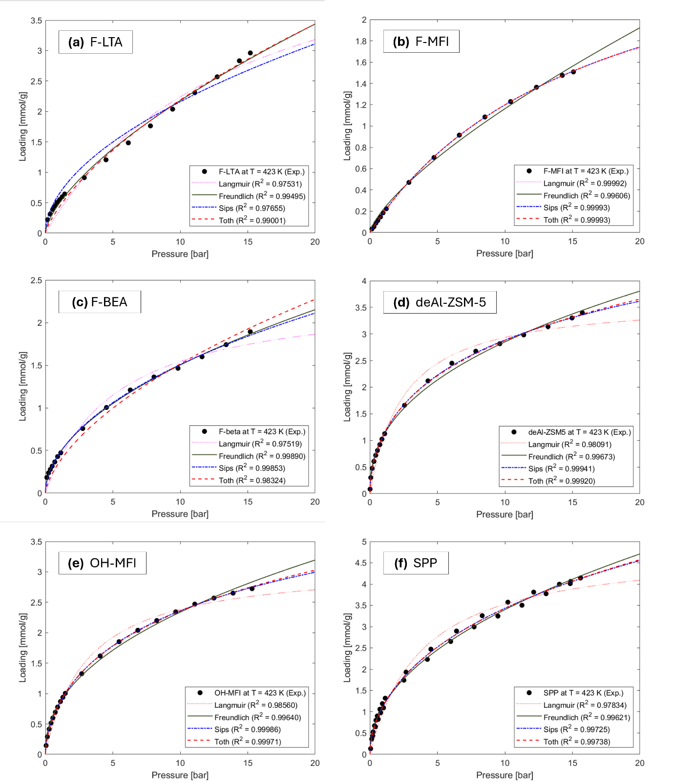
Fig. S3. Fitting of the six zeolites adsorption data at 423 K (linear x-axis scale) over four different isotherm using nonlinear least square fit: (a) F-LTA, (b) F-MFI, (c) F-BEA, (d) deAl-ZSM-5, (e) OH-MFI, and (f) SPP. Note that the y-axis ranges are not identical in each case.

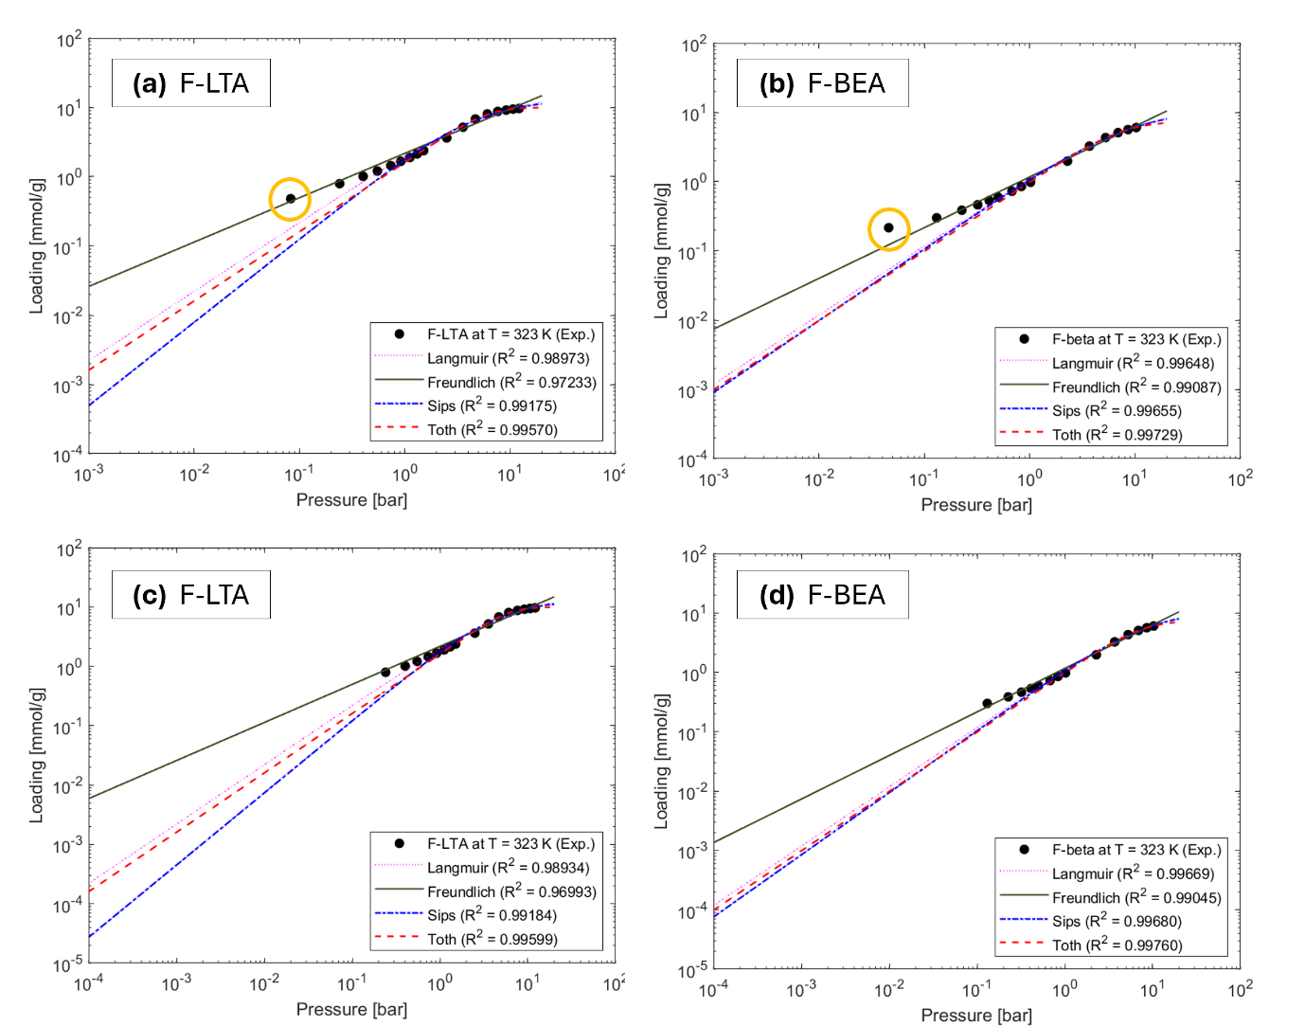
Fig. S4. Fitting of F-LTA and F-BEA at 323 K (log-log scale) over four different isotherm using nonlinear least square fit: (a) F-LTA, (b) F-BEA, (c) F-LTA excluding the experimental points below 0.1 bar, and (d) F-BEA excluding the experimental points below 0.1 bar. Even though Freundlich model does not give the best fit overall, it fits the low-pressure points well than other models. For piecewise fitting, the data points below 1 bar were fitted with Freundlich isotherm.

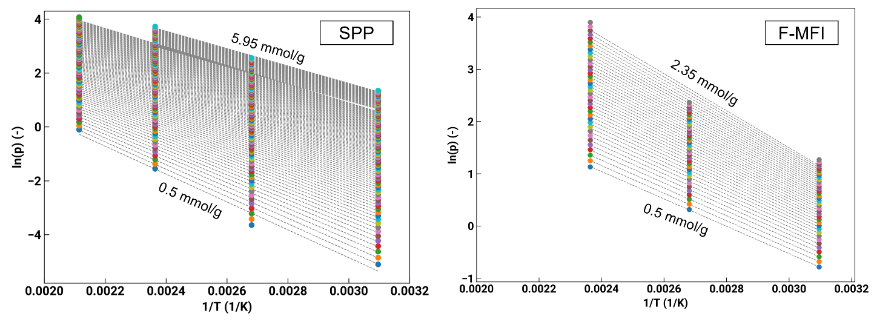
Fig. S5. Isosteres [in ln(p) vs (1/T) plot] for heat of adsorption calculation for SPP (left) and F-MFI (right): The isoloading lines are represented as gray dashed lines, with the lowest values positioned at the bottom and the highest values at the top, spaced evenly at intervals of 0.05 mmol/g.

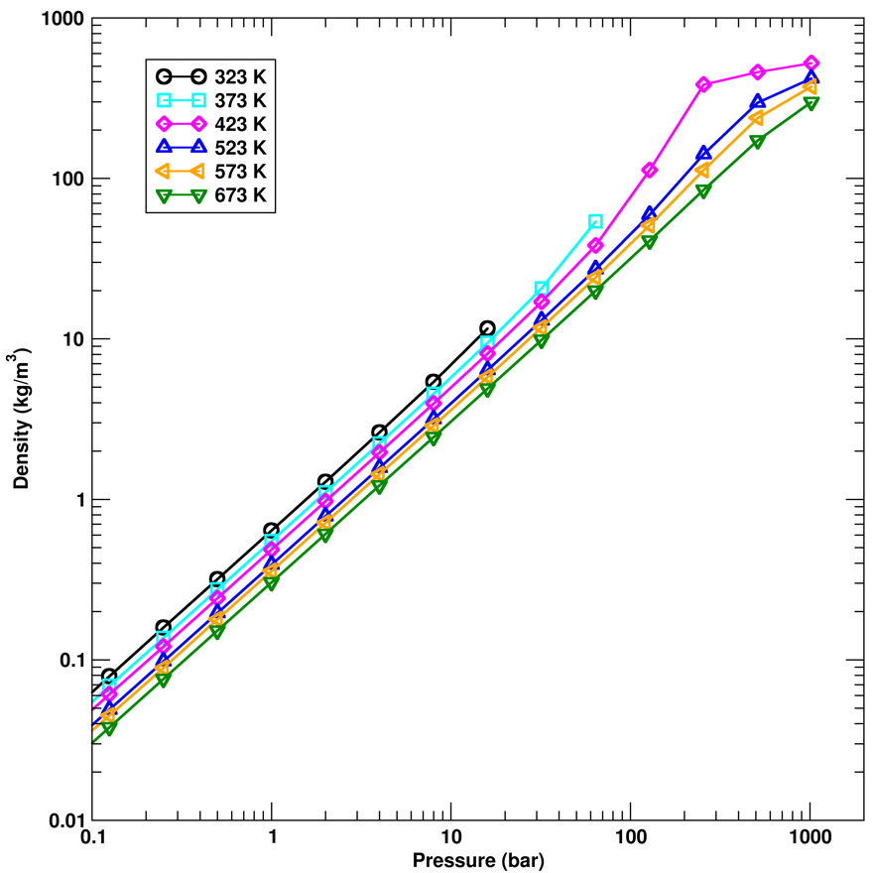
Fig. S6. Isotherms for the specific density of the gas-phase reservoir as function of pressure obtained from the Gibbs ensemble Monte Carlo simulations. The TraPPE−small ammonia model predicts a critical temperature of 406 K⁶⁸, and saturated vapor pressures of 20.1 and 61.7 bar at 323 and 373 K, respectively.

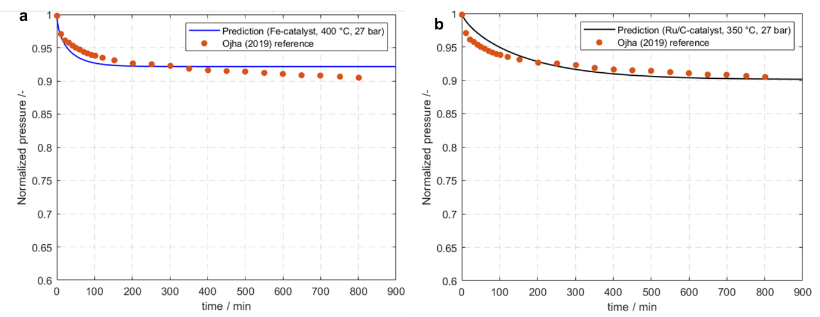
Fig. S7. Kinetic model prediction from MATLAB calculation. Commercial Fe catalyst kinetics⁷⁵ (a) and Ru/C catalyst⁷¹ (b) with experimental values from Ojha et al⁶.

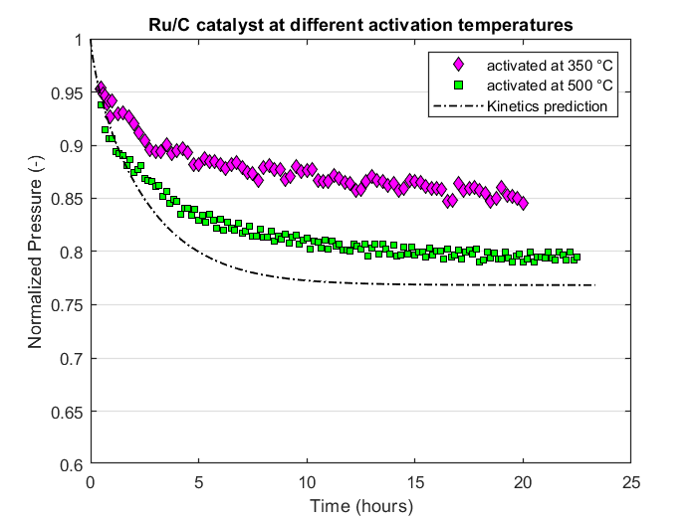
Fig. S8. The effect of Ru/C catalyst activation temperatures in the batch reactor. Normalized pressure trajectories of reaction at 350 °C over 20 hours. The diamond symbol is activated at 350 °C (magenta) and the square symbol is activated at 500 °C (green). Kinetics of Rossetti⁷¹ was used for Ru/C catalyst.

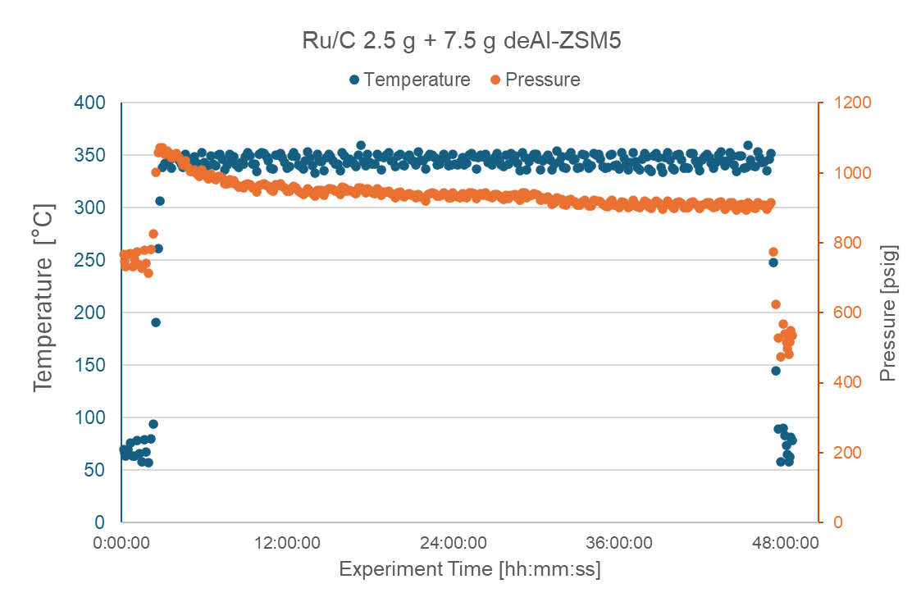
Fig. S9. Exemplary data for integrated adsorption-reaction batch reactor experiment. A 48-hour experiment with 2.5 g of Ru/C catalyst and 7.5 g of deAl-ZSM-5. The temperature is shown on the left axis with blue, and pressure is illustrated by right axis with orange. The reactor system started the measurement at 60 °C and ended at 60 °C.

Supplementary tables

Table S1. Unit cell parameters after Le Bail fitting on the PXRD patterns.
Sample name | SG (#) | a/Å | b/Å | c/Å | V/Å³ | R_{wp} | GOF
deAl-ZSM-5 (cal) | Pnma (#62) | 20.2396 | 19.8120 | 13.3179 | 5340.32 | 11.04% | 7.34
OH-MFI (as) | Pnma (#62) | 20.1496 | 19.9365 | 13.3870 | 5377.73 | 5.68% | 3.44
OH-MFI (cal) | Pnma (#62) | 20.2012 | 19.8442 | 13.3125 | 5336.65 | 9.73% | 6.23
F-MFI (as) | Pnma (#62) | 20.1928 | 19.9482 | 13.3937 | 5395.13 | 4.80% | 4.24
F-MFI (cal) | Pnma (#62) | 20.2395 | 19.9434 | 13.3701 | 5396.78 | 8.05% | 5.91
F-LTA (as) | Pm-3m (#221) | 11.8160 | 11.8160 | 11.8160 | 1649.74 | 8.59% | 5.17
F-LTA (cal) | Pm-3m (#221) | 11.8490 | 11.8490 | 11.8490 | 1663.58 | 16.67% | 11.37

Table S2. Isotherm fitting models explored. Units of loading q is mmol/g and pressure p is in bar.

Model | Equation | Parameters
Langmuir | $q=q^{sat} \frac{K_{L} p}{1+ K_{L} p}$ | $$q^{sat} \left[\frac{mmol}{g}\right], { K}_{L} [{bar}^{-1}]$$
Freundlich | $q=K_{F} p^{1/n_{F}}$ | $K_{F} \left[\frac{mmol}{g {bar}^{\frac{1}{n}}}\right], n_{F} [-]$
Sips | $q=q^{sat} \frac{{(K_{s} p)}^{n_{s}}}{1+ {(K_{s} p)}^{n_{s}}}$ | $q^{sat} \left[\frac{mmol}{g}\right], { K}_{s} \left[{bar}^{-1}\right], n_{s} [-]$
Toth | $q=q^{sat} \frac{K_{t} p}{{[1+ {\left(K_{t} p\right)}^{n_{t}}]}^{1/n_{t}}}$ | $$q^{sat} \left[\frac{mmol}{g}\right], { K}_{t} \left[{bar}^{-1}\right], n_{t} [-]$$

Table S3. Nonlinear curve fitting results for six zeosils: Four isotherm models and their corresponding R² and adjusted R² values (highest value is marked bold)
Material | T | model | R squared | adjusted R squared
F-BEA | 323 K | Langmuir | 0.9967 | 0.9961
F-BEA | 323 K | Freundlich | 0.9905 | 0.9887
F-BEA | 323 K | Sips | 0.9968 | 0.9958
F-BEA | 323 K | Toth | 0.9976 | 0.9969
F-BEA | 373 K | Langmuir | 0.9913 | 0.9897
F-BEA | 373 K | Freundlich | 0.9985 | 0.9982
F-BEA | 373 K | Sips | 0.9978 | 0.9971
F-BEA | 373 K | Toth | 0.9961 | 0.9949
F-BEA | 423 K | Langmuir | 0.9752 | 0.9711
F-BEA | 423 K | Freundlich | 0.9989 | 0.9987
F-BEA | 423 K | Sips | 0.9985 | 0.9981
F-BEA | 423 K | Toth | 0.9832 | 0.9787
F-LTA | 323 K | Langmuir | 0.9893 | 0.9877
F-LTA | 323 K | Freundlich | 0.9699 | 0.9653
F-LTA | 323 K | Sips | 0.9918 | 0.9898
F-LTA | 323 K | Toth | 0.9960 | 0.9950
F-LTA | 373 K | Langmuir | 0.9899 | 0.9886
F-LTA | 373 K | Freundlich | 0.9975 | 0.9972
F-LTA | 373 K | Sips | 0.9973 | 0.9968
F-LTA | 373 K | Toth | 0.9960 | 0.9952
F-LTA | 423 K | Langmuir | 0.9753 | 0.9718
F-LTA | 423 K | Freundlich | 0.9949 | 0.9942
F-LTA | 423 K | Sips | 0.9765 | 0.9711
F-LTA | 423 K | Toth | 0.9900 | 0.9877
F-MFI | 323 K | Langmuir | 0.9987 | 0.9984
F-MFI | 323 K | Freundlich | 0.9804 | 0.9765
F-MFI | 323 K | Sips | 0.9988 | 0.9984
F-MFI | 323 K | Toth | 0.9991 | 0.9987
F-MFI | 373 K | Langmuir | 0.9991 | 0.9990
F-MFI | 373 K | Freundlich | 0.9864 | 0.9846
F-MFI | 373 K | Sips | 0.9997 | 0.9997
F-MFI | 373 K | Toth | 0.9999 | 0.9999
F-MFI | 423 K | Langmuir | 0.9999 | 0.9999
F-MFI | 423 K | Freundlich | 0.9961 | 0.9954
F-MFI | 423 K | Sips | 0.9999 | 0.9999
F-MFI | 423 K | Toth | 0.9999 | 0.9999

Table S3-continued. Nonlinear curve fitting results for six zeosils: Four isotherm models and their corresponding R² and adjusted R² values (highest value is marked bold)
Material | T | model | R squared | adjusted R squared
deAl-ZSM-5 | 323 K | Langmuir | 0.9814 | 0.9785
deAl-ZSM-5 | 323 K | Freundlich | 0.9880 | 0.9862
deAl-ZSM-5 | 323 K | Sips | 0.9989 | 0.9987
deAl-ZSM-5 | 323 K | Toth | 0.9978 | 0.9973
deAl-ZSM-5 | 373 K | Langmuir | 0.9775 | 0.9742
deAl-ZSM-5 | 373 K | Freundlich | 0.9946 | 0.9938
deAl-ZSM-5 | 373 K | Sips | 0.9990 | 0.9988
deAl-ZSM-5 | 373 K | Toth | 0.9983 | 0.9979
deAl-ZSM-5 | 423 K | Langmuir | 0.9809 | 0.9784
deAl-ZSM-5 | 423 K | Freundlich | 0.9967 | 0.9963
deAl-ZSM-5 | 423 K | Sips | 0.9994 | 0.9993
deAl-ZSM-5 | 423 K | Toth | 0.9992 | 0.9990
deAl-ZSM-5 | 473 K | Langmuir | 0.9846 | 0.9837
deAl-ZSM-5 | 473 K | Freundlich | 0.9926 | 0.9922
deAl-ZSM-5 | 473 K | Sips | 0.9943 | 0.99384
deAl-ZSM-5 | 473 K | Toth | 0.9943 | 0.99382
OH-MFI | 323 K | Langmuir | 0.9641 | 0.9590
OH-MFI | 323 K | Freundlich | 0.9900 | 0.9886
OH-MFI | 323 K | Sips | 0.9963 | 0.9954
OH-MFI | 323 K | Toth | 0.9947 | 0.9934
OH-MFI | 373 K | Langmuir | 0.9723 | 0.9692
OH-MFI | 373 K | Freundlich | 0.9961 | 0.9957
OH-MFI | 373 K | Sips | 0.9988 | 0.9986
OH-MFI | 373 K | Toth | 0.9981 | 0.9978
OH-MFI | 423 K | Langmuir | 0.9856 | 0.9839
OH-MFI | 423 K | Freundlich | 0.9964 | 0.9960
OH-MFI | 423 K | Sips | 0.9999 | 0.9998
OH-MFI | 423 K | Toth | 0.9997 | 0.9997
OH-MFI | 473 K | Langmuir | 0.9866 | 0.9849
OH-MFI | 473 K | Freundlich | 0.9988 | 0.9987
OH-MFI | 473 K | Sips | 1.0000 | 1.0000
OH-MFI | 473 K | Toth | 0.9999 | 0.9999
SPP | 323 K | Langmuir | 0.9481 | 0.9377
SPP | 323 K | Freundlich | 0.9994 | 0.9993
SPP | 323 K | Sips | 0.9969 | 0.9958
SPP | 323 K | Toth | 0.9936 | 0.9915
SPP | 373 K | Langmuir | 0.9640 | 0.9584
SPP | 373 K | Freundlich | 0.9989 | 0.9988
SPP | 373 K | Sips | 0.9993 | 0.9992
SPP | 373 K | Toth | 0.9970 | 0.9963
SPP | 423 K | Langmuir | 0.9783 | 0.9769
SPP | 423 K | Freundlich | 0.9962 | 0.9959
SPP | 423 K | Sips | 0.9972 | 0.9970
SPP | 423 K | Toth | 0.9974 | 0.9971
SPP | 473 K | Langmuir | 0.9932 | 0.9922
SPP | 473 K | Freundlich | 0.9980 | 0.9977
SPP | 473 K | Sips | 0.9998 | 0.9998
SPP | 473 K | Toth | 0.9999 | 0.9999
Table S4. The isotherm parameters for six zeosils. The four models – Langmuir, Freundlich, Sips, Toth, as shown in Table S2, have been tested in Matlab, Athena Visual Plus, and Python ArViz. The estimated parameters from MCMC method are tabulated with their 95 % HPD intervals.
Material | T | model | K [bar⁻¹] | n [-] | q^{sat} [mmol/g]
F-BEA | 323 K | Freundlich (<1bar) | 1.17801 ±0.070064 | 1.3760 ±0.0550
F-BEA | 323 K | Toth | 0.12928 ±0.004018 | 2.0570 ±0.0833 | 7.5125 ±0.0927
F-BEA | 373 K | Freundlich | 0.53637 ±0.007504 | 1.3959 ±0.00955
F-BEA | 423 K | Freundlich | 0.44935 ±0.002802 | 1.9046 ±0.00846
F-LTA | 323 K | Freundlich (<1bar) | 2.11390 ±0.140499 | 1.5322 ±0.06978
F-LTA | 323 K | Toth | 0.15848 ±0.003597 | 3.0547 ±0.09339 | 10.0423 ±0.0806
F-LTA | 373 K | Freundlich | 0.97402 ±0.012114 | 1.4985 ±0.00940
F-LTA | 423 K | Freundlich | 0.47694 ±0.003969 | 1.5072 ±0.00817
F-MFI | 323 K | Toth | 0.28003 ±0.010667 | 1.2001 ±0.0100 | 4.1944 ±0.0710
F-MFI | 373 K | Toth | 0.11092 ±0.001132 | 1.5426 ±0.03472 | 3.4059 ±0.0376
F-MFI | 423 K | Toth | 0.06120 ±0.000408 | 0.9750 ±0.00603 | 3.2110 ±0.0095
deAl-ZSM-5 | 323 K | Sips | 0.28448 ±0.033225 | 0.5009 ±0.00993 | 9.3055 ±0.1034
deAl-ZSM-5 | 373 K | Sips | 0.14514 ±0.015309 | 0.5117 ±0.00994 | 9.5364 ±0.1008
deAl-ZSM-5 | 423 K | Sips | 0.14969 ±0.001494 | 0.6141 ±0.01044 | 4.0980 ±0.0779
deAl-ZSM-5 | 473 K | Sips | 0.07985 ±0.000798 | 0.6145 ±0.01039 | 3.6026 ±0.0712
OH-MFI | 323 K | Sips | 0.12099 ±0.005342 | 0.4930 ±0.00744 | 9.3821 ±0.0916
OH-MFI | 373 K | Sips | 0.03017 ±0.000292 | 0.5015 ±0.00417 | 9.7778 ±0.0588
OH-MFI | 423 K | Sips | 0.04700 ±0.000047 | 0.6097 ±0.00217 | 6.1011 ±0.0137
OH-MFI | 473 K | Sips | 0.01500 ±0.000015 | 0.6038 ±0.00123 | 7.0189 ±0.0152
SPP | 323 K | Freundlich | 3.54887 ±0.016162 | 2.6044 ±0.00948
SPP | 373 K | Sips | 0.00220 ±0.000002 | 0.4258 ±0.00130 | 33.0198 ±0.0970
SPP | 423 K | Sips | 0.01100 ±0.000011 | 0.5545 ±0.00684 | 15.0970 ±0.2015
SPP | 473 K | Toth | 0.08001 ±0.00008 | 0.2839 ±0.00049 | 26.7306 ±0.0984

Table S5. Lengths for the orthorhombic unit cells and the supercell used for the simulations, number of ammonia molecules, and number of Monte Carlo cycles (MCCs) used for the equilibration and production periods (where one cycle consists of N randomly selected moves with N being the total number of adsorbate molecules in the system).
Materials | Unit cell (Å) |  |  | Supercell (Å) |  |  | N | MCCs | MCCs
Materials | a | b | c | x | y | z |  | equil | prod
LTA | 11.857 | 11.857 | 11.857 | 35.571 | 35.571 | 35.571 | 1200 | 30000 | 60000
MFI | 20.022 | 19.899 | 13.383 | 40.044 | 39.798 | 40.149 | 1200 | 30000 | 60000
BEA | 12.6614 | 12.6614 | 26.4061 | 37.984 | 37.984 | 52.812 | 1200 | 30000 | 60000
SPP | 80.088 | 79.596 | 40.149 | 80.088 | 79.596 | 40.149 | 5000 | 6000 | 2000

Table S6. Force field parameters for zeosils and adsorbate molecules. The adsorbate–adsorbent cross interaction terms are obtained by Lorentz-Berthelot combining rules. Spherical potential truncation of the pairwise interactions at r_{cut} = 14 Å and 40% of the box length is employed for the zeolite phase and vapor phase, respectively. Analytical tail corrections are used to estimate long-range LJ interactions. Long–range electrostatic interactions are implemented using the Ewald summation method.

Molecule | Bead | $\frac{ε}{k_{B}}$ (K) | $σ$ (Å) | $q$ (|e|) | Force field
Zeolite | Si | 22 | 2.3 | 1.5 | TraPPE–zeo
Zeolite | O | 53 | 3.3 | −0.75 | TraPPE–zeo
Silanol group | O | 93 | 3.02 | −0.81 | TraPPE–UA alcohol
Silanol group | H | 0 | 0 | 0.435 | TraPPE–UA alcohol
Ammonia | N | 185 | 3.42 | 0 | TraPPE–small
Ammonia | H | 0 | 0 | 0.41 | TraPPE–small
Ammonia | M | 0 | 0 | −1.23 | TraPPE–small
Water | O | 78 | 3.1536 | 0 | TIP4P
Water | H | 0 | 0 | 0.52 | TIP4P
Water | M | 0 | 0 | −1.04 | TIP4P
Argon | Ar | 115 | 3.407 | 0

Table S7. Equilibrium calculation for integrated reaction-adsorption system for catalyst-only case and four adsorbent ratio scenarios shown in Fig. 5b. The Gillespie⁷² equilibrium constant is calculated at reaction temperature (340 – 350 °C) and at P_{i}. The extent of reaction, x, is calculated from the equilibrium constant, K_{eq}, and adsorbed amount, $α$, is calculated from the extrapolated adsorption equilibrium at the reaction temperature.

 | P_{i} [bar] | x [mmol] | $α$ [mmol] | H₂ conversion | P_{f} [bar] | (P_{f}/P_{i}) _{eq} | (P_{f}/P_{i}) _{eq, adsorb} /(P_{f}/P_{i}) _{eq, catalyst-only}
catalyst-only | 99.3 | 17.74 | - | 55.3% | 81.0 | 0.816 | -
deAl-ZSM5 7.5 g | 93.4 | 17.85 | 7.823 | 65.0% | 64.3 | 0.688 | 0.844
deAl-ZSM5 12.5 g | 94.0 | 18.89 | 11.799 | 72.1% | 57.3 | 0.609 | 0.747
SPP 7.5 g | 95.0 | 16.92 | 4.612 | 60.6% | 70.6 | 0.743 | 0.911
SPP 12.5 g | 94.5 | 17.16 | 7.197 | 65.3% | 65.3 | 0.691 | 0.847

