Supplementary material
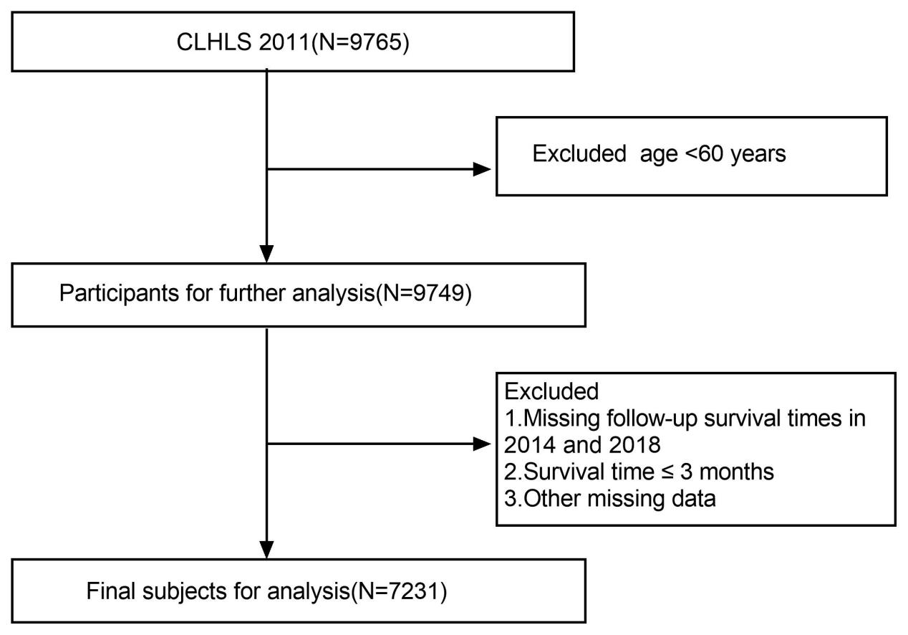
SFig. 1 Flow chart of this analysis based on CLHLS 2011-2018

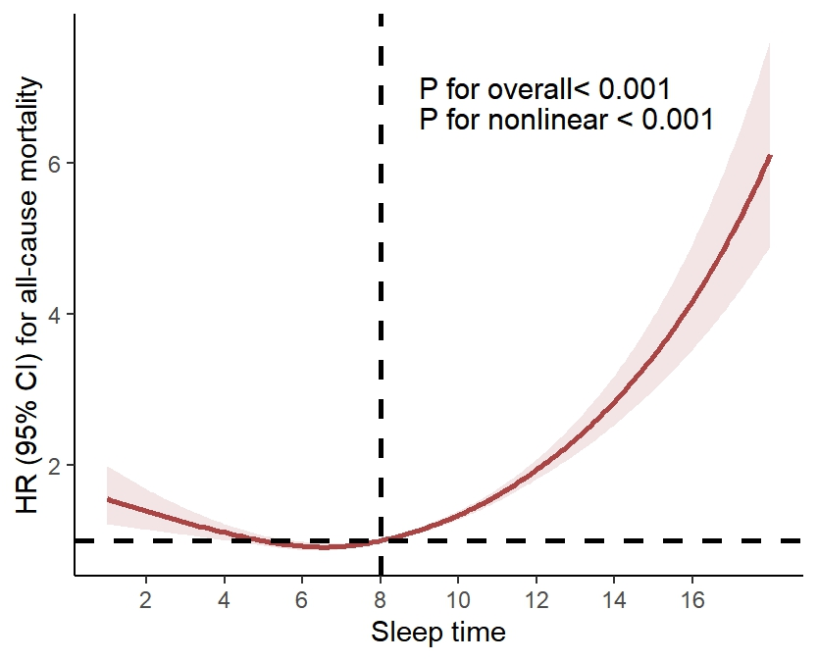
SFig. 2 Restricted cubic spline curves for the relationship between sleep time and all-cause mortality in Chinese older adults

