Integrating local malaria molecular monitoring into regular malaria indicator surveys on Bioko Island: high association between urban communities and low density infections.
Thomas C. Stabler^{1,2}, Salome Hosch^{1,2}, Elizabeth Nyakarungu³, Johanna Nouria Giger^{1,2}, Monserrat Kobe Elonga⁴, Rosalia Nzang Bibang⁴, Victoria Mangue Ndong⁴, Ilda Elobe Mometolo⁴, Alejandro Lopelo Bolopa⁴, Rosa Maria Oko Bedoung⁴, Jose Raso Bijeri⁴, Esperanza Willy Roka⁴, Ana Gertrudis Nguema⁴, Victoria Palacios Ichinda⁴, Salvador Bakale⁴, Cristina Nka Esokolete⁴, Matilde Riloha Rivas⁵, David S. Galick³, Wonder Philip Phiri³, Carlos A. Guerra⁶, Guillermo A. García⁶, Tobias Schindler⁷, Joana C. Silva^{8,9,10}, Claudia Daubenberger^{1,2}
- Department of Medical Parasitology and Infection Biology, Swiss Tropical and Public Health Institute, Basel, Switzerland
- University of Basel, Basel, Switzerland
- MCD Global Health, Malabo, Equatorial Guinea
- Baney Reference Laboratory, Baney, Equatorial Guinea
- Equatorial Guinea Ministry of Health and Social Welfare, Malabo, Equatorial Guinea
- MCD Global Health, Silver Spring, Maryland, USA
- Diaxxo AG, Zurich, Switzerland
- Department of Microbiology and Immunology, University of Maryland School of Medicine, Baltimore, Maryland, USA
- Institute for Genome Sciences, University of Maryland School of Medicine, Baltimore, Maryland, USA
- Global Health and Tropical Medicine, GHTM, Instituto de Higiene e Medicina Tropical, IHMT, Universidade NOVA de Lisboa, UNL, Lisboa, Portugal

Supplementary Table S1. List of categorical variables included in the analysis of Plasmopod. Survey data was generated from the 2023 MIS conducted between August – October 2023 on Bioko Island, Equatorial Guinea.
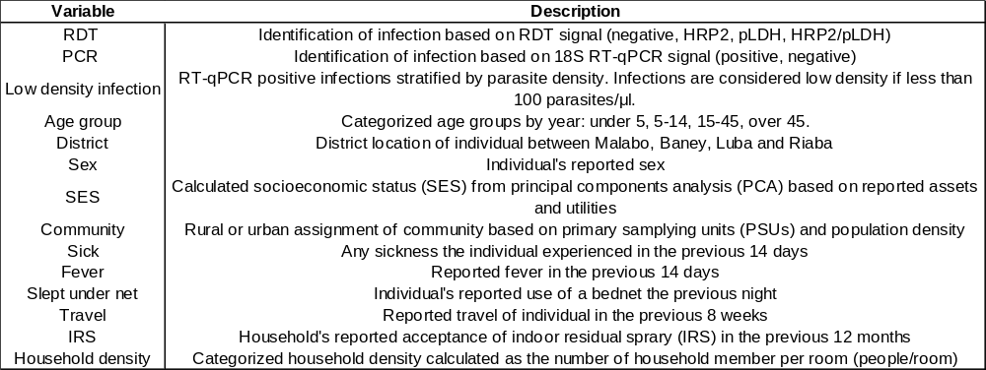
Supplementary Table S2. Median and range of Cq values stratified by subpopulation and RDT diagnosis (negative versus positive). P-values were calculated using t-test for mean difference of Cq values between subgroups.
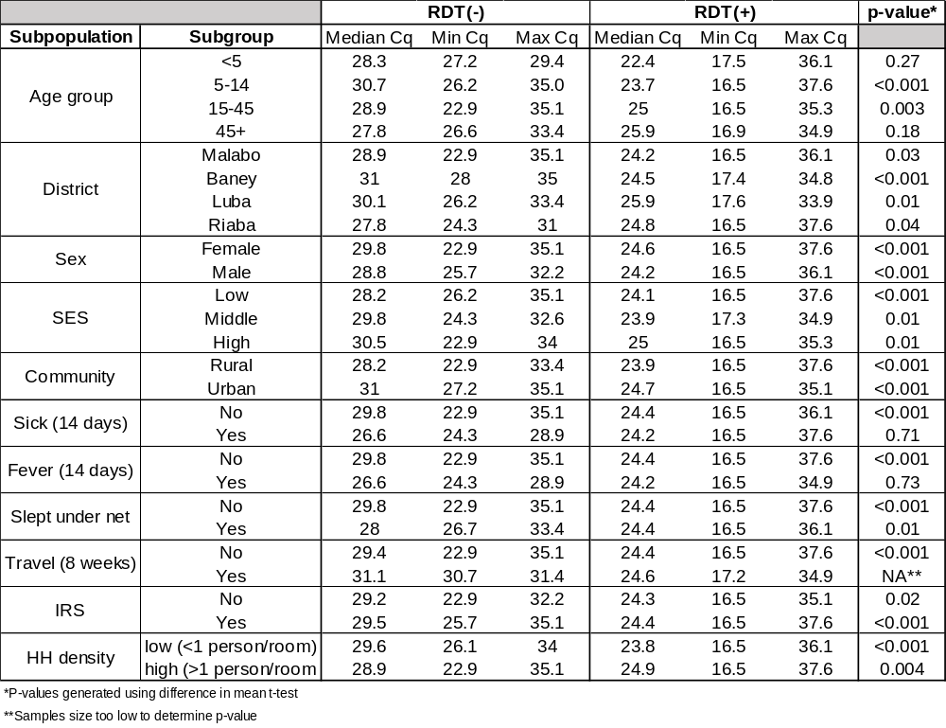
Supplementary Table S3. Estimated odds ratios from univariate and regression models between malaria infection by qPCR and epidemiological subpopulations. Univariate groups were included in the adjusted multivariate model if their inclusion improved or maintained the model’s fitness as measured by McFadden (R² = 0.08).
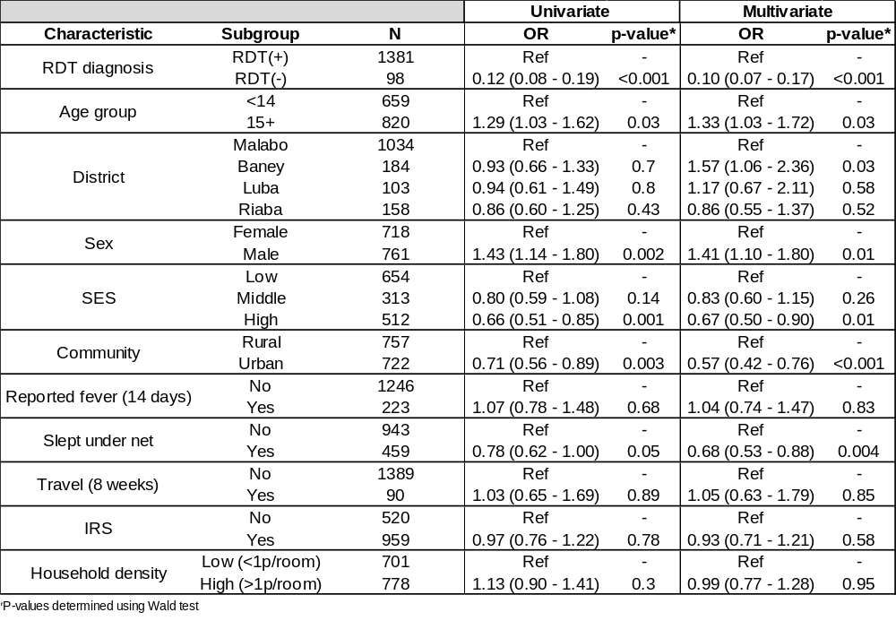

Supplementary Table S4. Estimated odds ratios from univariate and regression models between low density malaria infection by qPCR and epidemiological subpopulations. Univariate groups were included in the adjusted multivariate model if their inclusion improved or maintained the model’s fitness as measured by McFadden (R² = 0.06). Low density infections were defined as an infection quantified as having less than 100 parasites/μl.
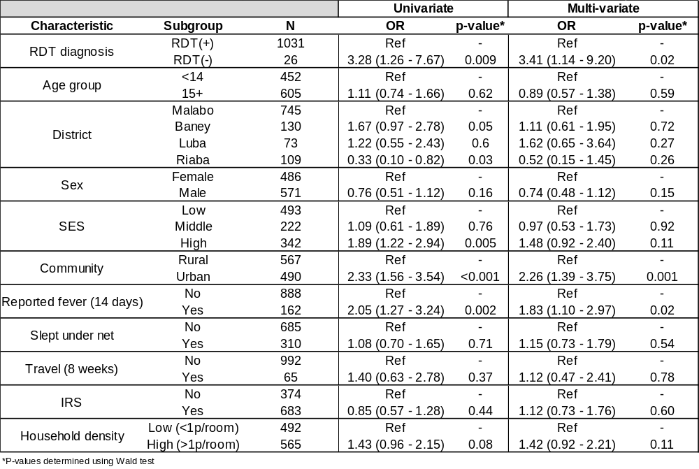

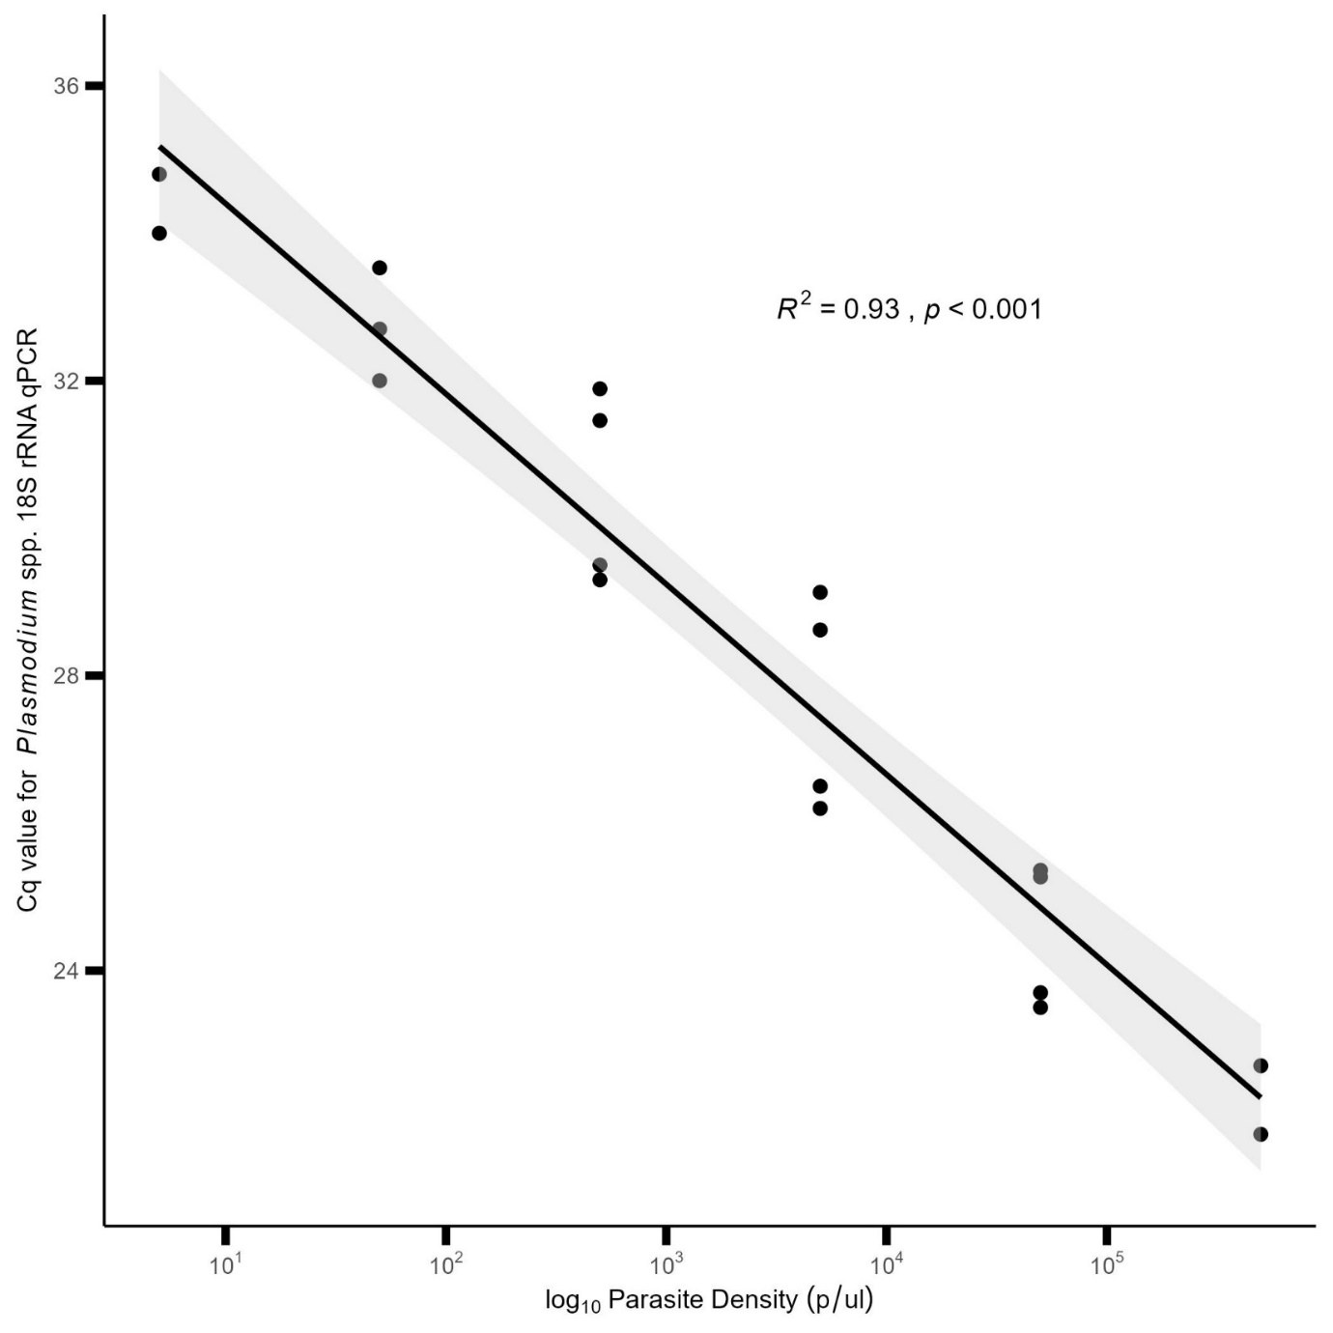
Supplementary Figure S1. Quantification of parasite density of DiaxxoPCR Plasmopod 18S RT-qPCR results. Known concentrations of parasite density by serial dilutions of WHO P. falciparum standard was compared with their corresponding qPCR value. Results were used as an estimate of parasite density of samples from the 2023 MIS. Parasite densities are reported on a log scale.

