Supplemental materials

Generation of frameshift mutated TGFβR2-specific T cells in healthy subjects following administration with cancer vaccine candidate FMPV-1/GM-CSF in a Phase 1 study

Else Marit Inderbergª, Nand Singh^{b}, Robert Miller^{c}, Sarah Arbe-Barnes^{c}, Henrik K. Eriksen^{c}, Berit lversen^{c}, Hedvig Vidarsdotter Juulª, Jon Amund Eriksen^{c}, Karianne Risberg Handeland^{c}

Contents
Figure S1. Method for measuring average skin induration area following evaluation of delayed type hypersensitivity response. 30
Figure S2. Mutated TGFβR2 cfDNA in plasma
Methods S1. Isolation of PBMC.
Methods S2. In vitro analyses of T-cell response against FMPV-1 peptide
Methods S3. Preparation of plasma from blood samples
Methods S4. Extraction and analysis of cfDNA

Figure S1. Method for measuring average skin induration area following evaluation of delayed type hypersensitivity response.

Average area = (a + b)/2

Figure S2 Mutated TGFβR2 cfDNA in plasma
A.
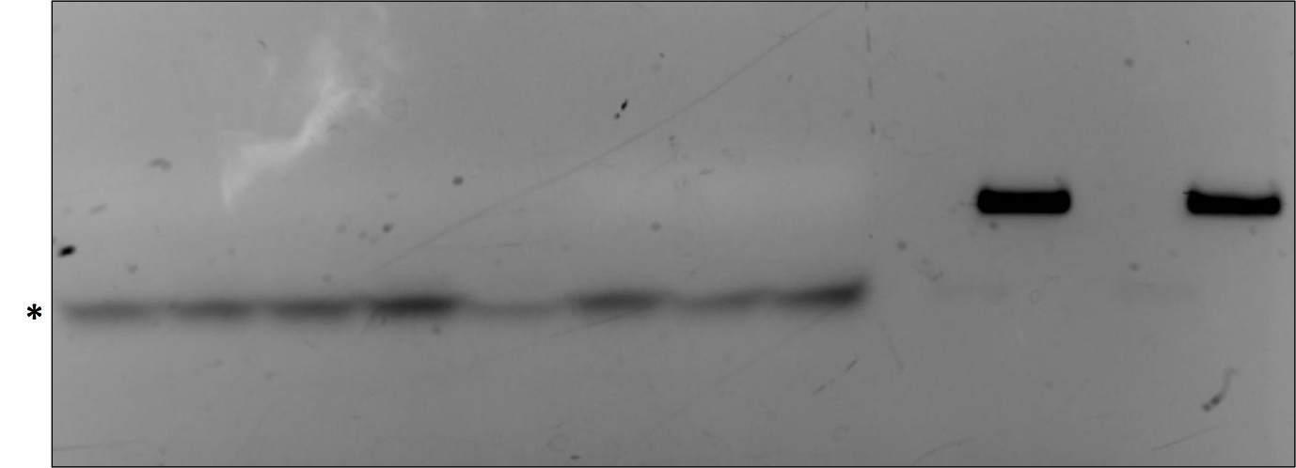
Wildtype TGFβR2 control
Mutant TGFβR2 control
101 102 103 104 105 106 107 108
Subject number

B. 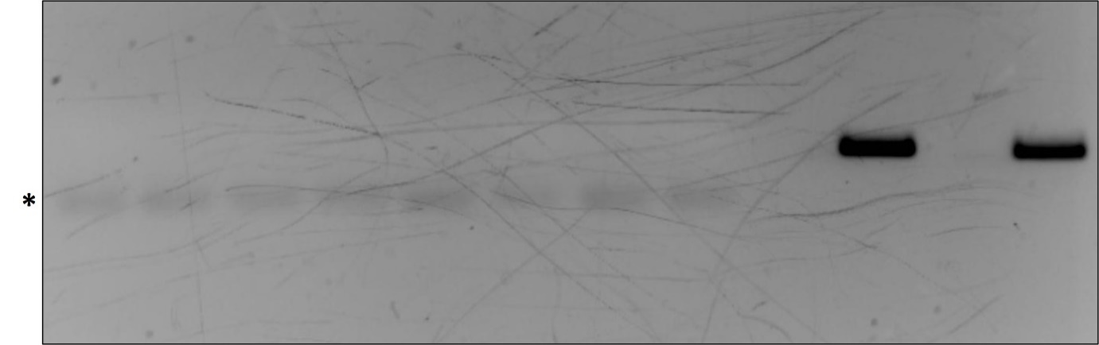
Mutant TGFβR2 control
Wildtype TGFβR2 control
201 202 203 204 205 206 207 208

Subject number

Gel images captured after gel electrophoresis of PCR products generated with primers for TGFβR2 detection and cfDNA extracted from plasma samples originating from healthy subjects as template. Synthetic DNA with mutated and wildtype TGFβR2 sequence as template for the positive controls. A. Gel image with cfDNA from plasma samples from subject 101-108 at Day 29. Asterisk indicates nonspecific bands resulting from primer dimerization. B. Gel image with cfDNA from plasma samples from subject 201-208 at Day 1. Asterisk indicates nonspecific bands resulting from primer dimerization.

Methods S1. Isolation of PBMC

Peripheral blood mononuclear cells (PBMCs) were obtained from 64 mL peripheral blood taken in CPT Sodium Heparin (CPT) tubes (BD Biosciences) prior to the first vaccination, Day 57, Day 80, Day 182 and Day 365. The CPT tubes were inverted 8 to 10 times and centrifuged within 2 h of collection at 1800 g for 20 min at room temperature. Subsequently, each CPT tube was gently inverted to suspend the PBMCs in the plasma. The PBMCs and plasma was transferred to a 50 mL tube, Ca²⁺ and Mg²⁺ free Phosphate Buffered Saline (PBS, Gibco) added and the tube was inverted 3 to 4 times and centrifuged at 400 g for 10 min at RT. Following centrifugation, the supernatant was aspirated and the PBMCs were resuspended in Ca²⁺ and Mg²⁺ free PBS before the cell count was determined by Trypan Blue Stain. The PBMCs were subjected to a second wash in PBS using the same conditions as during the first wash. Cells were resuspended at a concentration of 1 x 10⁶ per mL in RPMI-1640 (Sigma Aldrich) 10% Human Serum Albumin (Octapharma Ltd) and 10% Dimethyl sulfoxide (Sigma Aldrich). 1 mL cell suspension per vial was frozen at -70°C before shipment on dry-ice to the Department of Cellular Therapy, Oslo University Hospital-The Norwegian Radium Hospital, Norway for analysis.

Method S2. In vitro analyses of T-cell response against FMPV-1 peptide

The FMPV-1-spesific proliferative response was determined using thawed PBMC from each timepoint. PBMC were stimulated in vitro with 10 µM FMPV-1 (Baccinex SA, Courroux, Switzerland) at 2 x 10⁶ cells/mL in CellGro DC medium (Cell Genix, cat.no 20-801-0500) with 0.01M HEPES (Gibco, cat.no 15630-056), 0.05 mg/ml Gentamycin (Gibco, cat.no 15750-037) and 1.6 mg/ml N-acetyl cysteine (Mucomyst; Mylan, cat.no 078859). On day 3, IL-2 (Clinigen, cat.no PL31644/0003) and IL-7 (R&D, cat.no 207-IL-025) at final concentrations of 20 U/mL and 5 ng/mL were added the culture. If needed, medium containing the final concentration of 20 U/mL IL-2 and 5 ng/mL IL-7 was refreshed from Day 6. The cells were cultured for 12-14 days at 37°C, 5% CO₂.
For the proliferation assay, 5 x 10⁴ T cells were seeded in 100 µL CellGro DC medium using 96-well U-bottomed microtiter plates (Costar, cat.no 3799). 5 x 10⁴ irradiated (30 Gy) autologous PBMCs were added in 100 µL CellGro DC medium for use as Antigen Presenting Cells (APCs). FMPV-1 was added to a final concentration of 10 µM. Sec 3 (Toxin Technologies, cat.no CT333) at a final concentration of 0.1 µg/mL was used as positive control, T cells only was used as negative control. Proliferation was measured at day 3 after overnight labelling with 3.7 10⁴ Bq 3H-Thymidine (Hartman Analytical, cat.no MT6035) before harvesting. All conditions in T-cell proliferation assays were performed in triplicates.
Stimulation Index (SI) was calculated using counts of wells containing T cells and irradiated APCs loaded with FMPV-1 divided by mean counts of control wells containing T cells and irradiated APCs without FMPV-1. SI ≥ 2 was considered a positive response.
All results with T cell count at Day 12-14 < 5 x 10⁴ / well and the SI value of SEC 3 stimulated cells < 2 were excluded from the final analysis.

Method S3. Preparation of plasma from blood samples

2 mL peripheral blood was collected in pre-chilled K2EDTA tubes (Greiner Bio-One Ltd, Stonehouse, UK) and inverted 8-10 times at Day 1, Day 29, and Day 43. Plasma was obtained by centrifuging the samples at 1200 x g for 15 minutes at 4°C, brake off, within 30 minutes of collection. Without disturbing the buffy coat, the plasma was transferred to a pre-chilled tube and centrifuged at 2200 x g for 20 minutes at 4°C, brake off. Without disturbing the pellet, 600 µL plasma was transferred to a pre-chilled cryovial and frozen at -70°C for storage before shipment to Hubro Therapeutics, Oslo, Norway for analysis.

Method S4. Extraction and analysis of cfDNA

The sample was thawed on wet ice before 600 µL plasma was transferred from the cryovial to a fresh 1.5 mL microcentrifuge tube and centrifuged at 400 x g for 2 minutes at room temperature. Subsequently 500 µL of plasma was transferred to a fresh 2 mL Eppendorf tube.
cfDNA was extracted from the plasma samples using Plasma/Serum Cell-Free Circulating DNA Purification Mini Kit (Norgen Biotek, cat. #55100) according to the protocol included in the kit. Initial transfer of plasma and binding of DNA to the micro spin column was performed in three steps, with approximately 500 µL of solution transferred in each step. Both the spin columns (mini and micro) were washed twice during the washing step with 80% ethanol derived from absolute (> 99.9%) analytical grade ethanol (Merck provided by VWR Avantor cat. #1.00983) and MilliQ RO H₂0. Purified DNA was eluted using 25 µL of the elution buffer supplied with the kit.
PCR assay for indication of mutated TGFβR2 cfDNA fragments was performed with Taq-polymerase (New England Biolabs, cat. #M0273) according to the protocol included in the kit with slight modifications; the standard Taq Reaction buffer was substituted with 10x Key-buffer (VWR Avantor, cat. #733-1349). 5 µL of extracted cfDNA was used as template. Two reactions with 25 µL volume per cfDNA sample, one with primer pair for detection of the mutant sequence and one with primer pair for positive control indicating presence of TGFβR2 fragments (wt/mut) in the sample were incubated in PCR tubes (Thermo Fisher Scientific provided by VWR Avantor cat. #732-4809) in a Thermocycler (Bio-Rad, cat. #1841100) with 96-Well fast reaction module (Bio-Rad, cat. #1840196) and the following programme: 30 sec at 95°C, 25 cycles of 15 sec at 95°C - 15 sec at 57°C - 45 sec at 68°C, followed by 68°C for 5 min.
PCR assay for sequencing was performed with Q5 high-fidelity polymerase (New England Biolabs, cat. #M0491) according to the protocol included in the kit. 8 µL extracted cfDNA as template. One reaction with 25 µL volume per cfDNA sample with positive control primer pair were incubated in PCR tubes. The programme for the Thermocycler was according to the protocol included in the kit, with an annealing temperature of 65°C for 20 sec, and 30 cycles.
25 µL of PCR product was mixed with 4 µL of NonTox DNA-dye (PanReac AppliChem provided by VWR Avantor cat. #A9555.1000) and gel electrophoresis was performed using 1.8% agarose gels made with agarose (Thermo Fisher Scientific, cat. #J32802) and 50X TAE-buffer solution (Thermo Fisher Scientific, cat. #J63931) and processed at 110V for 45 minutes. Amersham Imager 600 (GE Healthcare, cat. #29-0834-63) was used for gel imaging.
PCR primer sequences:
5’-AGACAGTTTGCCATGACCC-3’
3’-CAGTGTCATAGAGCACATTCCT-5’
3’-CGAAAAAAAAAGCCTGGTGAGAC-5’

