Supplementary Materials

Table 1S Descriptive Statistics after Imputation using EM method (N=2756)
Domain | Variables | Mean | SD | skewness | kurtosis | Normality test
 |  |  |  |  |  | KS | p
NSSI | NSSI_T | 0.38 | 0.729 | 2.041 | 3.589 | 0.439 | <0.001
NSSI | NSSI_B | 0.20 | 0.534 | 3.068 | 9.828 | 0.499 | <0.001
Cognition | CSES | 31.57 | 7.653 | 0.051 | -0.273 | 0.053 | <0.001
Cognition | Se_Rej | 57.93 | 25.434 | 0.849 | 0.270 | 0.097 | <0.001
Cognition | Impair | 63.81 | 25.597 | 0.548 | -0.162 | 0.065 | <0.001
Cognition | Over | 38.64 | 13.365 | 0.414 | 0.074 | 0.043 | <0.001
Emotion | ERS_Sen | 11.61 | 9.366 | 0.876 | 0.059 | 0.116 | <0.001
Emotion | ERS_Ints | 8.87 | 6.428 | 0.730 | -0.011 | 0.104 | <0.001
Emotion | ERS_Per | 5.04 | 3.882 | 0.807 | -0.025 | 0.141 | <0.001
Emotion | Ob | 19.80 | 5.833 | 0.155 | -0.107 | 0.065 | <0.001
Emotion | Des | 22.60 | 4.872 | 0.046 | 0.885 | 0.079 | <0.001
Emotion | AW | 27.54 | 7.094 | -0.238 | -0.315 | 0.046 | <0.001
Emotion | Nju | 26.19 | 6.412 | -0.100 | 0.154 | 0.065 | <0.001
Emotion | Nreac | 17.79 | 5.117 | 0.209 | 0.581 | 0.072 | <0.001
Pain | PSQ_Mod | 5.13 | 1.917 | 0.111 | -0.218 | 0.028 | <0.001
Pain | PSQ_Min | 3.84 | 1.681 | 0.492 | 0.211 | 0.052 | <0.001
Cognition | IC | 21.42 | 5.572 | -0.355 | -0.395 | 0.062 | <0.001
Cognition | HH | 9.18 | 2.913 | 0.030 | -0.503 | 0.082 | <0.001
Cognition | TT | 11.40 | 2.772 | 0.242 | 0.237 | 0.104 | <0.001
Cognition | FW | 8.87 | 2.482 | 0.032 | -0.028 | 0.089 | <0.001
Cognition | RE | 10.92 | 2.966 | -0.567 | -0.286 | 0.118 | <0.001
Cognition | SPQ | 28.50 | 10.545 | 0.049 | -0.687 | 0.040 | <0.001
Pain | Pain_Ed | 3.29 | 0.933 | -0.306 | -0.228 | 0.059 | <0.001
Pain | Pain_Mag | 3.82 | 0.884 | -0.595 | -0.029 | 0.091 | <0.001
Note: NSSI_T: “NSSI Thoughts within a month", NSSI_B: "NSSI Behaviors within a month", CSES: Core self-evaluation, Se_Rej: "Separation and Rejection", Impair: "Autonomy and Competence Impairment", Over: "Overcompensation", ERS_Sen: "ERS_Sensitivity", ERS_Ints: "ERS_Intensity", ERS_Per: "ERS_Persistence", Ob: "Observe", Des: "Describe", AW: "Act with Awareness", Nju: "Nonjudge", Nreac: "Nonreact", PSQ_Min: "Mild Pain sensitivity", PSQ_Mod: "PSQ_Moderate", IC: "Impulse control", HH: "Healthy habits", TT: "Resisting temptation", FW: "Focus on work", RE: "Restrain entertainment", SPQ: "Social Pain", Pain_Ed: "Enduring the Pain", Pain_Mag: "Managing the Pain".

The three most central nodes in the network were ‘Impaired Autonomy and Performance,’ ‘Core Self-Evaluation,’ and ‘Acting with Awareness.’ Notably, ‘Impaired Autonomy and Performance’ was significantly more central than all nodes except ‘Core Self-Evaluation’ (Figure 1S). Strength centrality plots for the cognitive-emotional-pain perception networks are shown in Figure 2S.
Figure 1S Centrality Significance for the Cognitive-emotional-pain perception network
Note: NSSI_Thou: NSSI thoughts within a month", NSSI_Beh: " NSSI behaviors within a month", CSES: Core self-evaluation, Se_Rej: "Separation and Rejection", Impair: "Autonomy and Competence Impairment", Over: "Overcompensation", ERS_Sen: "ERS_Sensitivity", ERS_Ints: "ERS_Intensity", ERS_Per: "ERS_Persistence", Ob: "Observe", Des: "Describe", AW: "Act with Awareness", Nju: "Nonjudge", Nreac: "Nonreact", PSQ_Min: "Mild Pain sensitivity", IC: "Impulse control", RT: "Resisting temptation", HH: "Healthy habits", RE: "Restrain entertainment", SPQ: "Social Pain", Pain_Ed: "Enduring the Pain", Pain_Mag: "Managing the Pain".

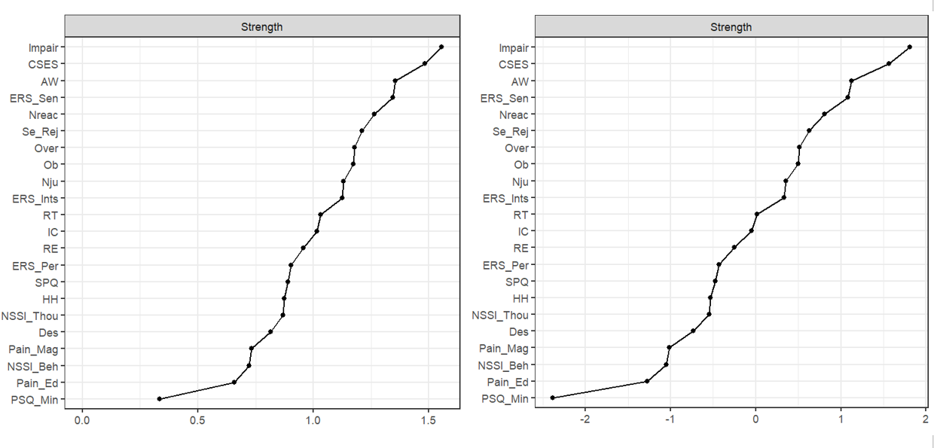
Figure 2S Strength Centrality of all Nodes across the Entire Sample, shown with (left) non-standardized values and (right) standardized values.
Note: NSSI_Thou: NSSI thoughts within a month", NSSI_Beh: " NSSI behaviors within a month", CSES: Core self-evaluation, Se_Rej: "Separation and Rejection", Impair: "Autonomy and Competence Impairment", Over: "Overcompensation", ERS_Sen: "ERS_Sensitivity", ERS_Ints: "ERS_Intensity", ERS_Per: "ERS_Persistence", Ob: "Observe", Des: "Describe", AW: "Act with Awareness", Nju: "Nonjudge", Nreac: "Nonreact", PSQ_Min: "Mild Pain sensitivity", IC: "Impulse control", RT: "Resisting temptation", HH: "Healthy habits", RE: "Restrain entertainment", SPQ: "Social Pain", Pain_Ed: "Enduring the Pain", Pain_Mag: "Managing the Pain".

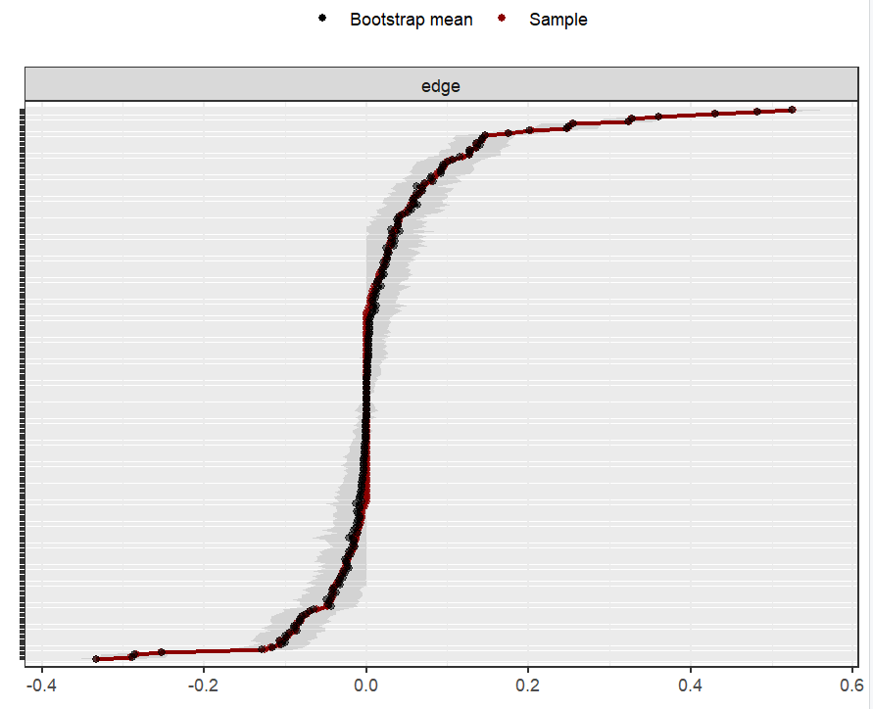
Figure 3S Edge Stability Test for the Network (nBoots = 1000)

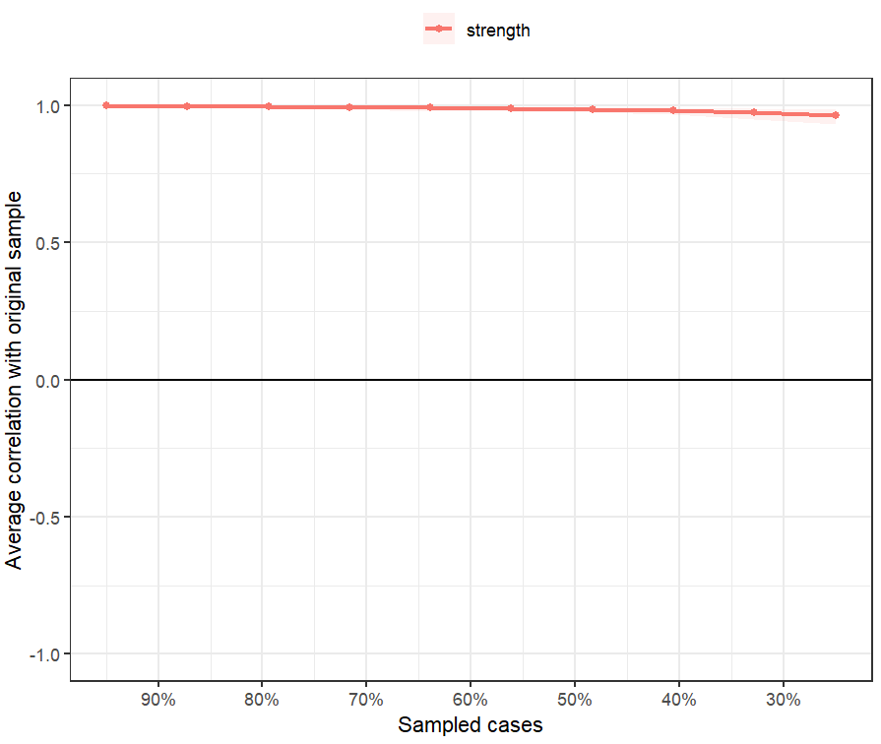
Figure 4S Node Stability Test for the Network (nBoots = 2500, type = "case")

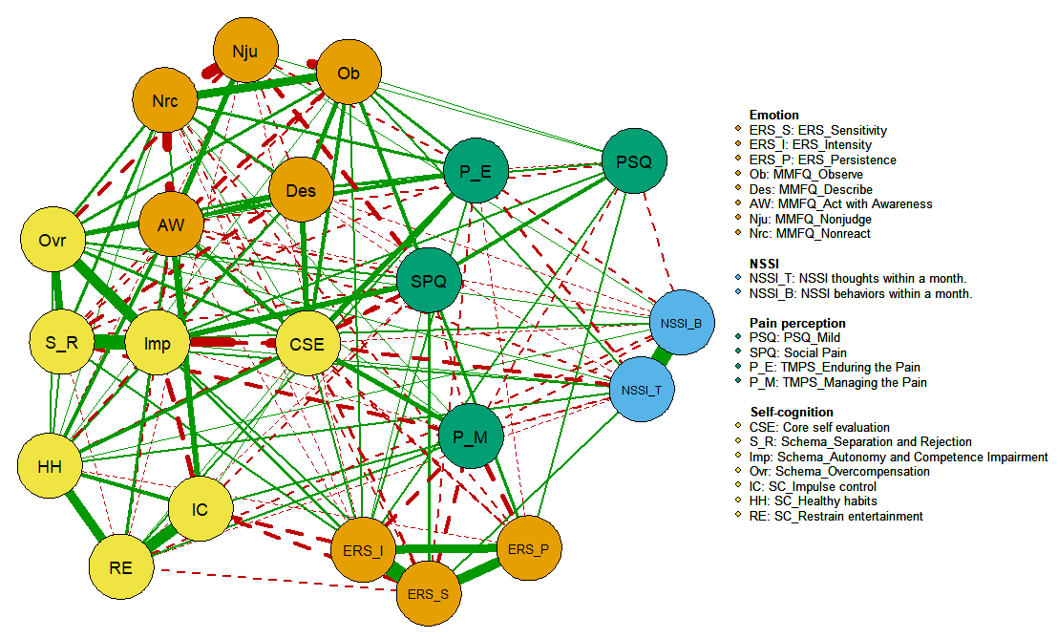
Figure 5S The network structure of Emotion-Cognitive-Pain perception after removing the node "Resisting temptation"

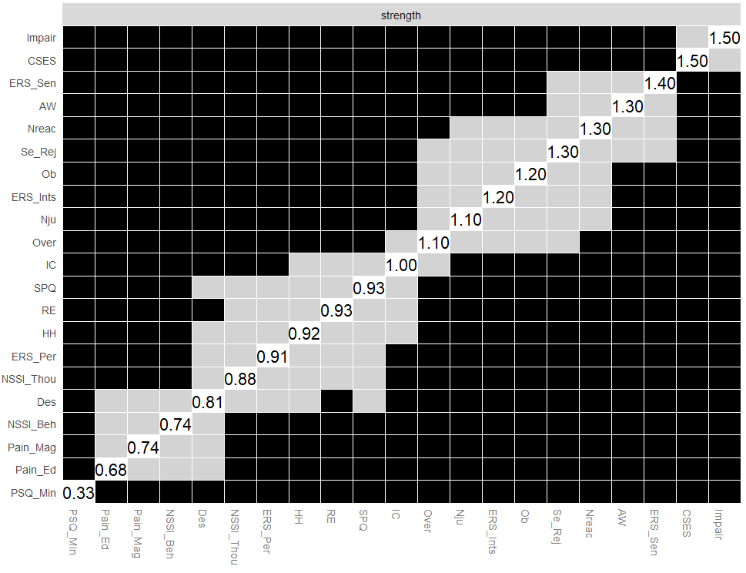
Figure 6S Centrality Significance for the Cognitive-emotional-pain perception network after removing the node "Resisting temptation"

Table 2S Differences in the scores of self-report questionnaires between DP and Non-DP groups
 | Mean±SD |  | t | p | Cohen's d
 | Non-DP | DP | t | p | Cohen's d
NSSI_Thoughts | 0.17±0.46 | 0.76±0.94 | -18.402 | <0.001 | 0.796
NSSI_Behavior | 0.07±0.33 | 0.42±0.73 | -14.003 | <0.001 | 0.619
CSES | 34.65±6.65 | 25.98±6.02 | 34.819 | <0.001 | 1.366
Se_Rej | 47.37±18.41 | 77.07±25.23 | -32.398 | <0.001 | 1.345
Impair | 53.32±20.00 | 82.83±23.59 | -33.140 | <0.001 | 1.350
Over | 34.60±11.78 | 45.97±12.96 | -22.762 | <0.001 | 0.918
ERS_Sen | 7.98±7.17 | 18.19±9.30 | -29.806 | <0.001 | 1.229
ERS_Ints | 6.65±5.23 | 12.89±6.44 | -25.933 | <0.001 | 1.062
ERS_Per | 3.74±3.12 | 7.40±4.01 | -24.725 | <0.001 | 1.018
Observe | 18.98±5.71 | 21.28±5.77 | -10.079 | <0.001 | 0.402
Describe | 23.52±4.58 | 20.93±4.95 | 13.524 | <0.001 | 0.544
Awareness | 29.94±6.31 | 23.20±6.33 | 26.808 | <0.001 | 1.067
Njudge | 27.51±6.14 | 23.79±6.20 | 15.125 | <0.001 | 0.603
Nreact | 16.78±4.94 | 19.61±4.92 | -14.432 | <0.001 | 0.574
PSQ_Mod | 4.91±1.83 | 5.52±2.00 | -7.944 | <0.001 | 0.320
PSQ_Min | 3.68±1.58 | 4.14±1.81 | -6.675 | <0.001 | 0.271
IC | 23.25±4.90 | 18.12±5.19 | 25.358 | <0.001 | 1.017
HH | 9.91±2.77 | 7.85±2.69 | 19.065 | <0.001 | 0.755
RT | 12.10±2.68 | 10.13±2.47 | 19.401 | <0.001 | 0.763
FW | 9.57±2.27 | 7.60±2.34 | 21.379 | <0.001 | 0.855
RE | 11.86±2.56 | 9.23±2.90 | 23.707 | <0.001 | 0.960
SPQ | 25.46±9.58 | 34.01±9.97 | -21.853 | <0.001 | 0.875
Pain_Ed | 3.42±0.94 | 3.05±0.86 | 10.220 | <0.001 | 0.402
Pain_Mag | 4.14±0.71 | 4.24±0.87 | 27.437 | <0.001 | 1.124
Note: CSES: Core self-evaluation, Se_Rej: "Separation and Rejection", Impair: "Autonomy and Competence Impairment", Over: "Overcompensation", ERS_Sen: "ERS_Sensitivity", ERS_Ints: "ERS_Intensity", ERS_Per: "ERS_Persistence", Njudge: "Nonjudge", Nreact: "Nonreact", PSQ_Mod: " Moderate Pain sensitivity", PSQ_Min: "Mild Pain sensitivity", IC: "Impulse control", HH: "Healthy habit", RT: "Resisting temptation", FW:“Focus on work”, RE: "Restrain entertainment", SPQ: "Social Pain", Pain_Ed: "Enduring the Pain", Pain_Mag: "Managing the Pain".

We fixed the average layout of both networks using the averageLayout function to ease interpretation of edge differences in Figure 7S & Figure 8S.

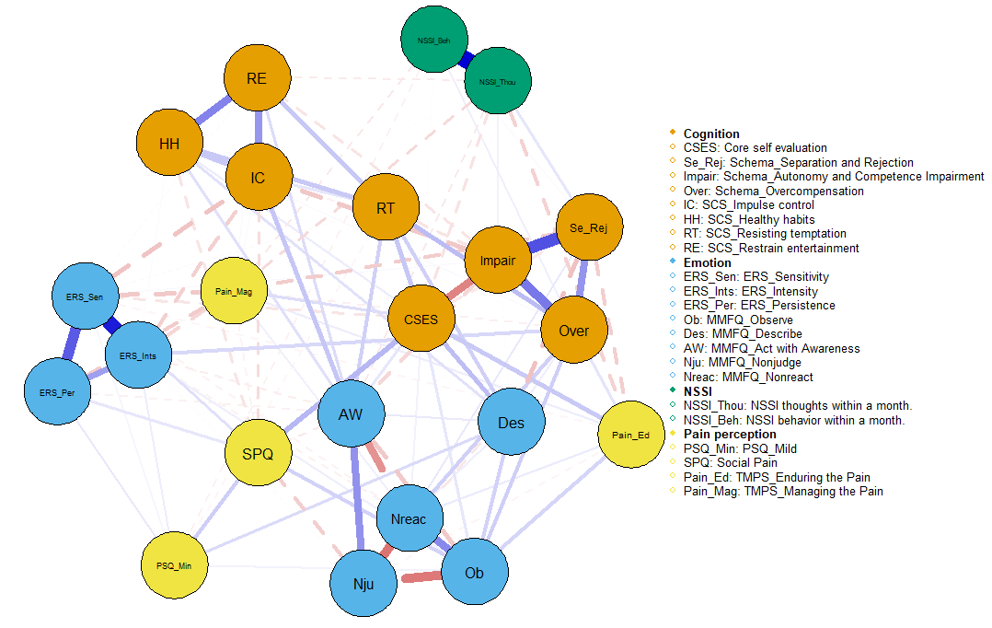
Figure 7S Network structure of Emotion-Cognitive-Pain perception in the group with Depression Proneness (DP group, N=980)

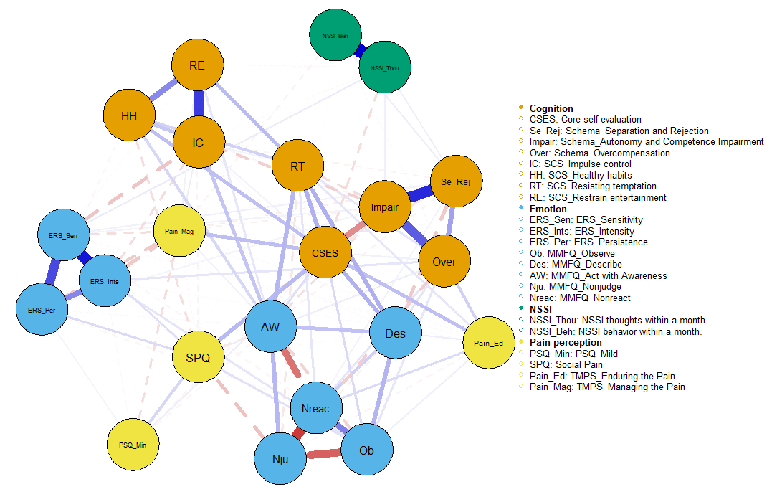
Figure 8S Network structure of Emotion-Cognitive-Pain perception fin the group with without Depression Proneness (Non-DP group, N=1776)

All significant (α=0.05) differences between DP and Non-DP groups in edge weight are presented below:
Table 3S Group differences in edge weight between DP and Non-DP groups
Variable1 | Variable2 | Test.statistic.E | p
IC | RE | 0.170 | <0.001
NSSI_Thou | Pain_Ed | 0.094 | <0.001
Pain_Ed | Pain_Mag | 0.052 | 0.001
Se_Rej | Pain_Ed | 0.103 | 0.004
Des | PSQ_Min | 0.077 | 0.005
Se_Rej | IC | 0.025 | 0.009
Nju | Nreac | 0.102 | 0.011
Nreac | Pain_Mag | 0.032 | 0.011
ERS_Sen | Nju | 0.010 | 0.013
CSES | HH | 0.087 | 0.021
NSSI_Beh | Over | 0.036 | 0.022
Over | RT | 0.090 | 0.023
NSSI_Thou | AW | 0.048 | 0.030
AW | Nju | 0.086 | 0.031
NSSI_Thou | Pain_Mag | 0.079 | 0.035
Des | Pain_Mag | 0.011 | 0.039
Des | IC | 0.015 | 0.041
ERS_Sen | RT | 0.014 | 0.042
Impair | RE | 0.056 | 0.047
CSES | ERS_Sen | 0.055 | 0.048
Des | HH | 0.062 | 0.048
Se_Rej | Pain_Mag | 0.073 | 0.048
Over | Pain_Mag | 0.031 | 0.049
Note: DP: Depression Proneness, NSSI_Thou: NSSI thought within a month", NSSI_Beh: " NSSI behavior within a month", CSES: Core self-evaluation, Se_Rej: "Separation and Rejection", Impair: "Autonomy and Competence Impairment", Over: "Overcompensation", ERS_Sen: "ERS_Sensitivity", ERS_Ints: "ERS_Intensity", ERS_Per: "ERS_Persistence", Ob: "Observe", Des: "Describe", AW: "Act with Awareness", Nju: "Nonjudge", Nreac: "Nonreact", PSQ_Min: "Mild Pain sensitivity", IC: "Impulse control", RT: "Resisting temptation", HH: "Healthy habit", RE: "Restrain entertainment", SPQ: "Social Pain", Pain_Ed: "Enduring the Pain", Pain_Mag: "Managing the Pain". The p values presented in the table are not corrected for multiple comparisons, and none of them survived after correction.
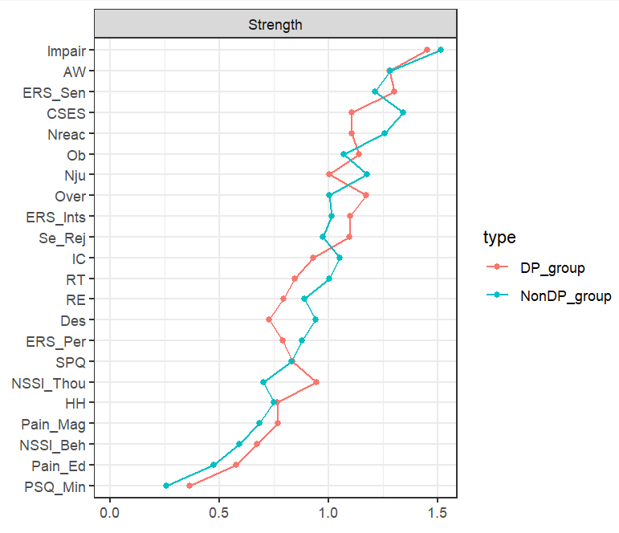
Figure 9S Strength Centrality for Students With and without Depression proneness
Note: NSSI_I: Ideation of NSSI within a month", NSSI_B: "Behavior of NSSI within a month", CSES: Core self-evaluation, Se_Rej: "Separation and Rejection", Impair: "Autonomy and Competence Impairment", Over: "Overcompensation", ERS_Sen: "ERS_Sensitivity", ERS_Ints: "ERS_Intensity", ERS_Per: "ERS_Persistence", Ob: "Observe", Des: "Describe", AW: "Act with Awareness", Nju: "Nonjudge", Nreac: "Nonreact", PSQ_Min: "Mild Pain sensitivity", IC: "Impulse control", TT: "Resisting temptation", HH: "Healthy habit", RE: "Restrain entertainment", SPQ: "Social Pain", Pain_Ed: "Enduring the Pain", Pain_Mag: "Managing the Pain".

Table 4S Table of Strength Centrality Difference before and after “bonferroni” correction
Node | Test statistics C （△Strength） | p | pª
NSSI_Thou | 0.243 | <0.001 | 0.015
NSSI_Beh | 0.079 | 0.336 | 1.000
CSES | -0.236 | 0.019 | 0.557
Se_Rej | 0.122 | 0.197 | 1.000
Impair | -0.059 | 0.360 | 1.000
Over | 0.169 | 0.146 | 1.000
ERS_Sen | 0.091 | 0.218 | 1.000
ERS_Ints | 0.085 | 0.298 | 1.000
ERS_Per | -0.090 | 0.180 | 1.000
Ob | 0.068 | 0.491 | 1.000
Des | -0.214 | 0.059 | 1.000
AW | -0.004 | 0.957 | 1.000
Nju | -0.174 | 0.029 | 0.733
Nreac | -0.149 | 0.216 | 1.000
PSQ_Min | 0.108 | 0.207 | 1.000
IC | -0.120 | 0.040 | 0.923
HH | 0.015 | 0.886 | 1.000
RT | -0.158 | 0.166 | 1.000
RE | -0.093 | 0.100 | 1.000
SPQ | 0.004 | 0.951 | 1.000
Pain_Ed | 0.105 | 0.336 | 1.000
Pain_Mag | 0.082 | 0.217 | 1.000
NSSI_Thou: NSSI thought within a month", NSSI_Beh: " NSSI behavior within a month", CSES: Core self-evaluation, Se_Rej: "Separation and Rejection", Impair: "Autonomy and Competence Impairment", Over: "Overcompensation", ERS_Sen: "ERS_Sensitivity", ERS_Ints: "ERS_Intensity", ERS_Per: "ERS_Persistence", Ob: "Observe", Des: "Describe", AW: "Act with Awareness", Nju: "Nonjudge", Nreac: "Nonreact", PSQ_Min: "Mild Pain sensitivity", IC: "Impulse control", RT: "Resisting temptation", HH: "Healthy habit", RE: "Restrain entertainment", SPQ: "Social Pain", Pain_Ed: "Enduring the Pain", Pain_Mag: "Managing the Pain".
ª：adjust.methods="bonferroni"

