Supplementary Information

SI 1 List of variables tested
CLIMAT
FROST
Variable | Description | Absolue | Recurrence* | Difference* | Standardized Index* | Source
Variable | Description | Unit | Unit | Unit | Unit | Source
TN01 and TN03 | Mean of the minimum temperature for January and March | °C | % | °C | /
HEAT |  |  |  |  |  | Climatic models AURELHY © and SAFRAN © METEOFRANCE (precipitation and temperature) and DIGITALIS © AGROPARISTECH for radiation.  See SI 2 for interannuality of the climatic variables  See SI 3 for standardized index and recurrence
TM_year | Mean annual temperature | °C | % | °C | /
TX0608 | Mean of the maximum temperature from June to August | °C | % | °C | /
PET_year | Annual potential evapotranspiration (Turc formula) | mm | Not estimated | mm | /
Deficit hydric CLIMATIC
P-PET_year  P-PET0410  P-PET0509  P-PET0608 | Climatic water balance (P-PET) for the year, April to October May to September and June to August | mm | % | mm | /
Water balance (AWC including)
Hyd_def | Hydric balance deficit (AWC included) calculated with the Thornthwaite model (1957) = PET-AET  (AET = actual evapotranspiration) | mm | % | mm | /
Hyd_defr | Hydric balance deficit % ((PET-AET)/PET) *100 | % | % | % | /
Nbdays_HydDef | number of days by year during which the REW <40%  (REW = relative extractable soil water) 40% is the threshold for soil water deficit | days | % | days | /
* Reccurence, difference and standardized index were calculated for 4 periods: 1, 3, 5, and 15 years before the year of measurement
TOPOGRAPHY
Variable | Description | Unit | Source
Curv_25m and Curv_75m | General curvature at the plot center calculated by using a 25m and 75m pixel resolution | / | DEM IGN 25m and 75m resolution
Conf | Confinement = slope (%) of the line connecting the studied point to the highest part of the landscape in the semicircle defined by the east-south-west direction | % | Field measurement
TPI_100 and TPI_1500 | Topographic position within a 100 and 1500 meters radius from the plot center | / | DEM IGN 25 m and 75 m resolution for TPI_100 and TPI_1500 respectively
IKR | Radiation index. Ratio between the annual mean radiation obtained by the 50m resolution digital model (SI 2), accounting for exposure and slope, and the annual mean radiation received by a flat surface at 8 km resolution. | / | DIGITALIS model
Slope | Slope (%) measured at the center of the plot | % | Field measurement
TWI25m and TWI75m | Topographic wetness index at the the plot center calculated by using the 25 m and 75m resolution | / | DEM IGN 25 and 75 m resolution

SOIL
Variable | Description | Unit | Source
pH* | pH H₂O measured at 20 cm of depth | / | Field measurement
Clay_depth | Depth of heavy clay presence | cm | Field measurement
AWC and AWCr | Available water capacity and Relative Available water capacity per centimeter of soil (AWC/depth of profile) | mm/cm | Field measurement
Intens_hydro | Intensity of maximal hydromorphy in the profile from 0 to 4 | / | Field measurement
Hydro_depth | Depth of maximal hydromorphy presence (>0) in the profile | cm | Field measurement
Heavy_hydro | Presence (1) or absence (0) of heavy hydromorphy i.e. totally discoloured soil matrix with rust spots or diffuse reduction > 35% of soil surface | / | Field measurement
Depth _Heavy_hydro | Depth presence heavy hydromorphy | cm | Field measurement
Rock_Exp | Percentage of rock exposure on the ground | % | Field measurement
Act_lime | Presence of active lime stone in the profile | / | Field measurement
*except in Jura pH computed with Agroparistech map (AGROPARISTECH and IFN 2008)
Dendrometry
Variable | Description | Unit | Source
G and G_beech | Total basal area and Beech basal area | m²/ha | Field measurement
%G_beech | Beech proportion in the total basal area | % | Field measurement
Hdom | Dominant height of beech | m | Field measurement
Ddom | Dominant diameter of beech | cm | Field measurement
DBH and CV_DBH | Diameter and Coefficient of variation of diameter at breast height of the first 15 beeches near the center of the plot. | Cm & % | Field measurement

SI 2 Method used to correct the climate data
The mean climatic information for each plot derived from the MétéoFrance AURELHY model (Bénichou and Lebreton 1987). This model provides the average monthly precipitation, mean, minimum and maximum temperatures for 1981-2010 at a resolution of 1 km. AURELHY integrates the effects of altitude and topography and uses data from 3400 meteorological stations for rainfall and 1500 stations for temperatures. The monthly average radiation from 1971 to 2000 is calculated by the DIGITALIS model at a resolution of 50 m using data from 88 meteorological stations and considering altitude, latitude, and topography (Piedallu and Gégout 2007). The climatic data from MétéoFrance SAFRAN model (Quintana-Seguí et al. 2008) were used to calculate monthly climatic parameters at a spatial scale of 8 km over the 30 years preceding the measurement year.
For every plot, every climate variable (precipitation, mean, minimum and maximum temperature), and every month, we calculated the difference in the long-term average value for the period 1981-2010 between the SAFRAN model and the AURELHY model. The SAFRAN model provides monthly climate data on an annual basis, but with a low spatial resolution at a 8km grid. In contrast, the AUREHLY model provides only average monthly data for the 1981-2010 period (low temporal resolution), but at high spatial resolution (1km grid). This difference is then used to bias-correct the annual SAFRAN values.
By using this method, we combined the advantages of these two models to conserve both spatial and temporal high resolution, assuming that the temporal variability in the SAFRAN data was similar within a 8-km grid cell.
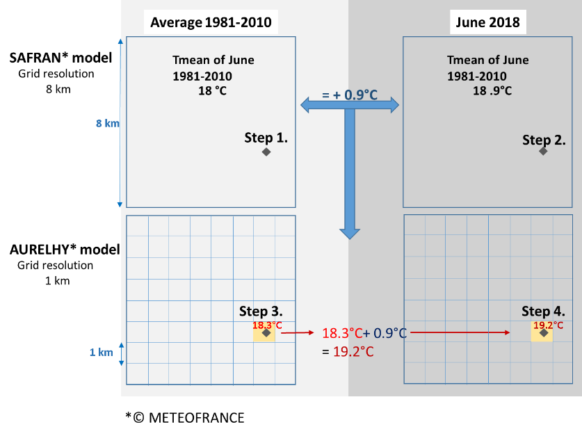
SI 2 Fig. 1 Schematic representation of the workflow used to correct the climate data at each study plot (materialised by a diamond) ; example with mean temperature in June 2018.

SI 3 : Calculation of climatic variables

Standardized index
The following formula is used to calculate the Standardized Index (SI) (McKee et al. 1993):
SI=(Xi−μ)/sd
where Xi is the value of a given climatic parameter X calculated for the period i (in our study 1,3,5,15 years before measurement); μ and sd are the average and standard deviation of X calculated for the period 1981 to 2010.

Estimation of the best quantile threshold to estimate the recurrence of extreme events
For each climatic variable (see Table SI1), we estimated the threshold of extreme values according to the following steps: (1) We computed the climatic variables for each 0.1° grid cell of European beech area as defined by Euforgen (Caudullo et al. 2017) using the CHELSA dataset (Schneider et al. 2013 ; Fig.1) ; (2) we calculated the 0.05, 0.1, 0.15, and 0.25 percentiles ; (3) for each quantile, we computed the linear regressions between XStem50 (%) and the recurrence (proportion of years when the variable exceeds the threshold) for four climatic variables (TX0608, P-PET0509, Nbdays_HydDef, and Hydr_def%, see SI 1 for denomination) and four periods (3, 5, 15, and 30 years before measurement) ; (4) the 0.1 quantile threshold was selected as it showed the highest R² value for all climatic criteria and periods (mean R² = 0.261 ; statistically significant in the twelve cases; Fig. 2).
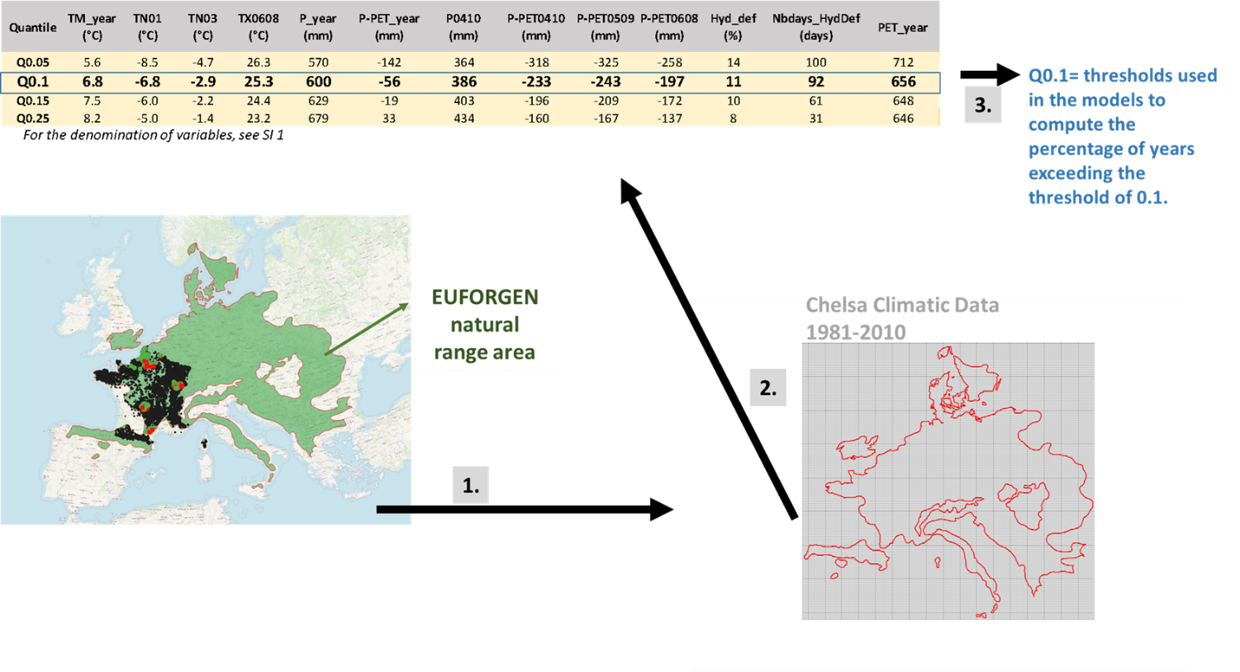
SI 3 Fig. 1 Estimation of climatic quantiles within the natural range (EUFORGEN) of Fagus sylvatica
- Decline plot > 20% of the trees had at least 50% of crown biomass loss Healthy plot < 20% of the trees had fewer than 50% of crown biomass loss Presence of beech (A) according to data from national forest inventory (plots 2002 – 2022) © IGN

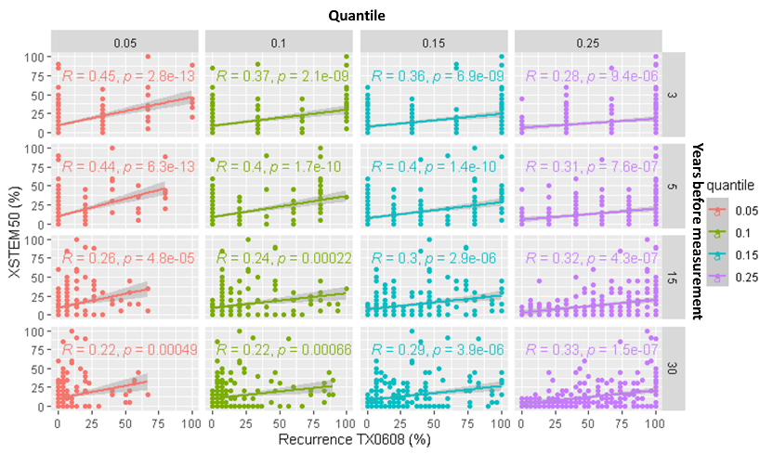 | 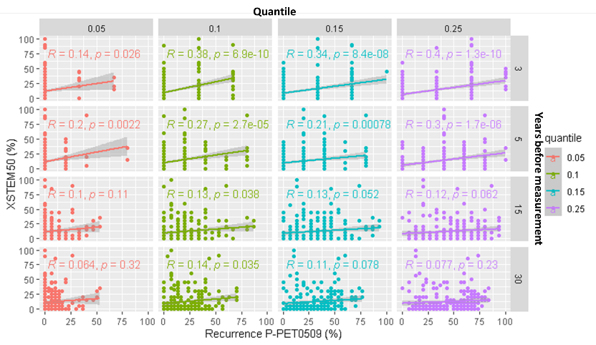
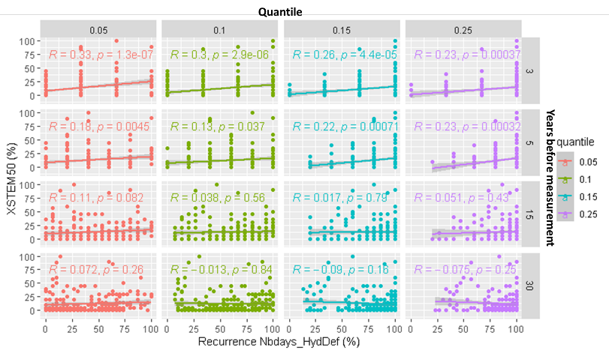 | 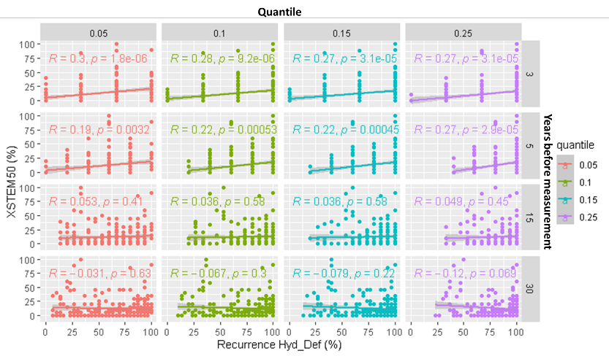
SI 3 Fig. 2 Linear regressions between XStem50 and the recurrence of climatic extremes, estimated for four climatic variables, four quantiles, and four periods, considering the 308 study plots

SI 4 Workflow followed to build the PLS regressions

Each PLS regression was developed to predict XStem50 based on large number of variables that potentially show a high intercorrelation, according to the 4 following steps.
- Variables were grouped into 7 major types (see also Table 2) : climate (with 4 subtypes), soil, topography and dendrometry (=stand characteristics)
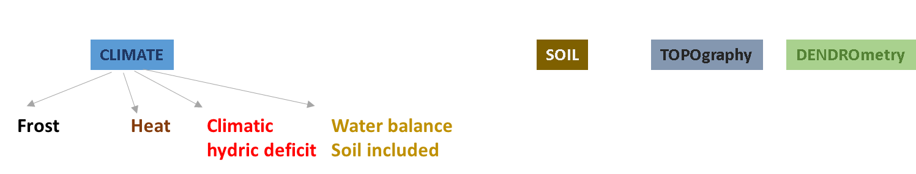
- A dendrogram was built using the hclust function in R for each of the 7 major types (Fig. 1 and 2), and the distance between each pair of variables y and z was calculated as d_{i} = d(y,z) = 1- │corr (yz)│
- We tested d_{i} thresholds from 0.1 to 0.6 by steps of 0.05 For each of these tested di thresholds, the cluster membership of each variable was computed. In our example below, clusters are defined for the distance di = 0.1. If the correlation between two variables is greater than or equal to 0.9, the two variables belong to the same cluster.
- For each d_{i}, we selected the variables to include in the PLS regression based on the dendrogram. Within each cluster, the variable with the highest absolute standard coefficient is selected as an explanatory variable in the stepwise PLS regression.
- The stepwise descending PLS regressions were run with the plsRglm R package (Bertrand and Maumy-Bertrand 2018). Non-significant variables at the p = 0.05 threshold were first eliminated as a block (Tenenhaus 1998). Then, among the significant variables, the variable with the lowest standard coefficient is tested for elimination. If removing this variable resulted in an increase in Q², the variable was removed. The procedure is followed step by step until removing the n^{th} variable induced a decrease in Q², in which case it stops (Fig. 3). If the number of PLS components decreased during this process, the regression was restarted with the new number of components, and the procedure continued with all variables at step 4 until the number of components no longer changed.
- Finally, we followed this procedure for the five models (four regional models and the national model) and selected the distance threshold d_{i} that maximized the Q² of the PLS : d_{i}=0.15 (Fig. 4).

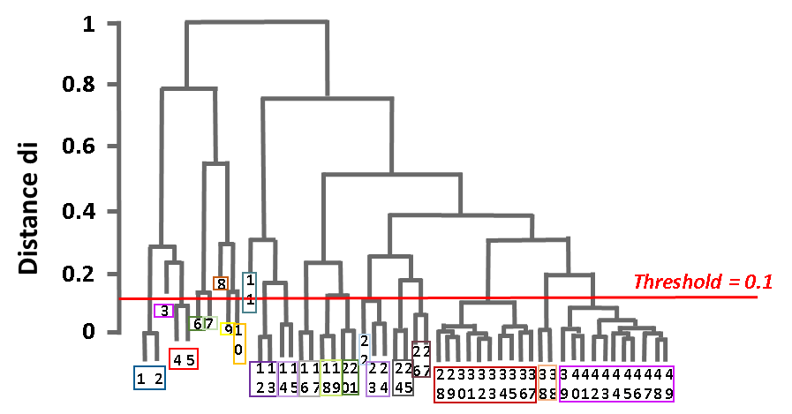
SI 4 Fig. 1 Delimitation of clusters (indicated by the coloured rectangles) determined based on a distance threshold of 0.1
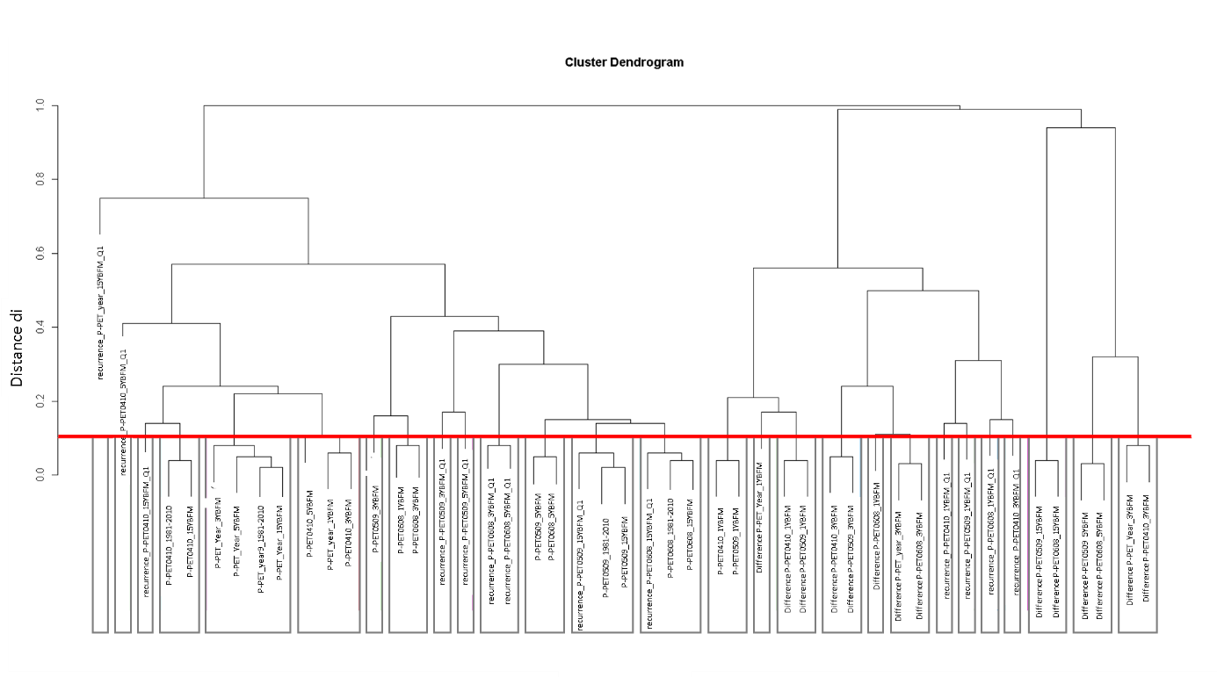 SI 4 Fig. 2 Example of one cluster dendrogram for the climatic hydric deficit parameters. Each rectangle is one cluster at intervals of 0.1 of distance di. For parameters see SI 1
Q1 = quantile 0.1; 1,3,5,15 (SI 3) BFM = periods BeFore Measurements (BFM)

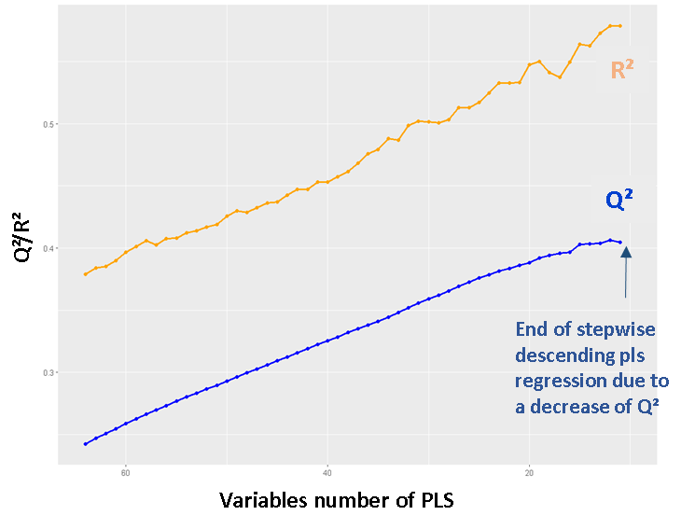
SI 4 Fig. 3 Example of the variation of Q² and R² during the stepwise PLS regression.
ETP_year_5YBM; 33 =
_ 19812
SI 4 Fig. 4 Variation of Q² evolution with distance di (average of the 5 models)

