Supplementary Data

Supplementary Table 1: Manually generated tRNA exon sequences to determine proximity of mutation to potential amino acid codon.
Location | Mutation | Codon (nucleotide sequence) | Coding domain sequence
MT-TW | C5541T  T5578C | ACC | ATT TAA AAC CCA AAC CAT CAC TTA TTC TG (+1)  A TTT AAA ACC CAA ACC ATC ACT TAT TCT G (+2)  AT TTA AAA CCC AAA CCA TCA CTT ATT CTG (+3)
MT-TI | A4263G  C4329G | TAA/TAG | AAA ATT TCT GAA AAG ATT ACT AAT AAT TAG GCC CTT ATT CT (+1)  A AAA TTT CTG AAA AGA TTA CTA ATA ATT AGG CCC TTA TTC T (+2)  AA AAT TTC TGA AAA GAT TAC TAA TAA TTA GGC CCT TAT TCT (+3)
MT-TQ | C4349T  C4329G | GTT/GTC | GG AGG GTG GGG CAG GGT TTC AGG TGG TTC ATC ATT CAG (-1)  G GAG GGT GGG GCA GGG TTT CAG GTG GTT CAT CAT TCA G (-2)  GGA GGG TGG GGC AGG GTT TCA GGT GGT TCA TCA TTC AG (-3)
MT-TM | C4467T  C4467A | TAT | AGA AGG CAC TAA AAG CTA TCG GCC CAT CCC GAA AAT GTT GGA CCT TCC CTC TA (+1)  A GAA GGC ACT AAA AGC TAT CGG CCC ATC CCG AAA ATG TTG GAC CTT CCC TCT A (+2)  AG AAG GCA CTA AAA GCT ATC GGC CCA TCC CGA AAA TGT TGG ACC TTC CCT CTA (+3)
MT-TD | A7551G | CTA/CTG | ATA TGA AAA AAT TCT ACT GTC AAT AAT TAG ACC TAA TT (+1)  A TAT GAA AAA ATT CTA CTG TCA ATA ATT AGA CCT AAT T (+2)  AT ATG AAA AAA TTC TAC TGT CAA TAA TTA GAC CTA ATT (+3)

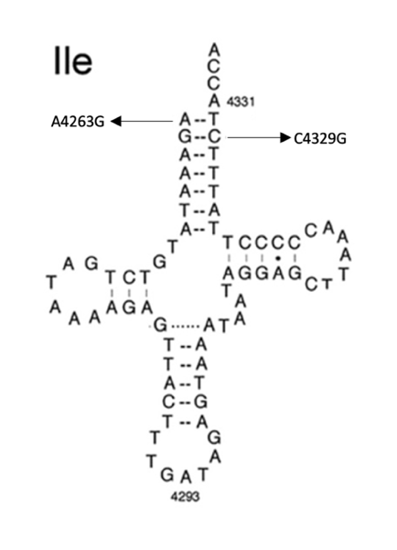
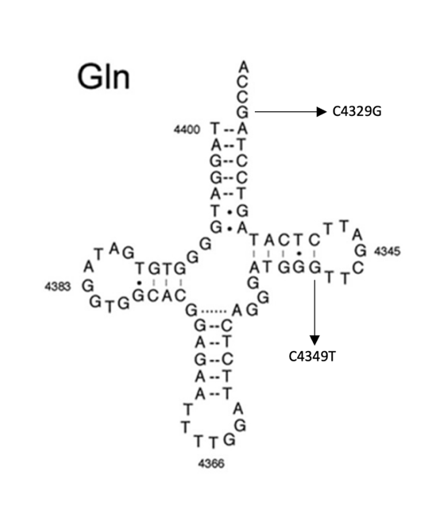
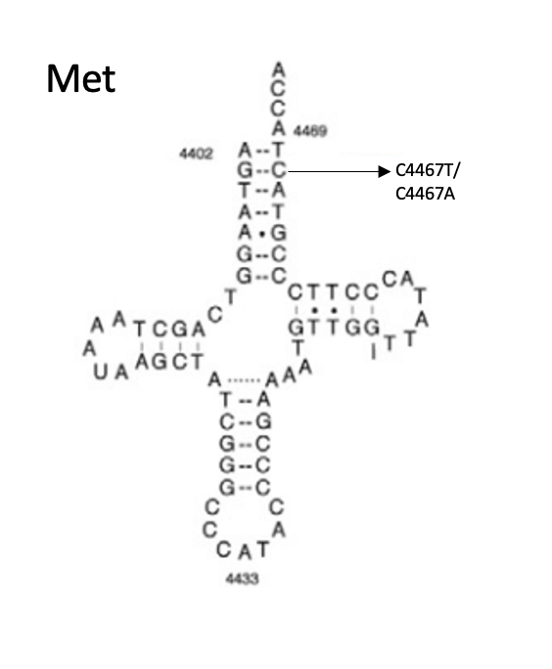
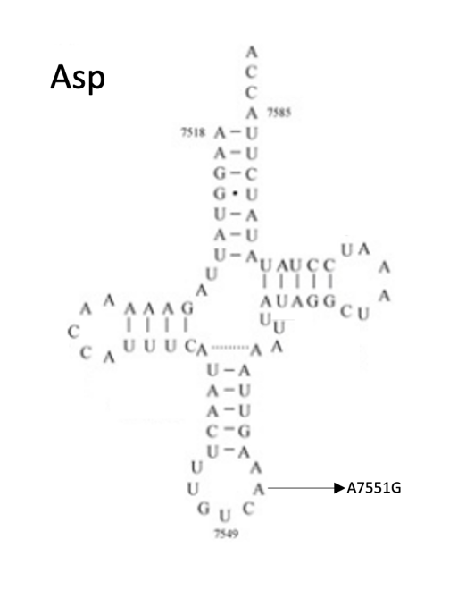
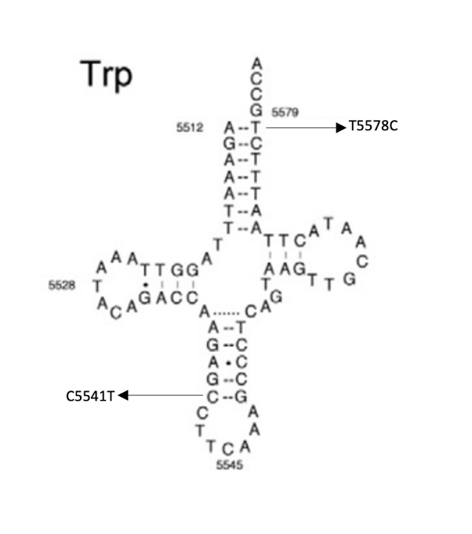

Supplementary Figure 1: Canonical cloverleaf structures for tRNAs and previously categorized mutations namely A4263G (Zhu et al., 2009), C4329A (Y. Liu et al., 2014), C4349T (Ji et al., 2020), C4467T (Y. Liu et al., 2016), C4467A (Y. Liu et al., 2017, C5541T (Hatakeyama et al., 2015), T5578C (Y. Liu et al., 2016) and A7551G (Xue et al., 2016).

