Supporting information for:
A pyrene-derived fluorescent probe for the visual detection of protamine and trypsin activity
Longjun Xiong, Yutian Jiao, Yu Liu, Gongli Wei, Baocai Xu, Li Zhao*
School of Light Industry, Beijing Technology and Business University, Beijing 100048, China. E-mail: zhaol@btbu.edu.cn

Synthesis:
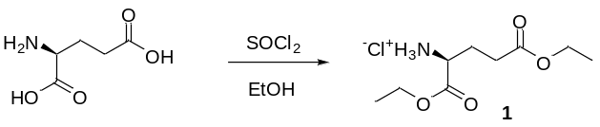
L-Glutamic acid (0.7 g, 5 mmol) was dissolved in 100 mL ethanol and cooled to -10℃. While stirring, 1.1 mL of thionyl chloride was slowly added dropwise. After dropwise addition, the mixture was stirred at room temperature for 1-2 h. Then the mixture was refluxed for 6-8 h, followed by stirring overnight at room temperature. Solvent was removed by evaporation. When a small amount of oily liquid remained in the bottle, diethyl ether was added. White solid precipitated and was filtered (compound 1). ESI-MS: m/z 204.0[(M-Cl)⁺].
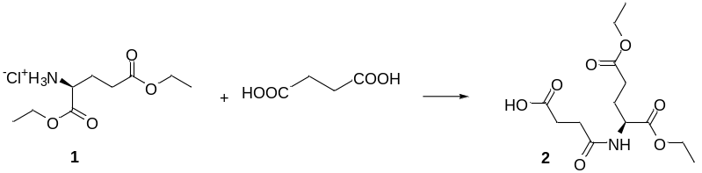
Compound 1 (1.2 g, 5 mmol) and triethylamine (0.6 g, 6 mmol) were dissolved in dichloromethane (50 mL). After stirring at room temperature for 30 minutes, EDCI (5.5 mmol, 1.05 g), DMAP (0.15 mmol, 0.018 g), and succinic acid (10 mmol, 1.18 g) were added, and the mixture was stirred at room temperature for 6 h. After the reaction completed, the mixture was washed with acidic water (pH 1-2) (3×50 mL) and water (3×50 mL) sequentially. The organic phase was collected and the solvent was removed. The crude product (compound 2) was obtained. ESI-MS: m/z 301.7[(M-H)⁻].
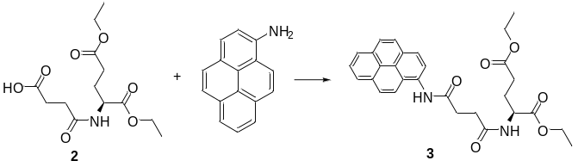
Compound 2 (5 mmol, 1.5 g), EDCI (7.5 mmol, 1.4 g), 0.3eq DMAP (0.15 mmol, 0.018 g) were dissolved in dichloromethane (50 mL). After the solution was stirred at room temperature for 30 min, 1-aminopyrene (5.5 mmol, 1.2 g) and triethylamine (6 mmol, 0.6 g) were added. The reaction was carried out in an ice bath at 0°C for 30 min, and was then stirred at room temperature for 24 h. The solution was washed with acidic water (pH 1-2) (3×50 mL), alkaline water (pH 8-9) (3×50 mL), and water (3×50 mL) sequentially. The organic phase was collected, and the crude product (compound 3) was collected after evaporation of solvent.
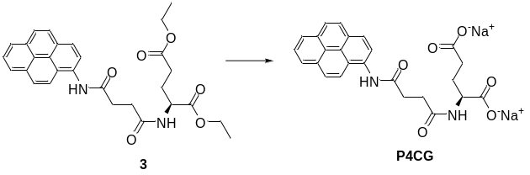
Compound 3 (0.5 g, 1 mmol) was dissolved in ethanol (20 mL), and sodium carbonate (0.12 g, 1.1 mmol) in water (20 mL) was added. The mixture was refluxed overnight. After most of the solvent was removed, water was added. After a filtration, excess hydrochloric acid was added to the solution. A solid precipitated, which was filtered and dried to give the acid product. ESI-MS: m/z 445.1[(M-2H)²⁻]. P4CG (sodium salt) was obtained through mixing 1 eq. of the acid product in ethanol and 2 eq. of sodium hydroxide in water, refluxing for 2 h, and then removing the solvent.
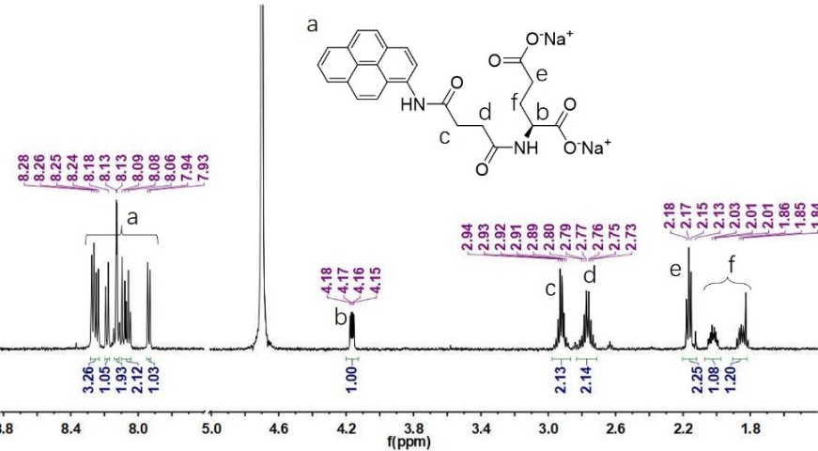
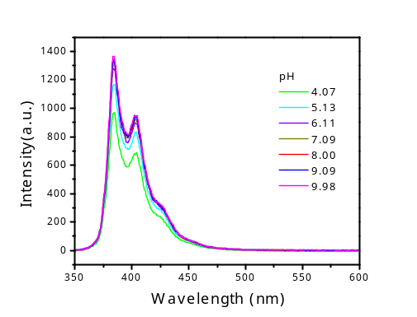
Fig. S1 Fluorescence spectra of P4CG in the aqueous solution at various pH conditions. [P4CG]=10 μΜ, [protamine]= 14 μg/mL.
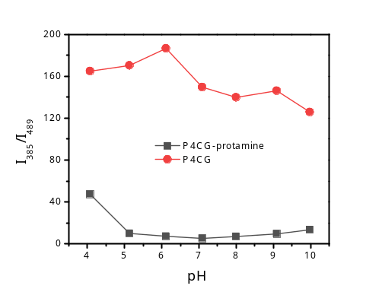
Fig. S2 pH Effect of the fluorescence intensity (I₄₈₉/I₃₈₅) of P4CG in the absence and presence of protamine. [P4CG]=10 μΜ, [protamine]= 14 μg/mL.
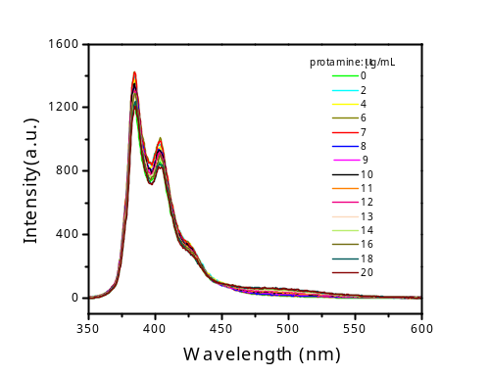
Fig. S3 Fluorescence emission spectra of P4CG upon the addition of protamine (0-20 μg/mL) in 0.1% FBS.

