Supplementary
Supplementary Figure 1:
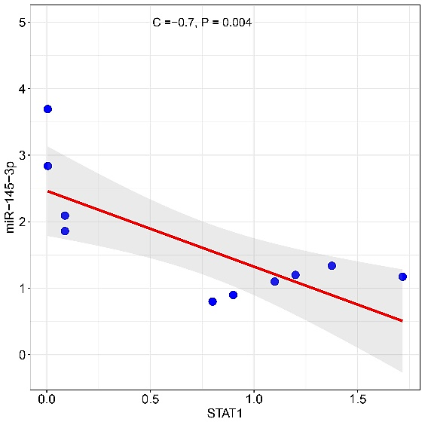
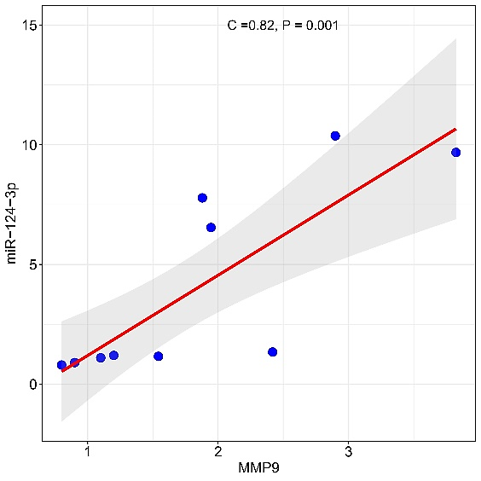
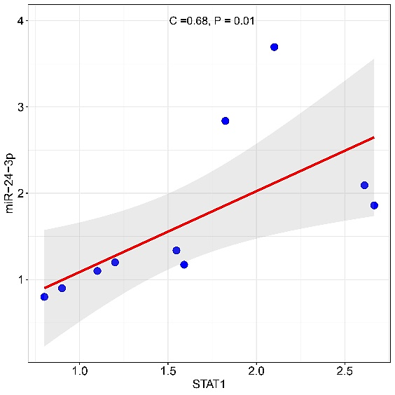
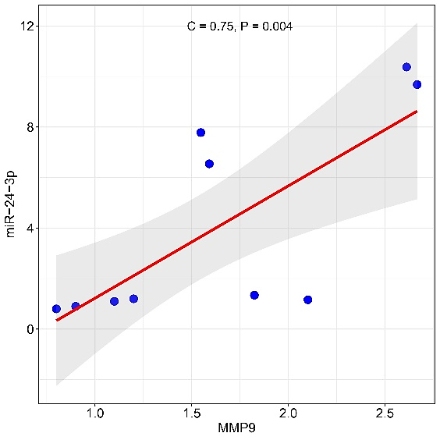
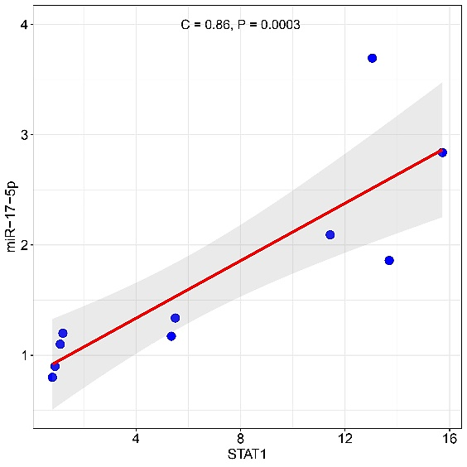
A
B
C
D

Figure 1. Correlation Analysis between miRNA-mRNA. (A) The positive correlation between miR-17-5p vs. STAT1; (B) The positive correlation between miR-24-3p vs. MMP9 and STAT1; (C) The positive correlation between miR-124-3p vs. MMP9; (D) The negative correlation between miR-145-3p vs. STAT1.
Supplementary Figure 2:
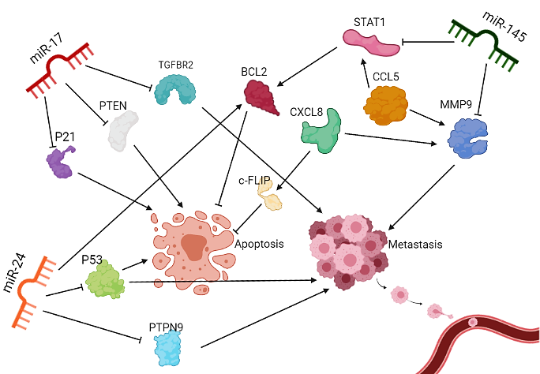
Figure 2. Interaction between microRNAs and genes which regulated drug resistance and metastasis in GC.
Supplementary Table 1: Patient Demography of non-metastatic (nM) and metastatic (M) Gastric adenocarcinoma samples (n=20)

non-Metastatic samples
No. | Histology | Gender | Race | Tumor Size (cm) | Perineural  Invasion | Pathological T | Pathological N | Clinical M | Grade | Donor Statue
1. | Adenocarcinoma | F | Azari | 6.00 | No | T2, N0S | N0 | M0 | 2 | Alive
2. | Adenocarcinoma | M | Azari | 4.50 | Yes | T4 | N2 | M0 | 2 | Deceased
3. | Adenocarcinoma | F | Kurd | 4.50 | No | T1b | N0 | M0 | 3 | Alive
4. | Adenocarcinoma | M | Azari | 2.00 | Yes | T2, N0S | N0 | M0 | 2 | Alive
5. | Adenocarcinoma | M | Azari | 1.50 | Yes | T3 | N1 | M0 | 4 | Deceased
6. | Adenocarcinoma | M | Azari | 10.00 | Yes | T4 | N2 | M0 | 3 | Deceased
7. | Adenocarcinoma | M | - | 6.50 | Yes | T4 | N1 | M0 | 3 | Alive
8. | Adenocarcinoma | M | Lur | 8.50 | Yes | T3 | N3 | M0 | 3 | Alive
9. | Adenocarcinoma | M | - | 4.50 | Yes | T3 | N2 | M0 | 3 | Alive
10. | Adenocarcinoma | M | Lur | 6.50 | Yes | T4 | N3 | M0 | 3 | Alive
Metastatic samples
11. | Adenocarcinoma,  Mixed Type | M | Mid. East | 7.00 | Yes | T3 | N1 | M1 | 2 | Deceased
12. | Adenocarcinoma  Invasive | F | Azari | 7.00 | Yes | T3 | N1 | M1 | 2 | Deceased
13. | Adenocarcinoma, Intestinal Type  Invasive | M | Kurd | 8.00 | No | T2b | N1 | M1 | 2 | Deceased
14. | Adenocarcinoma | F | Lur | 13.00 | No | T3 | N3 | M1 | 3 | Deceased
15. | Adenocarcinoma, Intestinal Type | M | Lur | 7.00 | No | T3 | N1 | M1 | 2 | Deceased
16. | Adenocarcinoma | M | Azari | 4.00 | Yes | T2 | N1 | M1 | 5 | Deceased
17. | Adenocarcinoma, Signet Ring Type | F | Kurd | 4.00 | Yes | T2b | N1 | M1 | 3 | Deceased
18. | Adenocarcinoma | M | Azari | 2.50 | No | T3 | N1 | M1 | 3 | Deceased
19. | Adenocarcinoma | F | - | 5.00 | Yes | T2b | N1 | M1 | 1 | Alive
20. | Adenocarcinoma | M | - | 5.00 | No | T3 | N1 | M1 | 2 | Alive

Supplementary table2. List and sequences of primers used in this study.
Company | Primer Name
Zist Royesh | miR-17-5p
Zist Royesh | miR-24-3p
Zist Royesh | miR-25-3p
Zist Royesh | miR-124-3p
Zist Royesh | miR-128-3p
Zist Royesh | miR-145-5p
Zist Royesh | U6 (housekeeping gene)

Sequence | Primer Name
F: 5' TAGCAAAATTGAGGCCAAG G 3'  R: 5' AGCAGACTAGGGTTGCCAGA 3' | CXCL8
F: 5' TGTACCGCTATGGTTACACTCG 3'  R: 5' GGCAGGGACAGTTGCTTCT 3' | MMP9
F: 5' CTGCTGCTTTGCCTACATTG 3'  R: 5' TGTACTCCCGAACCCATTTC 3' | CCL5
F: 5' ATCAGGCTCAGTCGGGGAATA 3'  R: 5' TGGTCTCGTGTTCTCTGTTCT 3' | STAT1
F: 5' GTA ACC CGT TGA ACC CCATT 3'  R: 5' CCA TCC AAT CGG TAGTAGCG 3' | 18S (housekeeping gene)

Supplementary Table 3: Bio Article\all.xlsx
Supplementary table 4: 286.txt
Supplementary Table 5: KEGG pathway analysis
No. | Pathways | Adj P-value | Differentially Expressed Genes (DEGs)
1 | Ascorbate and aldarate metabolism | 2.68E-09 | ALDH3A2;UGT1A10;UGDH;UGT1A1;UGT1A5;UGT1A4;UGT1A3;UGT1A9;  UGT1A8;UGT1A7;UGT1A6
2 | Pentose and glucuronate interconversions | 1.27E-08 | UGT1A10;UGDH;AKR1B10;UGT1A1;UGT1A5;UGT1A4;UGT1A3;UGT1A9;  UGT1A8;UGT1A7;UGT1A6
3 | Metabolism of xenobiotics by cytochrome P450 | 1.30E-08 | UGT1A10;UGT1A1;ADH1C;AKR1C1;EPHX1;CYP3A5;ALDH3A1;CYP2C9;  UGT1A5;UGT1A4;UGT1A3;UGT1A9;UGT1A8;UGT1A7;UGT1A6
4 | Leishmaniasis | 1.95E-08 | HLA-DRB5;CR1;HLA-DRB4;STAT1;FOS;IGH;RELA;MAPK11;FCGR3B;IL1B;  PTPN6; HLA-DRB3;HLA-DQA1;HLA-DRB1;HLA-DQB1
5 | Chemical carcinogenesis | 2.99E-08 | UGT1A10;UGT1A1;ADH1C;EPHX1;AKR1C2;CYP3A5;ALDH3A1;CYP2C9;  UGT1A5;UGT1A4;UGT1A3;UGT1A9;UGT1A8;UGT1A7;UGT1A6
6 | Influenza A | 3.20E-08 | PRSS1;HLA-DRB5;HLA-DRB4;CXCL8;STAT1;TMPRSS2;RELA;CASP9;  MAPK9;MAPK11;IL1B;CCL5;CASP1;HLA-DRB3;PRSS2;HLA-DQA1;  HLA-DRB1;TLR3;HSPA1B;HLA-DQB1;HSPA1A
7 | Hematopoietic cell lineage | 3.39E-08 | HLA-DRB5;CSF3R;HLA-DRB4;CR1;IL1R2;IGH;CD3E;CD2;CD8A;IL1B;KIT;  HLA-DRB3;CD24;HLA-DQA1;HLA-DRB1;HLA-DQB1
8 | Steroid hormone biosynthesis | 3.52E-08 | UGT1A10;UGT1A1;AKR1C1;AKR1C2;CYP3A5;CYP17A1;UGT1A5;UGT1A4;UGT1A3;UGT1A9;UGT1A8;UGT1A7;UGT1A6
9 | Retinol metabolism | 1.19E-07 | UGT1A10;UGT1A1;ADH1C;CYP3A5;CYP2C9;DHRS9;UGT1A5;UGT1A4;  UGT1A3;UGT1A9;UGT1A8;UGT1A7;UGT1A6
10 | IL-17 signaling pathway | 1.24E-07 | CXCL8;FOS;MMP9;IL17RC;MUC5AC;RELA;MAPK9;MAPK11;MMP13;IL1B;  FOSB;DEFB4A;DEFB4B;S100A9;S100A8
11 | Staphylococcus aureus infection | 1.31E-07 | HLA-DRB5;SELPLG;HLA-DRB4;DEFB1;IGH;KRT10;FCGR3B;DEFB4A;  HLA-DRB3;DEFB4B;HLA-DQA1;HLA-DRB1;HLA-DQB1
12 | Rheumatoid arthritis | 5.78E-07 | HLA-DRB5;CXCL8;HLA-DRB4;IL15;TNFSF13;TCIRG1;FOS;IGH;IL1B;CCL5;  HLA-DRB3;HLA-DQA1;HLA-DRB1;HLA-DQB1
13 | Porphyrin and chlorophyll metabolism | 7.35E-07 | UGT1A10;FECH;UGT1A1;UGT1A5;UGT1A4;UGT1A3;UGT1A9;UGT1A8;  UGT1A7;UGT1A6
14 | Intestinal immune network for IgA production | 2.68E-06 | HLA-DRB5;HLA-DRB4;IL15;TNFSF13;TNFRSF17;IGH;HLA-DRB3;HLA-DQA1;HLA-DRB1;HLA-DQB1
15 | Drug metabolism | 3.96E-06 | UGT1A10;UGT1A1;ADH1C;FMO4;CYP3A5;ALDH3A1;CYP2C9;UGT1A5;  UGT1A4;UGT1A3;UGT1A9;UGT1A8;UGT1A7;UGT1A6
16 | Tuberculosis | 4.16E-06 | HLA-DRB5;HLA-DRB4;CR1;BAD;STAT1;TCIRG1;IGH;RELA;CASP9;MAPK9;  MAPK11;FCGR3B;IL1B;ITGAX;HLA-DRB3;HLA-DQA1;HLA-DRB1;  HLA-DQB1
17 | Toxoplasmosis | 6.58E-06 | HLA-DRB5;HLA-DRB4;BAD;STAT1;RELA;CASP9;MAPK9;MAPK11;  HLA-DRB3;HLA-DQA1;HLA-DRB1;HSPA1B;HLA-DQB1;HSPA1A
18 | Legionellosis | 8.06E-06 | CASP9;CXCL8;CR1;IL1B;BNIP3;CASP1;RELA;HSPA1B;NFKB2;HSPA1A
19 | Th17 cell differentiation | 1.93E-05 | HLA-DRB5;HLA-DRB4;STAT1;FOS;CD3E;RELA;MAPK9;MAPK11;IL1B;  HLA-DRB3;HLA-DQA1;HLA-DRB1;HLA-DQB1
20 | Th1 and Th2 cell differentiation | 2.20E-05 | MAPK9;MAPK11;HLA-DRB5;HLA-DRB4;STAT1;FOS;CD3E;  HLA-DRB3;RELA;HLA-DQA1;HLA-DRB1;HLA-DQB1
21 | Antigen processing and presentation | 2.30E-05 | HLA-DRB5;HLA-DRB4;CD8A;KLRD1;CALR;HLA-DRB3;  HLA-DQA1;HSPA1B;HLA-DRB1;HLA-DQB1;HSPA1A
22 | Inflammatory bowel disease (IBD) | 3.28E-05 | HLA-DRB5;HLA-DRB4;STAT1;IL1B;HLA-DRB3;RELA;  HLA-DQA1;IL18R1;HLA-DRB1;HLA-DQB1
23 | Graft-versus-host disease | 5.16E-05 | HLA-DRB5;HLA-DRB4;IL1B;KLRD1;HLA-DRB3;HLA-DQA1;HLA-DRB1;HLA-DQB1
24 | Asthma | 7.20E-05 | HLA-DRB5;HLA-DRB4;IGH;HLA-DRB3;HLA-DQA1;HLA-DRB1;HLA-DQB1
25 | Cell adhesion molecules (CAMs) | 9.06E-05 | HLA-DRB5;CNTNAP1;HLA-DRB4;SELPLG;SELE;CD2;SELL;CD8A;CLDN18;  HLA-DRB3;HLA-DQA1;HLA-DRB1;MPZL1;HLA-DQB1
26 | TNF signaling pathway | 1.12E-04 | MAPK9;MAPK11;RPS6KA5;IL15;IL1B;CCL5;BCL3;FOS;SELE;MMP9;RELA;  IL18R1
27 | Epstein-Barr virus infection | 2.25E-04 | HLA-DRB5;HLA-DRB4;STAT1;IGH;CD3E;RELA;NFKB2;CASP9;MAPK9;  MAPK11;MDM2;CALR;HLA-DRB3;HLA-DQA1;HLA-DRB1;HLA-DQB1
28 | Allograft rejection | 2.57E-04 | HLA-DRB5;HLA-DRB4;IGH;HLA-DRB3;HLA-DQA1;HLA-DRB1;HLA-DQB1
29 | Nitrogen metabolism | 3.43E-04 | CA12;CA2;CA4;CA9;GLUL
30 | Type I diabetes mellitus | 5.55E-04 | HLA-DRB5;HLA-DRB4;IL1B;HLA-DRB3;HLA-DQA1;HLA-DRB1;HLA-DQB1
31 | Viral myocarditis | 6.17E-04 | CASP9;HLA-DRB5;HLA-DRB4;IGH;HLA-DRB3;HLA-DQA1;HLA-DRB1;  HLA-DQB1
32 | AGE-RAGE signaling pathway in diabetic complications | 0.001059468 | COL1A1;MAPK9;MAPK11;CXCL8;PLCB4;STAT1;IL1B;COL4A5;SELE;RELA
33 | Chagas disease (American trypanosomiasis) | 0.001316388 | MAPK9;MAPK11;CXCL8;PLCB4;IL1B;CCL5;CALR;FOS;CD3E;RELA
34 | Cytokine-cytokine receptor interaction | 0.001669744 | IL1RN;CSF3R;CXCL8;TNFSF14;IL15;GDF15;IL1R2;TNFSF12;TNFSF13;  OSM;IL17RC;BMP2;IL1B;CCL5;TNFRSF17;CCR7;TNFRSF14;IL18R1
35 | Osteoclast differentiation | 0.001674154 | MAPK9;MAPK11;FCGR3B;STAT1;IL1B;FOSB;LCP2;FOS;RELA;NFKB2;  FOSL2
36 | Autoimmune thyroid disease | 0.001812999 | HLA-DRB5;HLA-DRB4;IGH;HLA-DRB3;HLA-DQA1;HLA-DRB1;HLA-DQB1
37 | Systemic lupus erythematosus | 0.002305349 | HLA-DRB5;HLA-DRB4;FCGR3B;CTSG;IGH;HLA-DRB3;HIST1H2AC;  HLA-DQA1;HLA-DRB1;HIST2H2BE;HLA-DQB1
38 | Amoebiasis | 0.003178137 | COL1A1;CXCL8;PLCB4;IL1R2;IL1B;COL4A5;CTSG;IGH;RELA
39 | Fluid shear stress and atherosclerosis | 0.003199381 | MAPK9;MAPK11;DUSP1;IL1R2;IL1B;PDGFA;FOS;SELE;MMP9;RELA;KLF2
40 | Human T-cell leukemia virus 1 infection | 0.004822942 | HLA-DRB5;HLA-DRB4;IL15;IL1R2;FOS;CD3E;RELA;NFKB2;MAPK9;CALR;  HLA-DRB3;HLA-DQA1;HLA-DRB1;HLA-DQB1
41 | Toll-like receptor signaling pathway | 0.00517927 | MAPK9;MAPK11;CXCL8;STAT1;IL1B;CCL5;FOS;TLR3;RELA
42 | C-type lectin receptor signaling pathway | 0.005305594 | MAPK9;MAPK11;STAT1;IL1B;BCL3;MDM2;CASP1;RELA;NFKB2
43 | Salmonella infection | 0.00617411 | MAPK9;MAPK11;CXCL8;IL1B;CASP1;MYH14;FOS;RELA
44 | NOD-like receptor signaling pathway | 0.006644549 | MAPK9;MAPK11;GABARAPL1;CXCL8;PLCB4;STAT1;IL1B;CCL5;CASP1;  DEFB4A;DEFB4B;RELA
45 | Protein digestion and absorption | 0.007954089 | COL1A1;PRSS1;COL6A1;COL4A5;PGA3;PRSS2;PGA5;PGA4
46 | Measles | 0.009663345 | CASP9;MAPK9;BAD;STAT1;IL1B;FOS;CD3E;RELA;HSPA1B;HSPA1A
47 | Primary immunodeficiency | 0.010184106 | CD79A;DCLRE1C;CD8A;IGH;CD3E
48 | PI3K-Akt signaling pathway | 0.010640142 | MAGI1;CSF3R;BAD;INSR;LPAR1;OSM;PDGFA;PPP2R5D;IGH;RELA;  COL1A1;CASP9;TCL1A;KIT;COL6A1;MDM2;COL4A5;SGK2
49 | Gastric acid secretion | 0.011085536 | ATP4B;ATP4A;PLCB4;KCNE2;CA2;KCNJ15;KCNJ16
50 | Pertussis | 0.011501858 | MAPK9;MAPK11;CXCL8;IL1B;CASP1;FOS;RELA
51 | Prostate cancer | 0.011600443 | CASP9;BAD;IL1R2;MDM2;PDGFA;TMPRSS2;MMP9;RELA
52 | Pancreatic secretion | 0.011905182 | PNLIPRP2;PRSS1;PLCB4;CA2;ATP2A3;CEL;SLC4A4;PRSS2
53 | T cell receptor signaling pathway | 0.014127271 | MAPK9;MAPK11;CD8A;LCP2;PTPN6;FOS;CD3E;RELA
54 | Phagosome | 0.016785206 | HLA-DRB5;HLA-DRB4;FCGR3B;CALR;TCIRG1;IGH;HLA-DRB3;HLA-DQA1;HLA-DRB1;HLA-DQB1
55 | Relaxin signaling pathway | 0.018397209 | COL1A1;MAPK9;MAPK11;MMP13;PLCB4;COL4A5;FOS;MMP9;RELA
56 | Collecting duct acid secretion | 0.018405105 | ATP4B;ATP4A;CA2;TCIRG1
57 | Transcriptional misregulation in cancer | 0.02280337 | MYCN;CXCL8;NCOR1;HPGD;IL1R2;MDM2;PDGFA;TMPRSS2;IGH;MMP9;  RELA
58 | Epithelial cell signaling in Helicobacter pylori infection | 0.025635934 | MAPK9;MAPK11;CXCL8;CCL5;TCIRG1;RELA
59 | Hepatitis B | 0.025665575 | CASP9;MAPK9;MAPK11;CXCL8;BAD;STAT1;FOS;MMP9;TLR3;RELA
60 | Prolactin signaling pathway | 0.0290548 | MAPK9;MAPK11;STAT1;FOS;RELA;CYP17A1
61 | Lysosome | 0.040364039 | SCARB2;GGA2;SORT1;IDS;CTSG;TCIRG1;CTSF;CTSE
62 | MAPK signaling pathway | 0.046424317 | DUSP1;INSR;PDGFA;FOS;RELA;NFKB2;CACNB1;MAPK9;MAPK11;  RPS6KA5;IL1B;KIT;HSPA1B;HSPA1A
63 | Aldosterone-regulated sodium reabsorption | 0.049633169 | INSR;SCNN1B;SCNN1A;NR3C2

Supplementary Table 6: Biological Process Analysis of Differentially Expressed Genes.
No. | Term | Adjusted P-value | Z-score | DEGs
1 | flavonoid glucuronidation (GO:0052696) | 4.14E-11 | -3.613543965 | UGT1A10;UGT1A1;UGT1A5;UGT1A4;UGT1A3;UGT1A9;UGT1A8;UGT1A7;UGT1A6
2 | xenobiotic glucuronidation (GO:0052697) | 4.37E-10 | -2.156879256 | UGT1A10;UGT1A1;UGT1A5;UGT1A4;UGT1A3;UGT1A9;UGT1A8;UGT1A7;UGT1A6
3 | cellular glucuronidation (GO:0052695) | 5.68E-08 | -2.238782303 | UGT1A10;UGT1A1;UGT1A5;UGT1A4;UGT1A3;UGT1A9;UGT1A8;UGT1A7;UGT1A6
4 | phagocytosis, engulfment (GO:0006911) | 1.76E-07 | -2.38922503 | SCARB2;IGHM;IGHV4-31;GSN;IGHV3-23;RHOH;GULP1;IGHG3;IGHG4;IGLL5;IGHG1;IGKC;TRBC1;IGHD;IGLC1;IGHA1;IGHA2
5 | antigen receptor-mediated signaling pathway (GO:0050851) | 1.76E-07 | -1.06716259 | IGHM;IGHV4-31;IGHV3-23;CD3E;RELA;IGHG3;CD79A;IGHG4;IGHG1;IGKC;TRBC1;PDE4B;IGLC1;IGHA1;IGHA2;HLA-DQA1;BTNL8;HLA-DRB5;HLA-DRB4;IGLL5;IGHD;LCP2;MNDA;HLA-DRB3;HLA-DRB1;HLA-DQB1
6 | plasma membrane invagination (GO:0099024) | 8.67E-07 | -1.470865342 | SCARB2;IGHM;IGHV4-31;GSN;IGHV3-23;GULP1;IGHG3;IGHG4;IGLL5;IGHG1;IGKC;TRBC1;IGHD;IGLC1;IGHA1;IGHA2
7 | glucuronate metabolic process (GO:0019585) | 5.84E-06 | -2.59831285 | UGT1A10;UGT1A1;UGT1A4;UGT1A3;UGT1A9;UGT1A7;UGT1A6
8 | B cell receptor signaling pathway (GO:0050853) | 5.84E-06 | -2.310450005 | IGHM;IGHV4-31;IGHV3-23;IGHG3;CD79A;IGHG4;IGLL5;IGHG1;IGKC;TRBC1;IGHD;IGLC1;MNDA;IGHA1;IGHA2
9 | regulation of B cell activation (GO:0050864) | 1.18E-05 | -1.229417744 | IGHM;IGHV4-31;IGHV3-23;IGHG3;IGHG4;IGLL5;IGHG1;IGKC;TRBC1;IGHD;MZB1;IGLC1;IGHA1;IGHA2
10 | phagocytosis (GO:0006909) | 2.36E-05 | -1.968400783 | SCARB2;IGHM;IGHV4-31;GSN;IGHV3-23;GULP1;IGHG3;IGHG4;IGLL5;IGHG1;IGKC;TRBC1;IGHD;IGLC1;IGHA1;IGHA2
11 | cytokine-mediated signaling pathway (GO:0019221) | 2.36E-05 | -1.337324361 | IL1RN;CSF3R;CXCL8;RELA;OASL;IGHG4;IGHG1;MUC1;  RPS6KA5;FLRT3;CCL5;CASP1;ITGAX;TNFRSF17;TNFRSF14;DUOX2;HLA-DQA1;HLA-DRB5;HLA-DRB4;  TNFSF14;IL15;STAT1;IL1R2;TNFSF12;TNFSF13;OSM;  FOS;IL17RC;MMP9;IL1B;KIT;PDCD4;TFF2;PTPN6;  HLA-DRB3;HLA-DRB1;IL18R1;HLA-DQB1
12 | positive regulation of lymphocyte activation (GO:0051251) | 2.81E-05 | -2.198543681 | IGHM;IGHV4-31;IGHV3-23;  IGHG3;IGHG4;IGLL5;IGHG1;IGKC;  TRBC1;IGHD;CCR7;IGLC1;IGHA1;IGHA2
13 | humoral immune response mediated by circulating immunoglobulin (GO:0002455) | 4.26E-05 | -1.038069113 | IGHM;IGHV4-31;IGHV3-23;IGHG3;IGHG4;IGLL5;IGHG1;  IGKC;IGLV1-44;TRBC1;IGHD;IGLC1;IGHA1;IGHA2;  HLA-DQB1
14 | neutrophil activation is involved in immune response (GO:0002283) | 6.45E-05 | -1.24022531 | ORM1;B4GALT1;TNFAIP6;STXBP2;SLC2A3;TCIRG1;  IQGAP2;ORM2;PLAC8;FCGR3B;ITGAX;TIMP2;CTSG;  ENPP4;METTL7A;PRSS2;MGAM;CR1;GSN;PLAUR;  RAB27A;OLFM4;MMP9;SELL;MNDA;PTPN6;DNASE1L3;S100A9;HSPA1B;S100A8;HSPA1A
15 | neutrophil degranulation (GO:0043312) | 0.000150762 | -1.994505362 | ORM1;B4GALT1;TNFAIP6;STXBP2;SLC2A3;TCIRG1;  IQGAP2;ORM2;PLAC8;FCGR3B;ITGAX;TIMP2;CTSG;  ENPP4;METTL7A;PRSS2;MGAM;CR1;GSN;PLAUR;  RAB27A;OLFM4;MMP9;SELL;MNDA;PTPN6;S100A9;  HSPA1B;S100A8;HSPA1A
16 | defense response to bacterium (GO:0042742) | 0.000150762 | -1.622153017 | IGHM;IGHV4-31;IGHV3-23;DEFB1;HIST2H2BE;IGHG3;IGHG4;IGLL5;IGHG1;  IGKC;TRBC1;IGHD;CTSG;IGLC1;DEFB4A;IGHA1;IGHA2;  S100A9;S100A8;TLR3
17 | complement activation, classical pathway (GO:0006958) | 0.000157378 | -1.065052732 | IGHM;IGHV4-31;IGHV323;IGHG3;IGHG4;IGLL5;  IGHG1;IGKC;IGLV1-44;TRBC1;IGHD;IGLC1;  IGHA1;IGHA2
18 | neutrophil mediated immunity (GO:0002446) | 0.000171741 | -1.918253571 | ORM1;B4GALT1;TNFAIP6;STXBP2;SLC2A3;TCIRG1;  IQGAP2;ORM2;PLAC8;FCGR3B;ITGAX;TIMP2;CTSG;ENPP4;METTL7A;PRSS2;MGAM;CR1;GSN;PLAUR;RAB27A  ;OLFM4;MMP9;SELL;MNDA;PTPN6;S100A9;HSPA1B;  S100A8;HSPA1A
19 | antibacterial humoral response (GO:0019731) | 0.000171741 | -1.869147234 | FGB;FGA;IGHM;CTSG;DEFB1;IGHA1;IGHA2;HIST2H2BE
20 | regulation of inflammatory response (GO:0050727) | 0.000214461 | -1.01688262 | TNFAIP6;IL15;KLF4;SELE;RELA;GPRC5B;DDT;CCL5;  CASP1;PDCD4;FFAR2;DNASE1L3;S100A9;MGLL;S100A8;TLR3
21 | positive regulation of B cell activation (GO:0050871) | 0.000488534 | -1.494263972 | IGHM;IGHV4-31;IGHV3-23;IGHG3;IGHG4;IGLL5;IGHG1;IGKC;TRBC1;IGHD;IGLC1;IGHA1;IGHA2
22 | positive regulation of apoptotic signaling pathway (GO:2001235) | 0.001192497 | -1.810040579 | MLLT11; WWOX;GSN;BAD;BNIP3;TNFSF12;PLAUR;  MMP9;S100A9;S100A8
23 | steroid metabolic process (GO:0008202) | 0.002095526 | -1.732079259 | CYP2C9; WWOX;DHRS9;UGT1A1;AKR1C1;AKR1C2;  TFCP2L1;CYP3A5;DHRS2;UGT1A8;CYP17A1
24 | retinoic acid metabolic process (GO:0042573) | 0.002268348 | -2.445317954 | UGT1A1;UGT1A3;UGT1A9;UGT1A8;UGT1A7
25 | cellular response to cytokine stimulus (GO:0071345) | 0.002542407 | -1.147342748 | IL1RN;CSF3R;CXCL8;SELPLG;RELA;IGHG4;IGHG1;MUC1;TCL1A;FLRT3;CCL5;CASP1;ITGAX;CCR7;DUOX2;PTPN18;STAT1;IL1R2;OSM;FOS;MMP9;MAPK11;IL1B;KIT;PTPN6;IL18R1
26 | sodium ion homeostasis (GO:0055078) | 0.002659151 | -1.962298039 | ATP4B;ATP4A;SCNN1B;TMPRSS3;SCNN1A;CYP4F12
27 | monocarboxylic acid metabolic process (GO:0032787) | 0.004012491 | -1.631829487 | SCARB2;CYP2C9;FA2H;UGT1A1;VNN2;VNN3;AKR1C1;  UGT1A3;UGT1A9;UGT1A8;UGT1A7
28 | regulation of interleukin-1 secretion (GO:0050704) | 0.004493692 | -2.171460697 | ORM1;IGHD;CCR7;ORM2
29 | retinoid metabolic process (GO:0001523) | 0.005228884 | -1.485577053 | AKR1B10;DHRS9;UGT1A1;AKR1C1;UGT1A3;AGRN;  UGT1A9;UGT1A8;UGT1A7
30 | cellular response to organic substance (GO:0071310) | 0.005380156 | -1.116366296 | MAPK11;MAPK9;PTPN18;URI1;IGFBP5;CCL5;IL1B;  CASP1;CCR7;PTPN6;KLF4;IL18R1
31 | positive regulation of interleukin-8 production (GO:0032757) | 0.005526346 | -1.579818603 | CD2;ZNF580;IL1B;FFAR2;HSPA1B;TLR3;HSPA1A
32 | regulation of heterotypic cell-cell adhesion (GO:0034114) | 0.005592446 | -1.998993033 | FGB;FGA;IL1RN;IL1B;KLF4
33 | inflammatory response (GO:0006954) | 0.006634013 | -1.746565662 | ORM1;CXCL8;TNFAIP6;PTGER2;FOS;SELE;RELA;NFKB2;BMP2;CCL5;IL1B;KIT;CCR7;TNFRSF14;S100A9;MGLL;S100A8
34 | extracellular matrix organization (GO:0030198) | 0.006870905 | -1.601987492 | FGB;FGA;PRSS1;PDGFA;MMP9;COL1A1;MMP13;COL6A1;ITGAX;TIMP2;COL4A5;CTSG;AGRN;PRSS2;GPM6B;  DDR2
35 | progesterone metabolic process (GO:0042448) | 0.008126152 | -2.605393688 | DHRS9;AKR1C1;AKR1C2;CYP17A1
36 | positive regulation of translational initiation (GO:0045948) | 0.008126152 | -2.181524101 | CCL5;DAZ4;DAZ3;DAZ2;DAZ1
37 | regulation of acute inflammatory response (GO:0002673) | 0.008174368 | -1.538241063 | IGHG3;IGHG4;IGHG1;CR1;IGKC;IGHV3-23;IGLV1-44;OSM;FFAR2;IGLC1;DNASE1L3
38 | regulation of cell proliferation (GO:0042127) | 0.008174368 | -1.101935887 | CXCL8; PDGFA;PDS5B;PTN;TCIRG1;RELA;DNAJB2;TCL1A;SCIN;SSR1;TNFRSF14;DRD2;HIST1H2AC;IL15;INSR;STYK1;TNFSF13;OSM;AKR1C2;KLF4;DHRS2;AZGP1;BMP2;  CCPG1;DLG5;IL1B;KIT;MDM2;MZB1;PTPN6;CALR;SGK2;HSPA1B;HSPA1A
39 | C21-steroid hormone metabolic process (GO:0008207) | 0.009403 | -2.078060184 | DHRS9; AKR1C1;AKR1C2;DHRS2;CYP17A1
40 | multivesicular body sorting pathway (GO:0071985) | 0.01358649 | -2.164140875 | RUBCN; SORT1;RAB27A;CHMP5
41 | interferon-gamma-mediated signaling pathway (GO:0060333) | 0.01358649 | -1.287746427 | HLA-DRB5;HLA-DRB4;STAT1;HLA-DRB3;HLA-DQA1;HLA-DRB1;HLA-DQB1;OASL
42 | potassium ion import (GO:0010107) | 0.014337648 | -1.738621867 | ATP4B; ATP4A;KCNE2;KCNJ15;KCNJ16;SLC12A9
43 | positive regulation of inflammatory response (GO:0050729) | 0.016968842 | -1.769699099 | GPRC5B; DDT;IL15;OSM;PDCD4;S100A9;S100A8;TLR3
44 | positive regulation of release of cytochrome c from mitochondria (GO:0090200) | 0.018112638 | -2.48384308 | MLLT11;BAD;BNIP3;PLAUR;MMP9
45 | positive regulation of defense response (GO:0031349) | 0.018112638 | -1.277899947 | GPRC5B; DDT;IL15;CCL5;PDCD4;S100A9;S100A8;TLR3
46 | cellular response to oxidative stress (GO:0034599) | 0.019006656 | -1.973283945 | MAPK9;GPX3;PYROXD1;NOX5;FOS;DHRS2;MMP9;  PPARGC1A;HSPA1B;HSPA1A
47 | cellular response to interferon-gamma (GO:0071346) | 0.019928074 | -1.924460905 | HLA-DRB5; HLA-DRB4; STAT1;CCL5;CASP1;  HLA-DRB3; HLA-DQA1; HLA-DRB1;HLA-DQB1;OASL
48 | T cell receptor signaling pathway (GO:0050852) | 0.022394081 | -1.180893401 | BTNL8; HLA-DRB5; HLA-DRB4; TRBC1; PDE4B; LCP2; CD3E; HLA-DRB3; HLA-DQA1; HLA-DRB1; RELA; HLA-DQB1
49 | proteolysis (GO:0006508) | 0.024184532 | -1.78981798 | PRSS1; TMPRSS3; TMPRSS2;PGA3;MMP9;PGA5;WFDC2; PGA4;CAPN9;CAPN5;CASP1;MDM2;CTSG;CTSF;CTSE; PGPEP1;PRSS2
50 | positive regulation of interleukin-1 secretion (GO:0050716) | 0.027175202 | -1.727710991 | ORM1; CASP1; IGHD; TRIM16;ORM2
51 | positive regulation of tumor necrosis factor-mediated signaling pathway (GO:1903265) | 0.028675819 | -3.360290157 | CASP1; HSPA1B;HSPA1A
52 | leukocyte aggregation (GO:0070486) | 0.028675819 | -2.65704061 | IL1B;S100A9;S100A8
53 | 3'-UTR-mediated mRNA stabilization (GO:0070935) | 0.029434985 | -2.044891307 | DAZ4;DAZ3;DAZ2;DAZ1
54 | positive regulation of reactive oxygen species biosynthetic process (GO:1903428) | 0.029434985 | -1.948071842 | IL1B;INSR;RAB27A;KLF4;KLF2
55 | regulated exocytosis (GO:0045055) | 0.030984334 | -2.208543564 | FGB;FGA;ORM1;SCIN;RAB26;PLEK;STXBP2;PDGFA;  SYNGR3;ORM2;VAMP2
56 | regulation of apoptotic process (GO:0042981) | 0.031706839 | -1.702481587 | CD3E;RELA;CASP9;MAPK9;TCL1A;NUAK2;SCIN;BAG1;  CASP1;TNFRSF14;HTATIP2;DFFA;BAD;DUSP1;GDF15;  STAT1;BNIP3;INSR;PLAUR;DHRS2;MMP9;CIDEC;  MLLT11;BMP2;BCL3;KIT;GAS1;MNDA;CALR;ATF6;SGK2; HSPA1B;DDR2;HSPA1A
57 | positive regulation of macromolecule metabolic process (GO:0010604) | 0.032745315 | -1.767005768 | GSN;ZNF580;RAB27A;CD3E;KLF4;SELE;KLF2;MAPK11; MAPK9;BMP2;MYCN;IL1B;ADTRP;HSPA1B;TLR3;HSPA1A
58 | regulation of intrinsic apoptotic signaling pathway (GO:2001242) | 0.032756257 | -1.494135703 | URI1;BAD;PLAUR;MMP9;S100A9;S100A8
59 | positive regulation of respiratory burst (GO:0060267) | 0.033306997 | -3.521961195 | INSR;IGHA1;IGHA2
60 | doxorubicin metabolic process (GO:0044598) | 0.033306997 | -3.412199275 | AKR1B10;AKR1C1;AKR1C2
61 | daunorubicin metabolic process (GO:0044597) | 0.033306997 | -3.302230652 | AKR1B10;AKR1C1;AKR1C2
62 | aminoglycoside antibiotic metabolic process (GO:0030647) | 0.033306997 | -2.939534467 | AKR1B10;AKR1C1;AKR1C2
63 | response to organophosphorus (GO:0046683) | 0.033306997 | -2.246168466 | STAT1;AKR1C1;TRIM16;DUOX2
64 | cellular response to mechanical stimulus (GO:0071260) | 0.033306997 | -2.092723268 | TNFSF14;BAD;BNIP3;IL1B;CASP1;TLR3
65 | regulation of protein processing (GO:0070613) | 0.033306997 | -1.760384761 | IGHG3;IGHG4;IGHG1;CR1;IGKC;IGHV3-23;  IGLV1-44;GAS1;IGLC1;MAGEA3
66 | pattern recognition receptor signaling pathway (GO:0002221) | 0.033306997 | -1.443459027 | FGB;FGA;FFAR2;S100A9;S100A8;TLR3
67 | positive regulation of cell proliferation (GO:0008284) | 0.035414929 | -1.478719256 | BAD;IL15;STAT1;INSR;TNFSF13;OSM;AKR1C2;PDGFA;  PTN;TCIRG1;RELA;BMP2;TCL1A;CCPG1;CCL5;IL1B;MDM2;SSR1;PTPN6;CALR;DDR2
68 | apoptotic process (GO:0006915) | 0.037762435 | -1.931607449 | TNFSF14;BAD;BNIP3;TNFSF12;CIDEC;CASP9;CD2;IL1B;  RFK;CASP1;PDCD4;MAL;NOX5;PTPN6
69 | regulation of interleukin-8 production (GO:0032677) | 0.040205358 | -1.871161826 | ZNF580;IL1B;HSPA1B;TLR3;HSPA1A
70 | regulation of interleukin-1 beta secretion (GO:0050706) | 0.040205358 | -1.388825099 | ORM1;CASP1;CCR7;TRIM16;ORM2
71 | regulation of cysteine-type endopeptidase activity involved in apoptotic signaling pathway (GO:2001267) | 0.043471123 | -2.603386043 | GSN;PLAUR;MMP9
72 | regulation of humoral immune response (GO:0002920) | 0.044236127 | -2.160033615 | IGHG3;IGHG4;IGHG1;CR1;IGKC;IGHV3-23;  IGLV1-44;CCR7;IGLC1
73 | negative regulation of intracellular signal transduction (GO:1902532) | 0.046255841 | -1.282756049 | URI1; DUSP1;STAT1;DLG5;PLEK;MDM2;PLAUR;RHOH;  DRD2; MMP9;RELA
74 | negative regulation of G-protein coupled receptor protein signaling pathway (GO:0045744) | 0.046853573 | -2.100048534 | CXCL8; CCL5;PLEK;DRD2
75 | positive regulation of histone acetylation (GO:0035066) | 0.046853573 | -1.903146964 | MUC1; RPS6KA5;IL1B;PPARGC1A
76 | response to cytokine (GO:0034097) | 0.046935189 | -1.217408907 | PTPN18;STAT1;CASP1;TIMP2;CCR7;PTPN6;SELE;IL18R1; RELA;NFKB2
77 | negative regulation of blood coagulation (GO:0030195) | 0.047248788 | -1.442117336 | FGB; FGA; PLAUR;PDGFA;ADTRP
78 | positive regulation of cytokine secretion (GO:0050715) | 0.048949611 | -1.180416116 | CD2; MAPK11;ORM1;IGHD;FFAR2;DRD2;ORM2

Supplementary table 7. Degree, roles, and regulating microRNAs of genes
Target gene | Degree | Correlation with drug resistance | Correlation with  metastasis | Validated miR | Non- Validated miR | References
CXCL8 | 47 | Yes | Yes | hsa-let-7d-5p  hsa-miR-302c-3p | hsa-miR-145-5p | (50) (51) (53) (49)
MMP9 | 30 | Yes | Yes | hsa-let-7e-5p  hsa-miR-133a-5p  hsa-miR-892b | hsa-miR-145-5p  hsa-miR-25-3p | (17) (58)
CCL5 | 24 | Yes | Yes | hsa-miR-17-5p  hsa-miR-20a-5p  hsa-miR-93-5p  hsa-miR-619-5p | hsa-miR-25-5p  hsa-miR-124-5p  hsa-miR-128-2-5p | (61) (62) (63) (64) (65)
STAT1 | 24 | Yes | Yes | hsa-miR-34a-5p  hsa-miR-146a-5p  hsa-miR-500a-5p | hsa-miR-25-5p  hsa-miR-124-5p  hsa-miR-128-1-5p  hsa-miR-145-5p | (79) (55) (56) (57) (19) (18)

