Supplementary material
Sample | Depth (m) | Formation | Description
IA-1 | 2835 | Tablazo | Grain size medium to coarse. Dark black
CE-A | 2926 | Tablazo | Grain size medium to coarse. Dark grey
CE-B | 2987 | Tablazo | Grain size medium to coarse. Dark grey
PO-A | 3475 | Tablazo | Grain size medium to coarse. Traces of crystalline quartz
PO-B | 3505 | Tablazo | Grain size medium to coarse. Traces of crystalline quartz
GA-A | 3840 | Tablazo | Grain size medium to fine. Dark brown
GA-B | 3871 | Tablazo | Grain size medium to fine. Dark brown
LA-1 | 4420 | La Luna | Grain size medium to fine. Abundant crystalline quartz
Table S1. Depth and description of the samples.

Sample | Na | Mg | Al | K | Ca | Fe | Ti | P | S
IA-1 | 0.18 | 0.20 | 6.3 | 0.86 | 3.2 | 1.72 | 0.22 | 0.12 | 2.09
CE-A | 0.23 | 0.30 | 6.2 | 1.25 | 4.8 | 1.63 | 0.26 | 0.27 | 1.50
CE-B | 0.21 | 0.43 | 5.4 | 0.91 | 17.5 | 2.70 | 0.21 | 0.34 | 3.99
PO-A | 0.22 | 0.32 | 3.6 | 0.48 | 5.5 | 1.73 | 0.14 | 0.13 | 1.74
PO-B | 0.28 | 0.44 | 4.5 | 0.65 | 11.1 | 1.93 | 0.18 | 0.17 | 2.18
GA-A | 0.40 | 0.45 | 5.5 | 0.95 | 4.2 | 2.98 | 0.23 | 0.11 | 1.34
GA-B | 0.33 | 0.20 | 4.3 | 0.70 | 6.5 | 2.89 | 0.17 | 0.14 | 1.97
LA-1 | 0.16 | 0.23 | 6.4 | 0.85 | 8.8 | 1.98 | 0.17 | 0.66 | 2.50
Mean | 0.25 | 0.32 | 5.3 | 0.8 | 7.7 | 2.20 | 0.20 | 0.24 | 2.16
Min. | 0.16 | 0.20 | 3.6 | 0.5 | 3.2 | 1.63 | 0.14 | 0.11 | 1.34
Median | 0.23 | 0.31 | 5.5 | 0.9 | 6.0 | 1.96 | 0.20 | 0.15 | 2.03
Max. | 0.40 | 0.45 | 6.4 | 1.3 | 17.5 | 2.98 | 0.26 | 0.66 | 3.99
SD | 0.08 | 0.11 | 1.0 | 0.2 | 4.7 | 0.56 | 0.04 | 0.19 | 0.83
SDM | 0.03 | 0.04 | 0.4 | 0.1 | 1.7 | 0.20 | 0.01 | 0.07 | 0.29
Table S2. Concentration (%) of major elements in the samples.

Sample | Li | Cd | V | Cr | Mn | Ni | Hg | Co | Zn | As | Sr | Mo | Ba | Cu | Pb | Bi | Sb | Tl | Th | U
IA-1 | 58 | 16 | 978 | 119 | 57 | 318 | 0.05 | 5.8 | 781 | 24 | 238 | 178 | 144 | 50 | 23 | 0.38 | 11 | 11 | 15 | 14
CE-A | 84 | 14 | 786 | 76 | 90 | 188 | 0.04 | 5.2 | 702 | 15 | 294 | 101 | 156 | 51 | 19 | 0.34 | 7.8 | 4.7 | 18 | 12
CE-B | 59 | 86 | 1000 | 229 | 106 | 1440 | 0.12 | 8.7 | 3290 | 60 | 543 | 872 | 160 | 109 | 20 | 0.31 | 32 | 31 | 12 | 50
PO-A | 38 | 18 | 502 | 62 | 318 | 137 | 0.18 | 6.0 | 849 | 32 | 211 | 82 | 41 | 51 | 95 | 0.29 | 13 | 5.3 | 0.6 | 10
PO-B | 45 | 26 | 691 | 113 | 236 | 192 | 0.20 | 5.8 | 1140 | 33 | 537 | 115 | 35 | 54 | 101 | 0.31 | 14 | 6.3 | 2.3 | 8.8
GA-A | 57 | 4.8 | 233 | 41 | 662 | 55 | 0.81 | 5.6 | 368 | 31 | 442 | 24 | 66 | 66 | 27 | 0.28 | 9.9 | 2.9 | 0.9 | 5.2
GA-B | 53 | 21 | 630 | 96 | 682 | 142 | 0.62 | 4.5 | 1130 | 48 | 370 | 95 | 52 | 85 | 32 | 0.31 | 15 | 6.3 | 0.9 | 11
LA-1 | 57 | 58 | 1000 | 160 | 95 | 444 | 0.13 | 5.9 | 2530 | 36 | 398 | 213 | 152 | 85 | 26 | 0.36 | 18 | 13.6 | 15 | 43
Mean | 56 | 30 | 728 | 112 | 281 | 365 | 0.040 | 5.9 | 1349 | 35 | 379 | 210 | 101 | 69 | 43 | 0.32 | 15.1 | 10.1 | 8 | 19
Min. | 38 | 5 | 233 | 41 | 57 | 55 | 0.155 | 4.5 | 368 | 15 | 211 | 24 | 35 | 50 | 19 | 0.28 | 7.8 | 2.9 | 1 | 5
Median | 57 | 19 | 739 | 105 | 171 | 190 | 0.810 | 5.8 | 990 | 33 | 384 | 108 | 105 | 60 | 26 | 0.31 | 13.2 | 6.3 | 7 | 11
Max. | 84 | 86 | 1000 | 229 | 682 | 1440 | 0.285 | 8.7 | 3290 | 60 | 543 | 872 | 160 | 109 | 101 | 0.38 | 32 | 31 | 18 | 50
SD | 13 | 27 | 273 | 60 | 257 | 451 | 0.101 | 1.2 | 1015 | 14 | 126 | 274 | 57 | 22 | 34 | 0.03 | 7.4 | 9.0 | 8 | 17
SDM | 5 | 10 | 96 | 21 | 91 | 159 | 0.040 | 0.4 | 359 | 5 | 45 | 97 | 20 | 8 | 12 | 0.01 | 2.6 | 3.2 | 3 | 6
Table S3. Concentration (mg kg⁻¹) of minor and trace elements in the samples.

Sample | ²³⁸U | ²³⁴U | ²³⁰Th | ²²⁶Ra | ²¹⁰Po | ²³²Th | ²²⁸Ra | ²²⁸Th | ⁴⁰K
IA-1 | 169 ± 8 | 182 ± 8 | 158 ± 7 | 180 ± 7 | 141 ± 5 | 53 ± 3 | 59 ± 3 | 67 ± 3 | 291 ± 13
CE-A | 120 ± 7 | 124 ± 7 | 133 ± 6 | 161 ± 7 | 128 ± 4 | 66 ± 4 | 68 ± 3 | 78 ± 3 | 352 ± 16
CE-B | 561 ± 21 | 567 ± 21 | 549 ± 26 | 627 ± 25 | 450 ± 11 | 47 ± 5 | 48 ± 3 | 48 ± 2 | 307 ± 15
PO-A | 96 ± 6 | 81 ± 6 | 113 ± 5 | 122 ± 5 | 87 ± 3 | 37 ± 2 | 40 ± 2 | 41 ± 2 | 175 ± 9
PO-B | 92 ± 5 | 95 ± 5 | 115 ± 5 | 107 ± 4 | 79 ± 3 | 51 ± 3 | 43 ± 2 | 45 ± 2 | 216 ± 11
GA-A | 48 ± 4 | 43 ± 4 | 63 ± 7 | 60 ± 3 | 52 ± 3 | 47 ± 5 | 44 ± 3 | 46 ± 2 | 297 ± 16
GA-B | 106 ± 5 | 106 ± 6 | 122 ± 15 | 116 ± 5 | 108 ± 5 | 43 ± 8 | 45 ± 2 | 45 ± 2 | 246 ± 12
LA-1 | 578 ± 14 | 566 ± 14 | 588 ± 13 | 598 ± 24 | 467 ± 14 | 68 ± 3 | 62 ± 3 | 71 ± 3 | 276 ± 13
Mean | 221 | 221 | 230 | 246 | 189 | 52 | 51 | 55 | 270
Min. | 48 | 43 | 63 | 60 | 52 | 37 | 40 | 41 | 175
Median | 113 | 115 | 128 | 142 | 118 | 49 | 47 | 47 | 284
Max. | 578 | 567 | 588 | 627 | 467 | 68 | 68 | 78 | 352
SD | 218 | 217 | 211 | 229 | 169 | 10.7 | 10.4 | 14.4 | 56
SDM | 77 | 77 | 75 | 81 | 60 | 3.8 | 3.7 | 5.1 | 20
Table S4. Concentration (Bq kg⁻¹) of natural radionuclides in the samples.

Sample | ²³⁴U/²³⁸U | ²³⁰Th/²³⁸U | ²²⁶Ra/²³⁸U | ²¹⁰Po/²³⁸U | ²²⁸Ra/²³²Th | ²²⁸Th/²³²Th | ²³⁸U/²³²Th | ²³⁸U/⁴⁰K | ²³²Th/⁴⁰K
IA-1 | 1.08 ± 0.07 | 0.93 ± 0.06 | 1.07 ± 0.07 | 0.83 ± 0.05 | 1.11 ± 0.08 | 1.26 ± 0.09 | 3.19 ± 0.24 | 0.58± 0.04 | 0.18 ± 0.01
CE-A | 1.03 ± 0.08 | 1.11 ± 0.08 | 1.34 ± 0.10 | 1.07 ± 0.07 | 1.03 ± 0.08 | 1.18 ± 0.08 | 1.82 ± 0.15 | 0.34 ± 0.03 | 0.19 ± 0.01
CE-B | 1.01 ± 0.05 | 0.98 ± 0.06 | 1.12 ± 0.06 | 0.80 ± 0.04 | 1.02 ± 0.13 | 1.02 ± 0.12 | 12.0 ± 1.4 | 1.83 ± 0.11 | 0.15 ± 0.02
PO-A | 0.84 ± 0.08 | 1.18 ± 0.09 | 1.27 ± 0.09 | 0.91 ± 0.06 | 1.08 ± 0.08 | 1.10 ±0.08 | 2.59 ± 0.21 | 0.55 ± 0.04 | 0.21 ± 0.02
PO-B | 1.03 ± 0.08 | 1.25 ± 0.09 | 1.16 ± 0.08 | 0.86 ± 0.06 | 0.84 ± 0.06 | 0.88 ± 0.07 | 1.80 ± 0.14 | 0.43 ± 0.03 | 0.24 ± 0.02
GA-A | 0.90 ± 0.11 | 1.31 ± 0.18 | 1.25 ± 0.12 | 1.08 ± 0.11 | 0.94 ± 0.12 | 0.98 ± 0.11 | 1.02 ± 0.14 | 0.16 ± 0.02 | 0.16 ± 0.02
GA-B | 1.00 ± 0.07 | 1.15 ± 0.15 | 1.09 ± 0.07 | 1.02 ± 0.07 | 1.05 ± 0.20 | 1.05 ± 0.20 | 2.47 ± 0.47 | 0.43 ± 0.03 | 0.17 ± 0.03
LA-1 | 0.98 ± 0.03 | 1.02 ± 0.03 | 1.03 ± 0.05 | 0.81 ± 0.03 | 0.91 ± 0.06 | 1.04 ± 0.06 | 8.50 ± 0.43 | 2.09 ± 0.11 | 0.25 ±0.02
Mean | 0.98 | 1.12 | 1.17 | 0.92 | 1.00 | 1.07 | 4.2 | 0.80 | 0.19
Min. | 0.84 | 0.93 | 1.03 | 0.80 | 0.84 | 0.88 | 1.02 | 0.16 | 0.15
Median | 1.01 | 1.13 | 1.14 | 0.88 | 1.03 | 1.05 | 2.53 | 0.49 | 0.185
Max. | 1.08 | 1.31 | 1.34 | 1.08 | 1.11 | 1.26 | 11.9 | 2.09 | 0.25
SD | 0.08 | 0.13 | 0.11 | 0.12 | 0.09 | 0.12 | 3.90 | 0.73 | 0.03
SDM | 0.03 | 0.05 | 0.04 | 0.04 | 0.03 | 0.04 | 1.38 | 0.26 | 0.01
Table S5. Activity ratios of natural radionuclides in the samples.

Variables | ²³⁸U | ²³⁴U | ²³⁰Th | ²¹⁰Po | ²²⁶Ra | ²³²Th | ²²⁸Ra | ²²⁸Th | ⁴⁰K | Na | Mg | Al | K | Ca | Fe | Ti | P | S | Li | Cd | V | Cr | Mn | Ni | Hg | Co | Zn | As | Sr | Mo | Ba | Cu | Pb | Bi | Sb | Tl | Th | U
²³⁸U | 1
²³⁴U | 0.95 | 1
²³⁰Th | 0.98 | 0.98 | 1
²¹⁰Po | 1.00 | 0.95 | 0.98 | 1
²²⁶Ra | 0.95 | 0.93 | 0.90 | 0.95 | 1
²³²Th | 0.53 | 0.51 | 0.62 | 0.53 | 0.40 | 1
²²⁸Ra | 0.74 | 0.71 | 0.76 | 0.74 | 0.62 | 0.79 | 1
²²⁸Th | 0.65 | 0.63 | 0.68 | 0.65 | 0.56 | 0.87 | 0.96 | 1
⁴⁰K | 0.33 | 0.43 | 0.36 | 0.33 | 0.36 | 0.44 | 0.71 | 0.78 | 1
Na | -0.86 | -0.76 | -0.81 | -0.86 | -0.88 | -0.49 | -0.48 | -0.47 | -0.05 | 1
Mg | -0.57 | -0.46 | -0.53 | -0.57 | -0.42 | -0.22 | -0.50 | -0.28 | 0.07 | 0.44 | 1
Al | 0.57 | 0.52 | 0.62 | 0.57 | 0.45 | 0.90 | 0.81 | 0.90 | 0.57 | -0.52 | -0.25 | 1
K | 0.19 | 0.26 | 0.21 | 0.19 | 0.19 | 0.44 | 0.67 | 0.75 | 0.98 | 0.07 | 0.12 | 0.60 | 1
Ca | 0.26 | 0.38 | 0.33 | 0.26 | 0.29 | -0.07 | -0.14 | -0.19 | -0.19 | -0.14 | 0.24 | -0.29 | -0.33 | 1
Fe | -0.24 | -0.19 | -0.21 | -0.24 | -0.31 | -0.41 | -0.33 | -0.35 | -0.05 | 0.45 | 0.32 | -0.21 | 0.00 | 0.29 | 1
Ti | -0.02 | 0.10 | 0.05 | -0.02 | 0.00 | 0.50 | 0.52 | 0.67 | 0.86 | 0.14 | 0.24 | 0.57 | 0.90 | -0.43 | -0.19 | 1
P | 0.69 | 0.71 | 0.74 | 0.69 | 0.64 | 0.48 | 0.50 | 0.44 | 0.19 | -0.50 | -0.12 | 0.26 | 0.05 | 0.74 | -0.12 | -0.12 | 1
S | 0.67 | 0.76 | 0.74 | 0.67 | 0.67 | 0.25 | 0.17 | 0.12 | -0.10 | -0.64 | -0.16 | 0.17 | -0.26 | 0.74 | 0.05 | -0.31 | 0.67 | 1
Li | 0.62 | 0.69 | 0.64 | 0.62 | 0.62 | 0.61 | 0.88 | 0.90 | 0.93 | -0.36 | -0.20 | 0.69 | 0.86 | -0.12 | -0.26 | 0.74 | 0.38 | 0.14 | 1
Cd | 0.55 | 0.62 | 0.60 | 0.55 | 0.55 | 0.04 | 0.00 | -0.08 | -0.24 | -0.48 | -0.07 | -0.10 | -0.40 | 0.90 | 0.19 | -0.52 | 0.74 | 0.93 | -0.05 | 1
V | 0.92 | 0.97 | 0.97 | 0.92 | 0.90 | 0.64 | 0.69 | 0.66 | 0.37 | -0.81 | -0.36 | 0.60 | 0.22 | 0.41 | -0.28 | 0.12 | 0.75 | 0.80 | 0.65 | 0.63 | 1
Cr | 0.81 | 0.90 | 0.88 | 0.81 | 0.79 | 0.42 | 0.43 | 0.37 | 0.14 | -0.71 | -0.31 | 0.38 | -0.02 | 0.57 | -0.05 | -0.10 | 0.67 | 0.95 | 0.40 | 0.81 | 0.92 | 1
Mn | -0.64 | -0.64 | -0.67 | -0.64 | -0.67 | -0.78 | -0.71 | -0.78 | -0.45 | 0.74 | 0.32 | -0.74 | -0.38 | 0.19 | 0.74 | -0.48 | -0.33 | -0.31 | -0.69 | -0.02 | -0.73 | -0.50 | 1
Ni | 0.83 | 0.93 | 0.90 | 0.83 | 0.83 | 0.54 | 0.52 | 0.50 | 0.26 | -0.76 | -0.25 | 0.48 | 0.10 | 0.52 | -0.19 | 0.05 | 0.71 | 0.90 | 0.52 | 0.74 | 0.97 | 0.98 | -0.64 | 1
Hg | -0.69 | -0.69 | -0.67 | -0.69 | -0.76 | -0.56 | -0.71 | -0.71 | -0.50 | 0.69 | 0.40 | -0.50 | -0.38 | 0.10 | 0.79 | -0.38 | -0.43 | -0.26 | -0.74 | -0.07 | -0.71 | -0.45 | 0.90 | -0.60 | 1
Co | 0.38 | 0.37 | 0.32 | 0.38 | 0.57 | -0.07 | -0.19 | -0.10 | -0.16 | -0.65 | 0.26 | -0.02 | -0.28 | 0.46 | -0.07 | -0.31 | 0.32 | 0.61 | -0.05 | 0.59 | 0.43 | 0.49 | -0.24 | 0.51 | -0.24 | 1
Zn | 0.55 | 0.62 | 0.60 | 0.55 | 0.55 | 0.04 | 0.00 | -0.08 | -0.24 | -0.48 | -0.07 | -0.10 | -0.40 | 0.90 | 0.19 | -0.52 | 0.74 | 0.93 | -0.05 | 1.00 | 0.63 | 0.81 | -0.02 | 0.74 | -0.07 | 0.59 | 1
As | 0.29 | 0.36 | 0.31 | 0.29 | 0.26 | -0.32 | -0.21 | -0.34 | -0.26 | -0.10 | 0.01 | -0.33 | -0.38 | 0.83 | 0.62 | -0.60 | 0.48 | 0.69 | -0.21 | 0.86 | 0.29 | 0.55 | 0.43 | 0.40 | 0.33 | 0.37 | 0.86 | 1
Sr | 0.00 | 0.21 | 0.14 | 0.00 | 0.00 | 0.10 | -0.05 | 0.04 | 0.26 | 0.19 | 0.57 | 0.05 | 0.21 | 0.67 | 0.60 | 0.19 | 0.38 | 0.48 | 0.14 | 0.50 | 0.25 | 0.40 | 0.19 | 0.38 | 0.29 | 0.18 | 0.50 | 0.57 | 1
Mo | 0.83 | 0.93 | 0.90 | 0.83 | 0.83 | 0.54 | 0.52 | 0.50 | 0.26 | -0.76 | -0.25 | 0.48 | 0.10 | 0.52 | -0.19 | 0.05 | 0.71 | 0.90 | 0.52 | 0.74 | 0.97 | 0.98 | -0.64 | 1 | -0.60 | 0.51 | 0.74 | 0.40 | 0.38 | 1
Ba | 0.74 | 0.76 | 0.71 | 0.74 | 0.76 | 0.48 | 0.81 | 0.81 | 0.86 | -0.48 | -0.17 | 0.62 | 0.76 | 0.05 | -0.10 | 0.52 | 0.50 | 0.26 | 0.93 | 0.14 | 0.69 | 0.48 | -0.57 | 0.57 | -0.67 | 0.19 | 0.14 | 0.02 | 0.19 | 0.57 | 1
Cu | 0.33 | 0.40 | 0.38 | 0.33 | 0.26 | 0.01 | 0.14 | 0.10 | 0.21 | 0.00 | 0.18 | 0.05 | 0.14 | 0.71 | 0.71 | -0.14 | 0.60 | 0.50 | 0.17 | 0.64 | 0.35 | 0.45 | 0.31 | 0.38 | 0.26 | 0.18 | 0.64 | 0.81 | 0.76 | 0.38 | 0.38 | 1
Pb | -0.64 | -0.67 | -0.62 | -0.64 | -0.67 | -0.51 | -0.86 | -0.86 | -0.90 | 0.40 | 0.25 | -0.64 | -0.83 | 0.19 | 0.29 | -0.67 | -0.33 | -0.07 | -0.98 | 0.10 | -0.60 | -0.33 | 0.67 | -0.45 | 0.76 | -0.01 | 0.10 | 0.24 | 0.00 | -0.45 | -0.95 | -0.12 | 1
Bi | 0.76 | 0.73 | 0.81 | 0.76 | 0.63 | 0.77 | 0.78 | 0.71 | 0.24 | -0.71 | -0.71 | 0.71 | 0.17 | -0.10 | -0.56 | 0.20 | 0.41 | 0.44 | 0.56 | 0.20 | 0.77 | 0.63 | -0.83 | 0.68 | -0.73 | -0.02 | 0.20 | -0.17 | -0.22 | 0.68 | 0.44 | -0.15 | -0.51 | 1
Sb | 0.50 | 0.55 | 0.52 | 0.50 | 0.48 | -0.12 | -0.07 | -0.18 | -0.26 | -0.38 | -0.11 | -0.14 | -0.40 | 0.83 | 0.43 | -0.60 | 0.60 | 0.86 | -0.12 | 0.95 | 0.51 | 0.74 | 0.17 | 0.62 | 0.12 | 0.53 | 0.95 | 0.95 | 0.50 | 0.62 | 0.12 | 0.74 | 0.14 | 0.07 | 1
Tl | 0.81 | 0.86 | 0.83 | 0.81 | 0.79 | 0.20 | 0.31 | 0.20 | 0.00 | -0.71 | -0.42 | 0.24 | -0.17 | 0.55 | 0.07 | -0.31 | 0.57 | 0.93 | 0.26 | 0.83 | 0.83 | 0.95 | -0.33 | 0.88 | -0.33 | 0.53 | 0.83 | 0.67 | 0.29 | 0.88 | 0.40 | 0.48 | -0.24 | 0.54 | 0.83 | 1
Th | 0.66 | 0.70 | 0.73 | 0.66 | 0.59 | 0.90 | 0.92 | 0.94 | 0.65 | -0.53 | -0.34 | 0.82 | 0.59 | -0.07 | -0.53 | 0.60 | 0.52 | 0.28 | 0.84 | 0.05 | 0.76 | 0.51 | -0.88 | 0.64 | -0.81 | -0.07 | 0.05 | -0.31 | 0.04 | 0.64 | 0.70 | -0.01 | -0.77 | 0.84 | -0.12 | 0.30 | 1
U | 0.98 | 0.98 | 0.95 | 0.98 | 0.98 | 0.42 | 0.69 | 0.60 | 0.40 | -0.81 | -0.50 | 0.48 | 0.24 | 0.31 | -0.21 | 0.02 | 0.67 | 0.69 | 0.67 | 0.57 | 0.92 | 0.83 | -0.62 | 0.86 | -0.71 | 0.43 | 0.57 | 0.33 | 0.07 | 0.86 | 0.79 | 0.36 | -0.69 | 0.68 | 0.52 | 0.83 | 0.63 | 1
Table S6. Spearman correlation matrix. Significant correlations at significant level p < 0.05 indicated in bold.
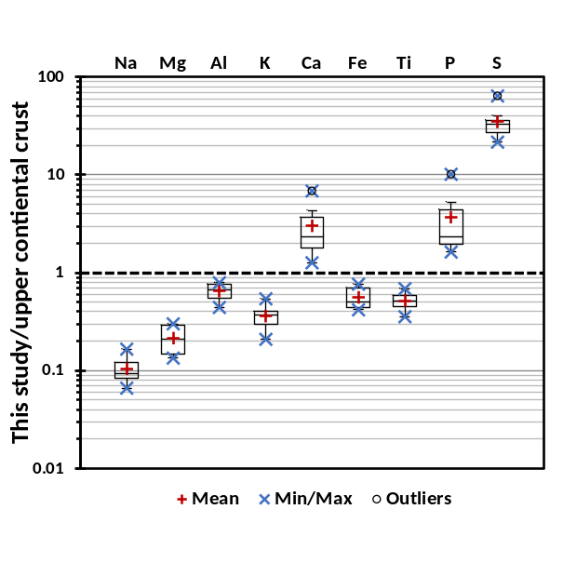
Figure S1. Ratio between major element concentrations in the studied samples and upper continental crust according to Rudnick and Gao (2003).
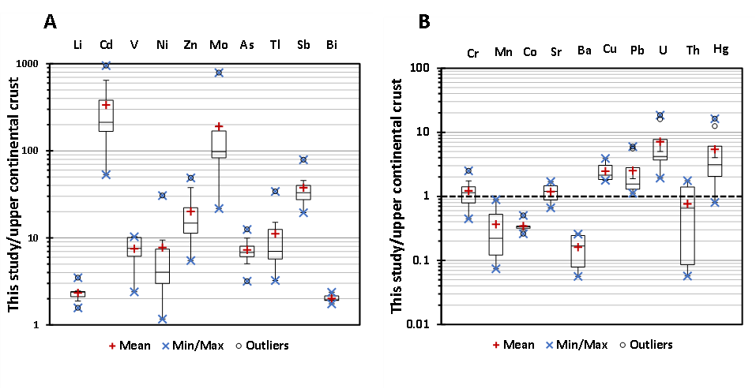
Figure S2. Ratio between minor and trace element concentrations in the studied samples and upper continental crust according to Rudnick and Gao (2003).

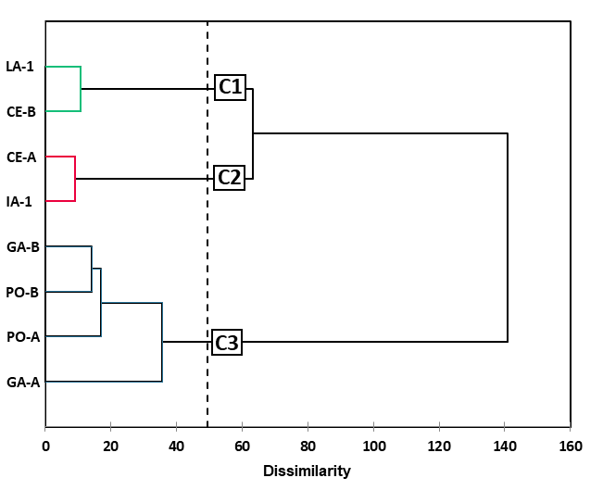
Figure S3. Hierarchical cluster analysis (HCA) by using the Ward’s method and the Euclidean distance.

