Supplementary Information for
Crystal structure of anthracen-9-yl(3,6-dimethoxynaphthalen-2-yl)methanone:
Decisive factors for formation of two-fold helical molecular assemblies in three directions affording chiral crystal

Kun Li¹, Hiroaki Iitsuka¹, Takehiro Tsumuki¹, Keiichi Noguchi², Noriyuki Yonezawa¹, Akiko Okamoto^{1*}
¹Department of Organic and Polymer Materials Chemistry, Tokyo University of Agriculture and Technology, 2-24-16 Nakamachi, Koganei, Tokyo, 184–8588, Japan.
² Instrumentation Analysis Center, Tokyo University of Agriculture and Technology, 2-24-16, Nakamachi, Koganei, Tokyo 184-8588, Japan

Corresponding author E-mail: aokamoto@cc.tuat.ac.jp

Table of Contents

1. Compound Data S-3
¹H, ¹³C NMR, and IR Spectra
2. X-ray Diffraction Analysis S-7

3. Hirshfeld surface analysis S-12
Hirshfeld surface mapped over d_{norm} and two-dimensional fingerprint plots

4. References S-15

- Compound Data
Spectral data of anthracen-9-yl(3,6-dimethoxynaphthalen-2-yl)methanone
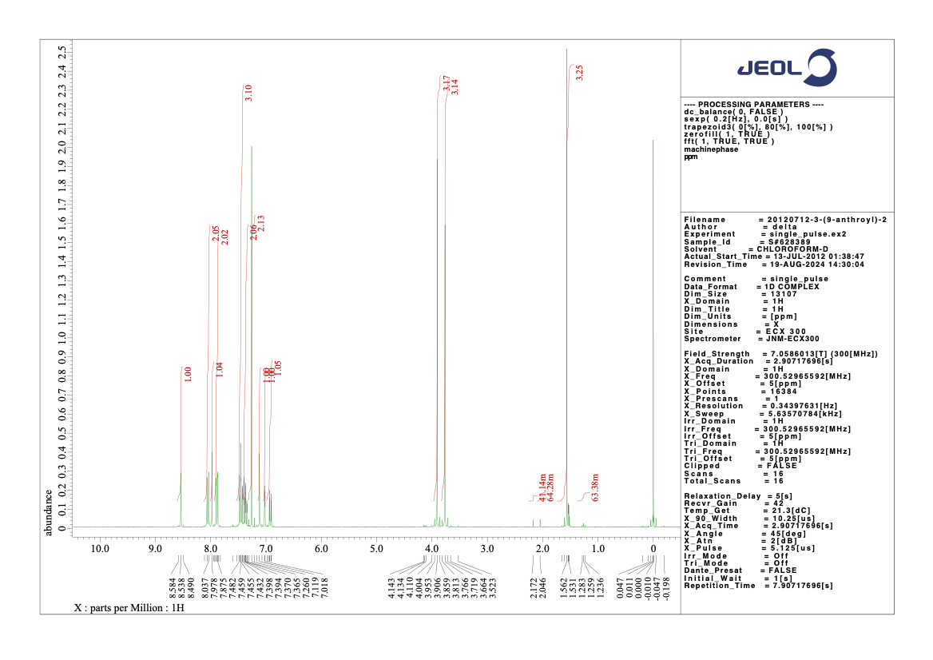
Figure S-1. ¹H NMR spectra of anthracen-9-yl(3,6-dimethoxynaphthalen-2-yl)methanone (300 MHz, in CDCl₃; -0.5~10.5 ppm).
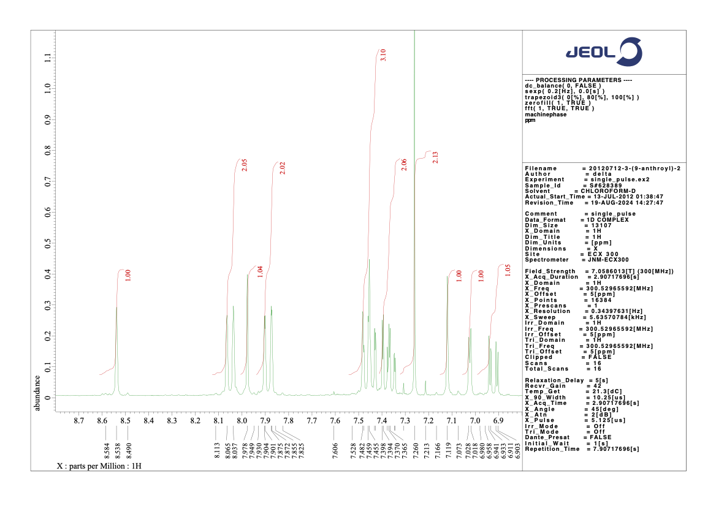
Figure S-2. ¹H NMR spectra of anthracene-9-yl(3,6-dimethoxynaphthalen-2-yl)methanone (300 MHz, in CDCl₃; 6.8~8.8 ppm).
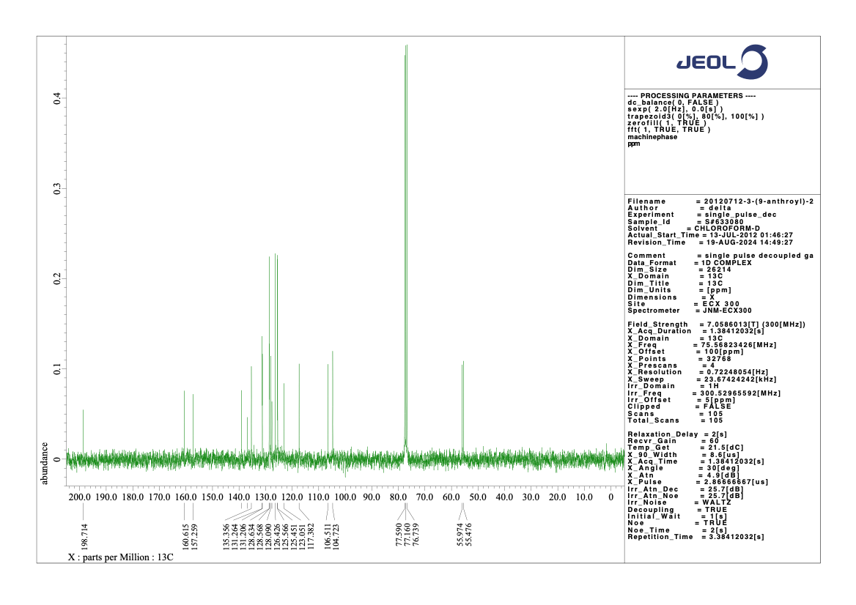
Figure S-3. ¹³C NMR spectra of anthracene-9-yl(3,6-dimethoxynaphthalen-2-yl)methanone (75 MHz, in CDCl₃; -0.5~200.5 ppm).
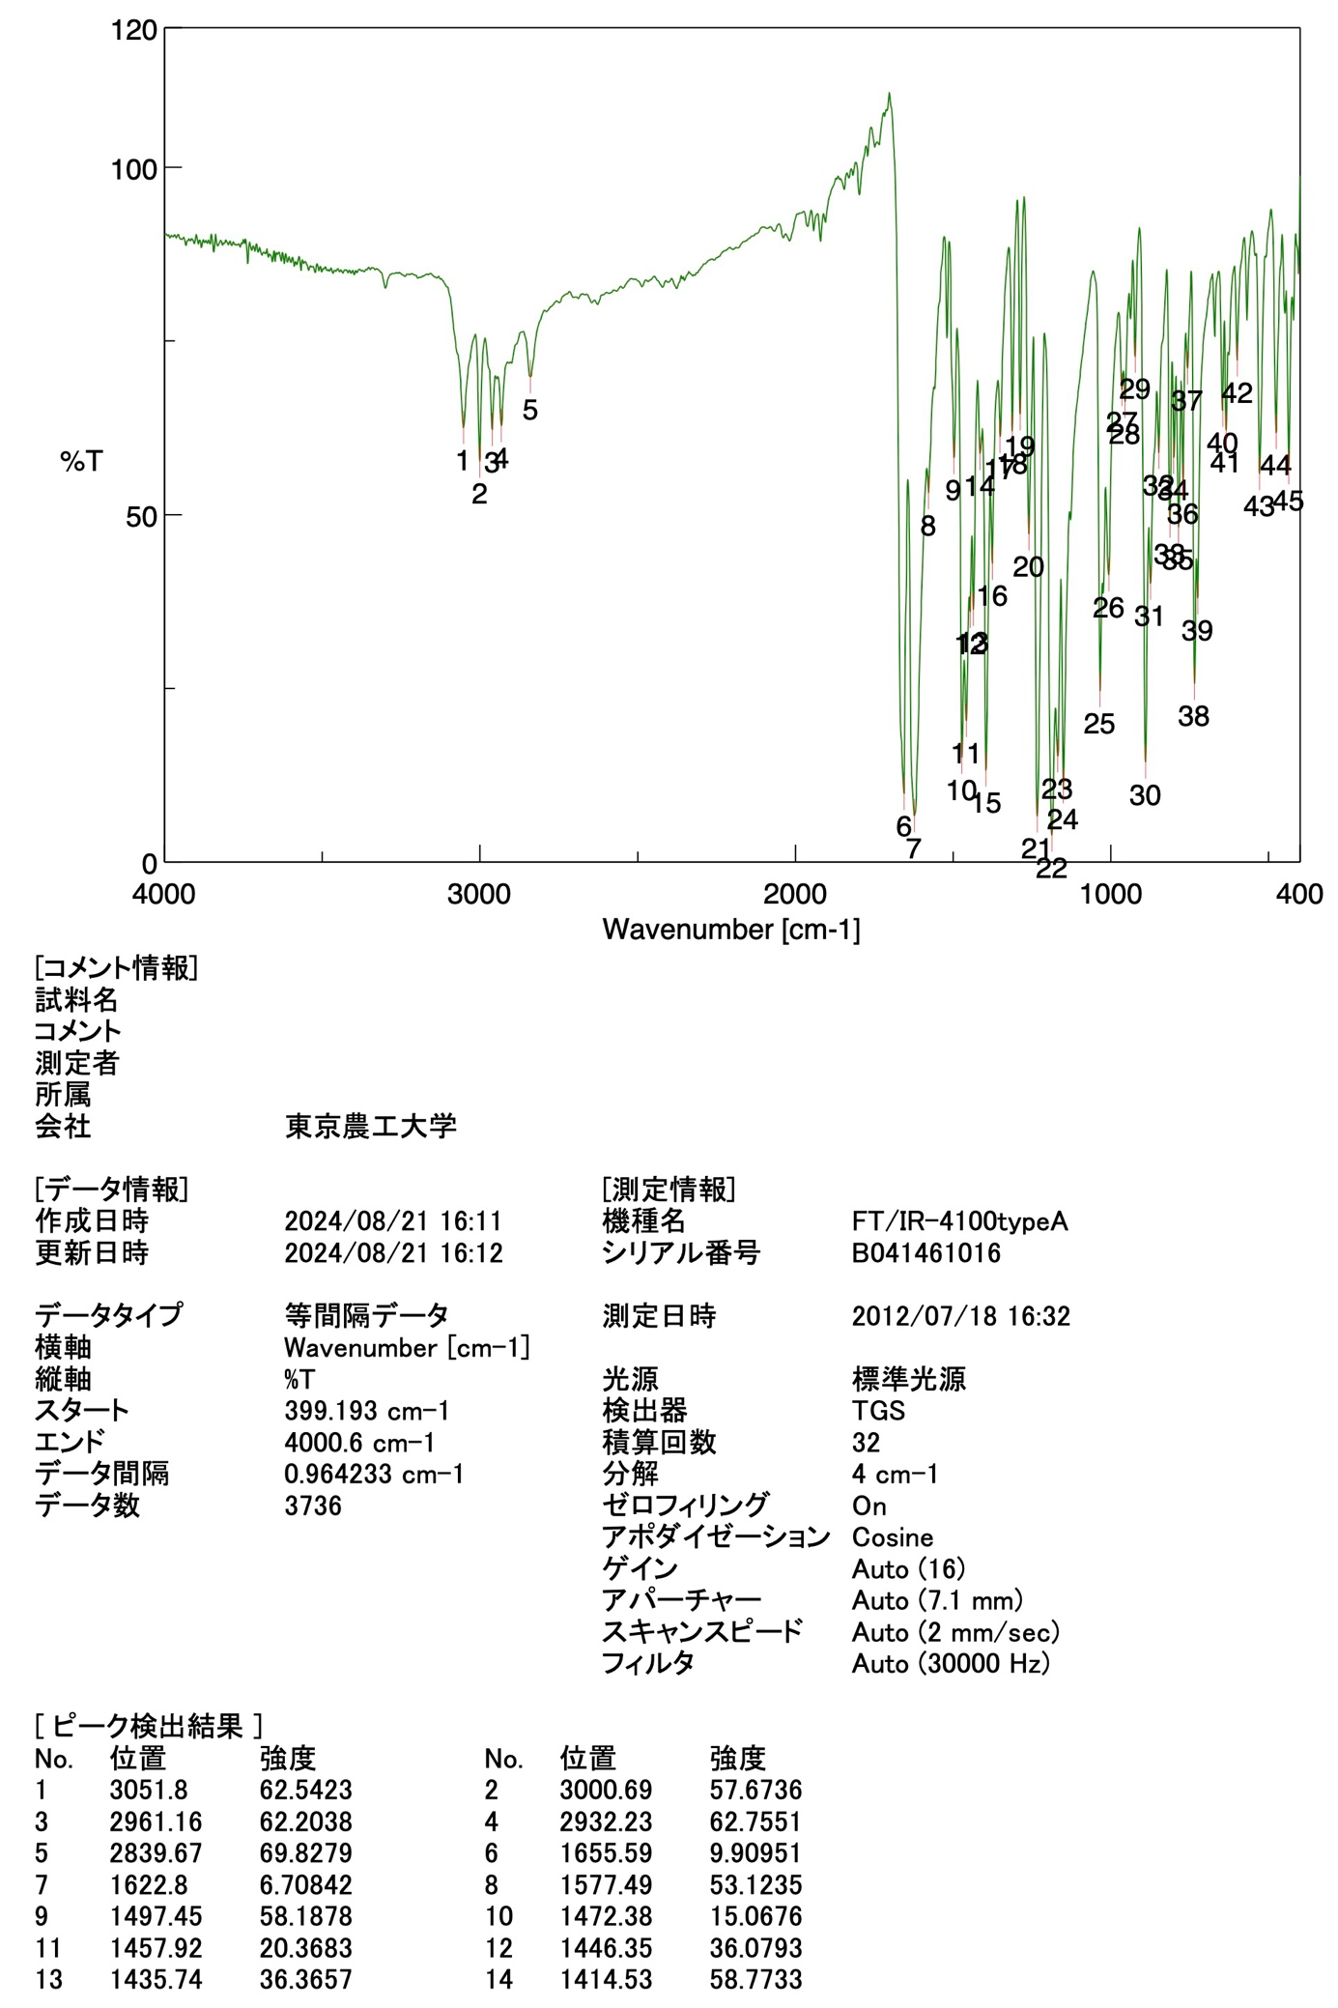
(equivalent interval)
(Standard)

Model name
Serial number
Affiliation
Organization

Analysis date
Update

Data type
Horizontal axis
Vertical axis
Start
End
Data interval
Number of data
Intensity

Wavenumber

Intensity

Wavenumber

Measurement date

Illuminant
Detector
Scan
Resolution
Zero filling
Apodization
Gain
Aperture
Scan speed
Filter

Model name
Serial number
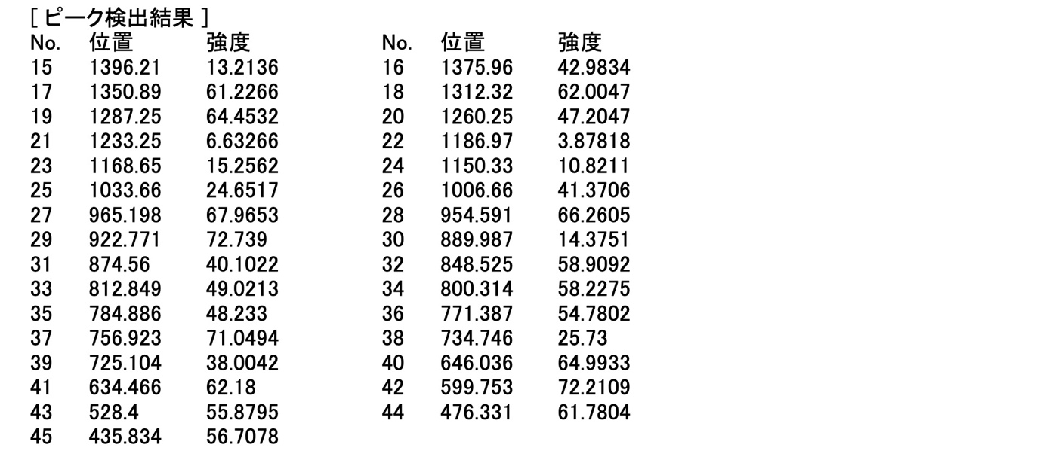
Figure S-4. IR spectra of anthracen-9-yl(3,6-dimethoxynaphthalen-2-yl)methanone.

- X-ray Diffraction Analysis.
For the crystal structure determination, the single crystal of the title compound was used for data collection on a four circle Rigaku RAXIS RAPID diffractometer (equipped with a two-dimensional area IP detector). The graphite-monochromated CuKα radiation (λ = 1.54187 Å) was used for data collection. The lattice parameters were determined by the least-squares methods on the basis of all reflections with F² > 2σ(F²). Crystal data, data collection, and structure refinement details are summarized in Table S-1. The data collection and cell refinement were performed using RAPID-AUTO software [1]. The data reduction was performed using CrystalStructure [2]. The structures were solved by direct methods using SIR2011[3] and refined by a full-matrix least-squares procedure using the program SHELXL-2014 [4]. All H atoms were found in a difference map and were subsequently refined as riding atoms, C–H = 0.95 (aromatic), and 0.98 (methyl) Å, with U_{iso}(H) = 1.2U_{eq} (C). Crystallographic data have been deposited at the Cambridge Crystallographic Data Centre, and can be obtained free of charge on application to CCDC, 12 Union Road, Cambridge CB21EZ, UK (fax: (+44) 1223-336-033; email: deposit@ccdc.cam.ac.uk).
Crystal data for title compound: C₂₇H₂₀O₃, , FW = 392.43, Orthorhombic, P2₁2₁2₁, a = 8.2094(2) Å, b = 9.8435(2) Å, c = 25.3131(5)Å, V = 2045.53(8) Å³, T = 193 K, Z = 4, D_{calcd} = 1.274 g cm⁻³, R₁ = 0.037, wR₂ = 0.117, GOF = 0.99. CCDC XXXXX.

Table S-2. Crystal data and details of the structure refinement for the title compound and
the homologous compounds.
 | I (Bz)  (Kato et al., 2011)[5] | II (Nap)  (Okamoto et al., 2016)[6] | III (Anth)
Crystal data
Chemical formula | C₁₉H₁₆O₃ | C₂₃H₁₈O₃ | C₂₇H₂₀O₃
M_{r} | 292.32 | 342.37 | 392.43
Crystal system, space group | Monoclinic, P2₁/c | Monoclinic, P2₁/c | Orthorhombic, P2₁2₁2₁
a, b, c (Å) | 8.7186(2), 20.4650(4), 8.5675 (2) | 8.8585(2), 22.1886(5), 9.10165(19) | 8.2094(2), 9.8435(2), 25.3131(5)
β (˚) | 102.475 (1) | 104.139 (1) | 90
V (Å³) | 1492.57(6) | 1734.80 (7) | 2045.53 (8)
Z | 4 | 4 | 4
μ (mm⁻¹) | 0.71 | 0.69 | 0.66
Crystal size (mm) | 0.60 x 0.50 x 0.20 | 0.60 x 0.30 x 0.10 | 0.50 x 0.50 x 0.30
Data collection
T_{min}, T_{max} | 0.677, 0.872 | 0.682, 0.934 | 0.735, 0.828
No. of measured, independent and observed [I > 2σ(I)] reflections | 26682, 2735, 2509 | 30270, 3173, 2587 | 11732, 3705, 3430
R_{int} | 0.044 | 0.054 | 0.022
(sin θ/λ)_{max} (Å⁻¹) | 0.602 | 0.602 | 0.602
Refinement
R[F² > 2σ(F²)], wR(F²), S | 0.034, 0.098, 1.06 | 0.041, 0.113, 1.09 | 0.037, 0.117, 0.99
No. of reflections | 2735 | 3173 | 3705
No. of parameters | 202 | 238 | 273
Δρ_{max}, Δρ_{min} (eÅ⁻³) | 0.23, -0.17 | 0.17, -0.15 | 0.20, -0.17

Table S-2. Geometric parameters for title compound: Bond lengths (Å)
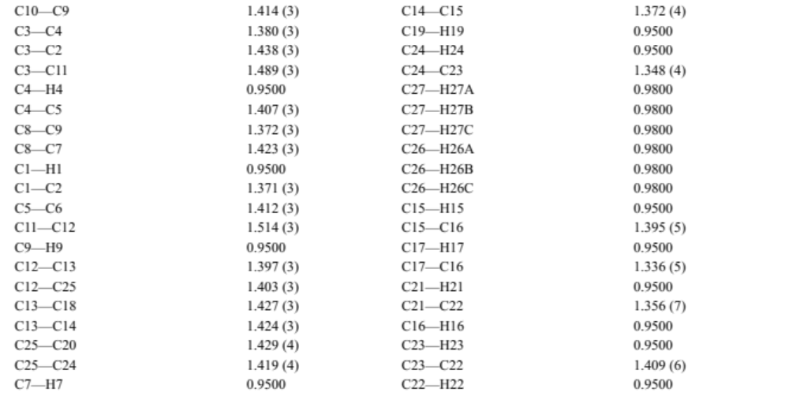
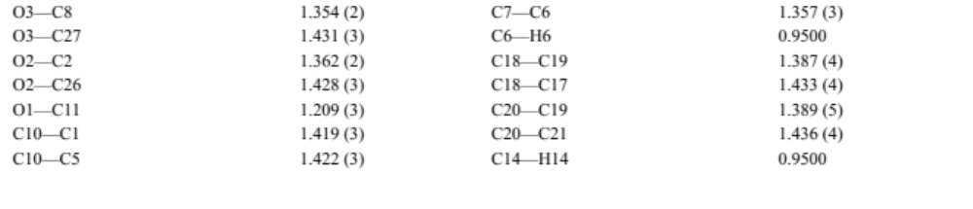

Table S-3. Geometric parameters for title compound: Bond angles (˚).
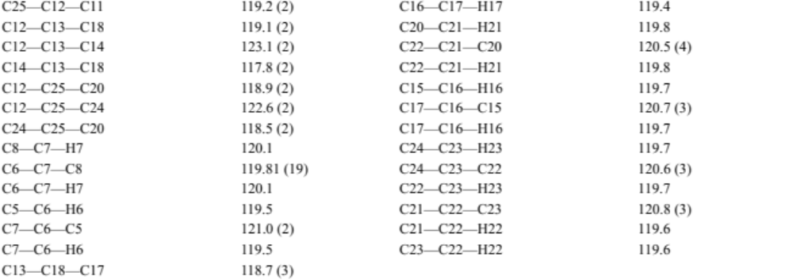
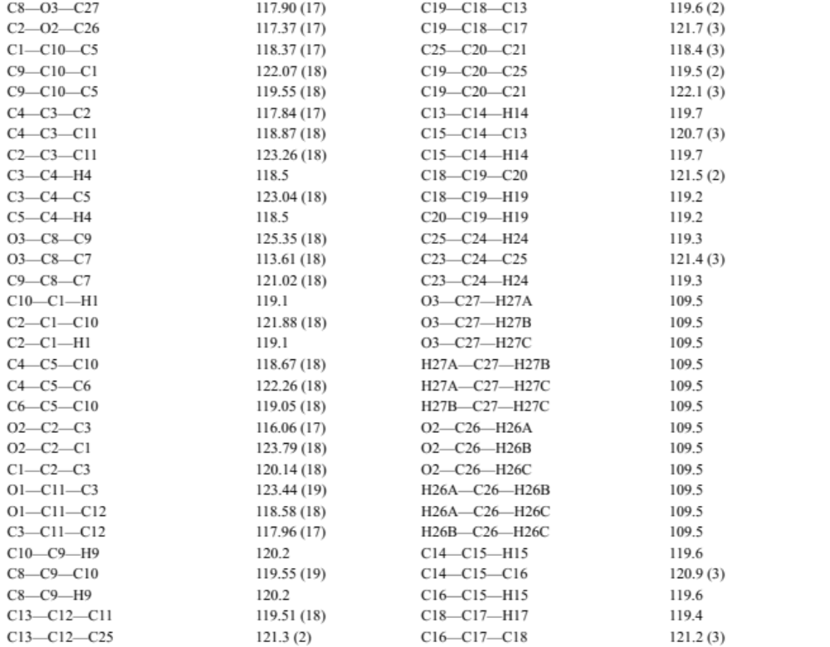

Table S-4. Geometric parameters for title compound: Torsion angles (˚).

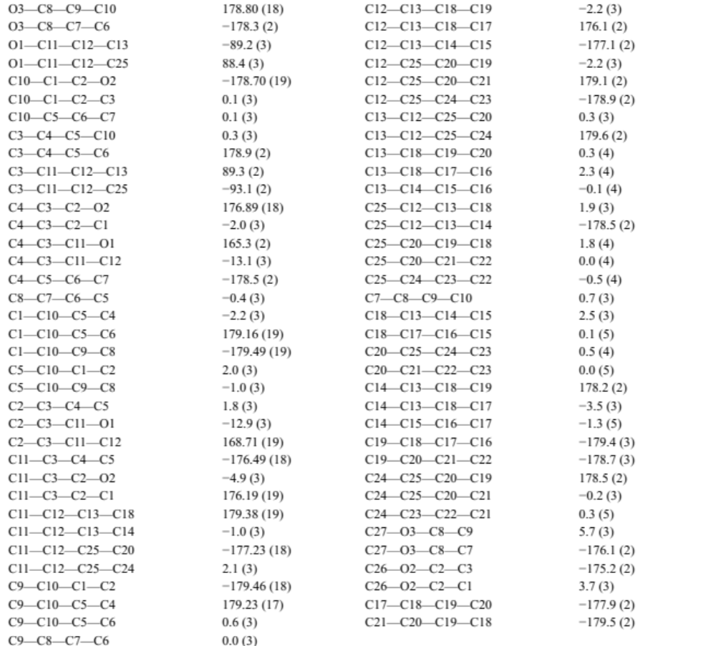

- Hirshfeld surface analysis [7-9]
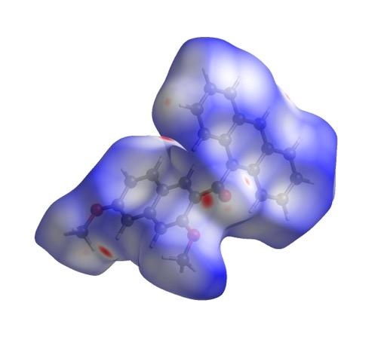
Figure S-5. Hirshfeld surface of title compound III (Anth) mapped over d_{norm} (top) and two-dimensional fingerprint plots (bottom): (a) layered full plot and those delineated into (b) H...H, (c) H...C/C...H, (d) H...O/O...H, (e) C...O/O...C, (f) C...C, and (g) O...O contacts.

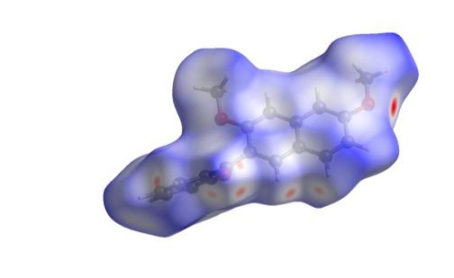
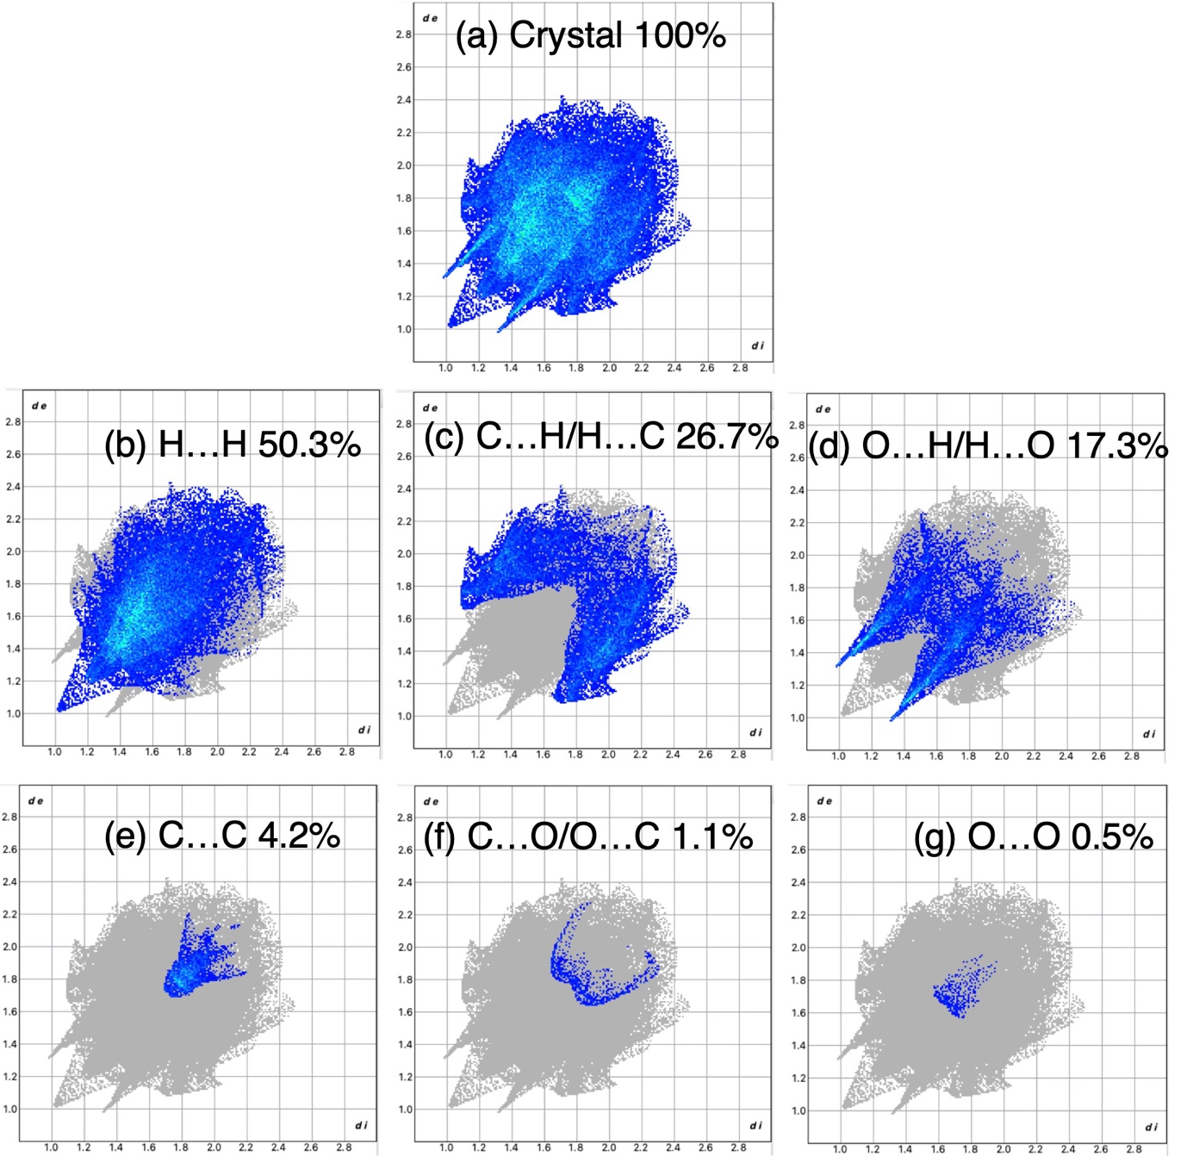
Figure S-6. Hirshfeld surface of homologous compound I (Bz) mapped over d_{norm} (top) and two-dimensional fingerprint plots (bottom): (a) layered full plot and those delineated into (b) H...H, (c) H...C/C...H, (d) H...O/O...H, (e) C... C, (f) C...O/O...C, and (g) O...O contacts.

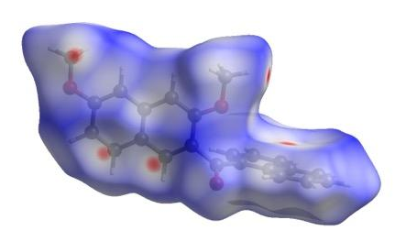
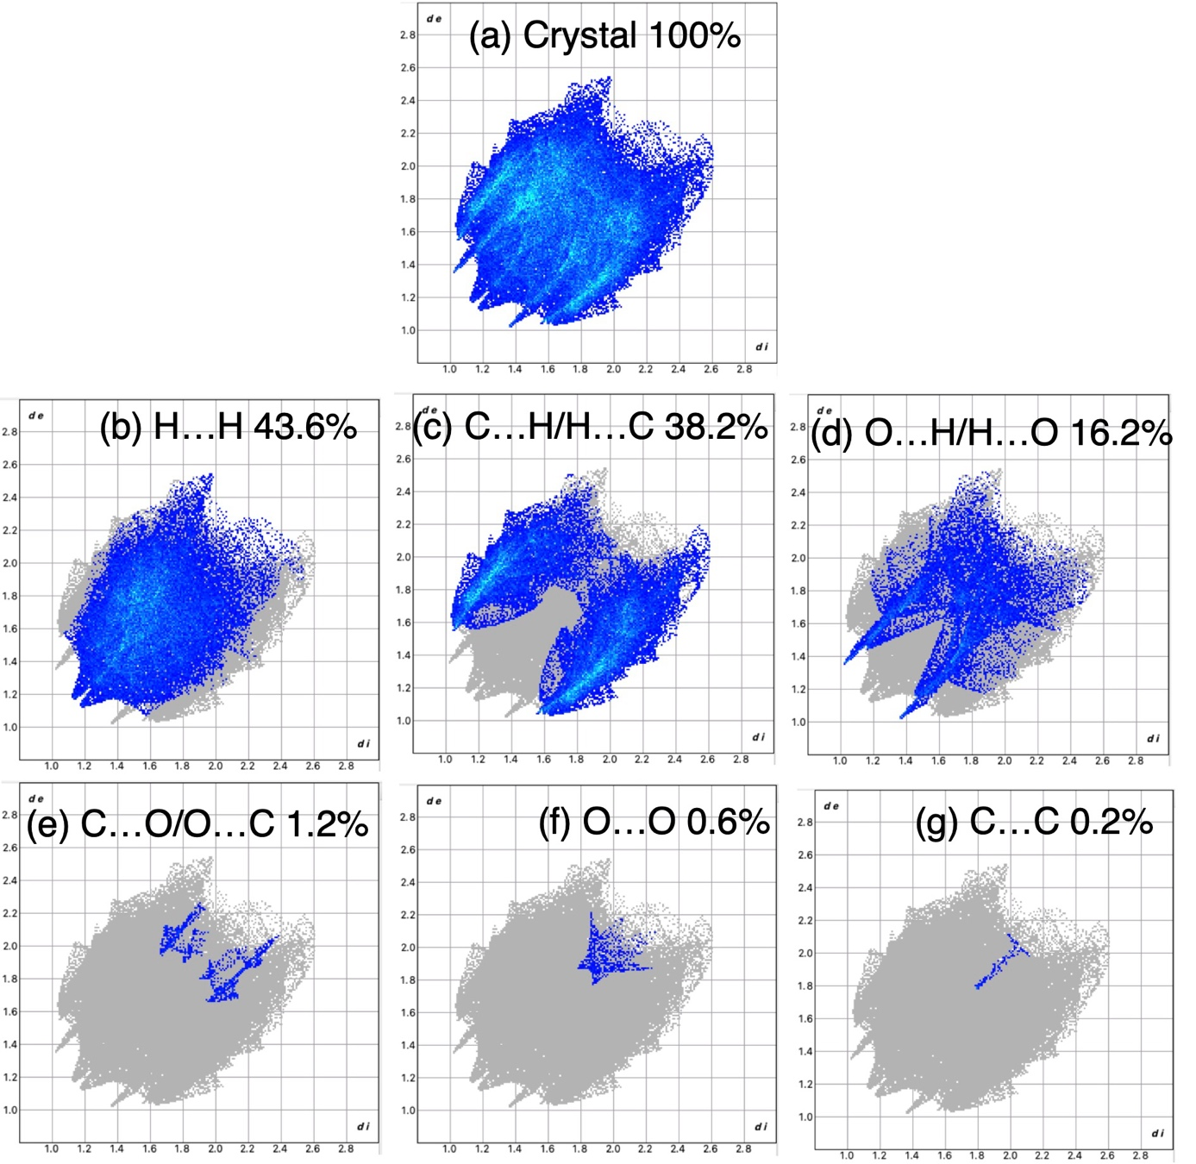
Figure S-7. Hirshfeld surface of homologous compound II (Nap) mapped over d_{norm} (top) and two-dimensional fingerprint plots (bottom): (a) layered full plot and those delineated into (b) H...H, (c) H...C/C...H, (d) H...O/O...H, (e) C...O/O...C, (f) O...O, and (e) C...C contacts.

- References
[1] Rigaku. In: Rigaku Corporation; Tokyo, Japan, 1998.
[2] Rigaku. CrystalStructure; Rigaku Corporation: Tokyo, Japan, 2010.
[3] Burla MC, Caliandro R, Camalli M, Carrozzini B, Cascarano GL, De Caro L, Giacovazzo C, Polidori G, Siliqi D, Spagna R (2007) J Appl Cryst 40:609-613.
[4] Sheldrick GM (2015) Acta Cryst A71: 3-8.
[5] Kato, Y., Takeuchi, R., Muto, T., Okamoto, A. & Yonezawa, N. (2011). Acta Cryst. E67, o668.
[6] Okamoto, A., Tsumuki, T. Sasagawa, K., Siqingaowa & Yonezawa, N. (2016). Eur. Chem. Bull. 5(6), 211-220.
[7] Spackman, M. A. & Jayatilaka, D. (2009). CrystEngComm, 11, 19-32.
[8] McKinnon, J. J., Jayatilaka, D. & Spackman, M. A. (2007). Chem. Commun., 3814-3816.
[9] Turner, M. J., McKinnon, J. J., Wolff, S. K., Grimwood, D. J., Spackman, P.R., Jayatilaka, D. & Spackman, M. A. CrystalExplorer17. University of Western Australia. http://hirsh-feldsurface.net 2017. Available from: http://hirsh-feldsurface.net

