Additional file 1
Table S 1. Chemical properties of soils used in the present study 3
Table S 2. Alpha diversity analysis showing significant factors among treatments based on linear mixed effect model (LMM) p < 0.05. The soil sampling locations were treated as the block factor in the model. Only significant features are denoted with asterisks 4
Table S 3. Permutational analysis of variance (PERMANOVA) of rhizosphere-associated bacterial and fungal communities in different soybean nodulation phenotypes grown under untreated and fumigant-treated conditions with the primary symbionts of soybean included. Adonis tests were based on Bray-Curtis distance matrices using 999 permutations. Significant factors are denoted by asterisk. 5
Table S 4. Permutational analysis of variance (PERMANOVA) of rhizosphere-associated bacterial and fungal communities in different soybean nodulation phenotypes grown under untreated and fumigant-treated conditions without the primary symbionts of soybean included. Adonis tests were based on Bray-Curtis distance matrices using 999 permutations. Significant factors are denoted by asterisk. 6

Fig. S 1. Rarefaction curves showing the sequence depths of (a) bacterial samples (b) fungal samples 7
Fig. S 2. Frequency distribution of the taxa affiliation at the genus level of the top 15 shared and unique rhizosphere communities in all samples. (a) bacterial communities (b) fungal communities 8
Fig. S 3. Alpha diversity measures in all test soils. Boxplots showing alpha diversity measures (Shannon diversity index and observed species richness) for (a) bacteria (b) fungi 9
Fig. S 4. Diversity measures in all test soils with the sequences of primary soybean symbionts removed. Boxplots showing alpha diversity measures for bacteria (a) observed species (b) shannon index (c) NMDS ordination plot based on Bray-Curtis distance on all samples. 10
Fig. S 5. Redundancy analysis based on Bray-Curtis showing the correlation between rhizosphere community structure of soybean and soil chemical properties for (a) bacterial communities (b) fungal communities. The points represent individual samples, colored and shaped according to treatment groups. Arrows represent soil properties, with their direction indicating the gradient of the representative property and the length indicating the strength of the correlation with the microbial community structure. Longer arrow means a stronger correlation, implying that the corresponding soil property has a greater influence on the microbial community structure. NT=non-treated soils T=treated soils. EC = Electrical conductivity, TOC = Total organic carbon, TN = Total nitrogen, NH₄⁺-N = Ammonium nitrogen, NO₃⁻-N = Nitrate nitrogen, Avail. P = Available phosphorus 11

Table S 1. Chemical properties of soils used in the present study
Farming pH EC TOC TN NH₄⁺-N NO₃⁻ -N Avail. P
Practice (mS/cm) ------%------ ------------mg/100g------------
Non-treated
Fuchu Synthetic 6.85 0.14 6.86 0.52 0.8 5.2 8.1
Nagano No fert 6.47 0.21 4.28 0.39 0.9 11.1 9.5
Saitama No fert 6.36 0.09 6.04 0.45 0.9 2.9 9.9
Tochigi No fert 6.28 0.19 5.46 0.45 8 3.3 4.6
Fumigated
Fuchu Synthetic 6.16 0.21 6.8 0.52 7.2 1.4 7.1 Nagano No fert 5.88 0.31 4.15 0.38 11.3 6.8 8.2
Saitama No fert 6.02 0.12 6.05 0.45 4.6 3.2 9.4
Tochigi No fert 5.86 0.28 5.47 0.44 10.9 3.7 9.4

EC = Electrical conductivity, TOC = Total organic carbon, TN = Total nitrogen, NH₄⁺-N = Ammonium nitrogen, NO₃⁻-N = Nitrate nitrogen, Avail. P = Available phosphorus

Table S 2. Alpha diversity analysis showing significant factors among treatments based on linear mixed effect model (LMM) p < 0.05. The soil sampling locations were treated as the block factor in the model. Only significant features are denoted with asterisks
Factor Bacteria Fungi
Observed Shannon Observed Shannon
Soil condition (C) p < 0.001 p < 0.001 p < 0.001 p < 0.001
Farming system (S) 0.255 0.559 0.108 0.366
Plant genotype (G) 0.042* 0.0004*** 0.351 0.4197
C × S 0.116 0.421 0.019 0.809
C × G 0.022* 0.0004*** 0.823 0.167
S × G 0.761 0.056 0.109 0.809
C × S × G 0.426 0.021 0.321 0.945

Table S 3. Permutational analysis of variance (PERMANOVA) of rhizosphere-associated bacterial and fungal communities in different soybean nodulation phenotypes grown under untreated and fumigant-treated conditions with the primary symbionts of soybean included. Adonis tests were based on Bray-Curtis distance matrices using 999 permutations. Significant factors are denoted by asterisk.
Factor Bacteria Fungi
R² p-value R² p-value
Soil condition (C) 0.168 0.001*** 0.150 0.001***
Farming system (S) 0.076 0.001*** 0.101 0.001***
Plant genotype (G) 0.0176 0.046* 0.018 0.046*
C × S 0.056 0.001*** 0.058 0.001***
C × G 0.015 0.084 0.016 0.086
S × G 0.008 0.558 0.013 0.232
C × S × G 0.009 0.333 0.014 0.222

Table S 4. Permutational analysis of variance (PERMANOVA) of rhizosphere-associated bacterial and fungal communities in different soybean nodulation phenotypes grown under untreated and fumigant-treated conditions without the primary symbionts of soybean included. Adonis tests were based on Bray-Curtis distance matrices using 999 permutations. Significant factors are denoted by asterisk.
Factor Bacteria
R² p-value
Soil condition (C) 0.165 0.001***
Farming system (S) 0.077 0.001***
Plant genotype (G) 0.0172 0.046*
C × S 0.059 0.001***
C × G 0.015 0.069
S × G 0.008 0.559
C × S × G 0.009 0.35

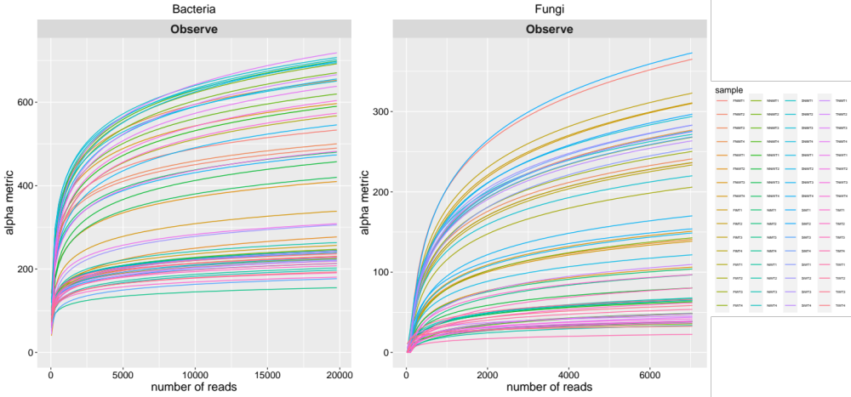
b
a

Fig. S 1. Rarefaction curves showing the sequence depths of (a) bacterial samples (b) fungal samples

b
a

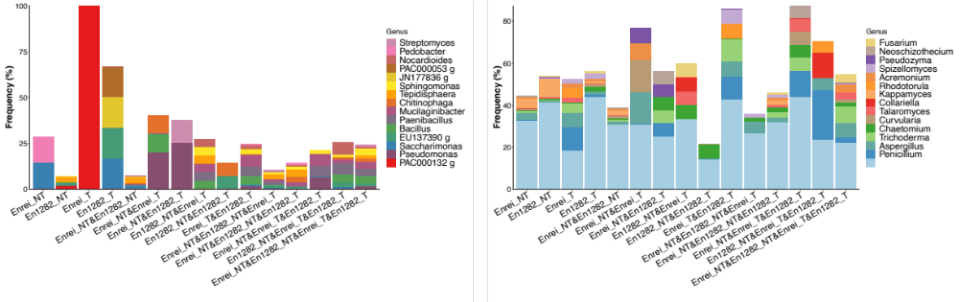

Fig. S 2. Frequency distribution of the taxa affiliation at the genus level of the top 15 shared and unique rhizosphere communities in all samples. (a) bacterial communities (b) fungal communities

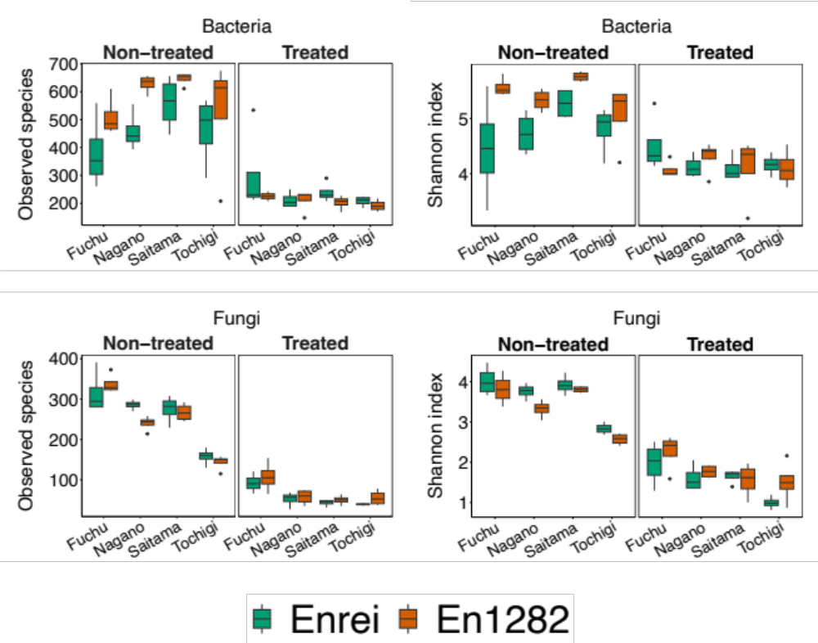
a
b

Fig. S 3. Alpha diversity measures in all test soils. Boxplots showing alpha diversity measures (Shannon diversity index and observed species richness) for (a) bacteria (b) fungi

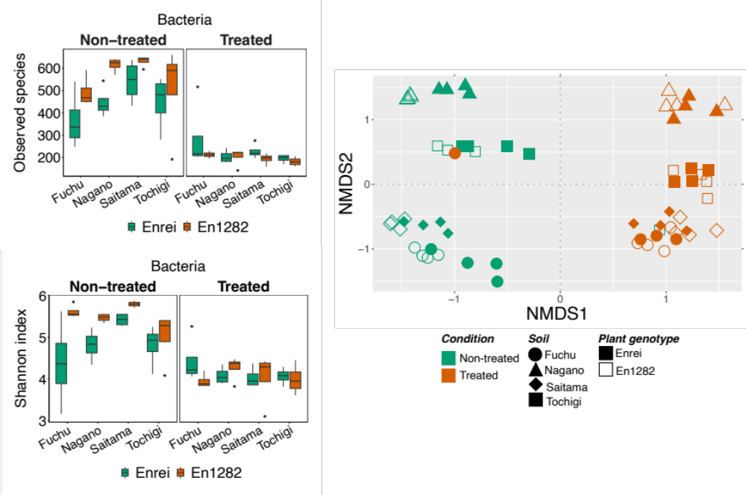
a
c
b

Fig. S 4. Diversity measures in all test soils with the sequences of primary soybean symbionts removed. Boxplots showing alpha diversity measures for bacteria (a) observed species (b) shannon index (c) NMDS ordination plot based on Bray-Curtis distance on all samples.

a
b

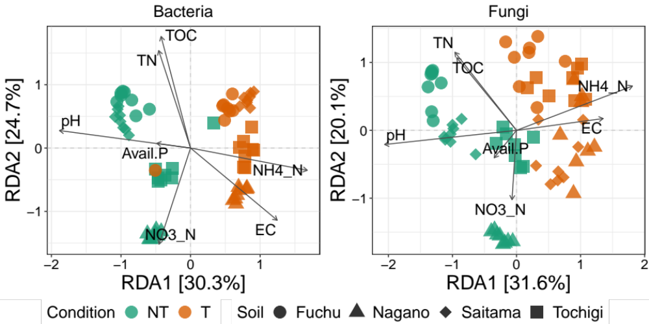

Fig. S 5. Redundancy analysis based on Bray-Curtis showing the correlation between rhizosphere community structure of soybean and soil chemical properties for (a) bacterial communities (b) fungal communities. The points represent individual samples, colored and shaped according to treatment groups. Arrows represent soil properties, with their direction indicating the gradient of the representative property and the length indicating the strength of the correlation with the microbial community structure. Longer arrow means a stronger correlation, implying that the corresponding soil property has a greater influence on the microbial community structure. NT=non-treated soils T=treated soils. EC = Electrical conductivity, TOC = Total organic carbon, TN = Total nitrogen, NH₄⁺-N = Ammonium nitrogen, NO₃⁻-N = Nitrate nitrogen, Avail. P = Available phosphorus

