ONLINE SUPPLEMENTARY DOCUMENT
Title: Global, regional, and national burden of thyroid cancer attribute to high body-mass index from 1990 to 2021 and forcast to 2049: insights from the global burden of disease 2021
Authors: Ye-xin Chen, Han-zhang Hong, Gai-weng Cui, Zi-heng Gao, Jiang-teng Liu, Yan Zhao, Jin-xi Zhao*

Fig. S1
The global ASMR and ASDR of TC-HBMI across countries by SDI for global from 1990 to 2021. Notes: (A) Deaths, (B) DALYs. TC-HBMI, thyroid cancer attribute to high body mass index; DALYs, the Disability-Adjusted Life Years; SDI, socio demographic index.

Fig. S2
Cases and ASR of TC-HBMI by different sexes in 1990. Notes: (A) Deaths, (B)DALYs. TC-HBMI, thyroid cancer attribute to high body mass index; DALYs, the Disability-Adjusted Life Years; ASMR, age-standardized mortality rate; ASDR, age-standardized DALYs rate.

Fig. S3
Global burden in 1990 of TC-HBMI by different countries. Notes: (A) ASMR, (B) ASDR, (C)AAPC of ASMR, (D)AAPC of ASDR. TC-HBMI, thyroid cancer attribute to high body mass index; DALYs, the Disability-Adjusted Life Years; ASMR, age-standardized mortality rate; ASDR, age-standardized DALYs rate; AAPC, average annual percent change.

Table S1.
Cases, ASR of TC-HBMI in 2021 and AAPC of TC-HBMI from 1990 to 2021 by different countries. TC-HBMI, thyroid cancer attribute to high body mass index; DALYs, the Disability-Adjusted Life Years; ASMR, age-standardized mortality rate; ASDR, age-standardized DALYs rate; AAPC, average annual percent change.

A | B
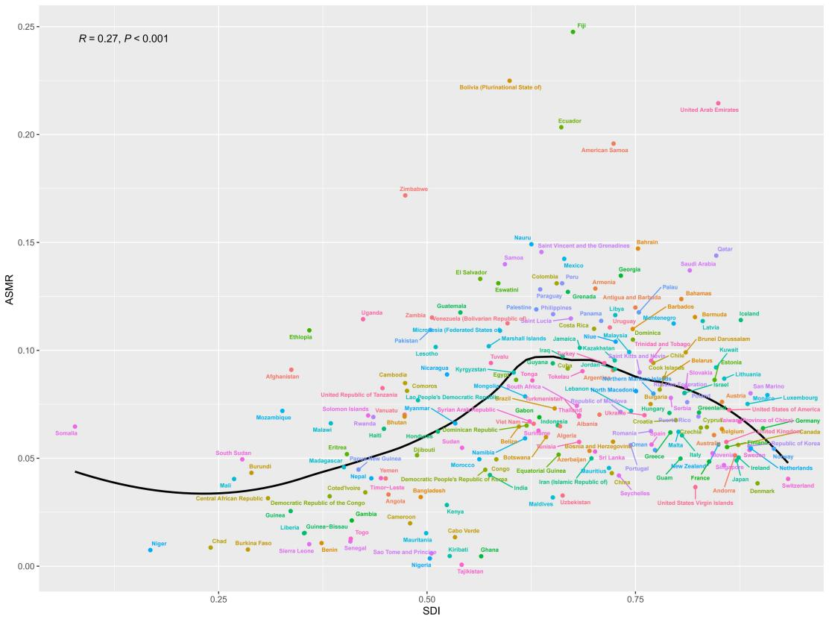 | 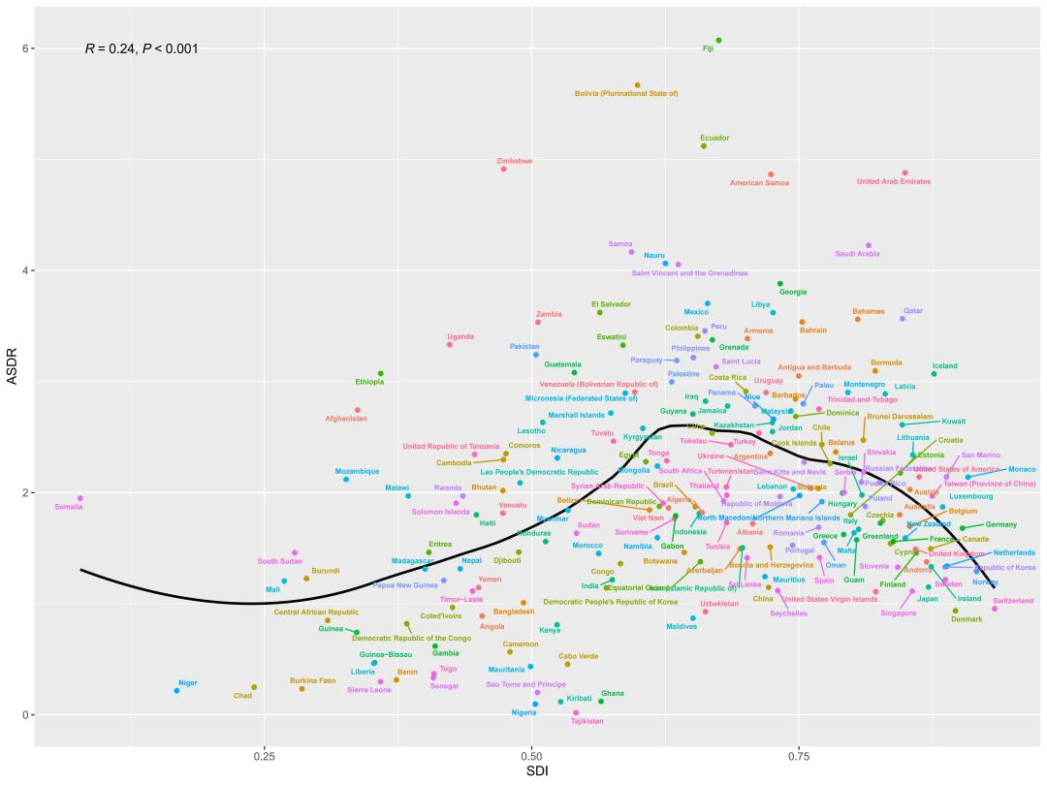

Fig. S1
The global ASMR and ASDR of TC-HBMI across countries by SDI for global from 1990 to 2021. Notes: (A) Deaths, (B) DALYs. TC-HBMI, thyroid cancer attribute to high body mass index; DALYs, the Disability-Adjusted Life Years; SDI, socio demographic index.

A | B
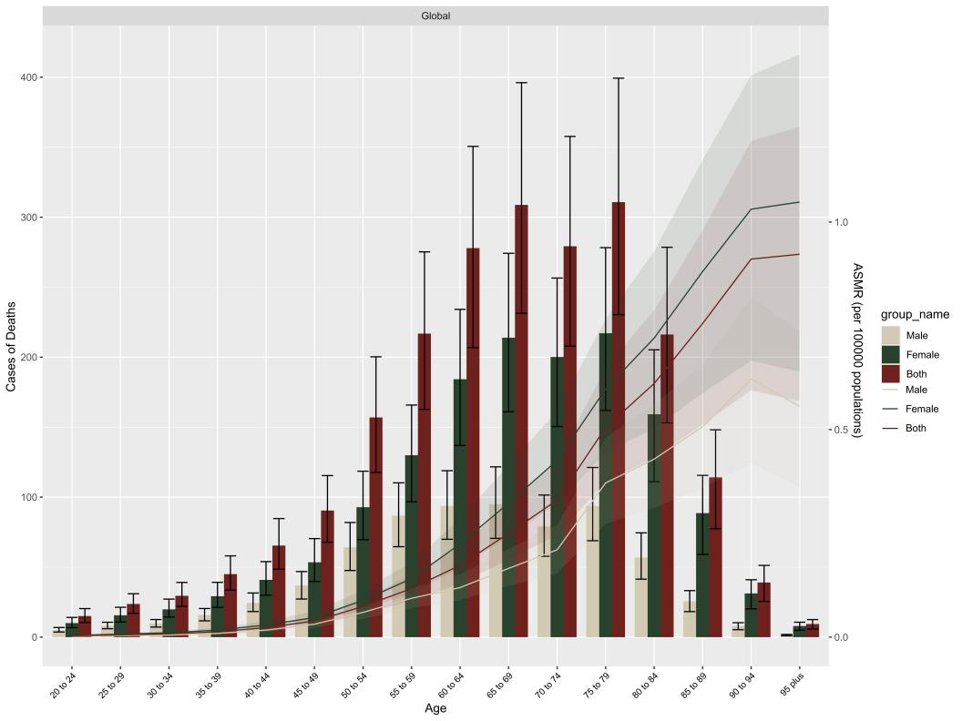 | 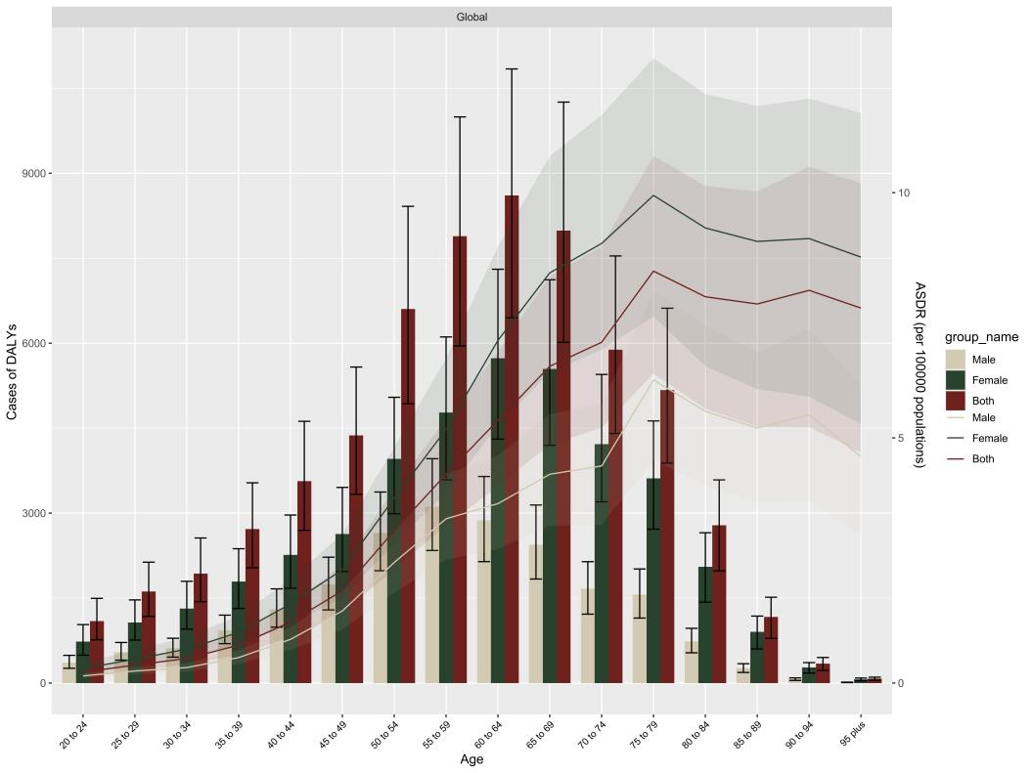
Fig. S2
Cases and ASR of TC-HBMI by different sexes in 1990. Notes: (A) Deaths, (B)DALYs. TC-HBMI, thyroid cancer attribute to high body mass index; DALYs, the Disability-Adjusted Life Years; ASMR, age-standardized mortality rate; ASDR, age-standardized DALYs rate.
A
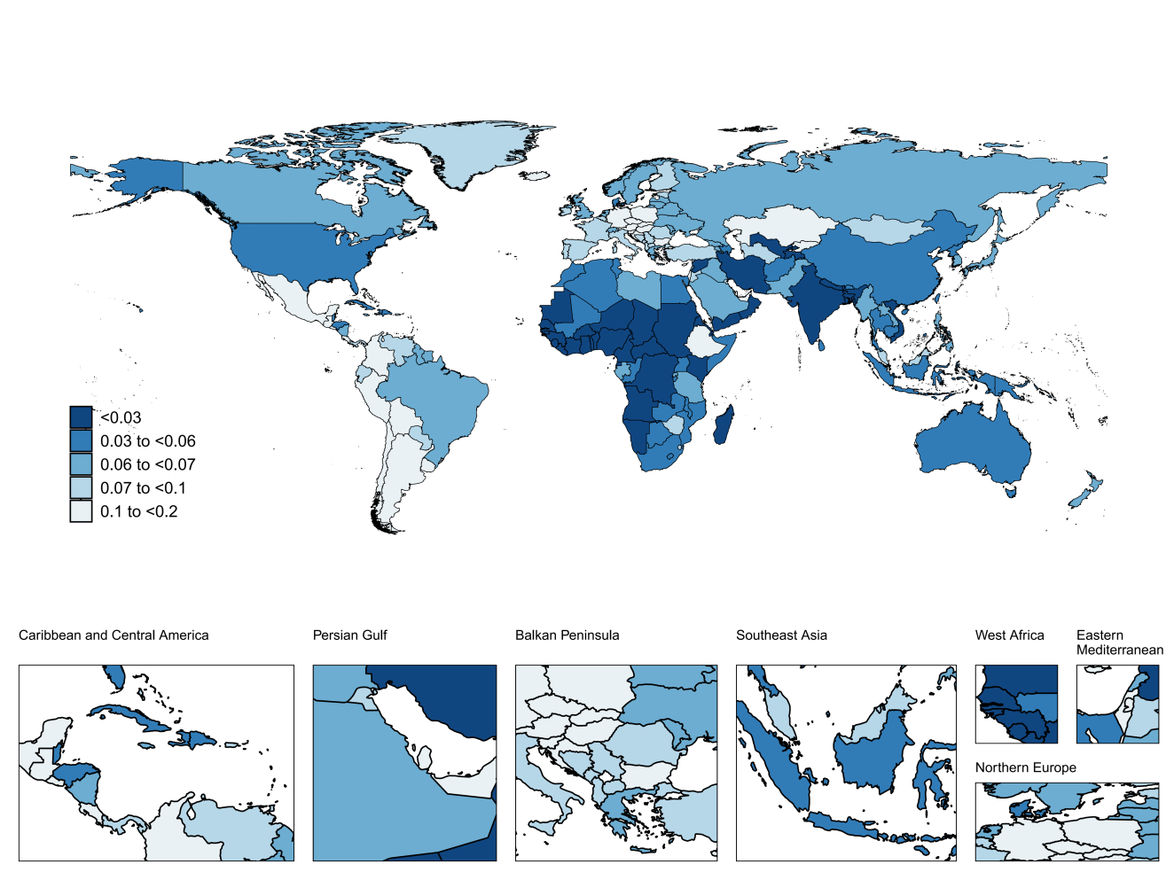
B
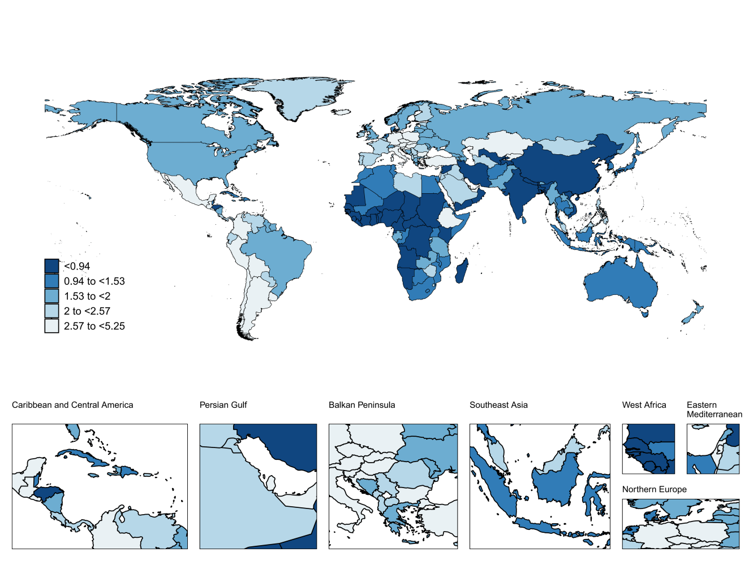
Fig. S3
Global burden in 1990 of TC-HBMI by different countries. Notes: (A) ASMR, (B) ASDR, (C)AAPC of ASMR, (D)AAPC of ASDR. TC-HBMI, thyroid cancer attribute to high body mass index; DALYs, the Disability-Adjusted Life Years; ASMR, age-standardized mortality rate; ASDR, age-standardized DALYs rate; AAPC, average annual percent change.

Table S1.
Cases, ASR of TC-HBMI in 2021 and AAPC of TC-HBMI from 1990 to 2021 by different countries. TC-HBMI, thyroid cancer attribute to high body mass index; DALYs, the Disability-Adjusted Life Years; ASMR, age-standardized mortality rate; ASDR, age-standardized DALYs rate; AAPC, average annual percent change.
 | Deaths |  |  | DALYs
 | Cases(95% UI) | ASMR(95% UI) | AAPC(95%CI) | Cases(95% UI) | ASDR(95% UI) | AAPC(95%CI)
Afghanistan | 10(4,17) | 0.09(0.04,0.16) | 2.14(1.96 to 2.31) | 316(186,484) | 2.30(1.36,3.50) | -2.96(-4.04 to -1.86)
Albania | 3(2,5) | 0.07(0.04,0.11) | -1.06(-1.65 to -0.46) | 23684(16056,32507) | 1.15(0.78,1.57) | -2.23(-3 to -1.45)
Algeria | 22(15,29) | 0.06(0.04,0.09) | 1.44(1.27 to 1.61) | 380(236,567) | 1.14(0.71,1.70) | -2.19(-2.46 to -1.92)
American Samoa | 0(0,0) | 0.20(0.12,0.28) | 0.73(0.33 to 1.14) | 765(553,1011) | 1.97(1.43,2.60) | -2.07(-2.48 to -1.67)
Andorra | 0(0,0) | 0.05(0.03,0.08) | -1.3(-1.63 to -0.96) | 4999(3087,7296) | 1.81(1.11,2.60) | -2.05(-2.55 to -1.56)
Angola | 4(2,7) | 0.03(0.02,0.06) | 1.2(0.9 to 1.51) | 980(623,1456) | 1.84(1.18,2.71) | -1.97(-2.44 to -1.49)
Antigua and Barbuda | 0(0,0) | 0.12(0.09,0.15) | 1.46(0.65 to 2.28) | 111(68,171) | 2.09(1.29,3.25) | -1.94(-2.6 to -1.26)
Argentina | 51(37,66) | 0.09(0.07,0.12) | -0.63(-1.45 to 0.19) | 2943(2048,4024) | 3.22(2.25,4.39) | -1.78(-1.94 to -1.62)
Armenia | 6(4,8) | 0.13(0.09,0.18) | 1.91(1.1 to 2.72) | 834(614,1141) | 2.73(2.00,3.75) | -1.72(-2.31 to -1.11)
Australia | 28(20,38) | 0.06(0.04,0.08) | 0.46(0.21 to 0.71) | 4(2,5) | 0.87(0.59,1.20) | -1.67(-2.02 to -1.31)
Austria | 14(10,20) | 0.08(0.05,0.10) | -1.38(-1.59 to -1.16) | 1997(1325,2968) | 1.86(1.23,2.73) | -1.66(-2.49 to -0.83)
Azerbaijan | 6(4,8) | 0.05(0.04,0.08) | 0(-0.32 to 0.32) | 385(240,582) | 1.41(0.89,2.13) | -1.6(-3.73 to 0.58)
Bahamas | 1(0,1) | 0.12(0.09,0.16) | 1.06(0.58 to 1.54) | 50(30,74) | 6.07(3.76,8.98) | -1.51(-1.85 to -1.18)
Bahrain | 1(1,1) | 0.15(0.10,0.21) | -0.05(-0.52 to 0.43) | 2076(1348,3328) | 1.98(1.28,3.17) | -1.49(-2.13 to -0.84)
Bangladesh | 45(26,79) | 0.03(0.02,0.05) | 1.58(1.25 to 1.91) | 10(6,16) | 1.11(0.69,1.75) | -1.42(-1.77 to -1.07)
Barbados | 1(0,1) | 0.11(0.08,0.15) | 0.97(-0.19 to 2.15) | 0(0,0) | 0.12(0.07,0.23) | -1.35(-2.26 to -0.42)
Belarus | 14(10,19) | 0.09(0.06,0.12) | 1.12(0.1 to 2.16) | 74(38,135) | 1.21(0.62,2.18) | -1.34(-1.92 to -0.75)
Belgium | 15(10,21) | 0.06(0.04,0.09) | -1.06(-1.89 to -0.22) | 7(4,10) | 4.17(2.71,6.42) | -1.28(-1.91 to -0.66)
Belize | 0(0,0) | 0.06(0.05,0.08) | 1.65(0.43 to 2.89) | 1(1,2) | 2.72(1.76,4.06) | -1.23(-1.51 to -0.95)
Benin | 1(0,1) | 0.01(0.01,0.02) | -0.88(-1.06 to -0.69) | 8(5,13) | 1.90(1.15,3.02) | -1.23(-1.53 to -0.92)
Bermuda | 0(0,0) | 0.12(0.08,0.16) | -0.35(-1.93 to 1.26) | 2(2,4) | 2.90(1.87,4.26) | -1.2(-1.8 to -0.6)
Bhutan | 0(0,1) | 0.07(0.04,0.11) | 0.88(0.81 to 0.95) | 2(1,3) | 2.29(1.36,3.47) | -1.15(-1.51 to -0.8)
Bolivia (Plurinational State of) | 20(12,30) | 0.22(0.14,0.34) | 0.72(0.64 to 0.79) | 503(371,673) | 2.63(1.94,3.50) | -1.09(-3.53 to 1.4)
Bosnia and Herzegovina | 4(3,5) | 0.06(0.04,0.08) | -0.81(-1.23 to -0.38) | 145(100,204) | 3.39(2.33,4.79) | -1.03(-1.27 to -0.8)
Botswana | 1(0,1) | 0.06(0.04,0.10) | 0.67(-0.39 to 1.74) | 141(92,202) | 2.58(1.72,3.67) | -1.02(-1.66 to -0.38)
Brazil | 181(133,229) | 0.07(0.05,0.09) | -0.01(-0.17 to 0.14) | 4(2,5) | 1.81(1.16,2.65) | -0.98(-1.14 to -0.82)
Brunei Darussalam | 0(0,0) | 0.10(0.07,0.14) | 0.04(-0.15 to 0.23) | 172(112,252) | 1.49(0.98,2.15) | -0.98(-1.41 to -0.54)
Bulgaria | 10(7,15) | 0.08(0.05,0.11) | -1.24(-1.6 to -0.87) | 213(155,291) | 3.88(2.81,5.32) | -0.94(-1.41 to -0.47)
Burkina Faso | 1(1,1) | 0.01(0.01,0.01) | -0.9(-1.05 to -0.75) | 62(42,90) | 2.24(1.53,3.27) | -0.92(-1.43 to -0.41)
Burundi | 2(1,4) | 0.04(0.03,0.07) | -0.23(-0.42 to -0.05) | 1(1,2) | 0.02(0.01,0.03) | -0.92(-1.41 to -0.43)
Cabo Verde | 0(0,0) | 0.01(0.00,0.03) | 4.5(4.36 to 4.63) | 72(46,111) | 1.72(1.10,2.66) | -0.9(-1.27 to -0.53)
Cambodia | 11(6,16) | 0.08(0.05,0.13) | 1.55(1.45 to 1.65) | 94(62,137) | 2.05(1.34,2.95) | -0.9(-1.72 to -0.06)
Cameroon | 3(2,4) | 0.02(0.01,0.03) | -0.71(-0.88 to -0.54) | 90(62,127) | 1.51(1.05,2.14) | -0.9(-1.45 to -0.34)
Canada | 42(30,55) | 0.06(0.04,0.07) | -0.15(-0.54 to 0.24) | 342(234,479) | 1.75(1.20,2.46) | -0.88(-1.4 to -0.35)
Central African Republic | 1(0,1) | 0.03(0.02,0.05) | 0.55(0.32 to 0.77) | 278(188,403) | 0.93(0.63,1.34) | -0.86(-1 to -0.73)
Chad | 1(0,1) | 0.01(0.01,0.01) | -0.34(-0.42 to -0.25) | 347(255,471) | 2.00(1.46,2.70) | -0.86(-1.07 to -0.65)
Chile | 24(18,32) | 0.09(0.07,0.12) | -0.89(-1.49 to -0.29) | 257(188,358) | 2.04(1.48,2.84) | -0.85(-1.02 to -0.67)
China | 871(588,1177) | 0.04(0.03,0.06) | 0.62(0.45 to 0.79) | 65(44,92) | 1.97(1.33,2.76) | -0.85(-1.56 to -0.13)
Colombia | 72(51,96) | 0.13(0.09,0.17) | 0.09(-0.6 to 0.78) | 147(109,198) | 1.80(1.34,2.43) | -0.84(-1.3 to -0.38)
Comoros | 0(0,1) | 0.08(0.05,0.13) | 1.41(1.27 to 1.55) | 573(409,774) | 1.69(1.20,2.28) | -0.8(-1.48 to -0.12)
Congo | 1(1,2) | 0.05(0.03,0.08) | 0.64(0.4 to 0.88) | 28(19,38) | 2.90(2.02,3.97) | -0.79(-1.06 to -0.53)
Cook Islands | 0(0,0) | 0.08(0.06,0.12) | -0.69(-1.38 to 0.01) | 311(210,436) | 2.00(1.35,2.79) | -0.77(-2.65 to 1.14)
Costa Rica | 6(4,8) | 0.11(0.08,0.14) | 0.17(-0.33 to 0.68) | 199(141,275) | 2.19(1.53,3.04) | -0.74(-1.27 to -0.2)
Croatia | 6(5,8) | 0.07(0.05,0.09) | 0.51(0.2 to 0.82) | 1272(935,1617) | 1.88(1.39,2.38) | -0.74(-1.12 to -0.35)
Cuba | 18(13,24) | 0.09(0.07,0.12) | -2.16(-2.54 to -1.78) | 54(37,76) | 1.33(0.90,1.85) | -0.7(-1.44 to 0.05)
Cyprus | 1(1,2) | 0.06(0.04,0.09) | 1.77(0.55 to 3.01) | 367(253,511) | 2.37(1.63,3.27) | -0.68(-0.83 to -0.52)
Czechia | 14(10,19) | 0.06(0.04,0.09) | -1.86(-2.39 to -1.34) | 54(38,76) | 2.18(1.54,3.08) | -0.65(-1.02 to -0.28)
C么te d'Ivoire | 4(3,6) | 0.03(0.02,0.05) | -2.37(-2.66 to -2.09) | 104(72,147) | 2.89(1.99,4.09) | -0.65(-0.8 to -0.49)
Democratic People's Republic of Korea | 14(9,21) | 0.04(0.03,0.07) | 0.82(0.77 to 0.87) | 120(87,162) | 2.34(1.71,3.14) | -0.61(-1.24 to 0.01)
Democratic Republic of the Congo | 11(6,19) | 0.03(0.02,0.06) | 1.13(1.07 to 1.2) | 115(83,153) | 1.96(1.43,2.61) | -0.61(-2.41 to 1.22)
Denmark | 5(3,6) | 0.04(0.03,0.05) | -0.75(-1.22 to -0.28) | 4798(3574,6109) | 2.09(1.56,2.67) | -0.59(-1.44 to 0.27)
Djibouti | 0(0,1) | 0.05(0.03,0.08) | 1.38(1.3 to 1.45) | 1473(990,2159) | 2.04(1.38,2.98) | -0.52(-1.23 to 0.19)
Dominica | 0(0,0) | 0.10(0.07,0.14) | 0.56(0.3 to 0.81) | 10(7,13) | 2.47(1.72,3.44) | -0.51(-0.59 to -0.44)
Dominican Republic | 7(5,10) | 0.07(0.04,0.09) | 1.05(0.84 to 1.26) | 3824(2504,5202) | 1.15(0.81,1.53) | -0.43(-0.81 to -0.06)
Ecuador | 33(23,45) | 0.20(0.14,0.28) | 2.93(1.62 to 4.26) | 1200(796,1815) | 1.33(0.89,2.02) | -0.43(-0.63 to -0.24)
Egypt | 50(35,69) | 0.09(0.06,0.12) | 1.53(1.2 to 1.86) | 722(503,953) | 1.80(1.26,2.38) | -0.43(-0.77 to -0.09)
El Salvador | 8(6,11) | 0.13(0.09,0.18) | 0.55(0.22 to 0.89) | 96(68,132) | 1.11(0.79,1.53) | -0.36(-0.56 to -0.16)
Equatorial Guinea | 0(0,0) | 0.05(0.03,0.09) | 1.54(1.19 to 1.89) | 2(1,3) | 1.38(0.85,2.10) | -0.34(-0.54 to -0.14)
Eritrea | 2(1,2) | 0.05(0.03,0.08) | 1.55(1.45 to 1.65) | 121(87,161) | 1.59(1.14,2.11) | -0.29(-0.61 to 0.03)
Estonia | 2(2,4) | 0.09(0.06,0.12) | 0.11(-0.45 to 0.68) | 332(229,451) | 2.03(1.42,2.75) | -0.26(-0.67 to 0.15)
Eswatini | 1(0,1) | 0.13(0.08,0.20) | 1.42(1.21 to 1.64) | 345(245,468) | 1.70(1.21,2.31) | -0.25(-0.4 to -0.11)
Ethiopia | 51(31,80) | 0.11(0.07,0.17) | -0.48(-0.61 to -0.35) | 30(20,43) | 1.54(1.04,2.18) | -0.22(-0.34 to -0.11)
Fiji | 2(1,2) | 0.25(0.16,0.36) | 0.63(0.33 to 0.93) | 102(72,133) | 0.94(0.67,1.24) | -0.18(-0.34 to -0.02)
Finland | 7(5,10) | 0.06(0.04,0.07) | -1.68(-2.36 to -1) | 159(113,209) | 1.46(1.04,1.91) | -0.17(-0.31 to -0.02)
France | 73(50,98) | 0.05(0.03,0.07) | -1.51(-2 to -1.02) | 1795(1286,2392) | 1.56(1.14,2.09) | -0.16(-1.76 to 1.46)
Gabon | 1(0,1) | 0.07(0.04,0.11) | 0.52(0.33 to 0.71) | 2823(1981,3745) | 1.68(1.20,2.24) | -0.12(-0.46 to 0.22)
Gambia | 0(0,0) | 0.02(0.01,0.03) | 1.34(0.88 to 1.81) | 329(245,423) | 1.62(1.21,2.08) | -0.1(-0.44 to 0.24)
Georgia | 8(6,11) | 0.13(0.10,0.18) | 2.17(0.48 to 3.88) | 16(12,22) | 3.07(2.21,4.13) | -0.1(-0.24 to 0.05)
Germany | 130(88,174) | 0.06(0.04,0.08) | -1.86(-2.21 to -1.51) | 99(70,133) | 1.33(0.94,1.79) | -0.09(-0.55 to 0.36)
Ghana | 1(0,1) | 0.00(0.00,0.01) | 1.54(1.49 to 1.6) | 231(165,312) | 1.98(1.41,2.65) | -0.09(-0.34 to 0.17)
Greece | 16(11,20) | 0.06(0.05,0.08) | -0.34(-0.58 to -0.1) | 2095(1521,2683) | 1.67(1.22,2.14) | -0.03(-0.49 to 0.43)
Greenland | 0(0,0) | 0.07(0.04,0.10) | -0.78(-1.15 to -0.41) | 19(14,25) | 1.87(1.39,2.43) | -0.03(-0.46 to 0.4)
Grenada | 0(0,0) | 0.13(0.09,0.17) | 0.54(-0.04 to 1.12) | 14(10,19) | 1.64(1.16,2.18) | -0.01(-0.2 to 0.19)
Guam | 0(0,0) | 0.05(0.04,0.07) | 0.05(-0.69 to 0.79) | 122(88,161) | 1.29(0.94,1.70) | -0.01(-0.15 to 0.13)
Guatemala | 13(9,16) | 0.12(0.09,0.15) | 0.13(-0.77 to 1.04) | 428(302,562) | 1.34(0.95,1.76) | -0.01(-0.48 to 0.47)
Guinea | 2(1,2) | 0.03(0.02,0.04) | 0.68(0.58 to 0.78) | 324(225,452) | 1.53(1.07,2.13) | 0.01(-0.57 to 0.59)
Guinea-Bissau | 0(0,0) | 0.02(0.01,0.02) | -0.51(-0.58 to -0.44) | 1721(1287,2167) | 1.49(1.12,1.87) | 0.05(-0.25 to 0.35)
Guyana | 1(0,1) | 0.09(0.07,0.13) | 1.11(0.26 to 1.96) | 1255(882,1691) | 1.42(1.00,1.89) | 0.09(-0.65 to 0.82)
Haiti | 5(3,7) | 0.06(0.04,0.10) | 0.57(0.51 to 0.63) | 243(168,330) | 1.22(0.85,1.64) | 0.1(-0.04 to 0.23)
Honduras | 4(2,6) | 0.06(0.04,0.09) | 1.92(1.47 to 2.38) | 161(113,219) | 0.95(0.68,1.30) | 0.1(-0.32 to 0.53)
Hungary | 14(10,19) | 0.07(0.05,0.10) | -2.03(-2.48 to -1.59) | 972(715,1279) | 1.49(1.08,1.97) | 0.13(-0.32 to 0.58)
Iceland | 1(0,1) | 0.11(0.08,0.16) | -1.79(-2.57 to -1) | 1276(913,1668) | 2.35(1.69,3.08) | 0.14(-0.06 to 0.34)
India | 506(366,661) | 0.04(0.03,0.06) | 2.6(2.32 to 2.88) | 607(447,801) | 2.43(1.80,3.20) | 0.16(-0.41 to 0.72)
Indonesia | 158(96,226) | 0.07(0.04,0.09) | 1.68(1.63 to 1.74) | 11323(8633,14103) | 2.14(1.64,2.67) | 0.16(-0.17 to 0.5)
Iran (Islamic Republic of) | 38(16,53) | 0.05(0.02,0.07) | 3.36(3.12 to 3.6) | 144(103,195) | 2.90(2.08,3.93) | 0.18(0.07 to 0.29)
Iraq | 23(15,32) | 0.10(0.07,0.14) | 1.15(0.91 to 1.39) | 16(11,21) | 3.56(2.47,4.72) | 0.2(-0.62 to 1.03)
Ireland | 4(3,6) | 0.05(0.03,0.07) | -1.96(-2.56 to -1.37) | 14(10,19) | 2.84(1.99,3.90) | 0.27(-0.38 to 0.92)
Israel | 10(7,14) | 0.08(0.06,0.11) | -1.5(-2.35 to -0.63) | 197(135,283) | 1.88(1.29,2.69) | 0.27(-0.79 to 1.35)
Italy | 95(66,125) | 0.06(0.04,0.08) | -1.49(-1.57 to -1.4) | 6(5,8) | 1.84(1.37,2.34) | 0.28(0.07 to 0.48)
Jamaica | 3(2,4) | 0.10(0.07,0.14) | 1.73(0.7 to 2.77) | 3(3,4) | 3.05(2.29,3.81) | 0.3(-0.17 to 0.77)
Japan | 223(141,308) | 0.05(0.03,0.07) | -0.43(-0.59 to -0.28) | 468(343,635) | 2.54(1.86,3.42) | 0.33(-0.87 to 1.53)
Jordan | 6(4,9) | 0.09(0.06,0.13) | 0.14(-0.39 to 0.68) | 2(2,3) | 2.69(1.92,3.66) | 0.35(0.26 to 0.45)
Kazakhstan | 17(12,22) | 0.10(0.07,0.13) | -1.33(-3.07 to 0.45) | 4(3,5) | 3.38(2.47,4.38) | 0.36(0.26 to 0.45)
Kenya | 7(4,10) | 0.03(0.02,0.04) | 2.28(2.2 to 2.35) | 8(5,10) | 3.13(2.24,4.14) | 0.37(0.02 to 0.72)
Kiribati | 0(0,0) | 0.00(0.00,0.01) | 0.68(0.6 to 0.76) | 19(13,27) | 2.71(1.85,3.75) | 0.37(0.27 to 0.48)
Kuwait | 3(2,3) | 0.09(0.07,0.12) | 0.52(-4.06 to 5.32) | 6(4,7) | 4.05(3.05,5.16) | 0.43(-4.18 to 5.26)
Kyrgyzstan | 4(3,6) | 0.09(0.06,0.13) | -0.68(-2.61 to 1.3) | 158(100,246) | 1.80(1.15,2.80) | 0.46(0.26 to 0.65)
Lao People's Democratic Republic | 4(2,6) | 0.08(0.05,0.12) | 0.83(0.76 to 0.91) | 86(58,119) | 2.78(1.88,3.85) | 0.47(0.22 to 0.73)
Latvia | 5(3,7) | 0.11(0.08,0.16) | 1.44(0.96 to 1.92) | 12(8,16) | 1.77(1.18,2.44) | 0.48(0.11 to 0.85)
Lebanon | 4(3,6) | 0.07(0.05,0.10) | 0.11(-0.05 to 0.28) | 52(36,74) | 2.75(1.88,3.90) | 0.5(-0.87 to 1.89)
Lesotho | 1(1,2) | 0.10(0.06,0.16) | 2.41(2.05 to 2.77) | 549(343,830) | 5.67(3.50,8.58) | 0.51(-0.1 to 1.12)
Liberia | 0(0,1) | 0.02(0.01,0.02) | -0.5(-0.68 to -0.31) | 855(597,1154) | 5.12(3.57,6.92) | 0.51(0.47 to 0.54)
Libya | 6(4,9) | 0.12(0.08,0.17) | 1.51(1.21 to 1.82) | 1186(747,1752) | 3.46(2.16,5.09) | 0.54(0.16 to 0.92)
Lithuania | 5(4,7) | 0.09(0.06,0.12) | 1.16(0.07 to 2.26) | 1885(1327,2509) | 3.41(2.40,4.54) | 0.54(-0.54 to 1.64)
Luxembourg | 1(1,1) | 0.08(0.06,0.10) | -1.91(-2.44 to -1.39) | 161(120,210) | 2.91(2.18,3.80) | 0.56(0.48 to 0.64)
Madagascar | 6(4,8) | 0.05(0.03,0.07) | 1.14(1.01 to 1.28) | 221(155,302) | 3.62(2.54,4.96) | 0.56(0.21 to 0.92)
Malawi | 5(3,9) | 0.07(0.04,0.10) | 1.61(1.42 to 1.79) | 360(268,462) | 3.08(2.29,3.96) | 0.59(0.51 to 0.67)
Malaysia | 28(20,38) | 0.10(0.07,0.14) | 0.79(0.6 to 0.98) | 105(67,153) | 1.56(0.99,2.26) | 0.59(0.52 to 0.67)
Maldives | 0(0,0) | 0.03(0.02,0.04) | -0.91(-1.14 to -0.67) | 4861(3540,6276) | 3.70(2.70,4.78) | 0.62(0.48 to 0.75)
Mali | 4(2,6) | 0.04(0.03,0.06) | -0.05(-0.19 to 0.1) | 889(605,1262) | 2.90(1.97,4.12) | 0.63(0.27 to 0.99)
Malta | 1(0,1) | 0.06(0.04,0.08) | -1.53(-2.04 to -1.03) | 123(86,164) | 2.78(1.96,3.73) | 0.64(0.42 to 0.85)
Marshall Islands | 0(0,0) | 0.10(0.07,0.15) | 0.91(0.82 to 0.99) | 120(83,169) | 2.31(1.60,3.28) | 0.67(0.45 to 0.89)
Mauritania | 0(0,1) | 0.02(0.01,0.02) | -0.98(-1.09 to -0.86) | 4760(3549,6012) | 1.87(1.39,2.37) | 0.69(0.47 to 0.91)
Mauritius | 1(1,1) | 0.05(0.03,0.06) | -1.27(-3.76 to 1.28) | 193(129,279) | 3.19(2.13,4.61) | 0.7(0.58 to 0.81)
Mexico | 178(130,227) | 0.14(0.10,0.18) | 0.88(0.68 to 1.08) | 720(471,988) | 1.82(1.20,2.51) | 0.72(0.54 to 0.91)
Micronesia (Federated States of) | 0(0,0) | 0.11(0.07,0.16) | 0.71(0.67 to 0.75) | 37(25,52) | 3.54(2.34,5.00) | 0.73(0.7 to 0.76)
Monaco | 0(0,0) | 0.08(0.05,0.11) | 0.05(-0.03 to 0.13) | 1616(1121,2246) | 2.28(1.59,3.17) | 0.76(0.6 to 0.91)
Mongolia | 2(1,3) | 0.08(0.05,0.11) | -0.18(-0.59 to 0.23) | 808(527,1196) | 2.82(1.86,4.10) | 0.77(0.71 to 0.83)
Montenegro | 1(1,1) | 0.11(0.08,0.15) | 1.02(0.83 to 1.21) | 223(149,319) | 2.55(1.73,3.61) | 0.77(0.59 to 0.96)
Morocco | 17(11,24) | 0.05(0.03,0.07) | 1.15(1.1 to 1.21) | 1288(520,1822) | 1.50(0.62,2.12) | 0.78(0.7 to 0.87)
Mozambique | 9(5,15) | 0.07(0.04,0.12) | 1.84(1.67 to 2) | 103(74,138) | 2.61(1.89,3.54) | 0.79(0.1 to 1.49)
Myanmar | 33(21,48) | 0.07(0.04,0.10) | 0.53(0.46 to 0.6) | 122(84,167) | 2.03(1.39,2.77) | 0.8(-0.1 to 1.71)
Namibia | 1(1,1) | 0.06(0.04,0.09) | 2.17(1.98 to 2.37) | 536(355,780) | 1.45(0.96,2.10) | 0.84(0.79 to 0.88)
Nauru | 0(0,0) | 0.15(0.09,0.23) | 1.27(1.18 to 1.35) | 84(51,113) | 3.00(1.79,4.12) | 0.85(0.82 to 0.89)
Nepal | 10(7,15) | 0.04(0.03,0.06) | 2.09(1.98 to 2.2) | 234(159,344) | 3.62(2.48,5.23) | 0.86(0.12 to 1.59)
Netherlands | 20(14,26) | 0.05(0.04,0.07) | -0.51(-0.73 to -0.29) | 45(28,63) | 1.55(1.02,2.13) | 0.87(0.06 to 1.68)
New Zealand | 5(3,6) | 0.06(0.04,0.08) | -1.01(-1.74 to -0.28) | 235(154,348) | 1.73(1.14,2.56) | 0.88(0.37 to 1.39)
Nicaragua | 4(3,6) | 0.09(0.06,0.13) | 0.88(0.4 to 1.35) | 51(32,76) | 3.57(2.34,5.12) | 0.89(0.2 to 1.58)
Niger | 1(0,1) | 0.01(0.00,0.01) | -1.03(-1.19 to -0.88) | 2431(1712,3389) | 2.54(1.77,3.53) | 0.91(0.23 to 1.59)
Nigeria | 3(2,6) | 0.00(0.00,0.01) | 1.5(1.38 to 1.61) | 1325(880,1941) | 4.23(2.95,5.99) | 0.95(0.54 to 1.35)
Niue | 0(0,0) | 0.10(0.07,0.15) | 1(0.91 to 1.1) | 227(153,322) | 4.88(3.42,6.73) | 0.96(0.79 to 1.14)
North Macedonia | 3(2,3) | 0.08(0.06,0.11) | -0.46(-0.77 to -0.16) | 270(163,426) | 1.91(1.16,3.00) | 0.97(0.92 to 1.01)
Northern Mariana Islands | 0(0,0) | 0.08(0.05,0.11) | 1.02(0.47 to 1.58) | 364(156,642) | 2.74(1.22,4.81) | 0.98(-0.31 to 2.28)
Norway | 6(4,8) | 0.05(0.04,0.07) | -0.7(-1.15 to -0.26) | 1551(894,2783) | 1.01(0.59,1.79) | 1.02(0.96 to 1.09)
Oman | 1(1,1) | 0.05(0.04,0.07) | 1.89(1.55 to 2.23) | 353(223,542) | 1.31(0.84,2.00) | 1.03(0.85 to 1.21)
Pakistan | 144(97,204) | 0.11(0.07,0.15) | 1.81(1.7 to 1.93) | 196(121,300) | 1.15(0.71,1.78) | 1.04(0.88 to 1.21)
Palau | 0(0,0) | 0.12(0.08,0.16) | 0.38(0.31 to 0.44) | 14(8,23) | 2.02(1.22,3.26) | 1.04(0.86 to 1.23)
Palestine | 3(2,4) | 0.12(0.07,0.16) | 0.02(-0.2 to 0.23) | 5231(3390,7604) | 3.24(2.16,4.65) | 1.06(0.6 to 1.52)
Panama | 5(4,7) | 0.11(0.08,0.15) | 1.03(0.23 to 1.84) | 15921(11546,20676) | 1.22(0.88,1.58) | 1.06(0.58 to 1.54)
Papua New Guinea | 2(1,4) | 0.04(0.02,0.08) | 0.61(0.51 to 0.72) | 46(28,72) | 1.36(0.84,2.15) | 1.06(0.78 to 1.35)
Paraguay | 7(5,10) | 0.13(0.08,0.18) | 1.02(0.71 to 1.34) | 345(188,585) | 0.82(0.44,1.38) | 1.08(0.94 to 1.21)
Peru | 44(27,64) | 0.13(0.08,0.19) | 0.78(-0.12 to 1.68) | 129(69,216) | 0.89(0.48,1.48) | 1.08(0.83 to 1.33)
Philippines | 96(68,130) | 0.12(0.08,0.16) | 1.6(1.48 to 1.72) | 23(14,39) | 0.85(0.51,1.41) | 1.09(1.02 to 1.16)
Poland | 56(41,72) | 0.08(0.06,0.10) | -2.64(-3.71 to -1.57) | 9(5,16) | 1.38(0.73,2.39) | 1.11(1 to 1.22)
Portugal | 14(10,20) | 0.06(0.04,0.08) | -1.67(-2.51 to -0.82) | 21(13,34) | 1.79(1.13,2.81) | 1.14(0.67 to 1.6)
Puerto Rico | 5(3,6) | 0.07(0.05,0.09) | -0.92(-1.57 to -0.27) | 82(48,135) | 1.23(0.75,1.99) | 1.15(0.94 to 1.35)
Qatar | 1(1,2) | 0.14(0.10,0.20) | -0.27(-0.78 to 0.25) | 14(8,22) | 2.35(1.42,3.76) | 1.15(0.82 to 1.48)
Republic of Korea | 52(34,76) | 0.06(0.04,0.08) | -0.34(-0.74 to 0.07) | 244(155,383) | 0.81(0.52,1.24) | 1.17(0.85 to 1.49)
Republic of Moldova | 4(3,6) | 0.07(0.05,0.09) | 0.01(-1.06 to 1.1) | 13(7,23) | 1.46(0.87,2.55) | 1.17(1.04 to 1.3)
Romania | 23(17,32) | 0.06(0.04,0.08) | -0.66(-1.36 to 0.04) | 203(131,301) | 1.31(0.85,1.91) | 1.18(1.12 to 1.23)
Russian Federation | 192(143,241) | 0.08(0.06,0.10) | 0.22(-0.78 to 1.24) | 54(33,86) | 1.46(0.92,2.29) | 1.18(1.07 to 1.29)
Rwanda | 5(3,7) | 0.07(0.04,0.10) | 0(-0.13 to 0.13) | 1761(1069,2843) | 3.07(1.89,4.82) | 1.19(0.66 to 1.72)
Saint Kitts and Nevis | 0(0,0) | 0.09(0.07,0.12) | 0.33(-0.26 to 0.92) | 206(123,338) | 1.97(1.24,3.13) | 1.2(1.11 to 1.29)
Saint Lucia | 0(0,0) | 0.11(0.08,0.15) | 0.03(-0.76 to 0.83) | 1(1,2) | 1.12(0.78,1.49) | 1.23(0.32 to 2.15)
Saint Vincent and the Grenadines | 0(0,0) | 0.15(0.11,0.19) | 0.8(0.2 to 1.41) | 23(17,30) | 1.24(0.92,1.60) | 1.3(1.06 to 1.54)
Samoa | 0(0,0) | 0.14(0.09,0.24) | 0.33(0.3 to 0.36) | 182(109,292) | 1.95(1.18,3.09) | 1.3(1.07 to 1.54)
San Marino | 0(0,0) | 0.08(0.05,0.13) | -2.02(-2.45 to -1.58) | 324(186,592) | 2.12(1.25,3.69) | 1.31(1.12 to 1.49)
Sao Tome and Principe | 0(0,0) | 0.01(0.00,0.01) | 1.69(1.46 to 1.93) | 162(101,247) | 1.97(1.25,2.95) | 1.33(1.09 to 1.58)
Saudi Arabia | 29(20,41) | 0.14(0.10,0.19) | 2.06(1.94 to 2.17) | 24(14,41) | 1.46(0.89,2.37) | 1.34(0.57 to 2.1)
Senegal | 1(1,1) | 0.01(0.01,0.02) | -0.62(-0.9 to -0.35) | 763(481,1159) | 2.34(1.53,3.47) | 1.35(1.24 to 1.45)
Serbia | 13(9,18) | 0.08(0.05,0.11) | -0.18(-0.4 to 0.03) | 684(439,1027) | 3.33(2.19,4.97) | 1.37(0.61 to 2.13)
Seychelles | 0(0,0) | 0.04(0.03,0.06) | 0.3(-0.09 to 0.7) | 31(19,50) | 2.63(1.64,4.16) | 1.42(1.32 to 1.52)
Sierra Leone | 0(0,1) | 0.01(0.01,0.02) | -0.39(-0.55 to -0.23) | 26(16,40) | 1.59(1.00,2.37) | 1.42(1.32 to 1.52)
Singapore | 4(3,5) | 0.05(0.03,0.07) | -0.5(-1.8 to 0.81) | 366(168,753) | 3.53(1.73,6.82) | 1.42(1.27 to 1.58)
Slovakia | 8(6,11) | 0.08(0.06,0.12) | -1.14(-1.47 to -0.81) | 21(12,34) | 3.33(1.94,5.19) | 1.43(1.34 to 1.53)
Slovenia | 2(2,3) | 0.05(0.04,0.07) | -2.06(-2.76 to -1.36) | 431(266,640) | 4.91(3.17,7.07) | 1.44(1.04 to 1.83)
Solomon Islands | 0(0,0) | 0.07(0.04,0.11) | 1.2(0.9 to 1.51) | 962(705,1244) | 1.92(1.40,2.50) | 1.46(0.89 to 2.04)
Somalia | 5(3,7) | 0.06(0.04,0.10) | 1.04(0.97 to 1.12) | 21(13,33) | 0.31(0.20,0.49) | 1.49(1.28 to 1.69)
South Africa | 33(24,43) | 0.07(0.05,0.10) | 1.44(1.19 to 1.69) | 2(1,5) | 0.46(0.10,0.97) | 1.5(1.37 to 1.63)
South Sudan | 2(1,3) | 0.05(0.03,0.08) | 1.37(1.26 to 1.47) | 28(18,42) | 0.23(0.15,0.35) | 1.51(0.94 to 2.09)
Spain | 59(41,81) | 0.06(0.04,0.08) | -1.1(-1.59 to -0.61) | 18(12,27) | 0.25(0.16,0.36) | 1.52(1.2 to 1.84)
Sri Lanka | 14(9,21) | 0.05(0.03,0.08) | 0(-0.32 to 0.33) | 94(58,145) | 0.57(0.35,0.86) | 1.56(1.41 to 1.71)
Sudan | 11(7,18) | 0.05(0.03,0.09) | 1.8(1.69 to 1.91) | 53(33,82) | 0.74(0.47,1.12) | 1.57(1.47 to 1.66)
Suriname | 0(0,1) | 0.06(0.04,0.09) | 0.21(-0.22 to 0.64) | 151(98,233) | 0.97(0.63,1.46) | 1.57(1.46 to 1.68)
Sweden | 13(8,17) | 0.05(0.04,0.07) | -0.88(-1.38 to -0.38) | 8(5,12) | 0.62(0.40,0.91) | 1.59(1.52 to 1.66)
Switzerland | 8(5,11) | 0.04(0.03,0.05) | -1.71(-2.58 to -0.83) | 5(3,7) | 0.47(0.31,0.68) | 1.67(1.45 to 1.9)
Syrian Arab Republic | 8(5,13) | 0.07(0.04,0.11) | 2.43(2.29 to 2.57) | 24(16,34) | 0.12(0.08,0.17) | 1.75(1.25 to 2.24)
Taiwan (Province of China) | 28(20,37) | 0.07(0.05,0.09) | 0.29(-0.1 to 0.67) | 14(9,22) | 0.46(0.29,0.70) | 1.76(1.52 to 2)
Tajikistan | 0(0,0) | 0.00(0.00,0.00) | -0.9(-1.34 to -0.45) | 23(13,36) | 0.22(0.13,0.34) | 1.8(1.55 to 2.04)
Thailand | 76(48,119) | 0.07(0.04,0.11) | 0.72(0.54 to 0.89) | 110(63,203) | 0.10(0.06,0.17) | 1.81(0.6 to 3.03)
Timor-Leste | 0(0,1) | 0.04(0.03,0.06) | 1.17(1.09 to 1.26) | 140(87,214) | 1.20(0.77,1.83) | 1.83(1.72 to 1.94)
Togo | 1(0,1) | 0.01(0.01,0.02) | -0.19(-0.33 to -0.06) | 11(7,17) | 0.43(0.27,0.66) | 1.84(1.46 to 2.22)
Tokelau | 0(0,0) | 0.09(0.06,0.13) | 0.62(0.53 to 0.71) | 0(0,1) | 0.20(0.11,0.34) | 1.84(1.67 to 2.01)
Tonga | 0(0,0) | 0.09(0.05,0.13) | 1.08(0.87 to 1.28) | 2(2,3) | 4.87(3.09,6.82) | 1.85(1.77 to 1.93)
Trinidad and Tobago | 2(1,3) | 0.10(0.06,0.13) | 0.32(-0.97 to 1.64) | 31(19,51) | 0.33(0.21,0.53) | 1.91(1.48 to 2.34)
Tunisia | 7(5,11) | 0.06(0.04,0.09) | 1.11(0.91 to 1.32) | 4(3,5) | 3.10(2.19,4.19) | 1.94(0.85 to 3.04)
Turkey | 86(60,117) | 0.09(0.07,0.13) | -0.1(-0.49 to 0.3) | 15(9,23) | 0.30(0.18,0.45) | 2.04(1.85 to 2.23)
Turkmenistan | 3(2,4) | 0.07(0.05,0.10) | -0.81(-2.71 to 1.12) | 19(11,30) | 0.37(0.22,0.59) | 2.07(0.28 to 3.89)
Tuvalu | 0(0,0) | 0.09(0.06,0.14) | 0.78(0.74 to 0.82) | 1(0,1) | 2.26(1.57,3.31) | 2.12(1.93 to 2.31)
Uganda | 19(12,28) | 0.11(0.08,0.17) | 2.65(2.49 to 2.82) | 1(1,2) | 1.72(1.10,2.43) | 2.13(2.03 to 2.24)
Ukraine | 54(36,79) | 0.07(0.05,0.10) | 0.7(-0.01 to 1.42) | 2(1,2) | 2.14(1.44,2.97) | 2.26(2.09 to 2.44)
United Arab Emirates | 6(4,8) | 0.21(0.15,0.30) | 1.03(-0.59 to 2.67) | 3(2,4) | 1.57(1.12,2.08) | 2.4(2.34 to 2.47)
United Kingdom | 77(57,98) | 0.06(0.04,0.07) | -0.38(-0.61 to -0.14) | 1(0,1) | 2.80(1.93,3.95) | 2.45(2.23 to 2.67)
United Republic of Tanzania | 22(15,33) | 0.08(0.06,0.12) | 1.27(1.19 to 1.35) | 0(0,0) | 4.06(2.34,6.36) | 2.46(2.34 to 2.59)
United States of America | 428(321,536) | 0.07(0.05,0.09) | 0.86(0.36 to 1.36) | 117(84,153) | 2.09(1.50,2.75) | 2.48(2.23 to 2.73)
United States Virgin Islands | 0(0,0) | 0.04(0.02,0.05) | -1.31(-1.6 to -1.01) | 0(0,0) | 2.66(1.70,3.79) | 2.48(2.26 to 2.71)
Uruguay | 6(4,8) | 0.11(0.08,0.15) | 0.23(0.14 to 0.32) | 2(1,2) | 2.27(1.67,3.02) | 2.51(2.14 to 2.88)
Uzbekistan | 9(6,13) | 0.03(0.02,0.05) | 2.92(2.32 to 3.52) | 1(1,1) | 1.92(1.33,2.49) | 2.7(2.5 to 2.91)
Vanuatu | 0(0,0) | 0.07(0.04,0.10) | 1.21(1.03 to 1.39) | 0(0,0) | 2.46(1.57,3.60) | 2.8(2.23 to 3.38)
Venezuela (Bolivarian Republic of) | 33(23,47) | 0.11(0.08,0.16) | 1.05(0.81 to 1.29) | 2(1,2) | 1.11(0.74,1.56) | 2.91(2.84 to 2.98)
Viet Nam | 64(42,93) | 0.07(0.04,0.10) | 2.75(2.67 to 2.83) | 1(1,2) | 2.14(1.15,3.44) | 2.92(2.5 to 3.33)
Yemen | 6(4,9) | 0.04(0.03,0.06) | 2.41(2.04 to 2.79) | 0(0,0) | 2.43(1.47,3.59) | 3.16(2.66 to 3.66)
Zambia | 9(5,18) | 0.12(0.06,0.21) | 2.5(2.35 to 2.65) | 75(45,124) | 1.46(0.88,2.40) | 3.63(3.34 to 3.91)
Zimbabwe | 12(8,18) | 0.17(0.12,0.24) | 2.7(2.27 to 3.14) | 406(235,658) | 1.63(0.99,2.66) | 4.93(4.67 to 5.2)

