Table 2: Test positions for the strength measurements.

Muscle | Description of the muscle test | Visual presentation of the muscle test
Supraspinatus | Straight arm.  In the scapular plane (30- degrees anterior to the frontal plane of movement). Dynamometer force applied at the radius 2 cm above the wrist line in a downward direction.. | 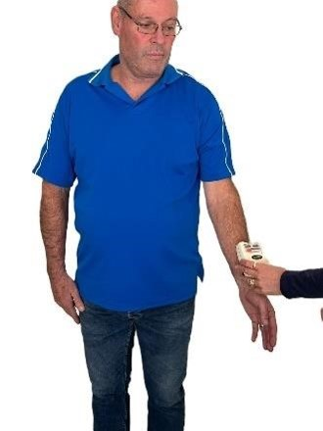
Anterior deltoid | Straight arm.  Flexion of 90-degrees in the frontal plane of movement.  Dynamometer force applied at the radius 2 cm above the wrist line just above the wrist line in a downward direction. | 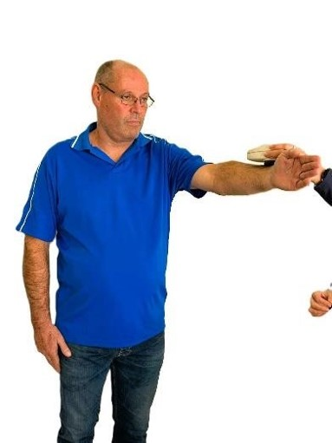

Table 3: Range of motion measurements.

Description of the movements | Range of  motion starting position | Range of motion end position
Frontal abduction.  Inclinometer placed on the posterior  aspect of the humerus | 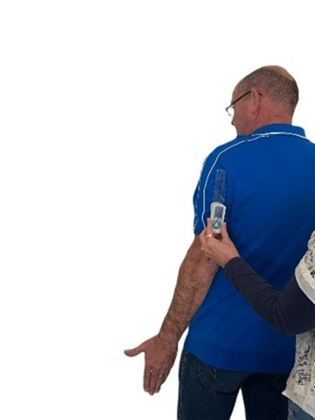 | 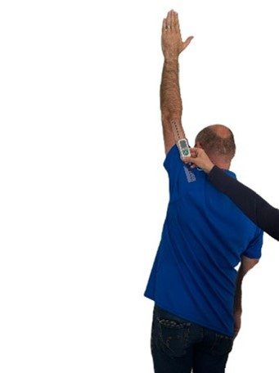
Sagittal flexion  Inclinometer placed on the lateral side of the humerus | 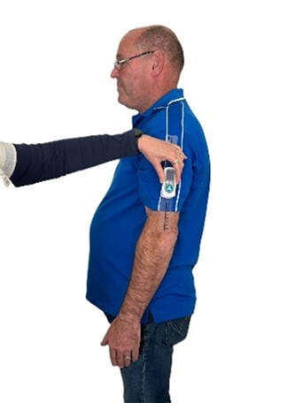 | 