Supplementary material

Supplementary Table 1. Anatomical Therapeutic Chemical codes for prescription drugs.
Ranitidine | A02BA02
Other H2 receptor blockers | A02BA01 and A02BA03
Proton pump inhibitors | A02BC
Non-steroidal anti-inflammatory drugs | M01A except M01AX
Thiazolidinedione | A10BD03-06 and A10BG
Low-dose aspirin and other platelet inhibitors | B01AC and N02BA01
Oral anticoagulants | B01AA, B01AE, and B01AF

Supplementary Table 2. The annual proportion of defined daily doses of medications sold by prescription in Denmark.
 | 1999 | 2000 | 2001 | 2002 | 2003 | 2004 | 2005 | 2006 | 2007 | 2008 | 2009
Ranitidine | 84% | 77% | 72% | 61% | 58% | 49% | 48% | 53% | 55% | 51% | 51%
Cimetidine and famotidine | 83% | 79% | 75% | 71% | 67% | 60% | 58% | 58% | 58% | 55% | 54%
Cimetidine | 79% | 75% | 71% | 70% | 65% | 62% | 58% | 55% | 52% | 57% | -
Famotidine | 98% | 98% | 97% | 97% | 96% | 97% | - | - | - | -
PPI | 99% | 99% | 99% | 99% | 99% | 99% | 99% | 99% | 99% | 99% | 98%

 | 2010 | 2011 | 2012 | 2013 | 2014 | 2015 | 2016 | 2017 | 2018
Ranitidine | 51% | 27% | 22% | 19% | 18% | 18% | 18% | 17% | 18%
Cimetidine and famotidine | - | - | - | - | - | - | - | -
PPI | 98% | 97% | 97% | 97% | 97% | 98% | 98% | 98% | 97%

Supplementary Table 3. International Classification of Diseases (ICD) and other codes used in the study.
 | ICD-8 | ICD-10
Esophageal cancer, any |  | C15
adenocarcinoma |  | Morfo-3: 814xxx
squamous cell carcinoma |  | Morfo-3: 807xxx
Stomach cancer, any |  | C16
proximal |  | C160 + C161
distal |  | C162-4
unknown/several regions |  | C165-9
Hepatocellular carcinoma |  | C22.0
Pancreatic cancer |  | C25
Underlying gastrointestinal disease
Gastroesophageal reflux disease | 530.90, 530.91, 530.92, 530.98 | K21, K222
Barrett’s esophagus |  | K22.7 or  SNOMED codes: T62 in combination with M73320 or M73330
Gastric of duodenal ulcer | 531-534 | K25-27
Comorbidity
Alcoholism-related disorders | 291, 303, 425.5, 537.5, 571.0, 571.1, 571.2, 571.3, 577.10 | K70, K852, K860, E244, F101, F102, F103, F104, F105, F106, F107,  F108, F109, G621, G721, G312, I426, K292, Z721, T500A, E529A, Z502, Z714
Myocardial infarction | 410 | I21;I22;I23
Chronic pulmonary disease | 490-493; 515-518 | J40-J47; J60-J67; J68.4; J70.1;  J70.3; J84.1; J92.0; J96.1; J98.2; J98.3
Connective tissue disease | 712; 716; 734; 446; 135.99 | M05; M06; M08; M09;M30;M31;  M32; M33; M34; M35; M36; D86
Moderate to severe renal disease | 403; 404; 580-583; 584; 590.09; 593.19; 753.10-753.19; 792 | I12; I13; N00-N05; N07; N11; N14; N17-N19; Q61
Congestive heart failure | 427.09; 427.10; 427.11; 427.19;  428.99; 782.49 | I50; I11.0; I13.0; I13.2
Peripheral vascular disease | 440; 441; 442; 443; 444; 445 | I70; I71; I72; I73; I74; I77
Cerebrovascular disease | 430-438 | I60-I69; G45; G46
Dementia | 290.09-290.19; 293.09 | F00-F03; F05.1; G30
Ulcer disease | 530.91; 530.98; 531-534 | K22.1; K25-K28
Mild liver disease | 571; 573.01; 573.04 | B18; K70.0-K70.3; K70.9; K71; K73; K74; K76.0
Diabetes, type 1  Diabetes, type 2 | 249.00; 249.06; 249.07; 249.09  250.00; 250.06; 250.07; 250.09 | E10.0, E10.1; E10.9  E11.0; E11.1; E11.9
Hemiplegia | 344 | G81; G82
Diabetes with end-organ damage | 249.01-249.05; 249.08  250.01-250.05; 250.08 | E10.2-E10.8 E11.2-E11.8
Moderate to severe liver disease | 070.00; 070.02; 070.04; 070.06;  070.08; 573.00; 456.00-456.09 | B15.0; B16.0; B16.2; B19.0; K70.4; K72; K76.6; I85
AIDS | 079.83 | B21-B24

Supplementary Figure 1. Crude number of cancers per person-years of follow-up, hazard ratio for cancer, 10-year cumulative cancer incidence (risk) with death as a competing risk, and 10-year risk differences comparing ranitidine initiators with initiators of other H2-receptor blockers (top) and comparing ranitidine initiators with initiators of proton pump inhibitors (PPIs). Follow-up started 1 year after the first prescription.
Supplementary Figure 2. Stabilized inverse-probability-of-treatment-weighted number of cancers per person-years of follow-up, hazard ratio for cancer, 10-year cumulative cancer incidence (risk) with death from other causes as a competing risk, and 10-year risk differences comparing ranitidine initiators with initiators of other H2-receptor blockers (top) and comparing ranitidine initiators with initiators of proton pump inhibitors (PPIs). The analysis was restricted to subjects with at least five prescriptions for the specific drug, with follow-up starting one year after the date of the fifth prescription.

Supplementary Figure 1. Crude Comparison of Risk of Cancer in Users of Ranitidine Versus Users of Other H2RBS/PPIs.
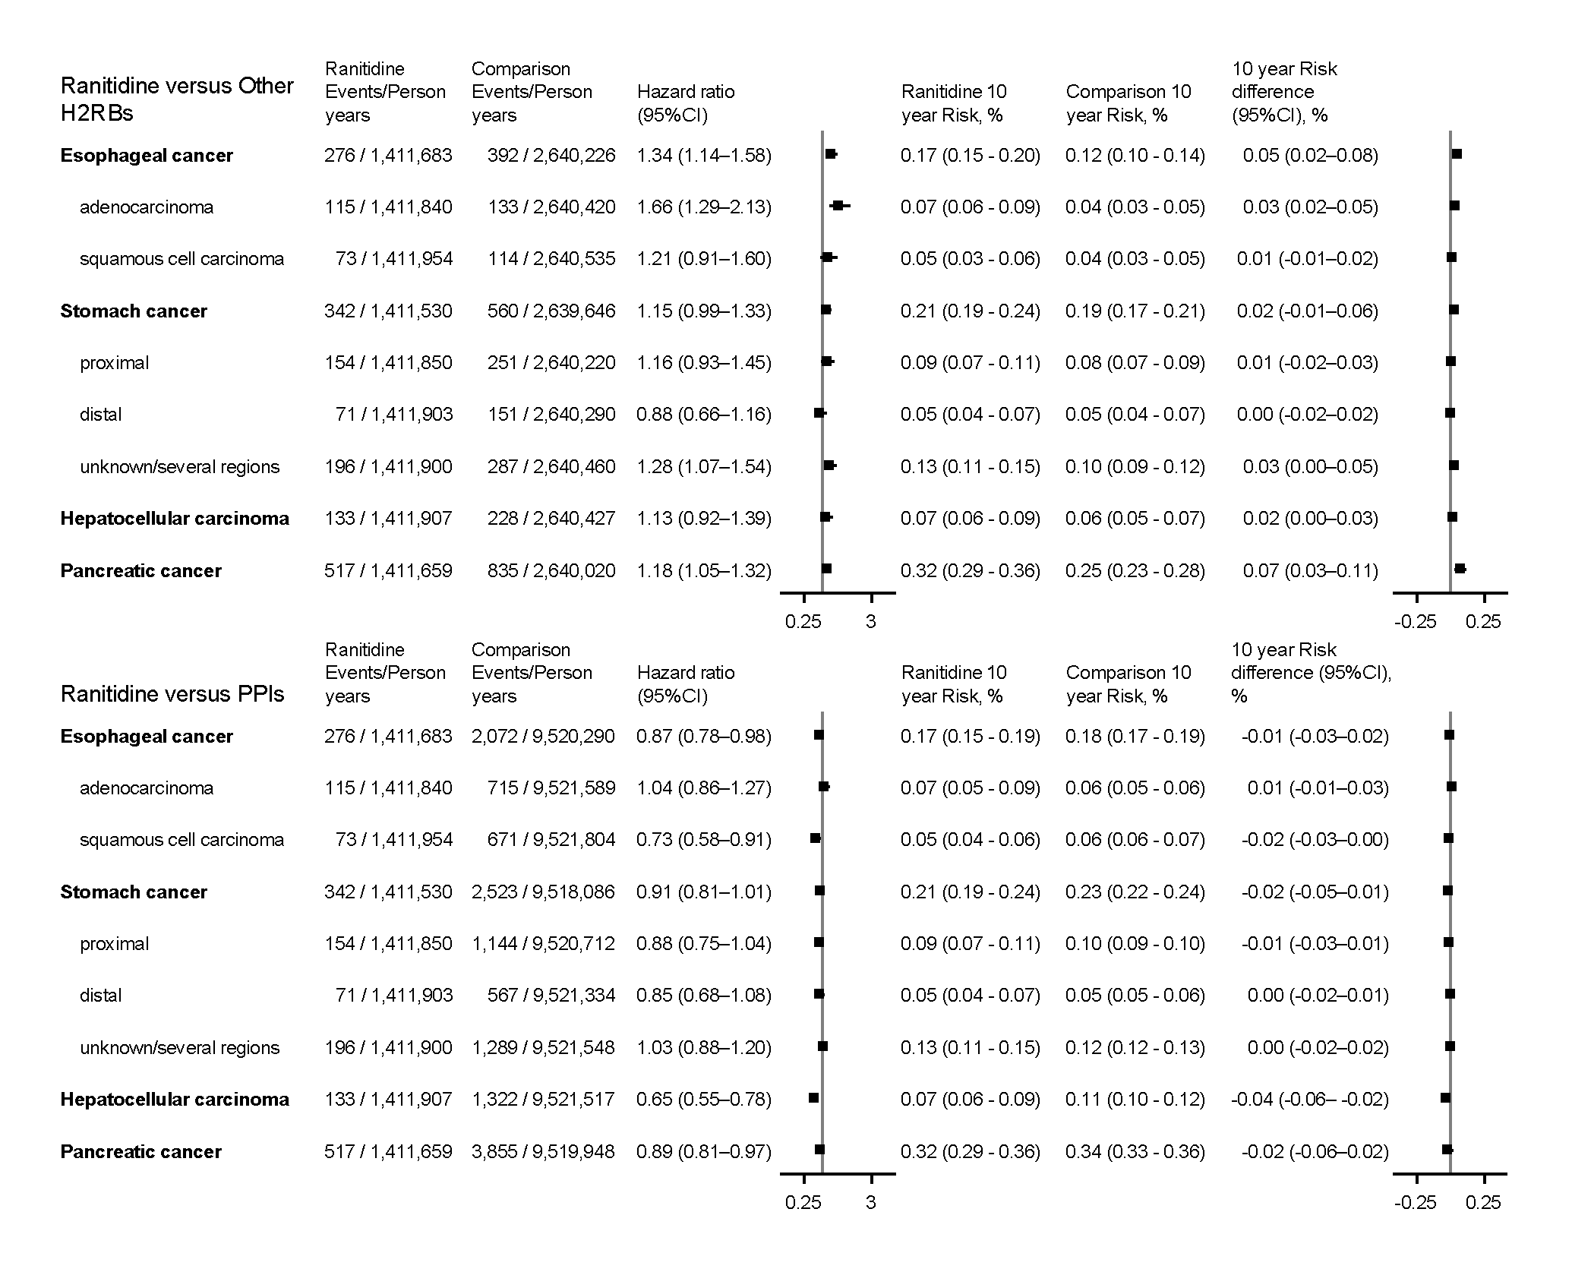
Supplementary Figure 2. Stabilized Inverse-Probability-of-Treatment-Weighted Comparison of Risk of Cancer in Users of Ranitidine Versus Users of Other H2RBs/PPIs Restricted to Patients with at least 5 Filled Prescriptions.
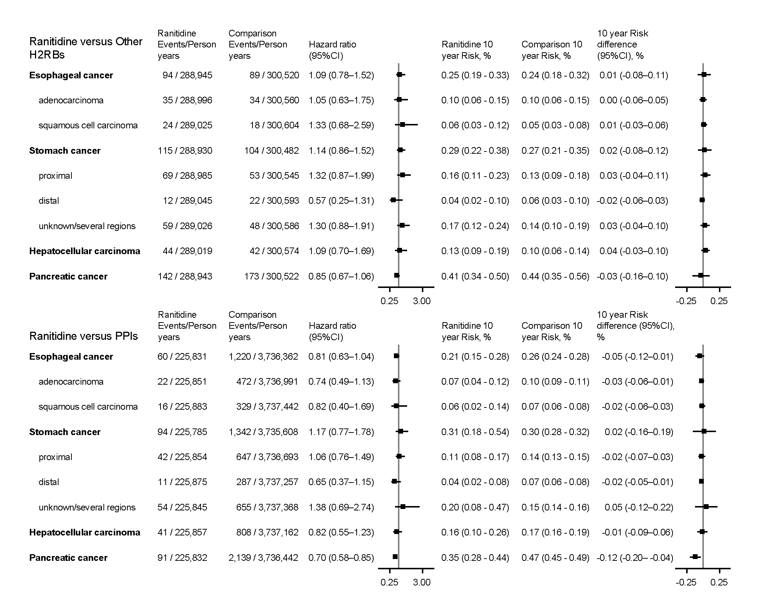
Logistic regression was used to estimate the propensity of ranitidine exposure. This model included age (as a spline), index date (as a spline), previous use of PPIs, previous use of other H2RBs, time between 1st and 10th prescription (as a spline) as well as sex, marital status, underlying gastrointestinal diseases, comorbidities, use of NSAIDs, thiazolidinedione, low-dose aspirin, and oral anticoagulants, respectively.
Propensity scores for ranitidine exposure were used to compute the stabilized inverse probability of treatment weights.
Hazard ratios were estimated using Cox proportional hazard regression analysis.

