Fast isolation and purification of the antidepressant phytochemicals, mesembrine and mesembrenone, from Mesembryanthemum tortuosum
Suzanne Elaine Van Niekerk†, Dorothea Malan†, Josias Hendrik Hamman, Frank Van der Kooy*
PharmacenTM, Centre of Excellence for Pharmaceutical Sciences, North-West University, Private Bag X6001, Potchefstroom 2520, South Africa
*Corresponding author: Frank van der Kooy, e-mail: frank.vanderkooy@nwu.ac.za

Fig. S1. A flow diagram depicting the extraction and purification steps, including the time that each step takes, for the purification of mesembrenone and mesembrine from Mesembryanthemum tortuosum L. (Mesembryanthemaceae).
Fig. S2. HPLC chromatograms and chemical structures of the purified mesembrenone and mesembrine, indicating the level of purity achieved.
Fig. S3. NMR spectrum of mesembrenone.
Fig. S4. NMR spectrum of mesembrine.
Fig. S5 LCMS (+) ESI data of mesembrenone.
Fig. S6. LCMS (+) ESI data of mesembrine.
Fig. S7. UV spectrum of mesembrenone.
Fig. S8. UV spectrum of mesembrine.

Fig. S1. A flow diagram depicting the extraction and purification steps, including the time that each step takes, for the purification of mesembrenone and mesembrine from Mesembryanthemum tortuosum L. (Mesembryanthemaceae).

Fig. S2. HPLC chromatograms and chemical structures of the purified mesembrenone and mesembrine, indicating the level of purity achieved.

Fig. S3. NMR spectrum of mesembrenone.

Fig. S4. NMR spectrum of mesembrine.

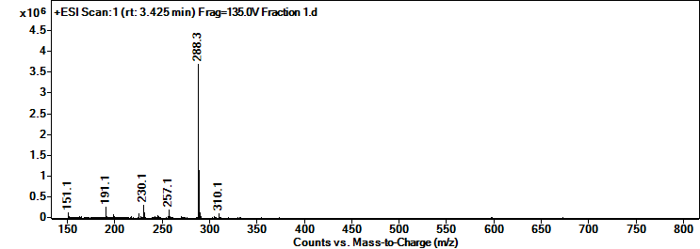
Fig. S5. LCMS (+) ESI data of mesembrenone.
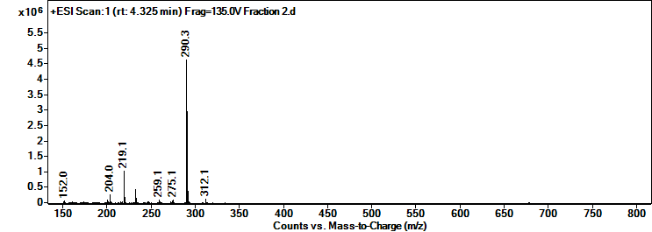
Fig S6. LCMS (+) ESI of mesembrine.

Fig. S7. UV spectrum of mesembrenone.
Fig. S8. UV spectrum of mesembrine.

