The Complex Relationship Between IQ and ADHD Symptoms: Insights from Behaviors, Cognition, Brain and impairment in 5,138 Children with ADHD
Running tile: IQ and ADHD core symptoms
Ningning Liu^{a,b#}, Gaoding Jia^{c#}, Yinshan Wang^{d}, Zelin Mou^{d}, Altansumber Bau^{d}, Haimei Li^{a,b}, Yufeng Wang, Qiujin Qian^{a,b}*, Lu Liu^{a,b}*.

Supplementary Material
Table S1. Model selection criteria for the primary analysisª
 | Model | FSIQ |  |  | PIQ |  |  | VIQ
 | Model | BIC | BICw |  | BIC | BICw |  | BIC | BICw
T | linear | 35929.47^{b} | 0.51^{b} |  | 35925.04 | 0.33 |  | 35937.31^{b} | 0.55^{b}
T | quadratic | 35938.00 | 0.01 |  | 35930.24^{b} | 0.02^{b} |  | 35945.49 | 0.01
T | log-linear | 35929.60 | 0.48 |  | 35923.65 | 0.65 |  | 35937.71 | 0.45
I | linear | 28700.61^{b} | 0.64^{b} |  | 28692.39 | 0.38 |  | 28721.10^{b} | 0.66^{b}
I | quadratic | 28708.47 | 0.01 |  | 28699.75 | 0.01 |  | 28726.91 | 0.04
I | log-linear | 28701.85 | 0.35 |  | 28691.47^{b} | 0.61^{b} |  | 28722.63 | 0.31
HI | linear | 32465.34 | 0.49 |  | 32481.85 | 0.44 |  | 32465.67 | 0.50
HI | quadratic | 32473.43 | 0.01 |  | 32487.11^{b} | 0.03^{b} |  | 32474.15 | 0.01
HI | log-linear | 32465.29 | 0.50 |  | 32481.45 | 0.53 |  | 32465.67 | 0.50
ªBIC values for each model are shown.
^{b}Best model fit for ADHD symptoms on IQ.
A bold font indicates a significant coefficient of the IQ term in the current model.
T, Total scores of ADHD symptoms; I, inattention; HI, hyperactivity/impulsivity; H, hyperactivity(H), IMP, impulsivity; FSIQ, full-scale intelligence quotient; PIQ, performance intelligence quotient; VIQ, verbral intelligence quotient

Figure S1. Optimal model fit curves for IQ and ADHD symptom scores after controlling for sex and age.

Table S2. Latent Profile Analysis in terms of Functional Impairment Scores
Class  (N) | AIC | BIC | aBIC | pLMR | pBLRT | Entropy | Group Size for each profile
 |  |  |  |  |  |  | 1 | 2 | 3 | 4 | 5
1 | 57429.01 | 57549.09 | 57472.86
2 | 24722.32 | 24847.40 | 24768.00 | <0.0001 | <0.0001 | 0.740 | 577 | 523
3 | 24093.84 | 24263.95 | 24155.96 | 0.0001 | <0.0001 | 0.762 | 446 | 362 | 292
4 | 23840.87 | 24056.01 | 23919.43 | 0.1004 | <0.0001 | 0.768 | 220 | 359 | 252 | 239
5 | 23595.25 | 23855.41 | 23690.25 | 0.0016 | <0.0001 | 0.802 | 185 | 371 | 159 | 189 | 196

Table S3. Group Comparisons among the Profiles on IQ and ADHD Symptom Scores
 |  | Difference | Chi-Square | df | P-value
 | Overall test | -- | 283.691 | 2 | <0.001
VIQ | Class 1 vs. 2 | 16.381 | 273.146 | 1 | <0.001
 | Class 1 vs. 3 | 10.493 | 95.205 | 1 | <0.001
 | Class 2 vs. 3 | -5.888 | 27.469 | 1 | <0.001
 | Overall test | -- | 148.596 | 2 | <0.001
PIQ | Class 1 vs. 2 | 11.704 | 143.571 | 1 | <0.001
 | Class 1 vs. 3 | 7.439 | 49.012 | 1 | <0.001
 | Class 2 vs. 3 | -4.265 | 14.868 | 1 | <0.001
 | Overall test | -- | 74.389 | 2 | <0.001
IA | Class 1 vs. 2 | -2.077 | 59.982 | 1 | <0.001
 | Class 1 vs. 3 | -1.966 | 46.584 | 1 | <0.001
 | Class 2 vs. 3 | 0.111 | 0.142 | 1 | 0.706
 | Overall test | -- | 16.256 | 2 | <0.001
HI | Class 1 vs. 2 | 1.579 | 12.135 | 1 | <0.001
 | Class 1 vs. 3 | -0.165 | 0.106 | 1 | 0.745
 | Class 2 vs. 3 | -1.762 | 11.715 | 1 | 0.001

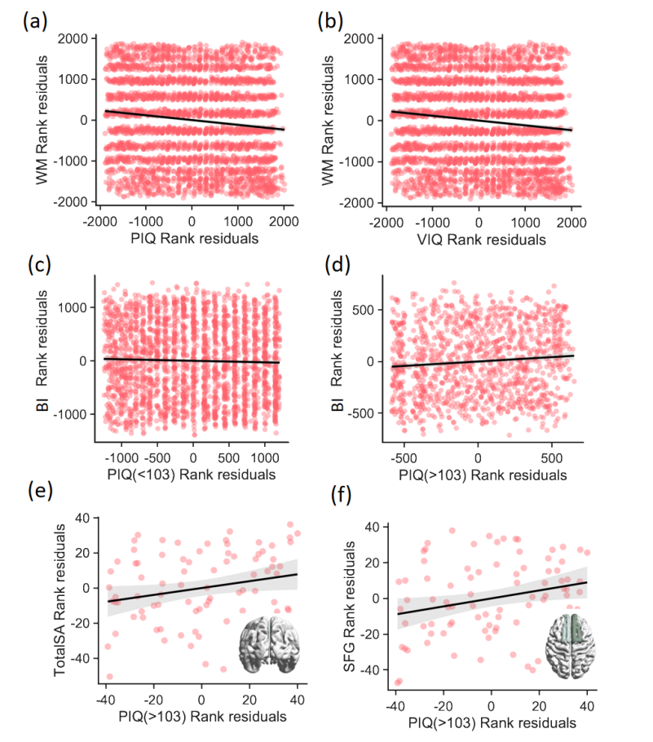
Figure S2. Associations between IQ, EF, and Brain Surface Area in ADHD
- Spearman correlation scatter plot of PIQ and WM (b) Spearman correlation scatter plot of VIQ and WM (c) Spearman correlation scatter plot of PIQ and BI for PIQ ≤ 103 (d) Spearman correlation scatter plot of PIQ and BI for PIQ > 103 (e) Spearman correlation scatter plot of PIQ and TotalSA for PIQ > 103 (f) Spearman correlation scatter plot of PIQ and SFG for PIQ > 103.
PIQ, Performance Intelligence Quotient; VIQ, Verbal Intelligence Quotient; WM, Working Memory; BI, Brain Index; TotalSA, Total Surface Area; SFG, Superior Frontal Gyrus; ADHD, Attention-Deficit/Hyperactivity Disorder; EF, Executive Function; IQ, Intelligence Quotien

