Table 1 The characteristics of patients
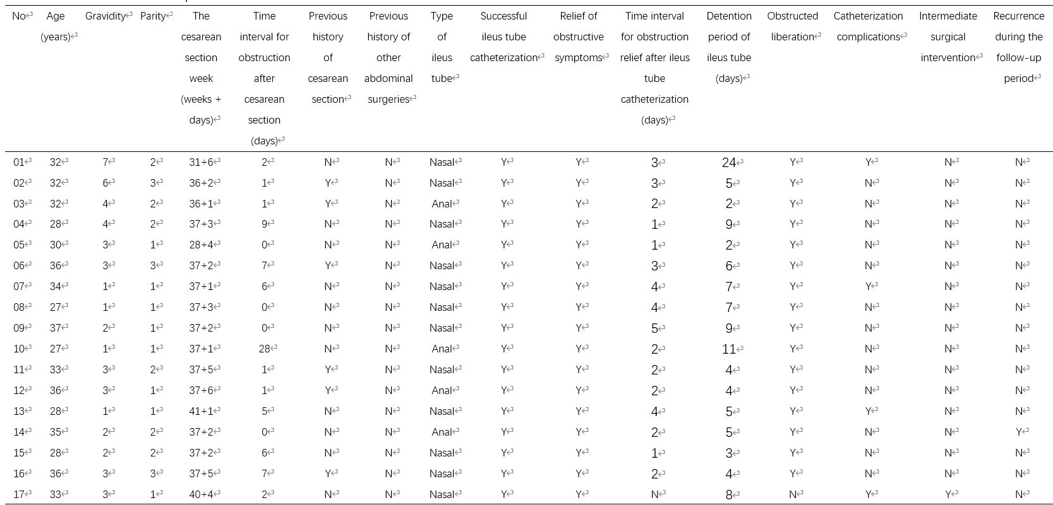
Y yes, N no, Nasal transnasal ileus tube catheterization, Anal transanal ileus tube catheterization.

