Supplemental Figure 1: Kaplan Meier survival curve for artificial urinary sphincter patients on androgen deprivation therapy vs not on androgen deprivation therapy for A) reintervention, B) complication, and C) infection.

1A.
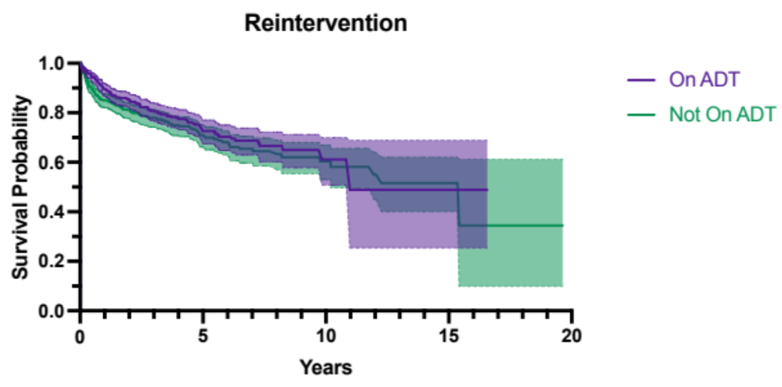
Median Survival (days, 4007 vs 5627), log-rank p=0.11, hazard ratio 0.83 [0.66, 1.05]

1B:
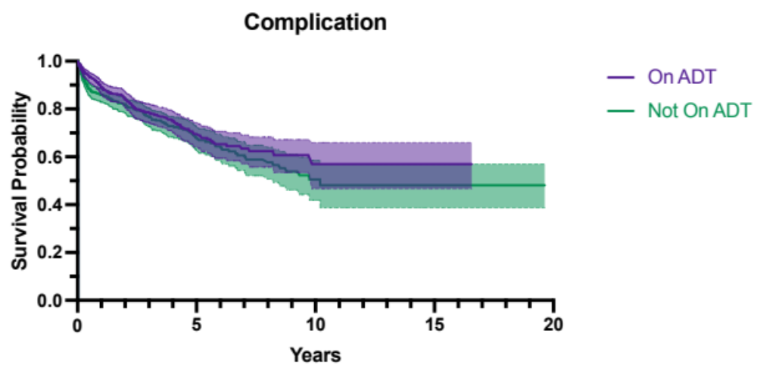
Median Survival (not met vs 3722 days), log-rank p=0.18, hazard ratio 0.85 [0.68, 1.08]

1C:
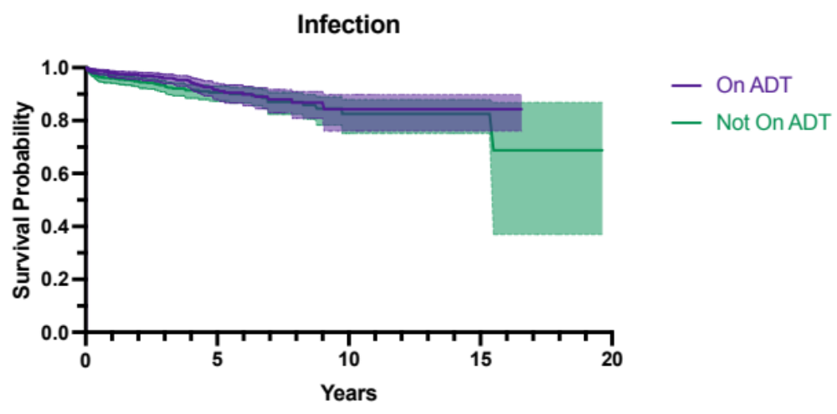
Median Survival (not met), log-rank p=0.16, hazard ratio 0.75 [0.50, 1.13]

Supplemental Figure 2: Kaplan Meier survival curve for inflatable penile prosthesis patients on androgen deprivation therapy vs not on androgen deprivation therapy for A) reintervention, B) complication, and C) infection.

2A:
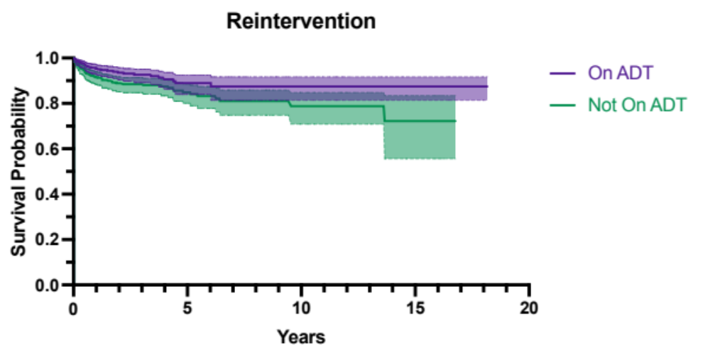
Median Survival (not met), log-rank p=0.02, hazard ratio 0.61 [0.39, 0.94]

2B:
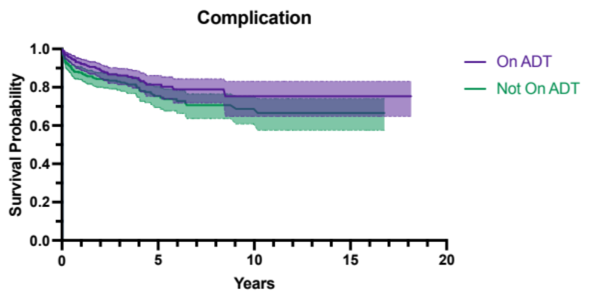
Median Survival (not met), log-rank p=0.03, hazard ratio 0.69 [0.48, 0.98]

2C:
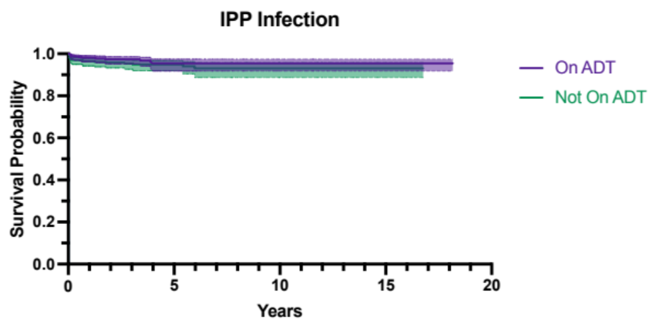
Median Survival (not met), log-rank p=0.19, hazard ratio 0.63 [0.32, 1.26]

