Revisiting the Plasmodium falciparum druggable genome using predicted structures and data mining
Karla P. Godinez-Macias^{1,†}, Daisy Chen^{1,†}, J. Lincoln Wallis², Miles G. Siegel³, Anna Adam⁴, Selina Bopp⁵, Krypton Carolino¹, Lauren B. Coulson⁶, Greg Durst³, Vandana Thathy^{7,8}, Lisl Esherick⁹, Madeline A. Farringer^{5,10}, Erika L. Flannery¹¹, Barbara Forte¹², Tiqing Liu¹³, Luma Godoy Magalhaes¹², Anil K. Gupta¹⁴, Eva S. Istvan¹⁵, Tiantian Jiang¹, Krittikorn Kumpornsin¹⁴, Karen Lobb³, Kyle McLean⁹, Igor M. R. Moura^{7,16}, John Okombo^{7,8}, N. Connor Payne^{5,17}, Andrew Plater¹², Srinivasa P. S. Rao¹¹, Jair L. Siqueira-Neto^{1,13}, Bente A. Somsen¹⁸, Robert L. Summers⁵, Rumin Zhang¹⁹, Michael K. Gilson¹³, Francisco-Javier Gamo²⁰, Brice Campo⁴, Beatriz Baragaña¹², James Duffy⁴, Ian H. Gilbert¹², Amanda K. Lukens^{5,21}, Koen J. Dechering¹⁸, Jacquin C. Niles⁹, Case W. McNamara¹⁴, Xiu Cheng¹⁹, Lyn-Marie Birkholtz²², Alfred W. Bronkhorst¹⁸, David A. Fidock^{7,8}, Dyann F. Wirth^{5,21}, Daniel E. Goldberg¹⁵, Marcus C.S. Lee²³, Elizabeth A. Winzeler^{1,13,*}

Affiliations
¹Department of Pediatrics, University of California, San Diego, La Jolla, CA 92093, USA
²Panorama Global, 2101 4th Ave, Ste 2100. Seattle, WA 98121, USA
³Lgenia, Inc., 412 S Maple St. Fortville, IN 46040, USA
⁴MMV Medicines for Malaria Venture, 1215 Geneva 15, Switzerland
⁵Department of Immunology and Infectious Diseases, Harvard T.H. Chan School of Public Health, Boston, MA 02115, USA
⁶Drug Discovery and Development Centre (H3D), Institute of Infectious Disease and Molecular Medicine, University of Cape Town, Cape Town, South Africa
⁷Department of Microbiology and Immunology, Columbia University Irving Medical Center, New York, NY 10032, USA
⁸Center for Malaria Therapeutics and Antimicrobial Resistance, Division of Infectious Diseases, Department of Medicine, Columbia University Irving Medical Center, New York, NY 10032, USA
⁹Department of Biological Engineering, Massachusetts Institute of Technology, Cambridge, MA 02139, USA
¹⁰Division of Infectious Diseases, Boston Children’s Hospital, Boston, MA 02115, USA
¹¹Global Health, Biomedical Research, Novartis, Emeryville, CA, USA
¹²Drug Discovery Unit, Division of Biological Chemistry and Drug Discovery, School of Life Science, University of Dundee, Dundee DD1 5EH, UK
¹³Skaggs School of Pharmacy and Pharmaceutical Sciences, University of California, San Diego, La Jolla, CA 92093, USA
¹⁴Calibr-Skaggs Institute for Innovative Medicines, a division of The Scripps Research Institute, La Jolla, CA 92037, USA
¹⁵Division of Infectious Diseases, Washington University School of Medicine, Saint Louis, MO 63130, USA; Department of Molecular Microbiology, Washington University School of Medicine, Saint Louis, MO 63130, USA
¹⁶São Carlos Institute of Physics, University of São Paulo, São Carlos, São Paulo 13563-120, Brazil
¹⁷Center for Systems Biology, Massachusetts General Hospital, Boston, MA 02114, USA
¹⁸TropIQ Health Sciences, 6534 AT, Nijmegen, The Netherlands
¹⁹Global Health Drug Discovery Institute, Beijing, 100192, China
²⁰Global Health Medicines R&D, GlaxoSmithKline, Tres Cantos, Madrid 28760, Spain
²¹Infectious Disease and Microbiome Program, Broad Institute, Cambridge, MA 02142, USA
²²Department of Biochemistry, Genetics & Microbiology, Institute for Sustainable Malaria Control, University of Pretoria, Private Bag X20, Hatfield, 0028 Pretoria, South Africa
²³Division of Biological Chemistry and Drug Discovery, Wellcome Centre for Anti-Infectives Research, University of Dundee, Dundee, DD1 5EH, UK

† Contributed equally
* Corresponding author. Email: ewinzeler@health.ucsd.edu

Table of Contents
Supplementary Data S1. Small molecule binding and blood stage essentiality evidence for all P. falciparum 3D7 protein-coding genes. 3
Supplementary Data S2. P. falciparum ortholog to UniProt protein IDs extracted from BindingDB having validated ligands. 3
Supplementary Data S3. List of candidate targets with evidence of small molecule binding and blood stage essentiality. 3
Supplementary Data S4. Ranking scores for selected candidate targets. 3
Supplementary Material A1. Description and proposed strategies for top 27 target candidates. 3
Supplementary Figure 1. Unique 1,660 Plasmodium falciparum coding-proteins with b 5
Supplementary Figure 2. Plasmodium falciparum 3D7 proteins having evidence of 5
Supplementary Figure 3. Essentiality categorization determination scheme for 5,318 P. falciparum protein-coding genes for target identification. 6
Supplementary Figure 4. Genome location of the 867 candidate targets with binding evidence and strong essentiality. 7
Supplementary Figure 5. Data collected for full genome. 8
Supplementary Figure 6. Similarity identity between 1,972 P. falciparum genes having a close human ortholog. 9
References 9

Supplementary Data S1. Small molecule binding and blood stage essentiality evidence for all P. falciparum 3D7 protein-coding genes. Attached Excel spreadsheet.

Supplementary Data S2. P. falciparum ortholog to UniProt protein IDs extracted from BindingDB having validated ligands. Attached Excel spreadsheet.

Supplementary Data S3. List of candidate targets with evidence of small molecule binding and blood stage essentiality. Attached Excel spreadsheet.

Supplementary Data S4. Ranking scores for selected candidate targets. Attached Excel spreadsheet.

Supplementary Material A1. Description and proposed strategies for top 27 target candidates. Attached PowerPoint slides.

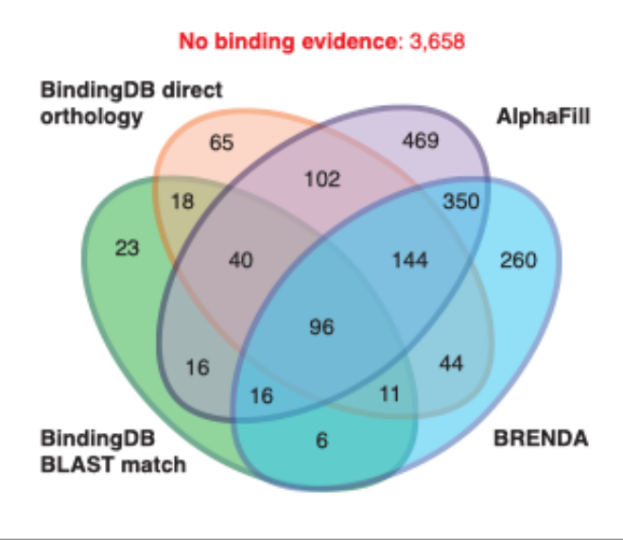
Supplementary Figure 1. Unique 1,660 Plasmodium falciparum coding-proteins with binding evidence by source. Venn diagram partitioning P. falciparum 1,660 3D7 genes with at least one source of binding evidence. A total of 817 genes were identified by only one source, and 843 genes had binding evidence from at least two sources. A total of 3,658 3D7 genes did not show binding evidence, and are reported in red.

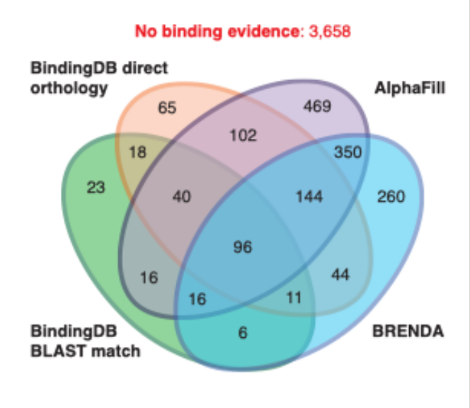
Supplementary Figure 2. Plasmodium falciparum 3D7 proteins having evidence of essentiality. Venn diagram partitioning all 5,318 P. falciparum 3D7 coding-proteins according to essentiality evidence. A total of 3,271 P. falciparum genes were essential according Zhang et al. piggyBac transposon mutagenesis screen¹, while 1,145 essential P. falciparum ortholog genes were found with PlasmoGEM² P. berghei dataset, and 1,319 orthologs from RMgmDB³. We found a total of 4,099 unique 3D7 genes with essentiality data, of which 1,566 genes had evidence in falciparum and berghei parasites. We did not find evidence for 55 genes, and 1,164 were defined as not essential.

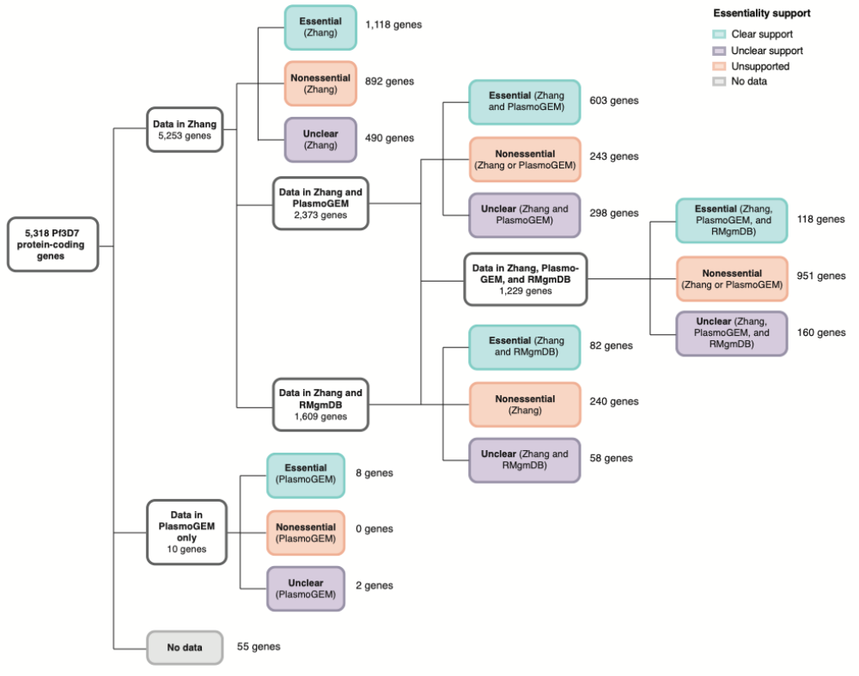
Supplementary Figure 3. Essentiality categorization determination scheme for 5,318 P. falciparum protein-coding genes for target identification. Criteria to categorize genes in essentiality bins, according to essentiality in the asexual blood stage support data across the different datasets¹⁻³. Four categories (clear support, unclear support, unsupported, and no data) were defined. Genes under each category based on available data are shown with teal squares for the 1,929 genes having full essentiality support, purple squares for the 1,008 genes having unclear evidence, orange squares represent 2,326 genes with clear unsupported essentiality evidence (e.g., not essential genes), and the remaining 55 genes, in grey, denotes those with no evidence. Breakdown of genes with support across the datasets are shown.

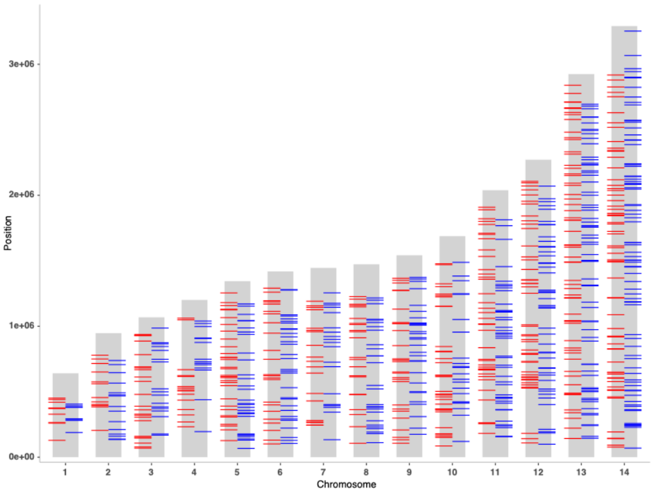
Supplementary Figure 4. Genome location of the 867 candidate targets with binding evidence and strong essentiality. Distribution of the 867 candidates across the genome, according to PlasmoDB release 66⁴. Five gives located in the apicoplast (pfrps12, pftufa, pfclpm, pfrpoc1, pfrpob) and two mitochondrial genes (pfcox1, pfcytb) are not displayed. Colored lines denote the gene position in the chromosome, with blue marks for sense genes and red marks are antisense genes.

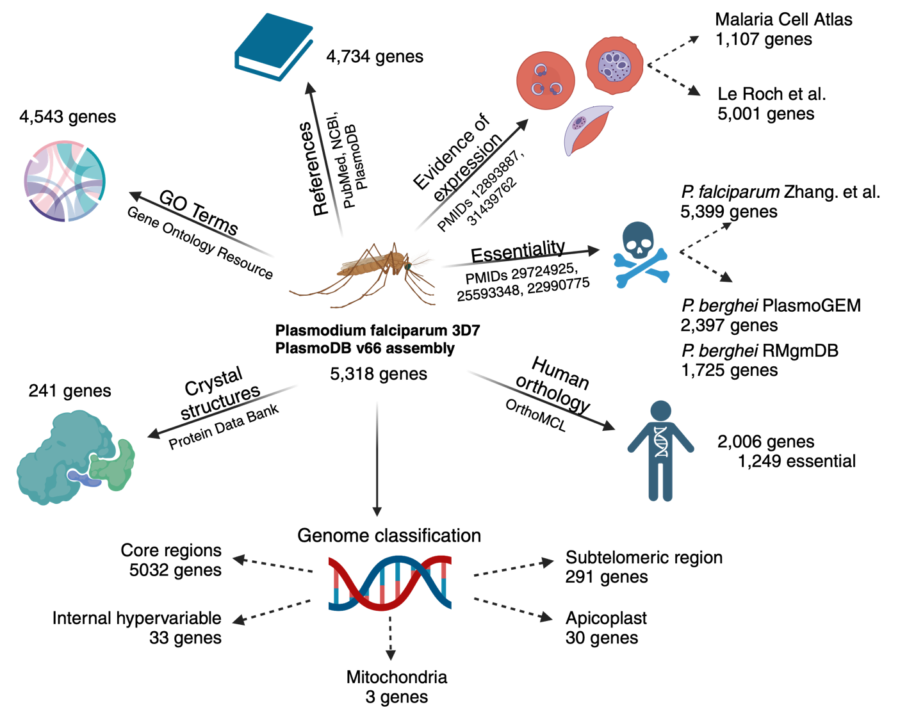
Supplementary Figure 5. Data collected for full genome. Information collected for all 5,318 P. falciparum genes from PlasmoDB release 66. Database resources for collected information is shown⁴⁻¹⁰. Total number of genes having at least one record per category are indicated. Out of the 19,900 genes in the human genome, only 2,006 were found to be orthologs to the P. falciparum genome, of which 1,249 were determined to be essential. Genome classification for the 5,318 genes was determined according to Methods.

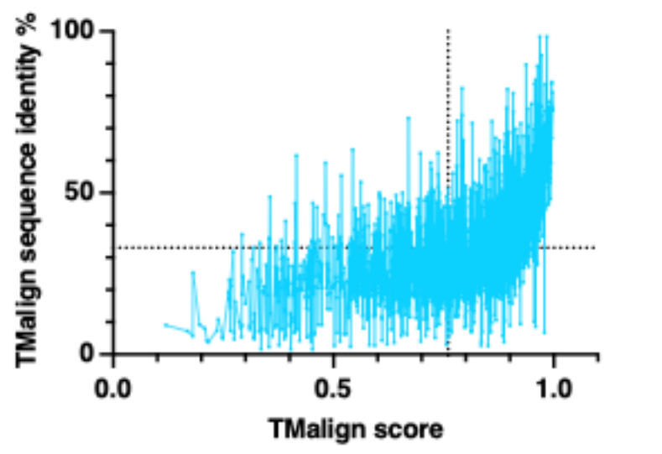
Supplementary Figure 6. Similarity identity between 1,972 P. falciparum genes having a close human ortholog. Similarity identity for 1,972 falciparum genes against its most similar human ortholog. Structure similarity score (0-1) and identity percentage were calculated with TM-align⁹. Dotted lines mark the average point for percent of identity (Y axis) and confidence score (X axis).

References

1 Zhang, M. et al. Uncovering the essential genes of the human malaria parasite Plasmodium falciparum by saturation mutagenesis. Science 360, eaap7847 (2018). https://doi.org:10.1126/science.aap7847
2 Schwach, F. et al. PlasmoGEM, a database supporting a community resource for large-scale experimental genetics in malaria parasites. Nucleic Acids Res 43, D1176-1182 (2015). https://doi.org:10.1093/nar/gku1143
3 Janse, C. J. et al. A genotype and phenotype database of genetically modified malaria-parasites. Trends Parasitol 27, 31-39 (2011). https://doi.org:10.1016/j.pt.2010.06.016
4 The Plasmodium Genome Database, C. PlasmoDB: An integrative database of the Plasmodium falciparum genome. Tools for accessing and analyzing finished and unfinished sequence data. The Plasmodium Genome Database Collaborative. Nucleic Acids Res 29, 66-69 (2001). https://doi.org:10.1093/nar/29.1.66
5 Miles, A. et al. Indels, structural variation, and recombination drive genomic diversity in Plasmodium falciparum. Genome Res 26, 1288-1299 (2016). https://doi.org:10.1101/gr.203711.115
6 Li, L., Stoeckert, C. J., Jr. & Roos, D. S. OrthoMCL: identification of ortholog groups for eukaryotic genomes. Genome Res 13, 2178-2189 (2003). https://doi.org:10.1101/gr.1224503
7 Sayers, E. W. et al. Database resources of the national center for biotechnology information. Nucleic Acids Res 50, D20-D26 (2022). https://doi.org:10.1093/nar/gkab1112
8 Berman, H. M. et al. The Protein Data Bank. Nucleic Acids Res 28, 235-242 (2000). https://doi.org:10.1093/nar/28.1.235
9 Zhang, Y. & Skolnick, J. TM-align: a protein structure alignment algorithm based on the TM-score. Nucleic Acids Res 33, 2302-2309 (2005). https://doi.org:10.1093/nar/gki524
10 Howick, V. M. et al. The Malaria Cell Atlas: Single parasite transcriptomes across the complete Plasmodium life cycle. Science 365, eaaw2619 (2019). https://doi.org:10.1126/science.aaw2619

