Graphical Abstract

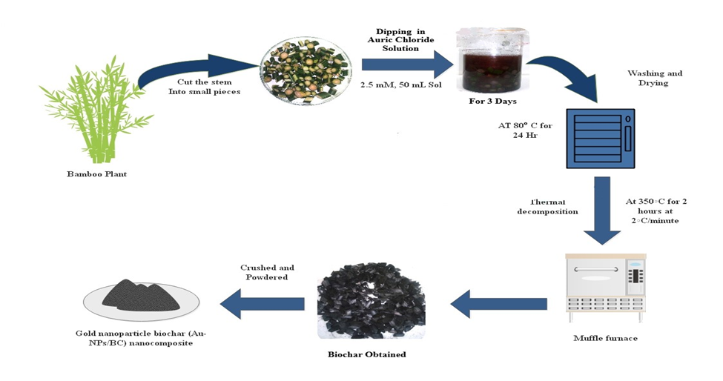

Fig 1:- Steps Involved in Biochar Synthesis

Fig 2. The SEM analysis of (2A) BC control (2B) Au-NPs/BC-350. The presence of Au-NPs is seen in the image

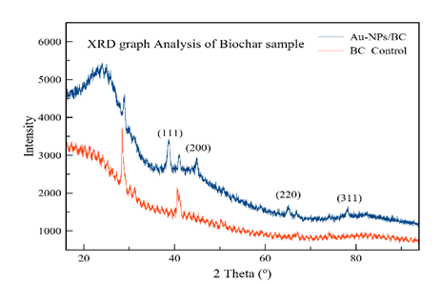

Fig 3. XRD analysis of the Biochar sample.

Table 1. EDS analysis of the Au-NPs/BC nanocomposites

Element | Weight% | Atomic%
C | 34.75 | 47.21
O | 49.74 | 50.73
K | 2.30 | 0.96
Au | 13.22 | 1.09
Totals | 100.00

