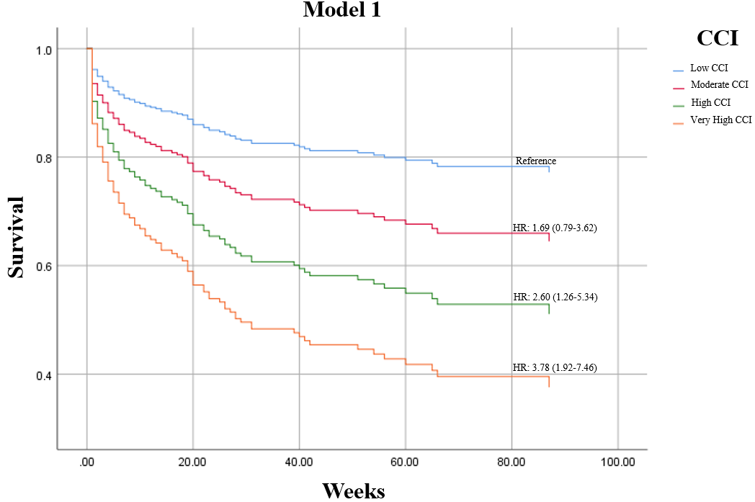
Fig 1. Univariate Analysis
CCI: Charlson Comorbidity Index; HR: hazard ratio

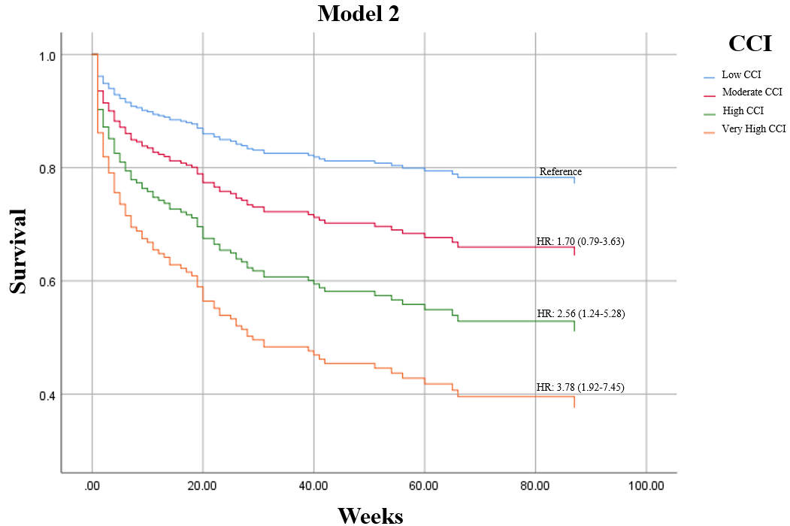
Fig 2. Adjusted for Clinical Characteristics

CCI: Charlson Comorbidity Index; HR: hazard ratio

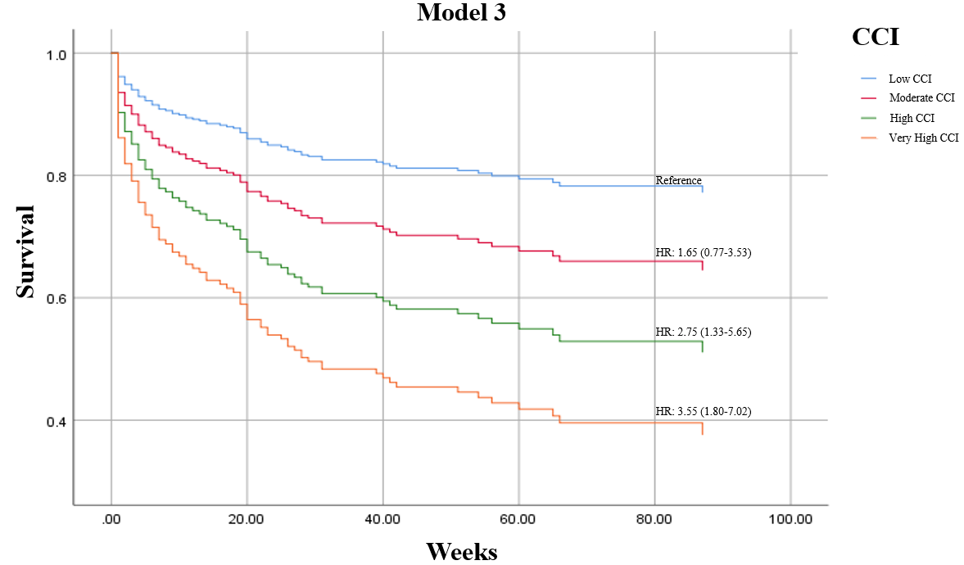
Fig 3. Adjusted for Biochemical characteristics

CCI: Charlson Comorbidity Index; HR: hazard ratio

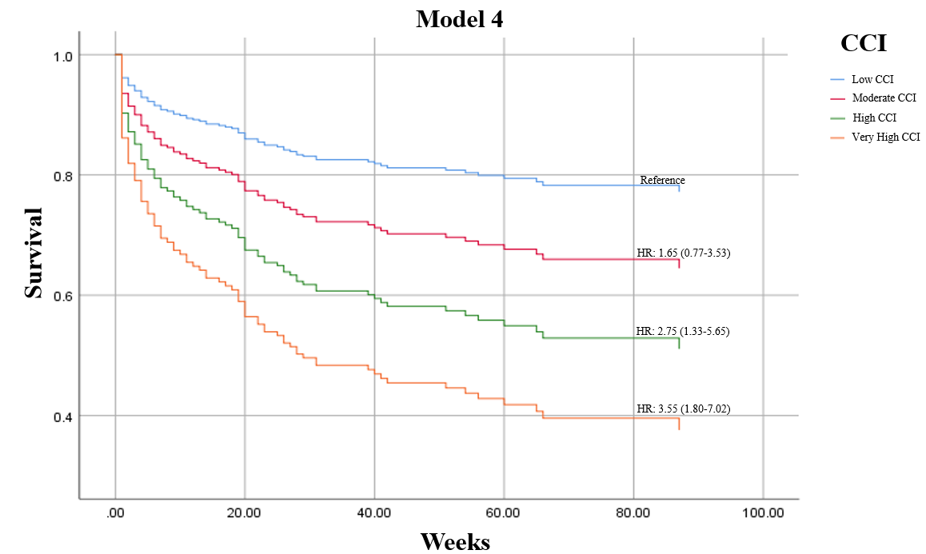
Fig 4. Adjusted for Clincal and Biochemical Charcteristics
CCI: Charlson Comorbidity Index; HR: hazard ratio

