Supplementary Figure 1.
Box plot of variables measured using a 5-point scale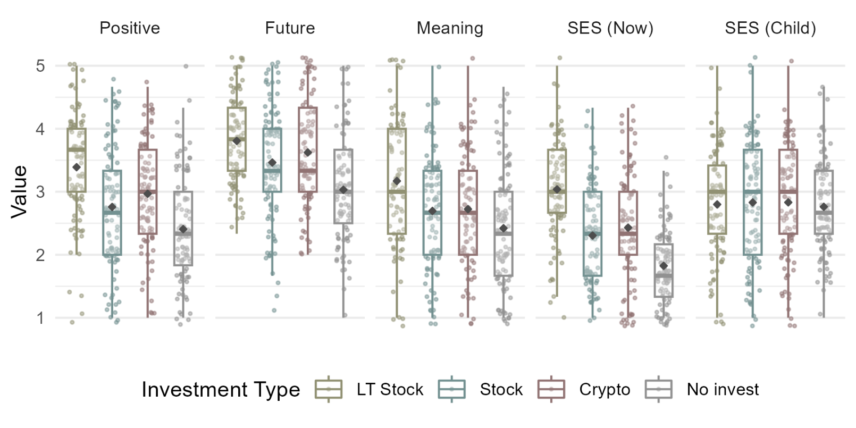
Note. Positive: optimistic and positive emotions toward life, Future: active and positive attitudes toward one’s future, Meaning: acknowledgment of the meaning of one’s existence

Supplementary Figure 2.
Box plot of variables measured using a 7-point scale
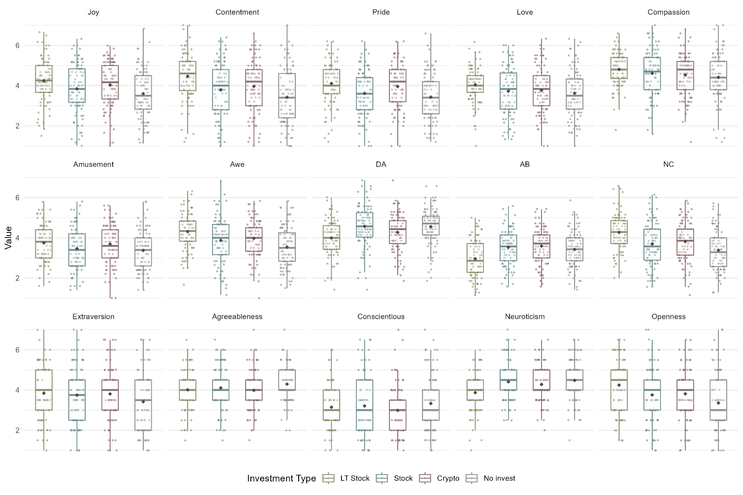
Note. DA: Discomfort with ambiguity, AB: Absolutism, NC: Need for complexity and novelty

