Supplement 2
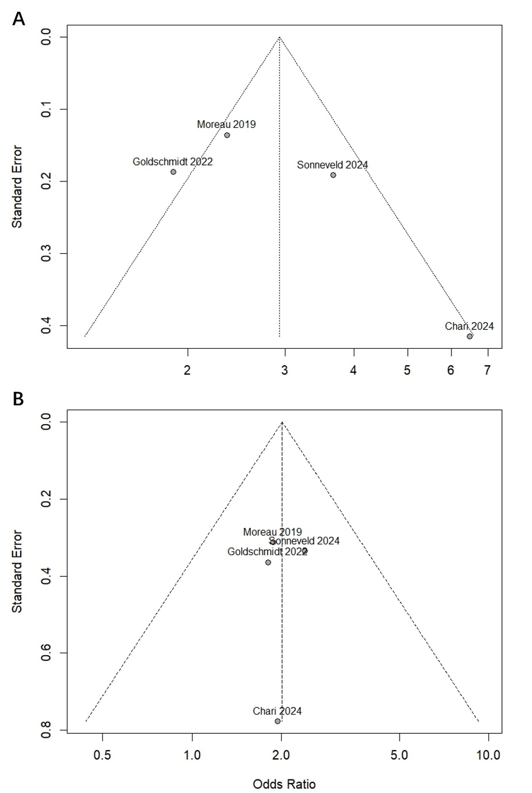
Figure 1. The funnel plot of MRD-negativity status rate by subgroups of (A) SRMM and (B)HRMM.

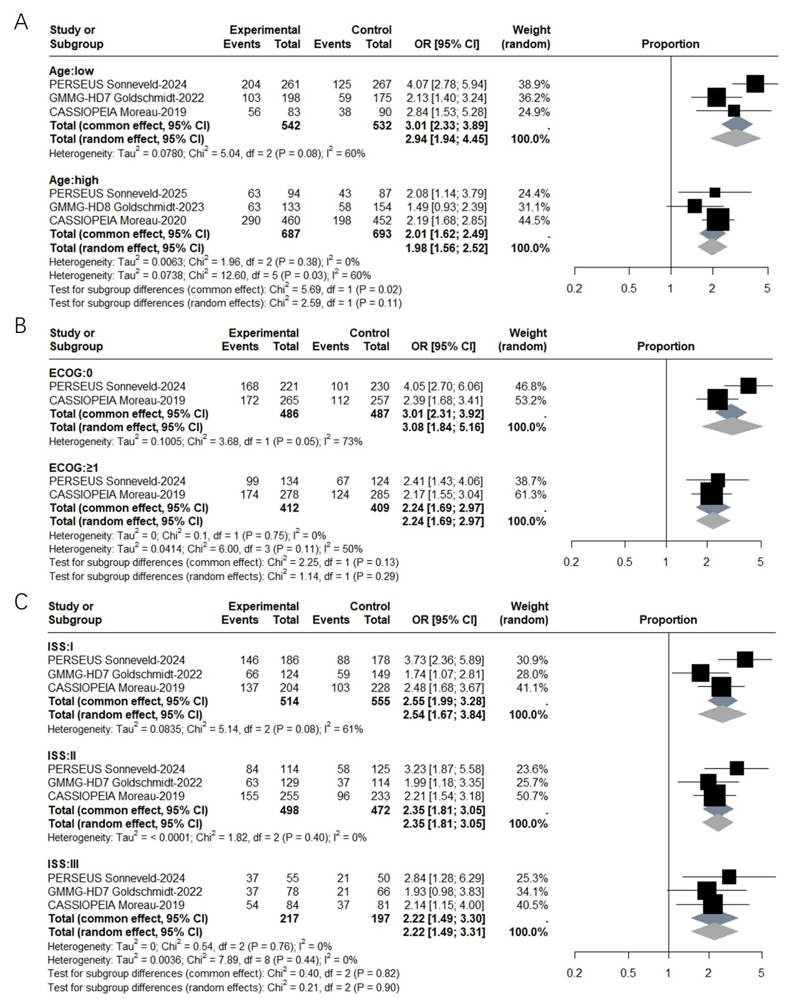
Figure 2. The meta-analysis of MRD-negativity status rate for TE NDMM by subgroups of (A) different age groups, (B)performance statuses, and (C)International Staging System (ISS) stages.

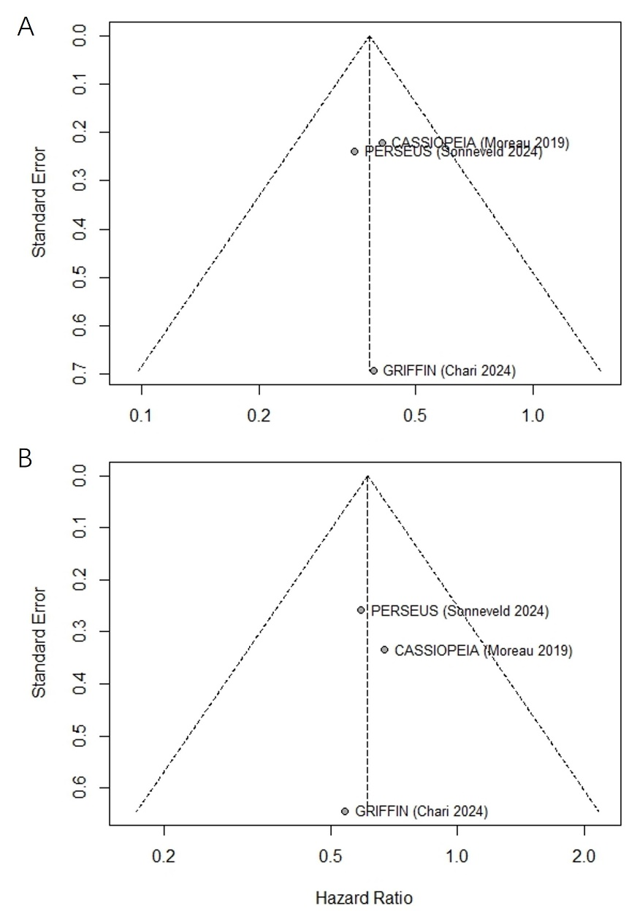
Figure 3. The funnel plot of PFS for TE-NDMM by subgroups of (A) SRMM and(B) HRMM.

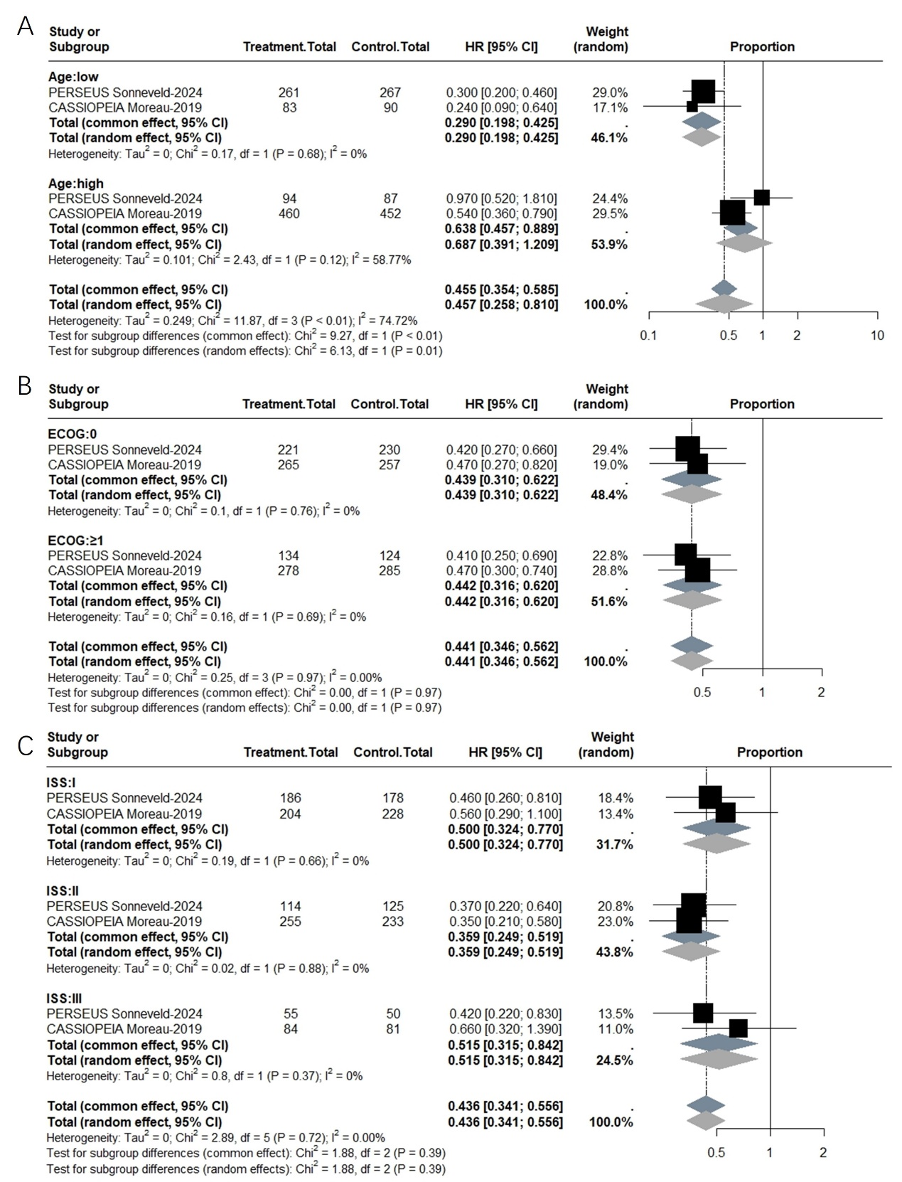
Figure 4. The meta-analysis of PFS for TE NDMM by subgroups of (A) different age groups, (B)performance statuses, and (C) ISS stages.

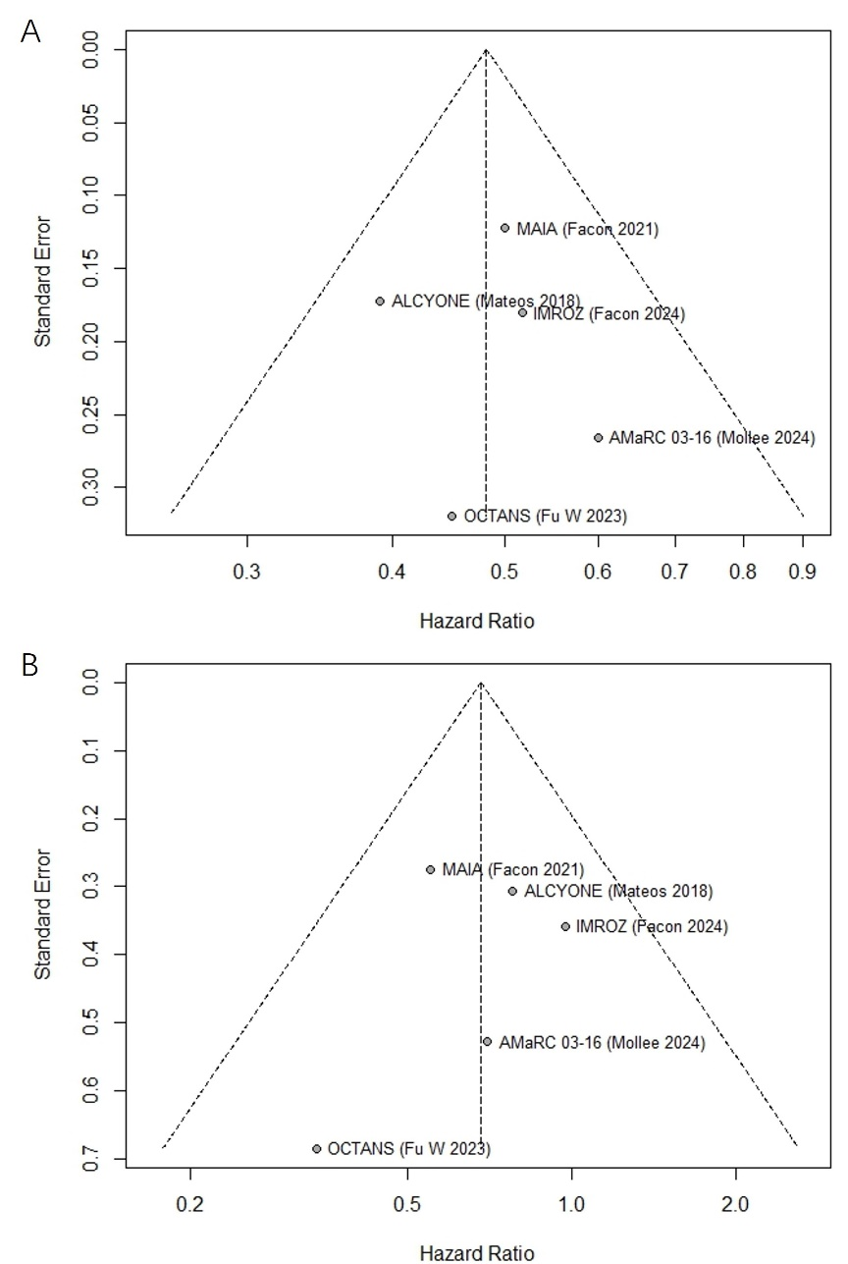
Figure 5. The funnel plot of PFS for TIE NDMM by subgroups of (A) SRMM and(B) HRMM.

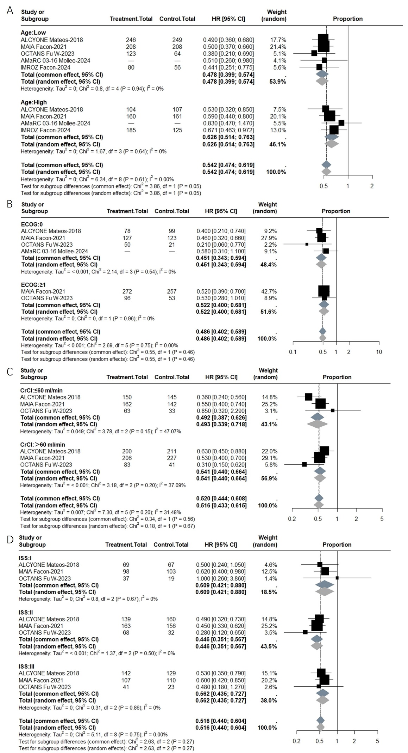
Figure 6. The meta-analysis of PFS for TIE NDMM by subgroups of (A) different age groups, (B)performance statuses, (C) creatinine clearance (CrCl) and (D) ISS stages.

