Table S1. qPCR primers
mTnf-F | GGTGCCTATGTCTCAGCCTCTT
mTnf-R | GCCATAGAACTGATGAGAGGGAG
mIl1b-F | GAAATGCCACCTTTTGACAGTG
mIl1b-R | TGGATGCTCTCATCAGGACAG
mCcl2-F | CATCCACGTGTTGGCTCA
mCcl2-R | TCTGGACCCATTCCTTCTTG
mAif1-F | TCTGCCGTCCAAACTTGAAGCC
mAif1-R | CTCTTCAGCTCTAGGTGGGTCT
mGfap-F | CCCTGGCTCGTGTGGATTT
mGfap-R | GACCGATACCACTCCTCTGTC
mTnfsf10q-F | GGAAGACCTCAGAAAGTGGCAG
mTnfsf10q-R | TTTCCGAGAGGACTCCCAGGAT
mC1q-F | GTGGCTGAAGATGTCTGCCGAG
mC1q-R | TTAAAACCTCGGATACCAGTCCG
mCox1-qF | GAATGCCACCTTCATCCGAGAAG
mCox1-qR | GCTCACATTGGAGAAGGACTCC
mCox2-F | GCGACATACTCAAGCAGGAGCA
mCox2-R | AGTGGTAACCGCTCAGGTGTTG
mPtges-F | CTGGTGATGGAGAGCGGCC
mPtges-R | GCGATCAGAGGGTTGGGTCC
mEp2-F | CTGCGGATTGTCTGGCAGTAG
mEp2-R | GAGCTCGGAGGTCCCACTTTT
mEp4-F | ACTGCGTGGGAAGAGACTGA
mEp4-R | GGATGGGGTTCACAGAAGCA
mNfat1-F | GGTGCCTTTTGCGAGCAGTATC
mNfat1-R | CGTATGGACCAGAATGTGACGG
mNfat2-F | ACTTCACAGCGGAGTCCAAGGT
mNfat2-R | GGATGTGCTTGTTCCGATACTCG
mNfkb1-F | GCTGCCAAAGAAGGACACGACA
mNfkb1-R | GGCAGGCTATTGCTCATCACAG
mRipk3-qF | GAAGACACGGCACTCCTTGGTA
mRipk3-qR | CTTGAGGCAGTAGTTCTTGGTGG
mMlkl-F | CTGAGGGAACTGCTGGATAGAG
mMlkl-R | CGAGGAAACTGGAGCTGCTGAT
mGapdh-F | TCAACAGCAACTCCCACTCTTCCA
mGapdh-R | ACCCTGTTGCTGTAGCCGTATTCA

Table S2. Pan-Cell Death Pathway PCR Array gene list
Gene symbol | Gene Name | Annotation
Bad | BCL2-associated agonist of cell death | Apoptosis-Intrinsic
Bak1 | BCL2-antagonist/killer 1 | Apoptosis-Intrinsic
Bax | BCL2-associated X protein | Apoptosis-Intrinsic
Bbc3 | BCL2 binding component 3 | Apoptosis-Intrinsic
Bcl2 | B-cell CLL/lymphoma 2 | Apoptosis-Intrinsic
Bcl2l11 | BCL2-like 1 | Apoptosis-Intrinsic
Bid | BH3 interacting domain death agonist | Apoptosis-Intrinsic
Bik | BCL2-interacting killer (apoptosis-inducing) | Apoptosis-Intrinsic
Bcl2l11 | BCL2-like 11 | Apoptosis-Intrinsic
Casp9 | caspase 9, apoptosis-related cysteine peptidase | Apoptosis-Intrinsic
Hrk | harakiri, BCL2 interacting protein | Apoptosis-Intrinsic
Mcl1 | myeloid cell leukemia 1 | Apoptosis-Intrinsic
Casp8 | caspase 8, apoptosis-related cysteine peptidase | Apoptosis-Extrinsic
Fas | Fas cell surface death receptor | Apoptosis-Extrinsic
Faslg | Fas ligand (TNF superfamily, member 6) | Apoptosis-Extrinsic
Tnf | tumor necrosis factor | Apoptosis-Extrinsic
Tnfrsf10a | tumor necrosis factor receptor superfamily, member 10a | Apoptosis-Extrinsic
Tnfrsf10b | tumor necrosis factor receptor superfamily, member 10b | Apoptosis-Extrinsic
Tnfrsf10c | tumor necrosis factor receptor superfamily, member 10c, decoy without an intracellular domain | Apoptosis-Extrinsic
Tnfrsf1a | tumor necrosis factor receptor superfamily, member 1a | Apoptosis-Extrinsic
Tnfrsf1b | tumor necrosis factor receptor superfamily, member 1b | Apoptosis-Extrinsic
Tnfrsf25 | tumor necrosis factor receptor superfamily, member 25 | Apoptosis-Extrinsic
Tnfsf10 | tumor necrosis factor (ligand) superfamily, member 10 | Apoptosis-Extrinsic
Tnfsf12 | tumor necrosis factor (ligand) superfamily, member 12 | Apoptosis-Extrinsic
Atg12 | autophagy related 12 | Autophagy
Atg14 | autophagy related 14 | Autophagy
Atg16l1 | autophagy related 16-like 1 (S. cerevisiae) | Autophagy
Atg5 | autophagy related 5 | Autophagy
Atg7 | autophagy related 7 | Autophagy
Becn1 | beclin 1, autophagy related | Autophagy
Gabarap | GABA(A) receptor-associated protein | Autophagy
Map1lc3a | microtubule Associated Protein 1 Light Chain 3 alpha | Autophagy
Sqstm1 | sequestosome 1 | Autophagy
Tfeb | transcription factor EB | Autophagy
Ulk1 | unc-51 like autophagy activating kinase 1 | Autophagy
Ulk2 | unc-51 like autophagy activating kinase 2 | Autophagy
Acsf2 | acyl-CoA synthetase family member 2 | Ferroptosis
Atp5g3 | ATP synthase, H+ transporting, mitochondrial complex V, subunit C3 (subunit 9) | Ferroptosis
Cs | citrate synthase | Ferroptosis
Gclc | glutamate-cysteine ligase, catalytic subunit | Ferroptosis
Gls2 | glutaminase 2 (liver, mitochondrial) | Ferroptosis
Got1 | glutamic-oxaloacetic transaminase 1, soluble | Ferroptosis
Gpx4 | glutathione peroxidase 4 | Ferroptosis
Ireb2 | iron-responsive element binding protein 2 | Ferroptosis
Rpl8 | ribosomal protein L8 | Ferroptosis
Slc1a5 | solute carrier family 1 (neutral amino acid transporter), member 5 | Ferroptosis
Slc7a11 | solute carrier family 7 (anionic amino acid transporter light chain, xc- system), member 11 | Ferroptosis
Tfrc | transferrin receptor | Ferroptosis
Birc2 | baculoviral IAP repeat containing 2 | Necroptosis
Birc3 | baculoviral IAP repeat containing 3 | Necroptosis
Cflar | CASP8 and FADD-like apoptosis regulator | Necroptosis
Cyld | cylindromatosis (turban tumor syndrome) | Necroptosis
Fadd | Fas (TNFRSF6)-associated via death domain | Necroptosis
Mlkl | mixed lineage kinase domain-like | Necroptosis
Ripk1 | receptor (TNFRSF)-interacting serine-threonine kinase 1 | Necroptosis
Ripk3 | receptor-interacting serine-threonine kinase 3 | Necroptosis
Tlr3 | toll-like receptor 3 | Necroptosis
Tlr4 | toll-like receptor 4 | Necroptosis
Tradd | TNFRSF1A-associated via death domain | Necroptosis
Traf2 | TNF receptor-associated factor 2 | Necroptosis
Aim2 | absent in melanoma 2 | Pyroptosis
Casp1 | caspase 1, apoptosis-related cysteine peptidase | Pyroptosis
Lamp2 | lysosomal-associated membrane protein 2 | Pyroptosis
Casp4 | caspase 4, apoptosis-related cysteine peptidase | Pyroptosis
Casp5 | caspase 5, apoptosis-related cysteine peptidase | Pyroptosis
Gsdmd | gasdermin D | Pyroptosis
Il18 | interleukin 18 | Pyroptosis
Il1b | interleukin 1, beta | Pyroptosis
Nfkb1 | nuclear factor of kappa light polypeptide gene enhancer in B-cells 1 | Pyroptosis
Nlrc4 | NLR family, CARD domain containing 4 | Pyroptosis
Nlrp1 | NLR family, pyrin domain containing 1 | Pyroptosis
Nlrp3 | NLR family, pyrin domain containing 3 | Pyroptosis
Elane | elastase, neutrophil expressed | NETosis
Ctsg | cathepsin G | NETosis
Azu1 | azurocidin 1 | NETosis
Mpo | myeloperoxidase | NETosis
Padi4 | peptidyl Arginine Deiminase 4 | NETosis
Cdh1 | cadherin 1, type 1, E-cadherin (epithelial) | Entosis
Cdh3 | cadherin 3, type 1, P-cadherin (placental) | Entosis
Rhoa | ras homolog family member A | Entosis
Hras | Harvey rat sarcoma viral oncogene homolog | Methuosis
Lamp1 | lysosomal-associated membrane protein 1 | Methuosis
Rab5a | RAB5A, Member RAS Oncogene Family | Methuosis
Rab7a | RAB7A, Member RAS Oncogene Family | Methuosis
Aif | allograft inflammatory factor 1 | Parthanatos
Mif | macrophage Migration Inhibitory Factor | Parthanatos
Par | PAR protein | Parthanatos
Parg | poly (ADP-ribose) glycohydrolase | Parthanatos
Actb | Actin, beta | Housekeeping Genes
B2m | Beta-2-microglobulin | Housekeeping Genes
Gapd | Glyceraldehyde-3-phosphate dehydrogenase | Housekeeping Genes
Gusb | Glucuronidase, beta | Housekeeping Genes
Hprt1 | Hypoxanthine phosphoribosyltransferase 1 | Housekeeping Genes
Pgk | Phosphoglycerate kinase 1 | Housekeeping Genes
Ppia | Peptidylprolyl isomerase A | Housekeeping Genes
Rpl13a | Ribosomal protein L13a | Housekeeping Genes

Table S3. Gene expression changes in LD-Vehicle retina vs. no LD at 24 hrs
Gene | Annotation | Fold Change | P value | Direction
Mlkl | Necroptosis | 72.99506 | 0.025392 | UP
Fas | Apoptosis-extrinsic | 10.94703 | 0.007938 | UP
Tnf | Apoptosis-extrinsic | 5.963991 | 0.076745 | UP
Tnfrsf1a | Apoptosis-extrinsic | 4.496509 | 0.040075 | UP
Casp8 | Apoptosis-extrinsic | 3.800598 | 0.021292 | UP
Ripk1 | Necroptosis | 3.376376 | 0.017621 | UP
Bid | Apoptosis-intrinsic | 2.85775 | 0.01449 | UP
Tlr4 | Necroptosis | 2.443729 | 0.092626 | UP
Trl3 | Necroptosis | 2.075707 | 0.080269 | UP
F2r | Parthanatos | 0.402668 | 0.00172 | DOWN
Bcl2l11 | Apoptosis-intrinsic | 0.422629 | 0.06729 | DOWN
Bcl2 | Apoptosis-intrinsic | 0.448642 | 0.09112 | DOWN
Bbc3 | Apoptosis-intrinsic | 0.493631 | 0.039446 | DOWN
Gclc | Ferroptosis | 0.495606 | 0.006825 | DOWN
Nfkb1 | Pyroptosis | 0.503991 | 0.001259 | DOWN
Casp6 | Pyroptosis | 0.522926 | 0.041614 | DOWN
Tnfsf12 | Apoptosis-extrinsic | 0.526821 | 0.037312 | DOWN
Map1lc3a | Autophagy | 0.564335 | 0.076412 | DOWN
Ireb2 | Ferroptosis | 0.573807 | 0.00451 | DOWN
Bik | Apoptosis-intrinsic | 0.612565 | 0.024268 | DOWN
Gsdmd | Pyroptosis | 0.631696 | 0.033057 | DOWN
Cyld | Necroptosis | 0.652641 | 0.074189 | DOWN
Tfrc | Ferroptosis | 0.657633 | 0.01097 | DOWN

Table S4, Gene expression changes in LD-Vehicle retina vs. No-LD at 72hrs
Gene | Annotation | Fold Change | P value | Direction
Bik | Apoptosis-intrinsic | 662.7828 | 0.015589 | UP
Gpx4 | Ferroptosis | 350.2738 | 0.035994 | UP
Ulk1 | Autophagy | 111.2123 | 0.005297 | UP
Mlkl | Necroptosis | 83.66036 | 0.012878 | UP
Bbc3 | Apoptosis-intrinsic | 82.62739 | 0.015283 | UP
Atg16l1 | Autophagy | 18.34101 | 0.009364 | UP
Lamp1 | Methuosis | 11.18304 | 0.000242 | UP
Gls2 | Ferroptosis | 9.353191 | 0.024919 | UP
Tnfrsf1a | Apoptosis-extrinsic | 8.434012 | 0.014842 | UP
Aif | Parthanatos | 6.961552 | 0.065826 | UP
Tnfrsf10b | Apoptosis-extrinsic | 6.184281 | 0.085988 | UP
Tlr4 | Necroptosis | 5.324468 | 0.047053 | UP
F2r | Parthanatos | 4.472848 | 0.014437 | UP
Cflar | Necroptosis | 4.312494 | 0.067588 | UP
Bid | Apoptosis-intrinsic | 3.840675 | 0.008415 | UP
Atg12 | Autophagy | 2.97817 | 0.082856 | UP
Tnfrsf1b | Apoptosis-extrinsic | 2.498622 | 0.012508 | UP
Fas | Apoptosis-extrinsic | 2.463814 | 0.084982 | UP
Trl3 | Necroptosis | 2.326312 | 0.02598 | UP
Got1 | Ferroptosis | 1.783193 | 0.048793 | UP
Gsdmd | Pyroptosis | 1.653095 | 0.02373 | UP
Acsf2 | Ferroptosis | 0.017184 | 0.030367 | DOWN
Birc2 | Necroptosis | 0.371841 | 0.039864 | DOWN
Nfkb1 | Pyroptosis | 0.375327 | 1.9586799226774e-05 | DOWN
Rab5a | Methuosis | 0.429739 | 0.007314 | DOWN
Mpo | NETosis | 0.434096 | 0.082659 | DOWN
Bcl2l11 | Apoptosis-intrinsic | 0.465881 | 0.078514 | DOWN

Table S5, Gene expression changes in LD-IBU retina vs. LD-Vehicle at 24hrs
Gene | Annotation | Fold change | P value | Direction
Tnfsf10 | Apoptosis-extrinsic | 0.139431 | 0.021507 | DOWN
Mlkl | Necroptosis | 0.190133 | 0.044345 | DOWN
Casp8 | Apoptosis-extrinsic | 0.246377 | 0.019958 | DOWN
Fas | Apoptosis-extrinsic | 0.346558 | 0.020996 | DOWN
Casp4 | Pyroptosis | 0.369312 | 0.07594 | DOWN
Casp1 | Pyroptosis | 0.444894 | 0.076668 | DOWN
Tnfrsf25 | Apoptosis-extrinsic | 3.422282 | 0.020897 | UP
Nlrp1 | Pyroptosis | 3.082297 | 0.008321 | UP
Ulk2 | Autophage | 2.952654 | 0.021685 | UP
Gls2 | Ferroptosis | 2.451357 | 0.012281 | UP
Bcl2l11 | Apoptosis-intrinsic | 2.396515 | 0.028701 | UP
Bak1 | Apoptosis-intrinsic | 2.323933 | 0.013937 | UP
Gclc | Ferroptosis | 2.271953 | 0.000227 | UP
Tfeb | Autophage | 2.22776 | 0.065168 | UP
Lamp1 | Methuosis | 2.201182 | 0.016858 | UP
Cflar | Necroptosis | 2.187675 | 0.001573 | UP
Tnfsf12 | Apoptosis-extrinsic | 2.181222 | 0.004552 | UP
Map1Lc3a | Autophage | 2.171287 | 0.014959 | UP
Cs | Ferroptosis | 2.13496 | 0.013932 | UP
Hrk | Apoptosis-intrinsic | 1.974409 | 0.092787 | UP
Bcl2 | Apoptosis-intrinsic | 1.7967 | 0.027539 | UP
Gsdmd | Pyroptosis | 1.750667 | 0.005645 | UP
Becn1 | Autophage | 1.723865 | 0.008056 | UP
Got1 | Ferroptosis | 1.681668 | 0.093527 | UP
Casp6 | Pyroptosis | 1.678937 | 0.018833 | UP
Rab7a | Methuosis | 1.626856 | 0.032685 | UP
Ireb2 | Ferroptosis | 1.587965 | 0.013534 | UP
Cyld | Necroptosis | 1.575352 | 0.003317 | UP
Atg5 | Autophage | 1.534139 | 0.049835 | UP

Table S6. Gene expression changes in LD-IBU retina vs. LD-Vehicle at 72 hrs
Gene | Annotation | Fold change | P value | Direction
Ripk3 | Necroptosis | 0.000518 | 0.020492 | DOWN
Mlkl | Necroptosis | 0.037359 | 0.016346 | DOWN
Aif | Parthanatos | 0.148447 | 0.060279 | DOWN
Casp1 | Pyroptosis | 0.262307 | 0.019093 | DOWN
Il18 | Pyroptosis | 0.34183 | 0.088726 | DOWN
F2r | Parthanatos | 0.565956 | 0.085477 | DOWN
Bid | Apoptosis-intrinsic | 0.575337 | 0.057184 | DOWN
Tnfrsf1b | Apoptosis-extrinsic | 0.592672 | 0.064641 | DOWN
Bcl2 | Apoptosis-intrinsic | 1.637877 | 0.099212 | UP
Bcl2l11 | Apoptosis-intrinsic | 1.572651 | 0.028354 | UP
Tnfsf12 | Apoptosis-extrinsic | 2.403763 | 0.005034 | UP
Ulk1 | Autophage | 1.869067 | 0.013513 | UP
Slc7a11 | Ferroptosis | 1.644828 | 0.037839 | UP
Tfrc | Ferroptosis | 3.395455 | 0.001104 | UP
Cyld | Necroptosis | 1.622023 | 0.049147 | UP
Rab5a | Methuosis | 1.988773 | 0.011289 | UP
Rab7a | Methuosis | 1.720208 | 0.036464 | UP

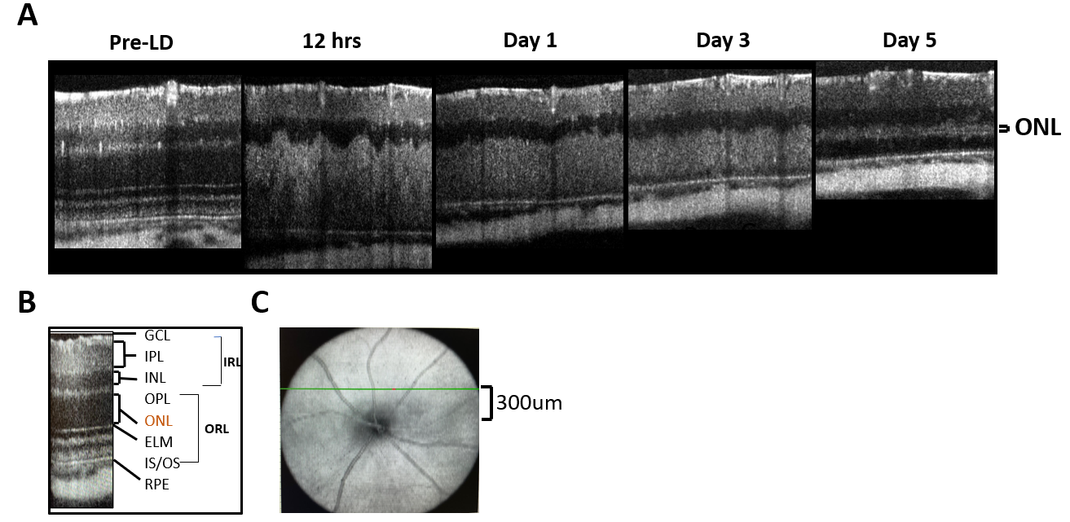
Figure S1. Post-LD OCT changes of retinas in light exposed mice. A Time course of retina OCT images post light exposure; B Representative retinal layers; C Position of SD-OCT measurements. Abbreviations: Ganglion cell layer; IPL, inner plexiform layer; INL, inner nuclear layer; OPL, outer plexiform layer; ONL, outer nuclear layer; ELM, external limiting membrane; IS/OS, inner/outer segment of the photoreceptors; RPE, retinal pigment epithelial.

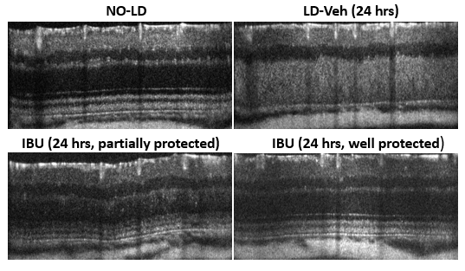
Figure S2. Representative OCT images of the retina 24 hours post-LD. The NO-LD group shows normal retinal structure. Vehicle-treated retina displays damage, while IBU-treated retinas show partially to well-protected retinal integrity.

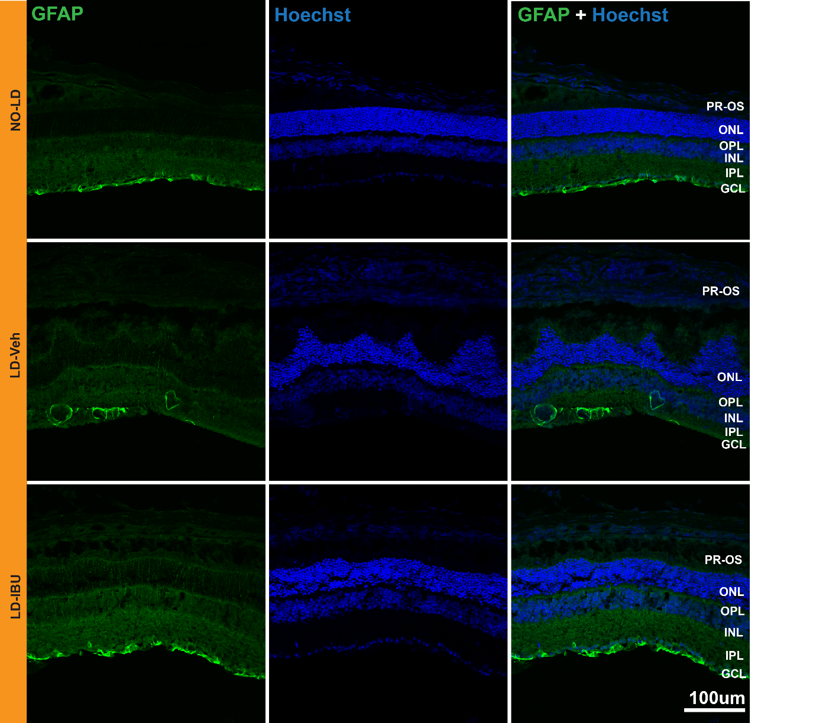
Figure S3. Comparison of GFAP expression 12 hrs post LD among three mice groups: No light damage (No-LD), light damage Vehicle (LD-Veh) and light damage IBU (LD-IBU). 200 mg/kg ibuprofen was used for IP injection.

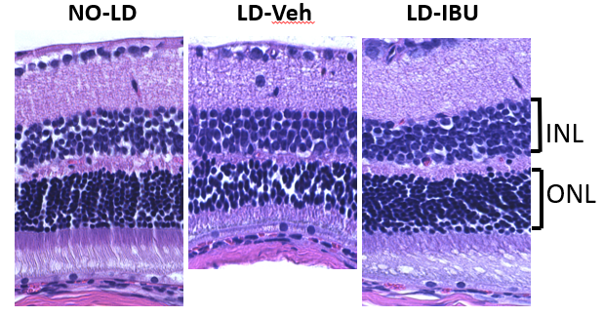
Figure S4. Histological analysis of retinal sections 72 hrs post-LD. The NO-LD group shows intact retinal layers. LD-Vehicle exhibits structural damage, whereas LD-IBU displays preserved retinal architecture, indicating IBU's protective effect. Abbreviations: ONL, outer nuclear layer; INL, inner nuclear layer.

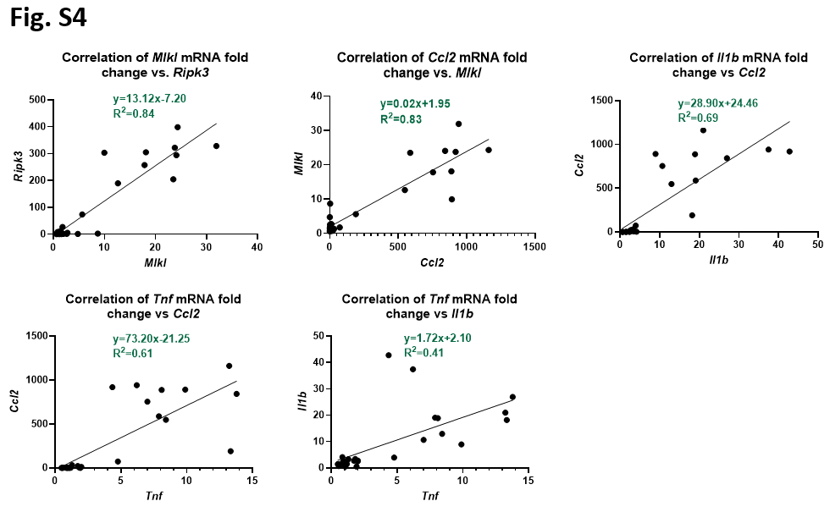
Figure S5. Correlation analysis of mRNA levels of inflammatory markers and Ripk3-Mlkl pathway 24 hrs after LD. A Correlation of Mlkl with Ripk3 mRNA expression (R²=0.78); B Correlation of Ccl2 with Mkl1 (R²=0.84); C Correlation of Il1b with Ccl2 (R²=0.83); D Correlation of Tnf with Ccl2 (R²=0.61). E Correlation of Tnf with Il1b (R²=0.41). Linear regression lines and equations are shown on each plot. These relationships indicate significant positive correlations between the expressions of these inflammatory markers and Ripk3-Mlkl pathway.

